**Please provide complete authors Information**

|  |  |  |  |  |  |
| --- | --- | --- | --- | --- | --- |
|  | 1st Author | 2nd Author | 3rd Author | 4rd Author | etc. |
| **\*Title**  (Prof, Dr, or?) |  |  |  |  |  |
| **\*Full Name**  (Firs, Middle, Last) | Hilman Fauzi | R.Poppy Yaniawati |  |  |  |
| **\*Department, University, City, and Country** | SMA Pasundan Banjaran | Pasundan University, Bandung, Indonesia |  |  |  |
| **\*Email** |  | [mpm@unpas.ac.id](mailto:mpm@unpas.ac.id) |  |  |  |
| **\*ORCID ID** |  |  |  |  |  |
| **Google Scholar URL** |  |  |  |  |  |
| **\*Author Contribution**  **(**[**https://www.elsevier.com/authors/policies-and-guidelines/credit-author-statement**](https://www.elsevier.com/authors/policies-and-guidelines/credit-author-statement)**)** |  |  |  |  |  |
| **\*Acknowledgments** |  | | | | |
| **\*Funding Statement** |  | | | | |

**\*Required**

**Please provide alternative names for potential reviewers for your manuscript**

|  |  |  |  |
| --- | --- | --- | --- |
|  | Reviewer 1 | Reviewer 2 | Reviewer 3 |
| **\*Title** (Prof, Dr, or?) |  |  |  |
| **\*Name** (First, Middle, Last) |  |  |  |
| **\*Department, University, City, and Country** |  |  |  |
| **\*Email** |  |  |  |

**\*Required**

**Development of Ethnomathematics Teaching Materials Based on Google Sites to Improve Students’ Mathematical Literacy and Learning Motivation Using a Differentiated Approach**

**Hilman Fauzi1*, Poppy Yaniawati2*, Achmad Murdikah3\***

1SMA Pasundan Banjaran, Kab. Bandung, Indonesia

2,3 Universitas Pasundan, Bandung, Indonesia

**Abstract**

*This study aims to develop ethnomathematics-based teaching materials delivered through Google Sites, designed to improve students’ mathematical literacy and learning motivation using a differentiated approach. The development process follows the ADDIE model, consisting of analysis, design, development, implementation, and evaluation stages. The material focuses on the topic of geometric transformation, contextualized through local cultural elements such as batik motifs and traditional architectural patterns, and presented in an interactive digital format. Validation results from media, content, and language experts indicate that the materials are valid and suitable for use. Classroom implementation showed significant improvements in students’ mathematical literacy and learning motivation. The differentiated approach allowed students to learn according to their individual styles and needs, while Google Sites facilitated access and engagement throughout the learning process. Therefore, the developed teaching materials are considered effective in supporting contextual, adaptive, and meaningful mathematics learning.*

**Keywords:** *teaching material, ethnomathematics, Google Sites, mathematical literacy, learning motivation, differentiated approach.*

**INTRODUCTION**

In the era of globalization and the Industrial Revolution 4.0, education plays a crucial role in preparing the younger generation to face future challenges. One key area of focus is mathematical understanding, which is not only a fundamental science but also a foundation for developing logical and analytical thinking skills (Sukartono, 2018). However, Indonesia still faces challenges in mathematics education, as reflected in the PISA 2018 report by OECD (2020), where Indonesian students scored below the OECD average. Preliminary studies at SMA Pasundan Banjaran also revealed that students' numeracy and literacy levels remain moderate, indicating the need for more effective learning innovations. One of the most challenging topics for students is transformation geometry, which requires strong spatial visualization skills (Nurmaya et al., 2021).

To address these issues, integrating technology into mathematics learning is seen as a promising solution. The use of digital tools can make learning more interactive and engaging (Yaniawati et al., 2023). Among these tools, Google Sites has emerged as a user-friendly platform that allows educators to develop interactive learning media without requiring advanced technical skills (Toyib et al., 2024). In addition, during the pandemic, the importance of accessible and affordable online learning platforms became increasingly evident (Bradley, 2020; Sejzi & Aris, 2013).

Moreover, literacy in mathematics can be enhanced through differentiated instruction, which considers students’ readiness, interests, and learning profiles (Asiyah, 2023). Integrating cultural elements into learning through ethnomathematics also helps students relate mathematical concepts to their daily lives, making learning more meaningful and motivating (Rachmavita, 2020). Ethnomathematics acknowledges the cultural context of mathematical practices and emphasizes the diversity of mathematical thinking around the world (Toyib et al., 2024). Therefore, developing ethnomathematics-based teaching materials using Google Sites can enhance students’ mathematical literacy and motivation while also promoting cultural values in the learning process.

**METHOD**

This research uses a mixed-methods approach with an Embedded Design, where qualitative data is the main focus and quantitative data is used to support and strengthen the findings. This design helps explore learning phenomena in depth while increasing the validity of the results.

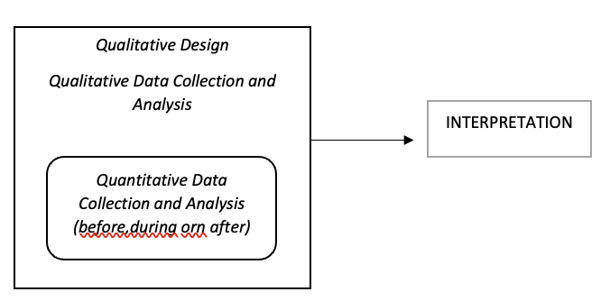

**Figure 1.** mixed-methods approach with an Embedded Design

The development of the learning media follows the ADDIE model (Analysis, Design, Development, Implementation, and Evaluation) as suggested by Muruganantham (2020). This model is used to create and test the effectiveness of interactive learning media based on Google Sites to improve students' motivation and mathematical communication skills.

1. **Analysis**

At this stage, student needs and characteristics are identified. Early data on students' mathematical literacy is collected through interviews, initial tests, and questionnaires.

1. **Design**

The media is planned using Google Sites. The learning content is developed based on the mathematics curriculum and adapted to student needs.

1. **Developmen**

The media is created and then validated by content and media experts. Revisions are made based on their feedback.

1. **Implementation**

The media is applied in the classroom. Data is collected through observations, interviews, and student test results.

1. **Evaluation**

The collected data is analyzed to evaluate the effectiveness of the media. Revisions are made to improve the learning product.

**Tables**

**Table 1**. Format Rules

|  |  |  |  |
| --- | --- | --- | --- |
| **Object** | **Alignment** | **Space above** | **Space below** |
| Title | centered | 6pt | 6pt |
| Table title | centered | 6pt | 3pt |
| Figure title | centered | 3pt | 6pt |

**RESULTS AND DISCUSSION**

These five stages in the ADDIE model are systematically interconnected, starting from needs analysis to final evaluation, to ensure that the developed teaching material is relevant, effective, and aligned with students' needs in culturally and technologically integrated mathematics learning

1. **Analysis Stage**

In the analysis stage, the development team identified students’ and teachers’ needs related to learning geometry transformations. Initial observations and interviews at SMA Pasundan Banjaran revealed that many students had difficulty understanding the abstract concepts due to traditional teaching methods and lack of contextual learning materials. Curriculum analysis was also conducted to align the content with the Merdeka Curriculum, which emphasizes flexible, contextual, and project-based learning. The current learning methods did not fully support this shift, and teachers needed time and support to adapt.

Furthermore, student analysis showed diverse learning styles and a strong need for differentiated instruction. Students struggled to connect geometric transformations with real-life applications due to the lack of visual and interactive media.Based on the 2023 School Report (Rapor Pendidikan), numeracy skills and learning quality were still moderate. These findings supported the urgency to develop a digital ethnomathematics learning material based on local culture, which could make learning more meaningful, contextual, and accessible through platforms like Google Sites. In the 2024 School Report, there was a significant improvement in students' numeracy skills, learning quality, and literacy. These achievements aligned with the research goals to enhance mathematical literacy through culturally relevant and technologically integrated materials using a differentiated learning approach.

1. **Design Stage**

In this stage, the learning materials were designed to improve students’ mathematical literacy through a differentiated approach, integrating ethnomathematics into the topic of geometric transformations for Grade 12 science students at SMA Pasundan Banjaran.

The learning media were developed using **Google Sites**, which contained videos, text, images, and interactive exercises. The instructional videos illustrated concepts such as translation, rotation, reflection, and dilation using local cultural patterns like batik, traditional carvings, and bamboo weaving.

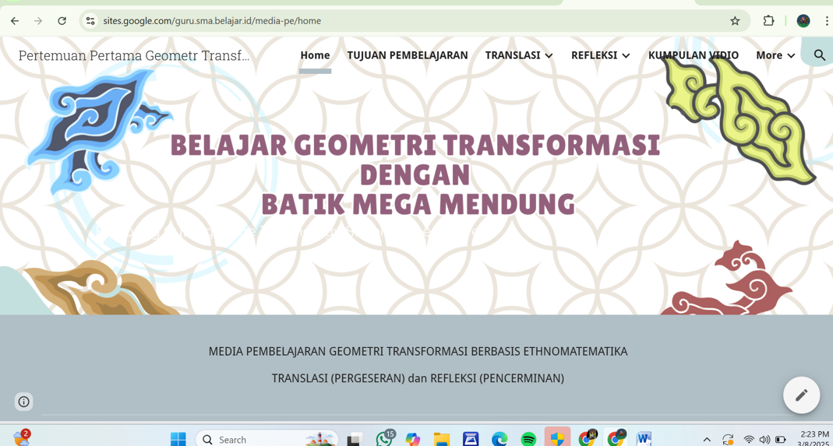

**Figure 2. Google Site**

The content was structured with animations, audio, and visuals to enhance understanding. Google Sites was chosen for its flexibility, allowing students to access the materials anytime and anywhere.

This design aimed to make learning more contextual and meaningful by connecting mathematical concepts to students’ real-life cultural experiences.

### **Development Stage**

### In this stage, the ethnomathematics-based teaching materials using Google Sites were developed to enhance students’ mathematical literacy through a differentiated approach. The development followed the previously designed plan to ensure the content matched learning needs. After development, the materials were validated by media, content, and language experts through questionnaires, comments, and suggestions. Validation was conducted twice until the materials were declared feasible without further revisions.

### The developed ethnomathematics-based teaching material using Google Sites underwent validation by three experts: a media expert, a content expert, and a language expert. Tatang Abdul Hamid, S.Kom., as the media expert, assessed aspects such as layout design, navigation, and material presentation. Although the media met basic feasibility standards, revisions were needed to improve layout, navigation, and resource quality before being declared valid for classroom use. Content validation by Dr. In In Supianti, M.Pd., focused on the material's accuracy, relevance, and clarity, resulting in suggestions for refining sentence structures, correcting typos, adding references, and improving video quality—after which the material was deemed appropriate for learning. Meanwhile, M. Dani Setia Nurchalis, M.Pd., the language expert, rated the linguistic aspects with a total score of 45 out of 50, highlighting the need for sentence simplification, spelling corrections, and punctuation adjustments. Following revisions based on expert feedback, the teaching material was validated and considered ready for effective implementation in the classroom.

1. **Implementation Phase**

The teaching materials, revised based on expert feedback, were tested with 32 students to evaluate their effectiveness. The trial was held on January 8, 2024, with students from class XII at SMA Pasundan Banjaran. The materials were developed using Google Sites to make learning more interactive and context-based, aiming to improve students' mathematical literacy and motivation through ethnomathematics. The materials, focusing on the cultural context, were designed to engage students more effectively (Sopiany Hanifah, et al., 2023). Google Sites provided a flexible platform for these materials, allowing students to interact with content that addressed their learning needs (Adawiah Eka Elia R., 2024).

1. **Using Google Sites and Differentiated Learning**

Ethnomathematics lessons with differentiated learning were implemented to improve students' mathematical literacy and motivation. Google Sites was used as the platform for developing the materials, and lessons were adapted to the varying needs of students. During four observation sessions, data was collected on the planning, execution, and student engagement. The analysis showed that Google Sites-based materials helped improve students' mathematical literacy and motivation. However, some areas, such as classroom cleanliness and student feedback, could be improved.

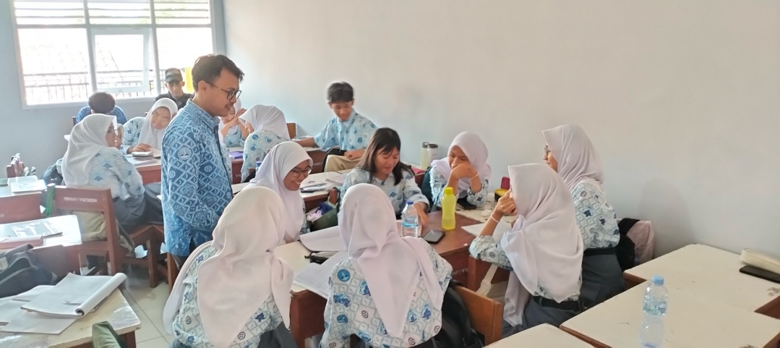

**Figure 2. Learning in the Class**

The teaching involved introducing the lessons, checking attendance, and setting lesson goals in the first session. The teacher used Google Sites to present materials on Megamendung batik and conducted diagnostic assessments to understand students' prior knowledge. Throughout the sessions, students were encouraged to use Google Sites to explore and verify data. The sessions ended with reflection and prayer (Yaniawat, et al., 2020).

**Table 1 Teacher and Student Avtivity Implementation**

|  |  |  |
| --- | --- | --- |
| **Session** | **Teacher Activities** | **Student Activities** |
| 1 | 94.66% (Almost all activities implemented) | 92% (Almost all activities implemented) |
| 2 | 95% (Almost all activities implemented) | 93.66% (Almost all activities implemented) |
| 3 | 94.22% (Almost all activities implemented) | 92.66% (Almost all activities implemented) |

The results from the descriptive analysis show a significant improvement in learning outcomes in the experimental class after the implementation of ethnomathematics learning materials based on Google Sites. Below is a summary of the pretest and posttest results for both classes:

#### ****Table 2.** Pretest and Posttest Results for Experimental and Control Classes**

| **Class** | **Pretest Average** | **Posttest Average** | **Improvement Difference** | **Pretest Standard Deviation** | **Posttest Standard Deviation** |
| --- | --- | --- | --- | --- | --- |
| Experimental | 60.14 | 82.14 | 22.00 | 24.216 | 20.560 |
| Control | 64.61 | 76.79 | 12.18 | 18.942 | 15.737 |

As seen in the table, the experimental class showed a larger improvement in mathematics learning outcomes, with an increase of 22 points compared to the control class, which only showed an improvement of 12.18 points. Furthermore, the experimental class also showed a more significant reduction in score variability, as seen in the lower standard deviation.

Normality tests were conducted to examine the distribution of the pretest and posttest data for both classes. The results are shown below:

#### ****Table 3. Ko**lmogorov-Smirnov and Shapiro-Wilk Normality Test Results**

| **Class** | **Shapiro-Wilk Test (Pretest)** | **Shapiro-Wilk Test (Posttest)** |
| --- | --- | --- |
| Experimental | 0.000 | 0.514 |
| Control | 0.000 | 0.880 |

The results show that the pretest data for both classes were not normally distributed (significance value < 0.05), while the posttest data showed normal distribution with significance values > 0.05. This indicates that after the implementation of ethnomathematics learning materials based on Google Sites in the experimental class, the distribution of scores became more even and stable.

To examine the difference in learning outcomes between the experimental and control classes, a Mann-Whitney non-parametric test was conducted:

#### ****Table 3.** Mann-Whitney Non-Parametric Test Results**

| **Class** | **Mean Rank** | **Sum of Ranks** |
| --- | --- | --- |
| Experimental | 44.07 | 1542.50 |
| Control | 26.93 | 942.50 |

The analysis shows that the mathematics literacy scores of students in the experimental class were higher, with a mean rank of 44.07, compared to the control class with a mean rank of 26.93. The Mann-Whitney test also shows a significance value of 0.000 (p-value < 0.05), indicating a significant difference between the two classes.

Student motivation was assessed using a questionnaire with 40 statements across 8 indicators. Below is a summary of the student motivation results:

#### ****Table 4** Summary of Student Motivation Results**

| **Indicator** | **Experimental Class (%)** | **Control Class (%)** | **Difference (%)** |
| --- | --- | --- | --- |
| Diligent in facing tasks | 87 | 86.1 | 0.9 |
| Persistent in facing difficulties | 86.7 | 86.3 | 0.4 |
| Shows interest | 89.1 | 88.7 | 0.4 |
| Enjoys working independently | 87 | 86.7 | 0.3 |
| Quickly bored with routine tasks | 89.9 | 89.1 | 0.8 |
| Can defend their opinions | 87.71 | 87.1 | 0 |
| Not easily give up their beliefs | 89.57 | 89.43 | 0.14 |
| Enjoys solving problems and puzzles | 87.71 | 87.57 | 0.14 |

With an average motivation percentage of 88.035% in the experimental class and 87.642% in the control class, the difference is 0.393%, showing slightly higher motivation in the experimental class. In almost all indicators, the experimental class had higher results, indicating the positive impact of using Google Sites-based learning materials.

### Evaluation Phase

### The evaluation phase in the ADDIE model serves as the final stage, aiming to assess the effectiveness of the developed teaching materials in improving students’ mathematical literacy. In this stage, the ethnomathematics-based teaching materials using Google Sites were tested on Grade XII students at SMA Pasundan Banjaran. The evaluation involved a pretest-posttest design with an experimental class and a control class. The experimental class used the differentiated learning materials through Google Sites, while the control class used conventional materials.

### Data collection was conducted using pretests and posttests to measure learning outcomes, along with student and teacher questionnaires to gather responses on the usability and acceptance of the materials. Further statistical tests, including normality tests, the Kolmogorov-Smirnov test, and path analysis, were used to explore both direct and indirect effects of the teaching materials on mathematical literacy improvement.

### The results showed that the developed materials were effective in enhancing students’ mathematical literacy and motivation. Quantitative data analysis indicated that students in the experimental class had a higher improvement in scores, with a 22-point increase in posttest scores, compared to a 12.18-point increase in the control class.

### Normality testing using the Shapiro-Wilk test showed that the posttest data in the experimental class had a normal distribution, suggesting improved consistency in students’ understanding. Levene’s Test confirmed the homogeneity of variance, enabling the use of a t-test. The independent t-test revealed a significant difference between the two groups (Sig. = 0.000), with a mean difference of 4.886 and a 95% confidence interval ranging from 2.380 to 7.392. These findings confirmed that the integration of local culture and technology through Google Sites had a significant impact on students' mathematical literacy.

### In terms of motivation, the student motivation questionnaire showed slightly higher average scores in the experimental class (88.04%) compared to the control class (87.64%). Although the difference was small, it indicated that the differentiated and culturally relevant learning approach had a positive influence on students’ affective aspects such as interest, persistence, and attitudes toward learning challenges. However, high responses in negative indicators such as "getting bored easily" highlighted the need for continued variation and innovation in learning activities.

### Overall, the evaluation showed that the differentiated approach combining ethnomathematics and Google Sites created an adaptive, engaging, and context-rich learning environment. Learning became more meaningful cognitively and emotionally, as reflected in increased student motivation and positive perceptions of the learning experience.

### In conclusion, this study confirms the importance of developing innovative teaching materials that incorporate local culture and differentiation principles. These strategies are essential for designing effective and inclusive mathematics instruction.

**CONCLUSIONS**

Based on the results of the study, it can be concluded that the ethnomathematics-based teaching materials developed using the ADDIE model (Analysis, Design, Development, Implementation, and Evaluation) are effective and feasible for use in mathematics learning:

1. **The developed teaching materials were validated and deemed suitable** for classroom use. Validation was confirmed through assessments by media, content, and language experts. Revisions were made based on expert feedback, ensuring the final product met the criteria for content quality, visual design, and communicative language use. Google Sites proved to be an effective platform for delivering accessible, engaging, and interactive materials.
2. **The teaching materials enhanced students' mathematical literacy** by connecting mathematical concepts with relevant local cultural contexts. Presenting mathematics in real-life, contextual situations made it easier for students to understand and apply the concepts. This approach strengthened conceptual understanding and encouraged critical and reflective thinking in problem-solving.
3. **Students’ learning motivation improved** due to the use of differentiated instruction. The integration of visual elements, diverse activities, and local cultural values created an enjoyable and meaningful learning experience. Students demonstrated increased interest, attention, and active participation throughout the learning process.
4. **Students and teachers responded positively** to the implementation of the teaching materials. Students found mathematics more interesting and easier to understand when taught through a culturally relevant and digital approach. Teachers reported that the materials supported more structured and flexible instruction. However, improvements are still needed, particularly in providing more personalized feedback and expanding the variety of learning activities to better meet students’ diverse needs.

These findings affirm that developing innovative, culture-based teaching materials using digital platforms and differentiated approaches is essential for effective and inclusive mathematics education.

**REFERENCES**

Kementerian Pendidikan dan Kebudayaan. (2019). Hasil PISA Indonesia 2018: Akses makin meluas, saatnya tingkatkan kualitas. <https://www.kemdikbud.go.id/main/blog/2019/12/hasil-pisa-indonesia-2018-akses-makin-meluas-saatnya-tingkatkan-kualitas>

Kementerian Pendidikan dan Kebudayaan. (2021). Panduan penguatan literasi dan numerasi di sekolah. Direktorat Jenderal Pendidikan Anak Usia Dini, Pendidikan Dasar, dan Pendidikan Menengah.

Kementerian Pendidikan Nasional. (2006). Peraturan Menteri Pendidikan Nasional Nomor 22 Tahun 2006. Jakarta: Kemendiknas

Nurmaya, R. (2021). Pengembangan bahan ajar berbasis etnomatematika pada materi transformasi geometri. RANGE: Jurnal Pendidikan Matematika, 2(2), 123–129.

OECD. (2020). Are students ready to thrive in an interconnected world? Annex C released test units (Vol. 6, pp. 394–416).

Article in Journal:

Rachmavita, P. F. (2020). Interactive media-based video animation and student learning motivation in mathematics. Journal of Physics: Conference Series, 1663, 012040. <https://doi.org/10.1088/1742-6596/1663/1/012040>

Rahmawati, N. I. (2018). Pemanfaatan ICT dalam meningkatkan kemampuan literasi matematika. Prosiding Seminar Nasional Matematika. Semarang: Universitas Negeri Semarang.

Toyib, M., Faiziyah, N., & Yuliana, I. (2024). Pelatihan dan pendampingan MGMP guru matematika Kabupaten Sukoharjo dalam pengelolaan pembelajaran bermuatan ethnomathematics berbasis Google Sites. Jurnal Terapan Abdimas, 9(2), 174–181.

Usqa, U. (2024). Literasi matematika siswa MTs melalui pembelajaran diferensiasi berdasarkan gaya belajar kinestetik. Skripsi. Universitas Islam Negeri Ar-Raniry Darussalam-Banda Aceh.

Uno, H. B. (2013). Teori motivasi dan pengukurannya. Jakarta: Bumi Aksara.  
Wiriaatmadja, R. (2006). Metode penelitian tindakan kelas. Bandung: Remaja Rosdakarya.

Warschauer, M., & Matuchniak, T. (2010). New technology and digital worlds: Analyzing evidence of equity in access. Review of Research in Education. <https://doi.org/10.3102/0091732X093497>

Wilsa, A. W. (2019). Perbedaan hasil belajar siswa yang menggunakan multimedia interaktif dengan buku teks dalam pembelajaran biologi di SMA. Jurnal Mangifera Edu, 4(1), 63.

Yaniawati, P. (2010). E-learning: Alternatif pembelajaran kontemporer. CV Rvindo Raya.

Yaniawati, P., et al. (2020). Integration of e-learning for mathematics on resource-based learning: Increasing mathematical creative thinking and self-confidence. International Journal of Emerging Technologies in Learning, 15(6), 60–78. <https://www.learntechlib.org/p/217189/>

Yaniawati, P. (2022). Problematika pendidikan dan pembelajaran. Deepublish.

Yaniawati, P., Fisher, D., Permadi, Y., & Yatim, S. (2023). Development of mobile-based digital learning materials in blended learning oriented to students’ mathematical literacy. International Journal of Information and Education Technology, 13(9). <https://doi.org/10.18178/ijiet.2023.13.9.1936>

Yaniawati, P., Fisher, D., & Nurusolih, S. (n.d.). Blended learning berbasis gaya belajar: Teknologi menjadi pedagogi.

Yaniawati, P. (2023). The potential of mobile augmented reality as didactic and pedagogical source in learning geometry 3D. JOTSE, 13(1), 4–22. <https://doi.org/10.3926/jotse.166>

Yaniawati, P., et al. (2023). Workshop pemanfaatan Mastering Math dan pembuatan bahan ajar. An-Nas: Jurnal Pengabdian Masyarakat, 3(1), 13–22.