Determinants Of Stock Prices And The Implications For Company Value With Moderation Of Company Size (Empirical Study on Companies Listed in LQ Index 45)

Widya Intan Sari1*, Jaja Suteja2, Mokhamad Anwar3

1Fakultas Ekonomi dan Bisnis, Universitas Pamulang

2Faculty of Economics, Universitas Pasundan

3Fakultas Ekonomi & Bisnis, Universitas Padjadjaran

Email Correspondence : [dosen02451@unpam.ac.id](mailto:dosen02451@unpam.ac.id)

ABSTRACT

*This research is aimed at finding out the determinants of share prices, namely Return On Assets (ROA), Net Profit Margin (NPM), Earning Per Share (EPS), Economic Growth, Exchange Rates and Inflation and their implications for company value which is moderated by company size (Study Empirical on Companies Listed on the LQ 45 Index). The method used is panel data regression using the Eviews program. Using a target population of 45 companies and a sample of 22 companies listed on the LQ 45 Index. Return On Assets (ROA), Net Profit Margin (NPM), Earning Per Share (EPS), Economic Growth, Exchange Rates and Inflation affect share prices respectively by 3.98%, 1.685%, 69.46%, 0.896% , 1.1368%, 0.44%. Together, Return On Assets (ROA), Net Profit Margin (NPM), Earning Per Share (EPS), Economic Growth, Exchange Rates and Inflation affect share prices by 72.59%. Of the six variables, Earning Per Share has a more dominant influence on share prices. This research also concluded that share prices have an effect on company value by 79.91%. The influence of share prices on company value through company size is 82.74%, meaning that company size can moderate share prices on company value.*

Keywords: *Return On Assets (ROA), Net Profit Margin (NPM), Earning Per Share (EPS), Economic Growth, Exchange Rates, Inflation, Share Prices, Company Value and Company Size.*

INTRODUCTION

In the current era of global integration, investment has become a crucial necessity, serving as a means to secure the future by anticipating unforeseen events through careful financial planning. People invest not only to prepare for future needs but also to mitigate uncertainties such as financial limitations, health conditions, economic downturns, and inflation (Samsuar & Akramunnas, 2017). Among various investment options, financial investment has gained popularity due to its accessibility and liquidity, allowing investors to withdraw funds at any time. The capital market, as a key platform for financial investment, facilitates transactions that help businesses raise long-term capital by issuing securities.

The capital market plays a vital role in a country’s economic growth by channeling funds from investors to businesses in need of financing. According to Indonesian Capital Market Law No. 8 of 1995, the capital market encompasses activities related to public offerings, securities trading, and entities associated with securities issuance. It serves as a financial intermediary, enabling efficient fund allocation between lenders and borrowers. Companies utilize the capital market to meet their long-term funding needs through instruments such as stocks, bonds, mutual funds, warrants, and options.

Regulated by the Financial Services Authority (OJK) under Regulation No. 3/POJK.04/2021, the capital market consists of key institutions, including the Stock Exchange, Clearing and Guarantee Institution, Central Securities Depository, and Securities Trading Intermediaries. These entities ensure the smooth operation of capital market activities by providing infrastructure for securities trading, clearing, settlement, and safekeeping. As Sukmawati Sukamulja (2021) states, the capital market acts as a meeting point between investors with surplus funds and corporations or institutions in need of financing. In essence, it serves as a critical financial ecosystem that fosters investment, economic growth, and business development.

Data from KSEI indicates a consistent increase in the number of capital market investors over the years. Between 2020 and 2021, investor growth surged by 92.99%, followed by a 33.53% increase from 2021 to 2022. Although the rate of increase slowed in 2022, the number of investors continued to rise, reaching 12 million in 2024. This trend highlights the growing public interest in investment, which plays a crucial role in driving economic growth. However, despite the rising number of investors, capital market literacy in Indonesia has declined.

While the Indonesia Stock Exchange (BEI) initially set a target of 14 million investors in 2023, the actual figure by July 2023 stood at 11.4 million. Meanwhile, capital market literacy decreased from 4.92% to 4.11%, even as financial inclusion rose from 1.55% to 5.19%. According to BEI Research Division Head Verdi (2023), this trend suggests that although more people are investing, their understanding of the capital market remains limited ([*www.cnbcindonesia.com*](http://www.cnbcindonesia.com)). This knowledge gap poses a challenge, as informed investment decisions are crucial for market stability and investor protection.

For publicly traded companies, corporate value is primarily reflected in stock prices, which serve as an indicator of shareholder wealth. In the short term, companies focus on maximizing profits by utilizing their resources efficiently, while in the long term, they aim to enhance shareholder prosperity by increasing firm value. A high corporate value signals financial stability, attracting investors and lenders alike. As Dedi Rosidi (2018) explains, investors perceive rising stock prices as a sign of strong company performance, encouraging further investment, while creditors view it as an assurance of the company’s ability to repay debts, reducing financial risk.

The Stock Price Index serves as a summary of the simultaneous and complex influences of various factors, particularly those related to a country's economic conditions. Investors need to understand the information embedded in the Stock Price Index to make informed investment decisions in the capital market. The Indonesia Stock Exchange currently has 11 types of stock indices, with the LQ45 Index being a key focus in this study. The LQ45 Index measures the performance of 45 highly liquid stocks with large market capitalizations, supported by strong company fundamentals (Sukmawati Sukamulja, 2021:244).

A company’s value is often reflected in its stock price. Tobin’s Q is a market ratio used to compare a company’s market value, as reflected in the financial market, with its book value or asset replacement cost (Sianturi, 2015). A higher Tobin’s Q indicates that investors perceive the company as having greater value compared to the capital it has invested. Maximizing corporate value is essential, as it directly aligns with enhancing shareholder wealth, which is the primary objective of a business.

Despite fluctuations in corporate performance each year, companies continuously strive to improve their value. While challenges may arise, firms consistently work towards enhancing their market position, demonstrating their ability to sustain and increase corporate value over time. This commitment to value creation strengthens investor confidence and supports long-term business growth.

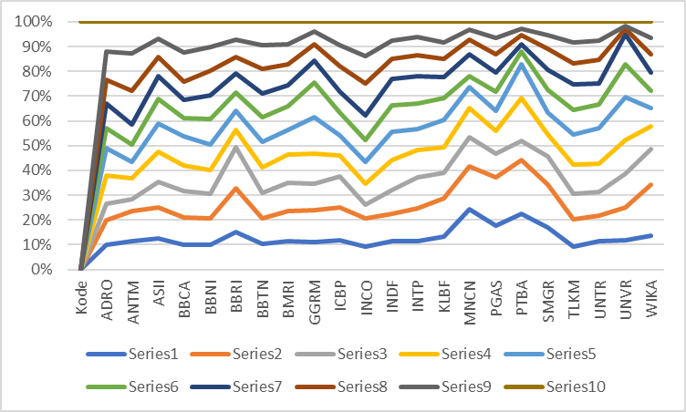

Figure 1. Company Value Data

Data from Figure 1 indicates that the corporate value of companies listed in the LQ45 Index has experienced fluctuations, as measured by Tobin’s Q. This ratio defines corporate value based on both tangible and intangible assets and serves as an indicator of a company's efficiency in utilizing its resources. A higher Tobin’s Q signifies greater market confidence and potential long-term success, as it reflects increased investor prosperity. Tobin’s Q is calculated by summing the market value of equity (outstanding shares multiplied by the closing price) and total debt, then dividing by total assets. Research by Harefan Arief (2020) suggests that Tobin’s Q significantly influences stock prices.

Corporate value is closely linked to stock prices, which are influenced by supply and demand dynamics in the capital market. Share prices fluctuate based on market participants' perceptions, where higher demand drives prices up, while excess supply causes them to decline (Deni Kurnia, 2019). Companies aiming to maximize corporate value must focus on optimizing shareholder wealth, as the stock price reflects investor confidence and overall company performance.

Beyond market mechanisms, stock prices are also influenced by a company’s financial performance. In capital markets, strong corporate performance is typically rewarded with rising stock prices, as investors anticipate higher returns. When a company demonstrates consistent growth, investor interest increases, leading to higher demand for its shares and, consequently, a rise in stock value. Conversely, declining company performance can reduce investor confidence, resulting in decreased stock prices.

Field observations indicate that stock prices of companies listed in the LQ45 Index fluctuate due to both internal and external factors. Investors closely monitor these price movements, as stock prices are a key indicator of corporate value (Hanifah & Khafid, 2016). Research by Mangeta et al. (2019) confirms that higher stock prices enhance a company’s perceived value among investors, while lower stock prices may indicate financial instability. Similarly, findings by Susi Rosmawati & Fatwa Rubiar (2023) highlight a significant positive relationship between stock prices and corporate value, reinforcing the importance of maintaining a strong market position.

Company size also plays a crucial role in influencing corporate value. Jogiyanto (2013:282) defines company size as a scale that classifies businesses based on various financial metrics such as total assets, market capitalization, and log size. Larger companies have greater access to both internal and external funding sources, enabling them to sustain operations and expand their market presence. Consequently, firms with substantial resources are more resilient to economic fluctuations and better positioned to generate long-term value. Furthermore, company size directly impacts investor confidence. Well-established corporations with significant total assets tend to attract more investors, as they are perceived as stable and capable of sustaining growth. Larger firms also benefit from greater market visibility, making it easier for investors to access relevant financial information. This transparency enhances trust, ultimately contributing to higher corporate value and increased investment potential.

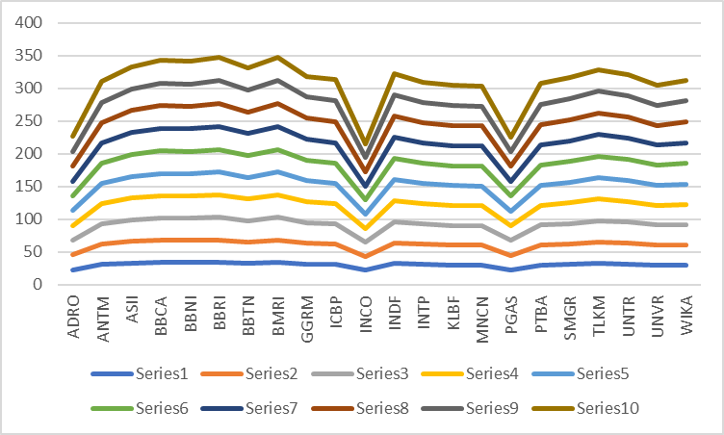

Figure 2. Company Size Data

Over the past few years, the size of companies listed in the LQ45 Index has fluctuated. Company size is a classification metric that can be determined using various indicators, including total assets, log size, and market capitalization. Additionally, it can be measured through total sales, average asset turnover, and the company’s total assets over time. Larger companies tend to gain greater public recognition, making it easier for investors to access relevant information, thereby enhancing corporate value. Firms with substantial total assets often attract more investors due to their perceived stability and growth potential.

Company size also reflects a firm’s financial management capabilities. Larger corporations typically have greater experience in managing funding structures and require significant capital to sustain operational activities (Gitman, 2016:16). These firms are better positioned to secure financing, both internally and externally, to support business expansion and maintain market competitiveness. Investors often view large companies as more reliable and financially stable, increasing their willingness to invest in such firms.

According to Gitman (2016:17), company size is commonly measured using total assets, which are converted into natural logarithms (Ln) for analytical purposes. Research by Putu Mikhy Novari (2016) indicates that company size has a significant positive impact on corporate value. This finding suggests that as a company grows, its value in the eyes of investors also increases, reinforcing the importance of efficient asset management and financial transparency in maintaining market confidence.

Inflation levels fluctuated between 2013 and 2022, with a sharp increase in 2013 and 2014, reaching 8%. Several factors contribute to rising inflation, which in turn affects stock prices. When production costs increase at a higher rate than the prices companies can charge, profitability declines. Reduced profits discourage investors from investing in affected companies, leading to a drop in stock prices. According to Indonesia’s Ministry of Finance Regulation No. 101/PMK.010/2021, inflation targets are determined based on the Consumer Price Index (CPI) and are published annually by the Central Statistics Agency. The regulation sets inflation targets as specific figures with a tolerance range (point with deviation) to manage economic stability.

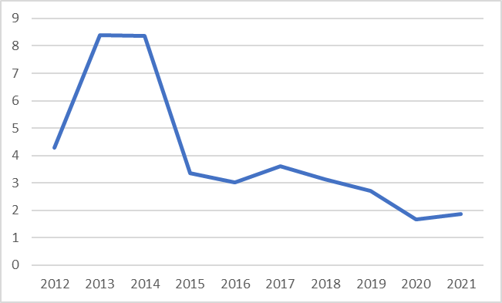

Figure 3. Inflation Chart in Indonesia Period 2012-2021

Inflation, as a broad-based increase in the prices of goods and services, also influences stock market movements. Research by Yoopi (2012:121) suggests that inflation has a positive correlation with stock prices—when inflation rises, stock prices tend to increase, and when inflation declines, stock prices also decrease. This relationship is further supported by the findings of M. Subhan et al. (2023), which confirm that inflation significantly impacts stock prices. These studies highlight the importance of monitoring inflation trends for investors, as fluctuations in inflation can directly affect market performance and investment decisions.

The exchange rate of the Rupiah against the US Dollar has experienced fluctuations over the past decade, generally showing an upward trend. Bank Indonesia actively monitors foreign exchange transactions through the Foreign Exchange Transaction Monitoring System (SISMONTAVAR), as regulated in Bank Indonesia Regulation No. 23/5/PBI/2012. This system enables real-time supervision of currency transactions between domestic and international banks, as well as between banks and non-bank entities. The exchange rate is determined by the supply and demand dynamics in the foreign exchange market, making it a critical factor for capital market participants, particularly in Indonesia. Given its influence on transaction costs, exchange rate fluctuations can significantly impact stock market returns.

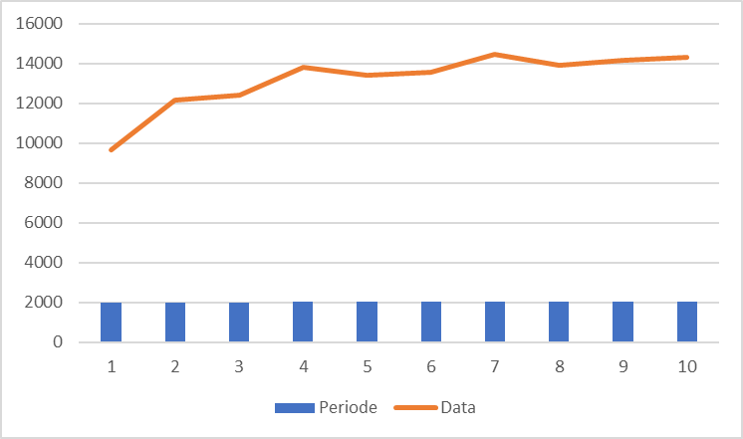

Figure 4. Rupiah Exchange Rate Against USD

A depreciating Rupiah can have adverse effects on stock prices, especially for publicly listed companies with foreign debt obligations (Cahya et al., 2015). According to Bodie et al. (2007), key macroeconomic factors such as interest rates, inflation, and exchange rates directly impact stock price movements. When the Rupiah weakens, it signals potential economic instability, leading to declining stock indices (Ang, 1997). Investors often interpret currency depreciation as a negative indicator, which may result in reduced market confidence and lower stock valuations.

Exchange rate movements are among the most closely watched variables by investors, as they directly affect short-term capital gains (Nurhakim, 2010). Research by Khaerunnida (2017) indicates that exchange rate fluctuations have a significant negative effect on stock prices, implying that currency depreciation tends to lower stock values. However, studies by Ni Putu Juniantari (2023) and Serena Sela Sebo (2020) suggest a negative but statistically insignificant relationship. These findings underscore the importance of exchange rate stability in maintaining investor confidence and overall market performance.

Field observations indicates that economic growth has fluctuated over time, with a significant decline during the COVID-19 pandemic, which led to widespread corporate bankruptcies. The drop in consumer demand resulted in lower stock prices, highlighting the direct relationship between economic growth and investment levels. A strong economy enhances national income, allowing more individuals to allocate surplus funds for savings or investment in financial securities traded in the capital market (Masta Sembiring, 2017). As economic conditions improve, increased production of goods and services drives corporate profitability, leading to higher stock prices.

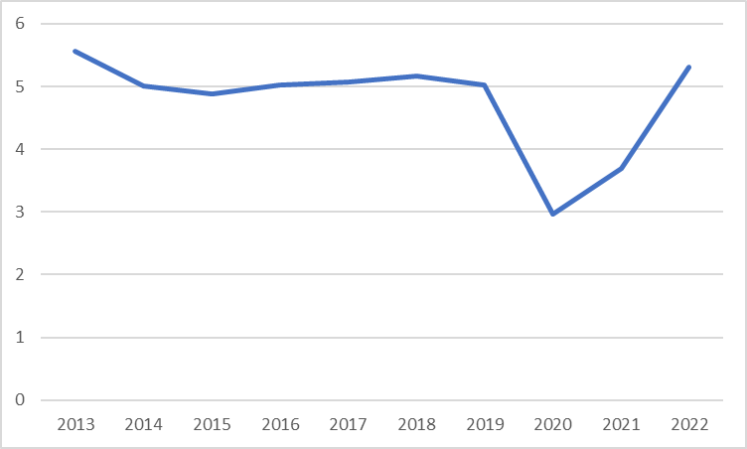

Figure 5. Economic growth

Economic growth and investment exhibit a positive correlation. A growing economy encourages higher levels of savings, which in turn boosts investment activity. When businesses expand and generate higher profits, investor confidence increases, leading to greater stock market participation. Higher economic growth signals better investment prospects, attracting both domestic and international investors (Safaruddin et al., 2019). This dynamic reinforces the importance of maintaining a stable and growing economy to support long-term investment trends. Research by Safaruddin et al. (2019) further emphasizes that economic growth influences investor activity in the capital market. Similarly, Anggreni & Purnamawati (2017) found that economic expansion positively impacts stock price performance. As economic growth strengthens, investment flows into capital markets increase, stimulating stock price appreciation. This underscores the crucial role of macroeconomic stability in fostering a conducive investment environment and enhancing corporate financial performance.

Field data indicates that Return on Assets (ROA) for companies listed in the LQ45 Index has fluctuated over the past decade, with a significant decline during the pandemic. ROA reflects a company's ability to generate profits from its assets after accounting for financing costs. A higher ROA indicates that the company effectively utilizes its assets to generate profits, while a lower or negative ROA suggests inefficiencies, leading to financial losses. Since ROA varies across industries, it is best evaluated over time within the same company or compared to similar firms in the industry to assess financial performance accurately. ROA serves as a key metric in evaluating a company’s efficiency in utilizing its assets to generate earnings. This ratio measures the return on investment derived from a company’s total assets. A higher ROA signifies strong profitability, making the company more attractive to investors. As investor confidence grows, the demand for company shares increases, ultimately driving up stock prices (Brigham & Houston, 2010). Research by Ni Komang Santi Ani (2019) confirms that ROA has a significant impact on stock prices, reinforcing its role as a critical factor in investment decision-making. Investors consider a company's ROA to assess its financial health and future growth potential. As profitability improves, stock prices tend to rise, making companies with higher ROA more appealing in the capital market.

Field data reveals that Net Profit Margin (NPM) for companies listed in the LQ45 Index has fluctuated over the past decade, with a significant decline during the pandemic. NPM measures a company's profitability in relation to its sales revenue, representing the net income after deducting all expenses and taxes. A higher NPM indicates that a company efficiently generates profits from its sales, reflecting strong financial performance (Enduardus Tandelin, 2017). A high NPM suggests a well-performing company capable of producing substantial profits, making it an attractive option for investors. To maintain and enhance profitability, company owners must focus on increasing sales, as higher revenue leads to greater net profits. A rising NPM ratio signals that a company operates efficiently, generating significant net income through its sales activities. Investors consider NPM when making investment decisions, as companies with strong profitability are more likely to attract investor interest. Increased investor confidence leads to greater demand for company shares, subsequently driving up stock prices (Chairunisa Mawarni Putri, 2013).

Research by Eny Purwaningsih (2022) confirms that NPM has a significant positive impact on stock prices. As net profit margins improve, investor interest grows, leading to increased stock market activity. This relationship highlights the importance of maintaining strong profitability levels, as companies with higher NPM tend to experience rising stock values, reinforcing the connection between financial performance and market attractiveness.

Field data indicates that Earnings Per Share (EPS) for companies listed in the LQ45 Index has fluctuated over the past decade, with a significant decline during the pandemic. EPS represents the net income earned per share of common stock, reflecting a company's ability to generate returns for shareholders. Typically, EPS influences stock prices, as a higher EPS signals strong financial performance, attracting investor interest (Budi Rahardjo, 2009). When EPS increases, the market perceives it as a positive signal, leading to higher demand for shares and an eventual rise in stock prices.

EPS serves as a key indicator of a company's ability to generate net profits per share, directly affecting stock market valuation (Sugeng, 2017:260). Investors closely monitor EPS growth as it reflects a firm’s profitability and financial health. Research by Puspita Sari Wijaya (2023) confirms that EPS has a significant positive effect on stock prices, reinforcing its role in investment decision-making. Companies with higher EPS are generally more attractive to investors, as they indicate strong earnings potential and contribute to sustained stock price growth.

METHODS

This research employs a descriptive and verificative approach to understand the factors affecting stock prices and company value. Descriptive research is used to explain the conditions of variables such as ROA, NPM, EPS, economic growth, exchange rates, and inflation. Meanwhile, verificative research, according to Sugiyono (2017), is used to test hypotheses derived from descriptive findings through statistical analysis to determine whether the hypotheses should be accepted or rejected. In this study, the verificative method is used to explore the relationships and impacts between multiple variables, including ROA, NPM, EPS, economic growth, exchange rates, inflation, and stock prices, both simultaneously and partially, as well as their influence on company value.

The research spans from January 2023, starting with the proposal stage, continuing through field data collection, and concluding with the final report by the end of 2023. The process includes preparation stages such as proposal defenses, field research, revisions, and final examination sessions. Data for this study is sourced from official websites: the Indonesia Stock Exchange (IDX), Bank Indonesia (BI), and the Central Bureau of Statistics (BPS). The IDX provides financial reports, BI offers data on exchange rates and inflation, while BPS supplies information on economic growth.

The research design follows a structured approach, including the following steps: conducting preliminary studies on the variables, reviewing relevant theories and previous research, defining the research problem and objectives, formulating hypotheses, selecting suitable research methods and analytical tools, and collecting and analyzing data. The study concludes with hypothesis testing, discussions, and recommendations based on the research problem.

**RESULT AND DISCUSSION**

**A. Descriptive Statistics**

This analysis describes each variable independently, without comparing or linking one variable to another. Descriptive analysis is used to answer the research problem formulated earlier, examining variables such as Return On Asset (ROA), Net Profit Margin (NPM), Earnings Per Share (EPS), economic growth, exchange rates, inflation, stock prices, company value, and company size for companies listed in the LQ 45 Index from 2013 to 2022. All data for these variables were derived from financial reports of the companies from 2013 to 2022.

Return on Asset (ROA) measures how efficiently a company's assets generate profit. The average ROA for companies in the LQ 45 Index showed variations over the years, with the highest value recorded in 2013 at 10.61%, and the lowest in 2020 at 6.41%. The highest ROA for individual companies was achieved by Unilever Indonesia (UNVR) consistently, while the lowest was seen in Bank Tabungan Negara (BBTN) in various years. Net Profit Margin (NPM), used to measure a company's profitability relative to its revenue, also fluctuated over the years. The highest NPM was 46.59% in 2022, seen in Bank Central Asia (BBCA), while the lowest was recorded in 2020, with a significant drop due to the pandemic. The average NPM was 18.95% in 2013, which decreased over the years but improved by 2022.

Earnings Per Share (EPS), a key indicator for investors, represents the profit available to shareholders. EPS varied greatly, with the highest recorded by Gudang Garam (GGRM) in 2013 at 2250 and the lowest at Kalbe Farma (KLBF) in 2013 with only 41. The average EPS was 547.80 in 2013, steadily increasing to 732.61 by 2022. Economic growth in Indonesia showed fluctuations, with an average growth rate of 4.70% from 2013 to 2022. The highest growth occurred in 2013 at 5.78%, while the lowest was in 2020 due to the pandemic, with a significant contraction to 2.07%. Growth picked up again in 2021, reaching 3.70%.

Exchange rates also showed a general upward trend from 2013 to 2022, with a significant increase in 2022 reaching 15,592 IDR per USD. This rise was attributed to various economic pressures, including increased imports and external debts. Inflation in Indonesia was volatile, with an average rate of 4.16% over the period. Inflation was highest in 2013 at 8.38% and lowest in 2020 at 1.68%. In 2022, inflation rose to 5.51%, driven by global price increases in energy and food. Stock prices of LQ 45 companies also varied, with the highest average stock price recorded in 2017 at IDR 13,614.8.

The stock market faced significant drops in 2020 but recovered by 2022, when the average stock price increased to IDR 6,701.8. Company value, measured using Tobin’s Q ratio, fluctuated across the years. The highest company value was recorded in 2017, with Unilever Indonesia (UNVR) having the highest value of 113.52. In contrast, companies like Adaro Energy (ADRO) had the lowest value, particularly in 2015 with a ratio of 0.64. The average company value declined after 2017 but showed recovery in later years. Company size, defined by total assets or market capitalization, remained stable across the years. The average size increased slightly from 30.41 in 2013 to 31.24 in 2022, with the largest companies being Bank Mandiri (BMRI) and Bank Rakyat Indonesia (BBRI).

**B. Selection of the best models**

Panel data regression in this study is conducted using three models: common effect, fixed effect, and random effect. Each model has its own advantages and disadvantages. The choice of model depends on the assumptions used by the researcher and the fulfillment of the correct statistical data processing requirements.

**1. Chow Test**

This Chow test is conducted to determine the most appropriate common effect or fixed effect model to use in estimating panel data.

**Table 1. Chow Test Result**

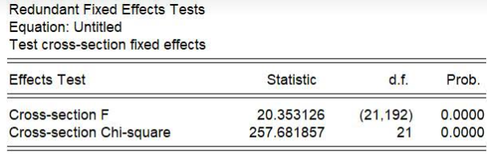

Based on Table 1, it can be seen that the Probability F value is 0.0000 with a significance level of 0.05. Since the Probability F value (0.0000) is less than 0.05, H0 is rejected, indicating that the selected model is the fixed effect model. Since the Chow test determines the fixed effect model, further testing using the Hausman test is needed to determine whether the appropriate model is the fixed effect model or the random effect model.

**2. Hausman test**

The Hausman test is conducted to test whether the data is analyzed using fixed effects or random effects.

**Table 2. Hausman Test Result**

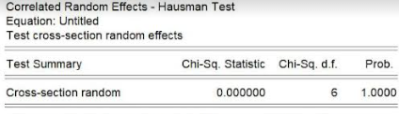

Based on Table 2, it can be seen that the Probability Chi-Square value is 1.0000 with a significance level of 0.05. Since the Probability Chi-Square value (1.0000) is greater than 0.05, H0 is accepted, indicating that the selected model is the random effect model. Since the Hausman test determines the random effect model, further testing using the Lagrange Multiplier test is needed to determine whether the appropriate model is the random effect model or the common effect model.

**3. Lagrange Multiplier Test**

This test is conducted to test whether the data is analyzed using common effect or random effect.

**Table 3. Lagrange Multiplier Test Results Structure I**



Based on Table 3, it can be seen that the Probability Breusch-Pagan value is 0.0000 with a significance level of 0.05. Since the Probability Breusch-Pagan value (0.0000) is less than 0.05, H0 is rejected, indicating that the selected model is the common effect model.

**C. Classic Assumption Test**

**1. Normality Test**

According to Sugiyono (2017:239), normality testing is used to assess whether thevariables being studied are normally distributed. In this study, normality testing aims to examine whether the variables in the panel regression model are normally distributed. A good regression model should have data that is normally distributed or close to normal.



Figure 6. Results of the Initial Model I Structure Normality Test

Based on the initial normality test results, the Probability value was 0.000944, which is less than 0.05, indicating that the data is not normally distributed. As a result, data reduction was performed by excluding values above and below the average, reducing the data from 220 observations to 211.

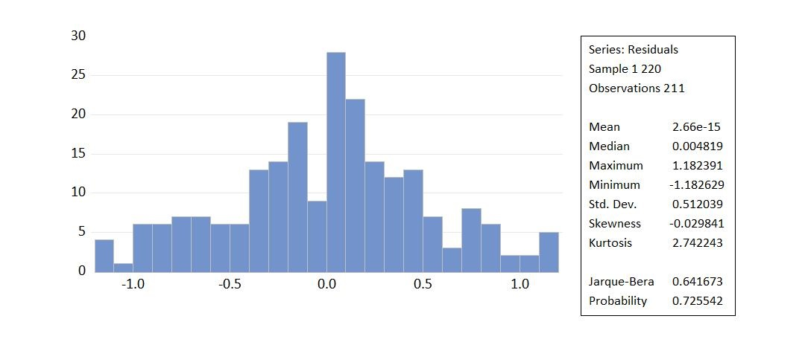

Table 7. Results of the Normality Test of the Final Model I Structure

After the data reduction, the normality test for variables such as Return on Asset (ROA), Net Profit Margin (NPM), Earnings Per Share (EPS), Economic Growth, Exchange Rate, and Inflation against Stock Prices showed a Probability value of 0.725542, which is greater than 0.05, indicating that the data is now normally distributed.

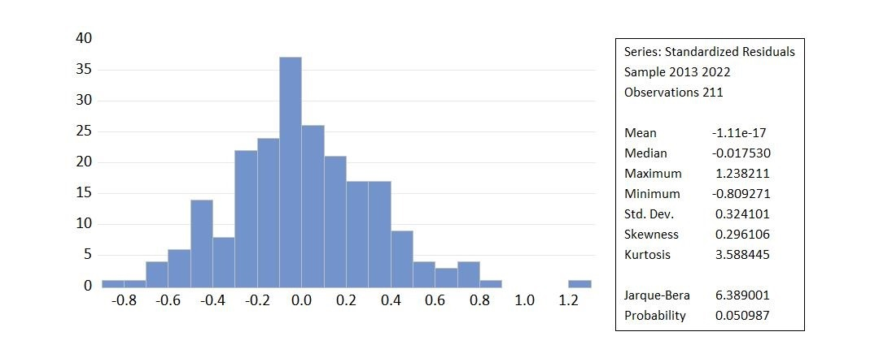

Figure 8. Results of Structural Normality Test II

Similarly, the normality test for Stock Prices against Company Value, using the Fixed Effect model, yielded a Probability value of 0.050987, which is also greater than 0.05, confirming that the data is normally distributed.

**2. Multicollinearity Test**

Multicollinearity testing is used to determine if there are any issues between the independent variables in a regression model (Sugiyono, 2019:79).

**Table 4. Results of Multicollinearity Test of Structure I**

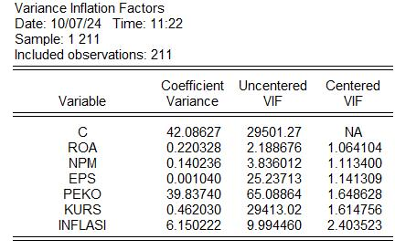

For the variables Return on Asset (ROA), Net Profit Margin (NPM), Earnings Per Share (EPS), Economic Growth, Exchange Rate, and Inflation against Stock Prices (Structure I), the Variance Inflation Factor (VIF) for all variables was found to be less than 10, indicating that there are no multicollinearity issues.

**Table 5. Results of the Multicollinearity Test of Structure II**

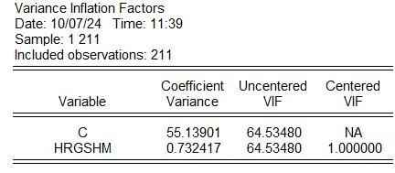

Similarly, for the relationship between Stock Prices and Company Value, all variables also had VIF values below 10, confirming that there are no multicollinearity issues present.

**3. Heteroscedasticity Test**

The heteroscedasticity test for the variables Return On Assets (ROA), Net Profit Margin (NPM), Earnings Per Share (EPS), Economic Growth, Exchange Rate, and Inflation on Stock Prices can be seen in the following image:

**Table 6. Heteroscedasticity Test Results of Structure I**

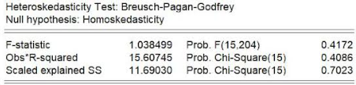

Based on Table 3 above, the p-value, represented by the Prob. chi-square(2) value in Obs*R-Squared, is 0.4086. Since the p-value of 0.4086 is greater than 0.05, it indicates that the regression model exhibits homoscedasticity, meaning there is no issue with the assumption of non-heteroscedasticity.

**Table 7. Results of Heteroscedasticity Test of Structure II**

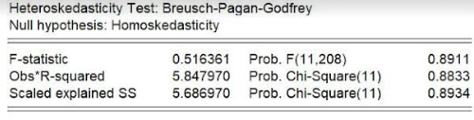

Based on Table 4 above, the p-value, represented by the Prob. chi-square(2) value in Obs*R-Squared, is 0.8833. Since the p-value of 0.8833 is greater than 0.05, it indicates that the regression model exhibits homoscedasticity, meaning there is no issue with the assumption of non-heteroscedasticity.

**D. Multiple Linear Regression Analysis**

**Table 4. Multiple Linear Regression Results with Common Effect Model Structure 1**

|  |  |  |  |  |
| --- | --- | --- | --- | --- |
|  |  |  |  |  |
|  |  |  |  |  |
| Variable | Coefficient | Std. Error | t-Statistic | Prob. |
|  |  |  |  |  |
|  |  |  |  |  |
| C | 21.56326 | 6.777014 | 3.181824 | 0.0017 |
| ln_roa | 1.729149 | 0.501156 | 3.450318 | 0.0007 |
| ln_npm | 1.398592 | 0.397073 | 3.522251 | 0.0005 |
| ln_eps | 0.745843 | 0.034750 | 21.46283 | 0.0000 |
| ln_peko | 1.952065 | 6.773933 | 0.288173 | 0.7735 |
| ln_kurs | -1.800351 | 0.710023 | -2.535624 | 0.0012 |
| ln_inflasi | -2.588726 | 2.655479 | -0.974862 | 0.3308 |
|  |  |  |  |  |
|  |  |  |  |  |
| R-squared | 0.725923 | Mean dependent var | | 8.600008 |
| Adjusted R-squared | 0.717862 | S.D. dependent var | | 1.099137 |
| S.E. of regression | 0.583825 | Akaike info criterion | | 1.794181 |
| Sum squared resid | 69.53370 | Schwarz criterion | | 1.905380 |
| Log likelihood | -182.2861 | Hannan-Quinn criter. | | 1.839130 |
| F-statistic | 90.05281 | Durbin-Watson stat | | 0.940093 |
| Prob(F-statistic) | 0.000000 |  |  |  |
|  |  |  |  |  |
|  |  |  |  |  |

Based on the data processing results above, the regression results can be seen in Table 4. The panel data regression equation using the common effect model is as follows:

ln_hargasaham = 21.56326 + 1.729149*ln_roa* – 1.398592*ln_npm* + 0.745843*ln_eps* + 1.952065*ln_peko* – 1.800351*ln_kurs* – 2.588726 *ln_inflasi* + *Ɛ1*

**Table 5. Simple Linear Regression Results with Fixed Effect Model Structure 2**

|  |  |  |  |  |
| --- | --- | --- | --- | --- |
| Dependent Variable: ln_nilaiperusahaan | | |  |  |
|  |  |  |  |  |
|  |  |  |  |  |
| Variable | Coefficient | Std. Error | t-Statistic | Prob. |
|  |  |  |  |  |
|  |  |  |  |  |
| C | -87.67144 | 10.21499 | -8.582628 | 0.0000 |
| ln_hargasaham | 10.72368 | 1.186456 | 9.038411 | 0.0000 |
|  |  |  |  |  |
|  |  |  |  |  |
|  | Effects Specification | |  |  |
|  |  |  |  |  |
|  |  |  |  |  |
| Cross-section fixed (dummy variables) | | | |  |
|  |  |  |  |  |
|  |  |  |  |  |
| R-squared | 0.799168 | Mean dependent var | | 4.552269 |
| Adjusted R-squared | 0.775667 | S.D. dependent var | | 14.83306 |
| S.E. of regression | 7.025510 | Akaike info criterion | | 6.839566 |
| Sum squared resid | 9279.264 | Schwarz criterion | | 7.204934 |
| Log likelihood | -698.5742 | Hannan-Quinn criter. | | 6.987255 |
| F-statistic | 34.00484 | Durbin-Watson stat | | 0.627445 |
| Prob(F-statistic) | 0.000000 |  |  |  |
|  |  |  |  |  |
|  |  |  |  |  |

Based on the results on Table 5, with the form of a simple linear regression equation with a fixed effect model as follows:

*ln_nilaiperusahaan* = -87.67144 + 10.72368*ln_hargasaham*

**Table 6. Simple Linear Regression Results with Fixed Effect Model Structure 3**

|  |  |  |  |  |
| --- | --- | --- | --- | --- |
| Dependent Variable: ln_nilaiperusahaan | | |  |  |
|  |  |  |  |  |
|  |  |  |  |  |
| Variable | Coefficient | Std. Error | t-Statistic | Prob. |
|  |  |  |  |  |
|  |  |  |  |  |
| C | 0.676667 | 0.049909 | 13.55806 | 0.0000 |
| ln_hargasaham*ln_m | 1.25E-06 | 1.66E-07 | 7.524551 | 0.0000 |
|  |  |  |  |  |
|  |  |  |  |  |
|  | Effects Specification | |  |  |
|  |  |  |  |  |
|  |  |  |  |  |
| Cross-section fixed (dummy variables) | | | |  |
|  |  |  |  |  |
|  |  |  |  |  |
| R-squared | 0.827447 | Mean dependent var | | 0.947130 |
| Adjusted R-squared | 0.807255 | S.D. dependent var | | 1.145629 |
| S.E. of regression | 0.502963 | Akaike info criterion | | 1.565992 |
| Sum squared resid | 47.55864 | Schwarz criterion | | 1.931360 |
| Log likelihood | -142.2122 | Hannan-Quinn criter. | | 1.713681 |
| F-statistic | 40.97827 | Durbin-Watson stat | | 0.549304 |
| Prob(F-statistic) | 0.000000 |  |  |  |
|  |  |  |  |  |
|  |  |  |  |  |

Based on the results om Table 6, with the form of a simple linear regression equation with a fixed effect model as follows:

*ln_nilaiperusahaan* = 0.676667+ 1.25*ln_hargasaham*ln_m*

Based on the results of multiple and simple linear regression analyses, it can be concluded that the selected models provide significant insights into the relationship between the independent and dependent variables. The findings indicate that Return on Assets (ROA), Net Profit Margin (NPM), Earnings Per Share (EPS), Economic Growth, Exchange Rate, and Inflation have varying influences on stock prices. Furthermore, stock prices significantly impact firm value, as demonstrated in the fixed effect models. These results highlight the importance of financial and macroeconomic factors in determining stock prices and firm value. Future research may explore additional variables or alternative methodologies to enhance the robustness of these findings.

**D. Discussion**

The determinants of stock prices, including Return on Assets (ROA), Net Profit Margin (NPM), Earnings Per Share (EPS), Economic Growth, Exchange Rates, and Inflation, play a crucial role in explaining stock price movements. According to Agency Theory, management must optimize all these variables to effectively enhance stock prices. A well-managed financial structure and profitability indicators contribute significantly to investor confidence and market valuation.

**1. Return on Assets (ROA) and Stock Prices**

Statistical analysis indicates that ROA has a positive and significant effect on stock prices. Research by Debbie Christine (2022) supports this finding, demonstrating that higher ROA correlates with increased stock values. Signaling Theory suggests that companies should provide financial signals to investors through profitability indicators like ROA. A higher ROA reflects efficient asset utilization, attracting investors and increasing stock demand, which in turn raises stock prices. The ability of a firm to generate profits from its assets serves as a positive signal to the market, encouraging further investment (Hery, 2016). From an investor’s perspective, profitability growth is a key indicator in assessing a company’s future prospects. Tandelilin (2010:240) highlights ROA and NPM as critical profitability measures that influence stock price fluctuations. The greater a company’s ability to generate profits, the more attractive it becomes to investors. Increased investor demand for shares subsequently drives up stock prices, reinforcing the connection between profitability and market performance (Brigham & Houston, 2010).

**2. Net Profit Margin (NPM) and Stock Prices**

Empirical findings indicate that NPM positively and significantly influences stock prices. Research by Evi Noviaty (2021) confirms this relationship, showing that higher NPM attracts investor interest. Based on Signaling Theory, a higher NPM reflects strong financial health, as it indicates the company's ability to control production costs and set competitive prices. Consequently, firms with higher NPM ratios generate more substantial net profits, making their stocks more appealing to investors. Kasmir (2014) asserts that a strong profit margin (NPM) enhances investor confidence, as it signifies effective cost management and profitability. A company with a high NPM demonstrates its ability to retain a portion of its revenue as net income, which benefits shareholders. Higher investor interest in firms with strong NPM performance leads to increased stock demand, ultimately driving stock prices higher. Diana (2018) further supports this by emphasizing NPM as a key metric in assessing a firm's ability to generate earnings from sales.

**3. Earnings Per Share (EPS) and Stock Prices**

Statistical analysis reveals that EPS has a positive and significant impact on stock prices. Research by Debbie Christine (2022) validates this relationship, indicating that an increase in EPS attracts more investors, leading to higher stock valuations. Signaling Theory suggests that a rising EPS signals profitability, encouraging investors to increase their capital allocation to such firms (Fathihani, 2020). The ability of a company to generate higher earnings per share directly influences investor perceptions and stock demand. EPS is a fundamental profitability metric, reflecting a company's capacity to distribute profits among shareholders (Cahyaningrum & Antikasari, 2017). Higher EPS values are associated with improved corporate performance, which in turn leads to greater investor interest and stock price appreciation. Hery (2016) emphasizes that investors are more likely to invest in firms with increasing EPS, as it indicates sustainable profitability and strong financial prospects.

**4. Economic Growth and Stock Prices**

Empirical analysis suggests that economic growth does not have a significant effect on stock prices. This finding is supported by Jumria (2017), who argues that while economic expansion typically boosts investor confidence, it does not necessarily translate into immediate stock price growth. Sri Handini (2020) notes that gross domestic product (GDP) growth influences market expectations, but its effect on stock performance depends on broader economic conditions. Renald Suganda (2018) highlights that while strong economic growth provides a positive investment outlook, it is not the sole determinant of stock prices. Other factors, including political stability and fiscal policies, influence investor decisions. Tandelilin (2010) asserts that economic expansion enhances purchasing power and corporate revenues, which may indirectly contribute to stock price movements. However, the relationship remains complex and influenced by multiple external variables.

**5. Exchange Rates and Stock Prices**

Statistical findings indicate that exchange rates negatively and significantly impact stock prices. Research by Khaerunnida (2017) supports this conclusion, showing that currency fluctuations can deter investors due to increased financial risks. A weakening currency raises import costs and foreign debt burdens, leading to reduced corporate profitability and declining stock prices. Niagian Toni (2021:25) explains that investors assess currency fluctuations when making investment decisions. A volatile exchange rate increases uncertainty, discouraging investment in certain sectors. Efriyenty (2020) emphasizes that exchange rate movements can either increase or decrease stock prices, depending on market reactions. Nopirin (2012) describes exchange rates as comparative measures of currency values, which influence business operations and investor sentiment.

**6. Inflation and Stock Prices**

Empirical analysis suggests that inflation does not significantly affect stock prices. Research by Nevy Agustin (2023) indicates that inflation negatively impacts stock values by increasing production costs and reducing consumer demand. As inflation rises, companies experience higher operational expenses, leading to lower profit margins and diminished investor confidence. Irving Fisher's Quantity Theory of Money states that inflation results from increased money supply, affecting overall price levels. Yuliani & Suwitho (2020) argue that rising production costs lower company profits, reducing dividend distributions to investors. Efriyenty (2020) emphasizes that inflation can lead investors to shift funds toward safer assets like savings and fixed-income securities, making stocks less attractive.

**7. Stock Prices and Corporate Value**

Statistical results confirm that stock prices positively and significantly influence corporate value. Agency Theory (Jensen & Meckling, 1976) explains the relationship between shareholders and management, where stock prices reflect investor confidence in a company’s operational efficiency. Research by Syahrinah (2017) highlights that higher stock prices indicate greater market trust, enhancing corporate valuation. Keown et al. (2010) describe corporate value as the market valuation of equity and debt, directly linked to stock price movements. Muchtalifah (2013) suggests that a strong stock price indicates both current performance and future growth potential. Research by Dirvi Surya Abbas (2020), Susi Rosmawati (2023), and Denny Kurnia (2019) further validate the positive impact of stock prices on corporate value.

**8. Stock Prices, Corporate Value, and Firm Size as a Moderator**

Empirical analysis demonstrates that firm size strengthens the relationship between stock prices and corporate value. Larger firms benefit from greater access to funding, stronger investor interest, and increased public recognition (Wida & Suartana, 2014). Rejeki & Haryono (2021) argue that larger companies attract more investors, enhancing corporate value. Husnan (2004:6) identifies dividend policy, investment decisions, and capital structure as key determinants of corporate value. Brigham & Houston (2006:65) highlight free cash flow and firm size as influential factors in valuation. Sujarweni (2015) asserts that larger firms tend to have higher stock turnover and financial stability, making them more attractive investment opportunities.

**E. Research Findings and Implications**

This study identifies the key determinants of stock prices in LQ45-listed companies and their influence on corporate value, with firm size serving as a moderating variable. The findings highlight that profitability indicators such as Return on Assets (ROA), Net Profit Margin (NPM), and Earnings Per Share (EPS) play a significant role in shaping stock prices, which in turn affect corporate valuation.

One of the key strengths of this study is the confirmation that stock prices have a substantial and positive impact on corporate value. An increase in stock prices reflects stronger investor confidence and market trust, ultimately leading to enhanced corporate valuation. This reinforces the importance of maintaining stable and strong stock performance as a strategic financial objective for companies.

However, certain macroeconomic variables, such as economic growth and inflation, do not exhibit a significant influence on stock prices. Economic expansion does not always translate into higher stock prices, as various external factors may affect investor sentiment. Additionally, inflation tends to have a negative impact on corporate earnings, increasing production costs and reducing investment attractiveness. These findings further emphasize the critical role of firm size as a moderating factor, as larger companies tend to have greater financial resilience, easier access to capital, and stronger investor appeal, which collectively contribute to sustaining stock prices and corporate value.

**CONCLUSION**

The analysis reveals that Return on Assets (ROA), Net Profit Margin (NPM), and Earnings Per Share (EPS) of LQ45 companies have shown fluctuations over the past decade, with a significant decline in 2019 due to the COVID-19 pandemic. Similarly, macroeconomic variables such as economic growth, exchange rates, and inflation have also experienced variations, with economic growth notably declining in 2020, exchange rates tending to rise, and inflation dropping sharply to below 2% in 2020 and 2021. Stock prices and corporate value, as measured by Tobin’s Q, also fluctuated, peaking in 2017 and reaching their lowest point in 2021. The study finds that EPS has the strongest impact on stock prices (69.46%), while other factors, including ROA, NPM, economic growth, exchange rates, and inflation, have smaller but significant influences. Collectively, these factors account for 72.59% of stock price variations, with the remaining 27.41% influenced by other unexamined variables. Additionally, stock prices significantly affect corporate value, contributing 79.91%, while the presence of company size as a moderating variable strengthens this relationship to 82.74%.

Based on these findings, companies should stabilize financial conditions by maximizing asset utilization for profit generation while reducing reliance on external financing. Enhancing sales performance and resource efficiency can also improve profitability and investor confidence. Since EPS plays a crucial role in attracting investors, companies should focus on strategies to increase EPS. Investors, on the other hand, should carefully assess economic growth trends, as they directly impact security supply and demand. Exchange rate stability is also essential, as excessive fluctuations can influence stock price movements. Additionally, implementing contingency plans for inflation spikes is crucial, as high inflation may reduce capital market attractiveness and shift investor preferences toward savings or deposits.

To strengthen corporate resilience, companies should monitor currency fluctuations that could affect import payments and foreign currency liabilities, as these may increase financial burdens and depress stock prices. Management must actively work toward stock price stability, as higher stock values reflect strong investor confidence and contribute to increased corporate value. Sustaining large company sizes can also facilitate capital market access and attract more investors. Moreover, companies must consider both internal and external factors influencing stock prices and take proactive steps to enhance investor relations, as investor engagement is critical for long-term business sustainability and operational success.

REFERENCES

Ang, Robert. (1997). Buku Pintar Pasar Modal Indonesia. Jakarta: Mediasoft Indonesia.

Bodie, Z., Kane, A., & Marcus, A. J. (2007). Investment (7th Ed.). New York: McGraw-Hill.

Brigham, Eugene F. & Houston, Joel F. (2010). Dasar-Dasar Manajemen Keuangan, Edisi Kesebelas. Jakarta: Salemba Empat.

Darmadji, Tjiptono & Fakhruddin, Hendy M. (2011). Pasar Modal di Indonesia. Jakarta: Salemba Empat.

Eduardus Tandelilin. (2017). Pasar Modal: Manajemen Portofolio dan Investasi. Depok: PT Kanisius.

Gitman, Lawrence J. & Zutter, Chad J. (2012). Principles of Managerial Finance (13th Edition). Pearson Education.

Gujarati, D. N. (2012). Dasar-Dasar Ekonometrika. Jakarta: Salemba Empat.

Hanifah, U., & Khafid, M. (2016). The Analysis of Earnings Persistence Roles in Mediating The Effect of Operating Cash Flow and Debt Level on Stock Return. Accounting Analysis Journal, 5(4), 290-298.

Hartono, Jogiyanto. (2016). Teori Portofolio dan Analisis Investasi, Edisi Kesepuluh. Yogyakarta: BPFE UGM.

Hery. (2015). Analisis Laporan Keuangan. Yogyakarta: CAPS (Center for Academic Publishing Service).

Hery. (2016). Financial Ratio for Business. Jakarta: PT Gramedia.

Kasmir. (2014). Analisis Laporan Keuangan, Cetakan Ketujuh. Jakarta: PT RajaGrafindo Persada.

Kasmir. (2017). Analisis Laporan Keuangan, Cetakan Kedelapan. Jakarta: Rajawali Press.

Kurnia, Deni. (2019). Pengaruh Profitabilitas, Kebijakan Dividen, dan Harga Saham terhadap Nilai Perusahaan. Jurnal Akuntansi: Kajian Ilmiah Akuntansi, Vol. 6, No. 2.

Mangeta et al. (2019). Pengaruh Harga Saham terhadap Nilai Perusahaan. Jurnal Keuangan dan Bisnis, 5(1), 45-60.

Nurhakim. (2010). Pengaruh Perubahan Nilai Tukar, Inflasi, Suku Bunga, dan Beta terhadap Return Saham Jakarta Islamic Index pada Periode Bullish dan Bearish (Januari 2004 – Desember 2008). Universitas Islam Negeri Sunan Kalijaga, Yogyakarta.

Rosmawati, S. & Fatwa, Rubiar. (2023). Pengaruh Harga Saham terhadap Nilai Perusahaan pada Perusahaan Sektor Properti dan Real Estate (Studi Kasus Bursa Efek Indonesia). Prosiding FRIMA No. 6 Tahun 2023.

Safaruddin, D., N., Raihan, R., & Anwar. (2019). The Effect of Macroeconomic Variables on Company Performance in Consumer Goods Industry Issuers on the Indonesia Stock Exchange. Proceedings of the Lhokseumawe State Polytechnic National Seminar.

Samsul. (2006). Pasar Modal dan Manajemen Portofolio. Jakarta: Penerbit Erlangga.

Sari, W. I. (2019). Analisis Pengaruh Inflasi, Suku Bunga SBI, Nilai Tukar Terhadap Return LQ 45 dan Dampaknya Terhadap Indeks Harga Saham Gabungan (IHSG) di Bursa Efek Indonesia (BEI). Jurnal SEKURITAS (Saham, Ekonomi, Keuangan dan Investasi), 3(1), 65.

Sianturi. (2015). Tobin’s Q sebagai Indikator Nilai Perusahaan. Jurnal Ekonomi dan Keuangan, 4(2), 85-101.

Sugiyono. (2017). Metode Penelitian Kuantitatif, Kualitatif, dan R&D. Bandung: Alfabeta.

Sukamulja, Sukmawati. (2021). Manajemen Keuangan Korporat. Yogyakarta: CV Andi Offset.

Tandelilin, Eduardus. (2010). Portofolio dan Investasi: Teori dan Aplikasi, Edisi 1. Yogyakarta: Kanisius.

Watung, R. W. & Ilat, V. (2016). Pengaruh Return on Asset (ROA), Net Profit Margin (NPM), dan Earning Per Share (EPS) terhadap Harga Saham pada Perusahaan Perbankan di Bursa Efek Indonesia Periode 2011-2015. Jurnal EMBA, 4(2), 518–529.