Please provide complete authors Information

 | 1st Author | 2nd Author | 3rd Author | 4rd Author | etc.
*Title  (Prof, Dr, or?) |  | Dr. | Ph.D
*Full Name  (Firs, Middle, Last) | Tantya | Inin Supianti | Bana G. Kartasasmita
*Department, University, City, and Country | SMP Negeri 2 Katapang | Universitas Pasundan | Universitas Pasundan
*Email | Tantya.wulansari@gmail.com | supianti@unpas.ac.id | bana.kartasasmita@gmail.com
*ORCID ID
Google Scholar URL |  | https://scholar.google.com/citations?view_op=search_authors&mauthors=in+in+supianti&hl=id&oi=ao
*Author Contribution
(https://www.elsevier.com/authors/policies-and-guidelines/credit-author-statement)
*Acknowledgments
*Funding Statement

*Required

Please provide alternative names for potential reviewers for your manuscript

 | Reviewer 1 | Reviewer 2 | Reviewer 3
*Title (Prof, Dr, or?)
*Name (First, Middle, Last)
*Department, University, City, and Country
*Email

*Required

Implementation of Inquiry Learning to Improve Mathematical Reasoning Ability Reviewed from the Fanaticism Attitude of Students

Tantya Wulansari¹, Inin Supianti², Bana G. Kartasasmita³
SMP Negeri 2 Katapang, University of Pasundan, Bandung, Indonesia
*tantya.wulansari@gmail.com * supianti@unpas.ac.id * bana.kartasasmita@gmail.com

Abstract
The mathematical reasoning ability of junior high school students in Indonesia is still considered low. Inquiry Learning is proposed as a learning model to overcome this problem. This study aims to determine whether students who are taught using Inquiry Learning show better improvement in mathematical reasoning ability compared to those who receive conventional teaching, considering the level of student fanaticism towards Korean dramas. This study uses a mix method approach with Convergent Parallel Design. The population consists of seventh grade junior high school students, with VII-F as the experimental group and VII-I as the control group. The instruments used include a mathematical reasoning test and a fanaticism questionnaire. The results of the study indicate that: (1) students who receive Inquiry Learning show greater improvement in mathematical reasoning ability, regardless of their level of fanaticism, compared to students who receive conventional teaching; (2) there is a positive correlation between student fanaticism and their mathematical reasoning ability when using Inquiry Learning. Therefore, the Inquiry Learning model is recommended as a method to improve mathematical reasoning ability.

Keywords: Inquiry, Mathematical Reasoning, Fanaticism, Junior High School.

INTRODUCTION
Good quality education is very important for the progress of a country, because quality human resources are measured by the ability of graduates of educational institutions to compete at the international level. The results of the TIMSS study show that Indonesia is ranked 72nd out of 78 countries in the 2018 PISA competition, although it has improved in PISA 2022. Therefore, it is important for Indonesia to improve its ability to learn mathematics, especially in the aspect of mathematical reasoning.
Reasoning is a basic ability that students must have, in every mathematics learning activity it cannot be separated from reasoning (Marian, 2021). The mathematical reasoning ability of students is essentially in line with the vision of mathematics, especially to meet future needs (Noviyana et al., 2024).
The importance of having mathematical reasoning skills has also been emphasized by (Khoirinisa & Malasari, 2021), who stated that correct mathematical reasoning helps individuals not only remember facts, rules, and problem-solving steps, but use reasoning skills to make estimates or rely on experience so that they can understand mathematical concepts that are related to each other and learn meaningfully.
Inquiry learning is an interesting alternative to improve students' mathematical reasoning skills. This learning model places students as active subjects in the learning process, encouraging them to seek and find answers to the problems they face (Gunardi, 2020). Inquiry learning focuses on contextual problems and open-ended questions that can stimulate students' thinking in solving mathematical problems. The final grade as a determination of students' attitudes in thinking skills can reduce the effectiveness of the evaluation approach to learning in mathematics.
This is in line with (Putri, 2020) the influence of the Korean Wave, especially through Korean dramas, causing problems with adolescent fanaticism. This phenomenon can affect adolescents' mindsets and behavior, which has the potential to distract them from learning mathematics. Then according to (Nawawi, 2021) fanaticism has become a phenomenon among adolescents, especially students at the junior high school level.
In addition, fanaticism as an attitude of enthusiasm that goes beyond limits towards a particular thought or cause. (Darmawan, 2020) in all indicators, the dominant indicator is something that is the biggest attraction to watch Korean dramas (Hadiyani et al., 2021). In this case, social identity theory can explain how students who are fanatical about Korean dramas can identify themselves with fan groups, which can affect their way of thinking and learning motivation (Damasta & Dewi, 2020).
This study aims to investigate the relationship between students' fanaticism towards Korean dramas and their mathematical reasoning ability when using the Inquiry Learning model. The focus of this study is to provide new insights into the low mathematical learning outcomes at SMP Negeri 2 Katapang, in class VII which shows a percentage of learning objective achievement (KKTP) of 53.4%.

METHOD
This study used a mixed-methods approach, combining quantitative and qualitative techniques to comprehensively understand the influence of Korean drama fanaticism on students' critical thinking and mathematical reasoning skills. As defined by Indrawan and Yaniawati (2016), mixed-methods research integrates various methodologies, philosophies, and design orientations by collecting qualitative and quantitative data, prioritizing the integration of these data, and designing the research design accordingly. This study used a convergent research design, also known as concurrent triangulation, in which qualitative data were collected through a survey assessing students' attitudes toward Korean drama fanaticism, along with quantitative data obtained through a pre-test and post-test to mathematical reasoning skills. The population of this study included all seventh-grade students enrolled in mathematics learning at SMPN 2 Katapang in the 2023/2024. The qualitative sample was selected by distributing a Google Form questionnaire to all eligible seventh-grade students, with attention to the varying levels of Korean drama fanaticism among participants. In contrast, the quantitative sample consisted of two groups of classes: the experimental class, VII-F, which implemented the Inquiry Learning model, and the control class, VII-I, which followed the conventional learning model. Each class consisted of 30 students, allowing for the application of different treatments to evaluate the impact of the Inquiry Learning model on students' mathematical reasoning skills. This structured approach allowed for an in-depth analysis of how Korean drama fanaticism affects educational outcomes, providing valuable insights for educators and researchers.

RESULTS AND DISCUSSION
The analysis of the data on the improvement of students' mathematical reasoning ability can use the gain index data (normalized gain). Gain (normalized gain) can be calculated by Meltzer & Hake (in Runisah 2008, p. 58) to calculate the gain index. Based on the calculation of the gain index test, it is obtained as in table 1 as follows:

Table 1. Descriptive Statistics of Mathematical Reasoning N-Gain Test Data
Parameter | N | Maximum | Minimum | Mean | Criteria
Gain Non Fanatic Experiment | 10 | 0.57 | 0.49 | 0.5172 | Currently
Gain Fanatic Experiment | 20 | 0.57 | 0.47 | 0.5183 | Currently
Non-Fanatical Control Gain | 12 | 0.54 | 0.47 | 0.5106 | Currently
Gain Control Fanaticism | 18 | 0.50 | 0.44 | 0.4761 | Currently

Based on the descriptive statistics of the N-Gain mathematical reasoning test data, all groups showed an increase that fell into the moderate category, both in the experimental and control groups, with a relatively small average difference between fanatic and non-fanatic students. Interestingly, although students with high levels of fanaticism had a slightly lower average increase than non-fanatic students, they actually showed greater activeness in field presentations. Fanatic students appeared more confident and persistent in conveying their arguments, although they tended to be more rigid in accepting new ideas. In contrast, non-fanatic students, although they had greater flexibility in reasoning, tended to be less prominent in presentations. These findings suggest that fanaticism can affect students' patterns of involvement and expression in academic activities, which needs to be considered in learning strategies.
After knowing the descriptive statistical description of N-Gain, the next step is to conduct a normality test on the four categories using the Kolmogorov-Smirnov and Shapiro Wilk tests with a significance level of 0.05. The tool for processing it is the SPSS 25.0 for Windows Software program. The output display is as shown in Table 2.

Table 2. Output Data Normality N-Gain Test Mathematical Reasoning Ability
Tests of Normality
Category |  | Kolmogorov-Smirnova |  |  | Shapiro Wilk
 |  | Statistics | df | Sig. | Statistics | df | Sig.
mathematical_reasoning_gain_score | Non-Fanatical Experiment | 0.251 | 10 | 0.073 | 0.895 | 10 | 0.194
 | Fanatic Experiment | 0.189 | 20 | 0.061 | 0.937 | 20 | 0.209
 | Non-Fanatical Control | 0.154 | 12 | .200* | 0.959 | 12 | 0.776
 | Fanatical Control | 0.209 | 18 | 0.037 | 0.945 | 18 | 0.346

The results of the normality test for the N-Gain data of mathematical reasoning ability showed that the data in the Non-Fanatic Experiment, Fanatic Experiment, and Non-Fanatic Control groups were normally distributed, with the Kolmogorov-Smirnov and Shapiro-Wilk significance values ​​all greater than 0.05. In contrast, the data in the Fanatic Control group showed a mostly normal distribution, with the significance value in the Kolmogorov-Smirnov test slightly below 0.05 but still within acceptable limits in the Shapiro-Wilk test. This indicates that the data generally follow a normal distribution, so the use of parametric statistical analysis for further testing of the Two-Way ANOVA test to compare differences in mathematical reasoning ability between different groups.
After knowing the normality of N-Gain, the next step is to conduct a Two-Way ANOVA test on the four categories as in the following table.

Table 3. Descriptive Statistics of Two-Way ANOVA Test Data on Mathematical Reasoning Ability
Category | Mean | Std. Deviation | N
Non-Fanatical Experiment | 0.5172 | 0.02530 | 10
Fanatic Experiment | 0.5183 | 0.02869 | 20
Non-Fanatical Control | 0.5106 | 0.01992 | 12
Fanatical Control | 0.4761 | 0.01528 | 18
Total | 0.5039 | 0.02914 | 60

Based on the descriptive statistics table of the two-way ANOVA test for mathematical reasoning ability, it can be seen that the Fanatical Experiment group has the highest mean of 0.5183, followed by the Non-Fanatical Experiment group with a mean of 0.5172. The Non-Fanatical Control group has a lower mean of 0.5106. Meanwhile, the Fanatical Control group shows the lowest mean of 0.4761. This difference in means indicates a variation in mathematical reasoning ability between the experimental and control groups, as well as between fanatical and non-fanatical participants. The experimental group, both fanatical and non-fanatical, tends to have better mathematical reasoning ability than the control group.

Table 4. Two-Way ANOVA Test Data Output for Mathematical Reasoning Ability
Tests of Between-Subjects Effects
Dependent Variables:
Source | Type III Sum of Squares | df | Mean Square | F | Sig.
Corrected Model | .020a | 3 | 0.007 | 12,779 | 0,000
Intercept | 14,156 | 1 | 14,156 | 26659,776 | 0,000
Category | 0.020 | 3 | 0.007 | 12,779 | 0,000
Error | 0.030 | 56 | 0.001
Total | 15,287 | 60
Corrected Total | 0.050 | 59

The results of the Two-Way ANOVA test showed that there were significant differences in mathematical reasoning ability between groups using the Inquiry Learning model and the conventional model, as well as between students with high fanaticism towards Korean dramas compared to students who were not fanatic. With an F value of 12.779 and a significance value of 0.000, the data indicated that differences in mathematical reasoning ability were not only influenced by the learning method but also by the level of student fanaticism towards Korean dramas. Specifically, although the Inquiry Learning method tended to show a higher mean in mathematical reasoning compared to the conventional model, differences in mathematical reasoning results were also influenced by students' fanaticism.

Table 5. Post Hoc Test Data Output of Two-Way ANOVA Test of Mathematical Reasoning Ability

Multiple Comparisons
Dependent Variable: mathematical_reasoning_gain_score
Tukey HSD
(I) Category | (J) Category | Mean Difference (IJ) | Std. Error | Sig. | 95% Confidence Interval
 |  |  |  |  | Lower Bound | Upper Bound
Non-Fanatical Experiment | Fanatic Experiment | -.0012 | .00892 | .999 | -.0248 | .0225
 | Non-Fanatical Control | .0066 | .00987 | .909 | -.0196 | .0327
 | Fanatical Control | .0411* | .00909 | .000 | .0170 | .0651
Fanatic Experiment | Non-Fanatical Experiment | .0012 | .00892 | .999 | -.0225 | .0248
 | Non-Fanatical Control | .0077 | .00841 | .795 | -.0146 | .0300
 | Fanatical Control | .0422* | .00749 | .000 | .0224 | .0620
Non-Fanatical Control | Non-Fanatical Experiment | -.0066 | .00987 | .909 | -.0327 | .0196
 | Fanatic Experiment | -.0077 | .00841 | .795 | -.0300 | .0146
 | Fanatical Control | .0345* | .00859 | .001 | .0117 | .0572
Fanatical Control | Non-Fanatical Experiment | -.0411* | .00909 | .000 | -.0651 | -.0170
 | Fanatic Experiment | -.0422* | .00749 | .000 | -.0620 | -.0224
 | Non-Fanatical Control | -.0345* | .00859 | .001 | -.0572 | -.0117

Based on the results of the two-way posthoc ANOVA table for the comparison of mathematical reasoning gain scores, there are several important findings. First, the difference between the non-fanatical experimental group and the fanatical experimental group, as well as the non-fanatical control, is not significant (p > 0.05). However, the difference between the non-fanatical experimental group and the fanatical control group is significant (p < 0.05), with a higher mathematical reasoning gain score in the fanatical control group. Furthermore, the fanatical experimental group also shows a significant difference compared to the fanatical control group (p < 0.05), where the fanatical experimental group has a higher gain score.
This means that the second hypothesis, which states that there are differences in students' mathematical reasoning abilities based on learning models and fanaticism attitudes, is proven true. Learning methods and fanaticism attitudes towards Korean dramas significantly affect students' mathematical reasoning abilities, so the combination of these two factors must be considered in designing learning strategies to improve mathematical reasoning abilities.
The discussion of this answer analysis aims to evaluate students' mathematical reasoning abilities based on their answers to various questions given. This analysis was conducted by comparing the results of four categories, namely (i) experimental classes with high and (ii) low levels of Korean drama fanaticism, and (iii) control classes with high and (iv) low levels of Korean drama fanaticism. Each category is analyzed to see how the level of fanaticism and the learning methods used affect students' abilities in understanding mathematical concepts, solving problems, and performing calculations logically and accurately.

Questions 1 and 2
- Uncle Sofyan has a parallelogram-shaped plantation that he will sell later. However, he wants to put a fence around his plantation so that he can know the boundaries of his land. The price of the fence per meter is Rp. 10,000. Make a sketch of the plantation, if the size of a pair of parallel sides of the plantation is 3 times the size of the other pair of parallel sides!

- Based on the sketch you drew in number 1, if one of the angles is 110 degrees. What are the other three angles? Explain according to the concept!
Student Answers
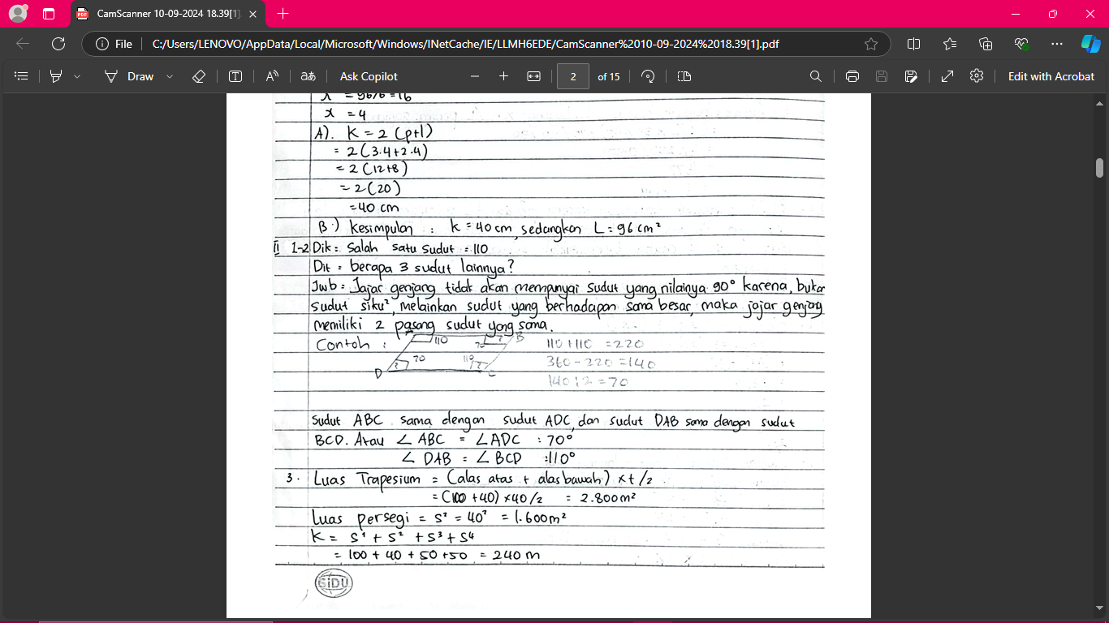
(i)
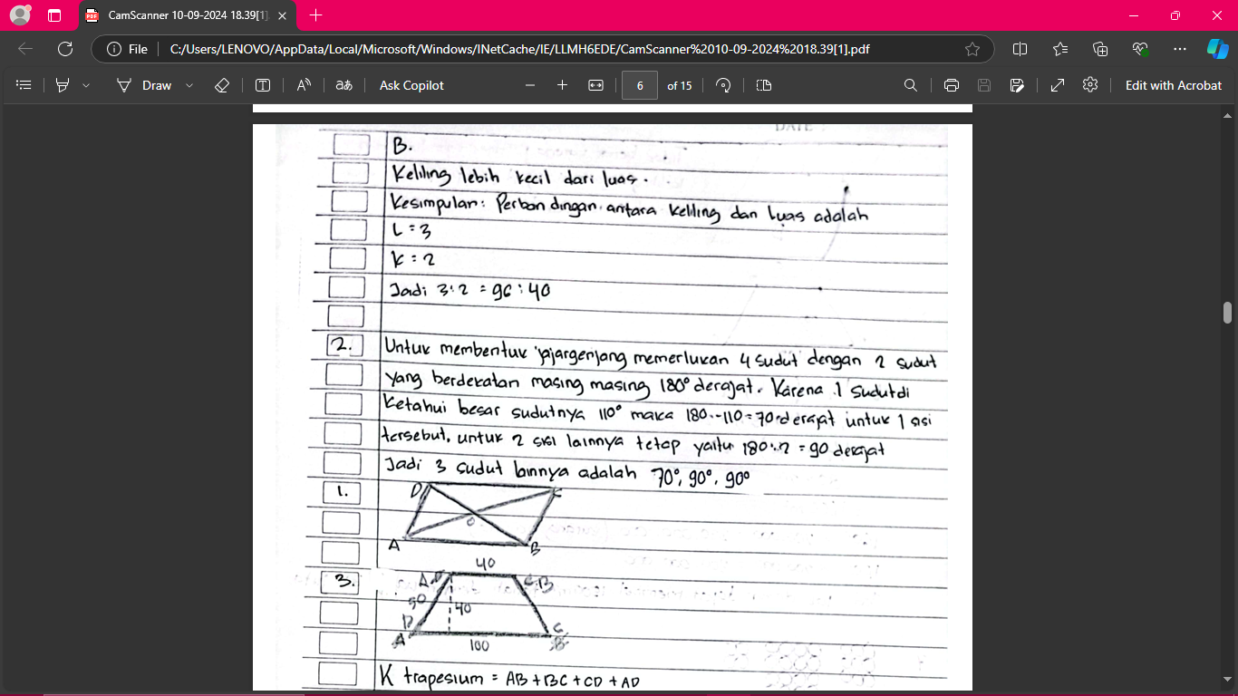
(ii)
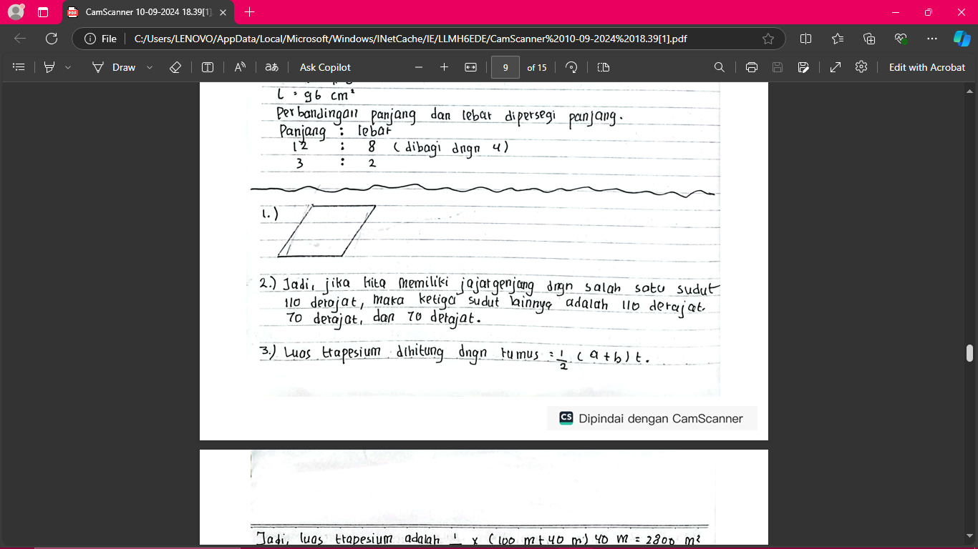
(iii)
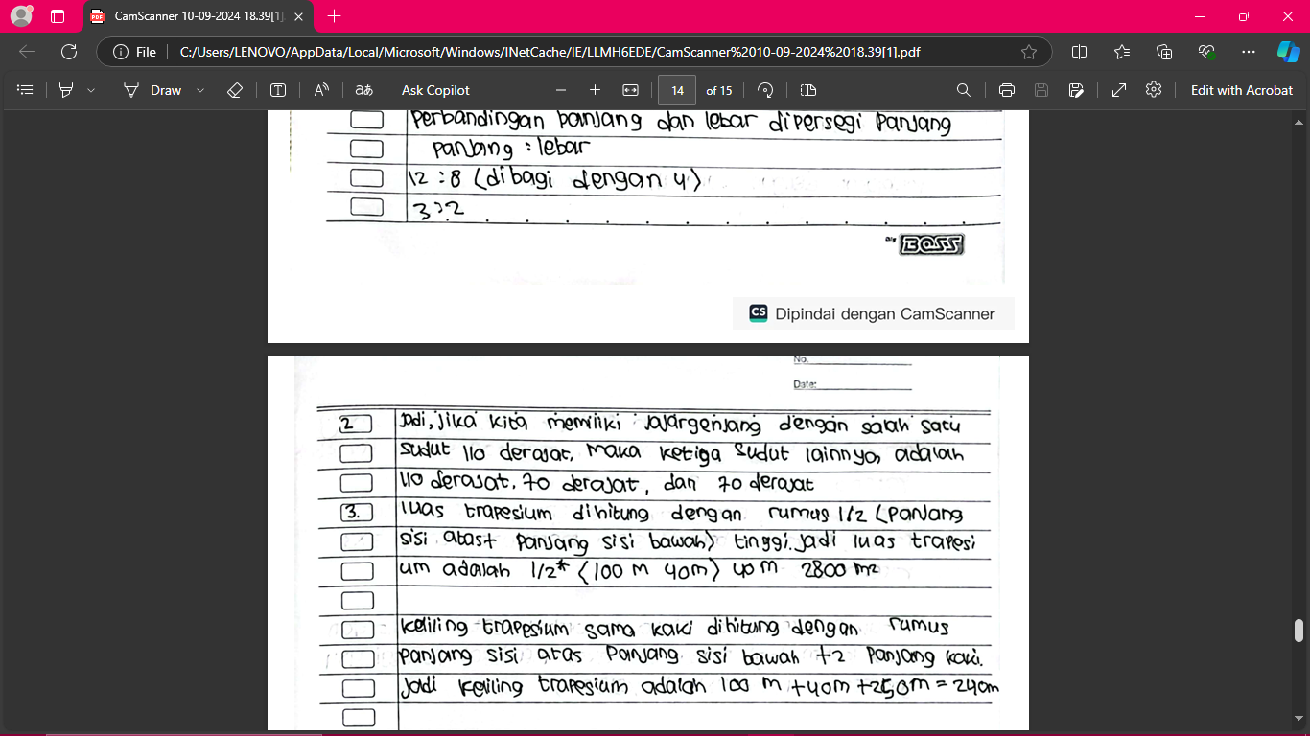
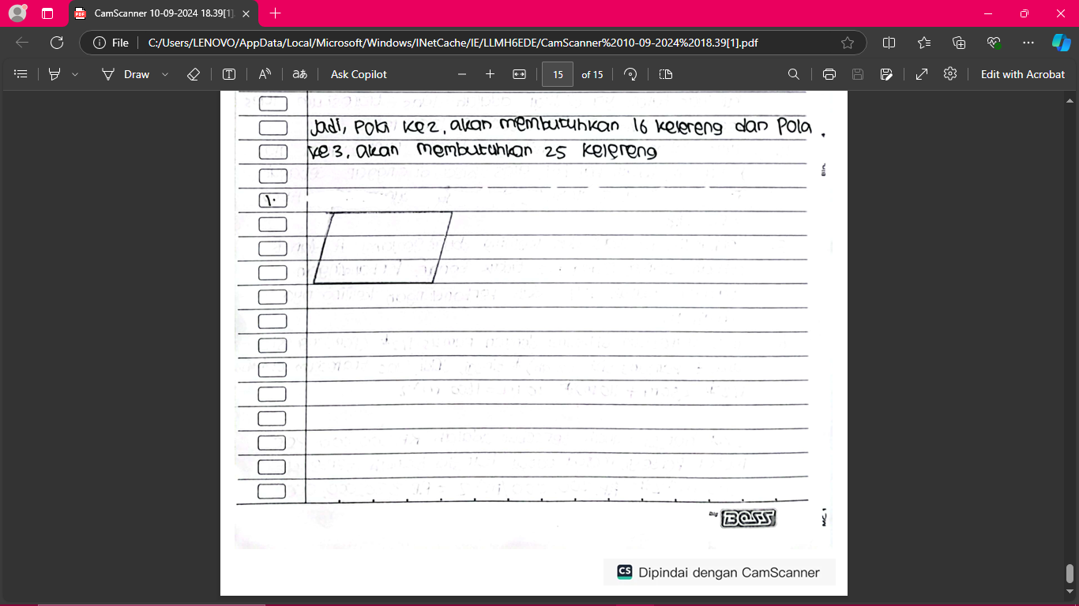
(iv)
Figure 1. Student Post Test Answers for Questions No. 1-2
In this question, participants were asked to sketch a parallelogram-shaped plantation and calculate its angles. In the experimental class with answer (ii), participants tended to understand the basic concept of a parallelogram but had difficulty focusing on completing angle calculations due to distractions from their non-academic interests. They were able to draw sketches, but their calculations were often inaccurate. Meanwhile, the experimental class with answer (i) was more focused and able to solve the questions correctly, providing logical explanations and precise calculations. On the other hand, answer (iv) showed less structured answers and often made mistakes in calculating angles because the conventional method used did not emphasize in-depth exploration of concepts. Meanwhile, participants from (iii) had a better understanding, their answers were more precise, and they were able to provide logical mathematical explanations related to sketches and angle calculations.

Question 3
Mr. Imam has a land in the form of an isosceles trapezoid with parallel sides measuring 100 meters and 40 meters, the height of the trapezoid is 40 meters and the length of the legs is 50 meters. Some of the land will be sold, so that the remaining land is in the form of a rectangle with a side of 40 meters, what is the area of ​​the land sold and the original perimeter of the land
Student Answers
(i)
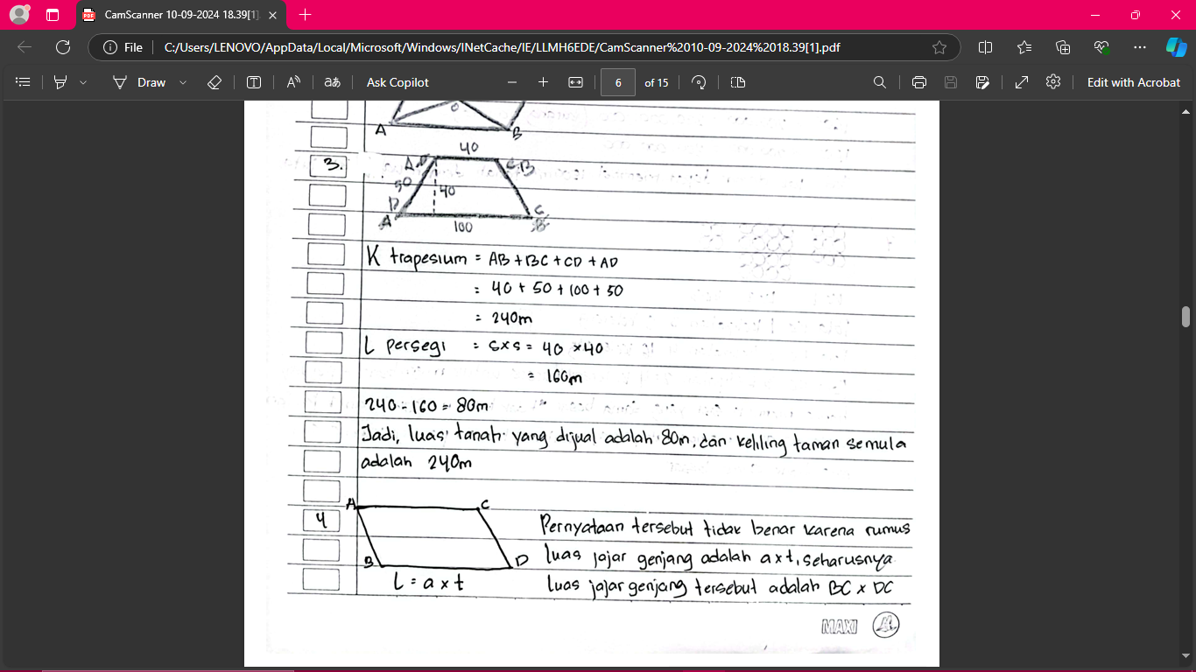
(ii)
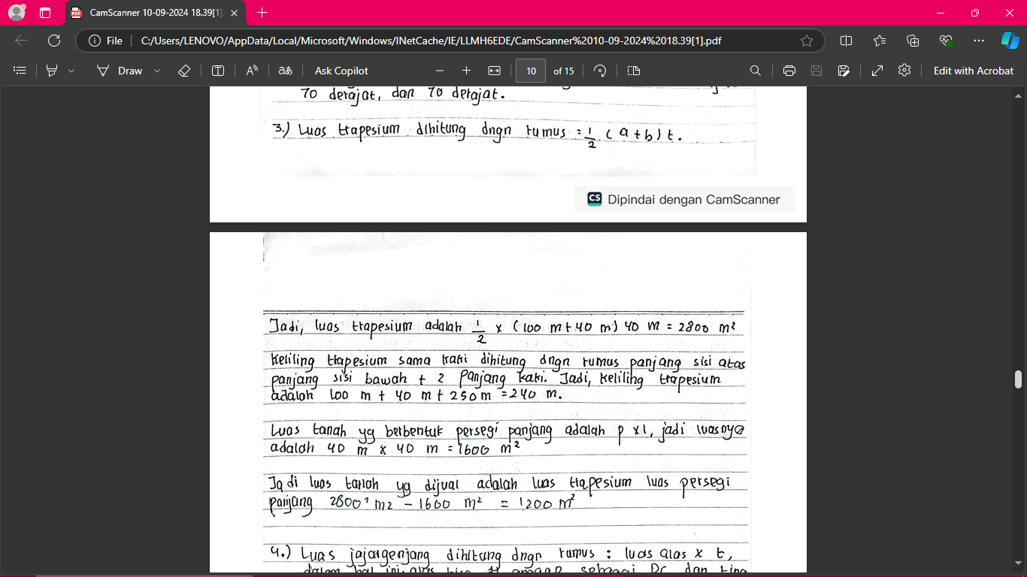
(iii)
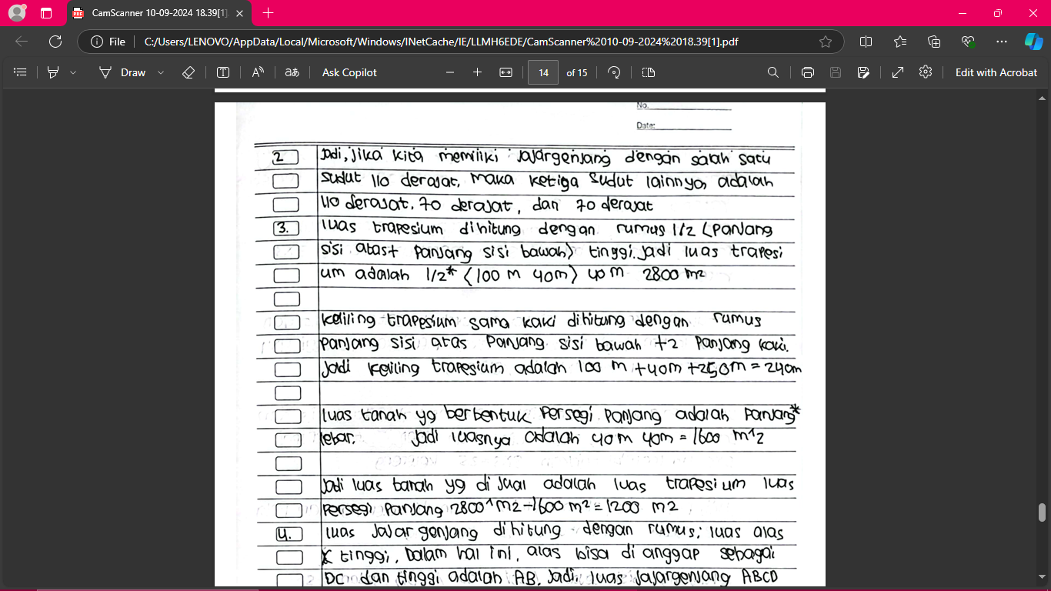
(iv)
Figure 2. Student Post Test Answers for Question No. 3

In questions related to trapezoids and calculating the perimeter of land, participants with answer (ii) often lack focus and even though they successfully identify important information, their calculations of the area and perimeter of land tend to be less accurate. In contrast, participants with answer (i) are more thorough and able to solve the questions correctly, showing a deep understanding of the concept of geometry. In answer (iv), participants have difficulty understanding the concept of trapezoids, and the answers given tend to be inaccurate. Participants with answer (iii), even though they use conventional methods, are able to provide better and more accurate answers related to calculating the perimeter and area of ​​land.

Question 4
If it is known that parallelogram ABCD with AB and DC are perpendicular lines, then prove that the area of ​​parallelogram ABCD = DC × AB. Give a conclusion regarding the area of ​​the parallelogram!

Student Answers
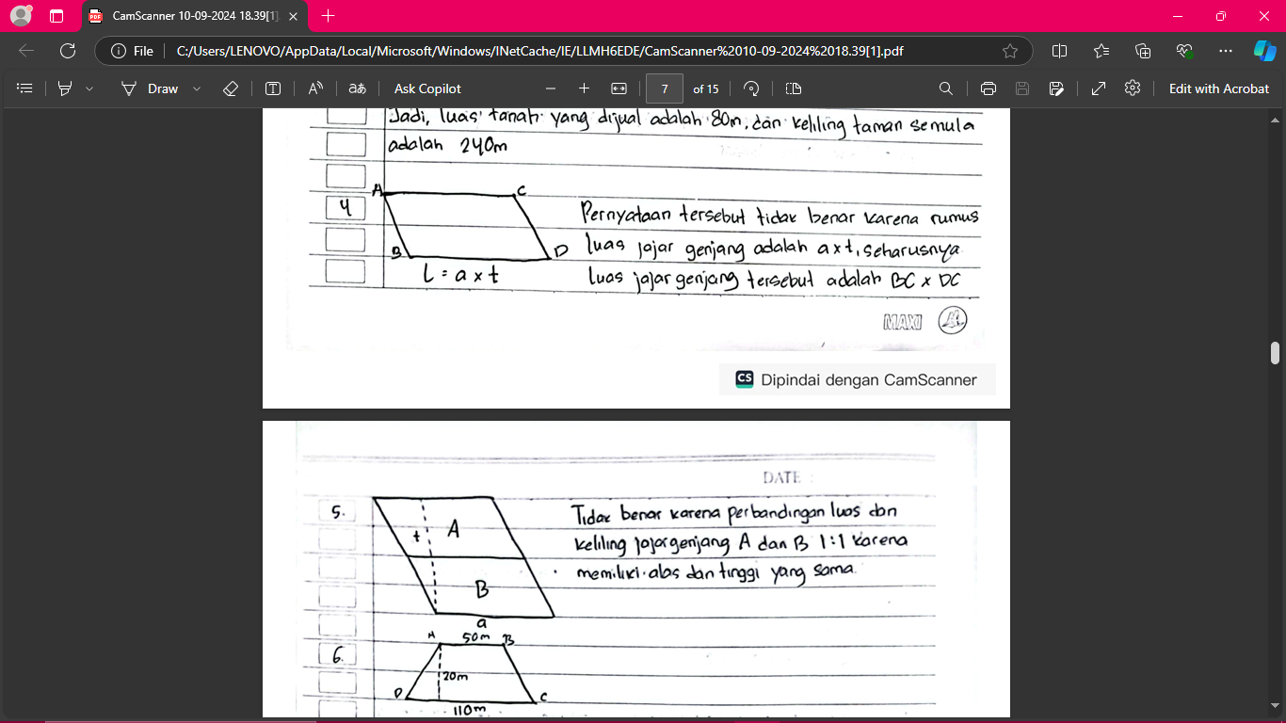
(i)
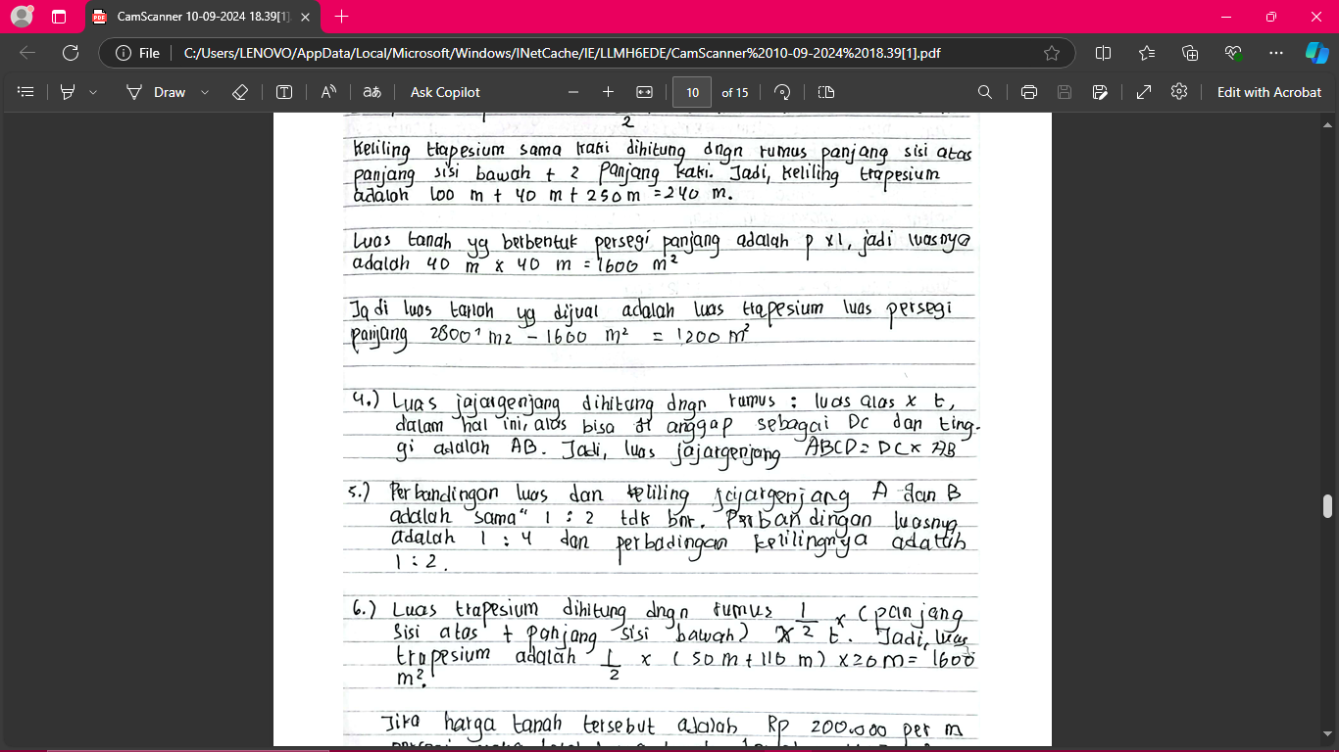
(ii)
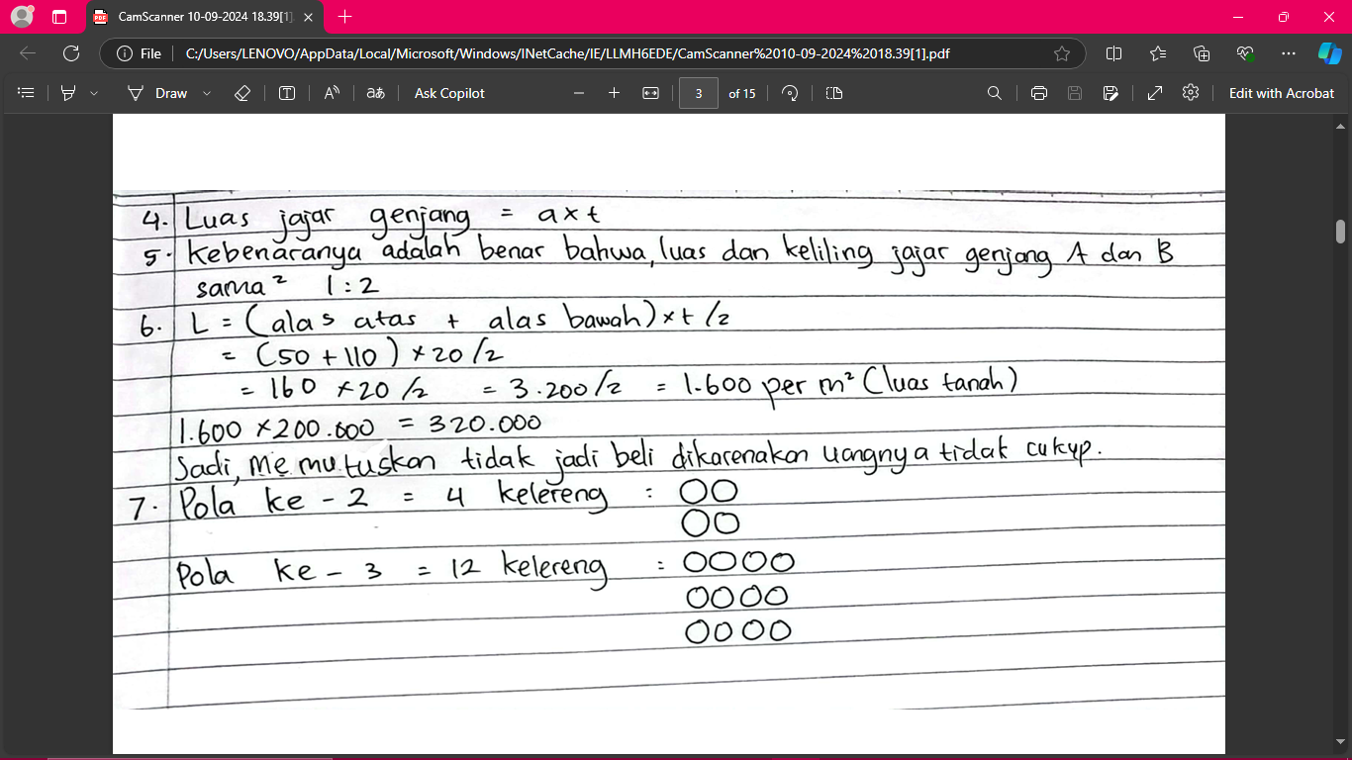
(iii)
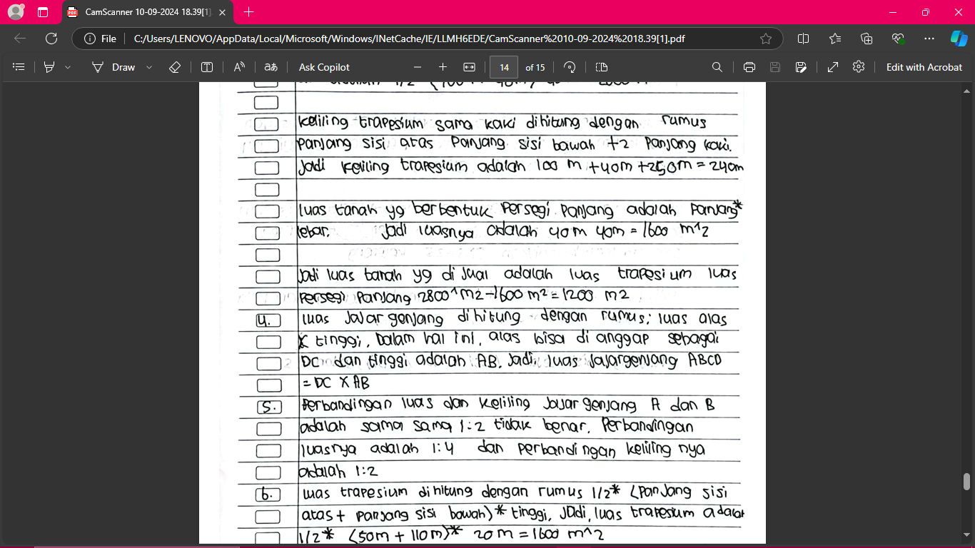
(iv)
Figure 3. Student Post Test Answers for Question No. 4

For this question, participants were asked to prove the formula for the area of ​​a parallelogram. Participants with answer (ii) were able to understand the basic concept of the area of ​​a parallelogram, but some had difficulty providing in-depth proof due to distraction from their interests. Meanwhile, answer (i) showed strong reasoning and was able to prove the formula well. In answer (iii), the participant's answer was less structured and only relied on memorizing the formula without understanding the concept behind it. In contrast, participants with answer (iv) were able to provide a more logical and in-depth explanation regarding the proof of the area of ​​a parallelogram.

Question 5
There are two parallelograms, namely parallelogram A and parallelogram B. If the base, height and slanted side of parallelogram B are twice the base, height and slanted side of parallelogram A. Then conclude that the ratio of the area and circumference of parallelogram A and parallelogram B are both 1:2. Check the truth of this conclusion!
Student Answers
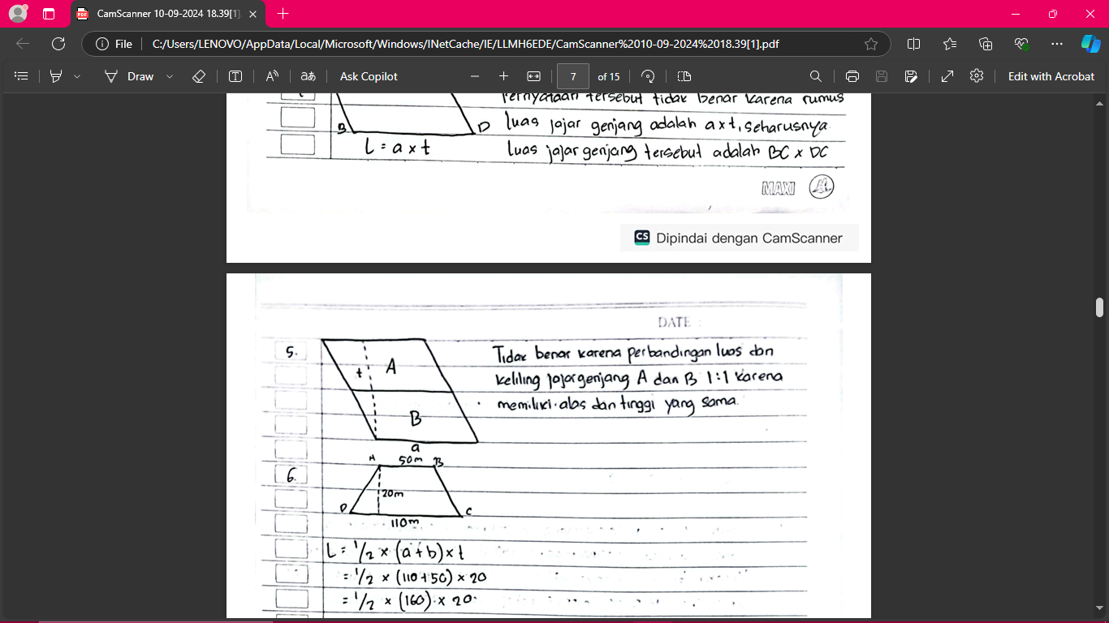
(i)
(ii)
(iii)
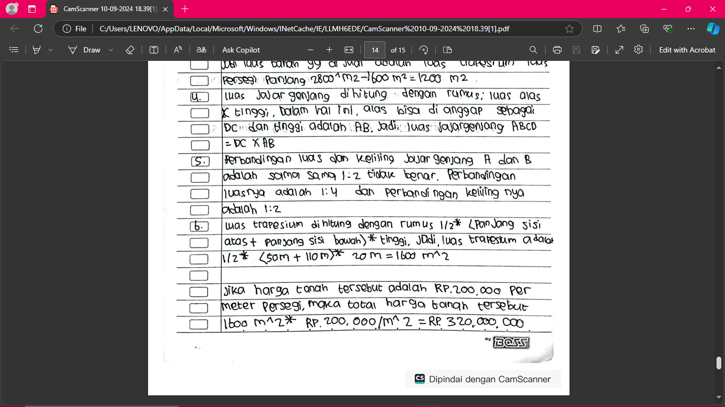
(iv)
Figure 4. Student Post Test Answers for Question No. 5

In the question of comparing the area and circumference of two parallelograms, participants with answer (ii) tend to make calculation errors due to lack of focus even though they understand the basic concept of parallelograms. On the other hand, answer (i) provides a more accurate answer, they are able to calculate the comparison of the area and circumference correctly. Participants with answer (iv) have difficulty understanding the comparison and tend to rely on memorization, which causes the answer to be less accurate. Answer (iii) shows a better understanding and provides an accurate and logical answer regarding the comparison of the area and circumference.

Question 6
Mr. Damar wants to buy a land in the form of an isosceles trapezoid with parallel sides measuring 50 m and 110 m with a height of 20 m. The price of the land is Rp. 200,000/m2. If Mr. Damar has 300 million, then Mr. Damar decides to buy the land. Check whether Mr. Damar's decision is correct!

Student Answers
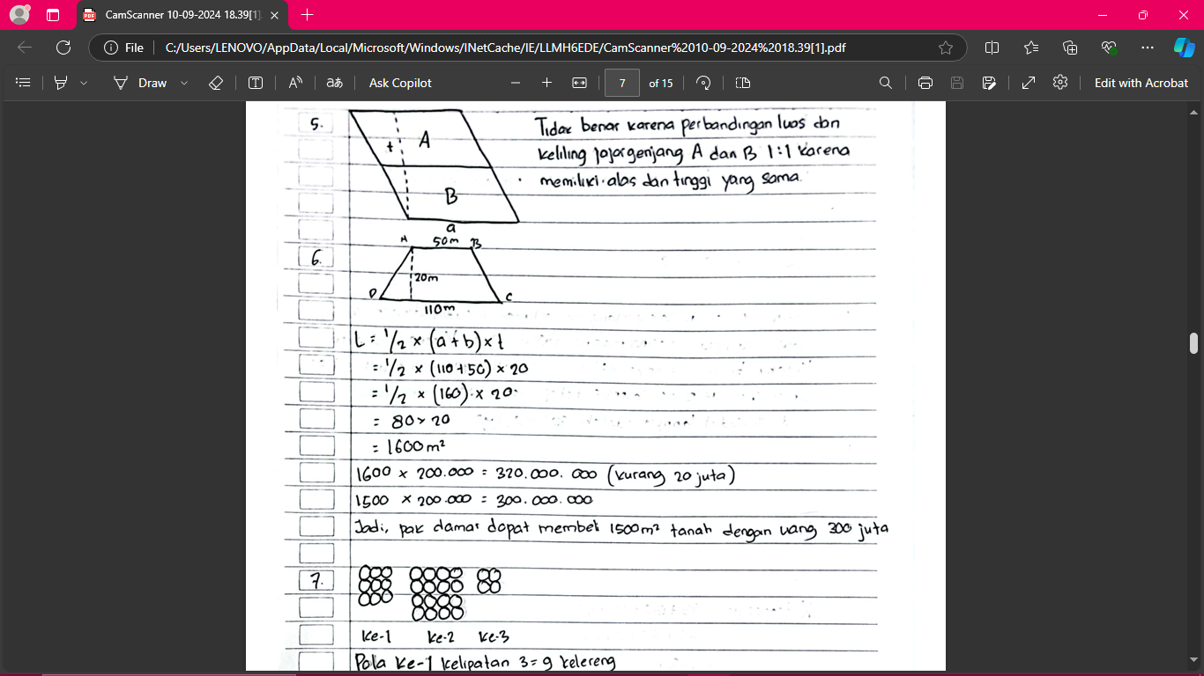
(i)
(ii)
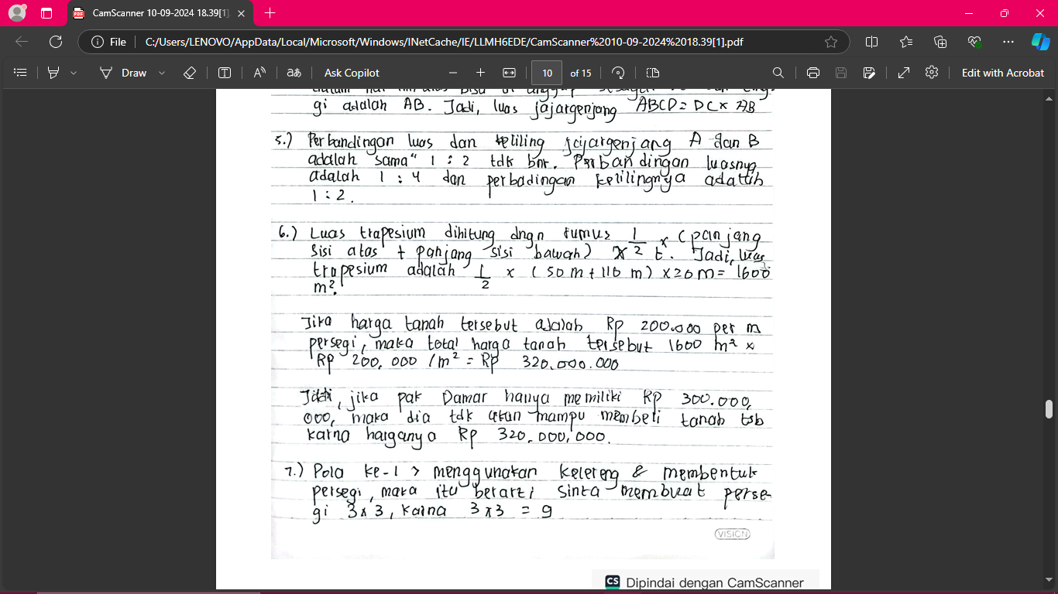
(iii)
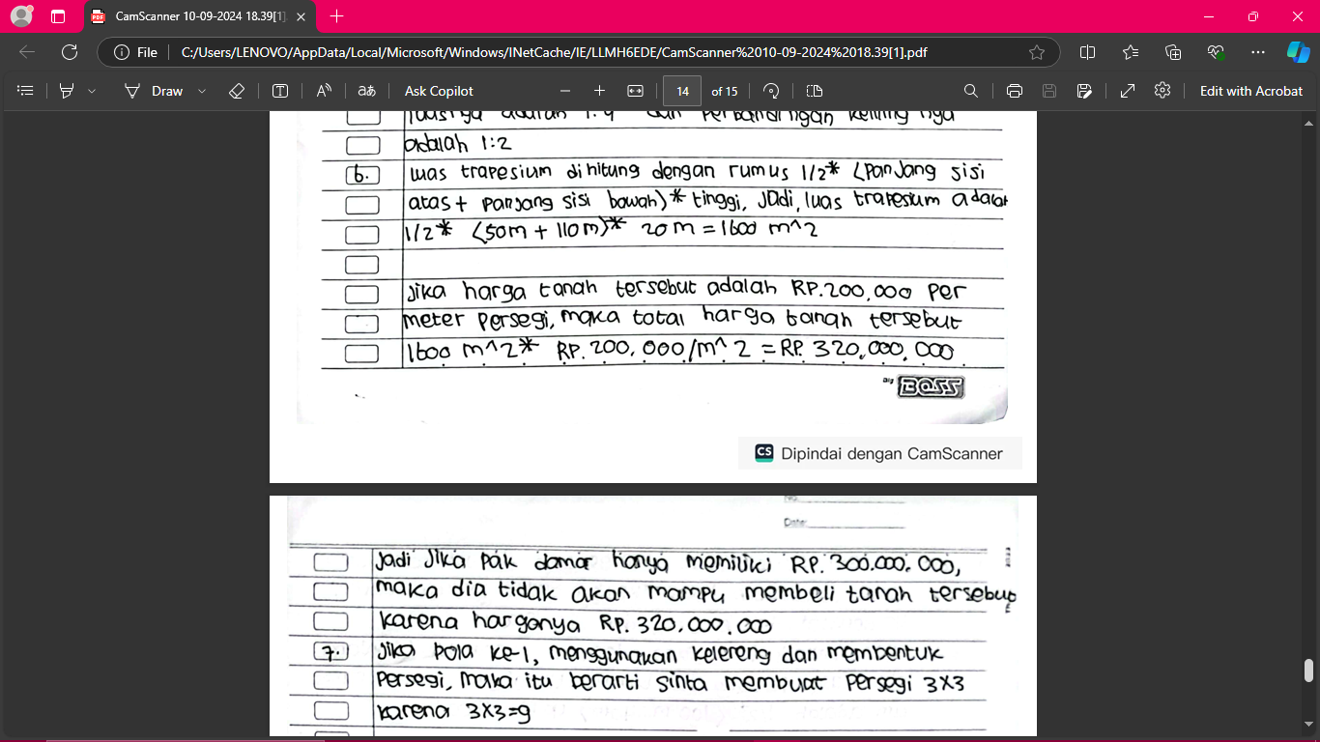
(iv)
Figure 5. Student Post Test Answers for Question No. 6

In this question, participants must calculate the area and price of land in the form of a trapezoid. In answer (ii) often the focus is wrong in solving the problem, which causes errors in calculating the price of the land. While in answer (i) shows better reasoning ability, provides accurate answers and is able to calculate the price of the land correctly. In answer (iv), students often have difficulty in understanding the calculation of the area of ​​a trapezoid and provide incorrect answers. On the other hand, in answer (iii) is able to solve the problem with correct calculations and logical reasoning.

Question 7
Sinta has many marbles to be arranged on the floor to form a square. In the 1st pattern, 9 marbles are used up. Describe and determine the 2nd and 3rd patterns?
Student Answers
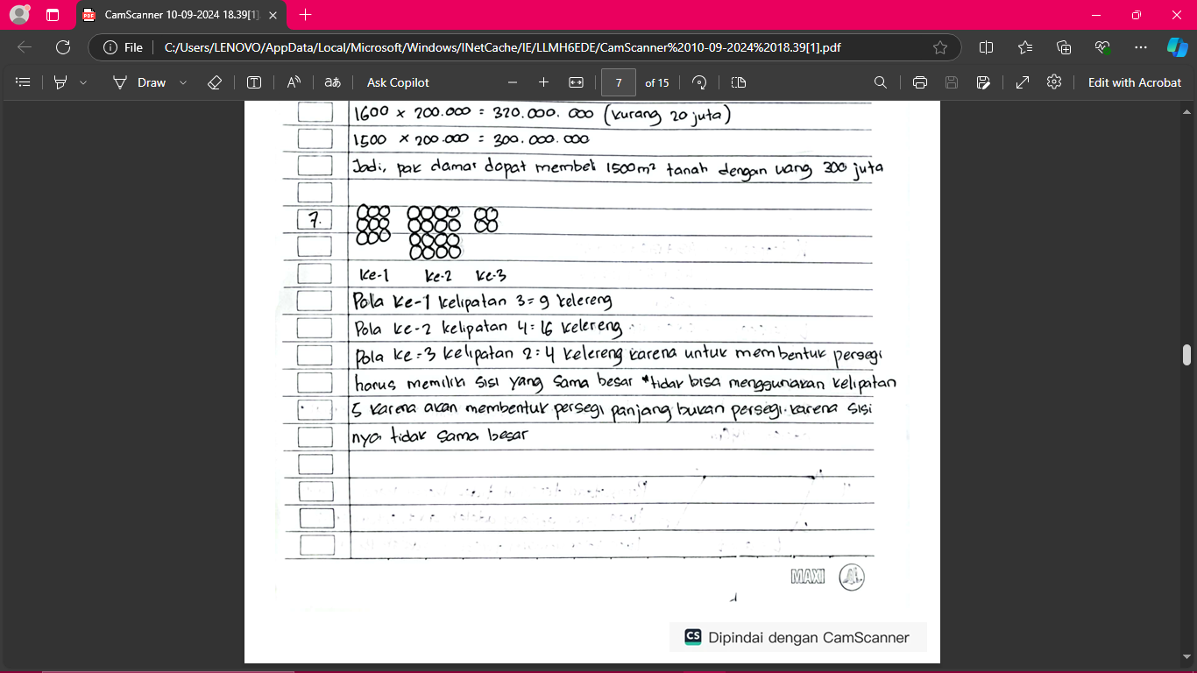
(i)
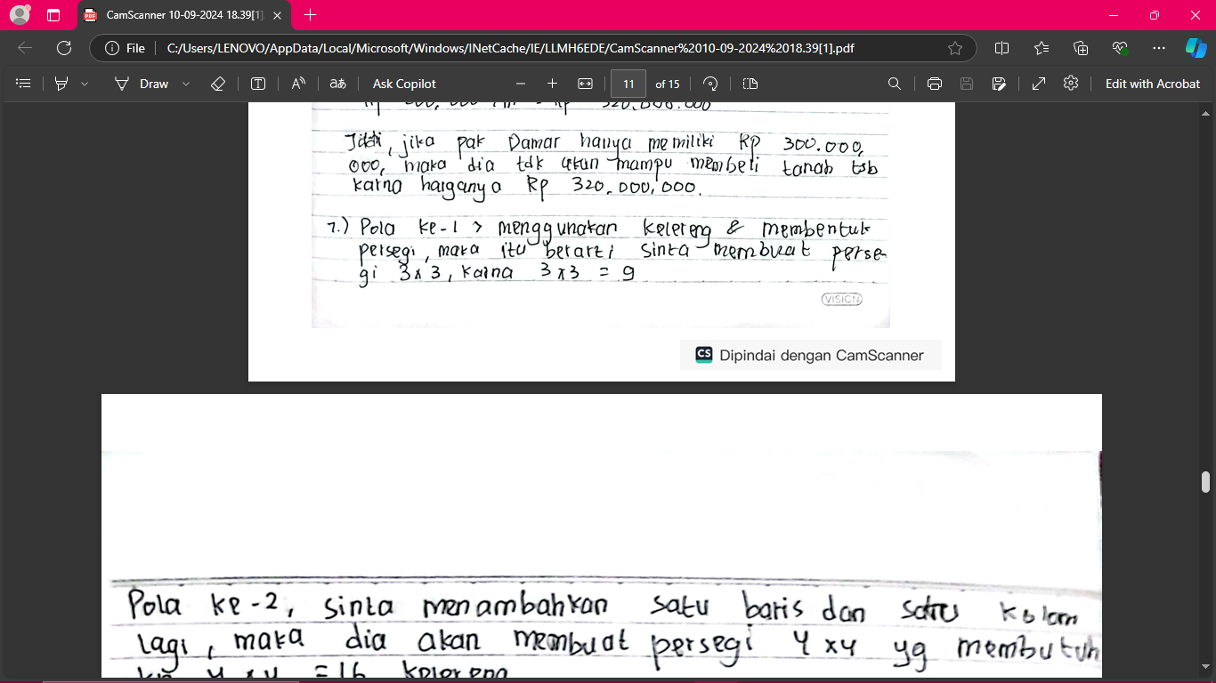
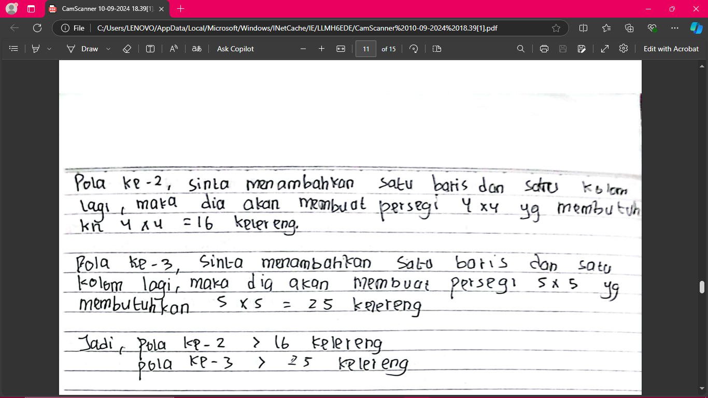
(ii)
(iii)
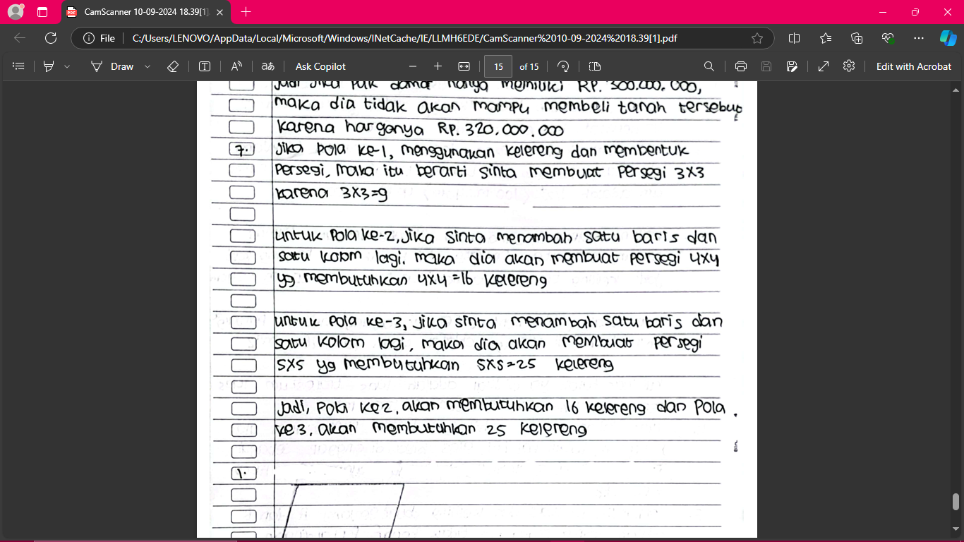
(iv)
Figure 6. Student Post Test Answers for Question No. 7

In the question asking participants to describe the pattern of marbles, students with answer (ii) have a good understanding of the pattern, but are often distracted and fail to provide accurate answers. Students with answer (i) are more careful and are able to describe and count the pattern of marbles correctly but are less able to describe it in the picture. In answer (iv), participants have difficulty understanding the pattern and give an answer that is less accurate. In contrast, students with answer (iii) show better ability in understanding and calculating the pattern of marbles, providing accurate answers and logical explanations.
This study shows a significant increase in mathematical reasoning. This increase is not only influenced by internal factors such as individual abilities, but also by external factors such as the learning model used. In this case, the inquiry model has been shown to be able to help students reason through discussions with friends. These discussions allow students to share ideas and clarify their understanding, thereby strengthening their logical and rational thinking skills. Technology also plays an important role in this process, where students can access various sources of information and learning tools that support rational thinking and logical decision making.
In addition, the phenomenon of fanaticism towards Korean dramas shows a unique impact on students' learning motivation. The interview results showed that students with a high level of fanaticism towards Korean dramas tend to have higher motivation in learning. Korean dramas, with storylines that are often full of challenges and struggles, can be a source of inspiration for students to stay enthusiastic and motivated in facing learning difficulties. They imitate the perseverance and hard work of the characters in the drama, which ultimately has a positive impact on their mathematical reasoning.
According to (Kunfiana et al., 2024), the scientific approach in learning provides space for students to develop their intelligence potential and build learning independence. This approach not only improves intellectual abilities but also students' mathematical reasoning. Mathematical reasoning is the ability of students to formulate new conclusions or statements based on statements whose truth has been proven.
According to (Mirlanda et al., 2020), discussion activities in learning greatly influence the improvement of students' mathematical reasoning. Through group discussions, students can solve problems together, propose conjectures, carry out mathematical manipulations, draw conclusions, compile evidence, and provide reasons or evidence for the correctness of the resulting solution. Group discussions also train students to think critically and analytically, which are important components in mathematical reasoning. In addition, presenting the results of the discussion in front of the class helps students check the validity of their arguments and receive constructive feedback, which ultimately improves their reasoning skills.
Mathematical reasoning is the ability of a person to think to make decisions logically (Eliza et al., 2023). Adolescence, which is full of challenges and self-discovery, requires the right support to develop mathematical reasoning skills. At junior high school or adolescence, finding their interests and hobbies is part of this process. One popular entertainment among teenagers is watching Korean dramas, which can have positive effects such as improving mood, reducing sadness, and reducing stress.
In this context, the role of teachers is very important. Teachers must get used to giving students the opportunity to present the results of their discussions. In this way, students not only learn from what they do, but also from the feedback they receive from their friends and teachers. This process helps students improve and strengthen their understanding, as well as improve their overall mathematical reasoning skills. Through inquiry learning models and scientific approaches supported by technology, students can develop critical and analytical thinking skills that are essential in learning mathematics. The results of this study emphasize the importance of using appropriate and interactive learning models in improving students' mathematical reasoning skills, as well as the role of motivation and inspiration from popular cultural phenomena such as Korean dramas in influencing students' learning motivation.
Therefore, Korean drama fanaticism is part of emotional entertainment and is directly related and connected to mindsets such as motivating learning.

CONCLUSIONS
Students with increased mathematical reasoning ability using the Inquiry Learning model are also better than students who use conventional learning methods. Students with a fanatic attitude towards Korean dramas show higher mathematical reasoning results than non-fanaticism, therefore using the Inquiry Learning model is more effective in improving reasoning abilities in both fanaticism and non-fanaticism groups than the conventional model.
Based on suggestions to improve learning and research results, teachers need to adapt teaching materials according to student interests, maintain consistency in the application of learning models, and use ice breaking techniques routinely. Researchers are advised to consider external factors and develop research by considering the diversity of student characteristics.

REFERENCES
Damasta, G. A., & Dewi, D. K. (2020). Hubungan antara fanatisme dengan perilaku konsumtif pada fans JKT48 Di Surabaya. Jurnal Penelitian Psikologi, 7(4), 13-18.
Darmawan, F. N. Analisis Teori NeoLiberalisme Pada Kasus Hallyu Sebagai Alat Diplomasi Korea Selatan dalam Kerjasama dengan Indonesia.
Eliza, R., Sepriyanti, N., & Husniyah, U. (2023). Penerapan Pendekatan Berpikir Metaforis Terhadap Kemampuan Penalaran Matematis Siswa. Mathema: Jurnal Pendidikan Matematika, 5(2), 82-92.
Gunardi, G. (2020). Inquiry Based Learning dapat Meningkatkan Hasil Belajar Siswa dalam Pelajaran Matematika. In Social, Humanities, and Educational Studies (SHES): Conference Series (Vol. 3, No. 3, pp. 2288-2294).
Hadiyani, B., Wati, V. W., Muslim, M. A., Fahrianti, N., & Majdi, I. (2021). Sosialisasi dan Pengenalan Keuangan dan Perbankan Syariah pada Siswa SMK Maraqitta’limat. KREASI: Jurnal Inovasi dan Pengabdian kepada Masyarakat, 1(1), 115-125.
Indrawan, R., & Yaniawati, R. P. (2016). Metodologi penelitian: Kuantitatif, kualitatif dan campuran untuk manajemen, pembangunan, dan pendidikan.
Khoirunnisa, P. H., & Malasari, P. N. (2021). Analisis kemampuan berpikir kritis matematis siswa ditinjau dari self confidence. JP3M (Jurnal Penelitian Pendidikan dan Pengajaran Matematika), 7(1), 49-56.
Kunfiana, E. T., Rahmatika, L. I., Prihantoro, I. F., & Susilo, B. E. (2024, February). Studi Literatur: Implementasi Pendekatan Saintifik dalam Peningkatan Kemampuan Penalaran Matematis Siswa SMP Materi Geometri. In PRISMA, Prosiding Seminar Nasional Matematika (pp. 475-481).
Marian, F. (2021). Analisis Kemampuan Penalaran Matematika Siswa Pada Materi Himpunan. Hipotenusa Journal of Research Mathematics Education (HJRME), 4(1), 13-22.
Mirlanda, E. P., Nindiasari, H., & Syamsuri, S. (2020). Pengaruh Pembelajaran Flipped Classroom Terhadap Kemampuan Penalaran Matematis Ditinjau Dari Gaya Kognitif Siswa. Prima: Jurnal Pendidikan Matematika, 4(1), 11-21.
Nawawi, M.Ichsan dkk.(2021). Pengaruh Tayangan K-Drama (Korean Drama) terhadap Motivasi Belajar. EDUKATIF:Jurnal Ilmu Pendidikan,3(6),4439-4447. https://edukatif.org/index.php/edukatif/article/view/1201/pdf
Noviyana, H., Nurdiana, A., & Zakia, A. H. (2024). Kemampuan Penalaran Matematis Siswa dalam Menyelesaikan Soal HOTS melalui Model Pembelajaran IMPROVE. JURNAL e-DuMath, 10(2), 152-160.
Putri, L. A. (2020). Dampak korea wave terhadap prilaku remaja di era globalisasi. Al-Ittizaan: Jurnal Bimbingan Konseling Islam, 3(1), 42-48.
Runisah. (2008). Penggunaan SQ3R dalam Pembelajaran Matematika untuk Meningkatkan Kemampuan Berpikir Kritis Matematis Siswa SMA. Tesis UPI Bandung: Tidak Diterbitkan.

