Bibliography

Anggraeni, Ane. 2018. An Analysis of English Indonesian Translation Method Used by Ingrid Dwijani Nimpoeno in Translating Green’s The Fault in Our Stars. Bandung: Pasundan University.

Arnold, Matthew. 1896. Essay in Criticism: The Study of Poetry; John Keats. Wordsworth. United States: Allyn and Bacon.

Corbin, J., & Strauss, A. 2008. Basics of qualitative research: techniques and procedures for developing grounded theory. Thousands Oaks, CA: SAGE Publication, Inc.

Denton, John. 1996. Andre Lefevere (1945-1966) A Brief Recollection. The University of Texas at Austin. Available at https://minio.la.utexas.edu/webeditor-files/germanic/pdf/lefevere.pdf (Accessed on September 15th, 2023)

Devi, Doenia. 2008. Proses Penerjemahan Puisi. Jurnal Bahasa dan Pariwisata, STBA Yapari-ABA Bandung. Available at https://doeniadevi.wordpress.com/2009/10/20/proses-penerjemahan-puisi/ (Accessed on August 14th, 2023)

Echols, J.M. & Hasan, S. 2000. Kamus Inggris-Indonesia (An English-Indonesian Dictionary). Jakarta: PT Gramedia Pustaka Utama.

Handayani, Ririn. 2020. Metodelogi Penelitian Sosial. Yogyakarta: Trus media Grafika.

Indah, Anisa Nur. 2017. A Process of Food Menu Translation of Belle Vue Restaurant at G.H. Universal Hotel. Bandung: Pasundan University.

KBBI VI Daring. Available at https://kbbi.kemendikbud.go.id/entri/takik (Accessed on October 5th, 2023)

Kosasih. 2012. Dasar-Dasar Keterampilan Bersastra. Bandung: Yrama Widya.

Lang Leav. Available at https://en.wikipedia.org/wiki/Lang_Leav (Accessed on May 27th, 2023)

Leav, Lang. 2013. Love and Misadventure. USA: Andrews MCMeel Publishing.

Leav, Lang. 2016. Love and Misadventure: Cinta dan Kesialan-Kesialan. Jakarta: PT Gramedia Pustaka Utama.

Lefevere, Andre. 2017. Translation, Rewriting, and the Manipulation of Literary Fame. United Kingdom: Routledge

Lufiani, Riska. 2023. The Translation Techniques on Rupi Kaur’s: The Sun and Her Flowers. Bandung: Pasundan University.

M. Aan Mansyur. Available at https://www.gramedia.com/author/author-m-aan-mansyur (Acceseed on May 27^{yh}, 2023)

M. Aan Mansyur. Available at https://id.wikipedia.org/wiki/M._Aan_Mansyur (Accessed on May 27th, 2023)

Muchtar, Muhizar and Farida Repelita Waty Kembaren. 2016. Basic Theory of Translation. Medan: Mitra Medan.

Mugalih. Ahmad. 2010. Translation Procedure Analysis of Indonesian-English Translation in Goenawan Mohamad’s Poems. Jakarta: State Islamic University Syarif Hidayatullah.

Newmark, Peter. 1988. A Text Book of Translation. United States of America: Shanghai Foreign Language Education Press.

Phurong, Nguyen Hoang Anh. 2017. Strategies Applied to the English-Vietnamese Translation of Poems in the Poetry Collection "Love and Misadventure" by Lang Leav. Hanoi: Vietnam National University.

Prafitasari, Aldita . An Analysis of Translation Technique and Translation Quality in Poem Book Entitled Love & Misadventure. Indonesian Journal of English Language Teaching and Applied Linguistics. 3(2), 2019.

Saputro, Aji, Utami. 2022. Analisis Semantik Pada Puisi “Tak Sepadan” Karya Chairil Anwar. Surabaya: Universita Dr. Sutomo.

Sugiyono. 2017. Metode Penelitian Kuantitatif, Kualitatif, dan R&D. Bandung: Alfabeta.

Sutriati, Ayu. 2019. A Study of Poetry Translation Strategies and Acceptability on Ten Poems in Rupi Kaur’s “Milk and Honey. Universitas Sanata Dharma: Thesis.

Trisvianti, Hilda. 2018. Student’s Translation Process in Translating Text at the Twelve Grade of SMA N 1 Air Joman. Medan: State Islamic University of North Sumatra.

Ulum, Mohammad Mufid Nasyirul. 2020. Analisis Pengelolaan Sumber Daya Manusia Dan Meningkatkan Loyalitas Kerja Karyawan Menurut Prespektif Ekonomi Islam Di Pabrik Bola Plastik Kudus. Kudus: Institut Agama Islam Negeri Kudus.

Wibawati, Ines Anggun. 2019. An Analysis of Translation Stategies in Peter Sohn’s Movie The God Dinosaur. Bandung: Pasundan University.

Curriculum Vitae

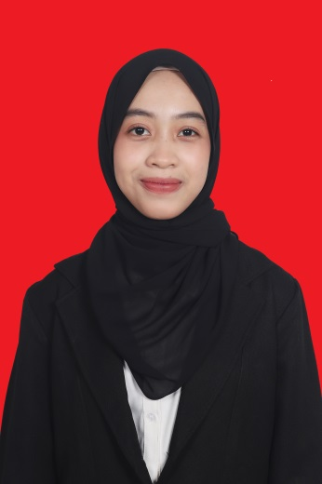
Hayatunnufus known as Haya, was born in Karawang on November 30th, 2000. She is the last children. She graduated from Senior High School in 2019 at SMA PGRI Cikampek. Then she started her study at the English Literature Department of Pasundan University in 2019. She actively participates in the English Student Association organization for the period 2020 to 2021, and she is also active as a volunteer at several campus events. She loves cooking and playing basketball as his hobbies. She also loves music and watching movies and series. Hayatunnufus can be contacted through email haya.herawan@gmail.com or instagram @hayatnnfs.

APPENDICES

APPENDIX I: BOOK COVER

English Version
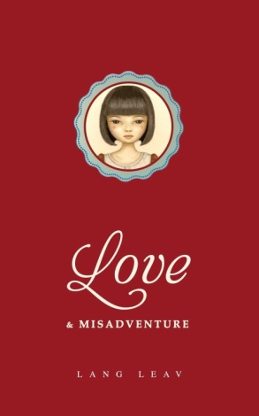

Indonesian Version
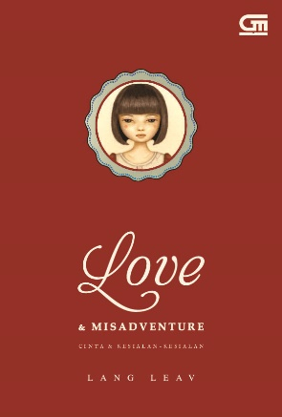

APPENDIX II: POEMS FROM LANG LEAV’S (RESEARCH DATA)

No 1 No 2
Source Language | Target Language
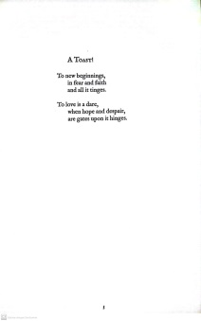 | 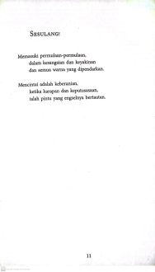
Source Language | Target Language
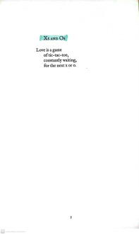 | 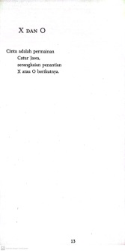

No 5 No 6
Source Language | Target Language
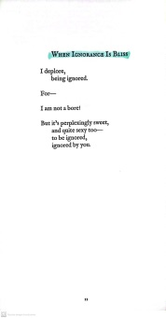 | 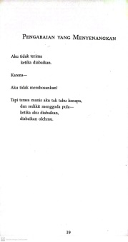
Source Language | Target Language
 | 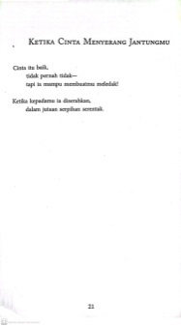

No 9
Source Language | Target Language
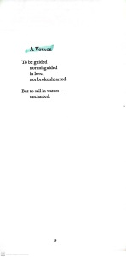 | 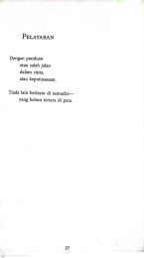

No 10 No 11
Source Language | Target Language
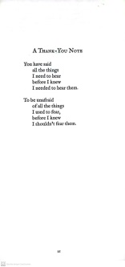 | 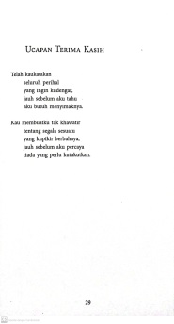
Source Language | Target Language
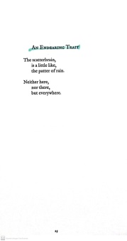 | 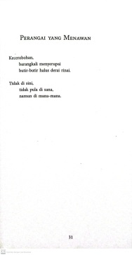

No 12 No 13
Source Language | Target Language
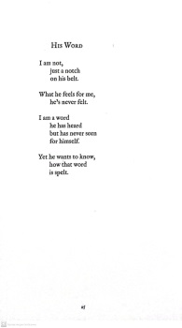 | 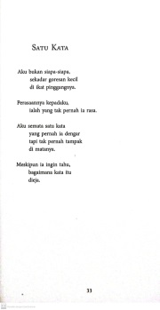
Source Language | Target Language
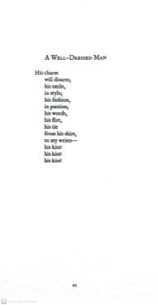 | 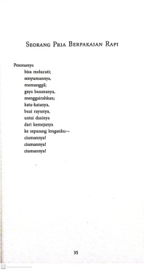

No 15
Source Language | Target Language
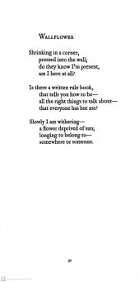 | 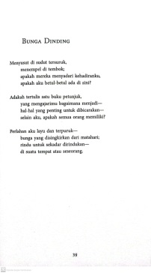

No 21 No 23
Source Language | Target Language
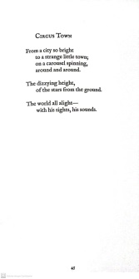 | 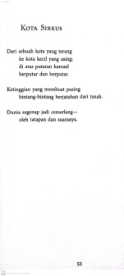
Source Language | Target Language
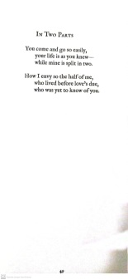 | 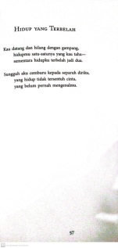

No 24 No 26
Source Language | Target Language
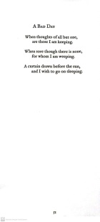 | 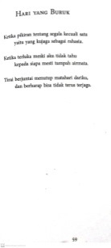
Source Language | Target Language
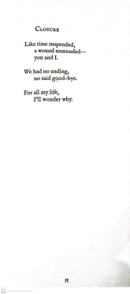 | 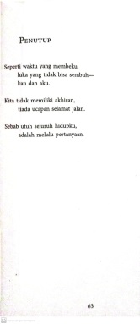

No 28
Source Language | Target Language
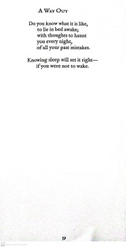 | 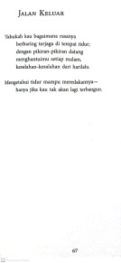

No 30 No 31
Source Language | Target Language
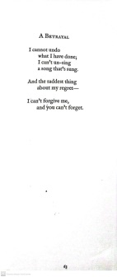 | 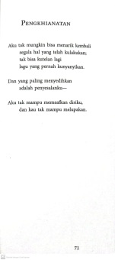
Source Language | Target Language
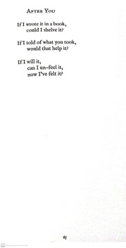 | 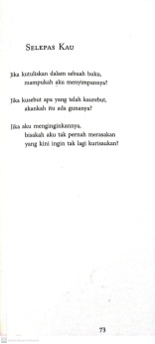

No 41 No 43
Source Language | Target Language
Source Language | Target Language
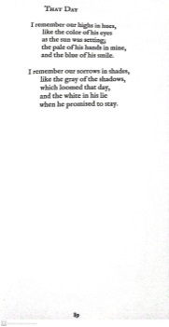 | 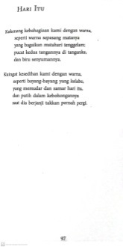

No 46
Source Language | Target Language
 | 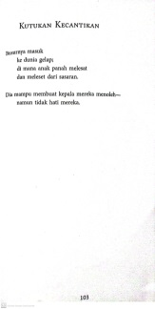

No 54 No 56
Source Language | Target Language
 | 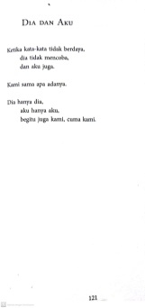
Source Language | Target Language
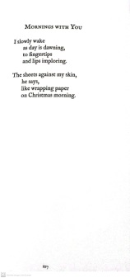 | 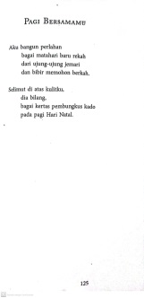

No 59 No 61
Source Language | Target Language
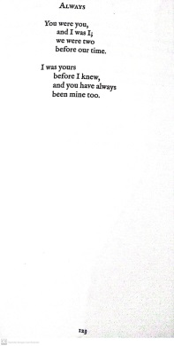 | 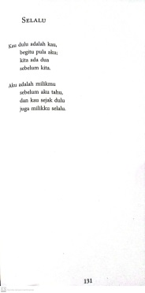
Source Language | Target Language
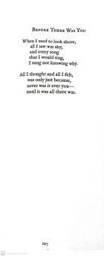 | 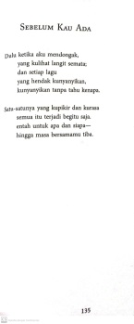

No 62
Source Language | Target Language
 | 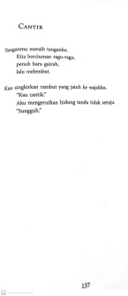

No 63 No 64
Source Language | Target Language
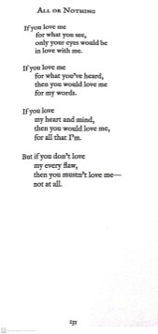 | 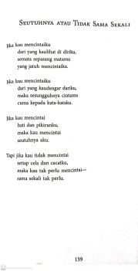
Source Language | Target Language
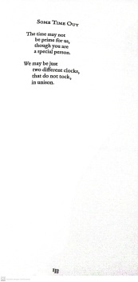 | 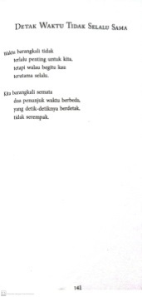

No 68 No 71
Source Language | Target Language
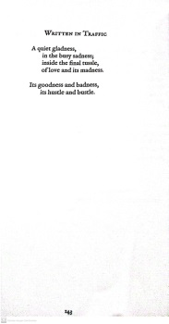
Source Language | Target Language
 | 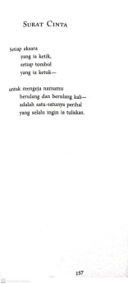

No 72
Source Language | Target Language

APPENDIX III: SK BIMBINGAN

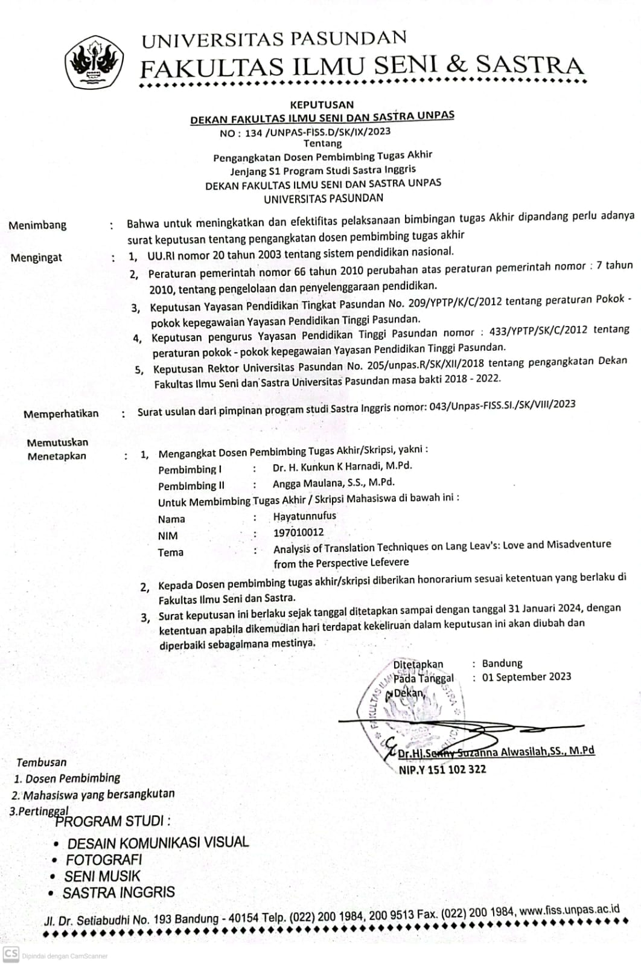

APPENDIX IV: BERITA ACARA BIMBINGAN SKRIPSI
Advisor I:

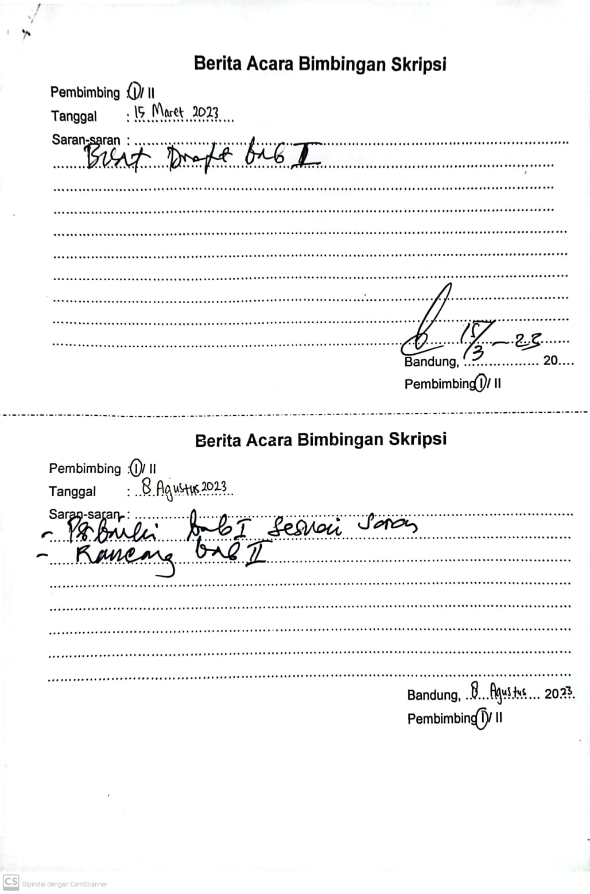

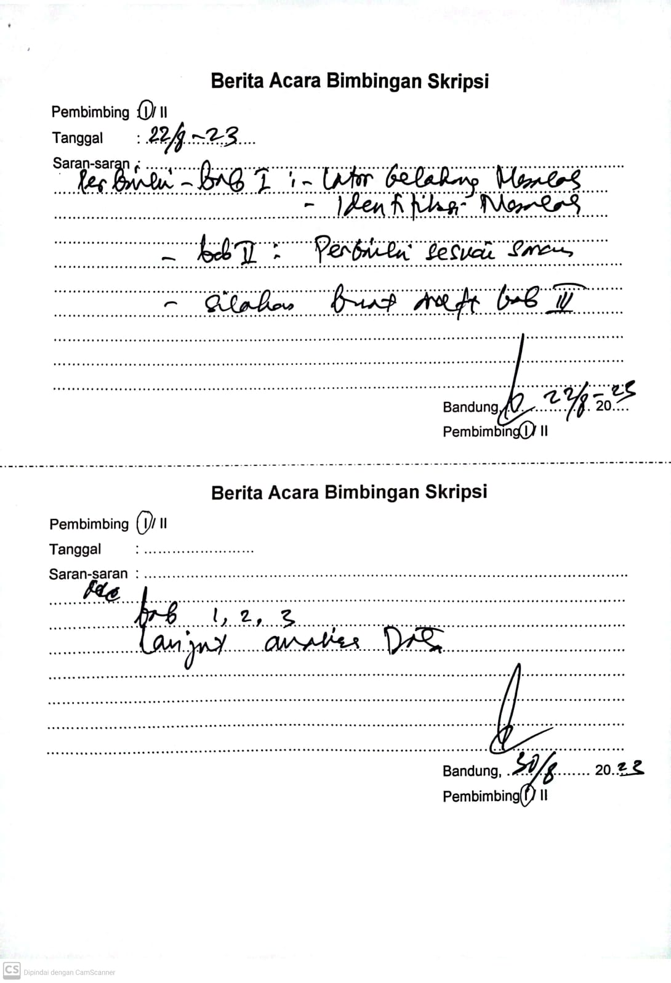

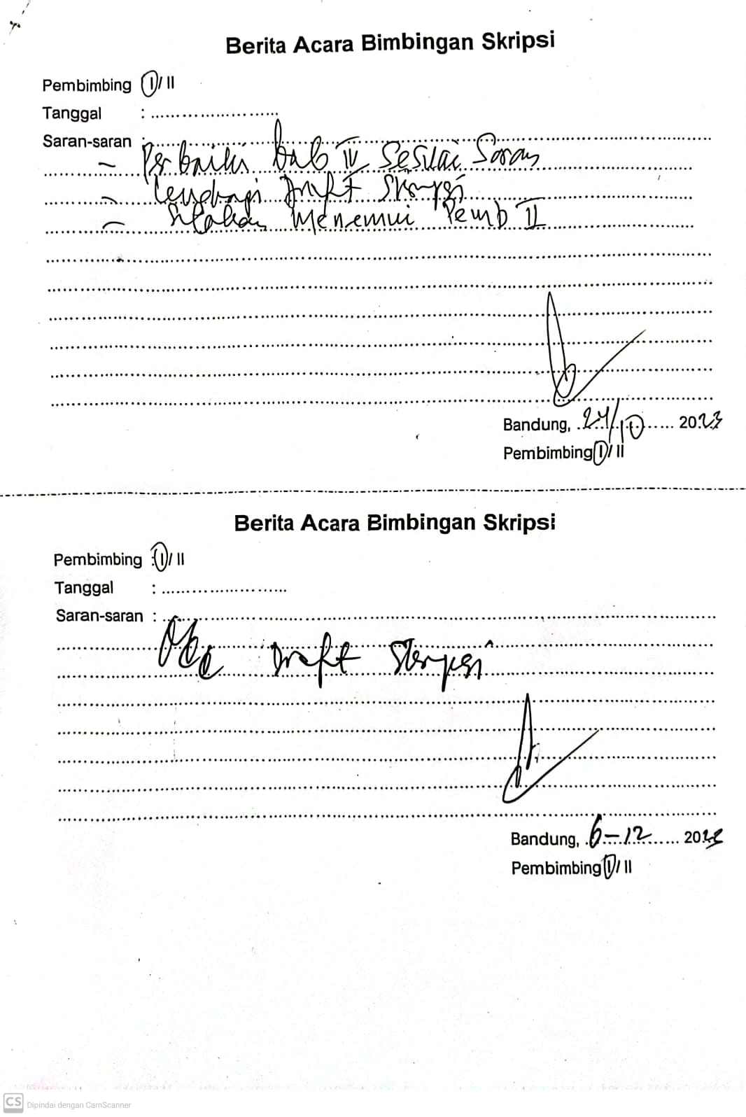

Advisor II:

