Acceptence Letter of ICOETESAH 2022 (Paper ID - 126)
1 pesan

Sayid Noval <smrn.uninus@gmail.com>

ICOETESAH 2022 <icoetesah2022@gmail.com> 25 November 2022 pukul 20.54 Kepada: smrn.uninus@gmail.com

Dear Mr./Mrs Sayid Muhammad Rifki Noval,

Thank you for your interest in The International Conference On Engineering, Technology, Economics, Social Affairs And Health Sciences 2022 (ICOETESAH 2022) and for submitting you're abstract entitled

“DUMPSTER DIVING THREAT IN PERSONAL”

Paper ID: 126

Room Presentation on Zoom: 13

It is our pleasure to inform you that your abstract has been accepted for presentation at ICOETESAH 2022 on December 17, 2022 in virtual zoom platform. Please submit your full paper and the payment receipt of the conference presenter fee no later than November 30, 2022.

We also attach the LoA with the publication options form, Guidelines for presenters, Presentation Template, and ZOOM background of the conference.

LoA and Publication Form: https://drive.google.com/file/d/1EJdWcyIUUCoSVmdfGcNe5EKslSXPye-4/view?usp=drivesdk

Guidelines for Presenter: bit.ly/Document-ICOETESAH2022
Presentation Template: bit.ly/Document-ICOETESAH2022
Zoom Background: bit.ly/Document-ICOETESAH2022

Presentation File Submission Deadline: December 14, 2022
Presentation Submission Link: bit.ly/Video-Presentation-ICOETESAH2022

Note: on the LoA with publication form, please choose one and send the form along with the full paper on the conference’s website at https://rccom.id/icoetesah-2022 in the Submissions menu and WA to +62 898-7058-643 (Panji).

Please do not hesitate to contact us at icoetesah2022@gmail.com and WA: +62 898-7058-643 (Panji) if you have any questions. Looking forward to your participation in ICOETESAH 2022.

Regards,
Committee of ICOETESAH 2022

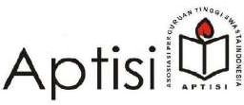
To Authors.
sayid muhammad rifki noval; soecipto; ahmad jamaludin
Universitas Islam Nusantara PaperID: 126
Room Presentation on Zoom: 13

Dear Authors,

Thank you for your interest in The International Conference On Engineering, Technology, Economics, Social Affairs And Health Sciences 2022 (ICOETESAH 2022) and submitting your abstract entitled
“DUMPSTER DIVING THREAT IN PERSONAL”
It is our pleasure to inform you that your abstract has been accepted for presentation at ICOETESAH 2022 on December 17, 2022 in virtual zoom platform. Please submit your full paper and the payment receipt of the conference presenter fee no later than November 30, 2022.
We also attach a publication options form of the conference, please choose one and send the form along with the full paper on the conference’s website at https://rccom.id/icoetesah-2022 in the Submissions menu.
Please do not hesitate to contact us at icoetesah2022@gmail.com or WA: +62 898-7058-643 (Panji) if you have any questions. Looking forward to your participation in ICOETESAH 2022.

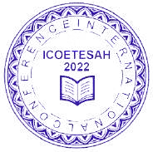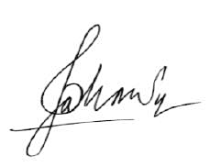Bandung, 25 November 2022

Conference Chairman of ICoETESAH 2022 Dr. Muhammad Deni Johansyah, M.M.

Attachment 1. Publication Form

PUBLICATION FORM

Paper ID: 126
Room Presentation on Zoom: 13
Title: “DUMPSTER DIVING THREAT IN PERSONAL”

No. | Journal/Proceeding | Fee | Checklist
1. | AIP (American Institute of Physics) Publishing: Proceeding  indexed by SCOPUS | IDR 2,700,000
2. | International Journal of IJGOR, IJQRM, IJBESD, IJRCS, IJEER Indexed by Google Scholar, Copernicus, WorldCat, ROAD,  GARUDA, and CrossRef | IDR 1,500,000
3. | Operations Research: International Conference Series (ORICS) Indexed by Google Scholar, Copernicus, WorldCat, ROAD,  GARUDA, and CrossRef | IDR 1,000,000
4. | Reputable International Journals SCOPUS Indexed Q4, Q3, Q2  or Q1 | Depends on the  selected journal

For payment of publication No. 1, 2, and 3 is paid directly along with the registration fee and proof of payment is attached to Website and WA: +62 898-7058-643 (Panji).
For payment of publication No. 4 will be contacted again by the ICOETESAH 2022 publication team, after confirmation from the selected journal.

Author,

…………………………………..

Sayid Noval <smrn.uninus@gmail.com>

Certificate Presenter ICOETESAH 2022 - Sayid Muhammad Rifki Noval
1 pesan
ICOETESAH 2022 <mochpanjiagung27@gmail.com> 10 Januari 2023 pukul 12.54 Kepada: smrn.uninus@gmail.com

Dear Mr./Mrs. Sayid Muhammad Rifki Noval,

We thank you for your participation as a presenter at the event:
INTERNATIONAL CONFERENCE ON ENGINEERING, TECHNOLOGY, ECONOMICS, SOCIAL AFFAIRS, EDUCATIONS AND HEALTH SCIENCES (ICOETESAH 2022)

With this message, we appreciate you being the presenter. Here we send you a certificate of appreciation.
Link Download Certificate:

https://drive.google.com/file/d/1KSFXK09Wq940-n7IurDOgUoUBqPATXMi/view?usp=drivesdk We hope to see you again at the next conference.
Thank you, Best Regards.
Committee of ICOETESAH 2022.

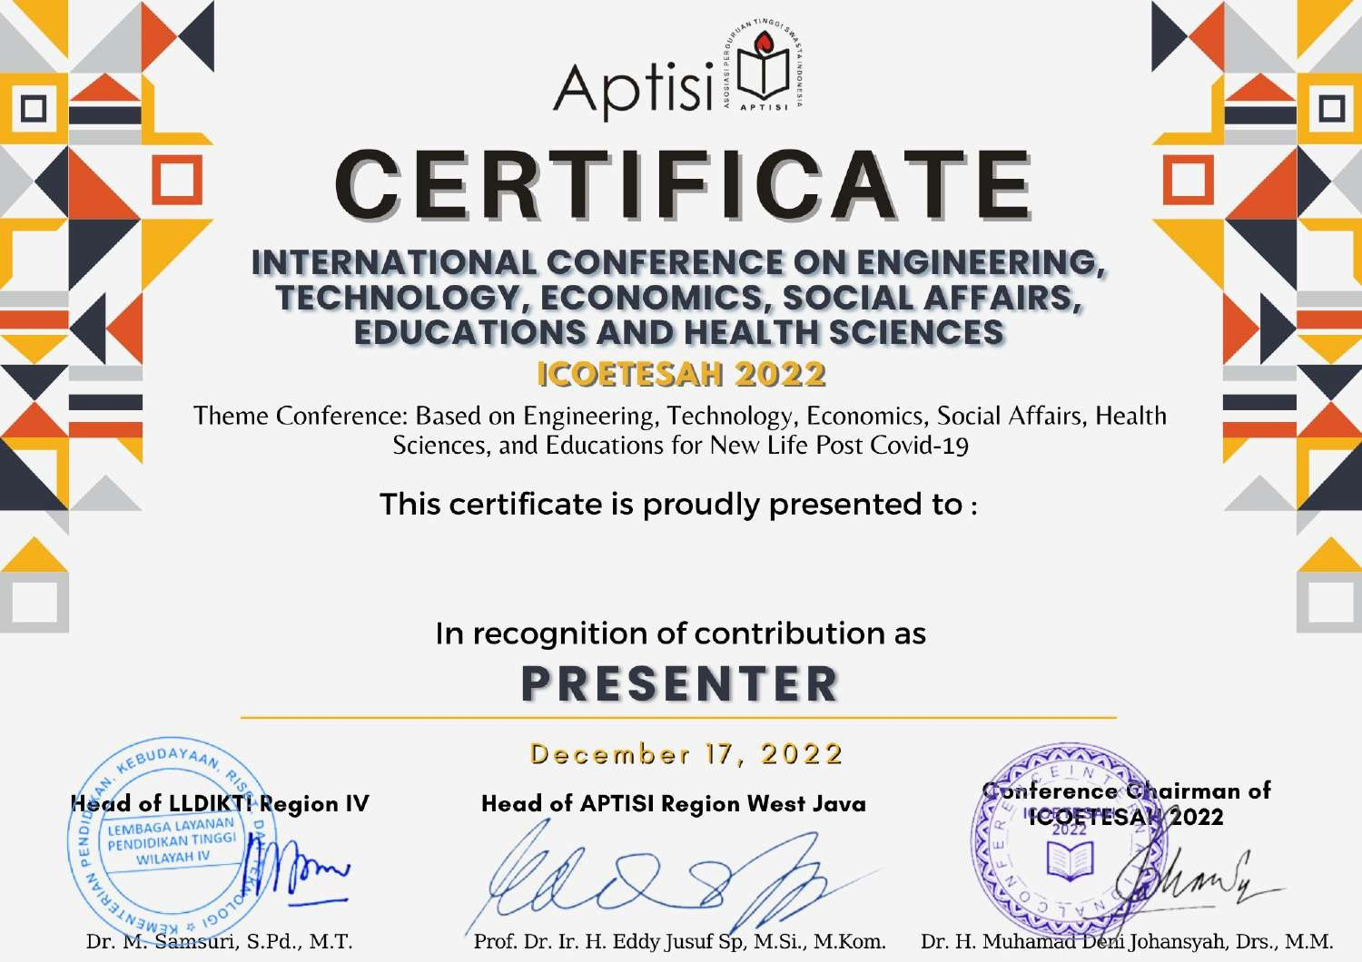

Sayid Muhammad Rifki Noval

