Sociological Impact of Cyber Laws on Media: Virtue Community and Controversies
by Sayid Muhammad Rifki Noval

Submission date: 12-Jul-2023 09:26PM (UTC+0700)
Submission ID: 2130116719
File name: of_Cyber_Laws_on_Media_Virtue_Community_and_Controversies.docx (173.17K)
Word count: 4934
Character count: 30608

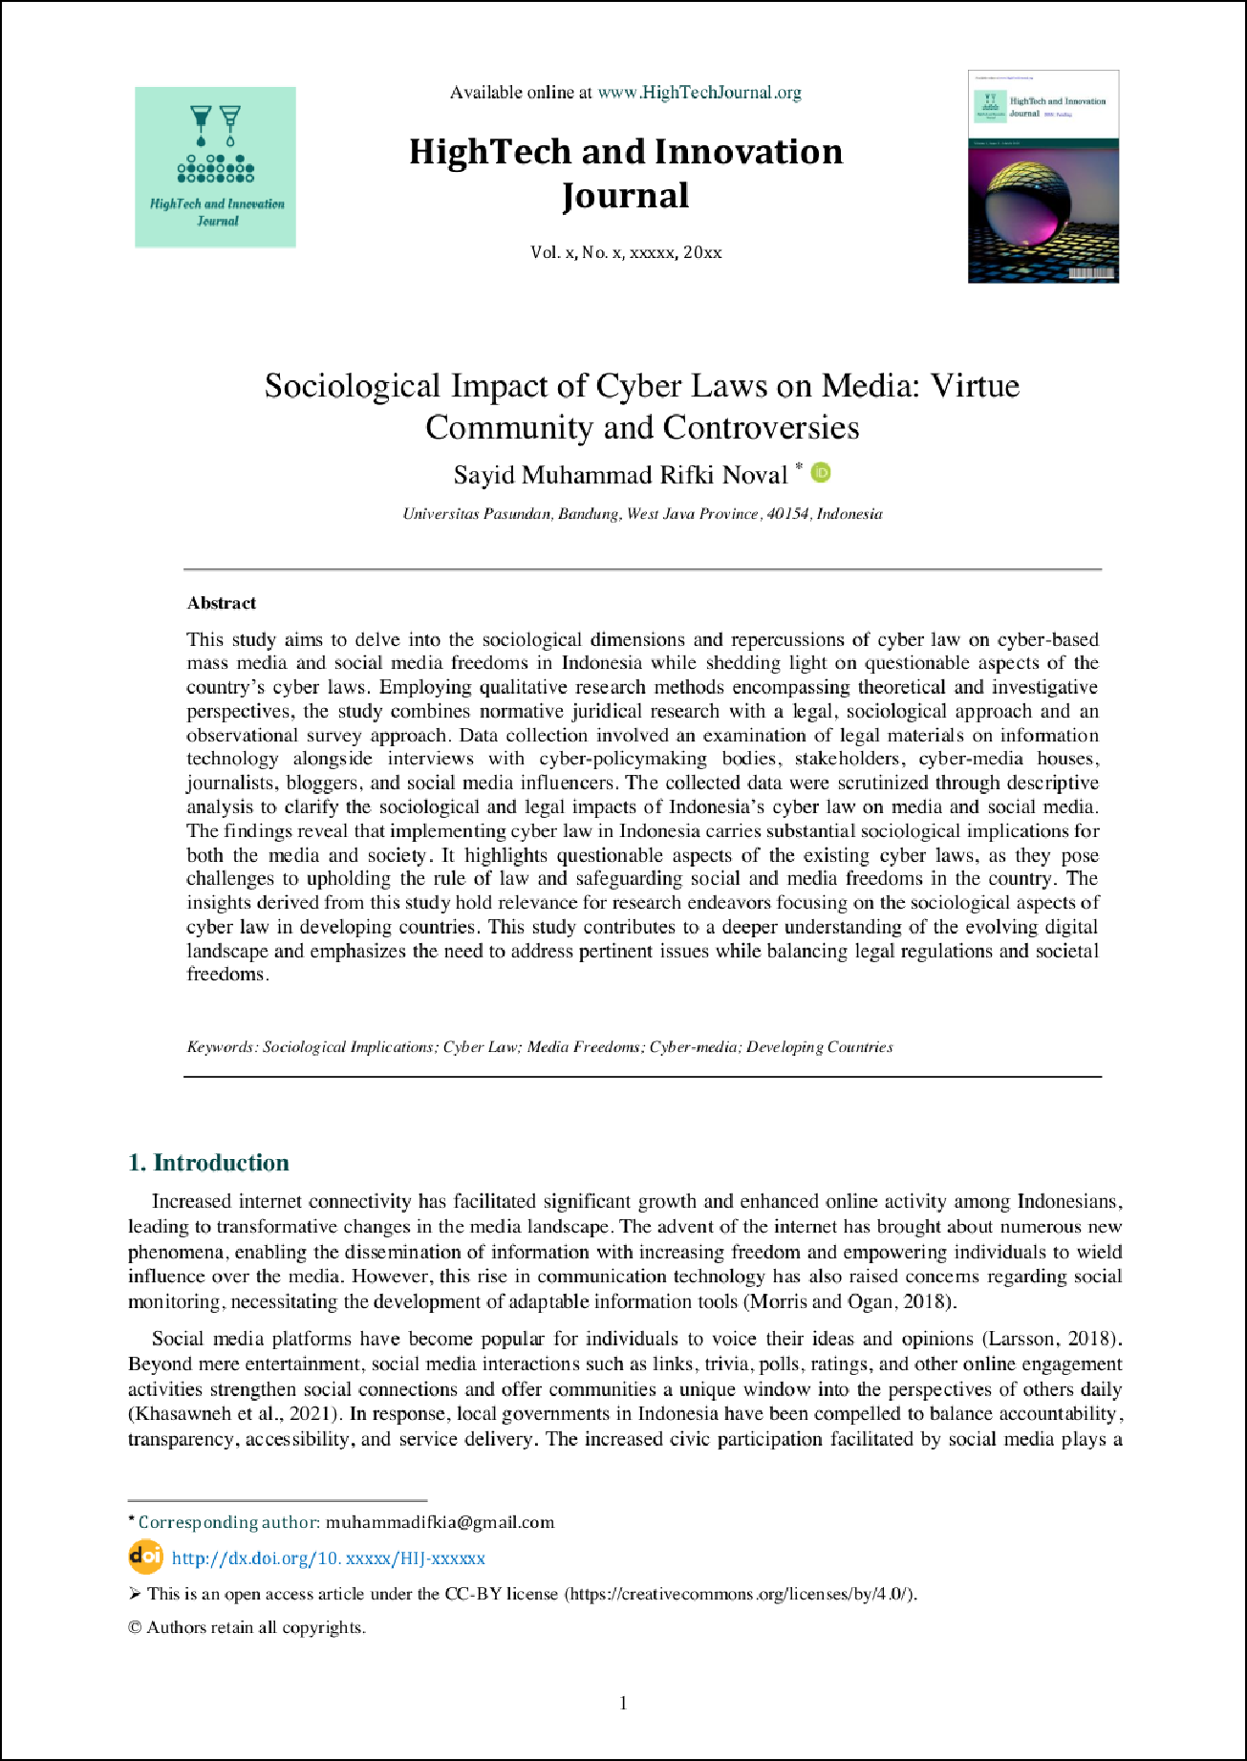

3

3

1

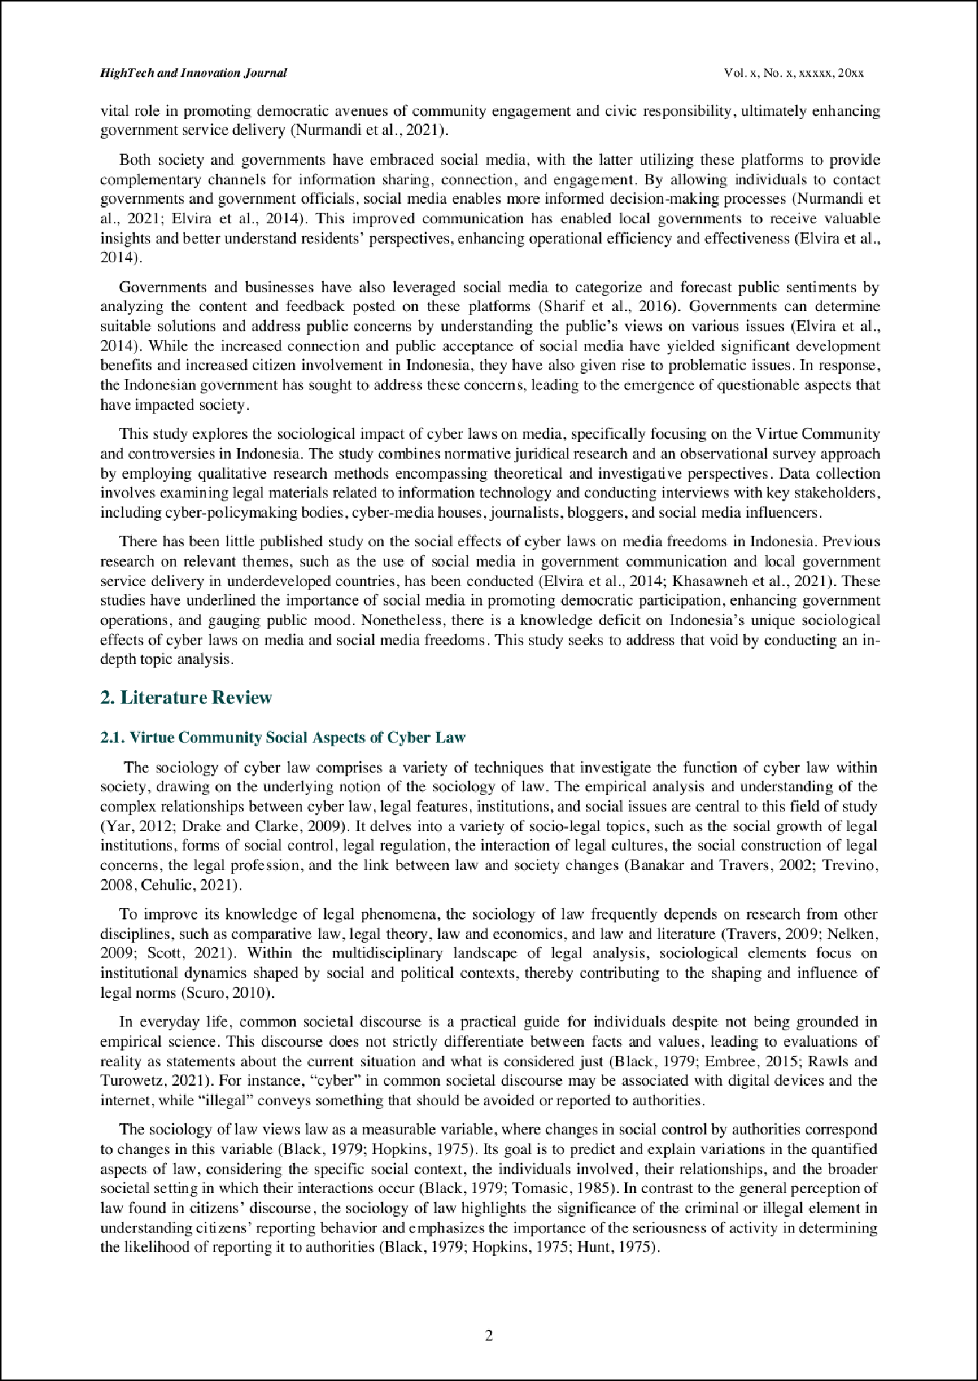

4

4

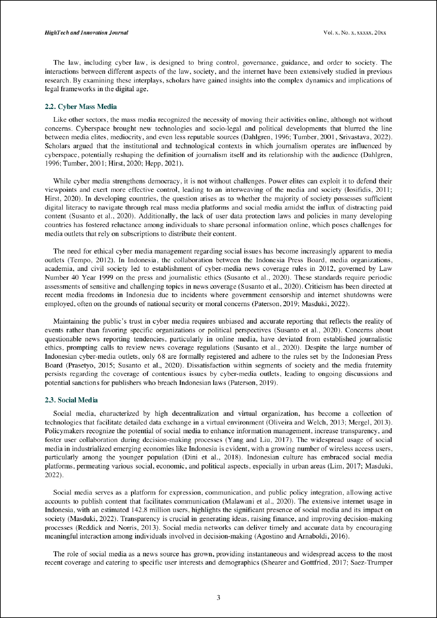

6 6

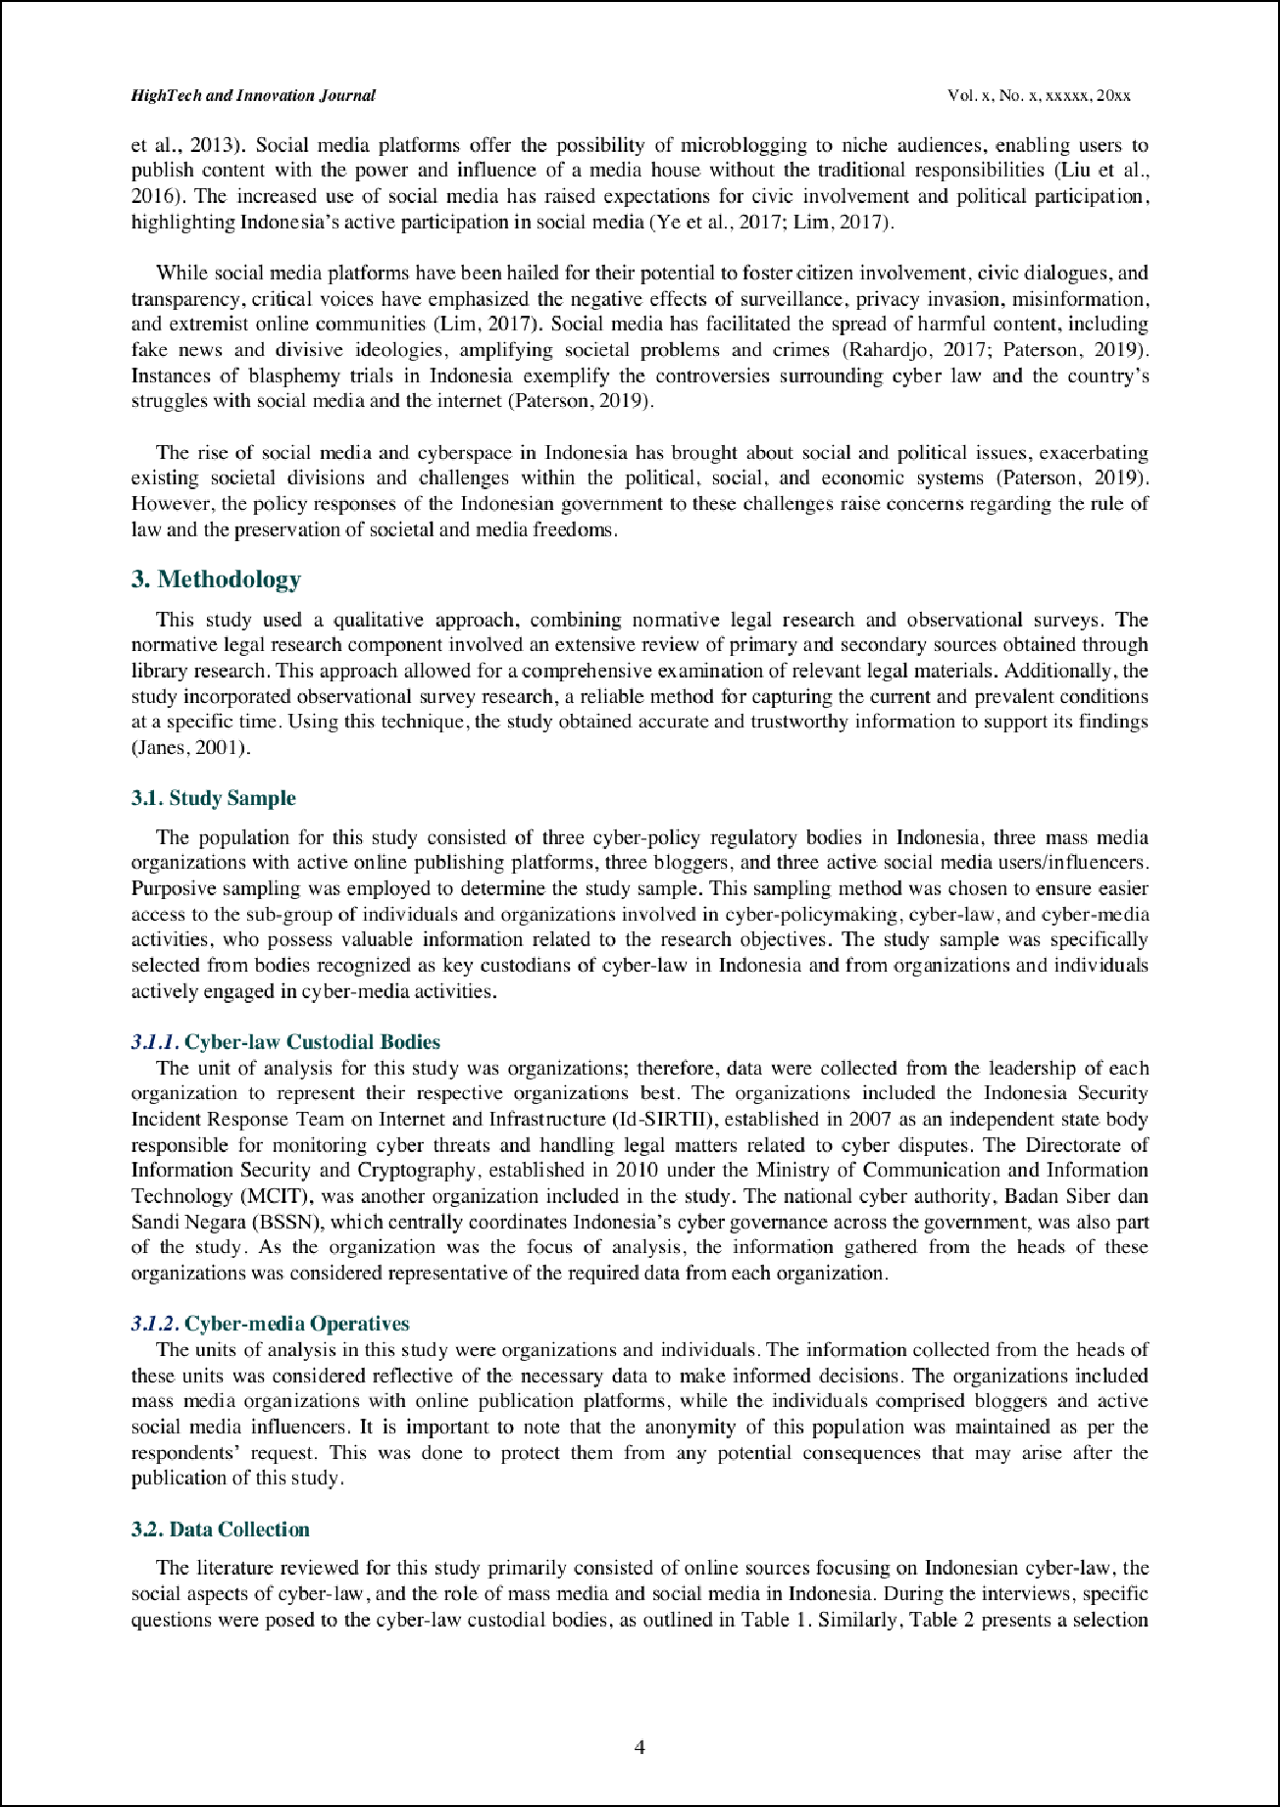

7

5
5

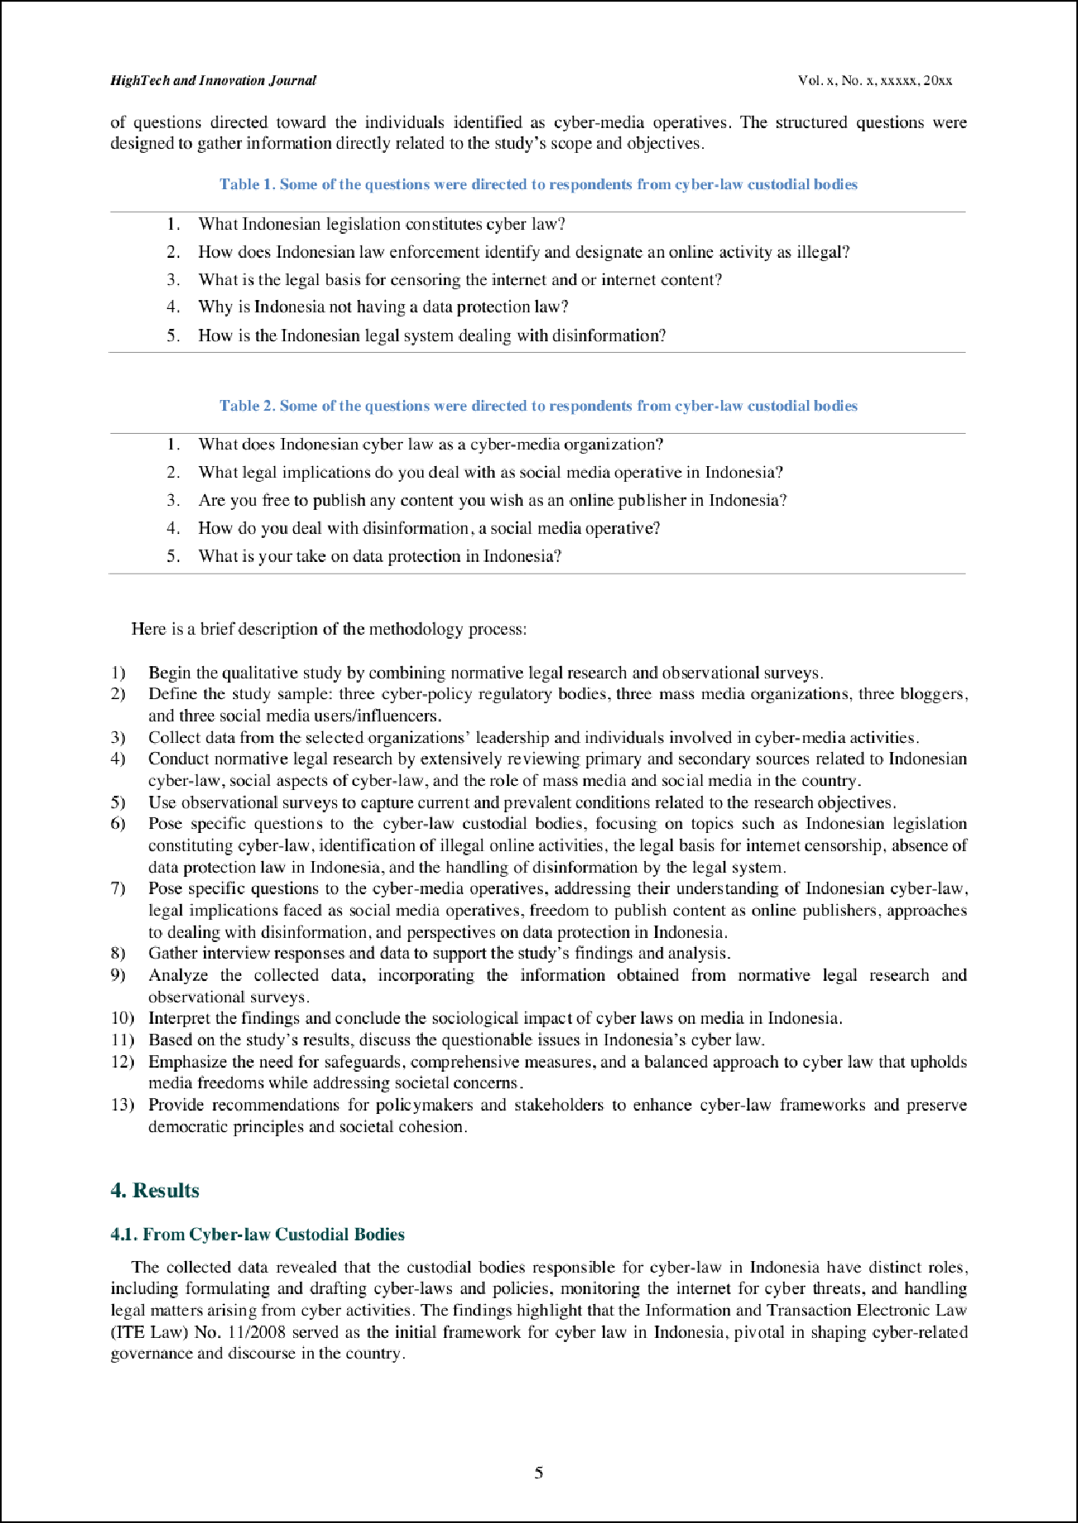

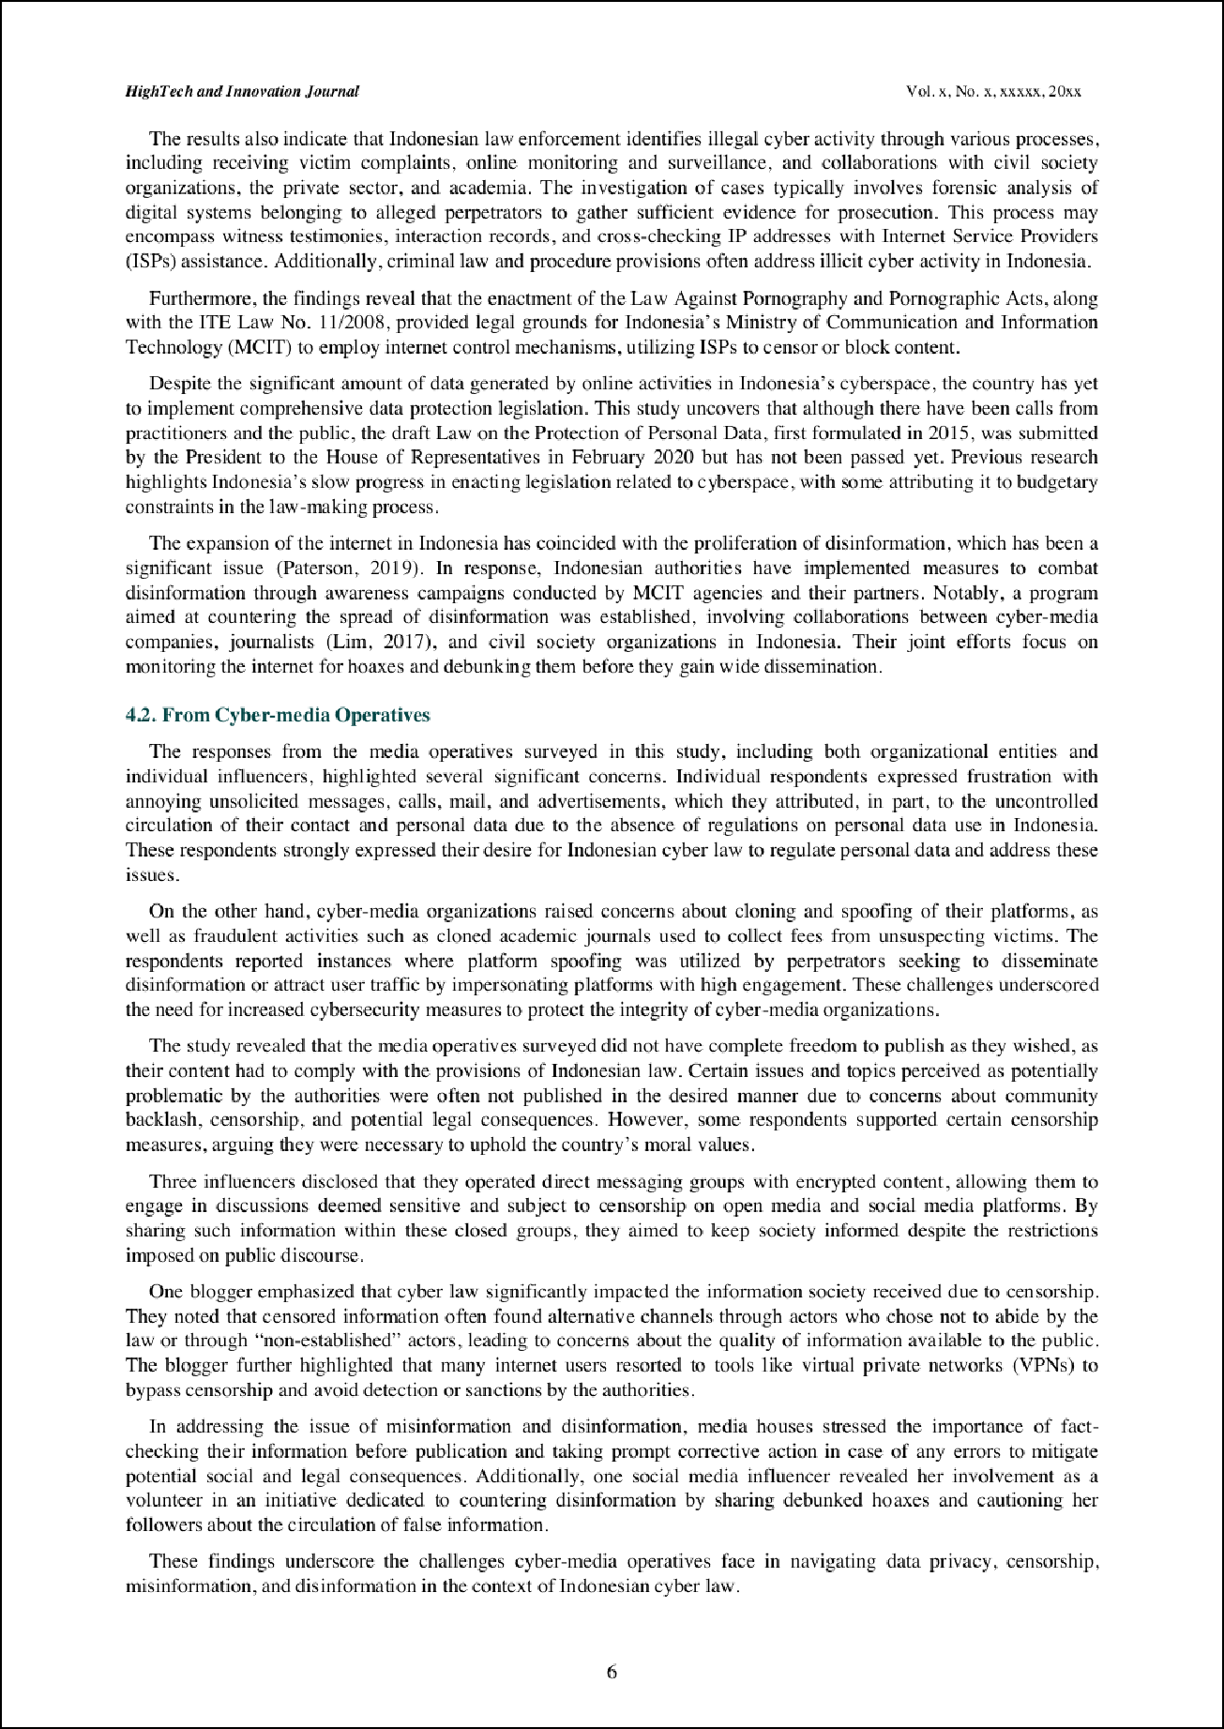

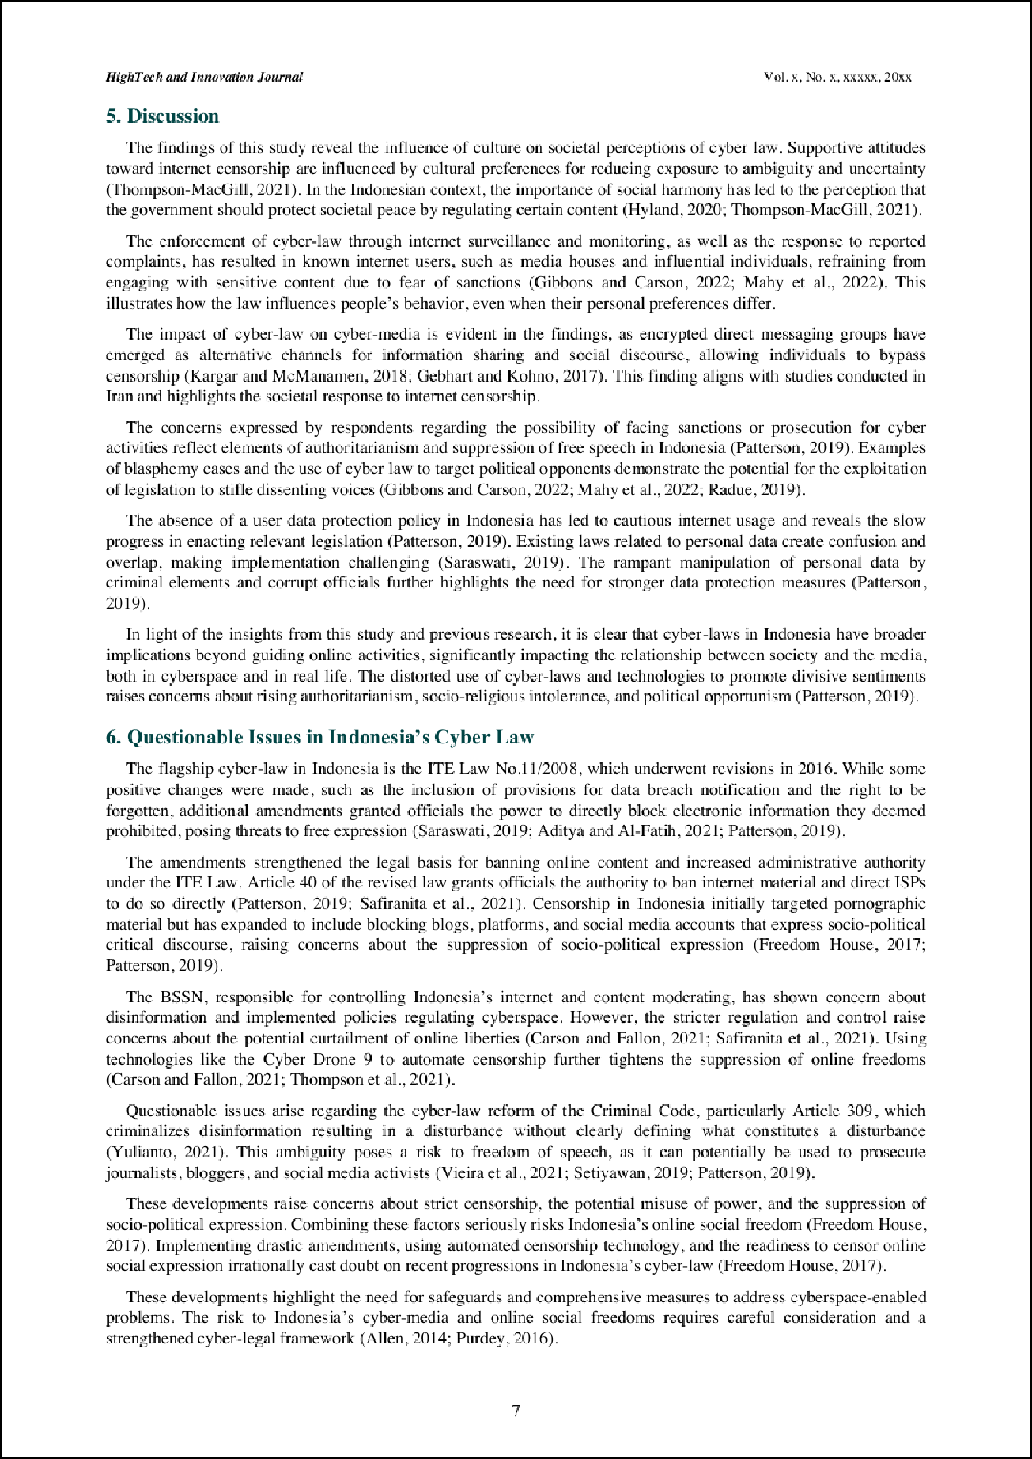

5

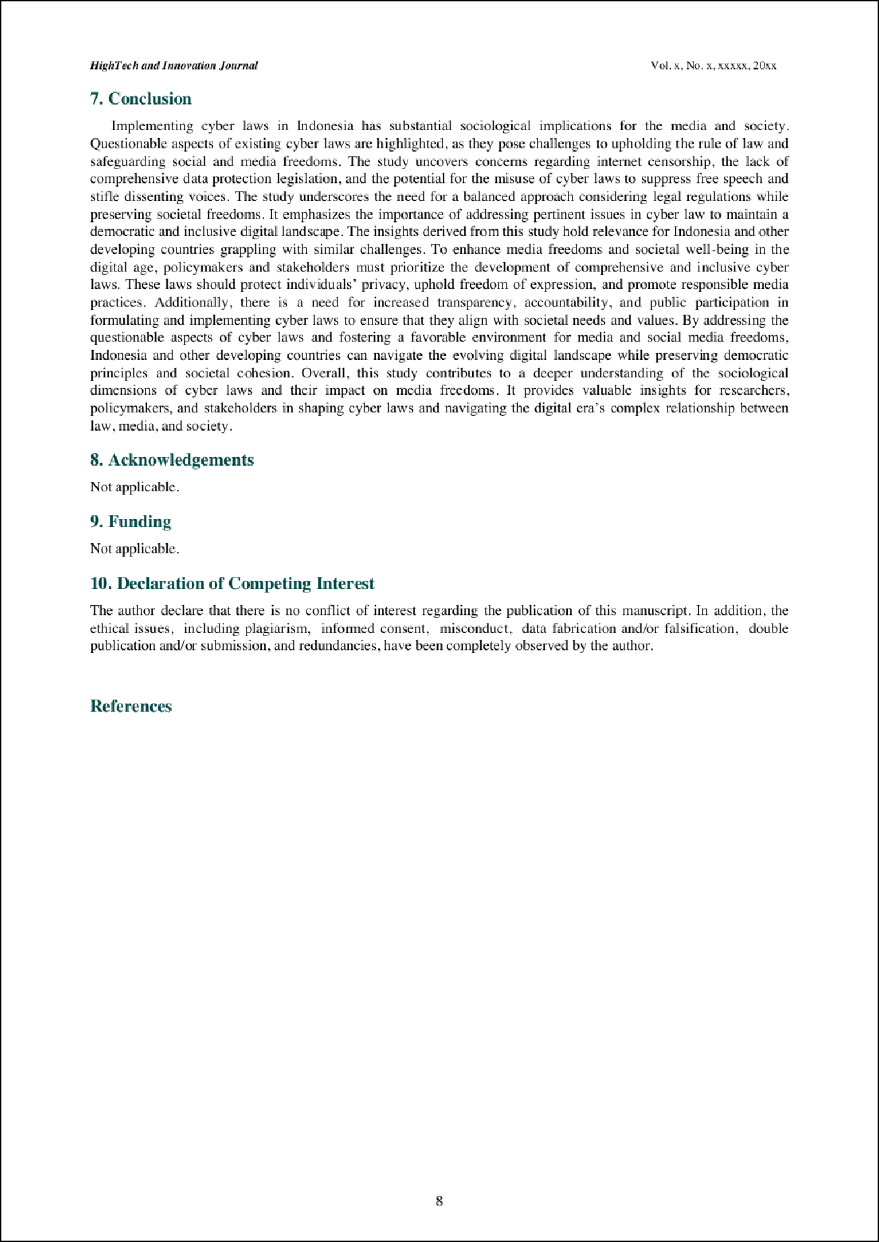

2

Sociological Impact of Cyber Laws on Media: Virtue Community and Controversies

ORIGINALITY REPORT
5

%
SIMILARITY INDEX
4%
INTERNET SOURCES
4%
PUBLICATIONS
4%
STUDENT PAPERS

PRIMARY SOURCES

Submitted to University of Diyala
1
Student Paper

www.scimedjournal.org
2
Internet Source

3 Submitted to College of Education for Pure Sciences/IBN Al-Haitham/ Baghdad University
Student Paper

en.wikipedia.org
4
Internet Source

www.tandfonline.com
5
Internet Source

6 Eko Harry Susanto, Riris Loisa, Ahmad Junaidi. "Cyber media news coverage on diversity issues in Indonesia", Journal of Human Behavior in the Social Environment, 2020
Publication

9dok.org
7
Internet Source
1%
1%
1%
1%
<1%
<1%

<1%

Exclude quotes Oﬀ Exclude bibliography On
Exclude matches Oﬀ

