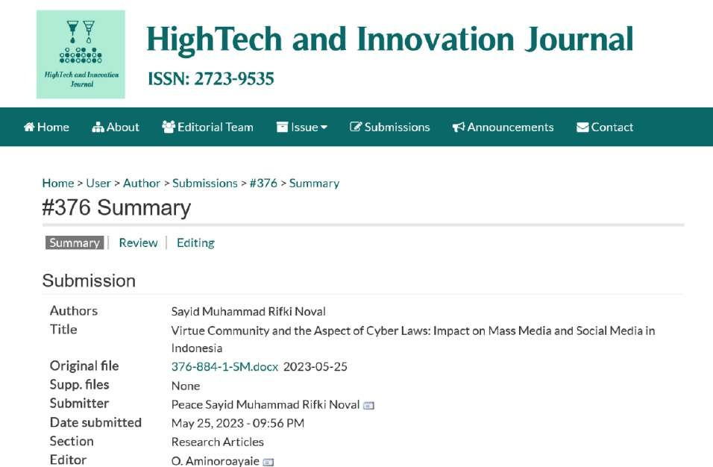

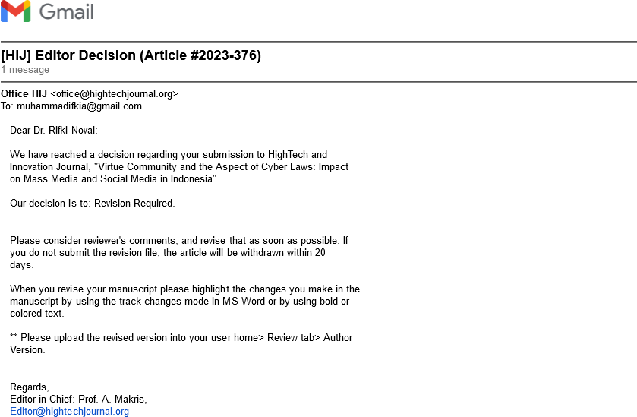

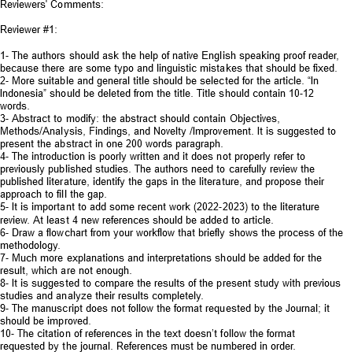

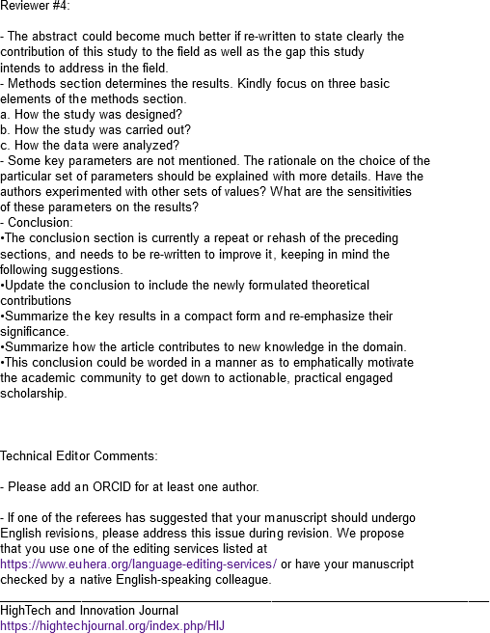

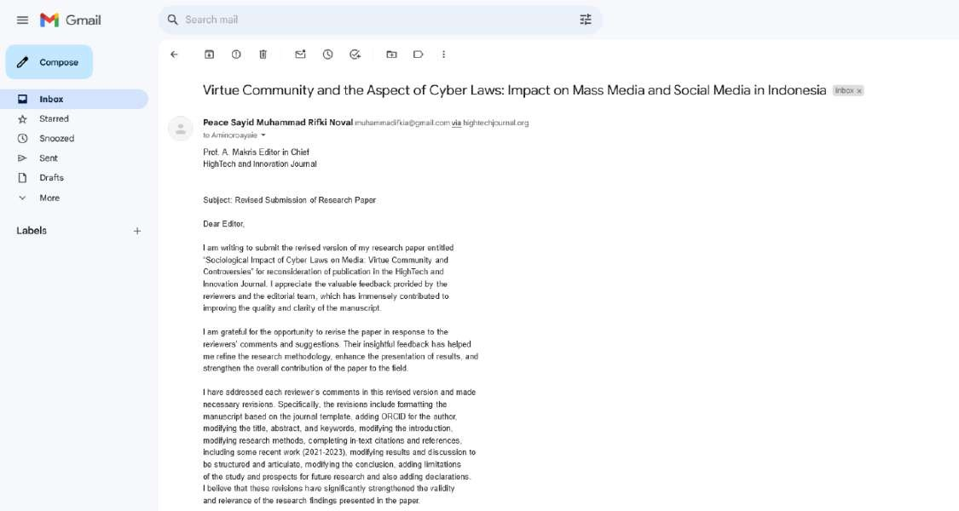

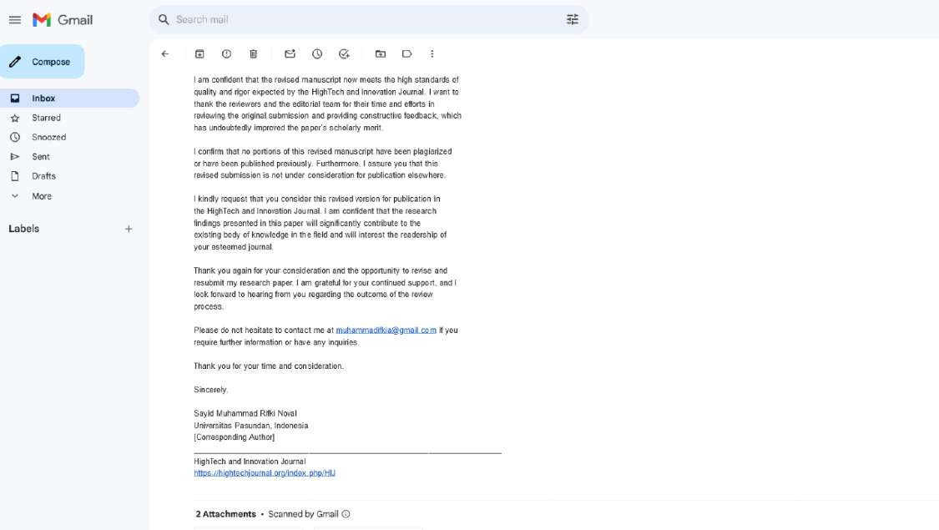

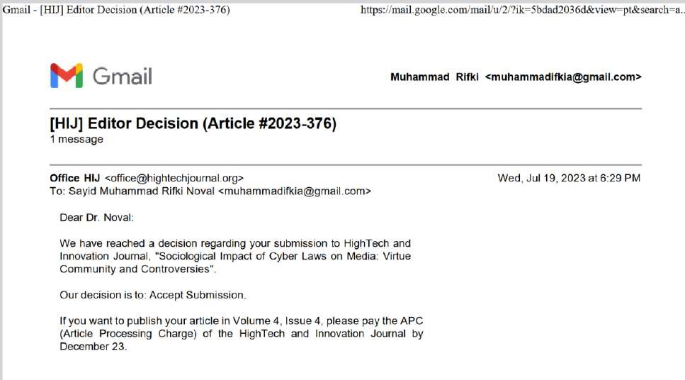

Sayid Muhammad Rifki Noval Universitas Pasundan

Prof. A. Makris Editor in Chief
HighTech and Innovation Journal

Subject: Revised Submission of Research Paper Dear Editor,
I am writing to submit the revised version of my research paper entitled “Sociological Impact of Cyber Laws on Media: Virtue Community and Controversies” for reconsideration of publication in the HighTech and Innovation Journal. I appreciate the valuable feedback provided by the reviewers and the editorial team, which has immensely contributed to improving the quality and clarity of the manuscript.
I am grateful for the opportunity to revise the paper in response to the reviewers’ comments and suggestions. Their insightful feedback has helped me refine the research methodology, enhance the presentation of results, and strengthen the overall contribution of the paper to the field.
I have addressed each reviewer’s comments in this revised version and made necessary revisions. Specifically, the revisions include formatting the manuscript based on the journal template, adding ORCID for the author, modifying the title, abstract, and keywords, modifying the introduction, modifying research methods, completing in-text citations and references, including some recent work (2021-2023), modifying results and discussion to be structured and articulate, modifying the conclusion, adding limitations of the study and prospects for future research and also adding declarations. I believe that these revisions have significantly strengthened the validity and relevance of the research findings presented in the paper.
I am confident that the revised manuscript now meets the high standards of quality and rigor expected by the HighTech and Innovation Journal. I want to thank the reviewers and the editorial team for their time and efforts in reviewing the original submission and providing constructive feedback, which has undoubtedly improved the paper’s scholarly merit.
I confirm that no portions of this revised manuscript have been plagiarized or have been published previously. Furthermore, I assure you that this revised submission is not under consideration for publication elsewhere.
I kindly request that you consider this revised version for publication in the HighTech and Innovation Journal. I am confident that the research findings presented in this

paper will significantly contribute to the existing body of knowledge in the field and will interest the readership of your esteemed journal.
Thank you again for your consideration and the opportunity to revise and resubmit my research paper. I am grateful for your continued support, and I look forward to hearing from you regarding the outcome of the review process.
Please do not hesitate to contact me at muhammadifkia@gmail.com if you require further information or have any inquiries.
Thank you for your time and consideration. Sincerely,
Sayid Muhammad Rifki Noval Universitas Pasundan, Indonesia [Corresponding Author]

