THE FUSION OF BLOCKCHAIN, PORNOGRAPHY AND HUMAN TRAFFICKING IN A GLOBAL DIGITAL DRAGNET THAT FORMS THE ONLINE CHILD SEX TRAFFICKING.
by Sayid Muhammad Rifki Noval

Submission date: 25-May-2024 08:15PM (UTC+0700)
Submission ID: 2338755607
File name: inal_Paper_Russian_Law_Spc-Sayid_Noval_2023-Revision_English.pdf (432K)
Word count: 13300
Character count: 74704

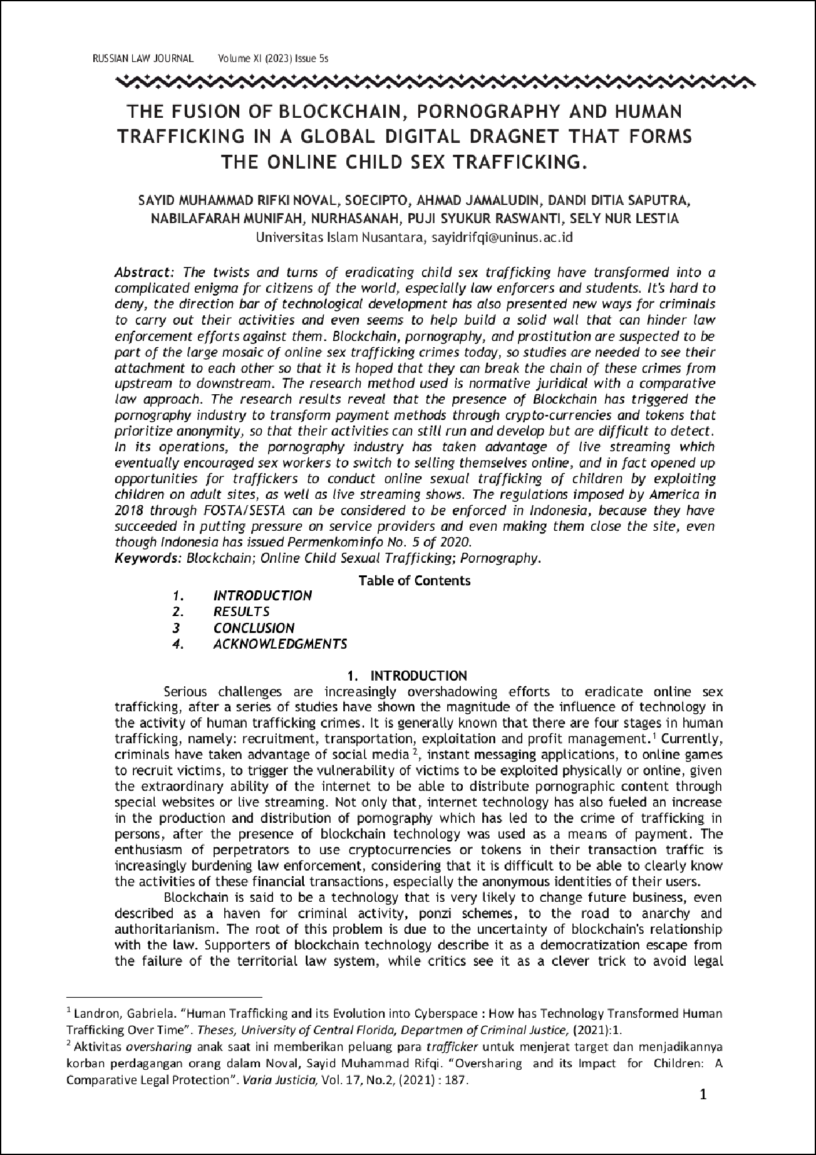

18

56

13

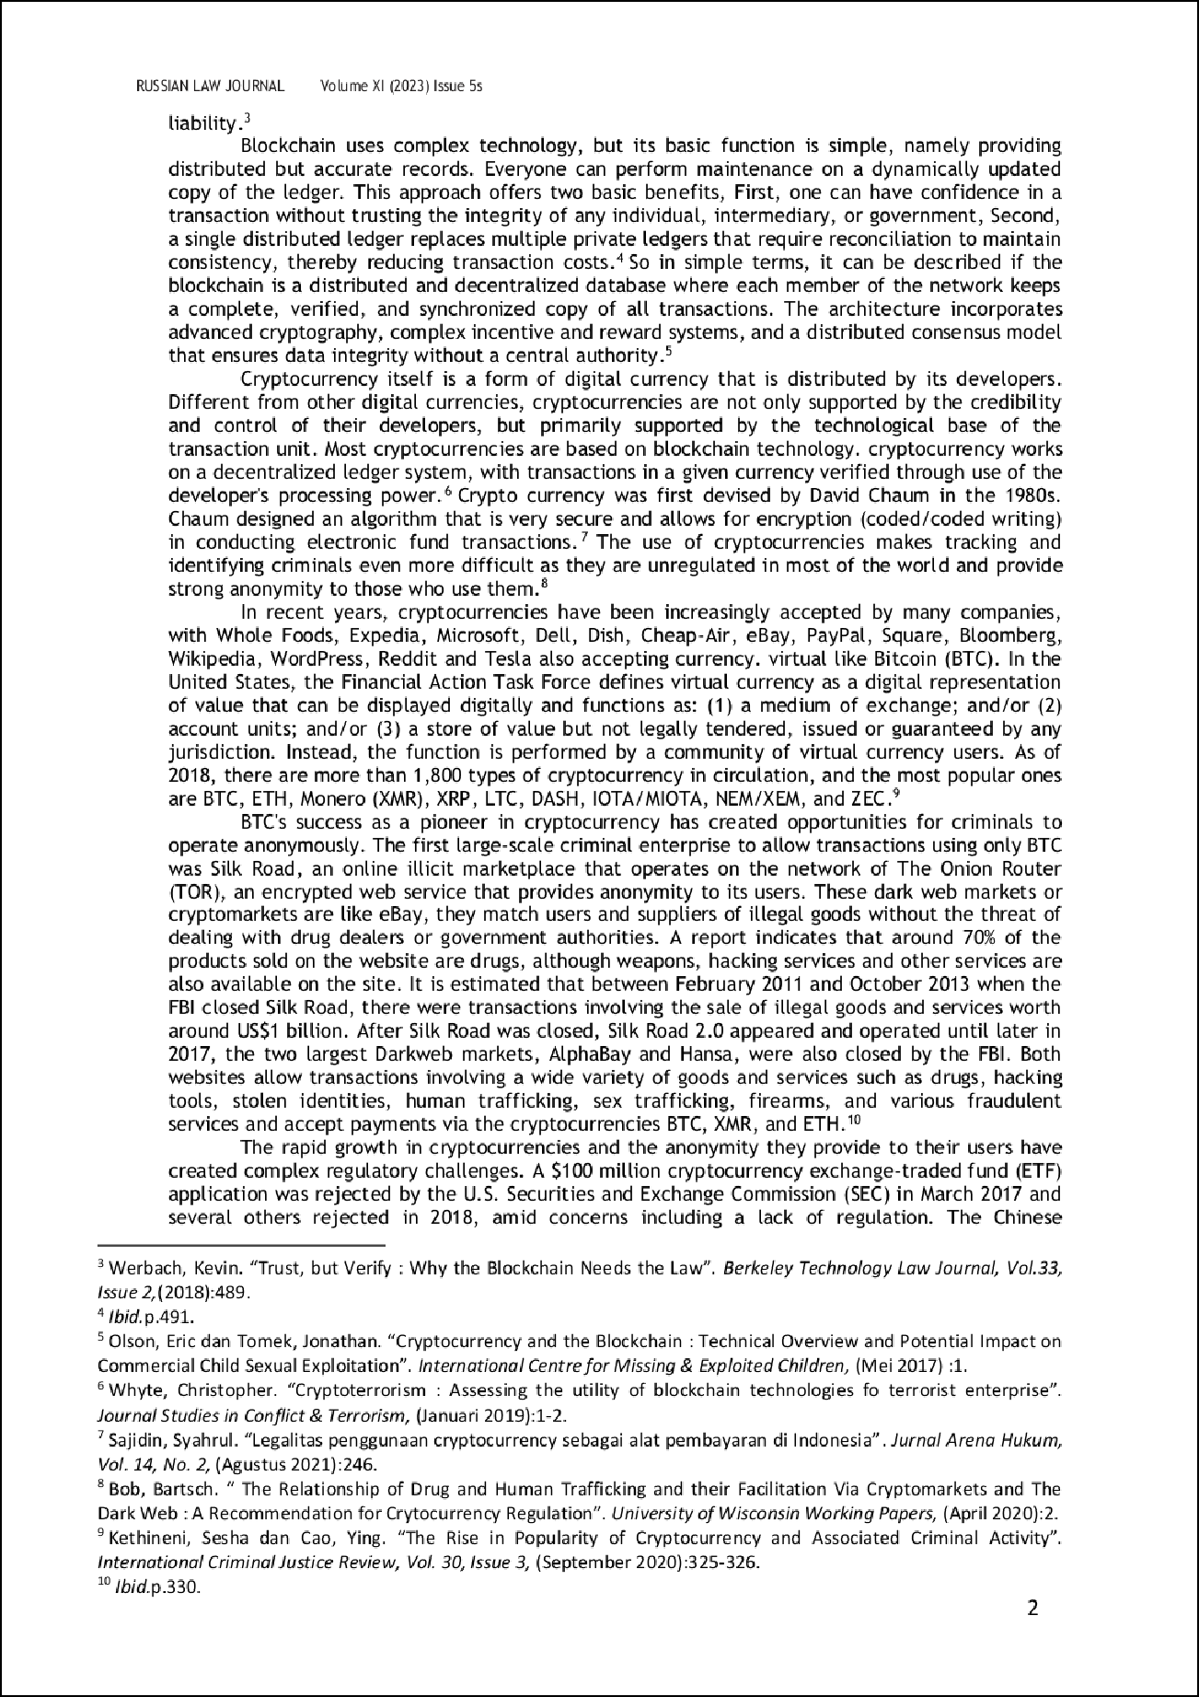

61

72

63

71

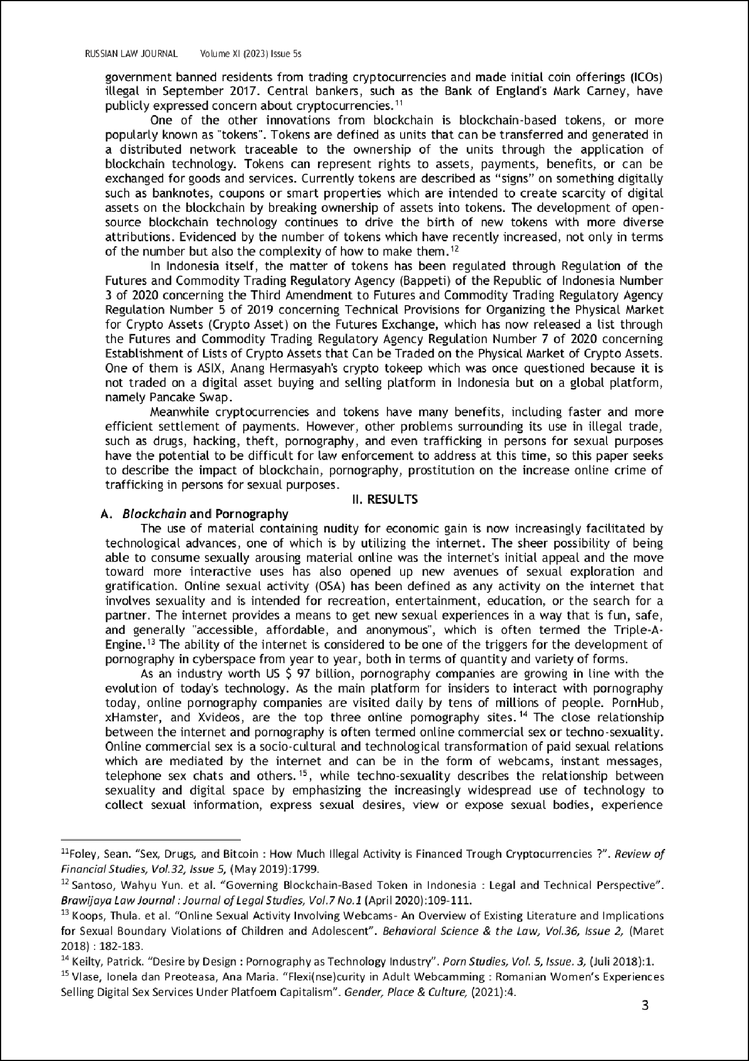

50

32

17

35

33

25

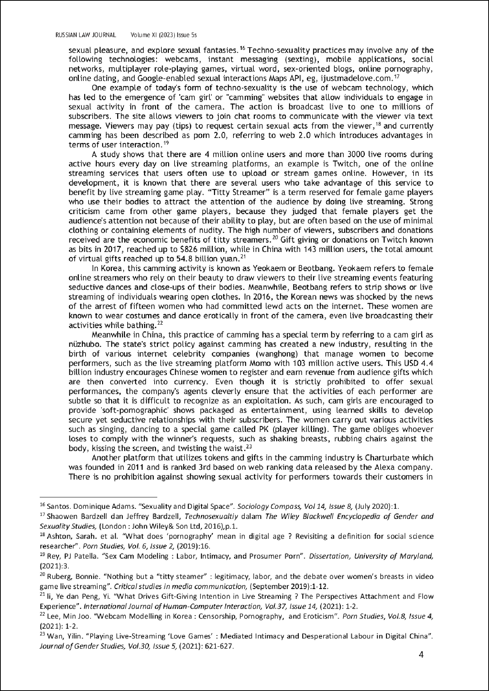

11

12

4

2

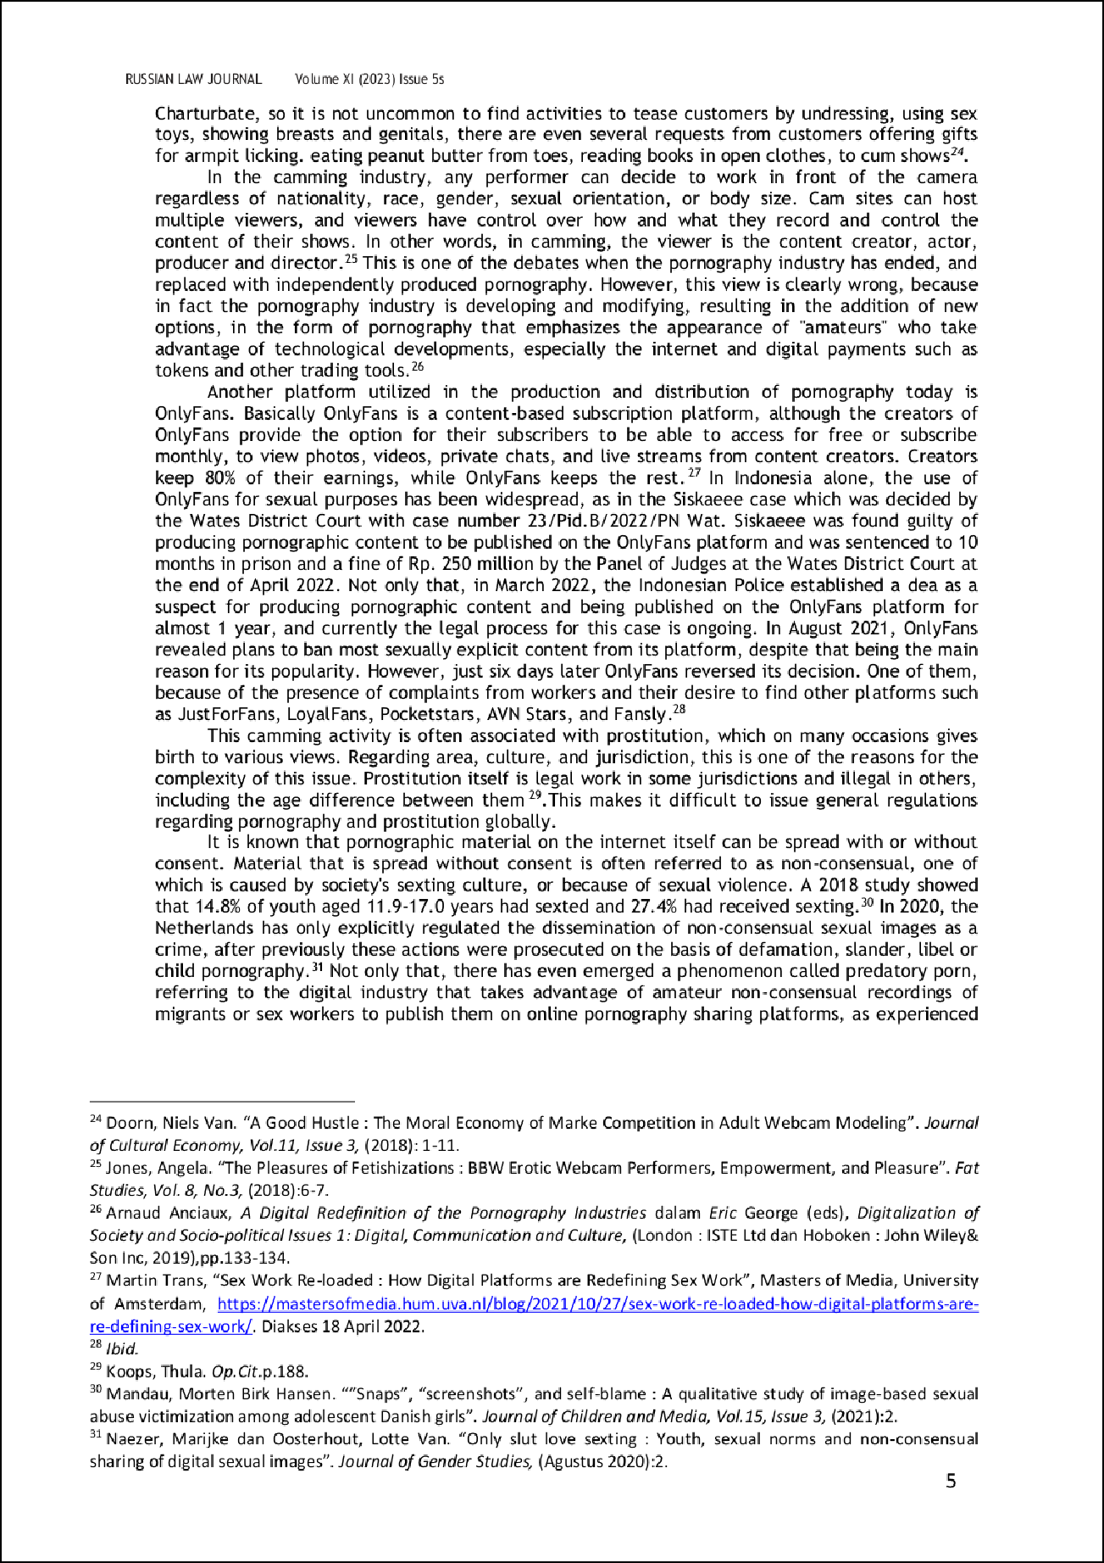

20

14

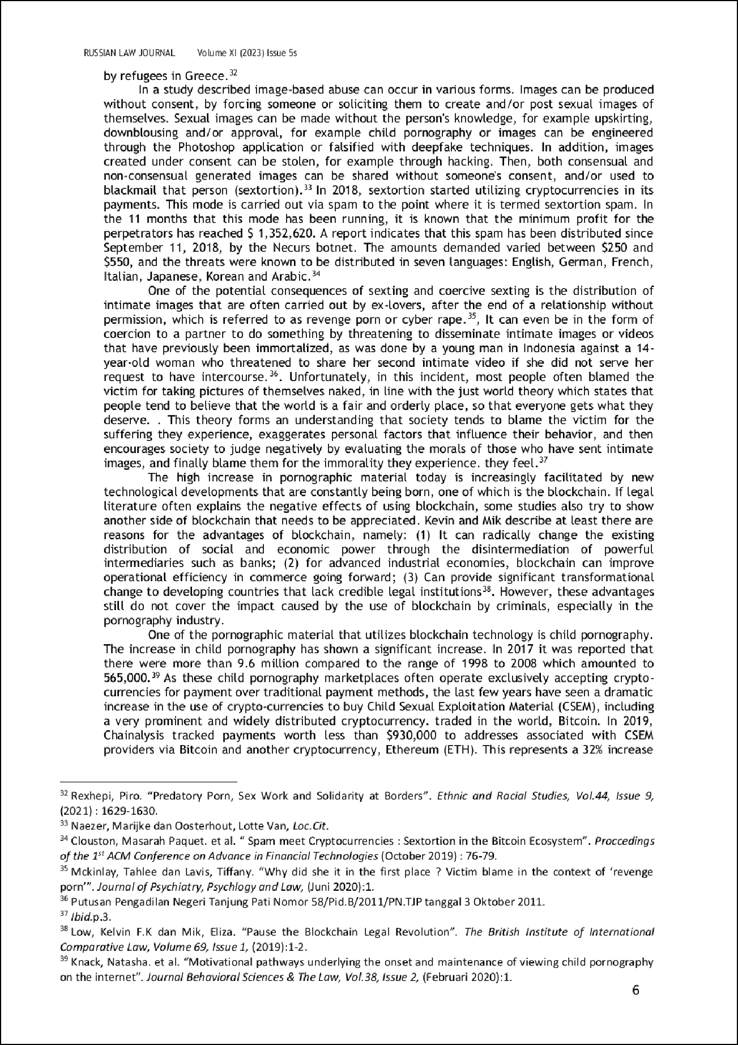

6

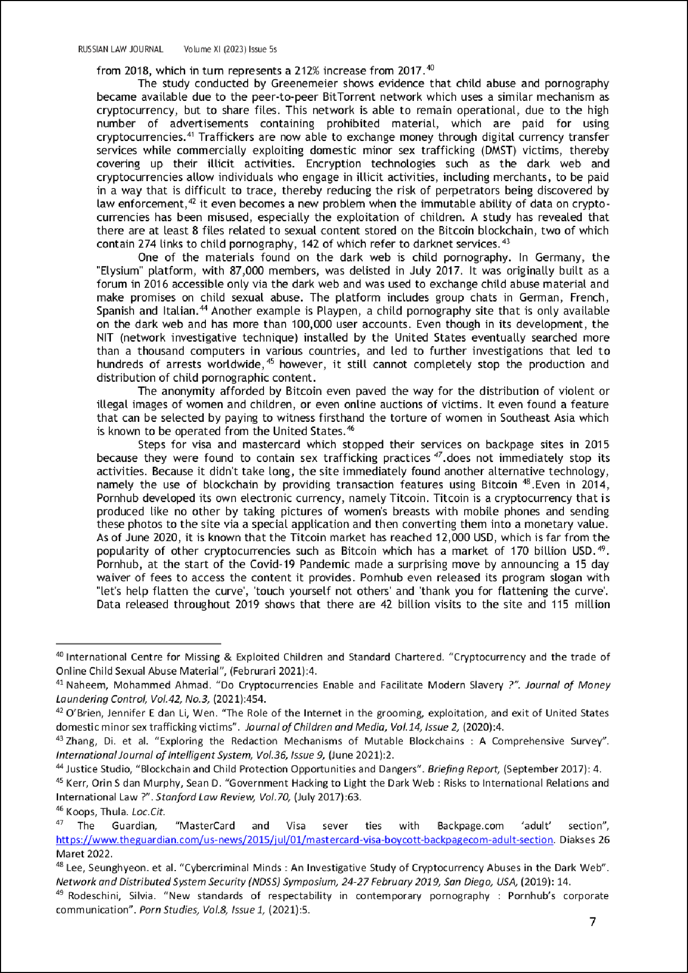

44

53 53

51

34
43

1

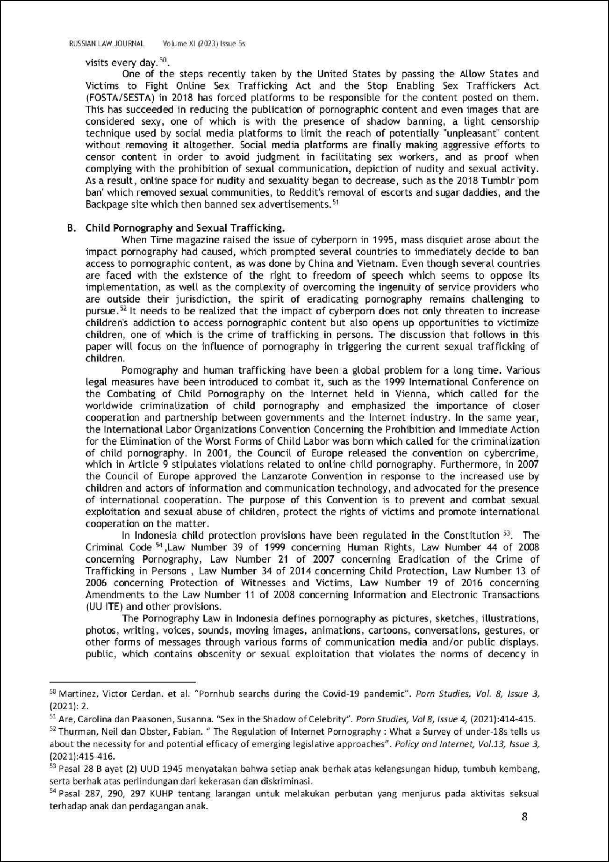

27

40

64
65

42

5

52
68

6
4

7

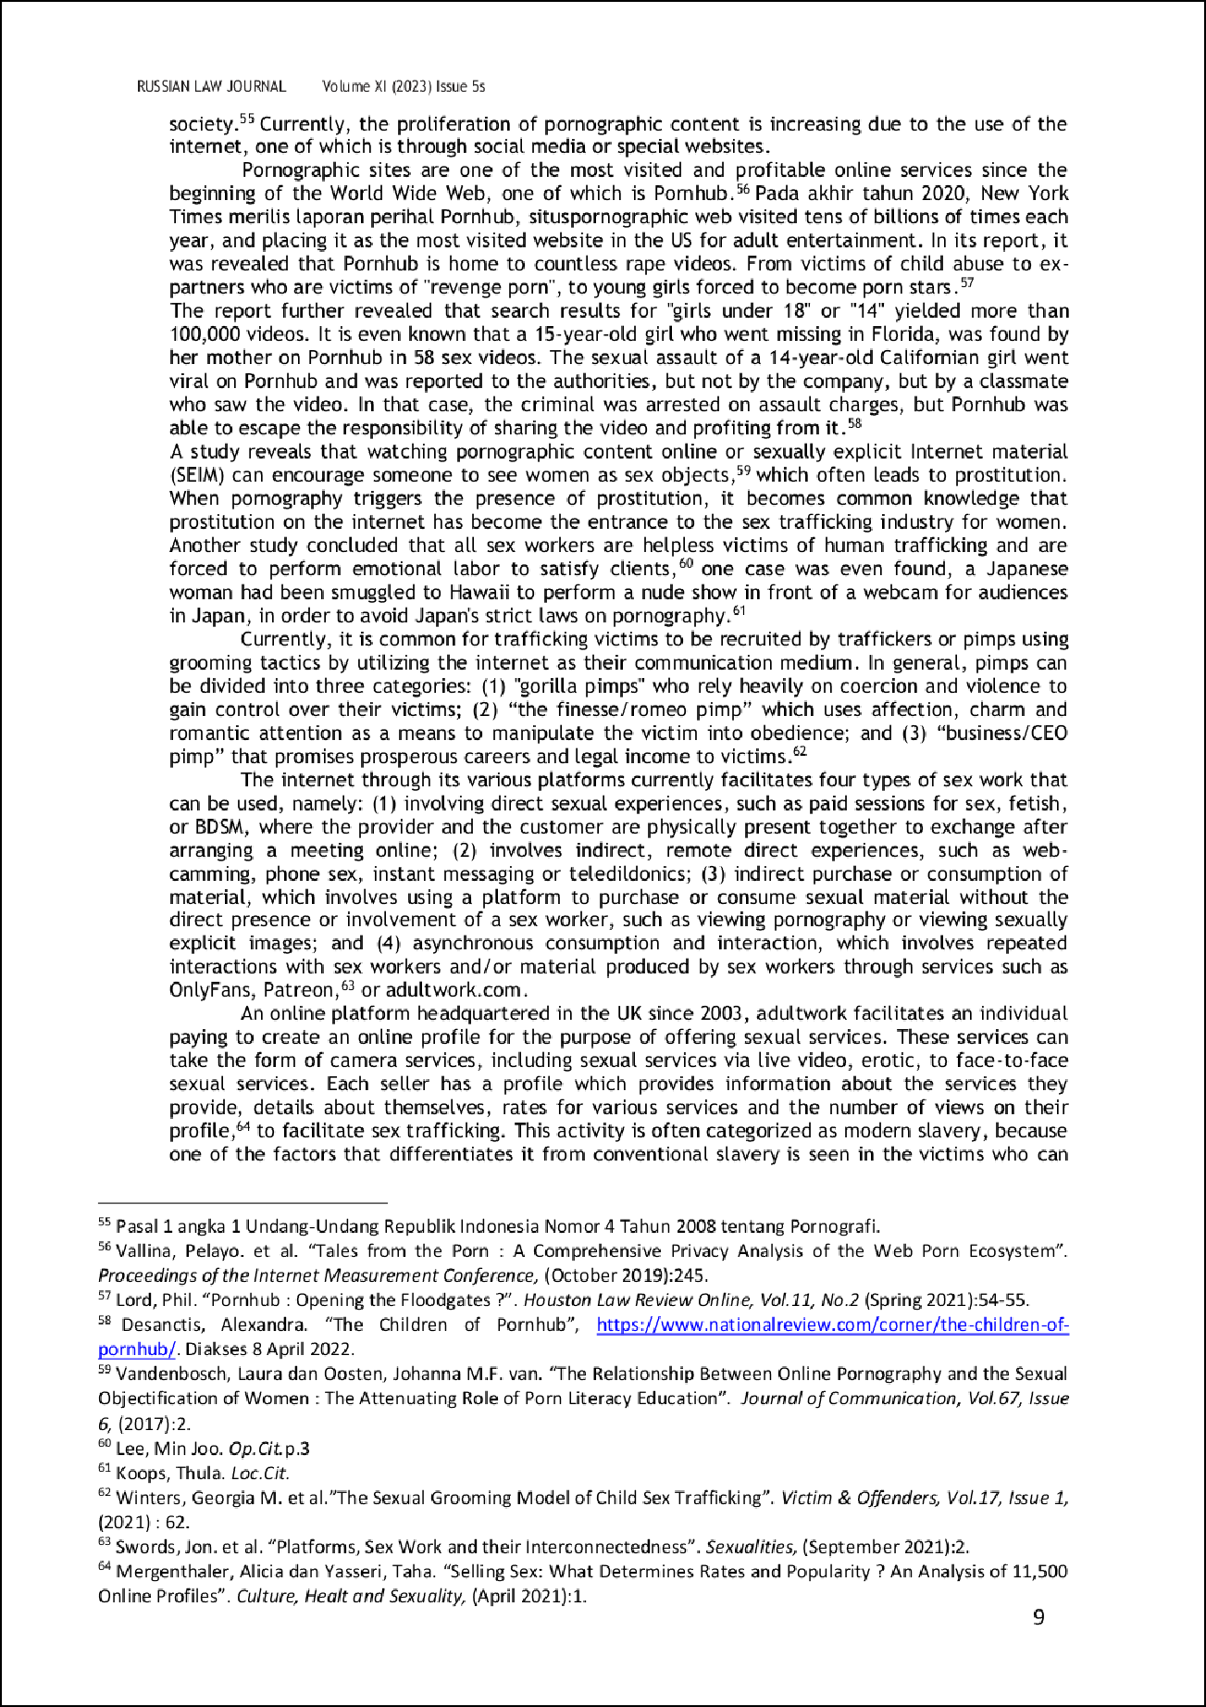

8

23

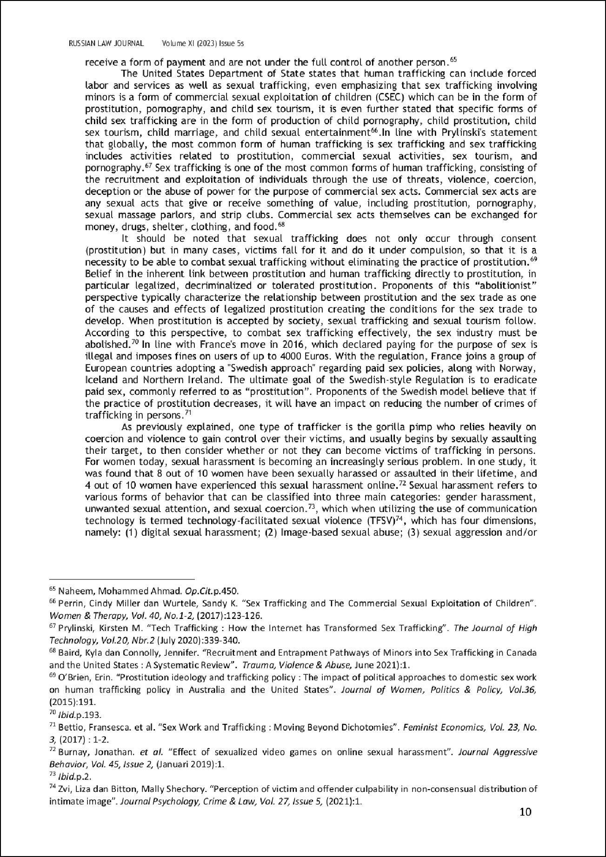

75
57

36

28
10

24

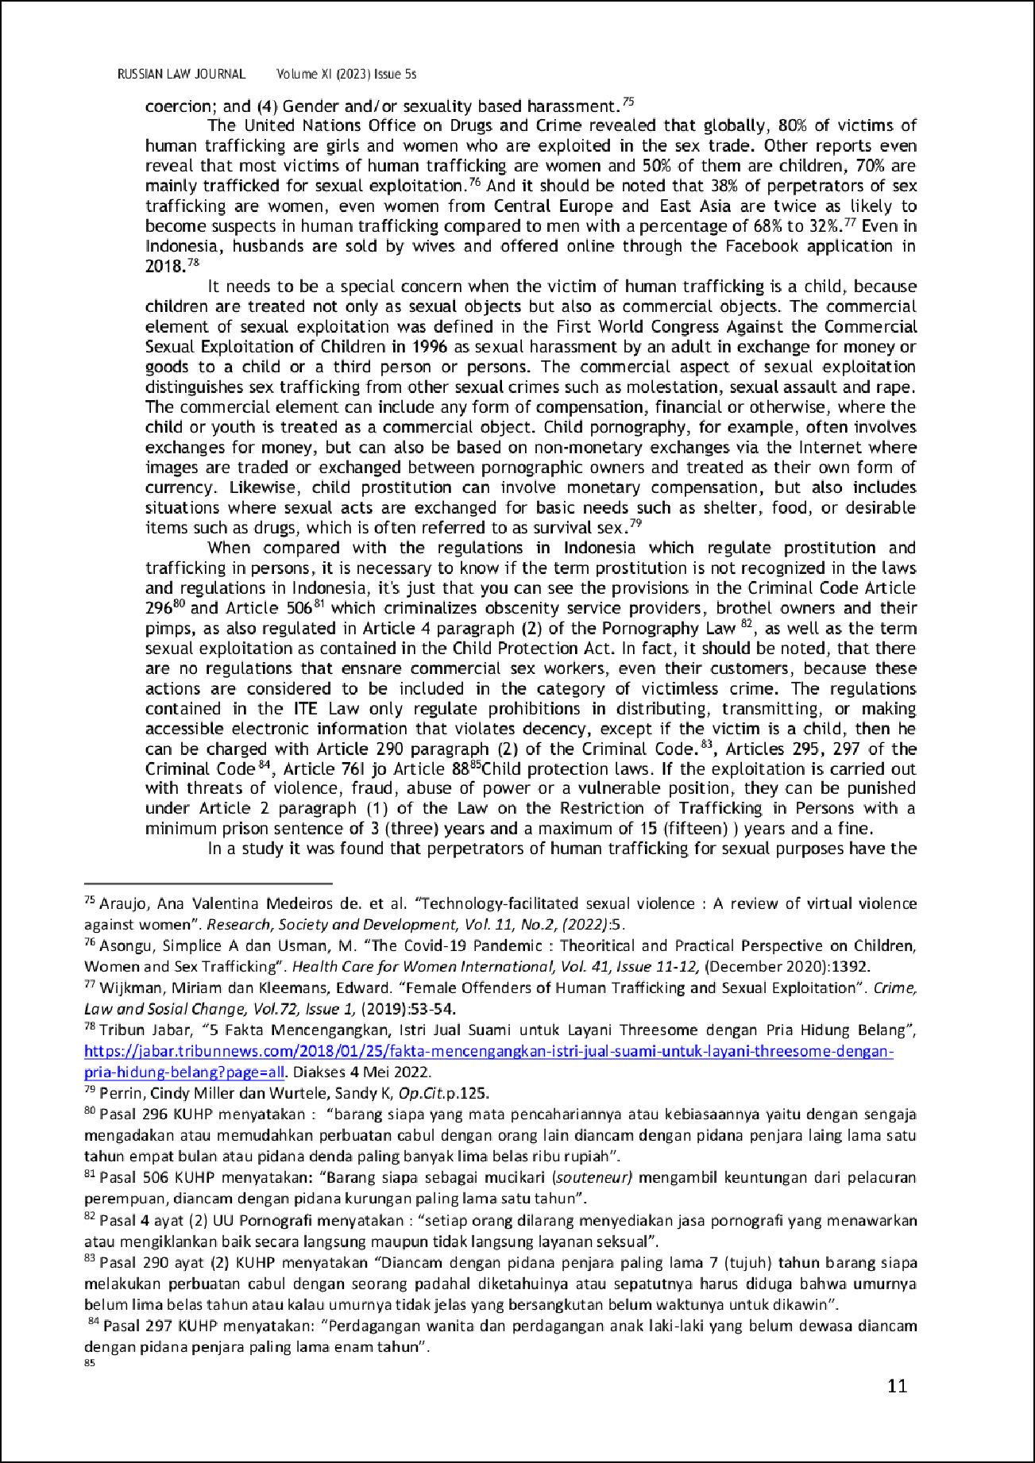

22

54

37

29

55

15

26

47
26

21

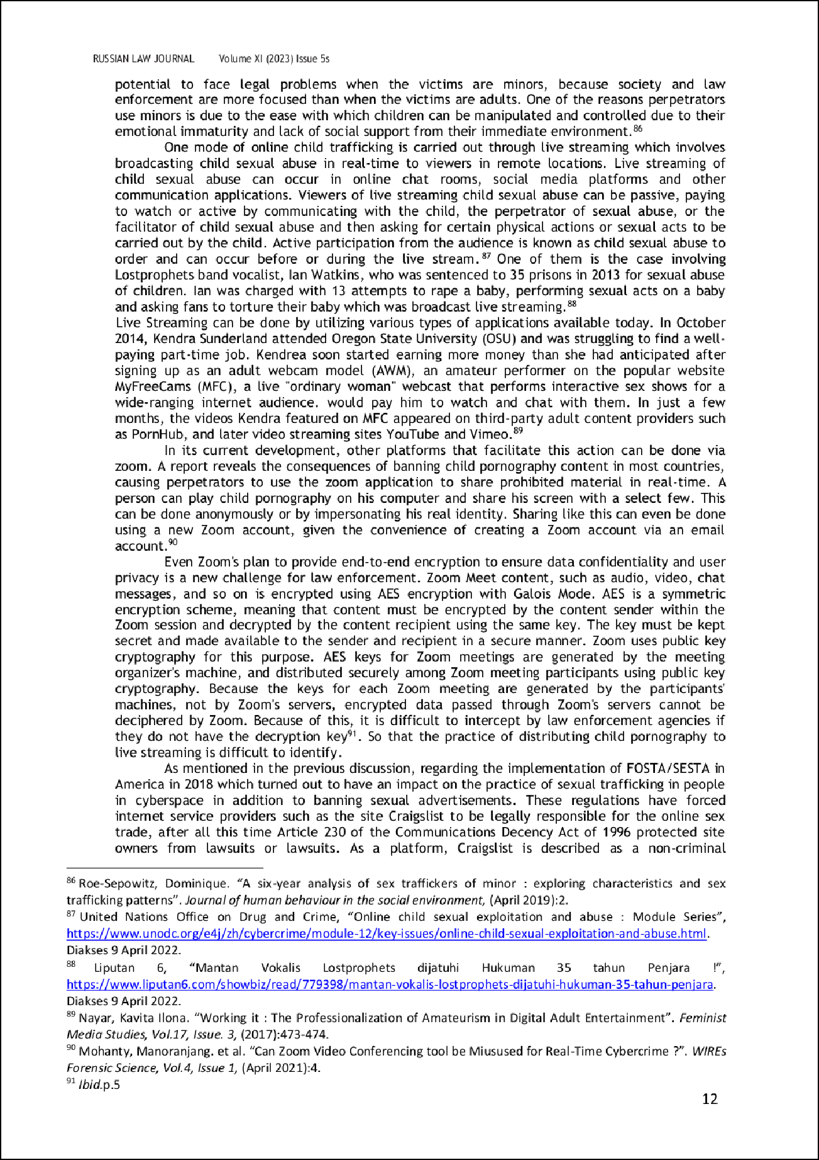

38

16

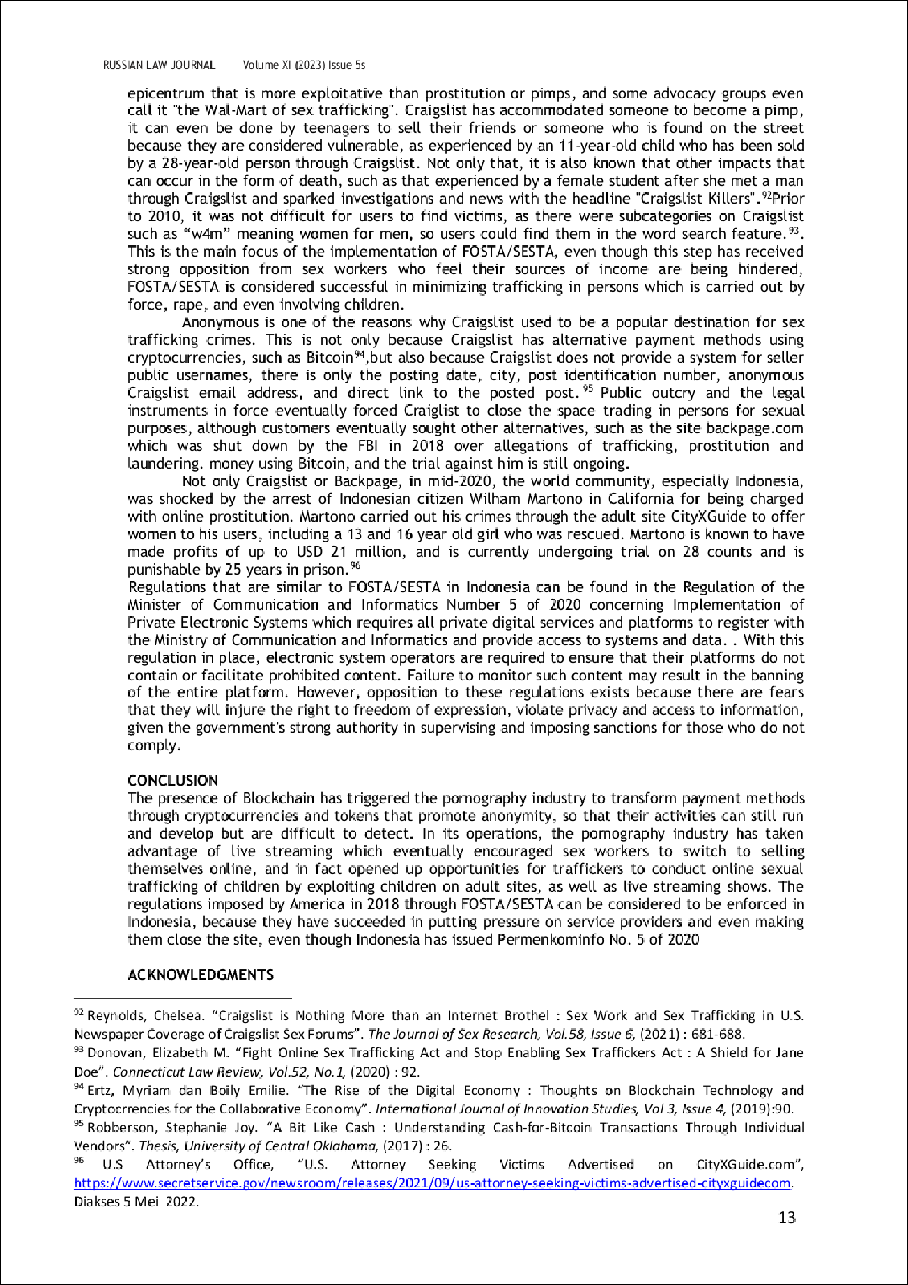

73

9

9

45

19

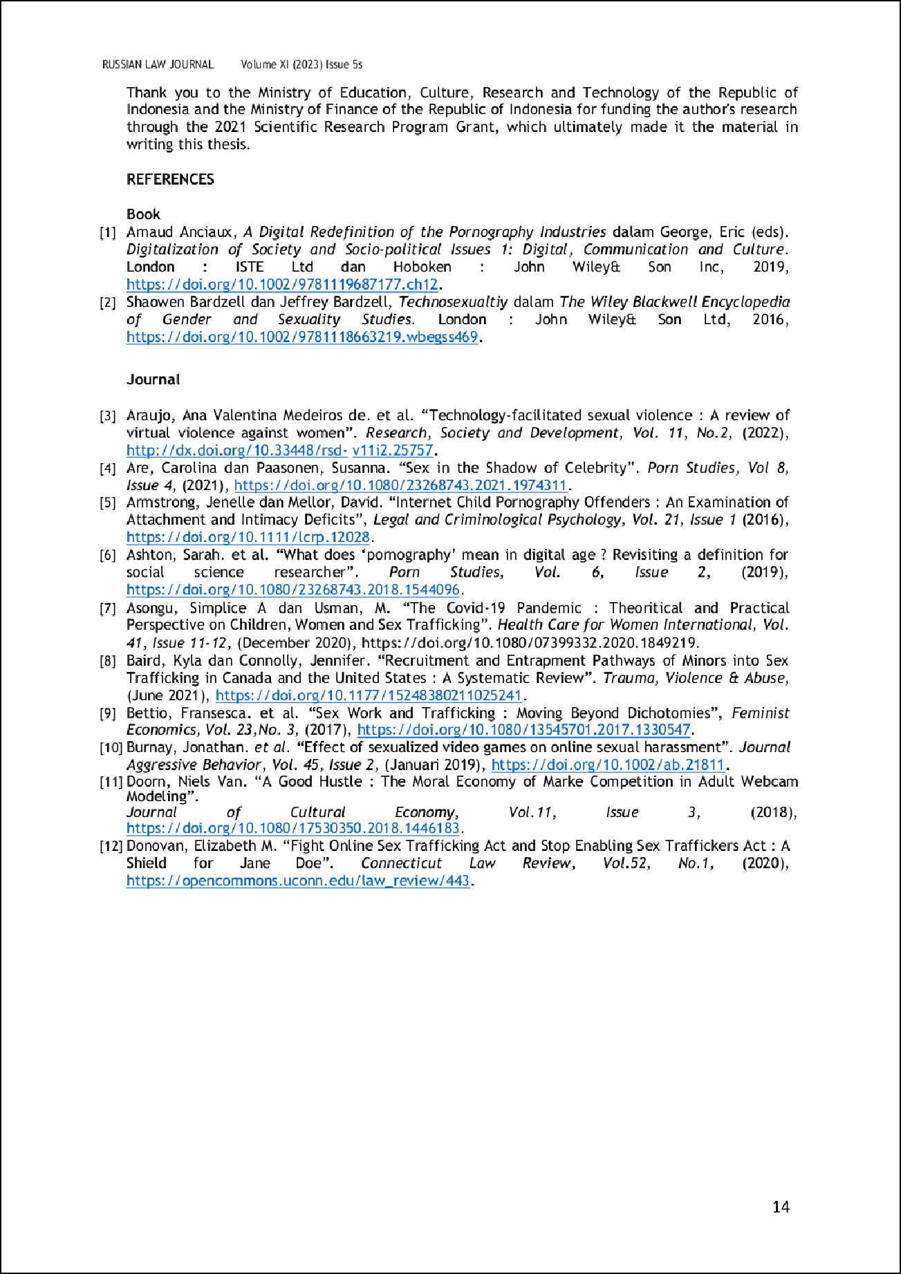

39

20

11
11

55
79

81
31

41

87

24
96

99

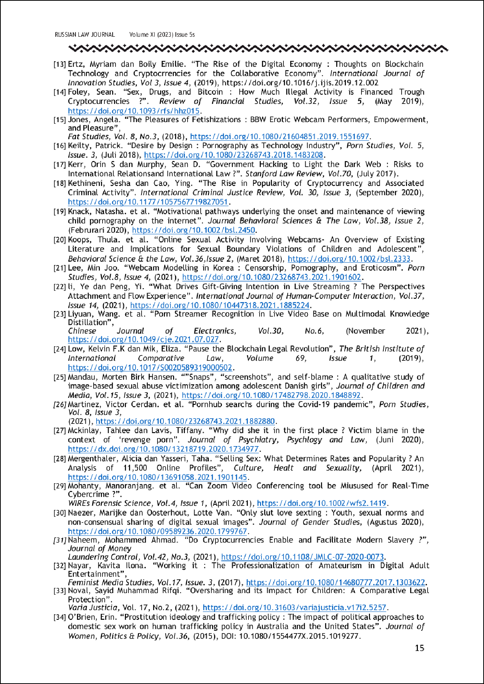

45
91

35

82
25
49

49

4

66
66
30
84

48

48

97

88

92

69

51
100

95
13

74

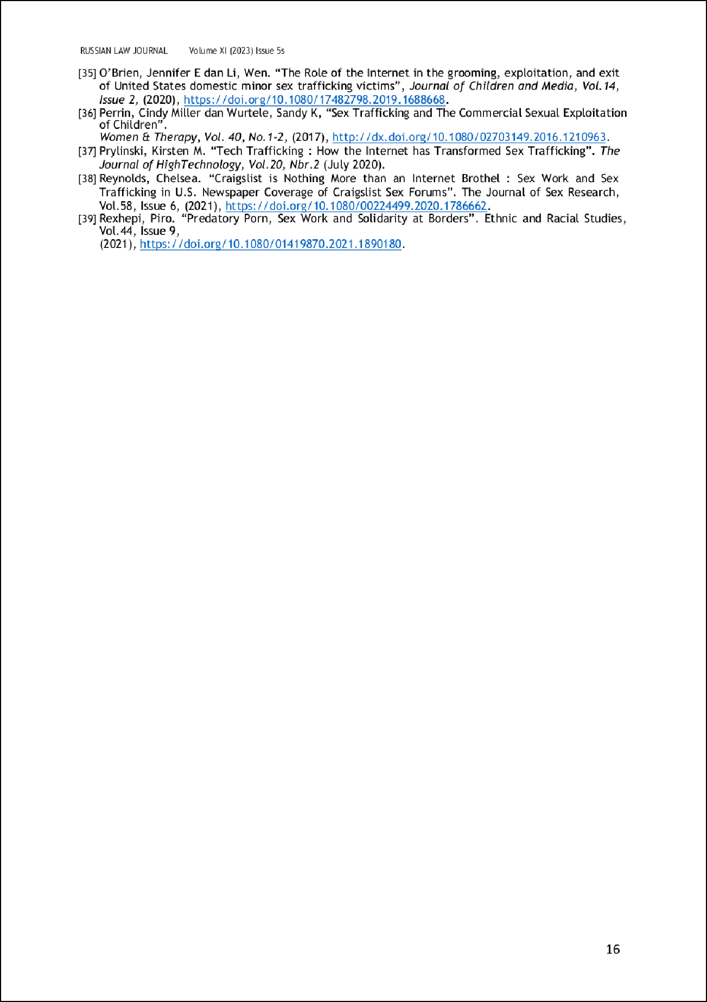

41

78

89
6

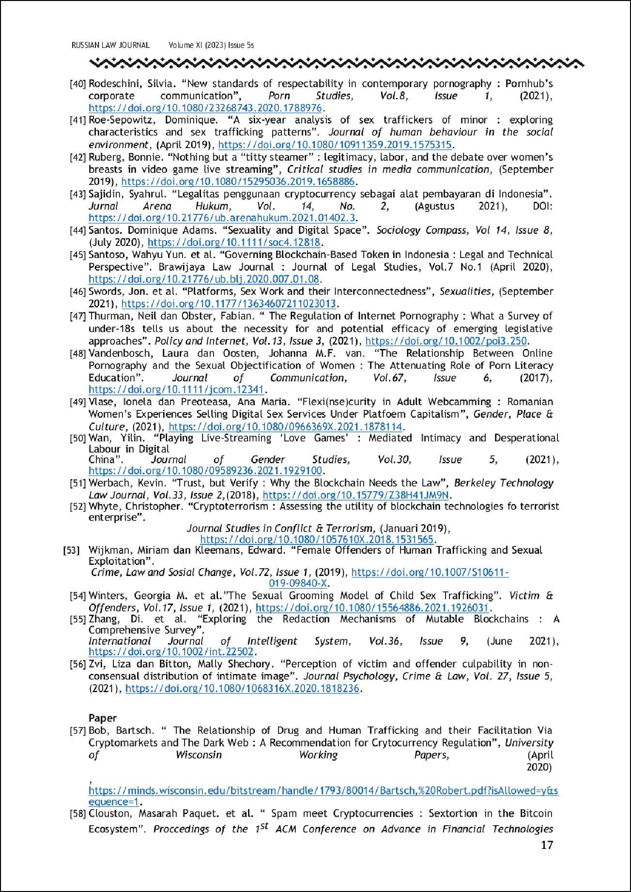

1

60

101

33

58

50

94

86
2

70

15

76

98

22

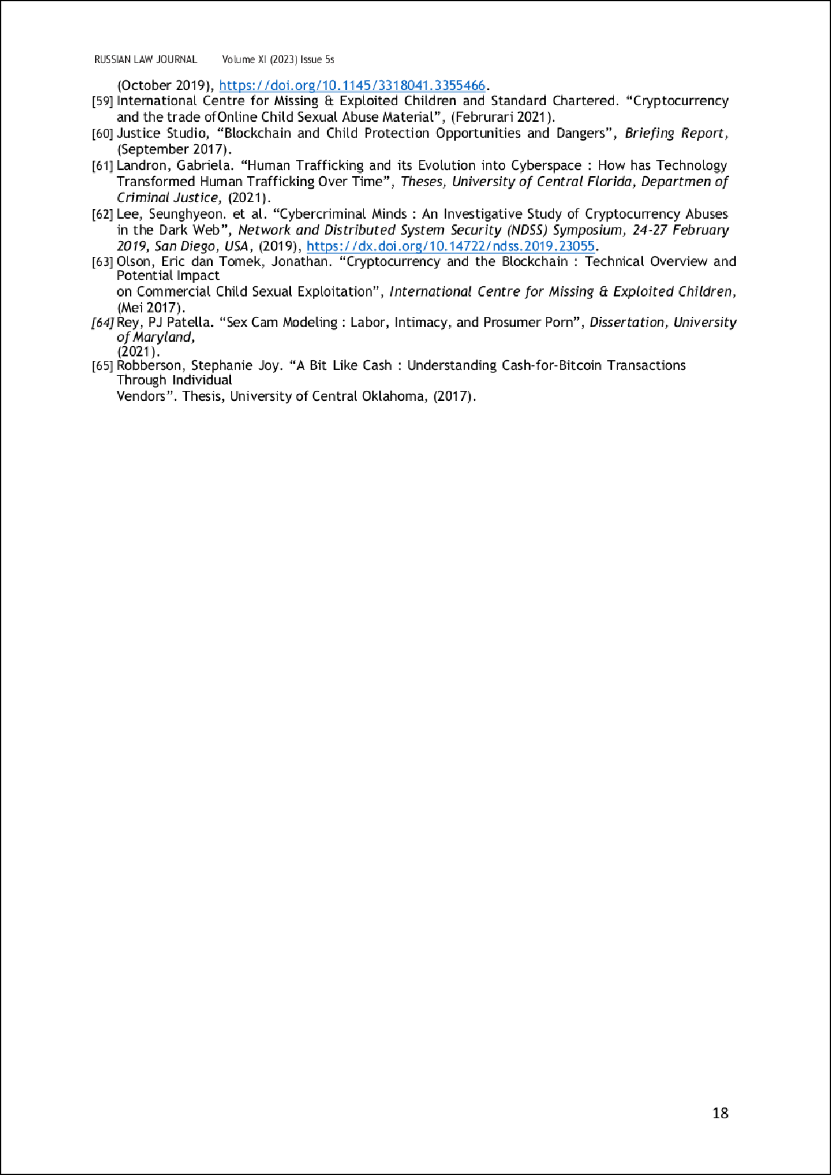

80

12

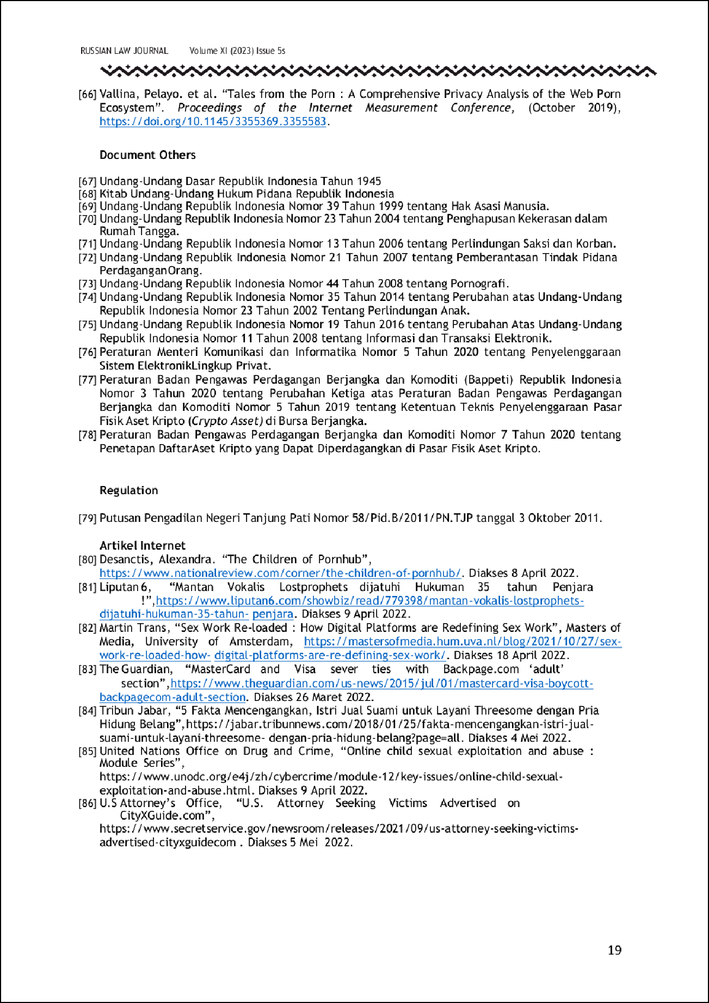

23

67
59
85

93
90
77
102

83
62

3

3

14

34
43

19

THE FUSION OF BLOCKCHAIN, PORNOGRAPHY AND HUMAN TRAFFICKING IN A GLOBAL DIGITAL DRAGNET THAT FORMS THE ONLINE CHILD SEX TRAFFICKING.
12
ORIGINALITY REPORT

%
SIMILARITY INDEX
9%
INTERNET SOURCES
3%
PUBLICATIONS
4%
STUDENT PAPERS

PRIMARY SOURCES

core-cms.prod.aop.cambridge.org
1
Internet Source

discovery.researcher.life
2
Internet Source

itgid.org
3
Internet Source

Submitted to University of Utah
4
Student Paper

Submitted to Yildirim Beyazit Universitesi
5
Student Paper

antitraffickingreview.org
6
Internet Source

bureaucracy.gapenas-publisher.org
7
Internet Source

recerc.eu
8
Internet Source

thediplomat.com
<1%
<1%
<1%
<1%
<1%
<1%
<1%
<1%

9

10

11

12

13

14

15

16

17

18

19

20
Internet Source

Submitted to American University
Student Paper

Sue V. Rosser. "Clinical Trials and Experimental Science, Bias Against Women in", Wiley, 2015
Publication

Submitted to Universidad Carlos III de Madrid
Student Paper

Submitted to University of the Sunshine Coast
Student Paper

books.openedition.org
Internet Source

dspace.stir.ac.uk
Internet Source

gizmodo.com
Internet Source

ingreat.id
Internet Source

sdil.ac.ir
Internet Source

traffickinginstitute.org
Internet Source

www.worldcat.org
Internet Source
<1%
<1%
<1%

<1%
<1%
<1%
<1%
<1%
<1%
<1%
<1%

21

22

23

24

25

26

27

28

29

30

31

agusheriyanto-media.blogspot.com
Internet Source

pacificsolstice.com
Internet Source

ris.utwente.nl
Internet Source

routledge.altmetric.com
Internet Source

spectrum.library.concordia.ca
Internet Source

ujiuu.blogspot.com
Internet Source

Submitted to Old Dominion University
Student Paper

Submitted to Southeastern College
Student Paper

Submitted to Texas State University- San Marcos
Student Paper

cje.ejournal.org.cn
Internet Source

dro.deakin.edu.au
Internet Source
<1%
<1%
<1%
<1%
<1%
<1%
<1%
<1%
<1%
<1%

<1%

32

33

34

35

36

37

38

39

40

41

42

ejournal.iainbatanghari.ac.id
Internet Source

qjpl.atu.ac.ir
Internet Source

www.theguardian.com
Internet Source

www.tse-fr.eu
Internet Source

Submitted to Delta College
Student Paper

Submitted to Long Island University
Student Paper

Submitted to Wawasan Open University
Student Paper

f1000research.com
Internet Source

susannapaasonen.org
Internet Source

traumainstitutehighered.org
Internet Source

Sonja Grover. "‘Child Soldiers’ as ‘Non- Combatants’: The Inapplicability of the
<1%
<1%
<1%
<1%
<1%
<1%
<1%
<1%
<1%
<1%
<1%
<1%

43

44

45

46

47

48

49

50

51
Refugee Convention Exclusion Clause", The International Journal of Human Rights, 2008
Publication

crackmagazine.net
Internet Source

Submitted to newcastle under lyme college
Student Paper

sandbox.ijcaonline.org
Internet Source

Submitted to Universitas Islam Lamongan
Student Paper

forumduniahukumblogku.wordpress.com
Internet Source

old.ueb.edu.vn
Internet Source

structurae.net
Internet Source

www.fujipress.jp
Internet Source

Mohammed Ahmad Naheem. "Is tackling Trade Based Money Laundering (TBML) through stricter reporting regulation the most effective response?", Journal of Money Laundering Control, 2018
Publication

<1%
<1%
<1%
<1%
<1%
<1%
<1%
<1%
<1%

52

53

54

55

56

57

58

59

60

61
Submitted to Universitas Indonesia
Student Paper

Víctor Cerdán Martínez, Daniel Villa-Gracia, Noelia Deza. "Pornhub searches during the Covid-19 pandemic", Porn Studies, 2021
Publication

epdf.pub
Internet Source

researchonline.ljmu.ac.uk
Internet Source

waset.org
Internet Source

Submitted to Marian High School
Student Paper

Submitted to Saint Bonaventure University
Student Paper

www.kalyanamitra.or.id
Internet Source

Haidan Angga Kusumah, Agus Rasyid ChandraWijaya. "Optimisation of the Application of Legal Aid for the Poor People in Sukabumi City", FIAT JUSTISIA, 2019
Publication

Submitted to South Bank University
Student Paper
<1%
<1%

<1%
<1%
<1%
<1%
<1%
<1%
<1%

<1%

62

63

64

65

66

67

68

69

70
temposiana.com
Internet Source

www.carolinaeast.org
Internet Source

Submitted to National University of Ireland, Galway
Student Paper

Submitted to Royal Melbourne Institute of Technology
Student Paper

Shuichi AMANO. "Solving the Dilemma of In- Class Presentation Sessions with a Two- Dimensional Virtual Space", Journal of the Chubu English Language Education Society, 2023
Publication

www.imlpc.or.id
Internet Source

webofscientist.pubmedia.id
Internet Source

www.hesperis-tamuda.com
Internet Source

www.resolvenet.org
Internet Source
<1%
<1%
<1%

<1%

<1%

<1%
<1%
<1%
<1%

71

72

73

74

75

76

77

78

79

80
Moh Holilur Rohman. "The Analisis Analysis of Cryptocurrency Evaluation Transactions Perspective of DSN-MUI Fatwa and Law No. 7 of 2011", Istinbath : Jurnal Hukum, 2023
Publication

Submitted to University of Johannsburg
Student Paper

ijersc.org
Internet Source

publikasi.polije.ac.id
Internet Source

www.ccu.ri.gov
Internet Source

Submitted to Georgia Gwinnett College
Student Paper

Submitted to Institut Pemerintahan Dalam Negeri
Student Paper

media.lit.uaic.ro
Internet Source

ojs.observatoriolatinoamericano.com
Internet Source

vixra.org
Internet Source

www.esri.ie
<1%

<1%
<1%
<1%
<1%
<1%
<1%

<1%
<1%
<1%

81

82

83

84

85

86

87

88

89

90

91

92
Internet Source

www.ije.ir
Internet Source

www.lbhpers.org
Internet Source

www.science.org
Internet Source

Submitted to Universiti Sains Malaysia
Student Paper

archimer.ifremer.fr
Internet Source

bmchealthservres.biomedcentral.com
Internet Source

bmcmedethics.biomedcentral.com
Internet Source

ckan.sobigdata.d4science.net
Internet Source

eprints.ubhara.ac.id
Internet Source

ijicc.net
Internet Source

journals.gujaf.com.ng
Internet Source
<1%
<1%
<1%
<1%
<1%
<1%
<1%
<1%
<1%
<1%
<1%
<1%

93

94

95

96

97

98

99

100

101

102
jurnaliainpontianak.or.id
Internet Source

mdsoar.org
Internet Source

on360.ca
Internet Source

pdxscholar.library.pdx.edu
Internet Source

pesquisa.bvsalud.org
Internet Source

politicalscience.sfsu.edu
Internet Source

producaoonline.org.br
Internet Source

www.ingentaconnect.com
Internet Source

www.neprimateconservancy.org
Internet Source

www.pa-lumajang.go.id
Internet Source
<1%
<1%
<1%
<1%
<1%
<1%
<1%
<1%
<1%
<1%

Exclude quotes Off Exclude bibliography Off
Exclude matches Off

