THE INFLUENCE OF SERVANT LEADERSHIP STYLE, COMPENSATION, AND SELF-EFFICACY ON EMPLOYEE Performance, Which HAS IMPLICATIONS FOR GOVERNMENT POLICY CONCERNING PPh 21 TAX INCENTIVES IN THE MANUFACTURING INDUSTRY OF THE CONSUMPTION GOODS SECTOR OF THE FOOD AND BEVERAGE SUBSECTOR IN THE JABODETABEK AREA

Anita Novialumi¹, M. Sidik Priadana², Erni Rustiani³, Nining Yuningsih⁴, Azhar Affandi⁵, Iman Sudirman⁶
Email : anytha.lumi7@gmail.com, anita@binainsani.ac.id, sidik.priadana.dim@unpas.ac.id, ernirusyani@unpas.ac.id, imansudirman@unpas.ac.id, azhar.affandi.dim@unpas.ac.id, nining.rasha2002@gmail.com
Mahasiswa Unpas, Lecture 4 Unpas, Universitas Pelita Bangsa

ABSTRAK
Pimpinan perusahaan memiliki tanggung jawab meningkatkan kinerja karyawan dengan meningkatkan keterlibatan karyawan pada pekerjaan. Gaya kepemimpinan yang tepat dinilai akan mampu meningkatkan kinerja karyawan karena menyebabkan karyawan merasa termotivasi untuk melakukan pekerjaan sesuai tujuan Perusahaan.
Tujuan penelitian ini adalah untuk mengetahui Pengaruh Gaya Kepemimpinan Melayani, Kompensasi dan Efikasi diri Terhadap Komitmen karyawan serta Implikasi oleh Kinerja Karyawan yang di Moderasi oleh Kebijakan Pemerintah (Studi tentang Pimpinan Perempuan pada Industri Manufaktur Sektor Barang Konsumsi Subsektor Makanan dan Minuman di Wilayah Jabodetabek). Jenis penelitian yaitu Kuantitatif dengan pendekatan deskriptif Verifikatif. Sampel yang digunakan sebanyak 383 responden dengan Tekhnik analisis structural equation model (SEM) AMOS dengan tekhnik sampling Cluster Stratified Random Sampling.
Hasil penelitian menyimpulkan bahwa terdapat pengaruh yang signi-fikan dari Komitmen Karyawan terhadap keempat variabel intervening yang terdiri dari, Gaya kepemimpinan melayani, Kompensasi, Efikasi diri, dan Kinerja karyawan, Selanjutnya terdapat pengaruh signifikan dari Gaya kepemimpinan melayani, kompensasi dan efikasi diri, selanjutnya terdapat pengaruh signifikan Variabel Komitmen karyawan dan Kinerja yang dimoderasi oleh kebijakan pemerintah pada manufaktur sub sektor makanan dan minuman wilayah Jabodetabek.
Kata kunci: Gaya Kepemimpinan Melayani, Kompensasi, Efikasi diri, Komitmen, Kinerja dan Kebijakan Pemerintah.

RINGKESAN
Pamingpin pausahaan ngagaduhan tanggung jawab pikeun ningkatkeun kinerja pagawe ku cara ningkatkeun partisipasi karyawan dina padamelan éta. Gaya kapamingpinan anu bener dianggap bisa ngaronjatkeun kinerja pagawé sabab ngabalukarkeun pagawé ngarasa termotivasi pikeun ngalaksanakeun pagawéan luyu jeung tujuan Pausahaan.
Tujuan tina ulikan ieu nyaéta pikeun supaya nyaho Pangaruh Gaya Kapamingpinan, Ngalayanan, Kompensasi sareng Kamampuhan diri Ngeunaan Komitmen Pagawe ogé Implikasi ku Kinerja Pagawe Anu dimoderasi ku Kawijakan Pamaréntah (Ulikan ngeunaan Kapamingpinan Wanita dina Industri Manufaktur Sektor Barang Konsumsi Subsektor Dahareun jeung Inuman di Wewengkon Jabodetabek. Jenis panalungtikan nyaéta Kuantitatif kalayan pendekatan Déskriptif, Verifikatif. Sampel anu digunakeun nyaéta 383 réspondén ngagunakeun Téhnik analisis structural equation model (SEM) AMOS kalawan téhnik sampling Cluster Stratified Random Sampling.
Hasil ulikan nyimpulkan yén aya pangaruh anu signifikan tina Komitmen Pagawe dina opat variabel intervening nu diwangun ku, Gaya Kapamingpinan, Ngalayanan, Kompensasi sareng Kamampuhan diri, Jeung Kinerja Pagawe, saterusna, aya pangaruh signifikan ti Gaya Kapamingpinan Ngalayanan, Kompensasi sareng Kamampuhan diri, salajengna aya pangaruh signifikan Variabel Komitmen sareng kinerja pagawe dimoderasi ku kawijakan pamaréntah dina manufaktur sub sektor dahareun jeung Inuman di wewengkon Jabodetabek.
Kecap Konci: Gaya Kapamingpinan Ngalayanan, Kompensasi, Kamampuan Diri,, Komitmen, Kinerja sareng Kawijakan Pamaréntah.

ABSTRACT
The background of this research is expected to provide in-depth insight into the internal dynamics of companies in facing the crisis, as well as help companies and the government in designing more effective strategies to support economic growth in the manufacturing sector, where this research contributes to further understanding of the factors that influencing employee performance amid a pandemic and the implementation of tax incentive policies. This research aims to evaluate the extent to which servant leadership style, compensation, and employee self-efficacy influence company performance, with a focus on the implementation of PPh 21 incentive policies in the consumer goods manufacturing sector.
Research Method applies a Structural Equation Modeling (SEM) approach in its analysis, involving 383 respondents as research samples. The findings show that the servant leadership style, compensation, and level of employee self-efficacy have a positive and significant impact on their performance, both directly and through indirect influences, which are then related to government policy.

Keywords: Servant Leadership Style, Compensation, Self-Efficacy, Employee Performance and Tax Incentive Policy

INTRODUCTION
The COVID-19 pandemic has had a serious impact on various industrial sectors, including manufacturing, especially the food and beverage subsector. One of the significant impacts that occurred was the decline in activity and production in the industry, so complex problems due to the spread of the virus began to occur, especially in the work environment. One of the impacts is that social restrictions and security protocols are implemented, which directly affects employee performance to be less than optimal. Performance is a crucial factor that influences the success of an organization.
According to Muis & Hasibuan, (2021), employee performance is the level of success of an employee in completing work. In this context, employee performance includes the extent to which the individual reaches or exceeds predetermined standards in carrying out their duties and responsibilities in the work environment. This level of success is not only reflected in the achievement of job goals, but also in the quality of work, demonstrated initiative, and positive contributions to the team or organization as a whole. Employee performance evaluation often involves assessing various aspects, including abilities, skills, attitudes, and positive impact on achieving organizational goals.
Due to the spread of the COVID-19 virus, employee performance is not the only factor that is expected in achieving organizational goals. The pandemic has introduced several challenges that affect various aspects of life and business, and organizations need to consider various factors to adapt and survive. The impact on the economy, including the decline in Gross Domestic Income (GDP), is indeed one of the main consequences. Based on the BPS data below, we can see the Value and GDP Growth of the Food and Beverage Industry (2010-2021).
Table 1. Value and GDP Growth of the Food and Beverage Industry
(2010-2021)
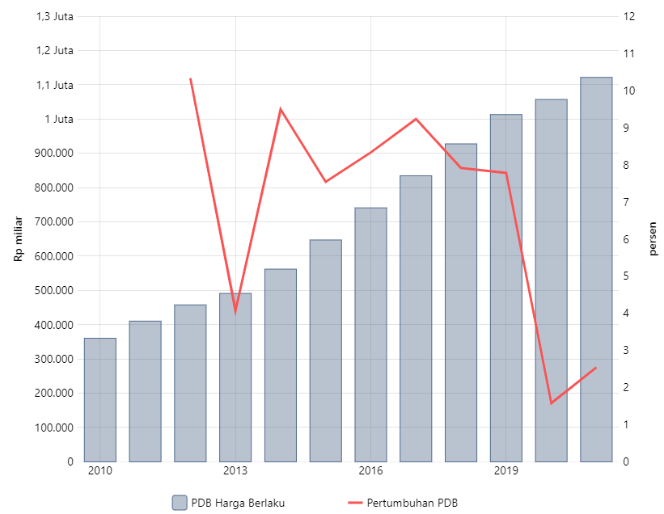
Based on Table 1 above, the Central Statistics Agency (BPS) reports that the gross domestic product (GDP) of the national food and beverage industry at current prices (ADHB) is IDR 1.12 quadrillion in 2021. This value accounts for 38.05% of the non-oil and gas processing industry. or 6.61% of national GDP which reached IDR 16.97 quadrillion. If measured according to GDP at constant prices (ADHK) 2010, the food and beverage industry grew 2.54% to IDR 775.1 trillion last year compared to the previous year. This achievement is better than the previous year which only grew 1.58%, but lower than before the pandemic which grew above 7%. This achievement is also below the national GDP growth last year.
So the impact of the growth of the food and beverage industry on employee performance can be influenced by business dynamics involving production volumes, changes in marketing strategies, and possible adjustments in company operations. Understanding these economic and industry factors can help companies and employees adapt to changing conditions.
Decreased employee performance can also be influenced by leadership, leadership is the process of influencing employees with motivation to produce employees with good performance Mitonga-Monga & Cilliers, (2016). Leadership involves influencing, motivating, and directing others so they can contribute effectively to achieving common goals. It includes several skills and traits that create direction, vision, and motivation to achieve desired results. Each leader can have a leadership style that is different from one another.
The servant leadership style has a central role in understanding and responding to employee needs in a situation full of uncertainty. A leadership style that emphasizes service to subordinates can provide much-needed psychological and emotional support, help maintain employee welfare, and motivate them to carry out their duties in the situation and conditions of the COVID-19 pandemic.
In this way, it is hoped that the leadership style will bring changes in policy making and in improving the welfare of employees. The welfare of employees can be seen by providing compensation received. In the current COVID-19 conditions, it is the company's PR and leadership to be able to provide effective compensation. to employees, in this situation maintaining company operations is a very difficult thing, the impact of this condition is that many companies are unable to pay employee salaries/wages so that many employees experience termination of employment (PHK) due to the company's inability to improve their welfare. employees during the Covid-19 pandemic. This is also confirmed by research by Ellis et al., (2011), that compensation management has a very big influence on employee satisfaction and motivation. Judging from the current pandemic situation, of the 17 employment categories there are sectors with average labor wages lower than the national average labor wage, namely Educational Services 2.67 million rupiahs, Processing industry 2.65 million rupiahs, Water supply, processing rubbish, waste and recycling 2.51 million rupiahs, Wholesale and Retail Trade, Car and motorbike repairs 2.32 million rupiah, provision of accommodation and food and drink 2.28 million rupiah, agriculture, forestry and fisheries 2.05 million rupiah and other services 1.68 million rupiah. Meanwhile, workers who work in the other ten main job categories receive wages above the national average wage, from the explanation above we can see the average of workers according to the main job fields.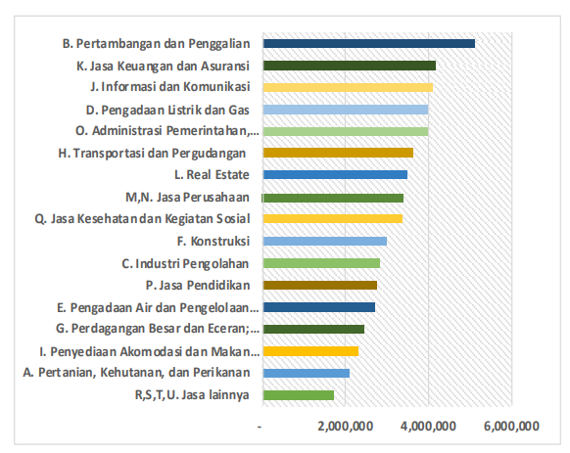
Figure 1. Average Labor Wages by Main Job Field, February 2020 (Rupiah)
Source: Central Statistics Agency (BPS)
To continue to be able to compete and survive. Apart from receiving balanced compensation, an employee must have adequate confidence and skills at work, producing brilliant ideas to achieve the desired goals. The concept of self-efficacy is Bandura, (2013) launched social cognitive theory. Through self-efficacy, it is hoped that employees will be able to continue to compete with the beliefs and ideas they have in this era of the COVID-19 pandemic. The good ideas that employees have are expected to be able to compete with comparable companies so that the resulting performance can increase.
Lastly, Government Policy through PMK Number 82/PMK.03/2021 regarding income tax adds complexity to the business context. The influence and implications of this policy on the company's compensation and financial systems as well as its impact on employee performance need to be explored in depth. This pandemic condition is certainly quite difficult, especially for people with low incomes who work as private employees. The PPh Article 21 DTP incentive is one of the various tax incentives provided by the Ministry of Finance to boost the community's economy from the pressure of this pandemic. This incentive is intended for employees of certain industries whose income does not exceed IDR 200 million per year. Providing this incentive is very suitable for industrial employees, especially for industries affected by the pandemic. Of course, the affected industries experienced a decline in turnover and the quality of performance of their employees. Therefore, the existence of this incentive is very helpful for private employees whose industries have been affected by the pandemic, not only in terms of reducing the tax burden but also helping private employees to be more enthusiastic about working so that the quality of performance of private employees also improves.
Table 3. 2021 PEN Program
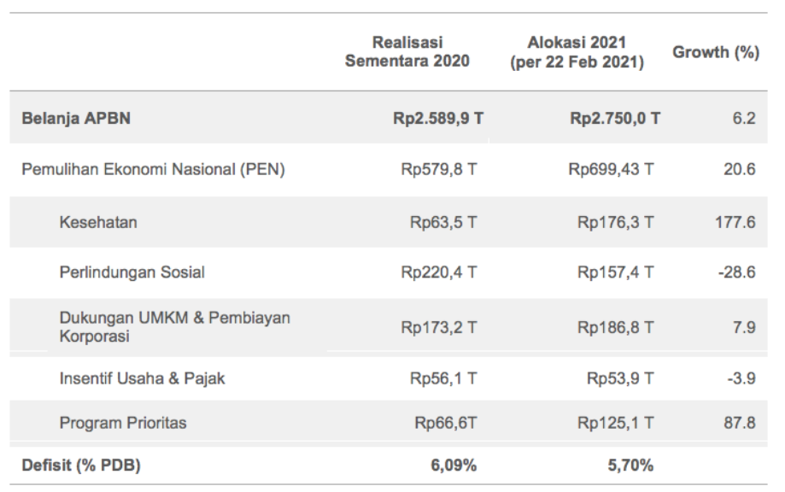 Source: Ministry of Finance

In the 2021 APBN, the Government also continues the PEN program amid a pandemic situation that has not yet ended and still requires financial support to strengthen measures such as TLI and vaccination. In addition, to strengthen economic recovery, the Government continues to strengthen various programs such as Social Protection, MSME Support, Business Incentives, and Priority Programs. The budget allocated for PEN 2021 reached IDR 699.43 trillion or an increase of 21% from the temporary realization of PEN 2020 which amounted to IDR 579.78 trillion.
With the above problems, the author is interested in conducting research with the theme "The Influence of Service Leadership Style, Compensation and Self-Efficacy on Employee Performance as Implicated by Minister of Finance Regulation Policy Number 82/PMK.03/2021 concerning PPh 21 Tax Incentives in the Manufacturing Industry sub-sector food and drinks in the Jabodetabek Region”.

Based on the background description above, several problems can be identified, namely:
- Decline in activity and production in the manufacturing industry, especially in the food and beverage subsector
- Social restrictions and security protocols that affect the work environment and employee performance
- Evaluation of employee performance involves various aspects, including abilities, skills, attitudes, and positive contributions to organizational goals
- The influence of the growth of the food and beverage industry on employee performance
- Influencing economic and industrial factors, such as production volume, marketing strategy, and adjustments to the Company's operations
- The leadership style serves as a central factor in understanding and responding to employee needs in a situation of uncertainty
- The impact of leadership on policies and improving employee welfare
- Challenges for companies and leaders in providing effective compensation to employees
- The impact of economic conditions and the pandemic on the company's ability to pay employee salaries/wages
- The importance of employee self-efficacy to remain competitive with confidence and brilliant ideas in the pandemic era
- The relationship between self-efficacy and employee competitiveness and increased performance.
- Complexity of government policies regarding income tax and their implications for the Company's compensation and financial systems
- Impact of PPh Article 21 DTP incentives on employee motivation and performance, especially in certain industries affected by the pandemic
- The impact of the spread of COVID-19 on the economy, including a decline in GDP and difficulties in adapting to companies
- The need for companies and employees to adapt to changing conditions.

RESEARCH PURPOSES
The purpose of this research is to analyze and test the influence of leadership style, compensation, and self-efficacy on employee performance, analyze and test servant leadership style on employee performance, analyze and test compensation on employee performance, test and analyze self-efficacy on employee performance and analyze and test servant leadership, compensation and self-efficacy on employee performance through government policies regarding PPh21 employment incentives.

METHODOLOGY
The use of quantitative analysis in this research is to determine the influence of servant leadership style, compensation, and self-efficacy on employee performance and its implications for government policy regarding PPh21 tax incentives (study of the food and beverage sector in the Jabodetabek area). The analysis uses Structural Equation Modeling (SEM). The operationalization of this variable can be seen in the following table:
Table 4. Operationalization variables
Variable | Indicator | Scale
Servant leadership style | Love | Ordinal
 | Empowerment | Ordinal
 | Vision | Ordinal
 | humility | Ordinal
 | Trsuh | Ordinal
Compensation | Wages | Ordinal
 | Bonus | Ordinal
 | Incentives | Ordinal
 | Allowance | Ordinal
 | Facility | Ordinal
Self-Efficacy | Task Completion | Ordinal
 | Motivation | Ordinal
 | Perseverance | Ordinal
 | Facing Hmabatan | Ordinal
 | Problem-solving | Ordinal
Employee performance | Quality | Ordinal
 | Quantity | Ordinal
 | Punctuality | Ordinal
 | Cost Effectiveness | Ordinal
 | Supervisory needs | Ordinal
 | Interpersonal influence | Ordinal
Tax Incentive Policy | There are tax reduction regulations | Ordinal
 | Fairness in providing tax incentives in tax reduction | Ordinal
 | The impact resulting from the regulations made | Ordinal
 | Benefit from reduced tax revenues | Ordinal

This research has explained in detail the research variables including the variable indicators used as a reference in determining question items or statements in the questionnaire using the following Likert scale:
Table 5. Likert Scale
No | Statement | Score
1 | Strongly Agree | 5
2 | Agree | 4
3 | Undecided/Neutral | 3
4 | Disagree | 2
5 | Strongly disagree | 1

This research uses a nonprobability sampling technique using proportional Stratified Random Sampling. In sampling, 383 respondents were taken. The analysis uses a structural equation modeling (SEM) model.

RESULT
Based on the results of distributing questionnaires to 383 people, the following table shows the respondents.

Table 6. Number of Respondents
No | Respondents (years) | Frekuensi | Persentase (%)
1 | 23 – 30 years | 119 | 31,1%
2 | 31 – 37 years | 124 | 32,4%
3 | 38 – 45 years | 89 | 23,2%
4 | - 50 years | 51 | 13,3%
Total |  | 38 | 100
No | Gender Responden | Frekuensi (Orang) | Persentase (%)
1 | Man | 216 | 56.4%
2 | Woman | 167 | 43,6%
Total |  | 383 | 100
No | Respondent's Education | Frekuensi (Orang) | Persentase (%)
1 | SD, PAKET B, SMP | 23 | 6,0%
2 | Paket C, SMA, STM, SMK | 198 | 51,7%
3 | D2, D3,D4,S1 | 118 | 30,8%
4 | S2, S3 | 44 | 11,5%
Total |  | 383 | 100
No | Position/Job | Number (Person) | Persentase (%)
1 | Assisten Manager | 12 | 3,1%
2 | Supervisor | 34 | 8,9%
3 | Staff | 45 | 11,0%
4 | Leader | 65 | 17,0%
5 | Operator Produksi | 227 | 59,3%
Total |  | 383 | 100

From Table 6, it can be seen that the majority of respondents in this study came from employees who held positions as operators, reaching 59.3%. This deviation is understandable considering that the majority of company members are production operators. Therefore, the main respondents in assessing leadership style in this study were employees with the position of production operator.
Next, a validity test was carried out on each variable. The validity test is carried out by calculating the correlation coefficient (r) of each indicator in the questionnaire with the total (Hair Jr, J. F., Black, W. C., Babin, B. J., & Anderson, 2014). An indicator is said to be valid if the factor weight coefficient is statistically the same as above 0.05. Below are presented the results of the validity test of the 5 variables used in the research as follows:
Table 7. Validity test Result
 | Description |  | λ
KIN | <--- | KMT | 0,422
KIN | <--- | KP | 0,217
KIN | <--- | Interaksi | 0,448
KN1 | <--- | KN | 0,875
KN2 | <--- | KN | 0,898
KN3 | <--- | KN | 0,855
KN4 | <--- | KN | 0,892
KOM5 | <--- | KOM | 0,799
KOM4 | <--- | KOM | 0,887
KOM3 | <--- | KOM | 0,746
KOM2 | <--- | KOM | 0,795
KOM1 | <--- | KOM | 0,891
ED5 | <--- | ED | 0,853
ED4 | <--- | ED | 0,894
ED3 | <--- | ED | 0,956
ED2 | <--- | ED | 0,923
ED1 | <--- | ED | 0,901
KIN1 | <--- | KIN | 0,911
KIN2 | <--- | KIN | 0,935
KIN3 | <--- | KIN | 0,9
KIN4 | <--- | KIN | 0,952
KIN5 | <--- | KIN | 0,827
KIN6 | <--- | KIN | 0,834
KP4 | <--- | KP | 0,945
KP3 | <--- | KP | 0,947
KP2 | <--- | KP | 0,863
KP1 | <--- | KP | 0,964
KN5 | <--- | KN | 0,866
Inter | <--- | Interaksi | 0,135

Based on the data produced in Standardized Regression Weights, it can be seen that the standard factor loading value is ≥ 0.05, this shows that the exogenous and endogenous variable indicators are valid.

Reliability Test
Reliabilitas merupakan ukuran konsistensi internal dari indikator-indikator suatu variabel yang menunjukkan variabel yang terbentuk secara umum, dengan menguji reliabilitas komposit (konstruk) dan varians diekstraksi. Nilai batas minimum reliabilitas konstruk adalah 0,70, sedangkan nilai batas minimum varians yang diekstraksi adalah 0,50, (Bagozzi, R.P., Yi, Y., and Phillips, 1991). Nilai reliabilitas the construct of each servant leadership style variable is 0.893; Compensation 0.884; Self-efficacy 0.945; Employee performance is 0.957 and government policy regarding PPh 21 tax incentives is 0.931. This means that all variables are reliable. All variable indicators have a construct reliability factor loading value of ≥ 0.5, so they all have good validity. The Variance Extracted value for all indicators is above ≥ 0.5. Therefore, all indicators have good reliability.

Normality Test
Estimation using Maximum Likelihood requires variables that must meet the assumptions of multivariate normality (Curran et al., 1998). This test is carried out by paying attention to the Skewness value of the data. To evaluate multivariate normality, the critical ratio (c.r.) criterion of Multivariate Skewness was used. If the value of c.r. is below 2.58, it can be concluded that the multivariate data is normally distributed. The data normality test result is 2.239, below 2.58, meaning the data is normally distributed.

Multicollinearity Test
The Multicollinearity Assumption requires that there is no large correlation between the two independent variables. The correlation value between observed variables is not allowed to be 0.9 or more. None of the observed variables has a correlation coefficient of 0.9 or more so all variables do not contain symptoms of multicollinearity.

The results of the Structural Equation Modeling test obtained a model as in the image below:

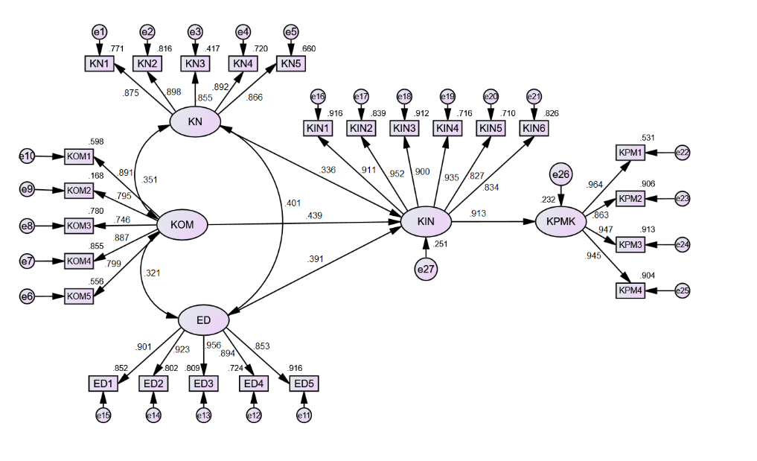
Figure 2. Full model

Table 8. Direct and Indirect Effects
Latin Variabel | Employee performance | Government policy | Indirect
Servant Leadership | 0,336 |  | 0,51
Compensation | 0,439 |  | 0,24
Self-efficacy | 0,391 |  | 0,11
Employee performance |  | 0,913

Based on the picture and Table 8 above, the relationship between servant leadership style and self-efficacy has a significant positive sign of 0.401. The direct effect of servant leadership on employee performance is significantly positive at 0.336. The direct effect of compensation and employee performance has a significant positive sign of 0.439. The direct influence of employee performance on government policy has a significant positive sign of 0.913. The indirect impact of servant leadership on employee performance through government policy is significantly positive 0.51. Compensation for employee performance through government policy is significantly positive at 0.24. The indirect effect of self-efficacy on employee performance through government policy has a significant positive sign of 0.11.

The results of the model analysis obtained have met the Goodness of fit Measures (GoF) so it can be said that the model obtained from the comparison between data and model is good, this can be seen based on the following criteria:
Table 9. Result of Goodness of Fit Model Analysis
No. | Goodness of Index | Cut-off Value | Hasil | Conclusion
1 | Chi Square | Diharapkan kecil | 4274.5297 | Fit
2 | Probability Chi-Square | > 0.05 | .0000 | Good Fit
3 | RMSEA | RMSEA ≤0.08 (Good Fit)  RMSEA ≤0.05 (Close Fit) | 0.07657 | Good Fit
4 | Normed Fit Index (NFI) | > 0.9 | 0.8320 | Fit
5 | Parsimonious Normal Fit Index (PNFI) | > 0.9 | 0.7624 | Fit
6 | GFI | > 0.9 | 0.8943 | Fit
7 | AGFI | > 0.9 | 0.8256 | Fit
Sumber : Sumber: Hasil Pengolahan data dengan SEM-AMOS.
The table above shows that in general, it meets the requirements in the Goodness of Fit model test. This means that the model built from this research is appropriate, so accurate conclusions can be drawn.

DISCUSSION
Based on the results of the analysis and statistical tests that have been carried out, the following discussion is obtained, the influence of the service leadership style on employee performance has a positive and significant influence on employee performance of 0.336. Thus, it can be concluded that in the context of the COVID-19 pandemic, the servant leadership style has a positive impact on employee performance. The influence of compensation on employee performance has a positive and significant influence on employee performance of 0.439. This shows that providing good compensation can improve employee performance, especially in difficult situations such as a pandemic. The influence of self-efficacy on employee performance has a positive and significant influence on employee performance of 0.391. This means that an individual's level of confidence and skills in facing challenges in the work environment can influence employee performance. The influence of performance on government policy has a positive and significant influence on government policy of 0.913. This indicates that good employee performance can contribute to government support, especially in terms of tax incentives. The indirect impact of servant leadership style, compensation, and self-efficacy on employee performance through government policy. Servant leadership style has a significant indirect impact on employee performance through government policy (0.51). Likewise with compensation (0.24) and self-efficacy (0.11). Goodness of Fit Model Analysis, The model built from this research meets the Goodness of Fit criteria, such as Chi-Square, Probability Chi-Square, RMSEA, NFI, PNFI, GFI, and AGFI. This shows that the model is reliable and accurate in explaining the relationship between variables. Implications and Recommendations. Servant leadership style, providing compensation, and developing employee self-efficacy can be the focus of companies to improve performance amid a pandemic. Companies need to pay attention to government policies regarding tax incentives and ensure that employee performance can support receiving these incentives. Company leaders and management can consider strategies to enhance servant leadership styles and provide appropriate incentives to motivate employees. Thus, this research contributes to understanding the dynamics of the influence of leadership style, compensation, and self-efficacy on employee performance in the context of the COVID-19 pandemic, as well as the implications for government policy regarding tax incentives.

CONCLUSION
Based on the results of the Structural Equation Modeling (SEM) analysis in this research, several conclusions can be drawn as follows: The servant leadership style has a positive and significant effect on employee performance. The servant leadership style has a significant positive impact on government policy through PPh 21 tax incentives. Compensation has a positive and significant effect on employee performance. Compensation also has a significant positive impact on government policy through PPh 21 tax incentives. Self-efficacy has a positive and significant effect on employee performance. Self-efficacy has a significant positive impact on government policy through PPh 21 tax incentives. Employee performance has a positive and significant impact on government policy through PPh 21 tax incentives. Implications for government policy. Servant leadership style, compensation, and self-efficacy indirectly through PPh 21 tax incentives influence employee performance. Goodness of Fit (GoF) Model. The model resulting from this research meets the goodness of fit criteria, indicating that the model has a good level of conformity to the data. Thus, the results of this research can be a basis for companies, especially in the food and beverage sector in the Jabodetabek area, to consider the importance of a servant leadership style, fair compensation, and increasing employee self-efficacy to improve their performance. Apart from that, the implications for government policy, especially regarding PPh 21 tax incentives, are also an important factor in supporting employee welfare and business sustainability.
REFERENCE
Ali, F., & Wardoyo, D. T. W. (2021). The Effect of Self-Efficacy on Employee Performance with Job Satisfaction as an Intervening Variable (Study of PT. Ultrajaya Milk Industry, Tbk Surabaya, Marketing Department). Journal of Management Science, 9(1), 367. https://doi.org/10.26740/jim.v9n1.p367-379
Armstrong, M. and B. F. (2016). Seventh Mold Performance Management (Mold To). Erlangga.
Areta, F. C. (2021). Analysis of the Effectiveness of Income Tax Incentives Article 21 Borne by the Government by PMK No.86/PMK.03/2020 at KPP Pratama Madiun. PKN STAN.
Arifudin, O. (2019). The effect of compensation on employee performance at PT. Global Media. MEA Scientific Journal (Management, Economics & Accounting), 3(2), 184-.
Ary, I. R., & Sriathi, A. A. A. (2019). THE INFLUENCE OF SELF-EFFICACY AND LOCUS OF CONTROL ON EMPLOYEE PERFORMANCE (Study at Ramayana Mal Bali). Udayana University Management E-Journal, 8(1), 30. https://doi.org/10.24843/ejmunud.2019.v08.i01.p02
Bagozzi, R. P., Yi, Y., and Phillips, L. . (1991). Assessing Construct Validity in Organizational Research, Administrative Science Quarterly. 36(3), 42.
Bandura, A. (2013). The role of self-efficacy in goal-based motivation.
Bandura, A. (2015). On Deconstructing Commentaries Regarding Alternative Theories of Self-Regulation. Journal of Management, 41(4), 1025–1044. https://doi.org/10.1177/0149206315572826
Curran, D. … Sylvester, R. J. (1998). Identifying the types of missingness in quality of life data from clinical trials. Statistics in Medicine, 17(5–7), 739–756. https://doi.org/10.1002/(sic)1097-0258(19980315/15)17:5/7<739::aid-sim818>3.0.co;2-m
Damayanti, A. … Kurniawan, I. S. (2022). The influence of leaders, organizational culture, self-efficacy, and emotional stability on employee performance. Journal of Management, 14(1), 191–200. https://doi.org/10.30872/jmmn.v14i1.10882
Darmadi, H. (2018). Educational Management Based on Local Wisdom (Descriptive Analytical Studies of Culture of Local Wisdom in West Kalimantan). JETL (Journal Of Education, Teaching and Learning), 3(1), 135. https://doi.org/10.26737/jetl.v3i1.603
Eka Sapengga, S. (2016). The Influence of Servant Leadership on Employee Performance at Pt. Kencana Sakti Leaf Mojokerto. Agora, 4(1), 645–650.
Ellis, I. I. … Evans, A. O. (2011). Compensation Management As a Tool for Improving Organizational Performance in the Public Sectors: a Study of the Civil Service of Anambra State of Nigeria. Sacha Journal of Policy and Strategic Studies, 1(1), 109–120.
Hair Jr, J. F., Black, W. C., Babin, B. J., & Anderson, R. E. (2014). Multivariate data analysis (Seventh). Kirby Street.
Kurniawan, T. … Employee, K. (2019). 287266-The-Effect-of-Servant-Leadership-On-Kin-751318D5. 7.
Marwansyah. (2016). Human Resource Management. ALPHABET.
Mitonga-Monga, J., & Cilliers, F. (2016). Perceived ethical leadership about employees' organizational commitment in an organization in the Democratic Republic of Congo. African Journal of Business Ethics, 10(1), 36–51. https://doi.org/10.15249/10-1-122
Muis, Muhammad Ras, & Hasibuan, Jasman Saripudin. (2021). The Role of Employee Performance: Work Discipline and Leadership Muhammad Ras Muis 1, Jasman Saripuddin Hasibuan 2. Synthesis, 1, 275–288.
Narimawati, U., Sarwono, J., Sos, S., Affandi, H. A., & Priadana, H. S. (2020). Various Analysis in Research Methods: for Writing Theses, Theses & Dissertations. Andi Publisher.
Pradana, I. Y. … Mulyanto, I. H. (2021). The Influence of Leadership Style, Training, and Compensation on Employee Performance. Paradigm: Journal of Social, Political, and Policy Issues, 25(1), 20. https://doi.org/10.31315/paradigma.v25i1.8562
Rachmawati, N. A., & Ramayanti, R. (2016). Benefits of providing income tax incentives in MSME taxpayer compliance. Journal of Accounting, Economics and Business Management, 4(2), 176–185.
Sayoga, I. W. P. A. … Astrama, I. M. (2022). The Influence of Servant Leadership and Work Ethic on Employee Performance. Widya Amrita: Journal of Management, Entrepreneurship and Tourism, 2(1), 12–20.
Sekaran, Uma and R. B. (2010). Research Method For Business: A Skill Building Approach. John Wiley @ Sons, (5th Edition).
Sinaga, L. M. (2021). Organizational culture, leadership style and compensation on employee performance through job satisfaction. Journal of Management and Business Research, 6(2), 61–70. https://doi.org/10.36407/jrmb.v6i2.439
Tatilu, James. Lengkong, Victor P.K and Sendow, G. M. (2014). Transactional Leadership, Transformational Leadership, and Servant Leadership Influence on Employee Performance at PT. Sinar Galesong Pratama Manado. EMBA Journal, Volume 2 N.
Tsabitah, D. A. … Emilisa, N. (2023). The Influence of Servant Leadership and Self-Efficacy on Psychological Well-Being Mediated by Life Satisfaction in Mixed Employees in Tangerang. Scientific Journal of Educational Vehicles, 9(17), 227–238. https://doi.org/10.5281/zenodo.8300389
Wastuti, S. N. Y. (2018). Self-Efficacy on the Performance of PDAM Tirtanadi Employees at the Sunggal Water Treatment Plant Unit. Biblio Couns: Journal of Counseling and Educational Studies, 1(2), 35–42. https://doi.org/10.30596/bibliocouns.v1i2.2076
Yulandri, Y., & Onsardi, O. (2020). The Influence of Compensation and Work Discipline on Employee Performance. BUDGETING:,. Journal of Business, Management and Accounting, 1(2), 203-.
Zuhendra, E., & Rahmi, N. (2023). Effectiveness of Intensive Income Tax Policy Article 21 at the Jakarta Cakung Primary Tax Service Office in 2021. Journal of Public Administration Science, 3(2), 168–177.

