Turnitin
by Dejavu

Submission date: 22-May-2022 04:32PM (UTC+0700)
Submission ID: 2269185706
File name: 535-1958-1-10-20230407_8.pdf
Word count: 4294
Character count: 27886

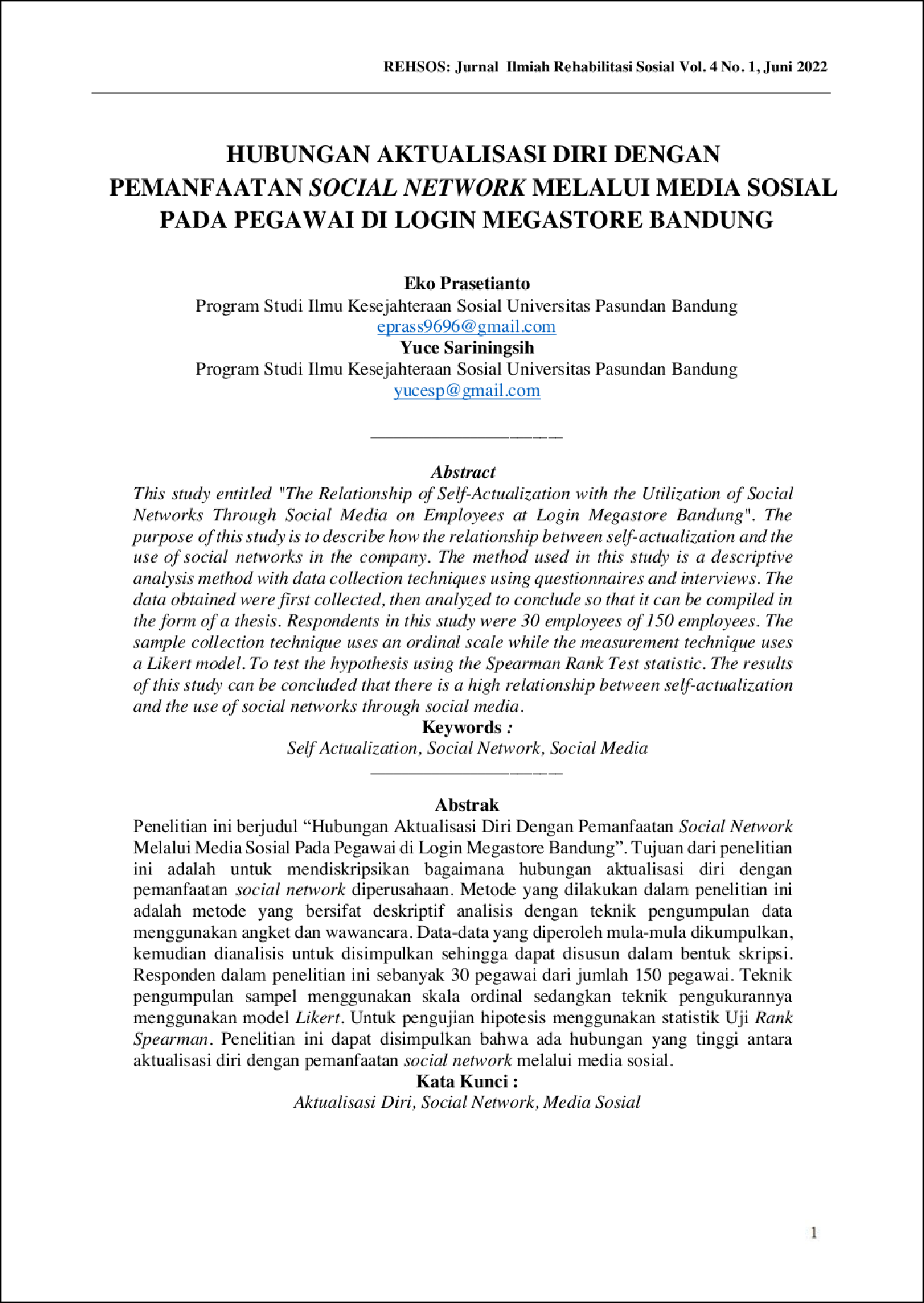

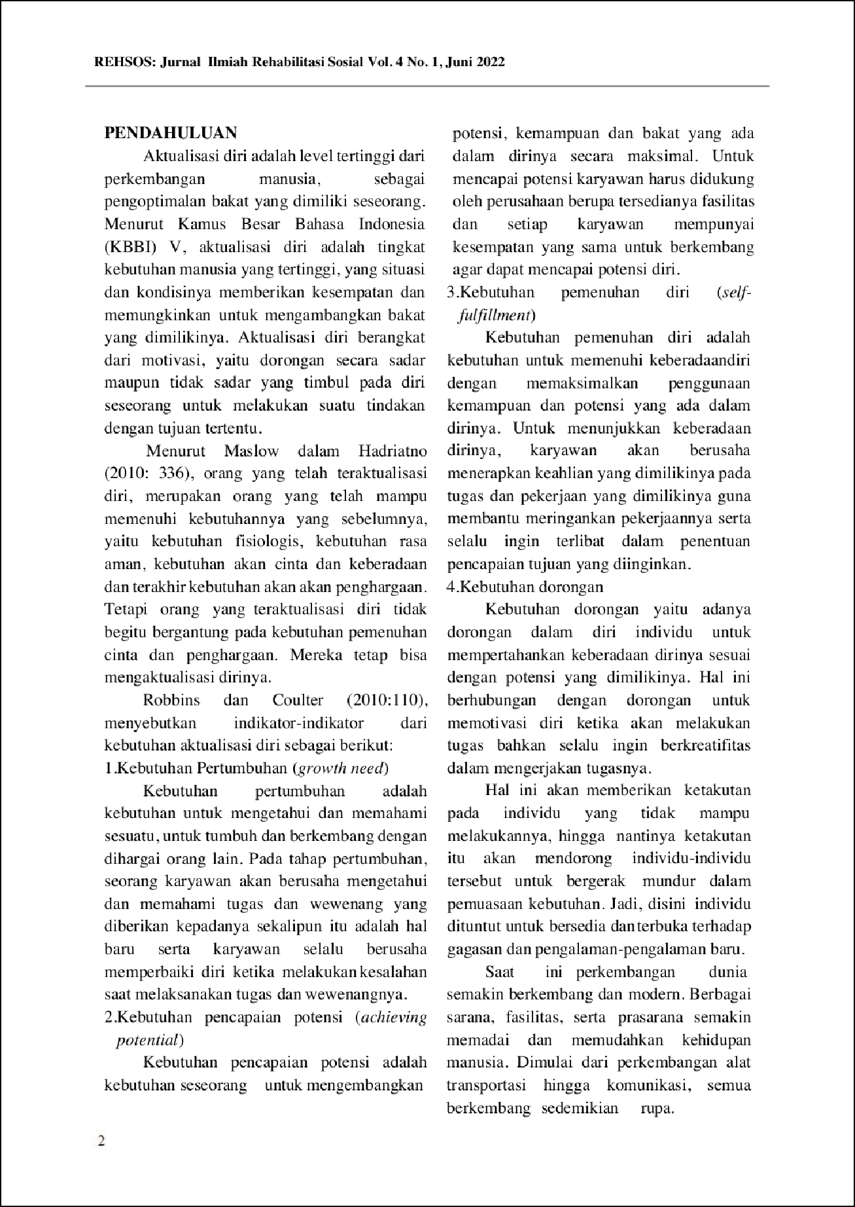

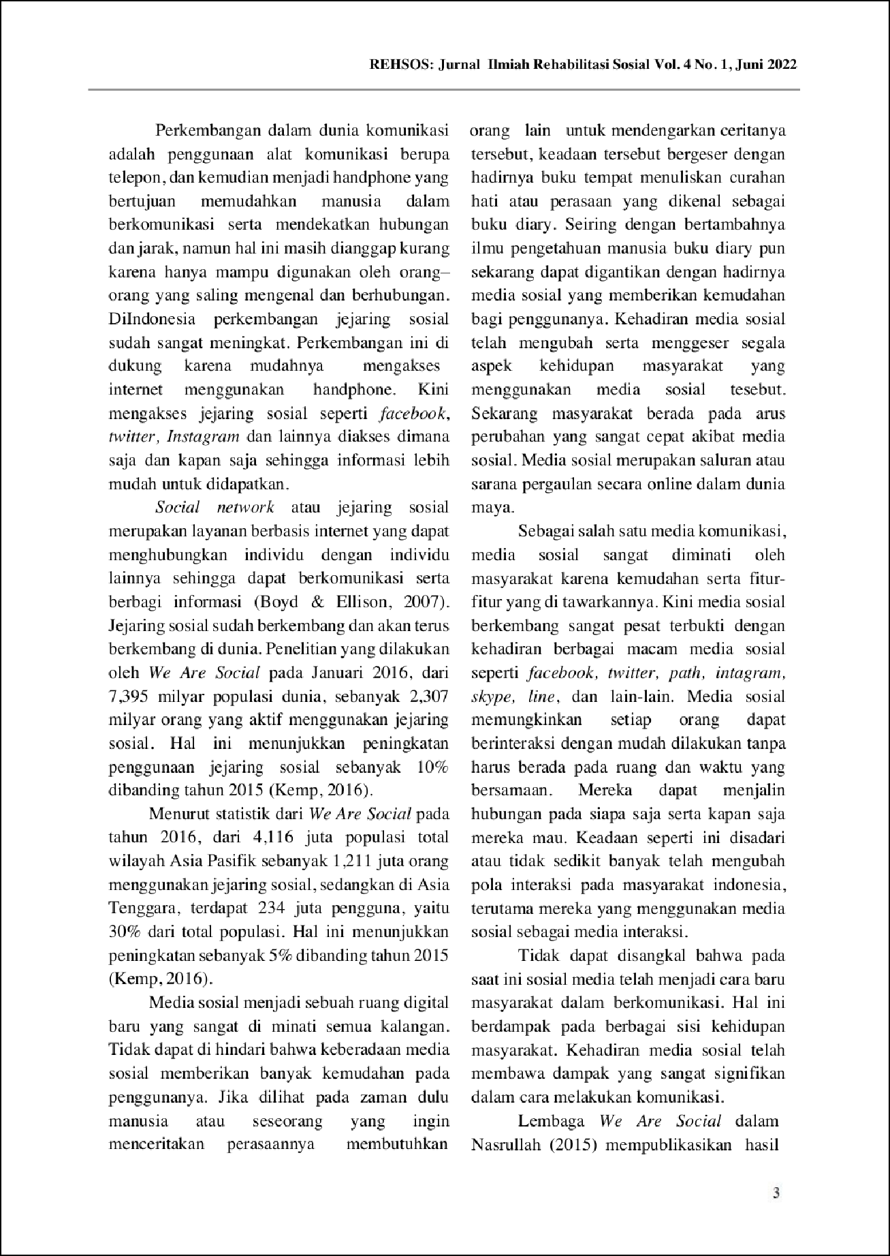

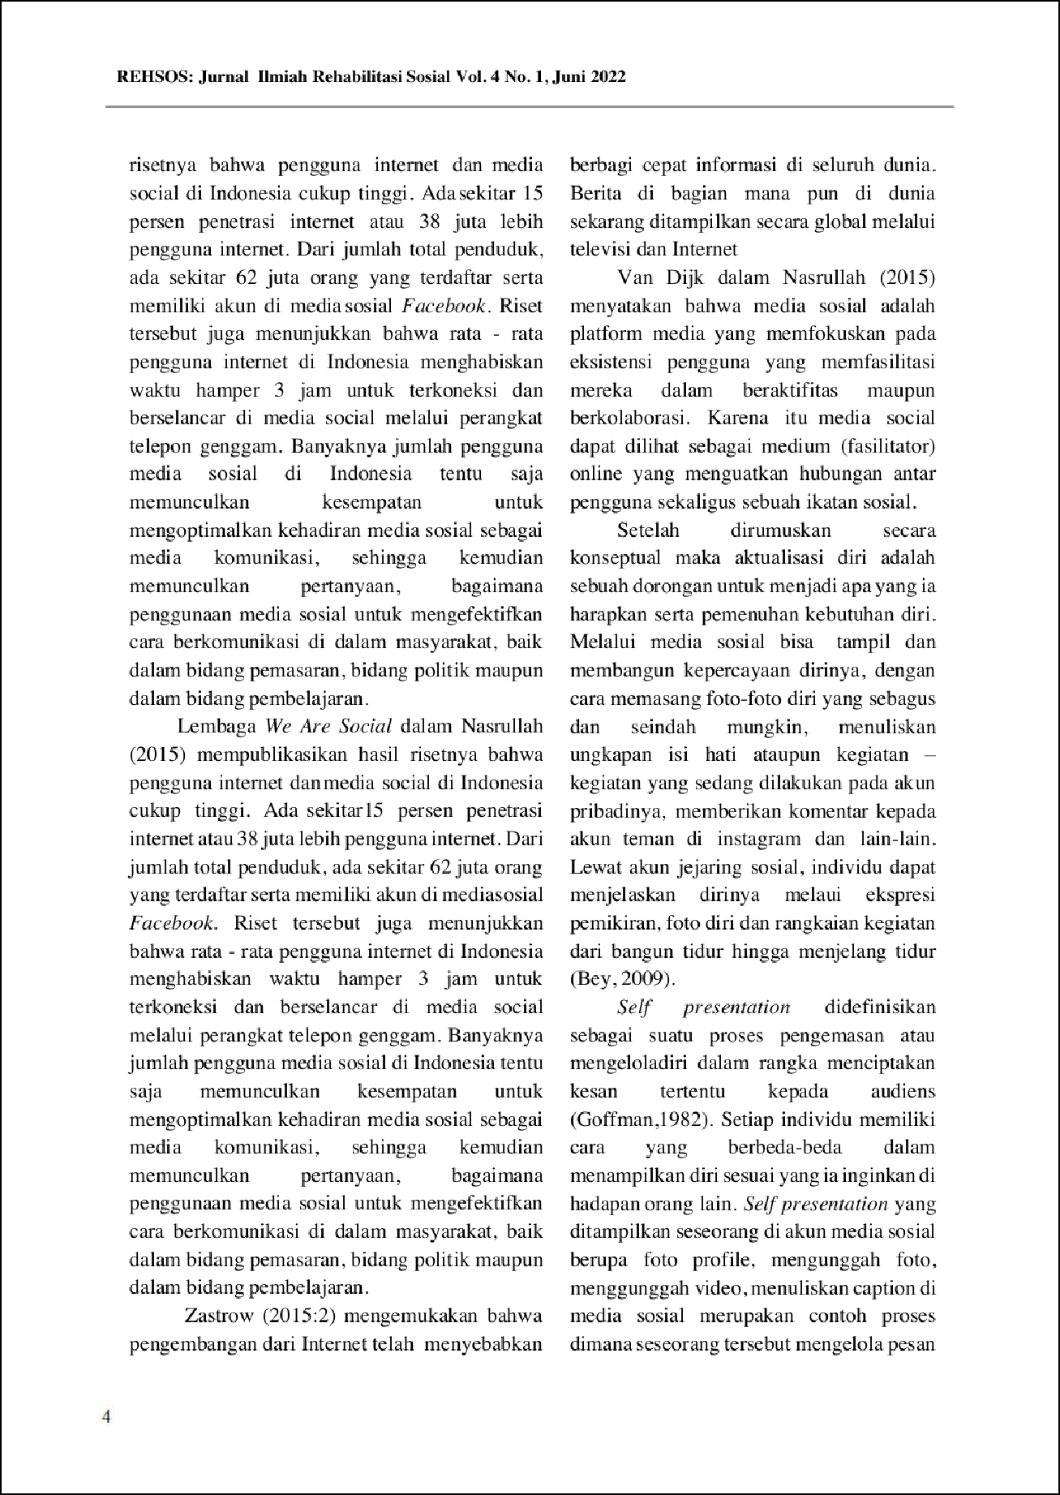

.

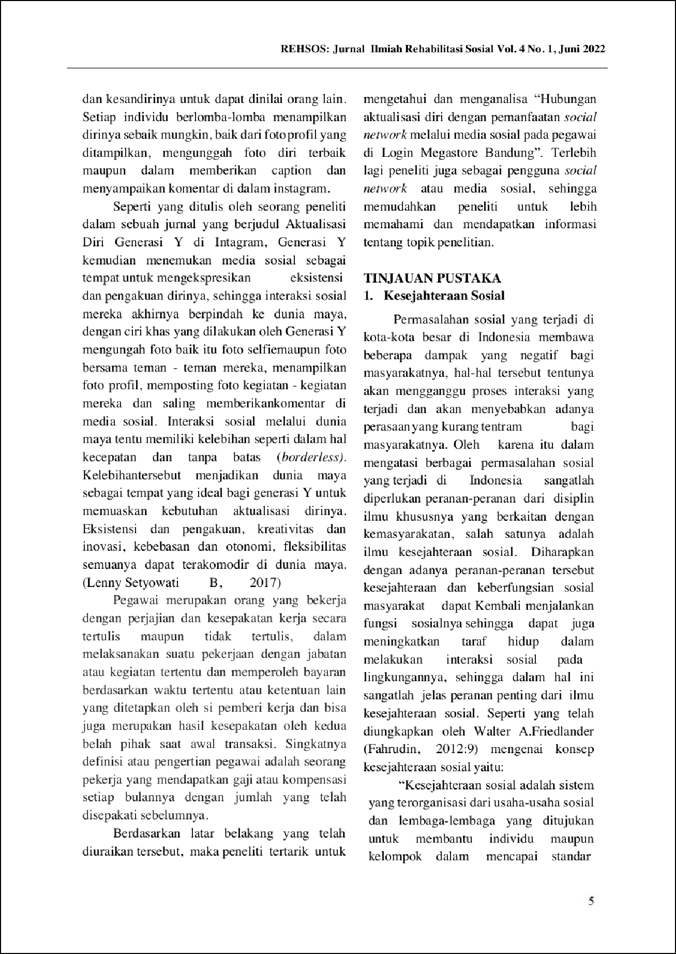

.

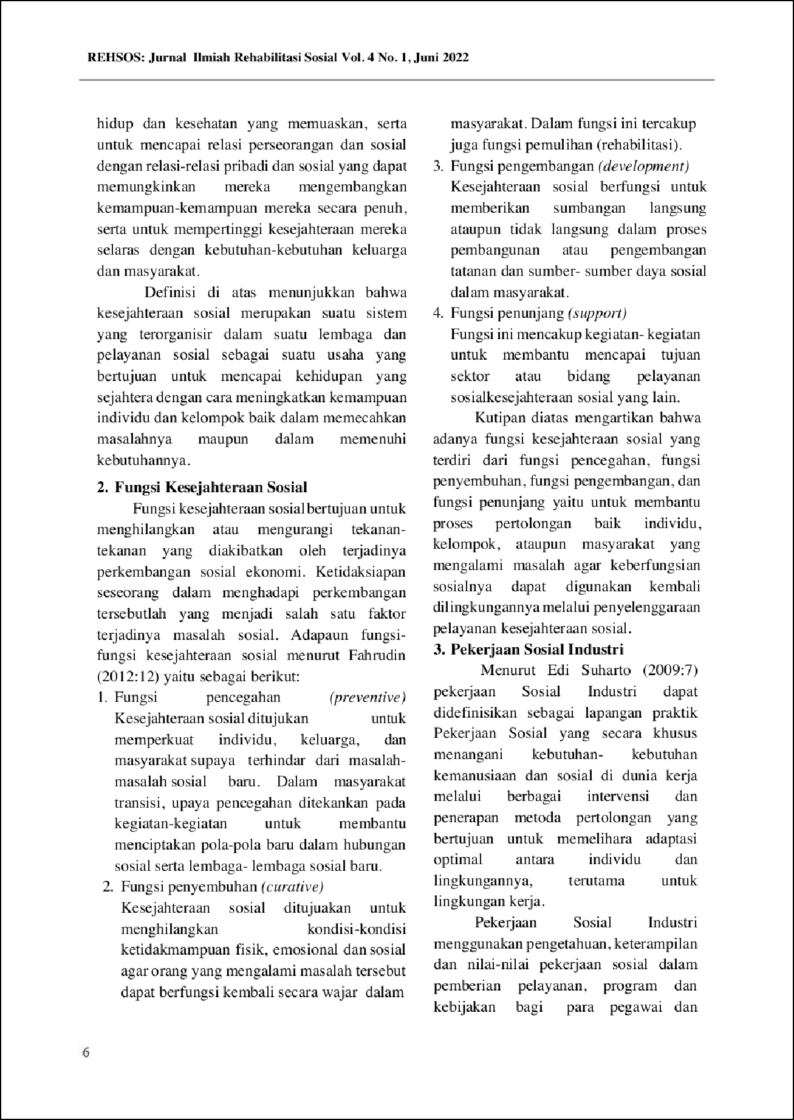

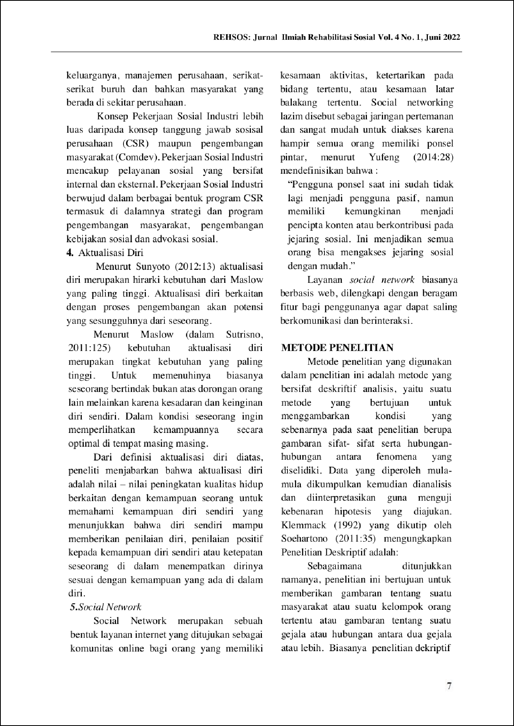

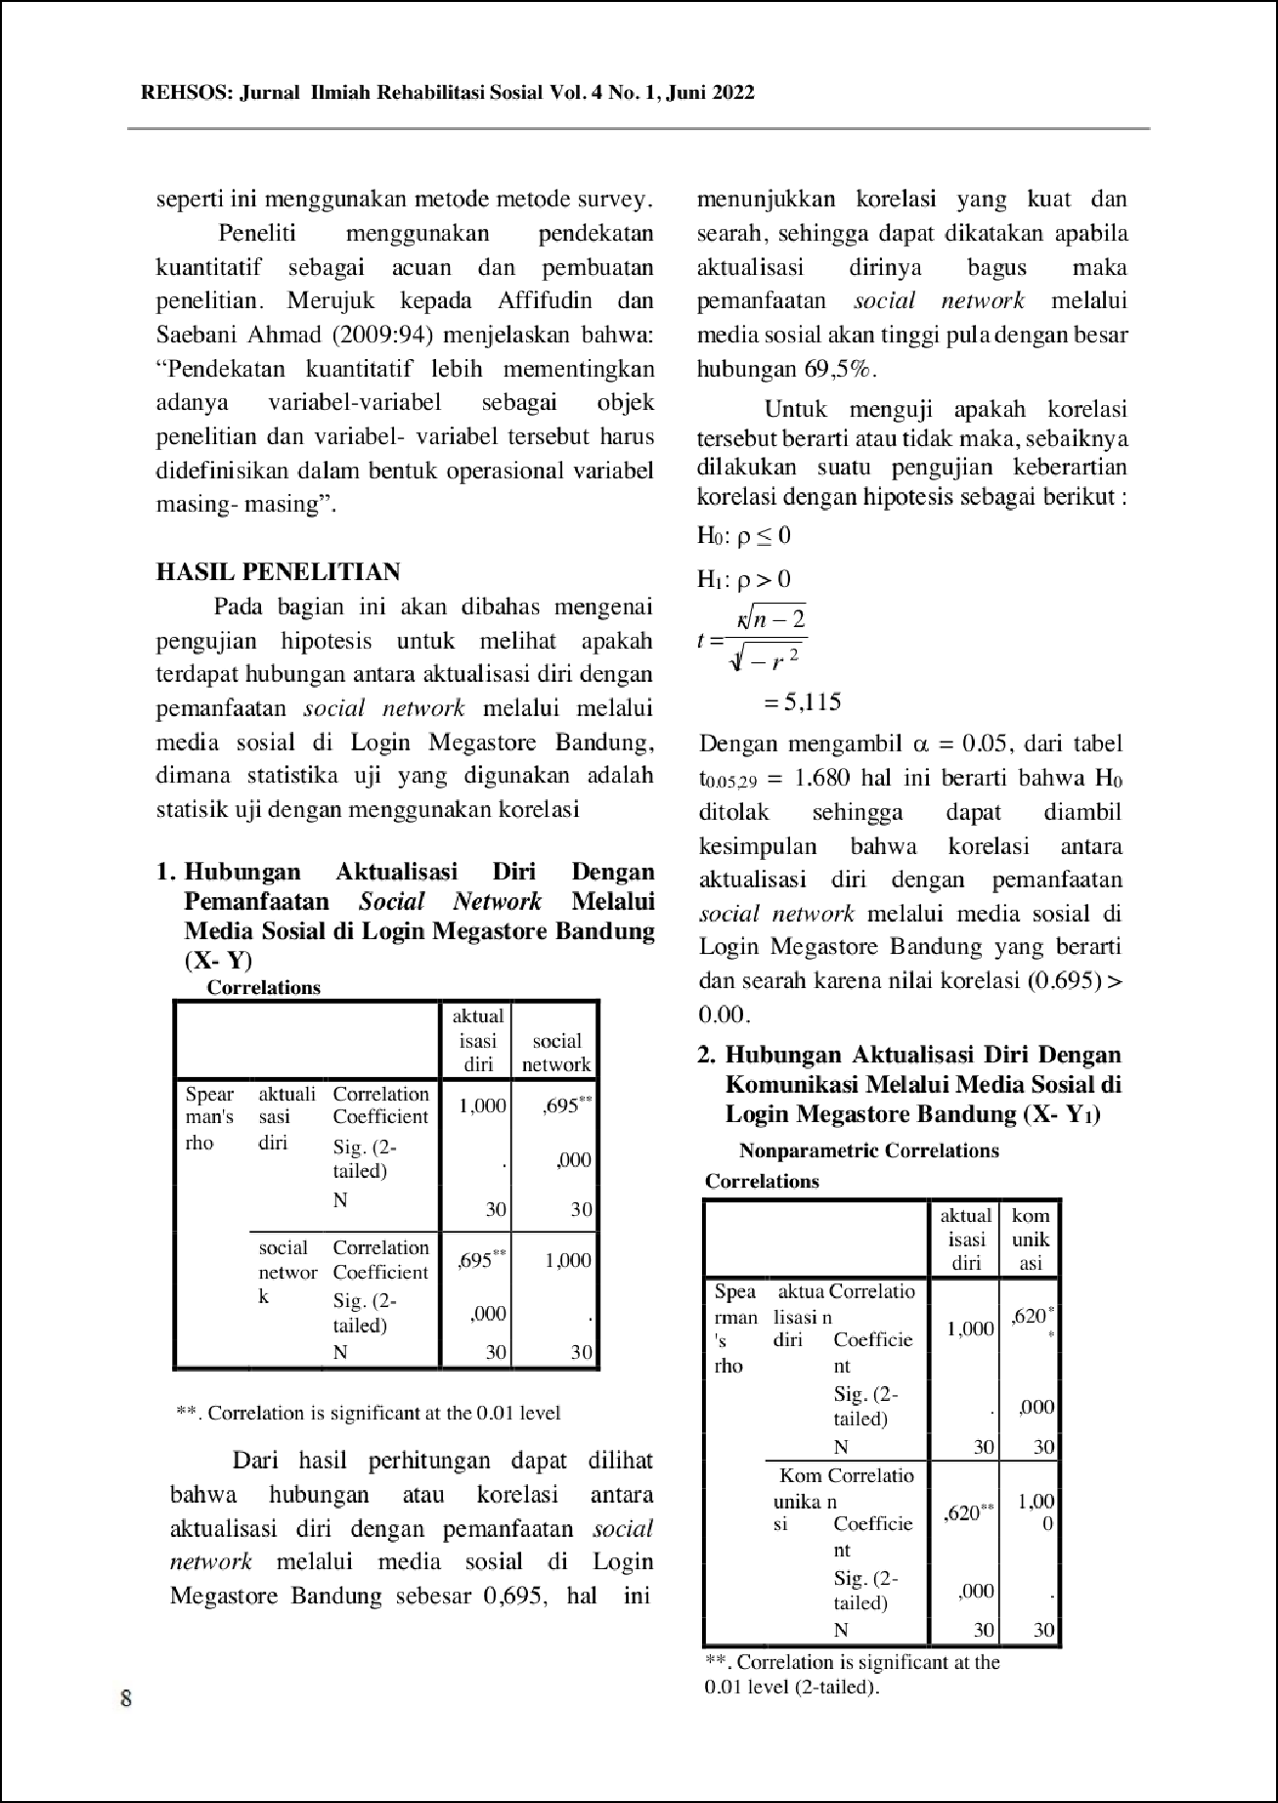

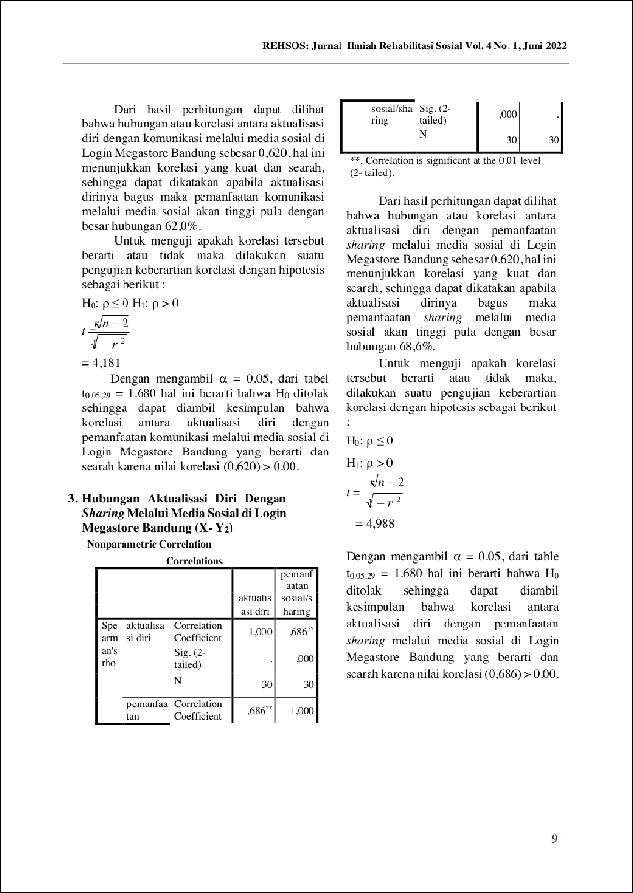

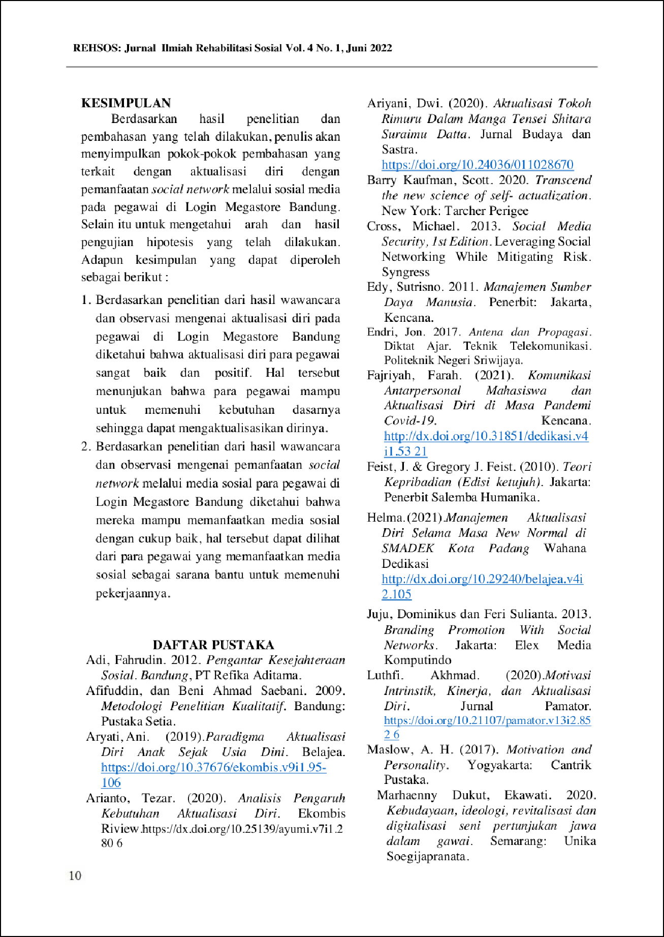

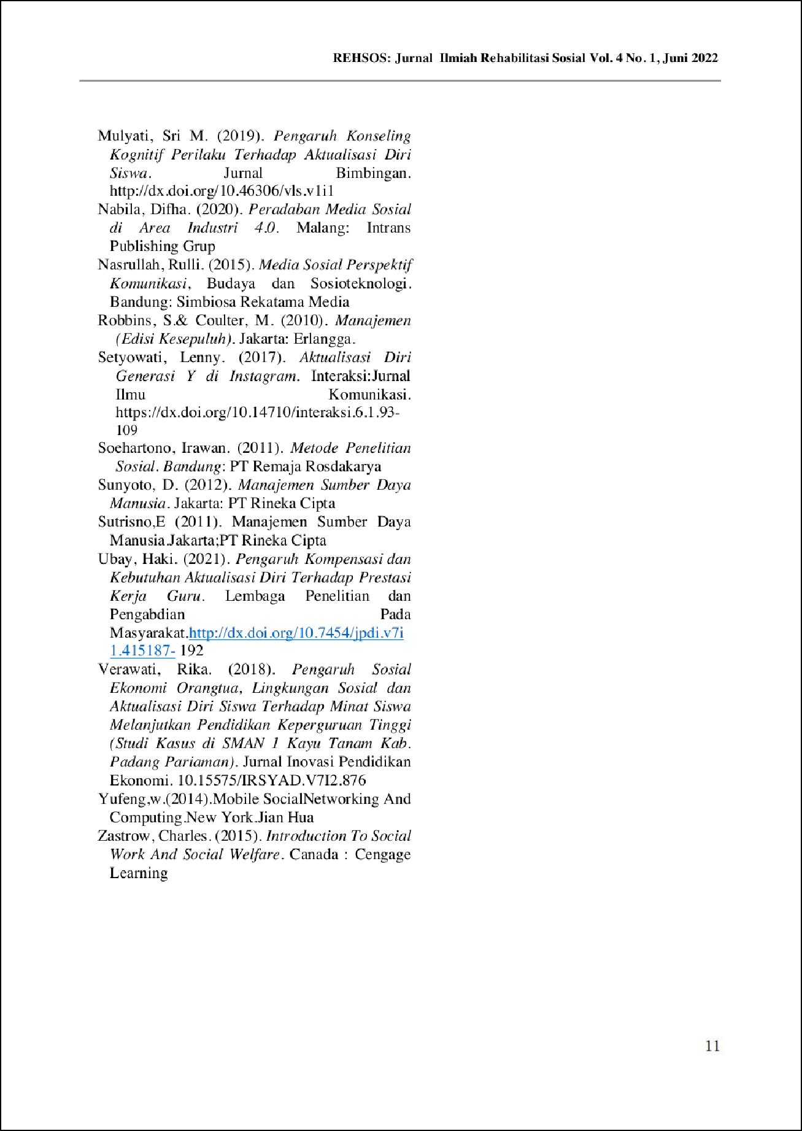

Turnitin-
ORIGINALITY REPORT
12

%

SIMILARITY INDEX

10%

INTERNET SOURCES

2%

PUBLICATIONS

2%

STUDENT PAPERS

MATCH ALL SOURCES (ONLY SELECTED SOURCE PRINTED)

1%
Submitted to Universitas International Batam

Student Paper

Exclude quotes On Exclude bibliography On
Exclude matches Off

Turnitin-

GRADEMARK REPORT

FINAL GRADE

/0
PAGE 1

PAGE 2

PAGE 3

PAGE 4

PAGE 5

PAGE 6

PAGE 7

PAGE 8

PAGE 9

PAGE 10

PAGE 11

PAGE 12

PAGE 13
GENERAL COMMENTS

