AN ANALYSIS OF THE MORAL MESSAGES IN WRECK-IT RALPH MOVIE

A Research Paper
Submitted to the English Department of Pasundan University as a Partial Fulfillment of the Requirements for Taking the Sarjana Degree (S-1)

By
Tsania Salsabila Rezky
Reg. Number 167010043

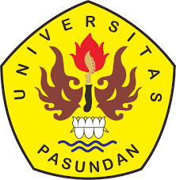

ENGLISH DEPARTMENT
FACULTY OF ARTS AND LETTERS
PASUNDAN UNIVERSITY
BANDUNG
2023

