Sosiohumaniora - Jurnal Ilmu-ilmu Sosial dan Humaniora Vol. xx, No. x, xxxx 20xx: x - xx

ISSN 1411 - 0903 : eISSN: 2443-2660

TALENT MANAGEMENT IMPLEMENTATION STRATEGY IN AN EFFORT TO REALIZE SUPERIOR PERFORMANCE IN LOCAL GOVERNMENT
WEST JAVA PROVINCE.

Ir. Widiyana Sudrajat, C.E.S¹, Prof. Dr. H. Azhar Affandi², SE., M.Sc², Prof. Dr. H. Horas Djulius SE³
^{1,2,3} Universitas Pasundan Bandung
Widiyanaunpas@gmail.com1 ; azhar.affandi.dim@unpas.ac.id2 ; horasdjulius@unpas.ac.id3

ABSTRACT

Qualitative research was carried out using the Exploratory Research method and the Snowball Sampling interview method with Functional Employees and Officials of the West Java Provincial Civil Service Agency, as key informants. Using the theoretical dimensions of Integrated Talent Management from Berger and Berger (2018) as a knife for analyzing the implementation of talent management, and making a SWOT analysis to choose the right strategy implementation. The results of the study show that effective talent management practices are able to create superior performing employees. To achieve effective talent management, a strategy is needed to strengthen Employee Career Planning, increase Employee Capabilities, build a Talent Mindset culture, obtain full support from the Organization's Top Leaders, and build a One Apps Talent Management Information Service System. The impact of this research is that it will be able to create opportunities to develop the implementation of effective talent management strategies in public organizations. In an effort to produce superior Employee Performance, it is important for the Organization to align its Organizational Strategy, Culture, Structure and Talent in order to create a world-class West Java Bureaucracy.

Key words ; Integrated Talent Management, Employee Superior Performance.

ABSTRAK

Penelitian ini bersifat Kualitatif dilakukan menggunakan metode Exploratory Research dan metode wawancara secara Snowball Sampling kepada Pegawai Fungsional dan Pejabat Badan Kepegawaian Provinsi Jawa Barat, sebagai informan kunci. Menggunakan dimensi Perencanaan Posisi dari teori Manajemen Talenta Terintegrasi oleh Berger and Berger (2018) sebagai pisau analisa penerapan manajemen talenta, dan membuat analisa SWOT untuk memilih implementasi strategi manajemen talenta yang tepat. Hasil penelitian menunjukan, penerapan manajemen talenta yang efektif mampu menciptakan pegawai berkinerja unggul. Untuk mencapai manajemen talenta yang efektif diperlukan strategi penguatan Perencanaan Karier Pegawai, peningkatan Kapabilitas Pegawai, membangun budaya Pola Pikir Talenta, memperoleh dukungan penuh dari Pimpinan Tertinggi Organisasi, membangun Sistem Pelayanan Informasi Manajemen Talenta One Apps. Menghasilkan Strategi Weakneses and Opportunity (Strategi W-O) interaksi peluang dan kelemahan dengan Implementasi Strategi Penguatan Kebijakan Penerapan Manajemen Talenta yang Efektif; Penguatan Manajemen Karier ASN; Penguatan Kinerja Unggul Pegawai; Pembuatan Sistem Informasi Manajemen Talenta One Apps. Dampak dari penelitian ini adalah akan mampu menciptakan peluang untuk mengembangkan penerapan strategi manajemen talenta yang efektif di lingkungan organisasi publik. Dalam upaya menghasilkan Kinerja Pegawai yang unggul. Penting bagi Badan Kepegawaian Daerah Provinsi Jawa Barat untuk menyelaraskan antara Strategi, Budaya, Struktur dan Talenta Organisasinya dalam rangka menciptakan Birokrasi Jawa Barat berkelas dunia.

Kata kunci ; Manajemen Talenta Terintegrasi, Kinerja Unggul Pegawai.

INTRODUCTION

Currently, implementing effective talent management is one of the important strategies to answer organizational needs in a changing environment, especially considering the COVID-19 pandemic which has resulted in significant changes in organizational governance, resulting in the achievement of sustainable organizational competitive advantage (Wahyuningtyas, 2015; Bidayatul, K.,2015; Azhar, A., 2020; Vaiman, V., 2021). Therefore, the implementation of an effective talent management program is believed to have an impact on improving employee performance within the regional apparatus organization of West Java province, in order to realize superior employee performance and have implications for achieving the regional development goals that have been set.
Implementing an effective talent management strategy is neither easy nor cheap. Sometimes, a well-designed talent management system is often constrained in the implementation process so that the results are far from expected (Wahyuningtyas, 2015). In an effort to produce superior employee performance, it is important for organizations to align between their organizational strategy, culture, structure and talent, so as to build a meaningful and lasting talent management culture (Mathis, R. et al.,2018 ; Noe,R. et al.,2021).
Today, the main problem is that the talent management that many organizations run looks ineffective (Vaiman et al., 2012 ; Sule & Wahyuningtyas., 2016., Berger & Berger., 2018) found, although organizations consider talent management important, they fail to manage it effectively so that talent management runs ineffectively. They suggest that the organization must have a strong commitment to pay attention to all aspects that affect it. In its application, it must be systematic and integrated, not as an activity that runs independently, and is in line with business strategy and corporate strategy.
The gap that occurs in the locus of the Regional Government of West Java Province is that it has not fully used the merit system or talent management, Hana explained that the partial system is only and the unavailability of rules and policies as a result of the system, and the process has not been systematic and integrated, so it is felt that it has not been effective. (Wahyunintyas, 2015; Noors, 2019; Sobandi, 2019; Wolor, CW et all.,2020). This resulted in a discrepancy in the placement of employees in occupying positions in accordance with their competence (Mukhlis Irfan, 2020).
State of the Art this research is There has been no research that examines the strategy of implementing talent management in the local government environment, and there has been no research using Explaratory Research for strategies for implementing talent management to realize superior employee performance, which begins during the recruitment process or selection of employee recruitment, career development, performance management; provision of compensation, to evaluation of the performance of the Primary High Officer apparatus.
This study aims to know, study, and analyze in depth the practice of implementing Talent Management and Performance Measurement, using the theory of Integrated Talent Management (Berger and Berger, 2018) as an analytical tool, within the Regional Equipment Organization of West Java Province which has implemented Talent Management in an effort to create professional, capable, and high-performance employees. This study also examines the obstacles and obstacles faced in practicing talent management, and finds the right strategy for implementing Talent Management in an effort to realize superior performance employees.

METHOD

This research uses a qualitative approach with exploratory research method, to conduct an in-depth exploration of the application of Talent Management in the Regional Government of West Java Province. The purpose of conducting a single case study is to explore and maximize understanding of the application of talent management associated with performance measurement. Researchers collected data by observation, documentation, and conducted in-depth interviews with Snowball Sampling Techniques to Admisitration and High Leadership Officials at the West Java Provincial Civil Service Agency office.
To obtain quality research data, triangulation of data collection techniques and triangulation of data sources are carried out. In this case, for triangulation data collection is observation, in-depth interviews, and focus group discussions. Meanwhile, triangulation of data sources is to use informants in three different levels of positions to answer the same research question. Aim to confirm each answer until it reaches a saturation point.
Interviews are conducted in stages, ranging from general and open-ended research questions to functional staff. The same question was asked again in a semi-structured and special manner to the chief administrative officer. Furthermore, the researcher confirmed the answers obtained to the head of BKD with in-depth interview techniques, in-depth interviews were also conducted with the Governor's Expert Staff related to talent management practices, so that quality data was obtained.
The data obtained is then analyzed repeatedly starting from collecting data, reducing data, presenting data, to verifying or making conclusions in accordance with the statements. (Miles & Huberman, 2017; Sugiono 2017).
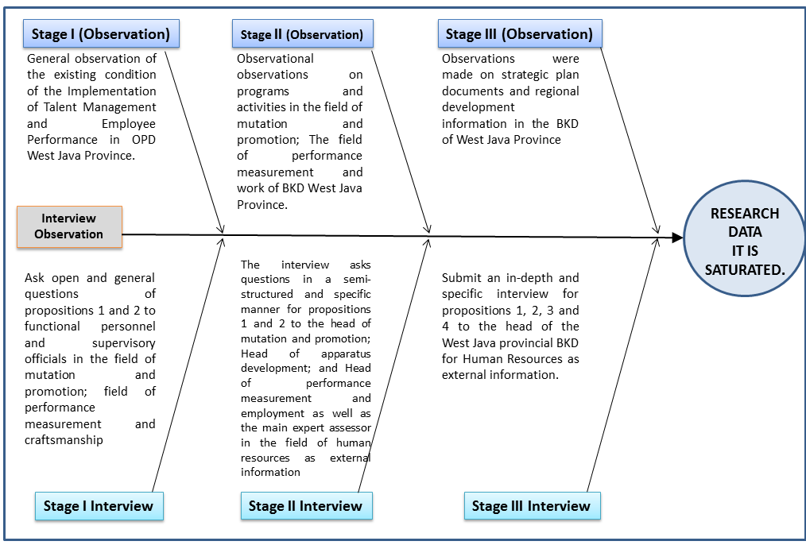
Figure 1: Snowball Diagram Observation and Interview Until Data Saturated.

RESULTS AND DISCUSSION

Referring to Government Regulation number 11 of 2017 concerning Civil Servant Management and Regulation of the Minister of State Apparatus Empowerment and Bureaucratic Reform Number 3 of 2020 concerning State Civil Apparatus Talent Management. The application of Talent Management in Regional Equipment Organizations within the Regional Government of West Java Province is based on Governor Regulation Number 69 of 2020 concerning Talent Management of State Civil Apparatus within the Regional Government of West Java Province, as shown in Figure 3. includes: (1) Acquisitions; (2) Development; (3) Retention; (4) Placement; and (5) Talent Monitoring and Evaluation.
There are four stages of analysis conducted in this study. First, according to Affandi's statement, A (2020), the research began by looking for Gap data when implementing talent management. Then, after finding the Gap based on these real conditions, the researchers tried to find the data again by conducting interviews again and conducting observations and reviewing relevant journals and theories using the 5W + 1H model approach.
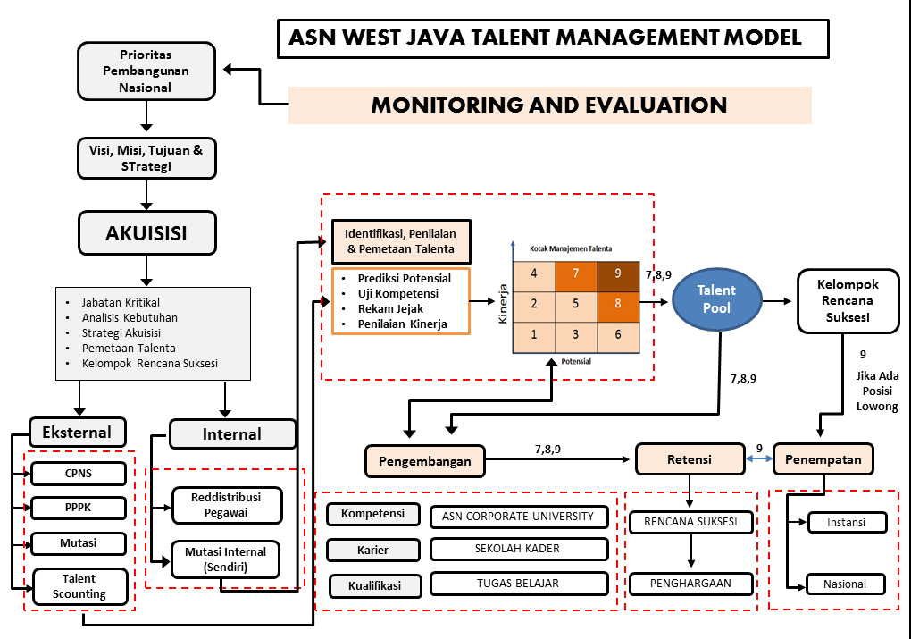
Source: West Java Province BKD Strategic Plan 2018-2023.

Figure 2 : Application of Talent Management ASN West Java Province.

Furthermore, an External and Internal Environmental Analysis was made in the West Java Provincial Government based on data on existing conditions obtained from in-depth interviews and information analysis from observations both during the initial survey and during the research according to Rangkuti's suggestion (2018: 83); Hunger and Wheelen (2018:204). Finally, compile and discuss strategic formulation until producing a grand matrix of strategies. The results obtained in the grand strategy matrix are used for strategy selection and implementation of talent management implementation strategies to realize superior employee performance.
Gap data when implementing Talent Management are presented in Figure 3.

Number. | Initial Conditions  GAP | Researcher Analysis 5W + 1H  HOW
1. | The results of the talent pool assessment, have not yet been determined into a succession plan group, as a reserve for key positions. | The West Java Provincial Government needs to immediately formulate an Employee Career Management policy. Need to integrate Career Planning, Succession Planning and Implementation of Talent Management.  Organizations need to immediately establish key positions, appoint replacement reserves for key positions, and draw up a talent mutation pattern plan to achieve these key positions.
2. | Talent pool assessment, The succession plan has not been aligned with the career pattern of OPD agencies.. | Employees must follow the career path that the organization has determined in order to get ahead in the organization.  Leaders have the task of being career advisors, coaches and mentors to assist talented employees in managing their careers to key positions.
3. | Employee performance is still output-based, not in accordance with organizational expectations. | BKD West Java Province needs to improve and strengthen employee performance.  Need to align between organizational performance goals and objectives to individual employee performance.  Hold a performance dialogue, to build the same perception.  Need to ensure that all employee performance has contributed to the achievement of their expectations.
4. | Employees in implementing talent management have not one perception. | Efforts are needed to socialize Talent Management, so that there are similarities in perspective and mindset in implementing Talent Management.
5. | Not all employees are familiar with using various digital-based staffing applications. | Need to educate and train the HR apparatus so that it is adaptive, as a learner and then also willing to change open mindset and able to use technology.
Figure 3 : GAP data in implementing talent management.
Actions that need to be taken to achieve the implementation of effective talent management within the West Java Regional Equipment Organization (Berger and Berger,2018; Mathis Jackson, et all. 2018); Sule and Wahyuningtyas 2016), are (1) A leader needs to formulate key performance that is aligned with organizational goals, then look for talents who are suitable for the job.; (2) It is necessary to strengthen the implementation of effective talent management strategies to produce the employees needed today and in the future; (3) Integrate the determination of key positions, succession planning, career planning, determination of key position reserves, employee competence development, and handling problem employees oriented towards creating superior performing employees based on Talent Management.
The value of the weighting results is used as input material in the SWOT Grand Strategy Matrix model.

Figure 4. : Grand Matrix SWOT Analysis Strategy.

Based on the weighting of factors of strategic internal and external organizational environment analysis, the results of the analysis of EFAS value 1.05 and IFAS value – 0.7 were obtained. So based on the SWOT analysis chart for the research theme of Talent Management Implementation Strategy to Realize Superior Performance of Employees in the West Java Provincial Local Government Organization Environment, located in Quadrant 3, W-O, the situation has opportunities and weaknesses that can be utilized to achieve organizational goals. The strategy to be implemented is Weakneses and Opportunity (W-O Strategy): the interaction of opportunities and weaknesses. The strategy is implemented based on the utilization of existing opportunities by minimizing existing weaknesses. The selected strategies are: (1) Strategy for Strengthening Effective Talent Management Implementation Policy; (2) ASN Career Management Strengthening Strategy; (3) strategies to strengthen superior employee performance; (4) Strategy for Creating One Apps Talent Management Information System.
- Strategy to Strengthen the Implementation of Effective Digital-Based Talent Management.
The strategy to strengthen the implementation of digital-based Talent Management, basically focuses on strengthening various indicators from the dimensions of Talent Management Position Planning which will reflect the expected human resource development process holistically, systematically, and integrated, so that the Talent Management Position Planning process becomes effective, namely: Determination of Key Positions; succession planning; career planning; and Appointment of Key Position Replacement Reserves. Strengthening the Implementation of Talent Management is carried out through the Simjawara application renewal policy; become a leading sector in the application of Talent Management; and become a role model and agent of change at the national and local government levels in West Java.
Implementing an effective digital-based talent management strategy is not easy and is a long-term endeavor. Sometimes, a well-designed talent management system is often constrained in the implementation process so that the results are far from expected. Therefore, the organization must be able to integrate the strategy of implementing talent management based on normative provisions referring to ministerial regulations, government regulations or laws, with the strategy of implementing talent management based on theory and the results of empirical studies as described above.
The above opinion is in accordance with the opinion adopted from (Mathis, Robert. et al., 2018; Dessler, Gary., 2020; Noe, et all., 2021; Pella and Inayati, 2017), and the results of research conducted by (Collings & Mellahi, 2009; Bidayatul,K et all., 2015; Wahyuningtyas, 2015; Gollardo-Gollardo et all., 2019; Kravatiri &; Johnston, 2019; Jac Fitzen in Eko, 2020; Sparrow & Makram, 2015; Cappelli & Keller, 2014); Chambers et al., 1998, in Cappelli & Keller, 2014; Kurgat, A., 2016; Smilansky, 2008) in (Asep Rustandi, 2015; Shahindra, 2007).
- Strategy for Strengthening Career Management through Integrated Planning of Succession Plan and Career Plan and Talent Management.
In this case, researchers assume that strengthening employee career management as an effective application of talent management needs to be implemented in an effort to produce the right employees on an ongoing basis. As contained in Law Number 5 of 2014 concerning State Civil Apparatus and PP Number 11 of 2017 concerning Civil Servant Management. The opinion of the researcher is in accordance with the statements (Mathis, Robert et all., 2018; Berger and Berger, 2018) that the most important part of Talent Management is Career Development for talented people and Talent Management that effectively integrates the processes of Succession Planning, Career Management, Development, and Performance Management.
The move is in the opinion of (Rothwell, et all, 2015; Berger and Berger, 2018) as described below (1) Socialization and Formulating appropriate Talent Management Policies, Objectives, Roles and Accountability; (2) Aligning Job Duties and Competence of Future Employees with Organizational Strategy; (3) Potential Assessment and Selection of Talents appropriate according to the Succession Plan; (4) Training and Development of Personal Competence of Employees through coaching, mentoring, and career counseling.
These results are in accordance with the theory of employee career management and its effect on improving employee or organizational performance as well as other research results that support the correlation between the two in accordance with the theoretical statement. (Berger and Berger,2018; Mathis,Robert et all, 2018; Dessler, Garry,2020), and according to the results of research conducted by (Rothwell,WJ et all, 2015; Kharadze, Natalia et all,2019; Nasir,NIIBM et all,2021; Ermawati,E dan Syahlani,DH,2021; Chen, SY et all, 2019; Maesah & Bawole, 2018; Apridar dan Adamy, 2017; Dharma,Y,2017; Ortiz,MZ et all, 2014; Lee,Yunsoo and Lee, Jae Young,2018; Marshall Goldsmith,2018) in (Berger and Berger, 2018).
- Strategy to strengthen superior employee performance.
Employee performance is a person's success in carrying out a job (William J.Rothwell, 2015) in (Berger and Berger, 2018; Mathis,Robert et all., 2018; Dessler, Gary, 2020), where they present the best performance management system measures individuals on performance (results) and behavior According (Robbins and Judge, 2015; Mathis, Robert et all., 2018) the performance and work behavior of an employee is influenced by: the ability to do tasks; effort expended to solve the task; and support from organizational leaders.
Collings and Mellahi (2009) in Eko Indra (2020:221); McShane and Von Glinow (2018) to create superior employee performance, organizations need to: (1) have a system that is able to develop the capabilities of its employees; (2) have a system in place to ensure these employees have assignment opportunities; (3) have a system that produces a leader who can assign clear roles and tasks to his employees; (4) Have a system that is able to create job satisfaction so that employees are highly motivated to maximize the achievement of their performance results.
The same opinion (Kamil, Bidayatul, et al., 2015) who made qualitative research in Malaysian private companies, talent management that is carried out effectively, raises employee satisfaction in the workplace because they feel there is clarity in career development, then interested and motivated to continue to develop and grow together with their organization. This is believed to encourage employees to behave superior performance at work. (Robbin and Judge, 2015; Mathis, Robert et al; 2020) employees who are satisfied with their work will be more likely to engage and move themselves to perform superior performance behaviors. This opinion is in line with the findings of Chen's research (SY et all., 2019); Maesah &; Bawole, 2018; Apridar and Adamy, 2017; Dharma,Y, 2017; Ortiz,MZ et all., 2014).
- Strategy for Creating One Apps Talent Management Information System and Personnel Big Data.
Policies and programs as derivatives of indicators of strengthening the development of Talent Management Information Systems and Personnel Big Data are in an effort to realize superior employee performance behavior based on talent management within the Regional Equipment Organization of West Java Province. In accordance with the opinion of (Craig M. Berger, 2018), who states that Big Data Personnel talent management information systems, help line managers and human resource professionals make better decisions faster by increasing their effectiveness in implementing programs that involve the acquisition, retention, improvement, positioning, and reward of high-quality employees. The above opinion is in accordance with the opinion adopted from (Mathis, Robert. et al., 2018; Dessler,Gary., 2020; Noe, et all.,2021; Pella and Inayati, 2017) and the results of research conducted by (Collings & Mellahi, 2009; Bidayatul,K et all., 2015; Wahyuningtyas, 2015; Gollardo-Gollardo et all., 2019; Smilansky, 2008) in (Asep Rustandi, 2015; Shahindra, 2007) in (Asep Rustandi, 2015; Kravatiri &Johnston, 2019; Sparrow &Kram, 2015; Chambers et al., 1998), in (Cappelli & Keller, 2014; Kurgat, A., 2016).

CONCLUSION

- Effective implementation of Talent Management is needed in order to find and develop the best talents to fill strategic positions as Future leaders. Talent Management practices in West Java Province are carried out with an objective, transparent, and accountable system, and are digital-based. It is necessary to strengthen the Employee Career Management process, because Career Management and Talent Management in West Java Province are very related and cannot be separated. Strategic positions will be filled by the best employees obtained from the Talent Management process.
- Effective employee performance measurement is necessary, to ensure continuity of performance, that all employees have contributed to the main performance objectives of the organization. The implementation is digital-based and has been integrated with the e-SAKIP strategic target program. In this case, employee performance appraisal has been integrated, between Individual / employee Performance with Organizational Performance Measurement.
- Basically, the obstacles and obstacles faced must be considered, especially in filling strategic positions through the Talent Management process. Adequate infrastructure preparation is needed, such as information systems that support the management of personnel big data, assessment centers and employee competence development, and finally is the adjustment of the regulatory umbrella that regulates Talent Management policies in the Regional Government of West Java Province. Efforts are needed to socialize Talent Management, so that there is a common perspective and mindset in implementing Talent Management and Performance measurement.
- The results of weighting the factors of the analysis of the strategic internal and external organizational environment, obtained the results of the analysis of EFAS value 1.05 and IFAS value – 0.7. So it is in Quadrant 3,. The strategy to be implemented is Weakneses and Opportunity (W-O Strategy): the interaction of opportunities and weaknesses. Organizations need to create strategies that take advantage of opportunities to address existing weaknesses. The selected Strategy Implementation is the Strategy for Strengthening Effective Talent Management Implementation Policy; Strengthening Career Management.; Strengthening Superior Employee Performance; Creation of One Apps Talent Management Information System and Staffing Big Data.
REFERENCES

Berger, Lance A. & Berger, Dorothy R., (2018). The Talent Management Handbook, Third Edition, McGraw-Hill Education.
Bidayatul, Kamil et al. (2015). A Study on The Implementation of Talent Management Practices at Malaysian Companies. Asian Journal of Business and Management Sciences Vol. 1 No. 4 [147-162], ISSN: 2047-2528.
Cappelli, P., & Keller, J. (2014). Talent Management: Conceptual Approaches and Practical Challenges. Annual Review of Organizational Psychology and Organizational Behavior, 1(1), 305–331. doi:10.1146/annurev-orgpsych-031413-091314
Collings, D. G., & Mellahi, K. (2009). Strategic talent management: A review and research agenda. Human Resource Management Review, 19(4), 304–313. doi:10.1016/j. hrmr.2009.04.001
Collings, D. G., Mellahi, K., & Cascio, W. F. (2019). Global talent management and performance in multinational enterprises: A multilevel perspective. Journal of Management, 45(2), 540–566. doi:10.1177/0149206318757018
Collings, D. G., Scullion, H., & Vaiman, V. (2011). European perspectives on talent management. European Journal of International Management, 5(5), 453–462. doi:10. 1504/EJIM.2011.042173
Collings, D. G., Scullion, H., & Vaiman, V. (2015). Talent management: Progress and prospects (Editorial). Human Resource Management Review, 25(3), 233–235. doi:10. 1016/j.hrmr.2015.04.005
Creswell W. John. (2013). Research Design Pendekatan Kualitatif, Kuantitatif, dan Mixed. Yogyakarta: Pustaka Pelajar.
Daft,Richard L. (2021). Management. Fourteenth Edition. Cengage. 200 Pier 4 Boulevard, Boston. MA 02210. USA.
Darmin Ahmad Pella dan afifah Inayati, (2011). Talent Management Building Human Capital For Growth And Excellence, PT. Gramedia Pustaka Utama, Jakarta.
David, Fred R. and David, Forest R., (2017), Strategic Management: A Competitive Advantage Approach, Concepts and Cases, Sixteenth Edition, Pearson Education Limited, England.
Delly Mustafa, et al. (2022). Service Quality And Performance Of Academic Administration Employees On Student Satisfaction. Jurnal Sosiohumainora, Vol 24, No 3.
Dessler, Garry, (2020). Human Resource Management, Sixteenth Edition, Pearson Prentice Hall.
Dries, N. (2013). The psychology of talent management: A review and research agenda. Human Resource Management Review, 23(4), 272–285. doi:10.1016/ j.hrmr.2013.05.001
Fatah, SJ. (2019). Applying Talent Management Practices by Management Involvement: A Theoretical Perspective, Cihan University-Erbil Journal of Humanities and Social Sciences Volume III, No. 1, pp1-6; DOI:10.24086/cuejhss.
Gallardo-Gallardo,E. Thunnissen,M & Scullion, H. (2020) : Talent Management : Context Matters. The International Journal of Human Resouece Management, 31:4, 457-473, DOI: 10.1080/09585192.2019.1642645.
Glenn.T. (2012). The State of Talent Management in Canada‘s public sector Volume.55. No.1, PP. 25– 51. Canada.
H.Azhar Afandi, Achmad Rozi dan Sunarsi. (2020). Manajemen Sumber Daya Manusia Strategik. Bandung: Bintang Visitama.
Heri, Eko Indra, (2020), Paradigma Baru Pengelolaan SDM dalam Organisasi, PT. Raja Grafindo Persada, Jakarta.
Jones,GR and George,JM. (2018). Contemporary Management. Tenth Edition. McGraw-Hill Education. 2 Penn Plaza, New York.
Luna-Arocas,R. (2020). Talent management and organizational commitment: the partial mediating role of pay satisfaction. The International Journal © Emerald Publishing Limited 0142-5455 DOI 10.1108/ER-11-2019-0429.
Mathis, Robert L & Jackson, John H., (2017). Human Resource Management, 15th Edition, Chengage Learning Boston, USA
Mathis, Robert L and Jackson,JH. (2018). Human Resource Management (edisi 10). Jakarta: Salemba Empat.
McDonnell, A., Collings, D. G., Mellahi, K., & Schuler, R. (2017). Talent management: A systematic review and future prospects. European Journal of International Management, 11(1), 86–128. doi:10.1504/EJIM.2017.081253
McShane / Von Glinow. (2018), Organizational Behavior. Eighth Edition. McGraw-Hill International Edition.
McShane, S. L., & Von Glinow, M. A. (2018). Organizational Behavior: Emerging Knowledge and Practice for The Real World (5th ed.). New York: The McGraw-Hill Companies, Inc.
Moeheriono. (2014). Pengukuran Kinerja Berbasis Kompetensi Edisi Revisi, Jakarta: PT RajaGrafindo Persada.
Noe et. Al. (2021). Human Resource Management, Gaining a Competitive Advantage, 12th Edition, International Edition, McGraw-Hill Education, USA.
Nuraeni Nuraeni, , et al. (2022). Determinants Of Employee Retention Millennials Workforce At Pt Asuransi Jasaraharja Putera. Jurnal Sosiohumainora, Vol 24, No 1.
Pella dan Inayati. (2011). Manajemen Talenta : mengembangkan SDM untuk mencapai pertumbuhan dan kinerja prima. PT. Gramedia Pustaka Utama, Jakarta.
Rd Siti Sofro Sidiq. (2020). Strategy Coastal Community Panglima Raja Village In Sustainability Of Life. Jurnal Sosiohumainora, Vol 22, No : 3.
Rivai,Veithzal. (2014). Manajemen Sumber Daya Manusia untuk Perusahaan, Edisi ke 6, PT. Raja Grafindo Persada, Depok.
Robbins,SP and Coulter,Mary. (2018). Manajemen. Jilid 1 Edisi 13, Alih Bahasa: Bob Sabran Dan Devri Bardani P. Jakarta: Erlangga
Robbins,SP dan Judge,TA. (2015). Perilaku Organisasi. Jakarta: Salemba Empat.
Sedarmayanti. (2018). Sumber Daya Manusia dan Produktivitas Kerja. Bandung: CV. Mandar Maju.
Sidik Priandana. (2015). Pengaruh motivasi terhadap kepuasan kerja pegawai Dinas Pertambangan dan Energi Provinsi Jawa Barat. Jurnal Manajemen Strategi Bisnis dan Kewirausahaan. Vol.3 No.8. 2014.
Silzer,Rob and Doewll,BE. (2010). Strategy-Driven Talent Management. A Leadership Imperatif. The Profesional Practice Series. Published by Jossey-Bass. A Wiley Imprint. 989 Market Street, San Francisco, CA 94103-1741—www.josseybass.com.
Sopiah, & Sangadji, E. M. (2018). Manajemen Sumber Daya Manusia Strategik. (D. Prabantini, Ed.) (Ed.1). Yogyakarta: CV Andi Offset
Sparrow, P. R., & Makram, H. (2015). What is the value of talent management? Building value-driven processes within a talent management architecture. Human Resource Management Review, 25(3), 249–263. doi:10.1016/j.hrmr.2015.04.002
Sparrow, P., Scullion, H., & Tarique, I. (2014). Multiple lenses on talent management: Definitions and contours of the field. In P. Sparrow, H. Scullion, & I. Tarique (Eds.), Strategic talent management: Contemporary issues in international context (pp. 36–70). Cambridge: Cambridge University Press.
Sugiyono. (2013). Metode Penelitian Pendidikan Pendekatan Kuantitatif, Kualitatif, dan R&D. Bandung: Alfabeta
Sule, ET. dan Wahyuningtyas, R., (2016). Manajemen Talenta Terintegrasi, Cetakan Kesatu, Penerbit Andi, Yogyakarta.
Sutrisno,Edy. (2019). Manajemen Sumber Daya Manusia. Jakarta: Kencana Prenada Media Group.
Thunnissen, Marian dan Dorien Buttiens. (2017). Talent Management in Public Sector Organizations: A Study on the Impact of Contextual Factors on the TM Approach in Flemish and Dutch Public Sector Organizations. Volume.46, Issue 4.
Vaiman, V., Collings, D. G., & Scullion, H. (2017). Contextualising talent management (Editorial). Journal of Organizational Effectiveness: People and Performance, 4(4), 294–297. doi:10.1108/JOEPP-12-2017-070
Vaiman, V., Sparrow, P. R., Schuler, R. S., Collings, D. (Eds.). (2018). Macro talent man- agement: A global perspective on managing talent in developed markets. London: Routledge.
Wahyuningtyas, Ratri. (2015). An Integrated Talent Management System: Challenges for Competitive Advantage, Full Paper Proceeding GTAR-2014, Vol. 1, 194-205 ISBN: 978-969-9948-30-5.
Wibowo. (2017). Manajemen Kinerja. Edisi Kelima. Depok: PT. Raja Grafindo Persada.
Wolor,CW. et al. (2020). Implementation Talent Management To Improve Organization’s Performance In Indonesia To Fight Industrial Revolution 4.0.Înternational Journal of Scientific & Technology Research Volume 9, issue 01, January 2020. ISSN 2277-8616

