BIBLIOGRAPHY

Akhadiah, et al. (2006) Pembinaan Kemampuan menulis bahasa Indonesia. Jakarta: Erlangga.

Andika, P and Gartika R, (2011) How to Write in English Correctly. Bekasi: Laskar Aksara

Ary Kristiyani,. (2016). Teks Deskripsi Berbasis Pendekatan Kontekstual. Modul Pembelajaran: Yogyakarta. Retrieved from; https://adoc.pub/teks-deskripsi- berbasis-pendekatan-kontekstual-ary-kristiyan.html Bandung: CV. Pustaka Setia.
Chaedar, A and Senny, S.A (2005). Pokoknya Menulis. Bandung: Kiblat Buku Utama

Eka Harum Puspitasari (2014) Peningkatan keterampilan menulis kembali dengan bahas dia sendiri melalui media film dongeng pada peserta didik kelas VII B MTS Mu'Allimin Malebo Temanggung (https://journal.unnes.ac.id/Sju/index.php/jpbsi)

Endah Ratnengsih (2016). Improving Students’ Writing Ability Through The Use Of Dictogloss Technique. Transformatika, Volume 12, Nomer 2, September 2016 ISSN 0854-8412. Retrieved from; https://www.neliti.com/id/publications/197163/improving-students-writing- ability-through-the-use-of-dictogloss-technique

Feri Rokhayani Tohid (2014). The Writing Journal Technique To Improve The Writing Fluency Of Grade Viii D Students At Mts Negeri Kawunganten In The Academic Year Of 2013/ 2014. Institut Keguruan dan Ilmu Pendidikan Yogyakarta: Unpublished Disertation.

Ferlazzo, Larry. (2014). The Picture Word Inductive Model. Research papers Milestones in ELT.

Fikri Asih Wigati, (2014). Kesulitan Pada Aspek-Aspek Writing Mahasiswa Dengan English Proficiency Levels Yang Berbeda. Jurnal Ilmiah Solusi Vol.1 No. 3 September - Nopember 2014: 46-61. Retrieved from; https://adoc.pub/kesulitan-pada-aspek-aspek-writing-mahasiswa-dengan- english-.html

Fithri Ana Nuur Afifah (2019). PENINGKATAN KETERAMPILAN MEMBACA PERMULAAN MELALUI PICTURE WORD INDUCTIVE MODEL (PWIM)
PADA SISWA KELAS I. Jurnal Pendidikan Guru Sekolah Dasar Edisi 19 tahun ke-8. Retrieved from: https://journal.student.uny.ac.id/ojs/index.php/pgsd/article/view/15436

H. Mahmud (2017). Upaya Meningkatakan Keterampilan Menulis Dengan Teknik RCG (Reka Cerita Gambar) Pada Siswa Kelas VI SDN Rengkak Kecamatan Kopang, Kabupaten. Lombok Tengah Tahun Pelajaran 2017/2018. JISIP, Vol. 1 No. 2 ISSN 2598-9944 November 2017 Jurnal Ilmu Sosial dan Pendidikan

Harmer, Jeremy (2001) How to teach English. England: Pearson Educational Limited. research paper in Yah Zawiyah

John W. Creswell 2013. Research Design (Pendekatan Kualitatif, Kuantitatif, dan Mixed). Yogyakarta: Pustaka Pelajar

Keraf (1998) in jurnal Erni Aryati "Presentasi belajar bahasa Indonesia siswa kelas viii di Mts tarbiyah Islamiyyah kab. Rejang Lebong" Vol 1, No 2, Desember 2015

Miftahul Huda, (2013). Model-Model Pengajaran dan Pembelajaran. Yogyakarta: Pustaka Pelajar

Nurfaidah (2019). Analisis Kemampuan Menulis Teks Deskriptif Pada Siswa Kelas VII SMP Negeri 11 Mataram. JISIP. Vol. 3 No. 1 ISSN 2598-9944 Maret 2019 Jurnal Ilmu Sosial dan Pendidikan 98. Retrieved from; https://ejournal.mandalanursa.org/index.php/JISIP/article/view/624/606

Prof. Dr. H. Asep Kartiwa And Drs., SH., MS 2015. Metode Penelitian Administrasi.

Roinah (2019). Problematika Dalam Pembelajaran Bahasa Inggris Di Stain Bengkalis. Volume 7, Nomor 1, 2019: 153-166. Retrieved from; https://journal.iainkudus.ac.id/index.php/Quality/article/view/4966

Sugiyono (2011). Metode penelitian Kombinasi (Mix Method). Bandung: Alfabeta. Universitas Pasundan Bandung (2022). Pedoman Penulisan Skripsi. Bandung:

Sugiyono (2013) in journal Jasmalinda "Pengaruh citra merek dan kualitas produk terhadap keputusan pembelian konsumen motor Yamaha di kabupaten Padang Pariaman" Vo 1, No. 10 Maret 2021 ISSN 2772-9475

Tarigan (2008) in jurnal Erni Aryati "Presentasi belajar bahasa Indonesia siswa kelas viii di Mts tarbiyah Islamiyyah kab. Rejang Lebong" Vol 1, No 2, Desember 2015

Ulfa Cahya Happyalita, dkk (2020) "Inovasi pembelajaran bahasa Inggris dalam mendukung program integrasi interkoneksi di fakultas Sains dan teknologi UIN sunan Kalijaga. Vol.2 ISSN 2662-9439; E-ISSN 2662-9447

CURICULUM VITAE

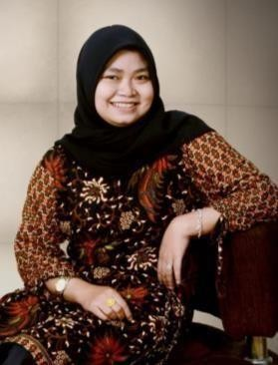
Malizha Erwinda Sari was born on July 01, 2000, in Lubuklinggau. Her nickname is Malizha. She is the second child from three children. From the couple Mr. Arwin,ST and Ms. Linda Mardalena. Malizha currently has been studying at Pasundan University, Bandung and majoring in English
Literature Department. She ever studied at RA/TK BAITUL „ALA Lubuklinggau in 2005- 2006, SD Negeri 41 Lubuklinggau in 2006-2009, SD Negeri Lubukbesar in 2010-2012, SMP Negeri Muara Beliti in 2012-2015, then continued at SMA Negeri1 Muara Beliti in 2015-2018. She also joined as member of DKM ULUL AL-BAAB in 2020-2021 and English Student Association (ESA) in 2019-2020 and 2020-2021 in campus. You can reach and ask more about Malizha on instagram maliza.arwindaa and email malizhaerwindas@gmail.com.

APPENDICES

Learning -Teaching Activities
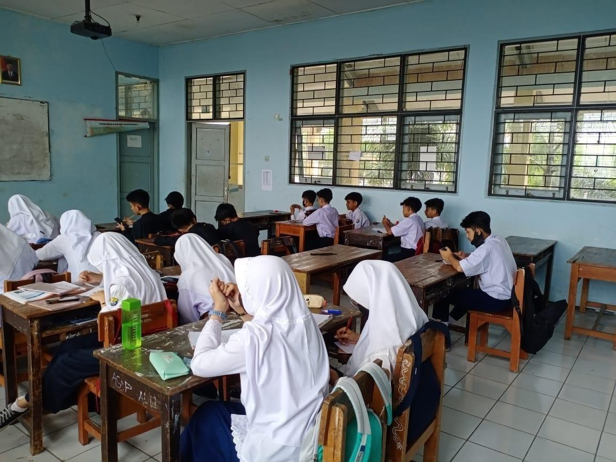

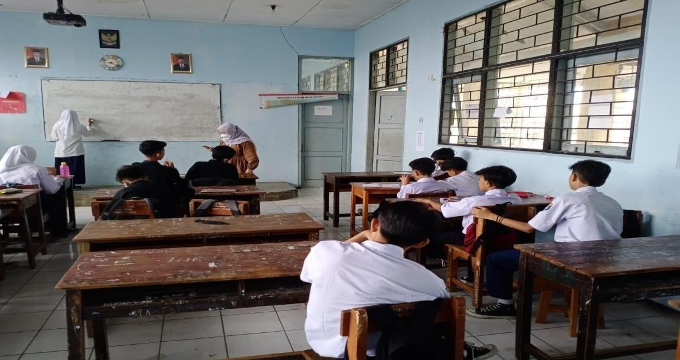

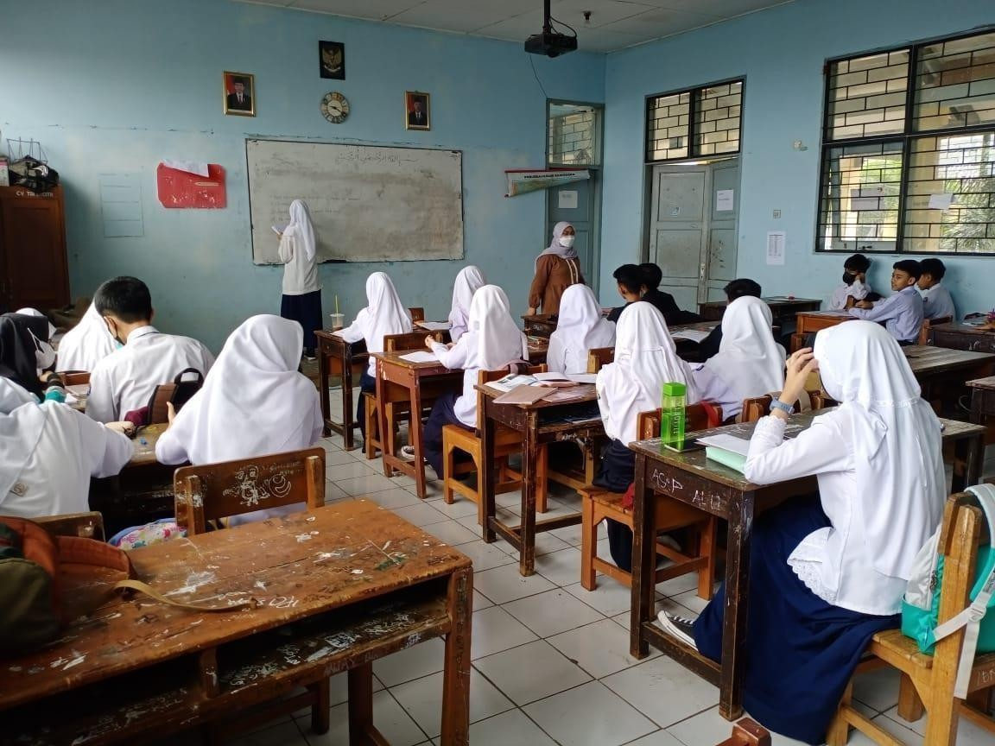

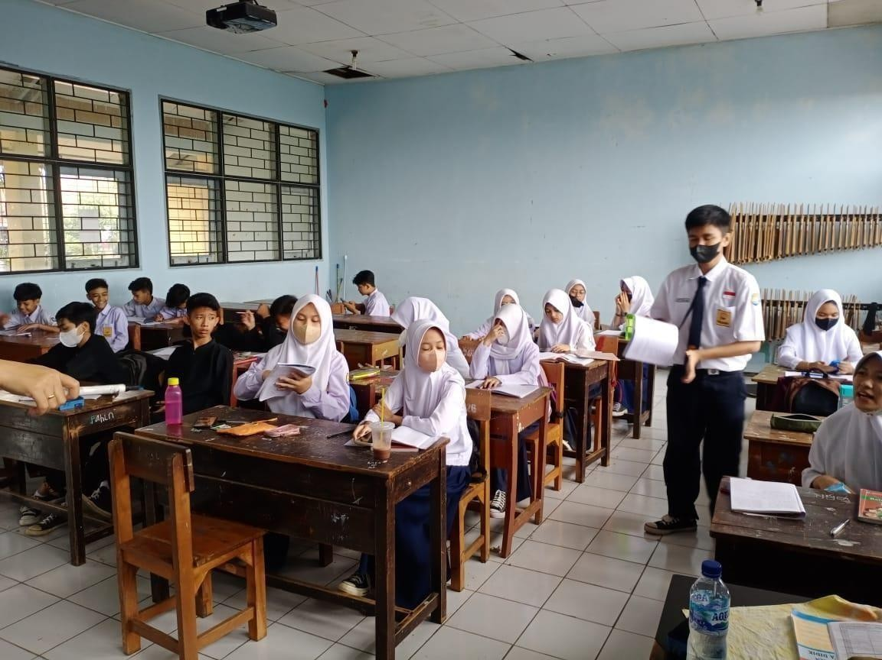

Students’ Interview Transcripts

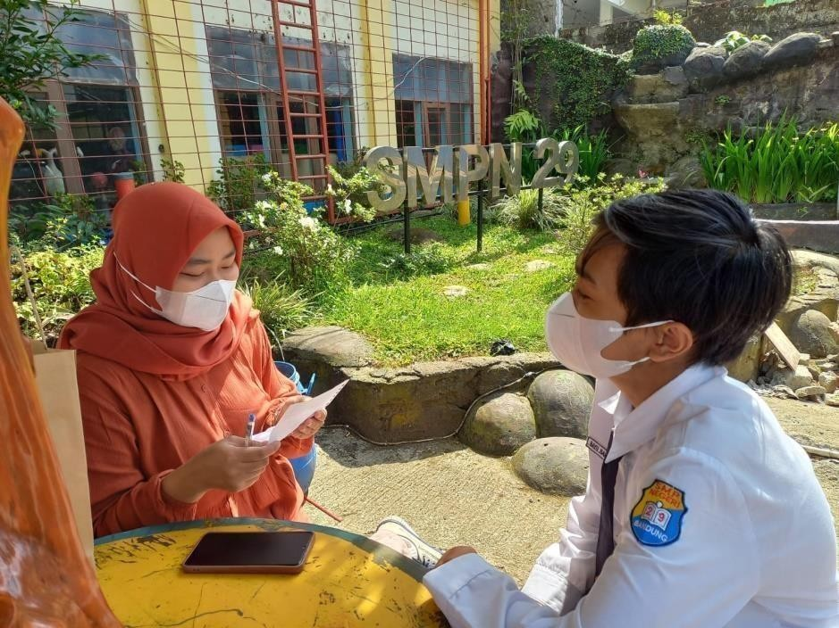

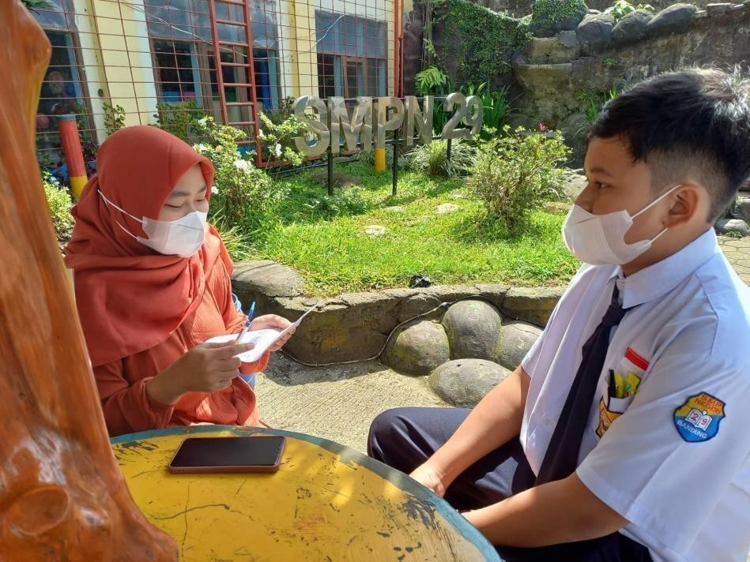

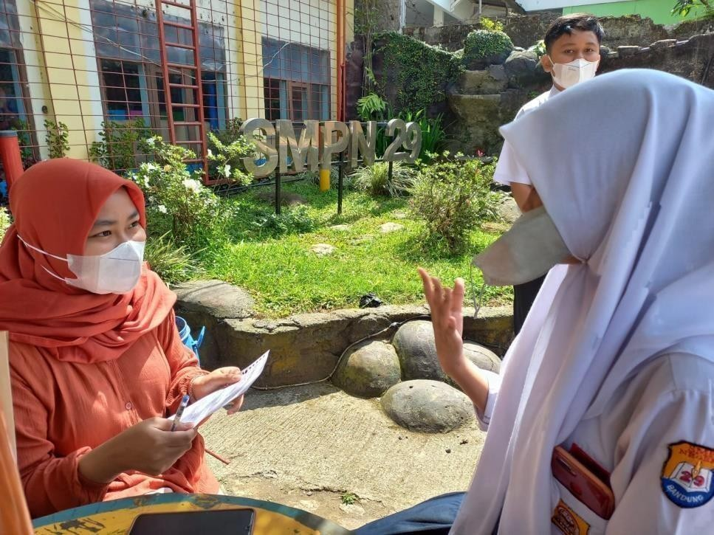

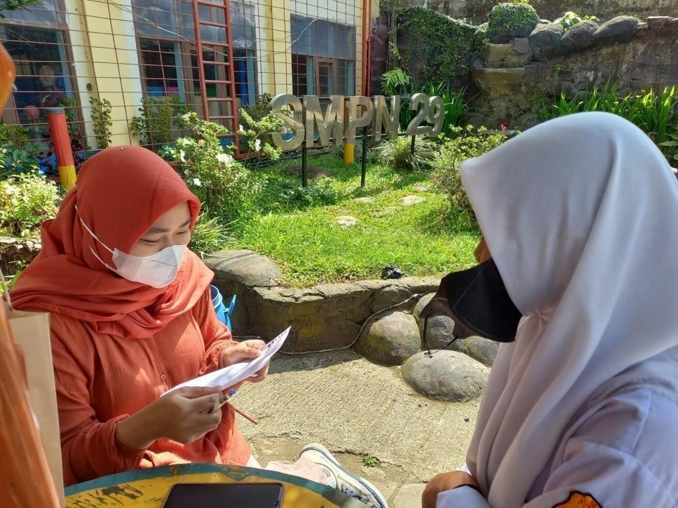

Example Picture Word Inductive Model

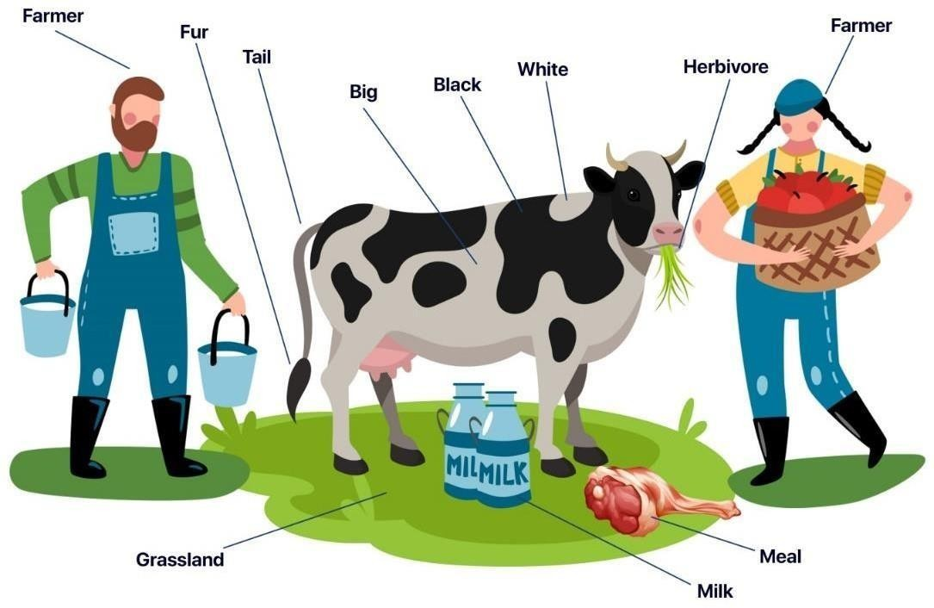

Lesson Planning
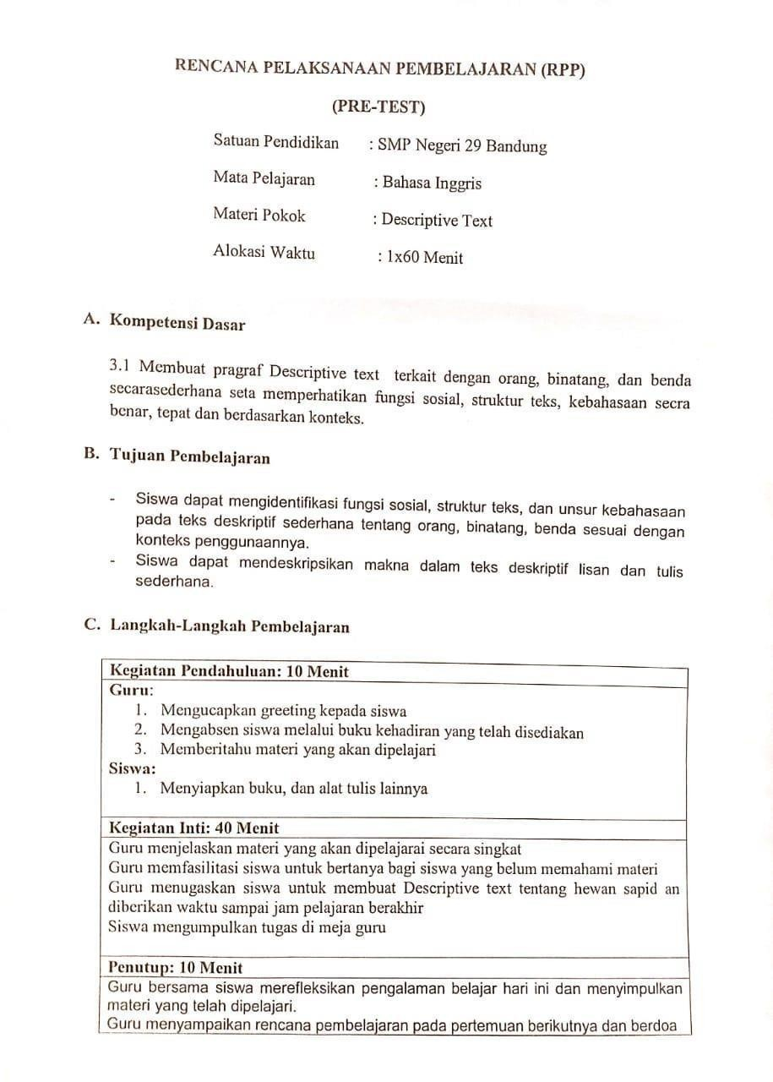

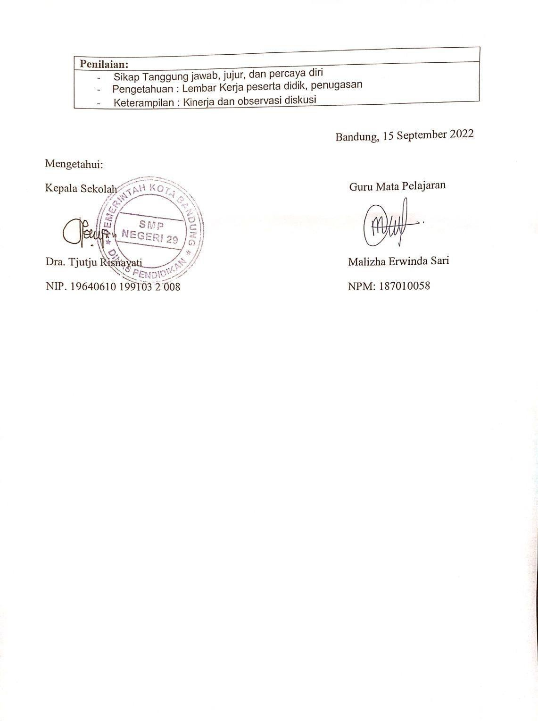

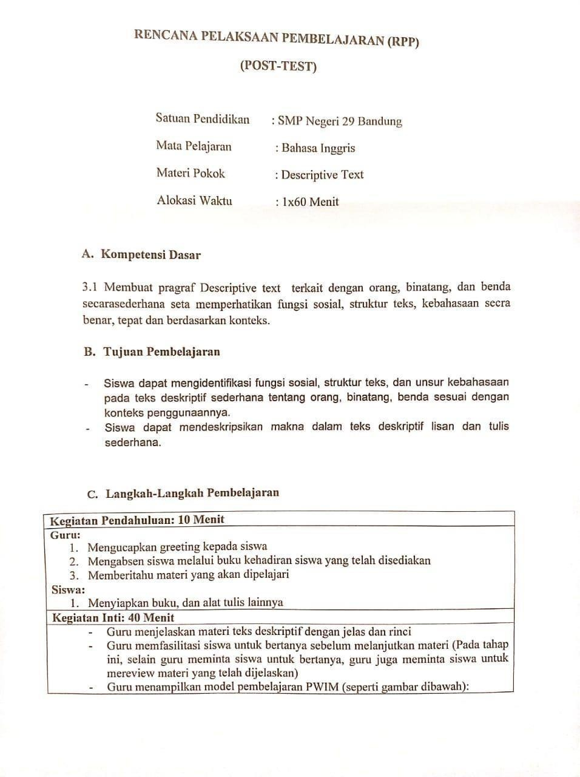

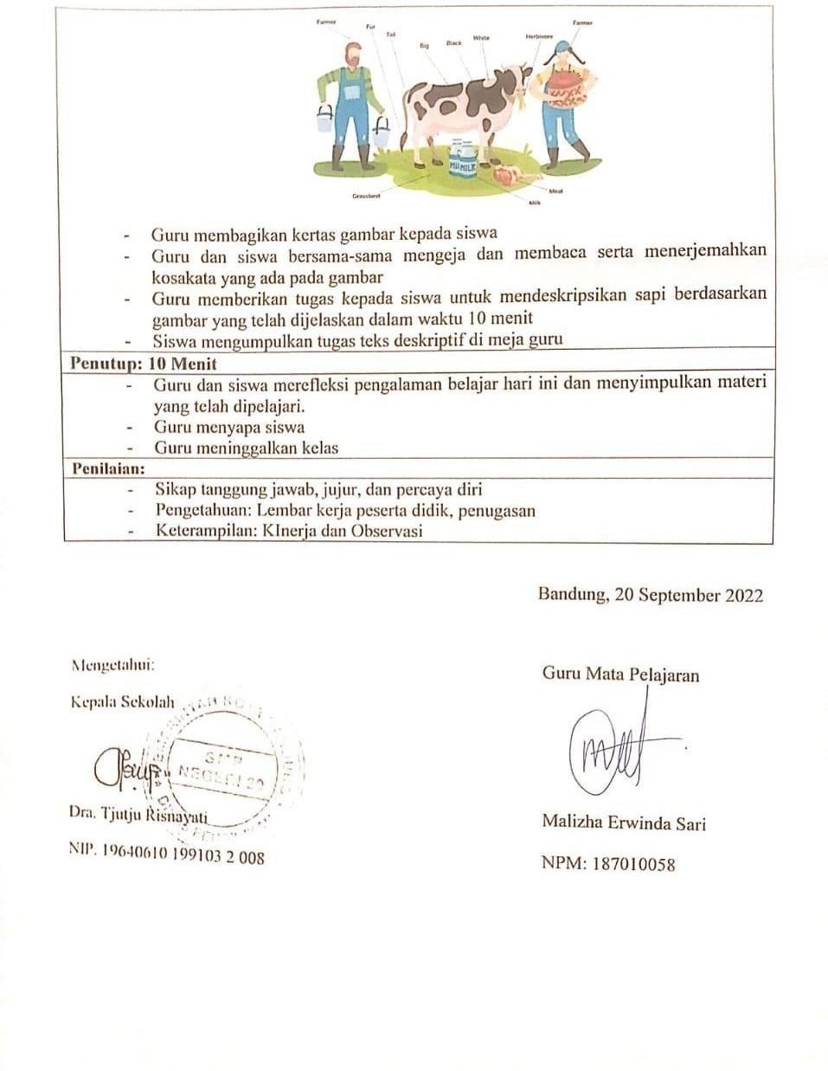

Assessment Component
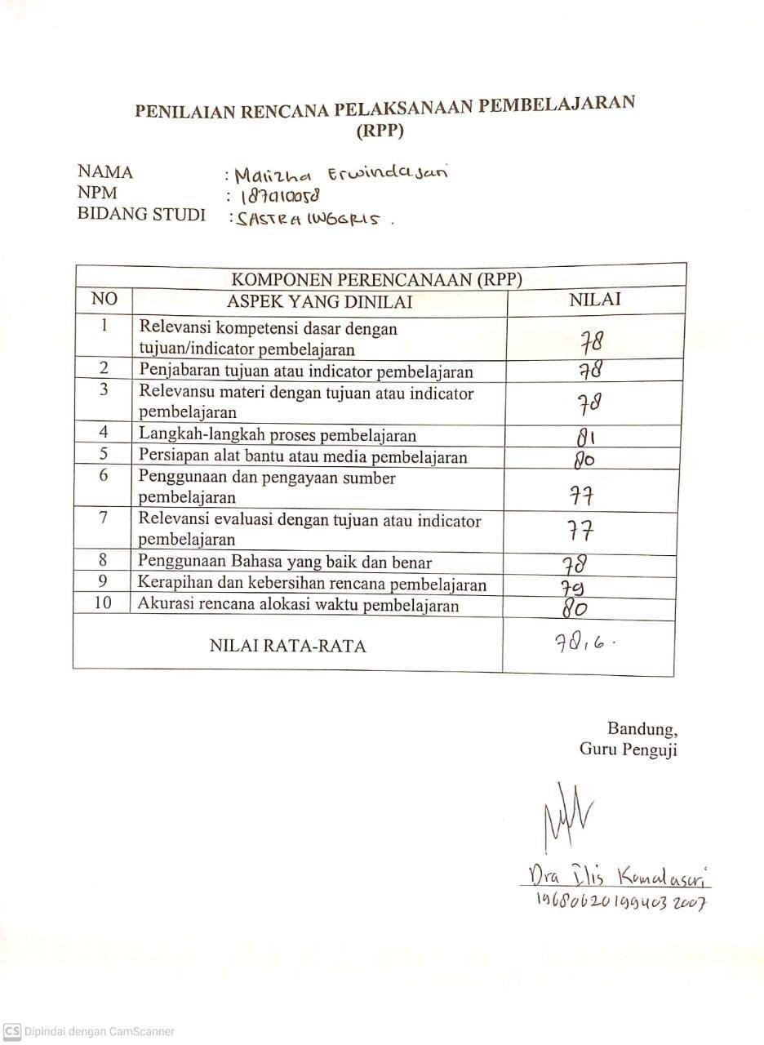

Statement Letter
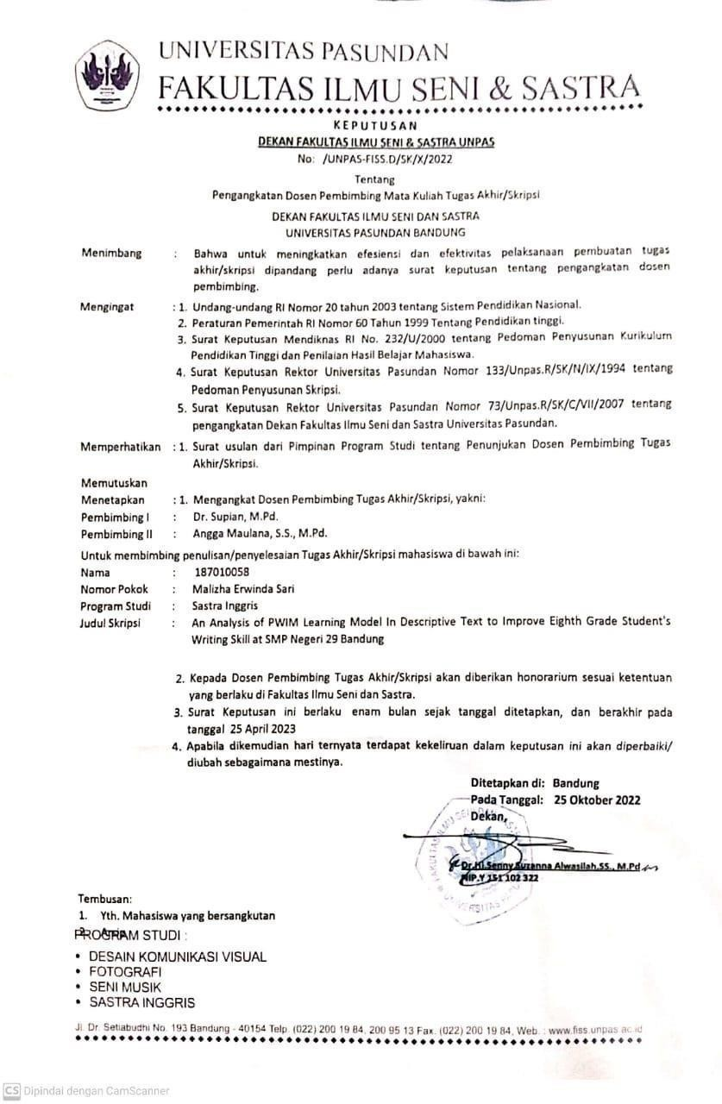

Students’ Assignment

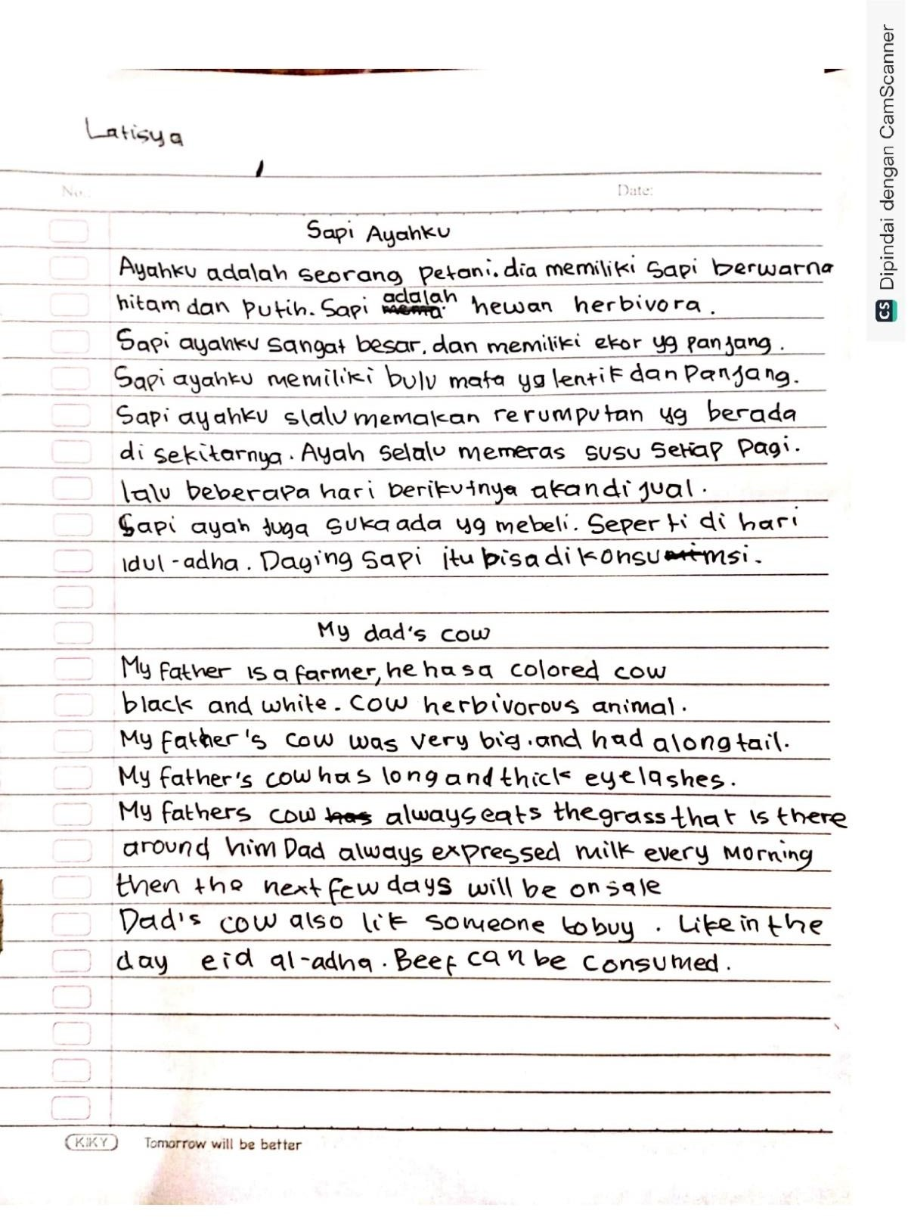

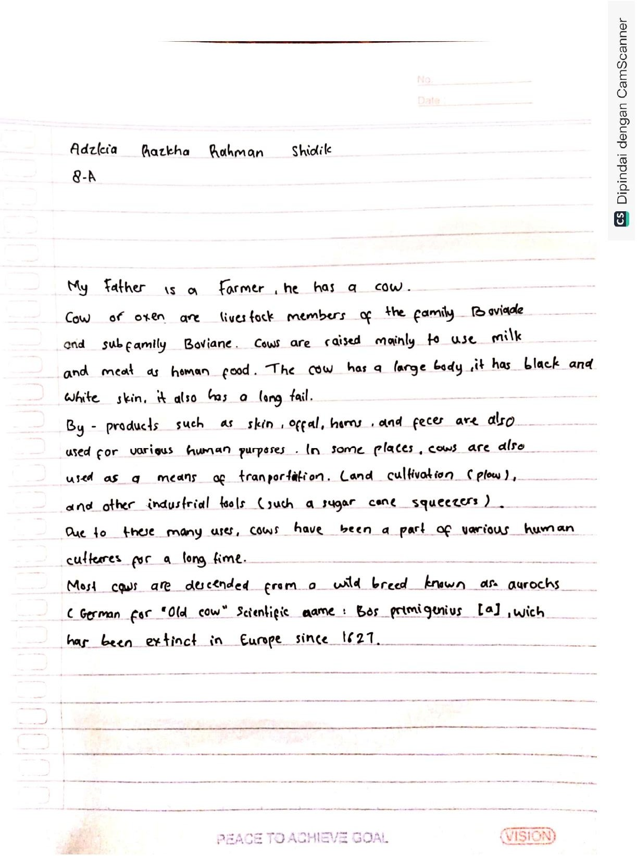

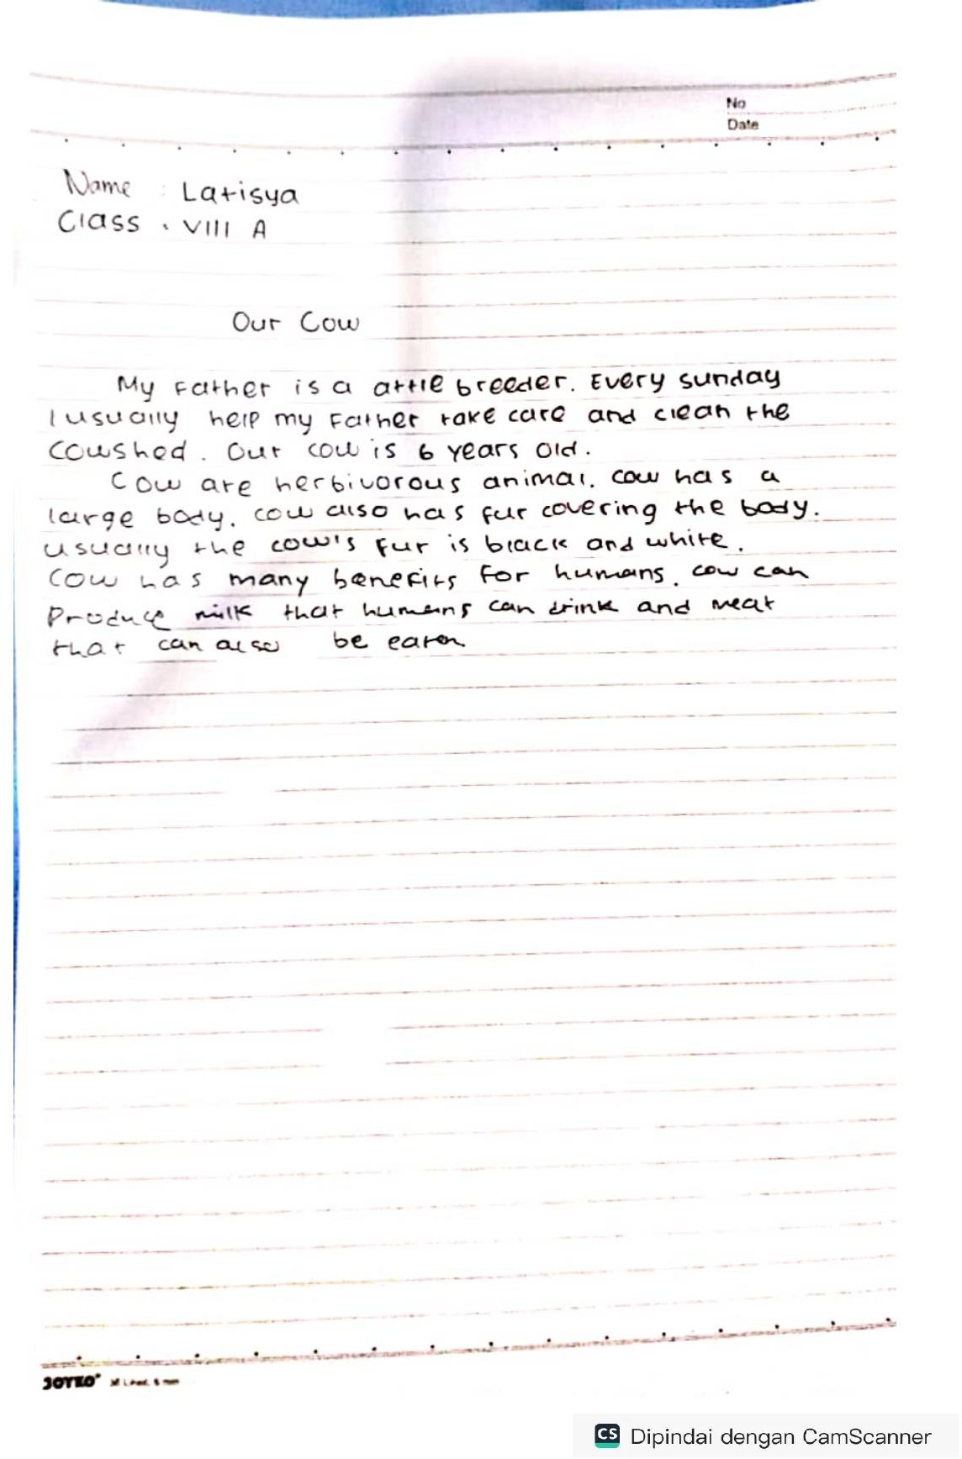

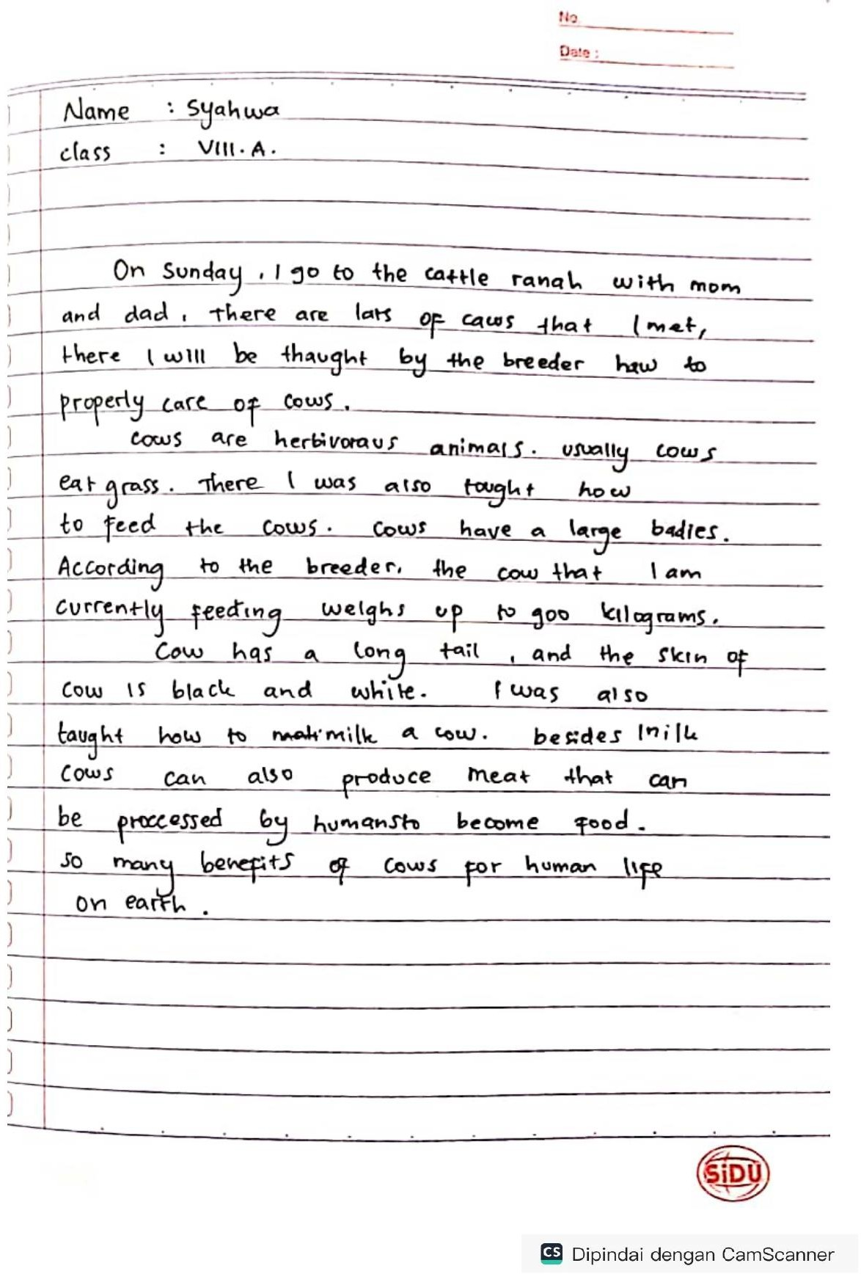

Berita Acara

