Bibliography

A.Pearce, J. I., & Richard B.Robinson, J. (2014). Manajemen strategi. Salemba Empat.
Arli, D., Tjiptono, F., & Porto, R. (2015). The impact of moral equity, relativism and attitude on individuals’ digital piracy behaviour in a developing country.
Marketing Intelligence & Planning, 33(3), 348–365.

Armstrong, G., Kotler, P., Trifts, V., & LBuchwitz, illy anne. (2017). Marketing an introduction (Vol. 4, Issue 1).
Astuti, M., & Amanda, A. R. (2020). Pengantar manajemen pemasaran. Deepublish.

Badan Pusat Statistik. (2022). Laporan Perekonomian Indonesia 2022. In Bank Indonesia (Issue 2).
Boyd, D. M., & Ellison, N. B. (2007). Social network sites: Definition, history, and scholarship. Journal of Computer‐mediated Communication, 13(1), 210–230.
Cooper, C., Fletcher, J., Gilbert, D., Shepherd, R., & Wanhill, S. (1998). Tourism Principles and Practices, England. Addison-Wesley, Longman.
Creswell, J. W., & Cresswell, D. (2018). Research design : Qualitative, quantitative, and mixed methods approaches. In Research design.
Crystal, D., & Davy, D. (2016). Investigating english style. Routledge.

80

Davenport, T. H., Harris, J. G., Jones, G. L., Lemon, K. N., Norton, D., & McCallister, M. B. (2007). The dark side of customer analytics. Harvard Business Review, 85(5), 37.
Donaldson, R., & Maumbe, K. (2010). Tracking the visitors to Cape Town and the Western Cape: The relationship between visitor characteristics and travel patterns and their implications to destination marketing. Journal of Tourism, 11(1), 1–20. http://ehis.ebscohost.com/eds/detail?vid=3&sid=bc38a1ed-dcd2- 4579-a1ce- aae84823e9e0%40sessionmgr11&hid=105&bdata=JnNpdGU9ZWRzLWxpdmU
%3D#db=hjh&AN=566604198

Elo, S., & Kyngäs, H. (2008). The qualitative content analysis process. Journal of Advanced Nursing, 62(1), 107–115.
Fitzsimmons, T. W., Callan, V. J., & Paulsen, N. (2014). Gender disparity in the C- suite: Do male and female CEOs differ in how they reached the top? The Leadership Quarterly, 25(2), 245–266.
Gaffar, V., Tjahjono, B., Abdullah, T., & Sukmayadi, V. (2022). Like, tag and share: bolstering social media marketing to improve intention to visit a nature-based tourism destination. Tourism Review, 77(2), 451–470. https://doi.org/10.1108/TR-05-2020-0215
Ghozali. (2018). Bab III - Metode Penelitian Metode Penelitian. Metode Penelitian,

9, 22–34.

Goi, C. L. (2009). A review of marketing mix: 4Ps or more. International Journal of Marketing Studies, 1(1), 2–15.
Griffiths, P. (2006). Introduction to English semantics and pragmatics. Edinburgh university press.
Herjanto, E. (1999). Manajemen produksi dan operasi. Edisi Kedua, PT Gramedia Widiasarana Indonesia, Jakarta.
Krippendorff, K. (2013). Content analysis: An introduction to its methodology. Sage publications.
Kaplan, A. M., & Haenlein, M. (2010). Users of the world, unite! The challenges and opportunities of Social Media. Business Horizons, 53(1), 59–68.
Kotler, P., & Alexander Rath, G. (1984). Design: A powerful but neglected strategic tool. Journal of Business Strategy, 5(2), 16–21.
Kotler, P., & Armstrong, G. (2016). Principles of Marketing, Global Edition (16th ed.).
Leech, G. (1981). Semantic The Study of Meaning (p. 9). https://yanjianghk.files.wordpress.com/2014/09/geoffrey_leech_semantics_the_s tudy_of_meaning.pdf

Löbner, S. (2013). Understanding Semantics, Second edition. In Understanding Semantics, Second edition. https://doi.org/10.4324/9780203528334
Maarif, M. S. (2003). Manajemen operasi. Grasindo.

Marasinghe, L., Rupasinghe, M., Kumarasinghe, B., Perera, M., & Thelijjagoda, S. (2018). Analyzing the Location Feasibility for Retail Businesses using Market Location Factors. 2018 IEEE 9th International Conference on Information and Automation for Sustainability, ICIAfS 2018, 1–5. https://doi.org/10.1109/ICIAFS.2018.8913366
Miles, M. B., & Huberman, M. A. (2009). Analisis Data Kualitatif. UI-Press.

Miller, A., & Dess, G. G. (1993). Assessing Porter’s (1980) model in terms of its generalizability, accuracy and simplicity. Journal of Management Studies, 30(4), 553–585.
Ravald, A., & Grönroos, C. (1996). The value concept and relationship marketing.

European Journal of Marketing, 30(2), 19–30.

Sari, V. M., & Anshori, A. (2022). Marketing communication strategy Sawah Pematang Johar tour in improving tourist visits. COMMICAST, 3(1), 113–120.
Setiadi, A. (2016). Pemanfaatan media sosial untuk efektifitas komunikasi.

Cakrawala: Jurnal Humaniora Bina Sarana Informatika, 16(2).

Sianipar, R., Juliana, J., & Sitorus, N. B. (2022). Marketing strategies for tourism

village In West Bandung District in covid-19 pandemic. Journal of Industrial Engineering & Management Research, 3(1), 234–240.
Singh, T. V. (2012). Critical debates in tourism (Vol. 57). Channel View Publications.

Small, J. A., Lyons, K., & Kemper, S. (1997). Grammatical abilities in Parkinson’s disease: evidence from written sentences. Neuropsychologia, 35(12), 1571– 1576.
Sugiyono, D. (2013). Metode Penelitian Kuantitatif, Kualitatif, dan R&D. Alfabeta. Tjiptono, F. (2008). Strategi Pemasaran. Andi Offset.
Utami, B. S. A., & Kafabih, A. (2021). Sektor Pariwisata Indonesia di Tengah Pandemi Covid 19. Jurnal Kajian Dan Terapan Pariwisata, 1(1), 39–57. https://doi.org/10.53356/diparojs.v1i1.21
Zhu, Y.-Q., & Chen, H.-G. (2015). Social media and human need satisfaction: Implications for social media marketing. Business Horizons, 58(3), 335–345.

Appendix

Instagram Kampung Turis
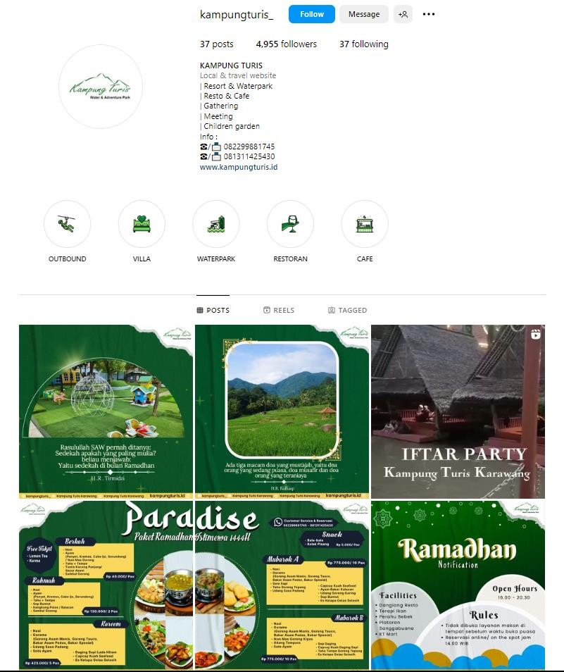

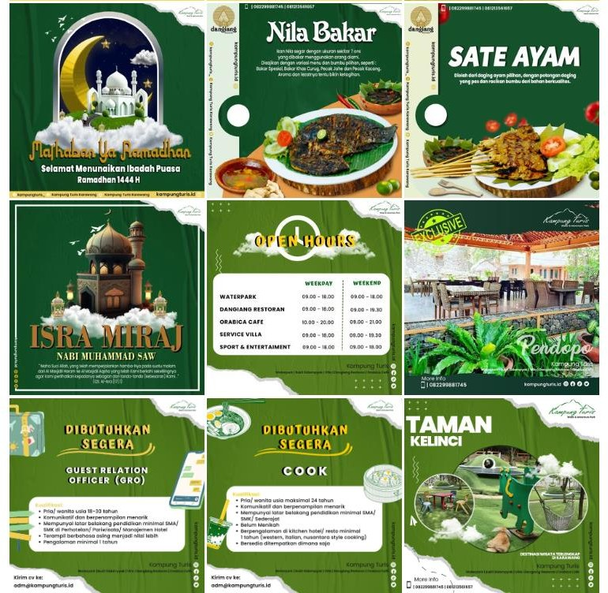

- Facebook Kampung Turis
