Chapter I
Introduction

1.1 Background of the Study
The tourism sector plays an important role in the economic development of a region. The goal is to improve the regional economy, create jobs, and even reduce poverty. The tourism sector is a sector that has the potential to be developed as a source of regional income. Like any other sector, tourism also affects the economy in a region or country's tourist destination. Development programs and empowering resources and tourism potential in an area can build the economy. Indonesia has a lot of tourism potential that has begun to develop. The tourism sector plays an important role in a country or region because it is one of the sectors that generate significant revenues. Salah Wahab (2003) said in his book Tourism Management, Tourism is a new type of financial industry that can create rapid economic growth by providing jobs and living standards and stimulating other productivity sectors. The tourism industry is developing rapidly, and the development of the tourism economy affects the country's exchange rate growth and even creates jobs for people when unemployment is overcome. The economic progress of tourism in an area depends on the number of tourist arrivals because the development of a good tourism economy needs to be supported by increasing the utilization of tourist destinations (DTW).
Accordance with the Tourism Law of the Republic of Indonesia Number 10 of 2009 explained, among others, several definitions of the term tourism. Tourism is a tourist activity carried out by individuals or groups who visit a place for recreation, personal development, or to learn about the uniqueness of the tourist destination they visit. Tourism is a range of activities supported by various services provided by the public, employers, States and municipalities.
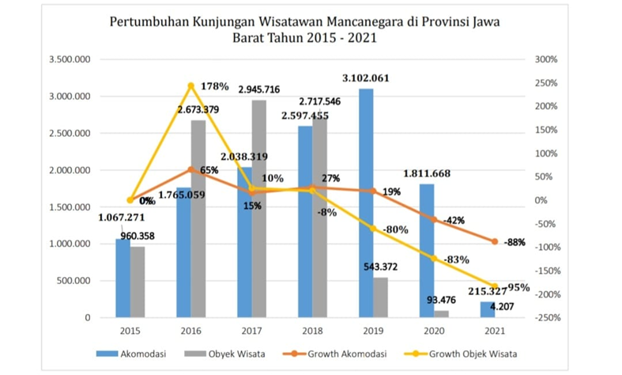
West Java is one of the main tourist destinations in Indonesia. It has some very perfect tourist attractions ranging from natural tourism to artificial tourism. Not only that, but West Java also has fresh air because it is surrounded by mountains, so West Java has a beautiful tourist destination. However, due to its vast potential, there may be no obstacles to managing its potential evenly. This administrative restriction caused a decrease in tourist visits to West Java, which can be seen in the following graph of the number of tourist visits to West Java. A tourist destination is a geographical area in one or more administrative areas in which there are tourist attractions, public facilities, accessibility, and communities that are interrelated and complement the realization of Tourism.
Picture 1. Graph Of The Visits Of The Tourists Mancanegara
Source : Department Of Tourism, The West Java Province Of 2022
Based on the data in Figure 1 Above, It can be seen that the number of dynamic tourist visits in 2015 was 1,067,271 foreign tourists who visited West Java. In 2016, 2017, 2018 and 2019, tourist visits increased significantly. In 2020-2021 tourist visits decreased very dramatically. In 2021 the number of visits was 215,327 visits. During dimming tourist visits, the government is pressing tourist visits. It plans to boost tourist visits to destinations that present natural beauty. People today are more interested in travelling to places that present beauty and experiences that have never been felt before.
The government's goal is to encourage tourist visits through various activities that promote people's economy. One solution is revitalising tourism in activities focusing on developing tourist villages through community empowerment. The community's welfare can be improved by developing tourism in tourist villages. A tourist village is a village that is used as a tourist destination because of its attractiveness. Tourism Village is a form of integration between attractions and supporting facilities that appear in the structure of community life, mixed with practical practices and traditions. Tourist villages are usually exposed to all tourist elements that have potential attractions. Among other things, attractions, accommodation, and other services support the uniqueness, nature, culture and characteristics of each tourist village in a particular area. This is by the wisdom of the local community. Fully integrated tourism village, all elements of the village show originality and local wisdom as tourism.
Bandung is an area or region located on a plateau surrounded by mountains, making it an area with very cool air temperatures. However, some areas, such as the Ciwidey natural tourism area, still have a very cold climate. It brings tourists from outside the area to Bandung to refresh and relax from the tired routine. Ciwidey is a sub-district in Bandung regency in West Java province, Indonesia. This area is located 35 km south of Bandung or about 15 km from Soreang, the capital of Bandung Regency. Before the expansion of the rancabali district, Ciwidey had a reasonably large area up to the border of the Cianjur Administrative Region and had many attractions. After the expansion, the Ciwidey area now serves as a supporting area for tourist attractions in the Rancabali area. Ciwidey has many tourist destinations, one of which is Lebakmuncang Tourism Village. This tourist village is used as a tourist attraction because of its attractiveness. Tourism Village is a form of integration between attractions, accommodation and supporting facilities that are presented in a community life structure that blends with the prevailing procedures and traditions.
According to (Suwandono in Yulianti, 2016), a tourist village is a combination of attractions, accommodation, and supporting services packaged in a model of community life that is integrated with existing practices and traditions to make a tourist village a destination. A fully integrated tourism village, all elements of the present village's uniqueness and local wisdom as tourism. In terms of community life, Tourism Village is a form of tourism with objects and attractions in the form of village life and has the characteristics of the community, natural and cultural panorama itself, so it is an opportunity to be utilized as a commodity for the community. Tourists, especially foreign tourists. Village life as a tourist destination is the village as an object and subject of Tourism, the organizer of various tourist activities, and people can immediately enjoy the results. Therefore, the sustainability of village activities is determined by the community's active role.
To be known by many tourists, promotion is needed to increase tourist visits and improve the economy of the population itself. Through several marketing efforts, tourist villages can develop and be recognized by tourists. Based on the background described above, the researcher are interested in conducting a study entitled "Analysis of Promotional Techniques to Increase Visitors (A Study Towards in Ciwidey, Bandung Regency, West Java)."
- Identification of Problems
According to Research Background, tourism plays an important role in the economy. The tourism sector is a sector that has the potential to be developed as a source of regional income. to increase tourist visits, and various promotional techniques are needed to increase tourist visits so that the tourism sector continues to grow.
- Research Questions
Based on the problem outlined, the formulation of the research question in this research are:
- What are the promotional techniques used by the management of the Lebakmuncang tourism village?
- What are the media used in promotion techniques for the management of the Lebakmuncang tourism village?
- Limitation the Problems
The title of this research is an Analysis of Technique Promotion to Improve Visitors. The author found various promotional methods through print and digital media. This research is expected to improve promotional techniques and perform various promotional techniques that have not been done. This research is limited to each application, website, and brochure post Lebakmuncang Tourism Village. The study results are expected to provide benefits for promotional actors and further research.
- Objectives of Study
This study aims to analyze the marketing promotion techniques used by Lebakmuncang Tourism Village to increase visitors and to see what techniques can attract the attention of tourists and increase tourist visits.
- Significances of the Study
The results of this study are expected to be useful for,
1. Theoretical
In the academic field, this research is expected to make a real contribution to tourism development, especially the Lebakmuncang Tourism Village in marketing techniques to increase visits and the economy, especially those related to Lebakmuncang Tourism Village.
2. Practical
Practically, this research is expected to be used as a reference for the government of the Ministry of Tourism and Creative Economy in promoting natural resources, especially in the development of Tourism Villages so that they become Tourism Villages that are beneficial to the community. everyone, especially society itself.

