Vibration Analysis on GT Ventilation Fan of LNG Cryogenic Process

ATTACHMENT OF THE JOURNAL

Mochamad Bhakti Prasastia Utama

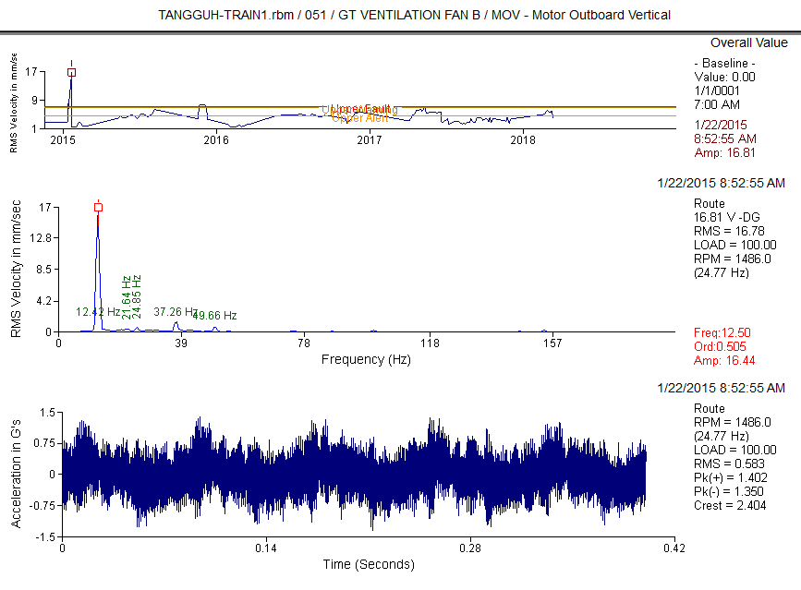
Graphic 1 MOH

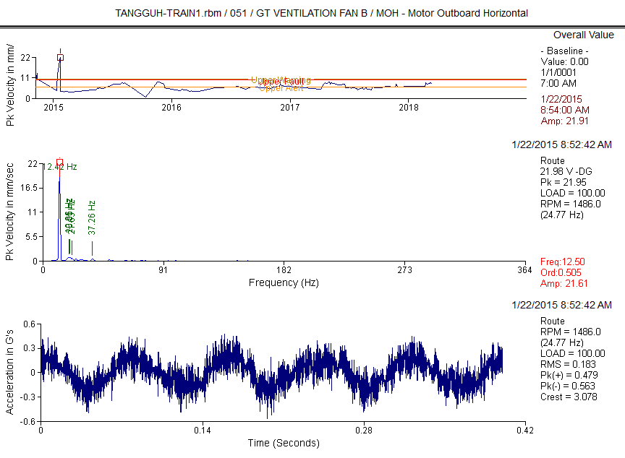
Graphic 2 MOH

Measurement Point History
*************************

Database: TANGGUH-TRAIN1.rbm
Area: PR & MR Compressor (051) Report Date: 20-Feb-19 09:13
Period Reported: 22-Jan-15 To 22-Jan-15

Equipment 1: GT VENTILATION FAN B
DATE TIME RPM LOAD OVERALL PAR#1 PAR#2 PAR#3 PAR#4 PAR#5 PAR#6

51CG101C2B-MOH (RPM) APS 25 mm/Sec G-s mm/Sec mm/Sec mm/Sec mm/Sec
15.54

22-Jan-15 08:52 1486. 100.0
51CG101C2B-MOV (RPM) APS 25 mm/Sec
22-Jan-15 08:52 1486. 100.0
16.81
51CG101C2B-MIH (RPM) APS 25 mm/Sec
22-Jan-15 08:53 1486. 100.0
13.97
1CG101C2B-M1H (RPM) APS 33 mm/Sec
22-Jan-15 08:53 1486. 100.0
13.86
51CG101C2B-MIV (RPM) APS 25 mm/Sec
22-Jan-15 08:54 1486. 100.0
14.21
51CG101C2B-M1V (RPM) APS 33 mm/Sec
14.04
22-Jan-15 08:54 1486. 100.0
51CG101C2B-MIA (RPM) APS 25 mm/Sec
22-Jan-15 08:54 1486. 100.0 3.947
22-Jan-15 08:55 722. 100.0
8.815
51CG101C2B-F1V (RPM) APS 34 mm/Sec
22-Jan-15 08:55 722. 100.0
8.767
51CG101C2B-FIA (RPM) APS 71 mm/Sec
7.141
22-Jan-15 08:56 722. 100.0
51CG101C2B-FOH (RPM) APS 71 mm/Sec
16.39
22-Jan-15 08:56 722. 100.0
51CG101C2B-FOV (RPM) APS 71 mm/Sec
22-Jan-15 08:56 722. 100.0
11.29
51CG101C2B-FOA (RPM) APS 71 mm/Sec
22-Jan-15 08:57 722. 100.0
6.802
1.042 3.076 15.47 .974 .572 .414
G-s mm/Sec mm/Sec mm/Sec mm/Sec 2.752 2.404 16.65 1.012 1.762 .473
G-s mm/Sec mm/Sec mm/Sec mm/Sec 1.655 2.980 13.86 1.149 .937 .462
G-s mm/Sec mm/Sec mm/Sec mm/Sec 1.647 2.980 13.76 1.149 .934 .457
G-s mm/Sec mm/Sec mm/Sec mm/Sec 2.086 3.237 14.15 .965 .607 .486
G-s mm/Sec mm/Sec mm/Sec mm/Sec 2.078 3.237 13.98 .962 .596 .482
G-s mm/Sec mm/Sec mm/Sec mm/Sec
.570 3.525 3.830 .336 .792 .359
5.399 3.419 .215 8.621 1.415 1.039
G-s mm/Sec mm/Sec mm/Sec mm/Sec 1.028 3.504 .228 8.584 1.374 1.012
G-s mm/Sec mm/Sec mm/Sec mm/Sec 2.239 3.294 .984 6.645 .337 2.379
G-s mm/Sec mm/Sec mm/Sec mm/Sec 6.516 4.010 .550 16.29 1.112 1.282
G-s mm/Sec mm/Sec mm/Sec mm/Sec 6.007 4.357 .129 11.18 .925 1.019
G-s mm/Sec mm/Sec mm/Sec mm/Sec 1.690 3.441 .690 6.363 .345 2.242

Clarification Of Vibration Units: Acc --> G-s RMS
Vel --> mm/Sec RMS

Table 1 Overall Value

Candidate | Common Solving Method | Finding & Analysis |  | Summary | Recommendation
 |  | Aggravating √ | Disanvantaging X
Unbalance | Perform Onsite Balancing | Seems like purely Sinusoidal waveforms occur | Sinusoidal waveforms aren't generated by 1X RPM of Motor | No | None
Misalignment | Check face to face uniformity of the coupling then Perform Laser Alignment | High Vibration phenomenon may be caused by Misalignment Problem | There's no 2x RPM frequency shown at the spectrum  There's no Out of Phase symptom at two pedestal bearing coupling | No | None
Bearing Problem | Perform Bearing Replacement | One of the most common problems which generate High Vibration phenomenon may be caused by Bearing Problem  1x RPM at Fan Side was occur | There's no harmonics pattern shown at the high frequencies of the spectrum | No | None
Looseness | Perform retighten on the system or relieve foot stress using the Online Check phase  analysis method | Looseness also can generate high vibration on the system  1x RPM was occur both at X- axis and Y-axis | There are no multiplies of 1x RPM harmonics pattern shown at the spectrum, it may be caused by spring effect at base frame was  too dominant | Yes | None

Tabel 4.1.1 Fault Tree Analysis Tabel (Non-Scoring Mode)

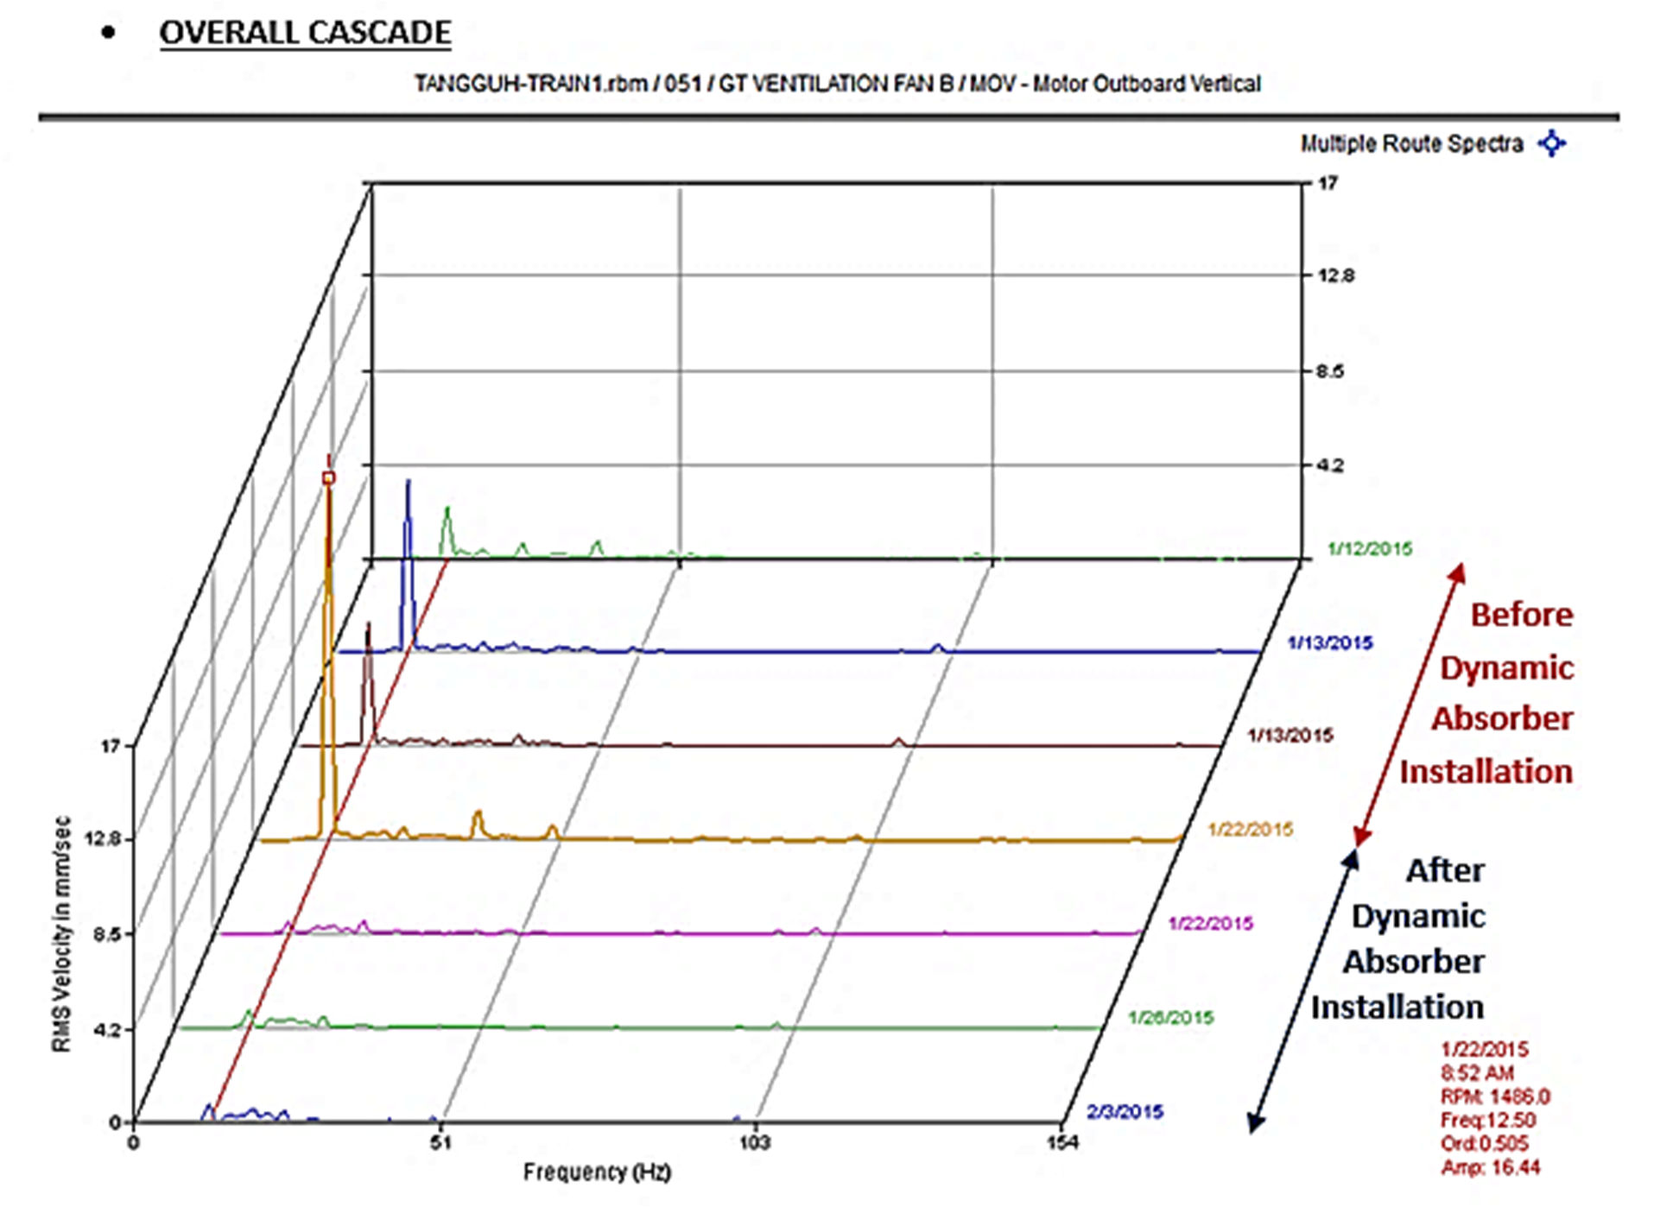

Picture 10 Confirmed at the time of dynamic absorber installation according to the recommendations, that the overall vibration tend to low

Measurement Point History
22-Jan-15 | 08:54 | 1486. | 100.0 | 14.04 | 2.078 | 3.237 | 13.98 | .962 | .596 | .482
22-Jan-15 | 15:06 | 1486. | 100.0 | 2.901 | 1.671 | 3.108 | 2.333 | 1.449 | .707 | .530

22-Jan-15 | 08:54 | 1486. | 100.0 | 3.947 | .570 | 3.525 | 3.830 | .336 | .792 | .359
22-Jan-15 | 15:06 | 1486. | 100.0 | 1.344 | .738 | 3.167 | 1.053 | .454 | .617 | .312

*************************

Database: TANGGUH-TRAIN1.rbm
Area: PR & MR Compressor (051) Report Date: 20-Feb-19 09:13

Period Reported: 22-Jan-15 To 22-Jan-15

Equipment 1: GT VENTILATION FAN B

DATE TIME RPM LOAD OVERALL PAR#1 PAR#2 PAR#3 PAR#4 PAR#5 PAR#6

51CG101C2B-MOH (RPM) APS 25 mm/Sec G-s mm/Sec mm/Sec mm/Sec mm/Sec
22-Jan-15 | 08:52 | 1486. | 100.0 | 15.54 | 1.042 | 3.076 | 15.47 | .974 | .572 | .414
22-Jan-15 | 15:05 | 1486. | 100.0 | 2.626 | .933 | 2.949 | 2.279 | 1.239 | .207 | .323

22-Jan-15 | 08:52 | 1486. | 100.0 | 16.81 | 2.752 | 2.404 | 16.65 | 1.012 | 1.762 | .473
22-Jan-15 | 15:05 | 1486. | 100.0 | 1.433 | .909 | 2.949 | .937 | .844 | .450 | .505

Early Warning Limits |  | --- | 7.407 | 4.348 | 4.045 | 7.342 | 1.574 | .320 | .426
Alert Limit Values |  | --- | 4.500 | 10.00 | 4.000 | 0. | 0. | 0. | 0.
Fault Limit Values |  | --- | 7.100 | 20.00 | 6.000 | 0. | 0. | 0. | 0.
51CG101C2B-MOV | (RPM) APS 25 |  | mm/Sec | G-s | mm/Sec |  | mm/Sec | mm/Sec | mm/Sec

Early Warning Limits |  | --- | 6.887 | 2.678 | 4.057 | 6.807 | 1.479 | .597 | .497
Alert Limit Values |  | --- | 4.500 | 10.00 | 4.000 | 0. | 0. | 0. | 0.
Fault Limit Values |  | --- | 7.100 | 20.00 | 6.000 | 0. | 0. | 0. | 0.
51CG101C2B-MIH | (RPM) APS 25 |  | mm/Sec | G-s | mm/Sec |  | mm/Sec | mm/Sec | mm/Sec

Early Warning Limits | --- | 7.660 | 5.411 | 3.717 | 7.584 | 1.087 | .434 | .522
Alert Limit Values | --- | 4.500 | 10.00 | 4.000 | 0. | 0. | 0. | 0.
Fault Limit Values | --- | 7.100 | 20.00 | 6.000 | 0. | 0. | 0. | 0.

51CG101C2B-M1H (RPM) APS 33 mm/Sec G-s mm/Sec mm/Sec mm/Sec mm/Sec
22-Jan-15 | 08:53 | 1486. | 100.0 | 13.97 | 1.655 | 2.980 | 13.86 | 1.149 | .937 | .462
22-Jan-15 | 15:05 | 1486. | 100.0 | 2.370 | 1.768 | 3.112 | 2.154 | .753 | .505 | .362

22-Jan-15 | 08:53 | 1486. | 100.0 | 13.86 | 1.647 | 2.980 | 13.76 | 1.149 | .934 | .457
22-Jan-15 | 15:05 | 1486. | 100.0 | 2.356 | 1.767 | 3.112 | 2.117 | .769 | .505 | .362

22-Jan-15 | 08:54 | 1486. | 100.0 | 14.21 | 2.086 | 3.237 | 14.15 | .965 | .607 | .486
22-Jan-15 | 15:06 | 1486. | 100.0 | 2.883 | 1.677 | 3.108 | 2.337 | 1.440 | .691 | .534

Early Warning Limits |  | --- | 7.588 | 5.403 | 3.709 | 7.507 | 1.062 | .424 | .520
Alert Limit Values |  | --- | 4.500 | 10.00 | 4.000 | 0. | 0. | 0. | 0.
Fault Limit Values |  | --- | 7.100 | 20.00 | 6.000 | 0. | 0. | 0. | 0.
51CG101C2B-MIV | (RPM) APS 25 |  | mm/Sec | G-s | mm/Sec |  | mm/Sec | mm/Sec | mm/Sec

Early Warning Limits |  | --- | 11.94 | 4.765 | 3.837 | 11.79 | 1.795 | .705 | .732
Alert Limit Values |  | --- | 4.500 | 10.00 | 4.000 | 0. | 0. | 0. | 0.
Fault Limit Values |  | --- | 7.100 | 20.00 | 6.000 | 0. | 0. | 0. | 0.
51CG101C2B-M1V | (RPM) APS 33 |  | mm/Sec | G-s | mm/Sec |  | mm/Sec | mm/Sec | mm/Sec

Early Warning Limits |  | --- | 11.78 | 4.668 | 3.868 | 11.64 | 1.791 | .665 | .731
Alert Limit Values |  | --- | 4.500 | 10.00 | 4.000 | 0. | 0. | 0. | 0.
Fault Limit Values |  | --- | 7.100 | 20.00 | 6.000 | 0. | 0. | 0. | 0.
51CG101C2B-MIA | (RPM) APS 25 |  | mm/Sec | G-s | mm/Sec |  | mm/Sec | mm/Sec | mm/Sec

Early Warning Limits | --- | 4.184 | 1.063 | 4.165 | 4.153 | .696 | .540 | .513
Alert Limit Values | --- | 4.500 | 10.00 | 4.000 | 0. | 0. | 0. | 0.
Fault Limit Values | --- | 7.100 | 20.00 | 6.000 | 0. | 0. | 0. | 0.

51CG101C2B-FIH (RPM) APS 71 mm/Sec G-s mm/Sec mm/Sec mm/Sec mm/Sec
22-Jan-15 | 08:55 | 722. | 100.0 | 19.18 | 9.792 | 3.826 | .644 | 18.98 | 1.366 | 2.189
22-Jan-15 | 15:07 | 722. | 100.0 | 2.041 | 10.06 | 4.095 | .280 | 1.652 | .854 | .688

22-Jan-15 | 08:55 | 722. | 100.0 | 19.07 | 1.841 | 4.512 | .476 | 18.87 | 1.326 | 2.206
22-Jan-15 | 15:07 | 722. | 100.0 | 2.054 | 1.541 | 4.032 | .349 | 1.609 | .908 | .686

22-Jan-15 | 08:55 | 722. | 100.0 | 8.815 | 5.399 | 3.419 | .215 | 8.621 | 1.415 | 1.039
22-Jan-15 | 15:08 | 722. | 100.0 | 1.185 | 16.23 | 4.419 | .180 | .648 | .803 | .521

22-Jan-15 | 08:55 | 722. | 100.0 | 8.767 | 1.028 | 3.504 | .228 | 8.584 | 1.374 | 1.012
22-Jan-15 | 15:08 | 722. | 100.0 | 1.130 | 1.079 | 3.727 | .202 | .638 | .703 | .533

22-Jan-15 | 08:56 | 722. | 100.0 | 7.141 | 2.239 | 3.294 | .984 | 6.645 | .337 | 2.379
22-Jan-15 | 15:08 | 722. | 100.0 | 2.052 | 3.494 | 3.966 | .909 | 1.371 | .584 | 1.049

22-Jan-15 | 08:56 | 722. | 100.0 | 16.39 | 6.516 | 4.010 | .550 | 16.29 | 1.112 | 1.282
22-Jan-15 | 15:08 | 722. | 100.0 | 2.087 | 10.71 | 4.634 | .465 | 1.853 | .467 | .496

22-Jan-15 | 08:56 | 722. | 100.0 | 11.29 | 6.007 | 4.357 | .129 | 11.18 | .925 | 1.019
22-Jan-15 | 15:09 | 722. | 100.0 | 1.105 | 8.315 | 3.981 | .081 | .699 | .695 | .438

22-Jan-15 | 08:57 | 722. | 100.0 | 6.802 | 1.690 | 3.441 | .690 | 6.363 | .345 | 2.242
22-Jan-15 | 15:09 | 722. | 100.0 | 1.874 | 3.972 | 3.899 | .495 | 1.452 | .453 | .954

Early Warning Limits |  | --- | 12.33 | 27.16 | 4.684 | .371 | 12.28 | 1.113 | .849
Alert Limit Values |  | --- | 4.500 | 10.00 | 4.000 | 0. | 0. | 0. | 0.
Fault Limit Values |  | --- | 7.100 | 20.00 | 6.000 | 0. | 0. | 0. | 0.
51CG101C2B-F1H | (RPM) APS 34 |  | mm/Sec | G-s | mm/Sec |  | mm/Sec | mm/Sec | mm/Sec

Early Warning Limits |  | --- | 12.18 | 2.496 | 5.391 | .639 | 12.12 | 1.087 | .881
Alert Limit Values |  | --- | 4.500 | 10.00 | 4.000 | 0. | 0. | 0. | 0.
Fault Limit Values |  | --- | 7.100 | 20.00 | 6.000 | 0. | 0. | 0. | 0.
51CG101C2B-FIV | (RPM) APS 71 |  | mm/Sec | G-s | mm/Sec |  | mm/Sec | mm/Sec | mm/Sec

Early Warning Limits |  | --- | 2.851 | 26.75 | 4.466 | .913 | 2.825 | 1.079 | .684
Alert Limit Values |  | --- | 4.500 | 10.00 | 4.000 | 0. | 0. | 0. | 0.
Fault Limit Values |  | --- | 7.100 | 20.00 | 6.000 | 0. | 0. | 0. | 0.
51CG101C2B-F1V | (RPM) APS 34 |  | mm/Sec | G-s | mm/Sec |  | mm/Sec | mm/Sec | mm/Sec

Early Warning Limits |  | --- | 2.855 | 1.990 | 4.463 | 1.209 | 2.792 | 1.060 | .703
Alert Limit Values |  | --- | 4.500 | 10.00 | 4.000 | 0. | 0. | 0. | 0.
Fault Limit Values |  | --- | 7.100 | 20.00 | 6.000 | 0. | 0. | 0. | 0.
51CG101C2B-FIA | (RPM) APS 71 |  | mm/Sec | G-s | mm/Sec |  | mm/Sec | mm/Sec | mm/Sec

Early Warning Limits |  | --- | 5.660 | 18.15 | 4.408 | .701 | 5.613 | .734 | 1.196
Alert Limit Values |  | --- | 4.500 | 10.00 | 4.000 | 0. | 0. | 0. | 0.
Fault Limit Values |  | --- | 7.100 | 20.00 | 6.000 | 0. | 0. | 0. | 0.
51CG101C2B-FOH | (RPM) APS 71 |  | mm/Sec | G-s | mm/Sec |  | mm/Sec | mm/Sec | mm/Sec

Early Warning Limits |  | --- | 11.92 | 18.58 | 4.870 | .526 | 11.88 | .676 | .510
Alert Limit Values |  | --- | 4.500 | 10.00 | 4.000 | 0. | 0. | 0. | 0.
Fault Limit Values |  | --- | 7.100 | 20.00 | 6.000 | 0. | 0. | 0. | 0.
51CG101C2B-FOV | (RPM) APS 71 |  | mm/Sec | G-s | mm/Sec |  | mm/Sec | mm/Sec | mm/Sec

Early Warning Limits |  | --- | 2.952 | 19.14 | 5.627 | .215 | 2.972 | 1.164 | .576
Alert Limit Values |  | --- | 4.500 | 10.00 | 4.000 | 0. | 0. | 0. | 0.
Fault Limit Values |  | --- | 7.100 | 20.00 | 6.000 | 0. | 0. | 0. | 0.
51CG101C2B-FOA | (RPM) APS 71 |  | mm/Sec | G-s | mm/Sec |  | mm/Sec | mm/Sec | mm/Sec

Early Warning Limits | --- | 2.908 | 13.54 | 5.023 | .762 | 2.557 | .777 | 1.192
Alert Limit Values | --- | 4.500 | 10.00 | 4.000 | 0. | 0. | 0. | 0.
Fault Limit Values | --- | 7.100 | 20.00 | 6.000 | 0. | 0. | 0. | 0.

