Vibration Analysis on GT Ventilation Fan of LNG Cryogenic Process

Mochamad Bhakti Prasastia Utama, Ir. Gatot Santoso, MT, Dr.Ir. Muki Satya, MT
NPM. 178070004
Program Studi Teknik Mesin, Universitas Pasundan Bandung

ABSTRACT

The majority of Vibration Analysts in the world agree that looseness is one of the five most common causes of breakdowns that result in excessive engine vibration, along with eccentricity, unbalance, and misalignment. The best solution to solve the looseness problem is to install the machine properly. Another possible temporary solution to solve the looseness problem is to install a dynamic absorber, a device designed to have the same reaction frequency as the dominant vibration direction of the structure itself that will counteract the initial motion. Vibrations from the machine will form a signal that can be detected by the CSI Analyzer 2130 tool to produce a vibration signal. The signal can be analyzed as damage to the machine from this vibration. Like the damage done to the GT Ventilation Fan base frames. The study analyzed vibrational signals in damaged Base frames by monitoring Spectrum signals at
12.5 Hz, the difference was seen in the shape of the spectral signal and vibrational waveform. In addition, the overall value also shows an increase in the GT Ventilation Fan Motor Side. The overall value produced on the
damaged Base frames can reach more than 15 mm/sec RMS on the motor outboard vertical side. In contrast to the system under normal conditions with an overall value of 1.433 mm/sec RMS. The overall value of the damaged system has exceeded the vibration limit of 4.5 mm/sec RMS.
Keywords: CSI Analyzer 2130, Vibration, Frequency, Spectrum, Waveform, Crack, Ventilation Fan.

INTRODUCTION
The mechanical vibrations generated from the machine come from the internal high- speed rotating activity of the system itself, so the vibration symptom has a frequency that cannot be felt significantly by the human senses.
One of the machines which a high-speed rotation with a stable vibration frequency is a Ventilation Fan.
The Ventilation Fan aims to inject the volume of air remaining from the turbine combustion and compressor gases. The Fan element itself is generally placed on the base-frames to support the rotation force of the system. And all the indications of a problem at the Ventilation Fan will determine from the fault frequency of vibration produced by the magnitude. The writing discussed, namely ‘Vibration
Analysis on GT Ventilation Fan of LNG Cryogenic Process’
The purpose of this paper is to determine the damage to the GT Ventilation Fan with vibration signal analysis and how to solve it according to the condition that surrounded by propane enclosure and zero downtime issue.

LITERATURE

Vibration analysis is one of the methodologies usually used in performing predictive techniques for Rotating Equipment (rotating machines). This technique utilizes the characteristics of the vibration generated by a rotating machine. Some of the defects that often appear on rotating machines are base-frames defects (looseness), unbalance, and misalignment. Each failure defects cases has its specific characteristics in the generated vibration signal pattern. There are three main parameters analysis should we concerned with vibration analysis performing, namely amplitude, frequency, and phase.
Amplitude is the size or magnitude of the vibration signal generated or identified as the magnitude of the generated force by the vibration. The higher the indicated amplitude, the greater the disturbance that occurs. The magnitude scale of the amplitude depends on the type of engine and its damage. The increase in amplitude at specific faults frequencies identifies the suspects of disturbances in the engine. By knowing the frequency when the machine vibrates, precision observation can determine the cause or source of the problem.
Measurement trending will send information about the increasing level of engine vibration. When the engine vibration level increases beyond the baseline signal, it is necessary to carry out special handling on the engine. Baseline data is a collection of data obtained through measurements when the machine is operating stably. The baseline data serves as a comparison of
measurement data to determine the engine condition. Meanwhile, to classify the level of damage or severity of the rotating machine, one of the standards is used to evaluate damage based on the class and type is ISO- 10816.

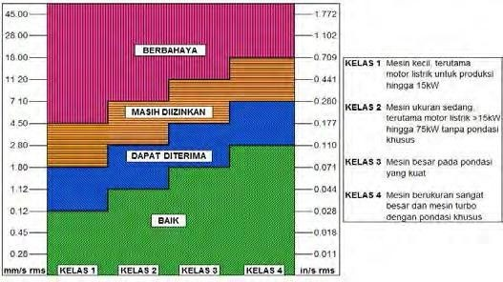
Organization for Standardization (ISO).
Picture 1 ISO 10816-1

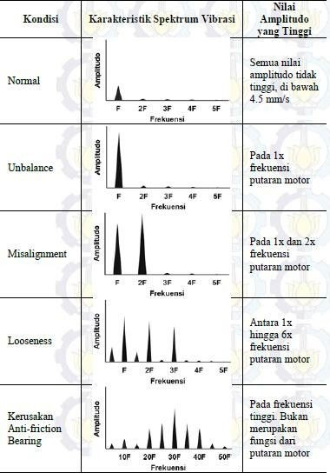
2. Tools
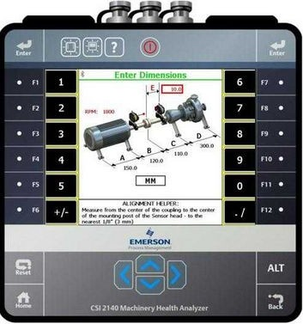
Picture 4 CSI Analyzer

- CSI Analyzer 2130
- GT Ventilation Fan
- AMS Suite Software: Machinery Health Manager
- Safety SPD & IK

Picture 2 Fault Characteristic

METHODOLOGY
1. Work Flow

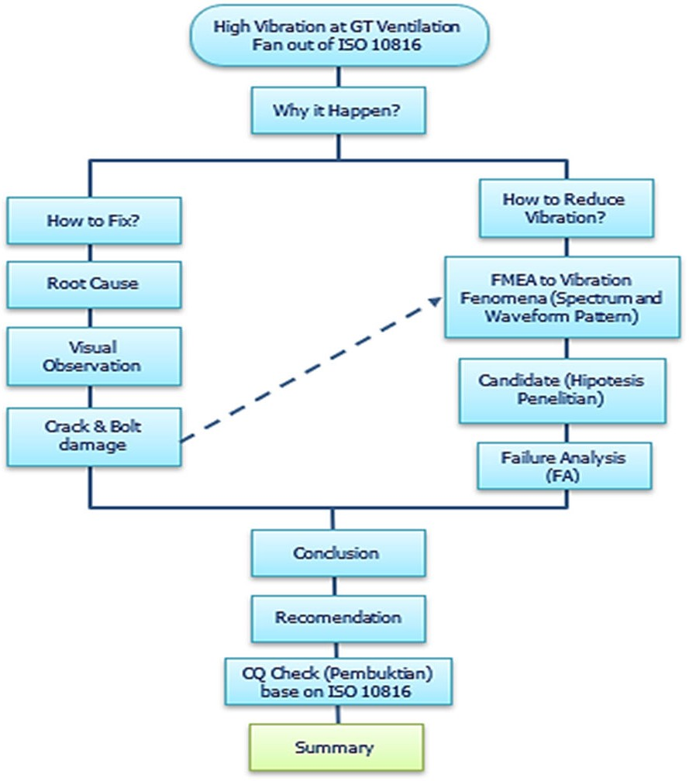
Picture 3 Work Flow

3. Procedure
The method used in this research is to take vibration signals with the CSI Analyzer 2130 on the vertical, horizontal, and axial GT Ventilation Fans. The procedure is as follows:
- GT Ventilation Fan in operating condition with a rotating speed of 2978 RPM, measured using a CSI Analyzer 2130.
- Measurement of vibration signals using this tool on the vertical, horizontal, axial, and peakvue on each inboard side.
- After obtaining a vibration signal indicating damage to the inboard side, the data is entered into the AMS Suite software database: Machinery Health Manager.
- The next measurement on the system uses

a monitoring signal on the Normal Averaging amplitude value at maximum frequency = 1000 Hz.

Data Collecting

Correct and accurate data collection will be helpful in the process of analyzing research results. The data collection method also determines the quality of the data obtained. In this study, researchers took data directly by observing several data of trending, waveform, and spectrum patterns of the damage on the system.

DATA
The presentation of research data is in the form of spectrum graphs and vibration signal waveforms from the research process on damaged GT Ventilation Fan Base frames and after installing a dynamic absorber.

Vibration Signal of Broken MOH
    - Fan Inboard Horizontal

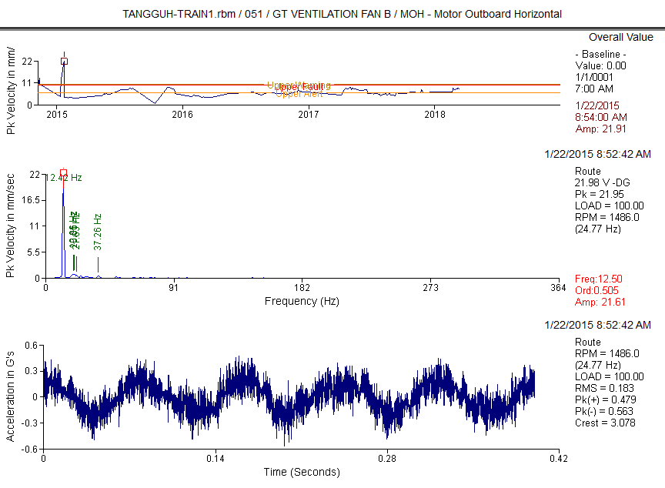
Graphic 2 MOH

Overall Value
Measurement Point History
*************************

Database: TANGGUH-TRAIN1.rbm Area: PR & MR Compressor (051) Report Date: 20-Feb-19 09:13
Period Reported: 22-Jan-15 To 22-Jan-15

Equipment 1: GT VENTILATION FAN B

DATE TIME RPM LOAD OVERALL PAR#1 PAR#2 PAR#3 PAR#4 PAR#5 PAR#6

51CG101C2B-MOH (RPM) APS 25 mm/Sec G-s mm/Sec mm/Sec mm/Sec mm/Sec

Vibration Signal of MOH
  - Motor Outboard Horizontal
22-Jan-15 08:52 1486. 100.0
51CG101C2B-MOV (RPM) APS 25 mm/Sec
16.81
15.54
22-Jan-15 08:52 1486. 100.0
51CG101C2B-MIH (RPM) APS 25 mm/Sec
13.97
22-Jan-15 08:53 1486. 100.0
1CG101C2B-M1H (RPM) APS 33 mm/Sec
13.86
22-Jan-15 08:53 1486. 100.0
51CG101C2B-MIV (RPM) APS 25 mm/Sec
14.21
22-Jan-15 08:54 1486. 100.0
51CG101C2B-M1V (RPM) APS 33 mm/Sec
14.04
22-Jan-15 08:54 1486. 100.0
51CG101C2B-MIA (RPM) APS 25 mm/Sec
22-Jan-15 08:54 1486. 100.0 3.947
8.815
22-Jan-15 08:55 722. 100.0
51CG101C2B-F1V (RPM) APS 34 mm/Sec
8.767
22-Jan-15 08:55 722. 100.0
51CG101C2B-FIA (RPM) APS 71 mm/Sec
7.141
22-Jan-15 08:56 722. 100.0
51CG101C2B-FOH (RPM) APS 71 mm/Sec
16.39
22-Jan-15 08:56 722. 100.0
51CG101C2B-FOV (RPM) APS 71 mm/Sec
11.29
22-Jan-15 08:56 722. 100.0
51CG101C2B-FOA (RPM) APS 71 mm/Sec
6.802
22-Jan-15 08:57 722. 100.0
1.042 3.076 15.47 .974 .572 .414
G-s mm/Sec mm/Sec mm/Sec mm/Sec 2.752 2.404 16.65 1.012 1.762 .473
G-s mm/Sec mm/Sec mm/Sec mm/Sec 1.655 2.980 13.86 1.149 .937 .462
G-s mm/Sec mm/Sec mm/Sec mm/Sec 1.647 2.980 13.76 1.149 .934 .457
G-s mm/Sec mm/Sec mm/Sec mm/Sec 2.086 3.237 14.15 .965 .607 .486
G-s mm/Sec mm/Sec mm/Sec mm/Sec 2.078 3.237 13.98 .962 .596 .482
G-s mm/Sec mm/Sec mm/Sec mm/Sec
.570 3.525 3.830 .336 .792 .359
5.399 3.419 .215 8.621 1.415 1.039
G-s mm/Sec mm/Sec mm/Sec mm/Sec 1.028 3.504 .228 8.584 1.374 1.012
G-s mm/Sec mm/Sec mm/Sec mm/Sec 2.239 3.294 .984 6.645 .337 2.379
G-s mm/Sec mm/Sec mm/Sec mm/Sec 6.516 4.010 .550 16.29 1.112 1.282
G-s mm/Sec mm/Sec mm/Sec mm/Sec 6.007 4.357 .129 11.18 .925 1.019
G-s mm/Sec mm/Sec mm/Sec mm/Sec 1.690 3.441 .690 6.363 .345 2.242

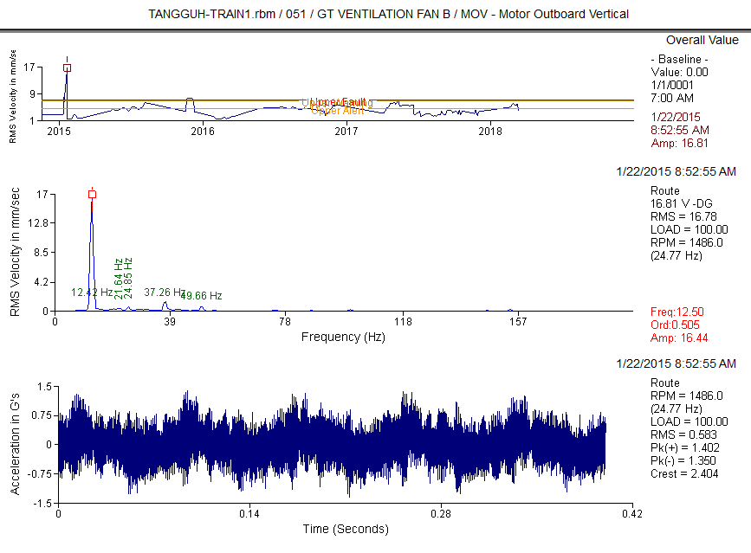--
Clarification Of Vibration Units: Acc --> G-s RMS
Vel --> mm/Sec RMS

Table 1 Overall Value

Graphic 1 MOH

DATA ANALYSIS
Graphic 1 The graph of the measurement results on the vertical direction of the outboard motor side, shown in the spectrum and waveform vibration signals. This spectrum and waveform signal indicates that the vertical outboard vibration signal is out of ISO-10816 severity. Although the spectrum graph shows that the system is in an unbalanced symptom due to the unbalance value in the spectrum, which is
16.81 mm/sec RMS overall, meanwhile it’s not normal for the motor side which 1X order is 25 Hz and the phase between the vertical and horizontal axis didn’t show 90’
±30’. The value is the average value or the overall value of the vibration amplitude against various frequencies that can express as speed, acceleration, or displacement.
Graph 2 is a graph that shows the vibration signal on the side of the outboard fan horizontal is also typical, which is the side that isn’t sensitive to base-frames damage. The vibration signal presents that the base- frames condition at the outboard motor has slightly lower than outboard it may be caused by the fan belt holding them.
The other way to find the dominant frequency, highest amplitude, and analyze their movement is using Operating Deflection Shape ODS Method.
Here we found that vibration at GT Ventilation fan was generated by 12.5 Hz and dominated by vertical axis or ‘Y’ direction.
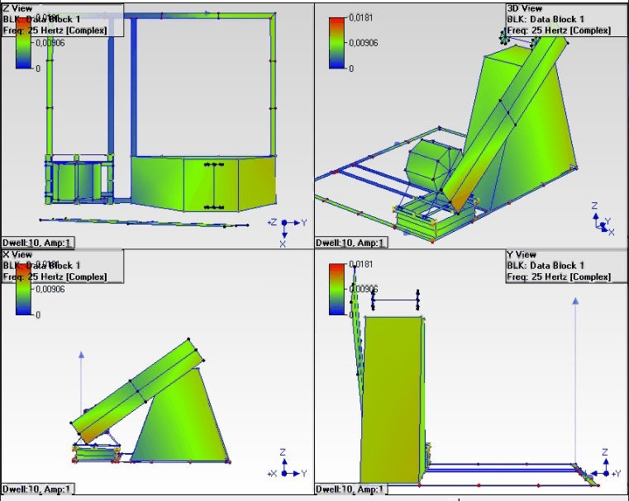

Picture 5 Operating Deflection Shape (ODS) as Finite Element Image

The first Hypothesis will be decided by FTA as below, it’s including the big four of a general problem in vibration-based on S Ralph Buscarello’s research.

Candidate | Common Solving Method | Finding & Analysis |  | Summary | Recommendation
 |  | Aggravating √ | Disanvantaging X
Unbalance | PerformOnsite Balancing | SemslikepurelySinusiodal waveformocur | Sinusiodal waveformaren't generatedby1XRPMof Motor | No | None
Mi salignment | Checkfacetoface uniformityof the couplingthenPerform LaserAlignment | HighVibrationphenomenon maycausedbyMi salignment Problem | There'sno2xRPM frequencyshownat the spectrum  There'snoOut of Phase  symptomat twopedestal bearingcoupling | No | None
Bearing Problem | PerformBearing Replacement | Oneof themost comon problemwhichgenerateHigh Vibrationphenomenonmay causedbyBearingProblem  1xRPMat FanSidewasocur | There'snoharminicspattern shownat thehigh frequencisof thespectrum | No | None
Losenes | Performretightenon thesystemorrelief fot stresusingOnline Checkphaseanalysis  method | Losenesalsocangenerate highvibrationonthesystem  1xRPMwasocurbothat X axisandYaxis | There'snomultipliesof 1x RPMharminicspattern shownat thespectrum,it maycausedbyspringeffect at baseframewasto  dominat | Yes | None
Tabel 2 Fault tree analysis (FTA)

FTA result was confirmed to the existing condition which visual inspection at the bottom of the inside motor base frames showed initial crack it may be caused by corrosion

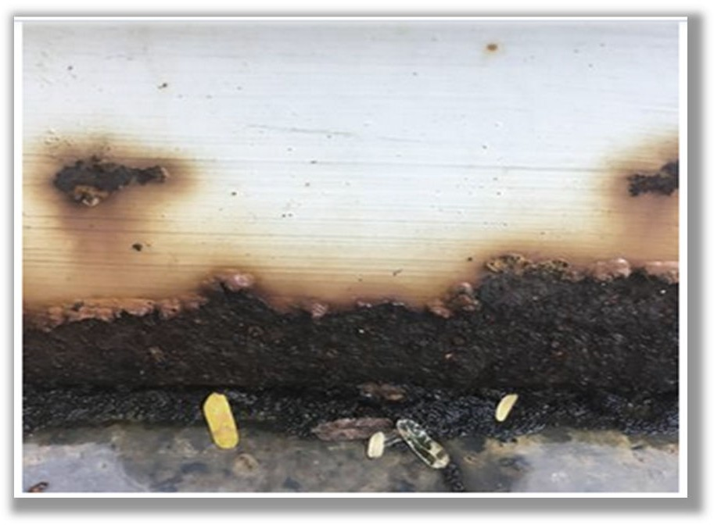Then the next step is entering the data into the calculation formula:
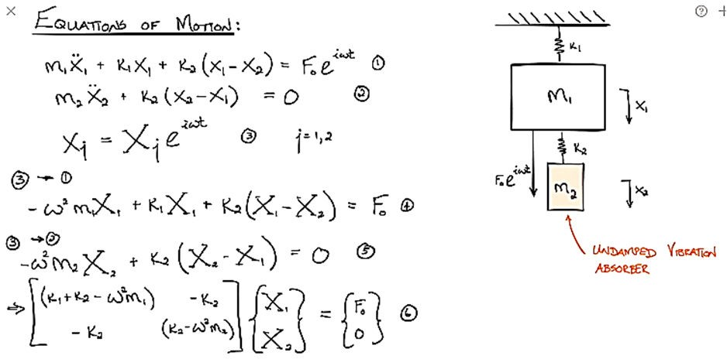

Picture 6 Visual inspection at the bottom of the inside motor base frames shown initial crack it may be caused by corrosion
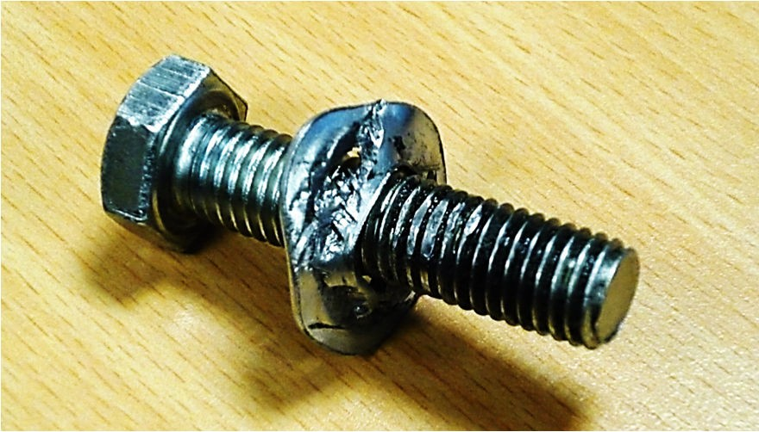
Picture 7 Several bots and nuts are broken

VERIFICATION AND SOLUTION (CALCULATION METHODOLOGY)
So, the first hypothesis based on FTA it’s declared as base frames looseness combined with soft foot (not purely structural which is caused by lost torsion of the bolts and join).
Then since its, base frames looseness it means 2 degrees of freedom in the vertical direction.
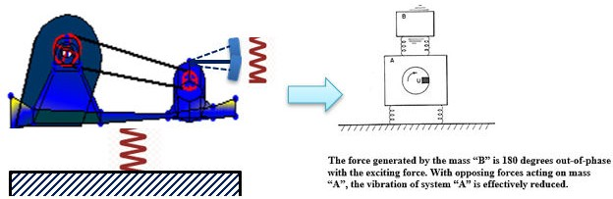
Picture 8 assumed GT Ventilation Fan in two degrees of freedom in Free Body Diagram

Picture 9 Two deg of freedom formula without damping

M Ẍ1 + k1X + k2 (X2 - X1) – Fa sin ⱷt (1)
m Ẍ2 + k2 (X2 - X1) = 0 (2)

Put X1 = Asin ⱷt and X = B2 sin ⱷt it’s mean Ẍ1 = rees-ⱷ² Asin ⱷt and Ẍ2 =-ⱷ² B sin ⱷt Subtitute to equations (1) dan (2)

k1 + k2 - Mⱷ²) A - k2B = F (3)

-k2A + (k2 - mⱷ²) B = 0 (4)

𝐹𝑎 (k2 − 𝑚ⱷ²)
𝐴 =
hence, (k1 + k2 − 𝑀ⱷ²)(k2 − 𝑚ⱷ²)−k2²
(5)

So, to counter all resultant of force in GT Ventilation Fan with mass M, then the number of A needs to the limit of zero, A
➔0, then k2 = mⱷ² or ⱷ² = k2/m = k1 /M.

- k1/M = k2/m or f1 = f2 …. (Seto. William W 1985)
It’s hard for us to estimate the mass of the GT Ventilation Fan on the site, but there are two keys that we can use to solve the problem:
- First we got the magnitude.
- Second we have the number of frequencies (12.5 Hz)
Since f1 = f2, then what we’ve to do now is find the tunning to create a 12.5 Hz

Dynamic Absorber to counter the force with
12.5 Hz of frequency.
Here we adopt the journal of Randy Fox in Entek IRD International Corp. Houston, TX to create a simple Dynamic Absorbers:
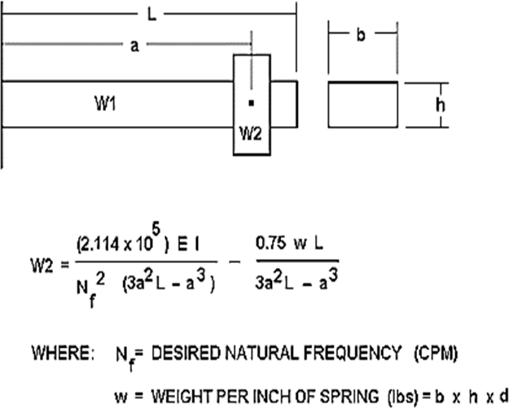
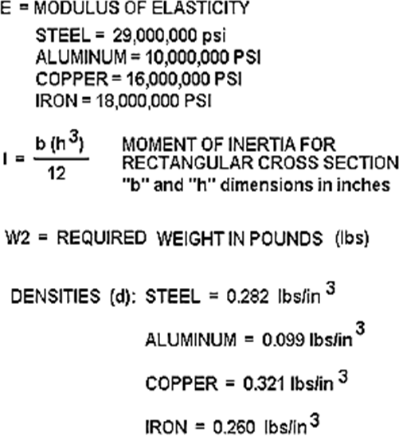

Then the next step is simulating the formula above into the excel program to calculate the dimension of dynamic absorber that we need:
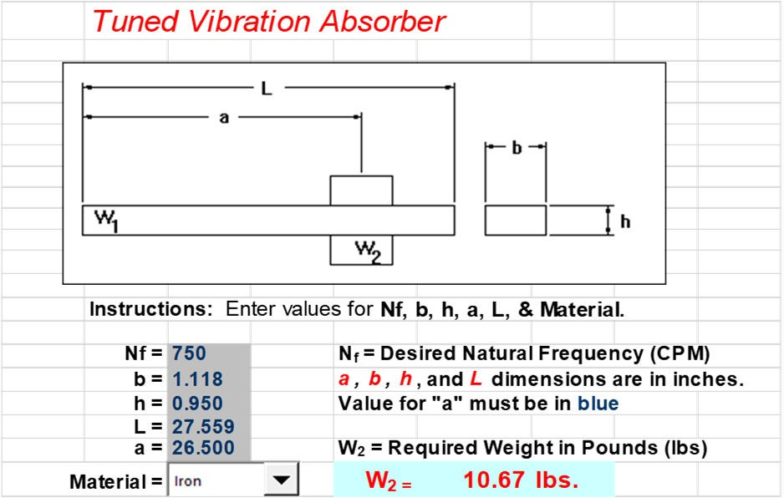
Picture 8 simple dynamic absorber dimension

Iron bar with a pendulum (weight) was
chosen as the construction of the Dynamic Absorber as shown in the picture below, hereinafter the Dynamic Absorber Trial is named Dynamic Absorber Trial-1 (DAT-1).
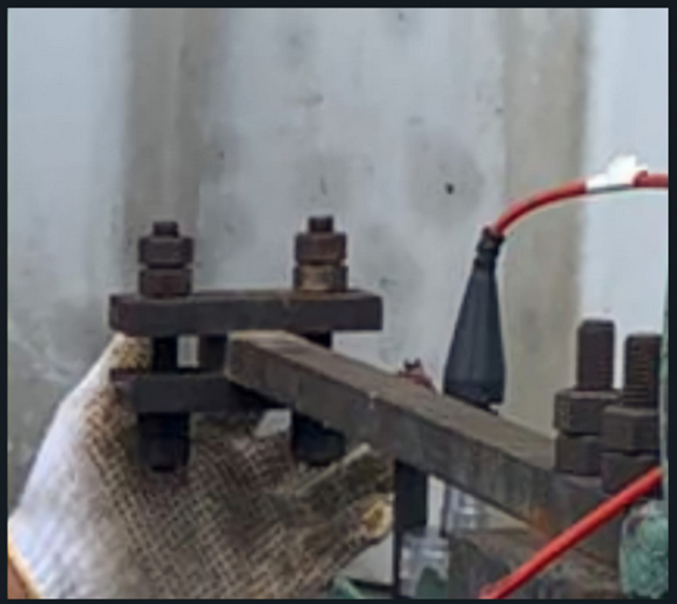
Picture 9 Dynamic Absorber yang diinstalasi, Dynamic Absorber Trial-1 (DAT-1)

As the result, all vibration value at GT Ventilation Fan tends to decrease after Dynamic Absorber Installation and this also confirms and proves the truth of the Failure Analysis first hypothesis regarding the cause of the alleged damage at GT Ventilation Fan.
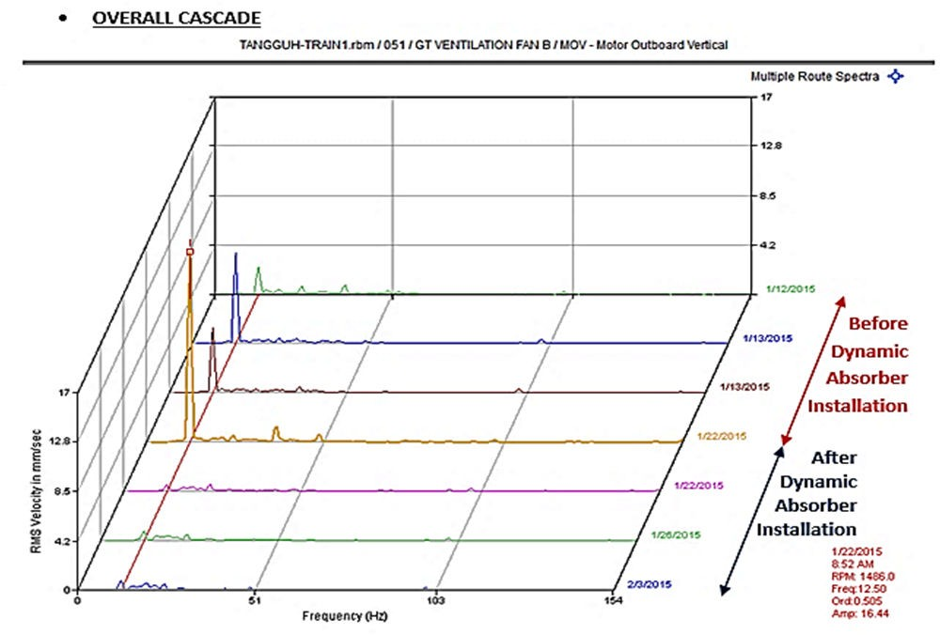

Picture 10 Confirmed at the time of dynamic absorber installation according to the recommendations, that the overall vibration tends to decrease

CONCLUSION
The results of the research on base-frames damage to the GT Ventilation Fan, the following conclusions are drawn:

- Vibration analysis can produce failure diagnosis stages in the machine that been occurred due to the interaction between vibration and improper quality of the base plate.
- The cause of the GT Ventilation failure is due to Initial Crack or deformation that causes looseness, resulting in the spring effect phenomenon.
- In the case of looseness, the accuracy of the absorber dynamic personal frequency value is the most influential factor in reducing the machine vibration amplitude value.
- The dynamic absorber square or rectangular rod can direct the vibration vector of the system but will reduce its effectiveness.
- Installing a dynamic absorber on the GT Ventilation Fan reduces the vibration amplitude value up to 80%.

BIBLIOGRAPHY
- Agilent Technologies. The fundamentals of Signature Analysis. Note: 243

- Mackay, Steve (Ed.). 2004. Practical Machinery of Vibration Analysis and Predictive Maintenance. Oxford: Elsevier.

- Pratama, Tiara Vibrasindo. 2005. Pemrosesan Sinyal. Jakarta: Tiara Reliability Solution.

- S Ralph Buscarello, Practical Solutions to Machinery and Maintenance Vibration Problems, Chapter 1, Basic Information. Section 1 What to Look For, Most of the Time

- Randy Fox, Dynamic Absorbers for Solving Resonance Problems, Entek IRD International Corp. Houston, TX

- ISO 10816: 2014 Mechanical vibration -- Evaluation of machine vibration

- Heinz P. Bloch - Elsevier, Practical Machinery Vibration Analysis & Predictive Maintenance

