LAMPIRAN

- Data Hasil Perolehan Suara Pemilu AS 2016
(Eileen J. Leamon, 2017).
Presidential candidate | Party | Home state | Popular vote |  | Electoral  vote | Running mate
 |  |  | Count | Percentage |  | Vice-presidential candidate | Home state | Electoral vote
Donald John Trump | Republican | New York | 62,984,828 | 46.09% | 304 (306) | Michael Richard Pence | Indiana | 305
Hillary Diane Rodham Clinton | Democratic | New York | 65,853,514 | 48.18% | 227 (232) | Timothy Michael Kaine | Virginia | 227
Gary Johnson | Libertarian | New Mexico | 4,489,341 | 3.28% | 0 | Bill Weld | Massachusetts | 0
Jill Stein | Green | Massachusetts | 1,457,218 | 1.07% | 0 | Ajamu Baraka | Illinois | 0
Evan McMullin | Independent | Utah | 731,991 | 0.54% | 0 | Mindy Finn | District of Columbia | 0
Darrell Castle | Constitution | Tennessee | 203,090 | 0.15% | 0 | Scott Bradley | Utah | 0
Gloria La Riva | Socialism and Liberation | California | 74,401 | 0.05% | 0 | Eugene Puryear | District of Columbia | 0
Individuals who did not run but received electoral votes from faithless electors
Bernie Sanders | Independent | Vermont | 111,850 | 0.08% | 1 (0) | Elizabeth Warren | Massachusetts | 1
John Kasich | Republican | Ohio | 2,684 | 0.00% | 1 (0) | Carly Fiorina | Virginia | 1
Ron Paul | Libertarian | Texas | 124 | 0.00% | 1 (0) | Michael Richard Pence | Indiana | 1
Colin Powell | Republican | Virginia | 25 | 0.00% | 3 (0) | Elizabeth Warren | Massachusetts | 1
 |  |  |  |  |  | Maria Cantwell | Washington | 1
 |  |  |  |  |  | Susan Collins | Maine | 1
Faith Spotted Eagle | Democratic | South Dakota | 0 | 0.00% | 1 (0) | Winona LaDuke | Minnesota | 1
Other |  |  | 760,210 | 0.56% | — | Other |  | —
Total |  |  | 136,669,276 | 100% | 538 |  |  | 538
Needed to win |  |  |  |  | 270 |  |  | 270
Lampiran 1Data Hasil Perolehan Suara Pemilu AS 2016

- Dana Kampanye

(Shana M. Broussard, 2020) | Panitia kampanye (per 9 Desember 2016) |  |  |  | Grup luar (per 9 Desember 2016) |  |  | Total yang dibelanjakan
 | Uang terkumpul | Menghabiskan uang | Uang di tangan | Hutang | Uang terkumpul | Menghabiskan uang | Uang di tangan
Donald Trump | $350.668.435 | $343.056.732 | $7.611.702 | $0 | $100.265.563 | $97.105.012 | $3,160.552 | $440.161.744
Hillary Clinton | $585.699.061 | $585.580.576 | $323,317 | $182 | $206.122.160 | $205,144,296 | $977.864 | $790.724.872
Gary Johnson | $12.193.984 | $12.463.110 | $6.299 | $0 | $1,386,971 | $1,314,095 | $75,976 | $13.777.205
Rocky De La Fuente | $8.075.959 | $8.074.913 | $1,046 | $8.058.834 | $0 | $0 | $0 | $8.074.913
Jill Stein | $11.240.359 | $11.275,899 | $105,132 | $87.740 | $0 | $0 | $0 | $11.275,899
Evan McMullin | $1.644.102 | $1,642,165 | $1,937 | $644.913 | $0 | $0 | $0 | $1,642,165
Kastil Darrell | $72,264 | $68,063 | $4.200 | $4.902 | $0 | $0 | $0 | $68,063
Gloria La Riva | $31.408 | $32.611 | $0 | $0 | $0 | $0 | $0 | $32.611
Monica Moorehead | $14.313 | $15.355 | -$1,043 | -$5.500 | $0 | $0 | $0 | $15.355
Peter Skewes | $8,216 | $8,216 | $0 | $4,000 | $0 | $0 | $0 | $8,216
Lampiran 2Dana Kampanye

- Data pengguna Facebook-Cambridge Analytica yang bocor
(Jarot, 2018)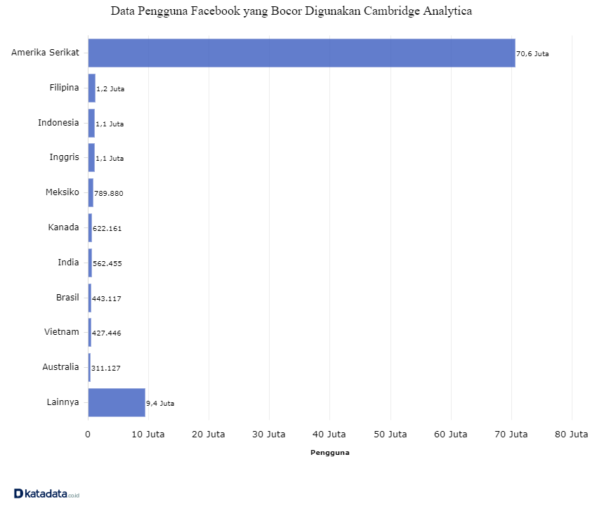
Lampiran 3Data Pengguna Facebook-Cambridge Analytica yang Bocor

