**An Analysis of Pop Up as a Media in Teaching Narrative Text in Enhancing Students’ Speaking Skill**

**(A Study Towards the Teaching and Learning Activity to 10th Grade Students of Pasundan 8 Senior High School Bandung Academic Year 2019-2020)**

**A Research Paper**

Submitted to the English Department

Faculty of Arts and Letters Pasundan University

as a Partial Fulfilment of the Requirements

for Taking the *Sarjana* Degree (S-1)

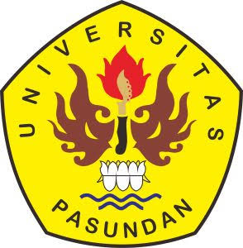

**By:**

**Lilis Sri Apriliani**

**Reg. Number: 167010015**

**ENGLISH DEPARTMENT**

**FACULTY OF ARTS AND LETTERS**

**PASUNDAN UNIVERSITY**

**BANDUNG**

**2020**