A Semiotic Analysis of Korean Tourism Product Advertisement Videos on VisitSeoulTV YouTube Channel
Entitled I Seoul U

A Research Paper

Submitted to the English Department of
Faculty of Arts and Letters
Pasundan University
as a Partial Fulfillment of the Requirements for taking the Sarjana Degree

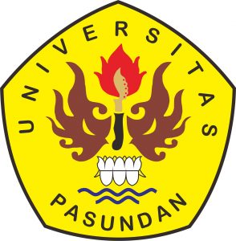

By:
Muthi Arina Maulana
167010011

ENGLISH DEPARTMENT
FACULTY OF ARTS AND LETTERS
PASUNDAN UNIVERSITY
BANDUNG
2020

