**AN ANALYSIS OF TRANSLATION METHOD ON WEBSITE**

***(A Study towards Web Content of the Ministry of Tourism and Culture West Java Province Office Website 2021)***

**A Research Paper**

Submitted to the English Department Faculty of Arts and Letters Pasundan University as a Partial Fulfillment of the Requirements for Taking the *Sarjana* Degree

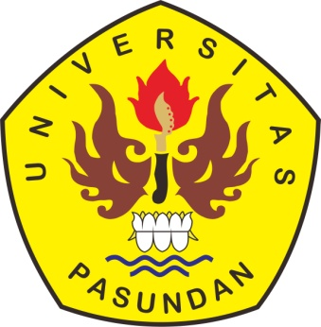

**Siti Eva Peruziah**

**Reg. Number 167010044**

**English Department**

**Faculty of Arts and Letters**

**Pasundan University**

**Bandung**

**2021**