An Analysis of Revenge as Punishment in Murder on the Orient Express Directed by Kenneth Branagh (2017)

A Research Paper
Submitted to the English Department, Faculty of Arts and Letters Pasundan University as a Partial Fulfillment of the Requirement for Taking the Sarjana Degree (S-1)

By:
Budi Cahyono
Reg. Number: 167010031

ENGLISH DEPARTMENT
FACULTY OF ARTS AND LETTERS
PASUNDAN UNIVERSITY

BANDUNG
2021

Declaration of Originality
I hereby state that the paper “An Analysis of Revenge as Punishment in Murder on the Orient Express Directed by Kenneth Branagh (2017)” is true masterpiece of myself.
I am fully aware that I have quoted some statements and ideas from various sources and they are properly acknowledged in my paper. I do not copy or quote with the way that is against from the scientific society. From the statement above, I accept any judgement if someone found there is scientific ethic contrary in this paper or there is claim from another side toward the original work.

Bandung, March 19th, 2021

Budi Cahyono
NRP.167010031

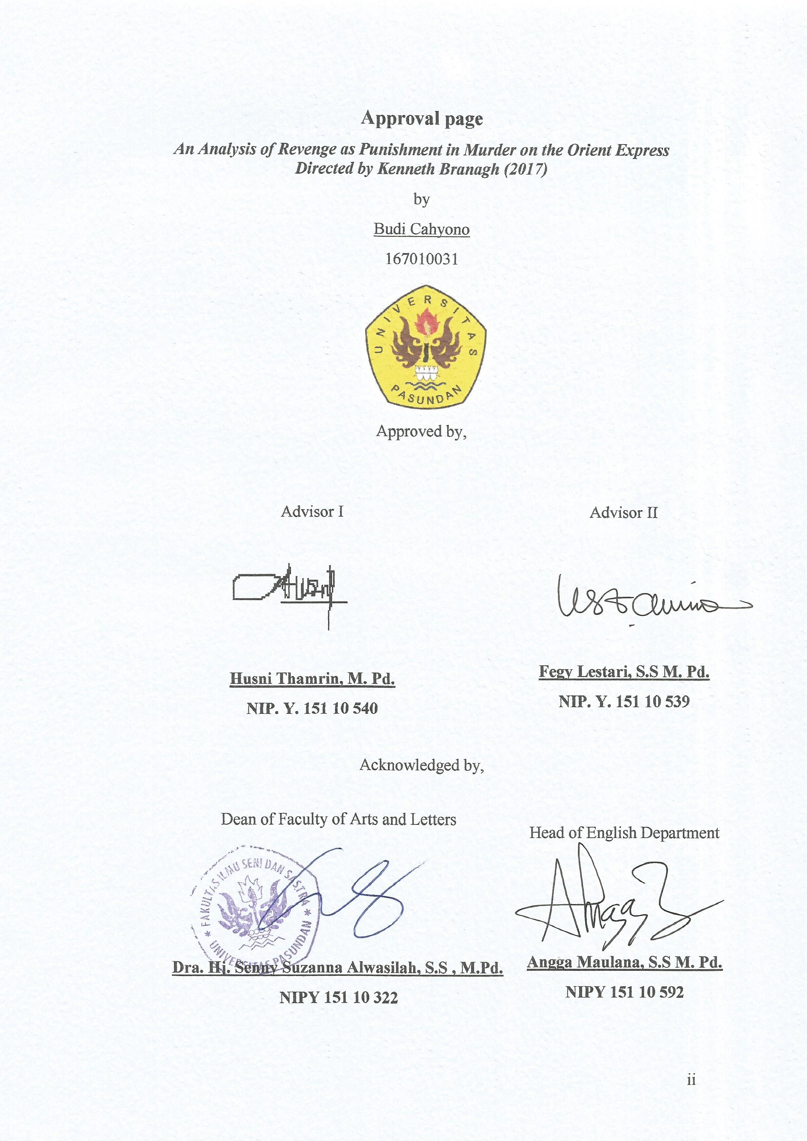

Dedicated Page
Alhamdulillahirabbil’alamin. Praise be to Allah Subhanahu wa Ta’ala, Lords of the worlds, who has permitted me to finish this research paper.
This research paper is proudly dedicated for my parents, Wawat and Yuniati. Thank you for always loving and taking care of me for these twenty tree years. You are the people who never underestimate and always convince me to reach my dreams. I love you so much!

Abstract
This research is entitled “An Analysis of Revenge as Punishment in Murder on the Orient Express Directed by Kenneth Branagh (2017)”. The objective of this research is to find out how the revenge influence the characterization of the main characters. The writer would limit the studies on the story within Murder on The Orient Express (2017) film and its main characters. The writer uses a descriptive qualitative method in order to answer the research problem by doing implementation of analysis about revenge as a punishment stated by Stephanie DiGiorgio. The writer collected that data in Murder on The Orient Express (2017) based on its characters, sequences of events, conversations between the characters. The writer finds that the incident of Rachett’s death was because the twelve people were taking revenge toward him as a punishment. The writer also finds that revenge is an act that can bring justice for the suspects in this film.
Keyword: film, detective story, revenge, characterization

Preface
Assalamu’alaikum Wr. Wb.
Praise to Allah Subhanahu wa Ta’ala, the Most Merciful and the Most Gracious, for the blessing and the permission, the writer could finish the paper entitled “An Analysis of Revenge as Punishment in Murder on the Orient Express Directed by Kenneth Branagh (2017)”. This paper is submitted to English Department, Faculty of Arts and Letters, Pasundan University, to fulfill the requirement for taking the Sarjana degree (S-1).
The writer realizes that the paper is not perfect and still contains some mistakes. Therefore, comments and critics are welcomed and appreciated. Finally, the writer hopes this paper can give information and significant contribution to the readers, especially in education aspect.
Wassalamu’alaikum Wr. Wb.

Bandung, March 19th, 2021

Budi Cahyono

NRP. 167010031

Acknowledgement
In the name of Allah Subhanahu wa Ta’ala, The Most Gracious and The Most Merciful, The Lord of the Universe. Because of Allah, the writer could finish this research paper as one of the requirements for Sarjana English Department of Faculty of Arts and Letters in Universitas Pasundan Bandung. Peace and salutation always be given to our prophet Muhammad SAW who has guided us from the darkness to the lightness.
The writer would not finish this paper without supports, guidances, advices, helps, and encouragements from people around him. The writer somehow realizes that this is an appropriate moment to deliver the deepest gratitude for:
- Husni Thamrin, M. Pd., the first advisor, who has also educated, supported, and given the writer advices, suggestions, and recommendations for this research paper from the beginning until the end,
- Fegy Lestari, S.S., M.Pd., the second advisor and the academic advisor of 2016 English Literature students, who has educated, supported, guided him during being English Literature student, and given the writer advices and suggestions for this research paper from the beginning until the end,
- Dr. Hj. Senny Suzanna Alwasilah, S.S., M.Pd., the Dean of Arts and Letters Faculty,
- Angga Maulana, S.S., M. Pd., the Head of English Department,
- All of the lecturers in the English Literature Department for giving the writer knowledge and guidance in his study,
- The writer’s special person, Vidya Evenangelia, who is never bored to listen, to discuss, and to motivate him,
- All of the writer’s close friends a.k.a. Majelis, Sammy, Raka, Awien, Ilham, Fakhri, and Anan, for all happiness, sadness, laughs, and tears that have been passed together for these four years,
- All of the writer’s friends in broadcasting division; Vidya, Awien, Anan, Yusuf, Nde, Fika, Selfina, Sania, Nadia, and Cila, for our togetherness in learning and improving ourselves to be good broadcaster during these one and a half years,
- All of the writer’s friends of 2016 English Department that could not be mentioned one by one.
Finally, this research paper is expected to be able to provide useful knowledge and information to the readers. Moreover, the writer is pleased to accept more suggestions and contributions from the readers for the improvement of this research.

TABLE OF CONTENT

DECLARATION OF ORIGINALITY i
APPROVAL PAGE ii
DEDICATED PAGE iii
ABSTRACT iv
PREFACE v
ACKNOWLEDGEMENT vi
TABLE OF CONTENT viii
BAB I INTRODUCTION 1
1.1 Background 1
1.2 Identification of Problems 3
1.3 Limitation of The Study 4
1.4 Research Question 4
1.5 Objective of The Study 4
1.6 Significances of The Study 5
BAB II Revenge in Murder on The Orient Express (2017) 6
2.1 Film 6
2.2 Genre in Film 7
2.3 Relation Between Novel and Film 9
2.4 Detective Story 10
2.5 Characterization 11
2.6 Conflict 12
2.7 Revenge 14
BAB III RESEARCH METHOD 16
3.1 Research Method 16
3.2 Procedure of Data Collection 17
3.3 Technique of Analysis Data 18
3.4 Research Object 19
BAB IV DISCUSSIONS AND FINDINGS 20
4.1 Sysnopsis 20
4.2 General Interpretation 21
4.2.1 Theme 21
4.2.2 Characters 22
4.2.3 The Plot of The Film 30
4.2.4 Setting 37
4.2.5 Point of View 38
4.2.6 Moral Message 38
4.3 Specific Interpretation 38
4.3.1 Revenge as A Theme 39
4.3.2 Revenge as A Conflict 46
4.3.3 Changes of Characteristic Caused by Revenge 54
4.4 Conclustion 67
BAB V CONCLUSION AND SUGGESTIONS 70
5.1 Conclusion 70
5.2 Suggestion 72
BIBLIOGRAPHY 73
CURRICULUM VITAE 75
APPENDICES 76

