An Analysis of English Lesson Planning at Pasundan 8 Senior High School Bandung
(A Study toward English Lesson Planning of 2nd Grade Class Academic Year 2019 – 2020 Compatibility with Indonesia Curriculum 2013)

A Research Paper

Submitted to the English Department of
Faculty of Arts and Letters
Pasundan University
as a Partial Fulfillment of the Requirements for Taking the Bachelor Degree

By:
Hanja Naila Granita Dewi
Reg. Number: 167010047

English Department
Faculty of Arts and Letters
Pasundan University
Bandung
2021

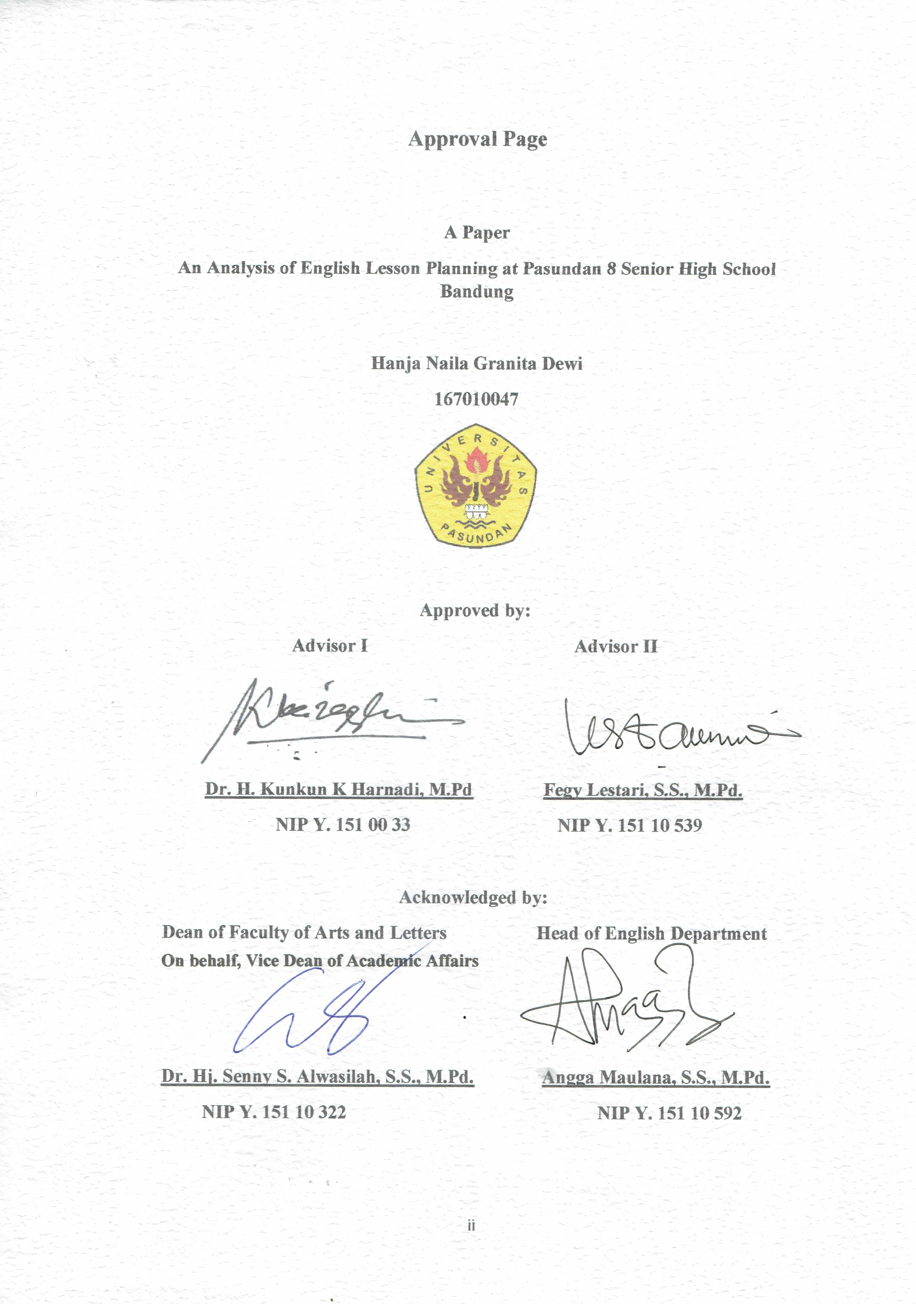

Declaration of Originality
I here stated that the paper entitled “An Analysis of English Lesson Planning at Pasundan 8 Senior High School Bandung” was trully written by the writer. This paper contains some quotes and statements from various sources and all of them were clearly mentioned who and where those statements came from, the writer was tried to avoid plagiarism. According to the statement above, the writer will be ready to revise the paper if there is found kinds of failures toward the plagiarism.

Bandung, March 17th 2021
The Writer

Hanja Naila Granita Dewi
NRP: 167010047

Preface
Bismillahirrahmanirahim
Alhamdulillaahi Robbil’aalaamiin, by the blessing of Allah SWT, the writer has finished this research entitled “An Analysis of English Lesson Planning at Pasundan 8 Senior High School Bandung” This paper was written to fulfill a requirement to take a bachelor degree at English Department of Pasundan University.
In the process of conducting this research, writer is facing many obstacles but it could be passed by the strength of herself, the prayer of my mother and all supports from her friends that could not be mentioned one by one. In this opportunity, the writer really do apologize for all the mistakes that have been made in this paper. The writer realized that this paper may not perfect in all the aspects but this paper hopefully could be used as a reference and evaluation to the next researcher who want to know all about the lesson planning and its equipment.

Bandung, March 17th 2021
The Writer

Hanja Naila Granita Dewi
NRP: 167010047

Dedication

“Stay focused when you’re playing alive, so you’re not distracted by something going on”

(John Petrucci)

This research paper is dedicated to:

To my beloved mother (Katrin Magdalena) who has given me unconditional love since I was born until now. The greatest woman behind me who has spent too much time, energy and everything to me. May Allah SWT always by her side to protect and send the everlasting love into her life.

Acknowledgements

After finishing this research, the writer would like to gratitude to all who was given her a blessing, guidance, support, motivation and encouragement through the process of this research. The writer would like to appreciate to those who helped her to finish this study, they are:
- Dr. H Kunkun K. Harnadi, M. Pd., as the first advisor who taught a lot of things, with his patient and his support the writer could conducted a research properly.
- Fegy Lestari, S.S, M. Pd., as the mother of Englite 2016 also as a second advisor who taught and give a guidance about grammatical rules in this research paper.
- Dr. Hj. Senny S. Alwasilah, S.S,M.Pd., as the Dean of Faculty of Art and Letters.
- Angga Maulana, S.S. M.Pd as the Head of English Department.
- Her mother Katrin Magdalena, beloved family of Alm.Tatang S and Alm.H.Tjetje Priatna who always give everything in their life for her.
- Her amazing partners Vidya, Khaliza, Regina, who always by her side and never get tired to help even in her hardest condition.
- Her friends from Englite 2016, 2015, 2014, 2013 & 2017, they were people who also gave her more support and gave her so many precious memories in college.
- Her friends from music community LI, JRS & J-Band for the support.
- The last appreciation is to her self because she has responsible to finish her study.

Abstract
The research entitles “The Analysis of English Lesson Planning at Pasundan 8 Senior High School Bandung” it attempt to find out how are the structure of lesson planning and component of teaching equipment arranged by 2nd grade English teacher of Pasundan 8 Senior High School Bandung academic year 2019 - 2020 based on the standard of Indonesia curriculum 2013. This research has passed through several process as example planning, implementing and reporting.
This research use qualitative method since it does not need a statistic approach. The data in this research is a bundle of lesson planning arranged by 2nd English teacher of Pasundan 8 Senior High School Bandung academic year 2019 – 2020. This lesson planning is as a main data of this research. The analysis used instrument document analysis in form of table content analysis checklist. The writer take the Ministry of Education and Culture regulation number 22 year 2018 and Training Module as a grand theory related with this research. Those two grand theories are become a parameters to compare each component and structure of lesson planning with Indonesia curriculum 2013.
The result of this research is the writer highlighting the teaching equipment as a weak part because the writer found some unavailable aspects on it. All the aspects in identity of lesson planning has in accordance with Indonesia curriculum 2013 since there is no found a missing aspect meanwhile in the teaching equipment not all the part has in accordance with Indonesia curriculum 2013.

Keywords: Lesson Planning, Teaching Equipment, Teaching, Curriculum 2013

