**Chapter II**

**THEORETICAL FOUNDATION**

In this chapter, the researcher tries to give a clear description of the theoretical foundation which covers the general concept of writing, descriptive text, and Mind Mapping method.

**2.1 Mind Mapping**

Students need a method to easily write a text. The Mind mapping method is one of the methods that can be used to solve a problem that is in a natural student when creating a writing. According to Buzan (2008) “Mind Mapping is a creative note-taking technique in visualization and graphic forms that are used to make people find it easy to enter information into their brains, keeping the information in a long term memory and taking it out from their brains easily by engaging imagination and association”. “Mind mapping is a creative way for every learner to generate their ideas, record what is learned, or plan new assignments”, stated by Silberman (1996).

Making a mind map is a strategy for note-making before writing. Mind mapping is actually about using our mind to think about what the importance information should be in the writing. Mind mapping can also be called as planning in making a writing there is an early planning to be written, this thought mapping method is one of the methods to facilitate making a writing.

Mind mapping is a visual to distinguish words or ideas by using colors and images. Usually it will create a line like a tree branch, by branching into the sub-section to be created. Mind mapping helps to be more creative, making it easier to pour ideas and information to be written. Mind mapping helps learners overcome difficulties, know what they want to write, and how to organize ideas, as this technique can help how to start making a writing.

**2.1.1 The Procedure of Mind Mapping method**

To start making mind mapping, students need some material. Materials are needed such as blank paper, pencil, and color pencils, and imagination and creativity. These are the steps according to apply mind mapping method:

1. Convey the learning objectives to be achieved.
2. Teacher delivers the material as usual.
3. Teacher tells students to form into group that consist two people in each group.
4. Command one of the students in each group to tell the material that have given by the teacher and the other student hear and make notes, then they switch roles.
5. All students take turns to deliver the results of the interview with their group partner, until all students have submitted the results of interview.
6. Teacher explains again the material that the students have not understand.
7. Teacher concludes the material.

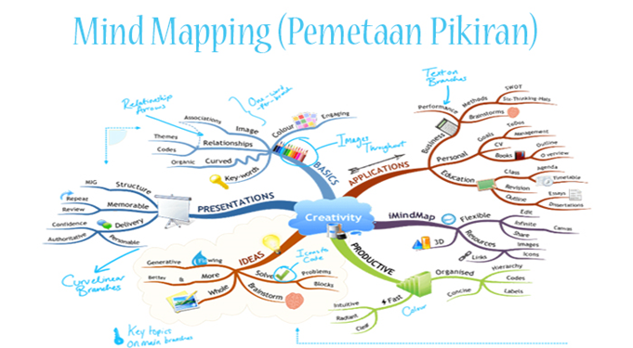

Pict 2.1 Example of Mind Mapping Method

Source: <https://www.pelajaran.co.id/2019/10/mind-mapping.html>

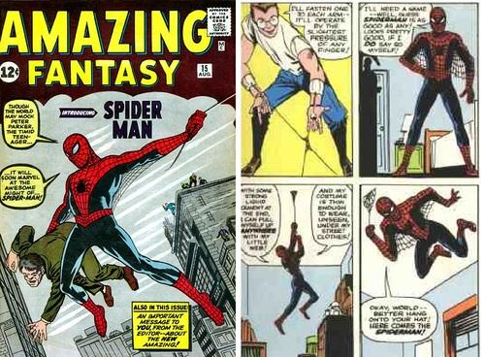

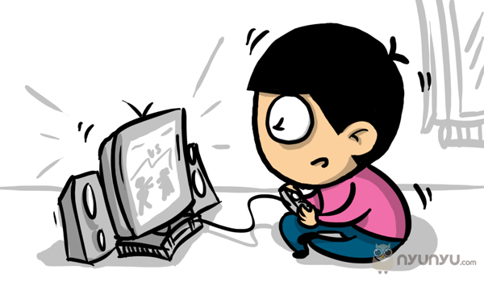

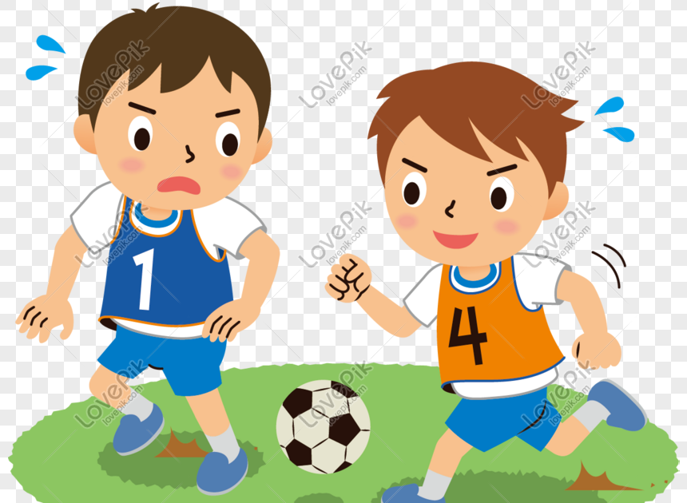

Hero

Buy in gramedia

Pict 2.2 Mind Mapping Picture

My name is Dika, I am 13 years old. I am the second child of two siblings. My hobbies are playing football, reading comics and playing games. I play football every Sunday at 3 pm with my friends. I have loved playing football since I was a child until now. One of my goals is to become a professional football player. After I played football I took a shower and dinner, after that, I entered the room and did school work, if any.

Before sleep I always read comics, I have several collections of comics. The comics that I like are about heroes and most of the comics that I bought at Gramedia. I buy comics sometimes after school or Saturday when my dad gets work off. Besides playing ball and reading comics, I also like playing harvest moon games. Sometimes I play games after school or when there is free time in the room.

**2.2** **Writing Skills**

“*Menulis itu berjamaah”* According to Alwasilah (2005: 25). It means, in wrting, we have to collaborate with other people because it gives a lot of advantages. One of the advantages is, in collaborating there will be priest or senior that will be a role model. The lectures are priest, that have a knowledge and excperience in writing. According to Oshima and Hogue (2006), “Writing is a process that transforms our mind or idea into the written form. It should be organized into coherent and cohesive paragraphs. "Coherence means the sentences must hold together, that is the movement from one sentence to the next must be logical and smooth". As described by Oshima and Hogue's writing is the act of pouring ideas into an ongoing writing so that it becomes a comprehensible paragraph.

It means writing one way of expressing ideas that are in your mind which is made into a paragraph that is easy to understand and clear. Writing is another form of communication with others. Writing is a productive and expressive activity.

Writing one skill which is difficult from other skills, such as listening, reading and speaking. In order to make the process of writing good and understandable, writing structure is indispensable, such as using word structure, phrases, paragraphs, etc.

According to Brown (2001), also states that writing is the written products of thinking, drafting, and revising that require specialized skills on how to generates the ideas, how to organize them coherently, how to use the discourse markers and rhetorical conventions coherently into a written text, how to revise a text for clearer meaning and how to edit a text for the appropriate grammar and how to produce a final products.

In the explanation by Brown above that writing requires expertise in alluring to the idea of ideas in mind into a writing itself. Writing requires imagination and creativity.

**2.2.1 Teaching Writing**

According to Brown (2003), stated five major categories of classroom writing performance. They are imitative, intensive, self-writing, display writing, and real writing.

1. Imitative, or writing down

At the beginning of writing, the students will write down English letters, words, and sentences. They will learn the conventions of the orthographic code.

1. Intensive, or controlled writing

The students will learn about grammatical concepts. This will be like written grammar exercises that have a function to improve the grammar ability of them.

1. Self-writing

The activity of this category in classrooms is note-taking, where the students take notes for later recall.

1. Display writing

The short answer exercises, essay examinations, and research reports are the elements of the display.

1. Real writing

Real writing has three types; academic, vocational, and personal. Academic is genuine information conveyed by the students to each other. Vocational 12 is an advancement of students' occupation. And personal involves the writing of diaries, letters, postcard, notes, and personal message.

**2.2.2 The Process of Writing**

Harmer (2004) stated that the writing process is the stages a writer goes through to produce something in the final written form. There are four main elements in the writing process:

1. Planning

When planning, the writers have to think about the three main issues. First, place they have to consider the purpose of their writing since this will influence amongst other things not only the type of text they wish to produce, but also the language they use, and the information they choose to include. Second, the experienced writer thinks of the audience they are writing for, since this will influence not only the shape of the writing (how it is laid out, how the paragraphs are structured, etc.) but also the choice of language –whether, for example, it is formal or informal in tone. Third, the writers have to consider the content structure of the piece –that is, how to sequence the facts, ideas, or argument which they have decided to include.

1. Drafting

We can refer to the first version of a piece of writing as a draft. This first go‟ at a text is often done on the assumption that it will be amended later. As the writing process proceeds into editing, some drafts may be produced on the way to the final version.

1. Editing (reflecting and revising)

Once writers have produced a draft, then they usually read through what they have written to see where it works and where it does not. Perhaps the order of the information is not clear. Perhaps the way something is written is ambiguous or confusing. They may then move around or write a new introduction. They may use a different form of words for a particular sentence. More skilled writers tend to look at issues of general meaning and overall structure before concentrating on detailed features such as individual words and grammatical accuracy. The latter two are, of course, important and are often dealt with later in the process.

Reflecting and revising are often helped by other readers or editors who comment and make suggestions. Another readers‟ reaction to a piece of writing will help the author to make appropriate revisions.

1. Final version

Once writers have edited their draft, making the changes they consider to be necessary, they produce their final version. This may look considerably different from both the original plan and the first draft because things have changed in the editing process. But, the writer is now ready to send the written text to its intended audience.

**2.2.3 Micro and Macro writing skilss**

The micro skills needed in writing are to help teachers determine the most appropriate criteria for assessing student writings. Brown (2004) describes writing that mimics, is intensive, responsive, and extensive. In writing imitations, they should get basic sub-skills such as vocabulary, punctuation, sentences, and spelling.

According to Brown (2004), micro-skills are pointed to responsive and extensive writing. Described as follows:

1. Using clear and accurate forms and rules of written discourse.
2. Accomplishing appropriately the communicative functions of various texts according to the form and purpose.
3. Conveying links and connections to organize every item such as topic sentence, supporting sentences, new information, given information, generalization, and exemplification.
4. Differing between literal and implied meanings when composing.
5. Delivering appropriately culturally specific sources in the context of the written text.
6. Developing and using writing strategies, such as accurately assessing the reader's interpretation, starting pre-writing devices with emphasizing fluency on the first draft, using paraphrases and similar words, requiring peer and teacher feedback, and implementing feedback for revising and editing.

It can be concluded, that macro writing skills are about how we make good structures by arranging sentences into paragraphs that are correct and understood so that the paragraphs can be sustainable with each other.

According to Brown (2004) elaborated that micro-skills refer to specific terms or patterns of writing work. Described as follows:

1. Producing graphemes and orthographic English forms.
2. Producing composing works at an efficient rate of speed to match the goal.
3. Producing an acceptable core of words and use appropriate word order patterns.
4. Using acceptable structural forms (e.g. tense, agreement,pluralization), sentence patterns and rules.
5. Expressing a certain meaning in diverse grammatical patterns, and using cohesive devices in written language. Produce graphemes and orthographic patterns of English.

It can be concluded, that macro writing skills are about how we make good structures by arranging sentences into paragraphs that are correct and understood so that the paragraphs can be sustainable with each other.

* 1. **Descriptive Text**

“*Deskripsi adalah sebuah bentuk tulisan yang bertalian dengan usaha para penulis untuk memberikan perincian dari obyek yang dibicarakan”,* Goryf Keraf (1981:93).

Descriptive Text is a kind of text with a purpose to give information. The context of this kind of text is the description of particular things, animals, persons, or others, for instance, our pets or a person we know well. It differs from a report which describes things, animals, persons, or others in general.

According to Hyland (2004) Descriptive text is a text which has a social purpose to give an account of imagined or factual events. Hyland explains more about the description that it tends to use present tense, and description makes use of "be" and "have”.

**2.3.1 Generic Structure**

The generic Structure of Descriptive text :

Identification: Identifying the phenomenon to be described

Description: Describing the phenomenon in part, qualities or and characteristics.

**2.3.2 The Function of Descriptive Text**

To describe everything, be it human, animal, plant or inanimate objects with inherent characteristics such as size, type, color, etc. so that the reader can know what something is like from the picture that we convey even though he has never seen it

**2.3.3 Language Feature of Descriptive Text**

Descriptive Text has the following linguistic features or Language Features:

1. Using Simple Present Tense

Because its function is to describe something where the characteristics or characteristics of the object or thing will not change, Descriptive Text uses Simple Present Tense.

Example: This car is a Kombi one. This car has a sunroof cloth and two doors at its one side.

1. Using adjectives

Describing or describing something will be easier to understand if you use an adjective (Adjective) so that the things we describe can be imagined more real.

1. Using conjunctions

The conjunctions are words that connect the subject with the word explanation. The conjunctions can be to be (is, am, are) or others, such as seem, look, appear, sound, etc.

Example: This car is red and cream, the chairs are good.

**2.3.4 Example Descriptive Tex**

THE COW

Cows are very useful to mankind, in supplying them with milk from which both butter and cheese are made. Their young ones are called calves, and the flesh of calves is veal. A good Cow will give about fifteen or more quarts of milk a day, but much depends upon the quality of the pasture she feeds upon.

Her age is told by her horns; after she is three years old a ring is formed every year at the root of the horn, so that by counting the number of circles, her age may be exactly known.

Cows are sometimes prettily marked with black, brown, and yellow spots, and, as they lie scattered about a green meadow, add much to the charms of a landscape

Source: <https://www.sederet.com/tutorial/10-contoh-descriptive-text-dalam-bahasa-inggris/>