“THE USE OF AUDITORY, INTELLECTUAL AND REPETITION (AIR) METHOD IN TEACHING DESCRIPTIVE TEXT TO IMPROVE THE STUDENT’S SPEAKING SKILLS”
(A Study towards the Tenth Excellent Class of SMA 8 Pasundan Bandung 2019/2020)

A Research Paper
Submitted to the English Department
Faculty of Arts and Letters Pasundan University
as a partial fulfilment of the requirements
for taking the Sarjana Degree.

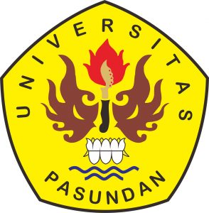

Agung Sahrudin
Reg. Number: 157010050

ENGLISH DEPARTMENT
FACULTY OF ARTS AND LETTERS
PASUNDAN UNIVERSITY
BANDUNG
2019

