Appendices

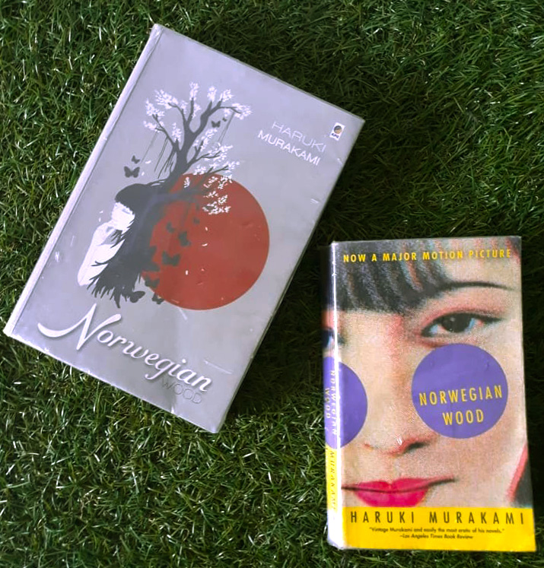

Left: Indonesian translation, right: English translation

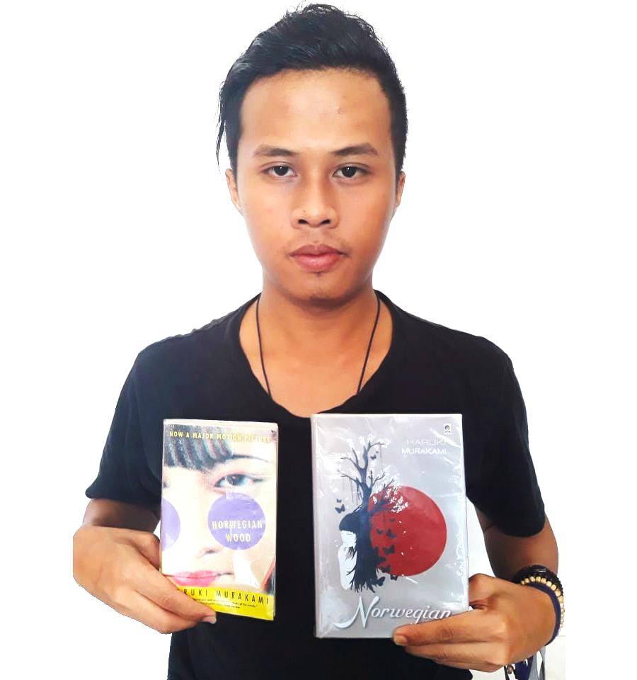

About Haruki Murakami
Haruki Murakami is a Japanese novelist, translator, and professional runner. An important asset to the Japanese literature of the 20th century, Haruki has received several noted awards for his fiction and non-fiction works. He was also referred to as one of the world’s greatest living novelists by The Guardian.
Hear the Wind Sing, Haruki’s first novel was published in 1979 which was a part of The Trilogy of the Rat. The book received the Gunzou Shinjin Sho (Gunzo New Writer Award). His next publication also a part of The Trilogy of the Rat, Pinball, 1973 was published in 1980. In 1981, Murakami decided to make writing his ultimate profession and therefore, sold the bar he ran with his wife. The third part of the same trilogy named A Wild Sheep Chase was published in 1982. Haruki won the Noma Bungei Shinjin Sho (Noma Literary Award for New Writers) for this book in the same year.
After spending some time moving to Fujisawa and then Sendagaya, Haruki published Hard boiled Wonderland and the End of the World in 1985. This book was also immensely praised and received the Junichi Tanizaki Award. Haruki then moved to Oiso and travelled to Rome and Greece before publishing Norwegian Wood (1987), an extremely popular novel among the Japanese youth and abroad. Haruki won the Yomiuri Literary Award for Wind-up Bird Chronicle in 1996. Some of his more recent novels include The Sputnik Sweetheart (1999), and Kafka on the Shore (2002). The Elephant Vanishes, A collection of Murakami’s short stories published in 1993 was also liked well by his fans. Underground (2001) is a significant non-fiction work of Haruki Murakami based on the gas attacks by religious extremists in the Tokyo subway in 1995.
In January 1991, Murakami moved to New Jersey and became an Associate Researcher at Princeton University. A year later he was promoted as an Associate Professor at Princeton University. In 1993, Haruki started teaching at William Howard Taft University in Santa Ana CA.
Murakami was born in Kyoto, Japan on January 12, 1949. Haruki probably inherited the passion for writing from his parents who were teachers of Japanese literature. Haruki, however, was never a big fan of Japanese literature and was instead under heavy influence of Western culture. He has been criticized on being overly westernized by the Japanese on several occasions. In 1968 Haruki attended Waseda University as a Theater Arts major student. Not very studious by nature, Murakami would spend hours reading film scripts at the Theater Museum at the university. He also met his wife for the first time in Waseda University and they married in 1971. Together they opened a Jazz Bar named Peter Cat in Kokobunji, Tokyo which was later shifted to Sendagaya, Tokyo, a quite locality.
Haruki Murakami is an iconic figure of postmodern literature known mostly for his unreal, humorous work focusing on the loneliness and empty mindedness of Japan’s work dominated generation. He now resides in The United States and is an enthusiastic marathon runner, a hobby he acquired at the age of 33.

Curriculum Vitae

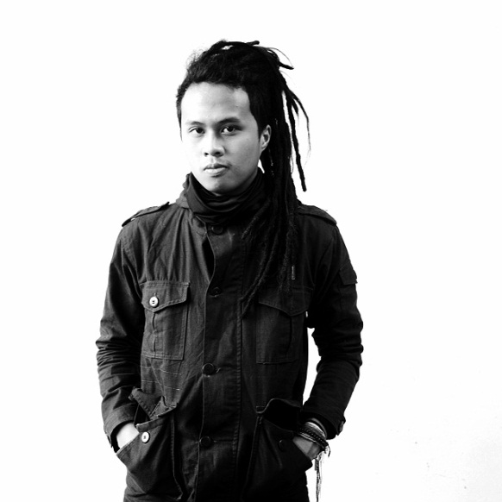
Bondan Pamungkas Sakti. Born in Bandung 20th January 1994. He has a brother, Ambar Pangaribowo Sakti. He also has two sisters, they are Anggit Rindyasmoro and Besti Rahulasmoro. His hobbies are playing musical instrument, especially classical guitar, and reading novels.
His elementary school was in SDN Sukagalih VII in Bandung, and his Junior High School was in SMPN 6 Bandung. And he continued his study in SMAN 15 Bandung. After he finished at Senior High school in 2011, he continued his study in English Department of Faculty of Arts and Letters, Pasundan University Bandung.

