The Concept of Big Data in Bureaucratic
Service using Sentiment Analysis

Lia Muliawaty1, Kamal Alamsyah1, Ummu Salamah1, Dian Sa’adillah Maylawati2,3
1Universitas Pasundan, Indonesia
2Sekolah Tinggi Teknologi Garut, Indonesia
3Universiti Teknikal Malaysia Melaka, Malaysia

ABSTRACT
The implementation of bureaucratic reform in Indonesia is not optimal which faces various obstacles. At present public services demand excellent service and meet public satisfaction. The obstacles are rigid bureaucracy, incompetent bureaucrats or apparatuses, not professional, and technological gaps. Rapid technological development, such as digital technology and big data, has not been responded positively by most bureaucrats. Big data is a great potential for improving bureaucratic and public services. With qualitative method and Waterfall Software Development Life Cycle, this article provides the design of bureaucracy sentiment analysis application as implementation of big data technology for analyzing the opinion about bureaucracy service in Indonesia. So that, the quality of bureaucrats and bureaucracy services can be increased based on society opinion. The result of experiment using RapidMiner showed that sentiment analysis as big data technique for bureaucracy service based on society opinion can be used to evaluate bueaucratic service performance better.

Keywords: Big Data, Bureaucrats, Bureaucratic Reform, Digital, New Public Service, Opinion Mining, Sentiment Analysis, Social Media, Text Mining

INTRODUCTION
Until today, there has been a stigma regarding the performance of bureaucrats and bureaucracy in various governments in the world, especially governments in developing countries such as Indonesia.
Bureaucracy in many developing countries is rigid, slow, inefficient, ineffective and so on. In the midst of society a "bad" stigma develops about bureaucracy, related to the services provided because it is still far from the expectations of society, there are "bacterial" pathologies in the body of the bureaucracy, making the image of the bureaucracy in the public eye "bad".

Therefore, the negative stigma needs to be eliminated. One way is to do bureaucratic reform. The Indonesian government carried out reforms since 1998, together with the formation of the Reform Order. Reformation is a systematic, integrated and comprehensive effort aimed at realizing good governance, including good public governance, and good corporate governance (Damanhuri., 2017). The demands of bureaucratic reform in Indonesia occur as a result of public pressure on past government dissatisfaction (Mariana, 2017).

The fact is that bureaucratic reform in Indonesia has not been optimally implemented because of various obstacles, especially in the bureaucrats or apparatus as implementers of the policy. For example, the quality of public services that have not been optimal, is not in accordance with the criteria of the New

Public Service (NPS) model. So that the level of community satisfaction is still low on services provided by the government. Some bureaucratic reforms in the aspect of public services that are the focus of attention are issues of corruption and public service and public information disclosure.

The essence of bureaucracy is its Human Resources (HR), namely bureaucrats or apparatus. HR factors that are incompetent, unprofessional, and do not master modern technology, are the weaknesses of bureaucratic reform in Indonesia. This has led to a gap between technological advances, such as digital technology and big data, with slow and less responsive bureaucracy. According to Kaloh that work begins to change into knowledge-based work and human resource needs also change towards knowledge workers.

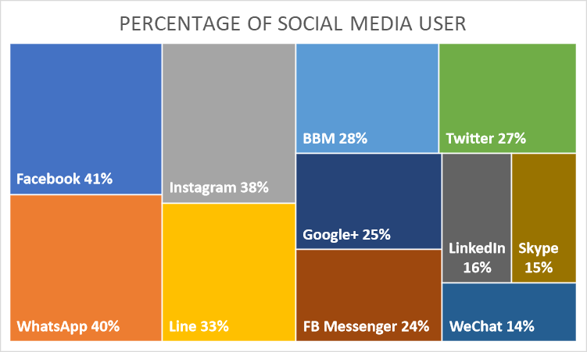
Figure 1 Percentage of Social Media User in Indonesia

To improve the quality of HR in serving the community, big data technology can be used optimally, one of which is opinion mining from social media (Jumadi, Maylawati, Subaeki, & Ridwan, 2016). Where, data from social media and analyzed so as to get an analysis of community sentiment on the quality of service bureaucracy in Indonesia. Until January 2018, social media users in Indonesia reached 132.7 million out of a total population of 265.4 million (Laksana, 2018). This figure is relatively fantastic, where around 50% of Indonesia's population owns and becomes an active social media user, starting from Twitter, Facebook, Instagram, Youtube, and so on. Smartphone is the main choice (90%) that is used as a device to run social media applications. Based on survey results that described in Figure 1, Youtube is the most widely used social media reaching 43%, followed by Facebook 41%, WhatsApp 40%, Instagram 38%, Line 33%, BBM 28%, Twitter 27%, Google+ 25%, FB Messenger 24 %, LinkedIn 16%, Skype 15%, and WeChat 14% (Haryanto, 2018). Social media users in Indonesia have a unique pattern, one of which is based on gender, men are more active using social media such as Facebook and Instagram than women for users in the age range of 18 to 24 years. Therefore, this article utilizes social media and big data technology to analyze people's sentiments and opinions about bureaucratic services in Indonesia.

RESEARCH METHOD
This research used qualitative method. The qualitative research method is used in the following conditions (Tracy, 2016): (a) when there is rarely any information available about the topic (b) when the researcher’s variables are unclear and unknown, and (c) when a relevant theory base is missing in any sense (Tavallaei & Abu Talib, 2010). Qualitative research can be used to examine topics such as

contextual conditions-the social, institutional, and environmental conditions. A qualitative research is an inductive process which builds concepts, hypotheses, or theories rather than testing hypotheses. One of the uses of the research method delineates the process (rather than the outcome or product) of meaning- making. Qualitative research is focusing on the emergence of situations. The research methodology is a case study that has the following characteristics: particularistic, descriptive, and heuristic. A qualitative research is an inductive process which builds concepts, hypotheses, or theories rather than testing hypotheses. One of the uses of the research method delineates the process (rather than the outcome or product) of meaning-making (Sharan B. Merriam, 2009). Qualitative research is focusing on the emergence of situations. Qualitative researchers are concerned primarily with process, rather than outcomes or products, qualitative researchers are interested in meaning how people make sense of their lives, experiences, and their structures of the world, the qualitative researcher is the primary intrument for data collection and analysis, qualitative research involves fieldwork.

Beside qualitative method, this research used Waterfall as Software Development Life Cycle (SDLC). Waterfall is the basic and simple software development method that begin from requirement elicitation, analysis, design, implementation, testing, deployment, and maintenance (Nayan B. Ruparelia, 2010; Pressman, 2011; Sommerville, 2010). In requirement elicitation, the needs of stakeholder and system are collected (Muhammad Ali Ramdhani, Sa’adillah Maylawati, Amin, & Aulawi, 2018). Then, in analysis and design, we create a system model, among others architecture model and software model using Unified Modelling Language (Booch, 2005, 1998; D.S. Maylawati, Darmalaksana, & Ramdhani, 2018; Dian Saadillah Maylawati, Ramdhani, & Amin, 2018). In the implementing and testing phase, we used RapidMiners for analyzing the sentiment of bureaucratics service.

RESULT AND DISCUSSION
The Performance of Bureaucrats in the Digital Age
Bureaucracy is a device/ institution of employees/ HR and a system of government administration carried out by civil servants based on legislation (Damanhuri., 2017). Bureaucracy is a storage place for a typical and unique public trust. “In general, the term ‘bureaucracy’ is regarded as having a negative connotation, although there have been anarchists that enjoyed the excess of formalism and rigor” (Liviora, G., 2018). There are three bureaucratic concepts, namely (Mariana, 2017): 1) Weber Bureaucracy Concept; 2) The Concept of Parkinson Law; and 3) Ovulation Concept (2017:93).
Bureaucracy is characterized by hierarchy, specialization, formalization, and impersonality (Widiyastuti, Andretti Abdillah, & Kurniawan, 2014). Bureaucracy only emphasizes how the bureaucratic machine should be professionally and rationally run. Furthermore, bureaucracy shows a lot about how government organizations are adopted by means of official kingdoms. The bureaucratic model currently being implemented does not show a system that represents the nature of justice, transparency and efficiency (Sanrego Nz & Muhammad, 2013).

Social media is one of the characteristics of technological development in the era of Industry 4.0. In the Industrial 4.0 era, where everything is connected to internet technology (internet of things) (Kemeristekdikti, 2018; Muhammad Nizam, 2018; Sadiyoko, 2017). Where, industry 4.0 is characterized by internet usage in each sector, both in the economy, social, education, and other sectors. The entire process and production utilizes internet technology and utilizes digital technology, artificial intelligence, big data, robotics, etc. which are also known as the disruptive innovation phenomenon (Office of Chief Economist Bank Mandiri, 2018; Sumber Daya IPTEK & DIKTI, 2018). Big data is a very large set of data that can be computationally analyzed to find patterns, trends, associations, and specifically those related to habits and human interactions (Philip Chen & Zhang, 2014; Sagiroglu & Sinanc, 2013; Wu, Zhu, Wu, & Ding, 2014). In analyzing social media, of course big data technology is needed, considering that data in the media has big data characteristics. At the beginning of its appearance, big data only has

3V characteristics, including volume, variety, and velocity (Sagiroglu & Sinanc, 2013; Tan, Blake, Saleh,
& Dustdar, 2013). However, there are currently at least 10V, 17V, up to more, including: volume, velocity, variety, veracity, value, validity, variability, venue, vocabulary, vagueness, visualization, etc. (Arockia, Varnekha, & Veneshia, 2017; Borne, 2014). Social media that has various types of data such as text, images and videos is very suitable if processed with big data technology. Various big data applications are ready to use to process and analyze data from social media to reveal insight knowledge from the data (Ganesh Panatula, K Sailaja Kumar, D Evangelin Geetha, 2019; Vinutha & G.T, 18AD).

The discovery of computer technology is a big leap of human civilization on earth that drives other discoveries, such as digital technology. The digital age is a new paradigm in the government bureaucracy in Indonesia, including the public service sector. This paradigm is an important and radical transition from New Public Management (NPM) towards a digital governance model (Kosorukov, 2017). Most governments in the regions have not been able to implement bureaucratic digitalization because of various factors, including large costs and qualifications of human resources who master technology are still minimal. Although there are exceptions to the cities of Bandung and Banyuwangi which are considered capable of applying modern technology.

Through the use of digital devices (e-government), public services are more efficient, effective, fast, and accurate (Pamoragung, Suryadi, & Ramdhani, 2006). So that bureaucratic procedures are more practical and brief. Similarly, through digitalization, the number of operational officers can be reduced but the number of services can be increased (M A Ramdhani, Aulawi, & Gojali, 2018). Previously, the process of public services such as health services, education, licensing, etc., took a long time/ took a long time.
Besides that, direct interaction between bureaucrats or apparatus can encourage acts of corruption and the like.

Rapid technological developments have caused previous technologies to become unused or obsolete, such as hardware or computer software. In addition, it has a direct impact on its users, namely the bureaucrats and apparatus must improve their knowledge and skills with these new devices. If not done it can cause their performance to be unproductive and the level of community satisfaction low. Public services require the involvement of many actors because their implementation is related to many actors. Faulkner also explained the need for cooperation in implementing public services. Government Leadership and Public Services can be generated and sustained a sense of shared purpose and responsibility.

Big Data: A New Paradigm, Challenges, and Constraints
Big data can be used by all parties and sectors, including government. For example for the provision of health services, education, and improving the quality of the bureaucracy and its bureaucrats. The use of big data is important for improving the quality of public services, especially associated with modern developments that require many aspects, including excellent service quality and speed of service processes. At present the public policy model adopts many services provided by the private sector in order to fulfill public satisfaction as service users. Through big data, policies or programs can be designed appropriately, efficiently and effectively. So far, big data has been used by large private companies in improving product quality, developing markets, and choosing the right marketing techniques. Big data provides accurate data so that programs designed using big data have high accuracy and are economical. Big data has a variety of data and large, so that it is just how to process and use these data for an interest.

But big data cannot be accessed or processed with traditional devices because of the huge amount of data and many variants. So to access it requires the latest technology. This is an obstacle for some companies and governments in utilizing the potential of big data. As is known, most governments are held in a limited and less optimal manner. The limitations of technology-based work devices have caused minimal

quality of public services, low bureaucrat work productivity, rigid bureaucratic procedures, and non- optimal results.

This is caused by a variety of factors, including the quality of human resources (HR) and their working devices. Only a few local governments are able to provide the latest technology-based work tools because these facilities are expensive and require professional HR. Knowledge-based works require knowledge workers. The change in work orientation is a new paradigm and challenges and obstacles for bureaucrats in carrying out efficient and effective bureaucracy. The criteria for efficient and effective bureaucracy is the absolute demand in modern government, namely in order to provide quality and optimal public services.

Sentiment Analysis Architecture as Big Data Technology for Bureaucratic
The data from social media that is the easiest to process is text. Text is the unstructured data, so that it must be conducted the pre-process until the text data ready to be processed in mining process (D S Maylawati, Sugilar, & Yudhiantara, 2018; Dian Saadillah Maylawati, Ramdhani, Rahman, & Darmalaksana, 2017; Dian Sa’Adillah Maylawati & Putri Saptawati, 2017; Slamet et al., 2018). In the requirement elicitation phase, we defined several requirements of bureaucracy sentiment analyzer application, among others:
- Application can read the corpus that contain document from social media, such as Twitter, Facebook, or blog and news website.
- Application can do text pre-processing, such as lowercase, tokenizing, emoticon handling, abbreviation handling, reguler expression (regex) removal, stopwords removal, and stemming.
- Application can conduct feature extraction, either bag of words or multiple of words (n-gram)
- Application can conduct feature selection, such as remove redundant.
- Application can do mining process with classification technique for sentiment analysis using specific algorithm, such as Naive Bayes algorithm, Decision Tree, Artificial Neural Network, and so on. Where in mining process there are two main process in classification, among others training process and testing process.
- Application provides the result of bureaucracy sentiment analysis.
Figure 2 describes the bureaucracy sentiment analyzer architecture, while Figure 3 describes use case diagram of bureaucracy sentiment analyzer which is representation model of analysis in Waterfall SDLC after requirement elicitation.

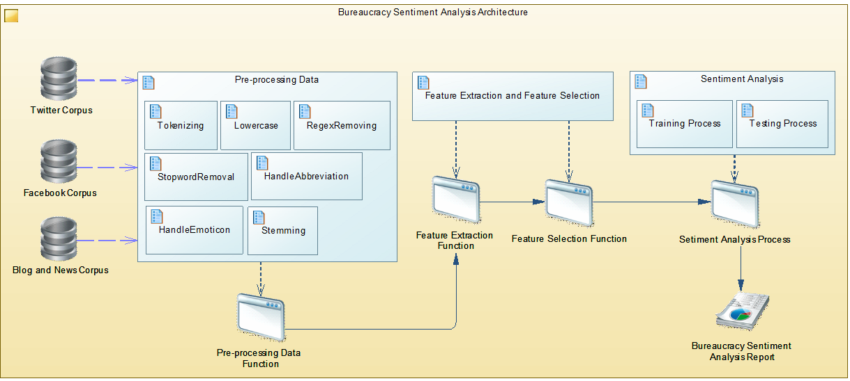
Figure 2 Bureaucracy Sentiment Analyzer Architecture

Bureaucracy Sentiment Analyzer
Lowercase
Input Text or Comment
Users
Tokenizing
Conduct Sentiment Anaysis
Removing Regex
Feature Extraction using Tf/Idf
Handling Emoticon
Feature Selection
<<include>>
Handling Abbreviation
Sentiment Analyzing using Naive Bayes
Removing Stopwords
Training Process
Testing Process
Stemming Process
Show The Result of Sentiment Analysis

Figure 3 Use Case Diagram of Bureaucracy Sentiment Analyzer

The Example of Sentiment Analysis Application
Many data mining tools as big data technique that can be used easily, one of which is RapidMiner (Studio, n.d.). This article used RapidMiner as the implementation example for analyzing the sentiment of bureaucrats and bureaucracy service in Indonesia. Figure 4-7 shows the process scheme of bureaucracy sentiment analysis in RapidMiner. In RapidMiner there are many text analytic extentions that can be used easily, among others Aylien (Aylien, n.d.) and Rosette (Rosette, n.d.). All of text mining or text analytic process have been included in its funtions, so that we just combine the function in the process and run it. We collect the data from Twitter with keyword “bureaucracy” and “birokrasi”. Sentiment analysis from text data is depend on the language. Every language is unique and has different treatment to get clean data and accurate result (D. S. A. Maylawati, 2015; Dian Sa’adillah Maylawati, Aulawi, & Ramdhani, 2019; Dian Sa’adillah Maylawati, Zulfikar, Slamet, & Ramdhani, 2018; D. Sa’Adillah Maylawati & Putri

Saptawati, 2017), and RapidMiner is limited to English, German, French, Czech, and Arabic. For another language, RapidMiner provide general function to insert dictionary and process it.

Figure 4-7 also describe the result of bureaucracy sentiment analysis from Twitter directly. Figure 4 shows the result of bureaucracy sentiment analysis using Aylien, from 100 tweets from Twitter, 62 tweets have positive opinion, 32 tweets are negative, and 6 tweets are neutral. While, the result using Rosette quite different (with the same data collection and illustrated in Figure 5), where positive tweets are 21, 40 tweets are negative, and 39 tweets are positive. Even though there are different in classifiying the sentiment, but the important thing is around 36% from 100 tweets have negative opinion about bureaucracy and it must be followed up. We also collect 200 tweets with Indonesian language for analyzing the sentiment about bureaucracy in Indonesia. The result of Aylien in Figure 6 shows that only 3 tweets that have positive opinion, 1 tweet is negative, and 196 tweets are neutral. While the result using Rosette in Figure 7 shows that 1 tweet is detected has positive opinion, 0 for negative tweet, 5 for neutral tweets and 194 tweets for unsupported language. The results sentiment analysis with Indonesian text in RapidMiner have not been capable yet to be used to analyze the public opinion about bureaucracy in Indonesia, because because it is constrained by language processing that has not been supported by RapidMiner. Those result can be used as an illustration of how the public opinion about bureaucracy.
Beside that, the process in RapidMiner is an implementation illustrastion of sentiment analysis prosess as big data technique that has been provided in architecture and use case diagram above (in Figure 2 and 3). The main idea is big data technology can be used to improve bureaucracy service based on society or public opinions.

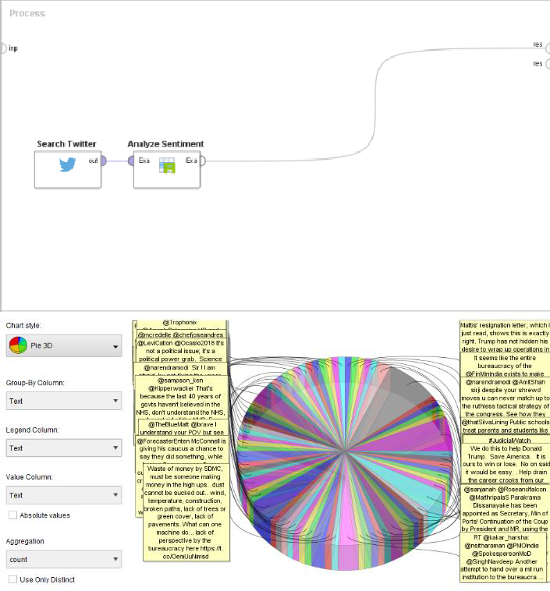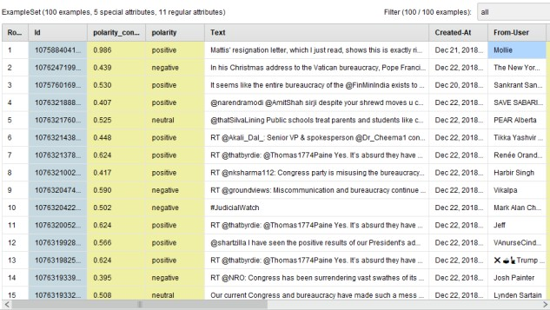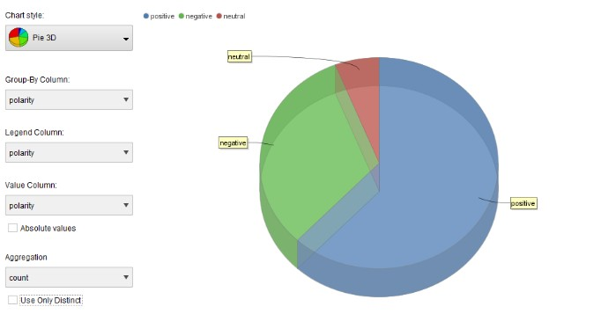
Figure 4 The Result of Aylien for Bureaucracy Sentiment Analysis

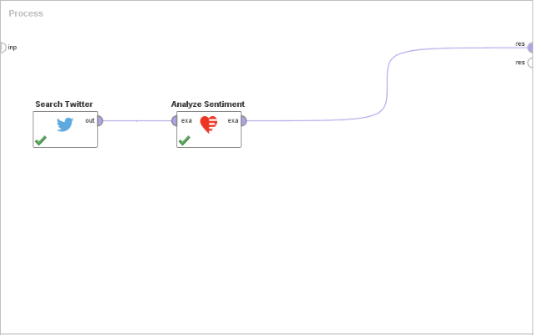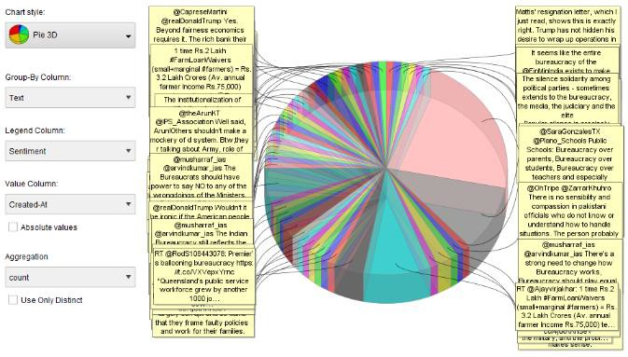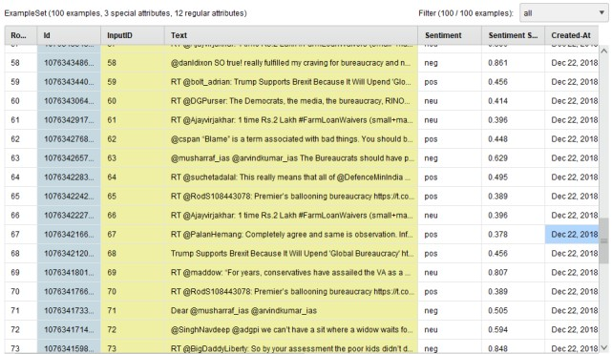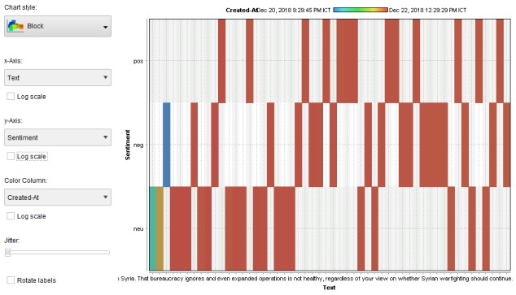
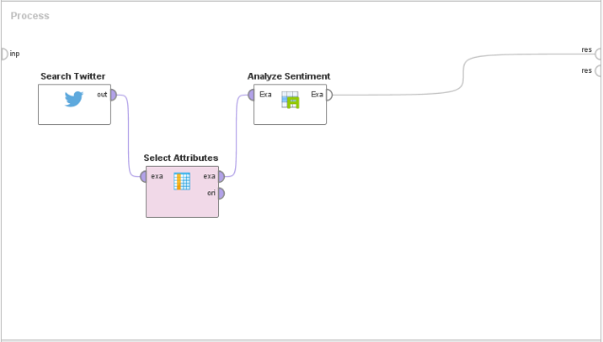Figure 5 The Result of Rosette for Bureaucracy Sentiment Analysis

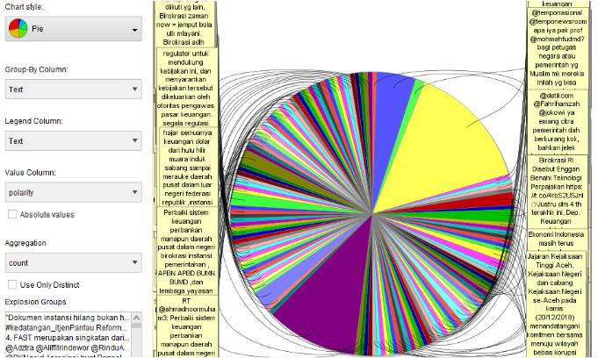

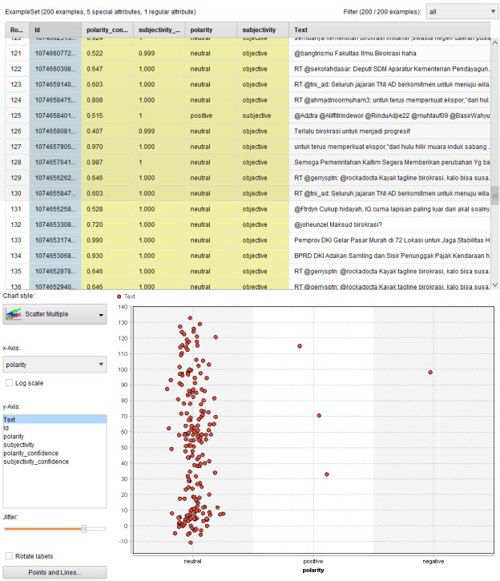
Figure 6 The Result of Aylien for Bureaucracy Sentiment Analysis with Indonesian Text

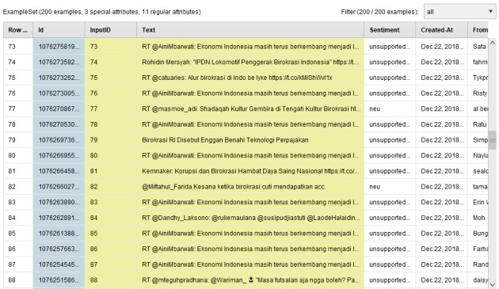
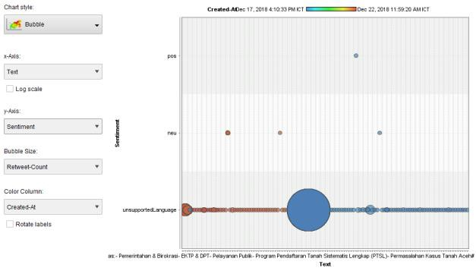

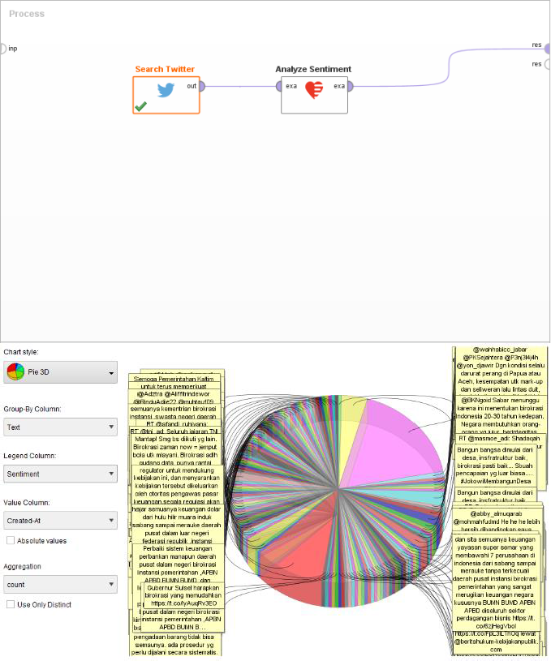Figure 7 The Result of Rosette for Bureaucracy Sentiment Analysis with Indonesian Text

CONCLUSION
Bureaucratic reform in most regional governments has not yet materialized. This causes the quality of public services is not optimal and public satisfaction is low. Therefore, the reform process needs to be accelerated. The main obstacle in realizing bureaucracy in accordance with good governance is its human resources, namely bureaucrats. Most bureaucrats are unprofessional, do not have expertise that is in accordance with the field and work responsibilities. So that the performance of bureaucrats is not optimal. Another obstacle is the factor of working facilities or working devices that are limited and simple. While, the demands of the modern bureaucracy are work devices based on modern technology, such as digital technology. Big data can be utilized by regional government bureaucracies because of the two main factors above, namely bureaucrats and modern technological devices. So that the potential for big data can be used optimally. This article success to design a sentiment analysis architecture and functional model as big data technology for bureaucracy opinion in social media. The experiment proved that the result of sentiment can be used as information to evaluate, to make decision, and to improve bureaucracy service quality.

REFERENCES

Arockia, P. S., Varnekha, S. S., & Veneshia, K. A. (2017). The 17 V’s of Big Data. International Research Journal of Engineering and Technology(IRJET), 4(9), 3–6. Retrieved from https://irjet.net/archives/V4/i9/IRJET-V4I957.pdf
Aylien. (n.d.). Aylien Text Analytics. Retrieved from https://aylien.com/
Booch. (2005). The Unified Modeling Language User Guide. The Addison-Wesley Object Technology Series, 496. Retrieved from http://books.google.com/books?id=xfQ8JCbxDK8C&pgis=1

Booch, G. (1998). Object-Oriented Analysis and Design (2nd ed.). Santa Clara, California: Addison- Wesley.
Borne, K. (2014). Top 10 List – The V’s of Big Data. Retrieved from https://www.datasciencecentral.com/profiles/blogs/top-10-list-the-v-s-of-big-data
Damanhuri., J. R. (2017). Reaktualisasi reformasi birokrasi menuju good governance. In Prosiding Seminar Nasional Pendidikan FKIP, (pp. 297–304).
Ganesh Panatula, K Sailaja Kumar, D Evangelin Geetha, T. V. S. K. (2019). Performance evaluation of cloud service with hadoop for twitter data. Indonesian Journal of Electrical Engineering and Computer Science, 13(1).
Haryanto, A. T. (2018). 130 Juta Orang Indonesia Tercatat Aktif di Medsos. Retrieved November 30, 2018, from https://inet.detik.com/cyberlife/d-3912429/130-juta-orang-indonesia-tercatat-aktif-di- medsos
Jumadi, Maylawati, D. S. A., Subaeki, B., & Ridwan, T. (2016). Opinion mining on Twitter microblogging using Support Vector Machine: Public opinion about State Islamic University of Bandung. In Proceedings of 2016 4th International Conference on Cyber and IT Service Management, CITSM 2016. https://doi.org/10.1109/CITSM.2016.7577569
Kemeristekdikti. (2018). Pengembangan Iptek dan Pendidikan Tinggi di Era Revolusi Industri 4.0. Kosorukov, A. A. (2017). DIGITAL GOVERNMENT MODEL: THEORY AND PRACTICE OF
MODERN PUBLIC ADMINISTRATION. Journal of Legal, Ethical & Regulatory Issues.
Laksana, N. C. (2018). Ini Jumlah Total Pengguna Media Sosial di Indonesia. Retrieved November 30, 2018, from https://techno.okezone.com/read/2018/03/13/207/1872093/ini-jumlah-total-pengguna- media-sosial-di-indonesia
Liviora, G., G. (2018). Bureaucratic administration in modern society.
Mariana, D. (2017). Aparatur sipil negara dan reformasi birokrasi. Jurnal Ilmu Politik, 22(1), 91–104. Maylawati, D. S. A. (2015). PEMBANGUNAN LIBRARY PRE-PROCESSING UNTUK TEXT MINING
DENGAN REPRESENTASI HIMPUNAN FREQUENT WORD ITEMSET (HFWI) Studi Kasus:
Bahasa Gaul Indonesia. Bandung.
Maylawati, D. S., Aulawi, H., & Ramdhani, M. A. (2019). Flexibility of Indonesian text pre-processing library. Indonesian Journal of Electrical Engineering and Computer Science, 13(1), 420–426.
Maylawati, D. S., Darmalaksana, W., & Ramdhani, M. A. (2018). Systematic Design of Expert System Using Unified Modelling Language. IOP Conference Series: Materials Science and Engineering, 288(1), 012047. https://doi.org/10.1088/1757-899X/288/1/012047
Maylawati, D. S., Ramdhani, M. A., & Amin, A. S. (2018). Tracing the Linkage of Several Unified Modelling Language Diagrams in Software Modelling Based on Best Practices. International Journal of Engineering & Technology, 7(2.29), 776–780. https://doi.org/10.14419/ijet.v7i2.29.14255
Maylawati, D. S., Ramdhani, M. A., Rahman, A., & Darmalaksana, W. (2017). Incremental technique with set of frequent word item sets for mining large Indonesian text data. 2017 5th International Conference on Cyber and IT Service Management, CITSM 2017, 1–6. https://doi.org/10.1109/CITSM.2017.8089224
Maylawati, D. S., Sugilar, H., & Yudhiantara, R. A. (2018). KUALITAS PERANGKAT LUNAK: MODULARITAS PUSTAKA TEXT PRE-PROCESSING. Jurnal Perspektif, 1(2).
Maylawati, D. S., Zulfikar, W. B., Slamet, C., & Ramdhani, M. A. (2018). An Improved of Stemming Algorithm for Mining Indonesian Text with Slang on Social Media. In The 6th International Conference on Cyber and IT Service Management (CITSM 2018).
Muhammad Nizam, S. (2018). Revolusi industri 4.0: Suatu Pengenalan. Seranta FELDA Jabatan Perdana Menteri.
Nayan B. Ruparelia. (2010). Software Development Lifecycle Models. ACM SIGSOFT Software Engineering Notes. https://doi.org/10.1145/1764810.1764814
Office of Chief Economist Bank Mandiri. (2018). Menghadapi Era RI 4.0.
Pamoragung, A., Suryadi, K., & Ramdhani, M. A. (2006). Enhancing the Implementation of E-

Government in Indonesia through the High-Quality of Virtual Community and Knowledge Portal Design. In European Conference on e-Government (pp. 341–348).
Philip Chen, C. L., & Zhang, C. Y. (2014). Data-intensive applications, challenges, techniques and technologies: A survey on Big Data. Information Sciences. https://doi.org/10.1016/j.ins.2014.01.015
Pressman, R. S. (2011). Software Engineering: A Practitioner’s Approach (7th ed.). New York: McGraw- Hill.
Ramdhani, M. A., Aulawi, H., & Gojali, D. (2018). Analysis of determinant factors of e-Government implementation. In IOP Conference Series: Materials Science and Engineering (Vol. 434, p.
12049).
Ramdhani, M. A., Sa’adillah Maylawati, D., Amin, A. S., & Aulawi, H. (2018). Requirements Elicitation in Software Engineering. International Journal of Engineering & Technology. https://doi.org/10.14419/ijet.v7i2.29.14254
Rosette. (n.d.). Rosette Text Analytics. Retrieved from https://www.rosette.com/
Sa’Adillah Maylawati, D., & Putri Saptawati, G. A. (2017). Set of Frequent Word Item sets as Feature Representation for Text with Indonesian Slang. In Journal of Physics: Conference Series (Vol. 801). https://doi.org/10.1088/1742-6596/801/1/012066
Sa’Adillah Maylawati, D., & Putri Saptawati, G. A. (2017). Set of Frequent Word Item sets as Feature Representation for Text with Indonesian Slang. Journal of Physics: Conference Series, 801(1). https://doi.org/10.1088/1742-6596/801/1/012066
Sadiyoko, A. (2017). Industry 4.0 Ancaman, Tantangan atau Kesempatan. Oratio Dies XXIV FTI UNPAR.
Sagiroglu, S., & Sinanc, D. (2013). Big data: A review. In Proceedings of the 2013 International Conference on Collaboration Technologies and Systems, CTS 2013. https://doi.org/10.1109/CTS.2013.6567202
Sanrego Nz, Y. D., & Muhammad, R. (2013). Analisa perbandingan model birokrasi Indonesia: model modern David Osborne, Ted Gaebler dan pendekatan konsep Islam perspektif Umer Chapra. Jurnal Al-Muzara’ah, 1(1), 18–38.
Sharan B. Merriam. (2009). Qualitative Research: A Guide to Design and Implementation. Wiley. https://doi.org/10.1017/CBO9781107415324.004
Slamet, C., Atmadja, A. R., Maylawati, D. S., Lestari, R. S., Darmalaksana, W., & Ramdhani, M. A. (2018). Automated Text Summarization for Indonesian Article Using Vector Space Model. In IOP Conference Series: Materials Science and Engineering. https://doi.org/10.1088/1757- 899X/288/1/012037
Sommerville, I. (2010). Software Engineering. Software Engineering. https://doi.org/10.1111/j.1365- 2362.2005.01463.x
Studio, R. (n.d.). RapidMiner. Retrieved from https://rapidminer.com/
Sumber Daya IPTEK & DIKTI. (2018). Era Revolusi Industri 4.0 Saatnya Generasi Millenial Menjadi Dosen Masa Depan.
Tan, W., Blake, M. B., Saleh, I., & Dustdar, S. (2013). Social-network-sourced big data analytics. IEEE Internet Computing. https://doi.org/10.1109/MIC.2013.100
Tavallaei, M., & Abu Talib, M. (2010). A General Perspective on Role of Theory in Qualitative Research.
Spring. https://doi.org/1 85864 381 3
Tracy, J. S. (2016). Qualitative Research Methods. United Kingdom: Wiley-Blackwell. Vinutha, D. ., & G.T, R. (18AD). An Accurate and Efficient Scheduler for Hadoop MapReduce
Framework. Indonesian Journal of Electrical Engineering and Computer Science2, 12(3). Widiyastuti, S., Andretti Abdillah, L., & Kurniawan. (2014). Sistem Informasi Eksekutif Bagian
Kepegawaian Pada Pt. Pelindo Ii (Persero) Palembang. Seminar Nasional Teknologi Informasi, Komunikasi Dan Manajemen.
Wu, X., Zhu, X., Wu, G. Q., & Ding, W. (2014). Data mining with big data. IEEE Transactions on Knowledge and Data Engineering. https://doi.org/10.1109/TKDE.2013.109

