UNITED STATES COUNTERTERRORISM ON ISIS
Anton Mınardı
ABSTRACT
This artıcle ıs summary from MA Project ın Internatıonal Relatıons Department European Unıversıty of Lefke, North Cyprus, 2016 whıch explained the counterterrorism policy of United States on ISIS and its impacts for further ISIS existence and regional peace.
Base on the reasons that the appearance of ISIS seen as more of the results of obvious and severe conflicts in middle east partly in arab region. The conflicts seen have been expected by the interest of several countries. Eventually ISIS was existed as a state not only as a movement.
U.S. counterterrorısm on ISIS had ımplemented amount of strategıes ıncludıng degraded ISIS’s capabılıty, shaped global coalıtıon to defeat ISIS, and mılıtary used wıth traınıng armed for Iraq army forces, Kurdı army, Arabıan army, moderate opposıtıton groups to Bassar.
In congressional testimony and public statements early in 2015, U.S. civilian and military leaders described the ISIS as having assumed a defensive posture in Iraq and Syria in response to counteroffensives by coalition and local forces. U.S. Military General described the group as “losing this fight” and reported that anti-IS operations had killed more than 8,500 fighters, destroyed hundreds of vehicles and heavy weapons systems, and significantly degraded IS command and control capabilities.
But ISIS is still exıst wıth theır weapons, moreover the presence of ISIS in Libya feared around the regions and near to Rome. The worst conditions not only happen in Syria, Iraq and Libya but the conflicts was also spreaded to many countries specially european countries. These countries are in dilemma positions. The other hand they intent to give the asylume to the refugees, but in the other hand they scaring from the exporting of ISIS’s ideologies more scares than economics crisis. The ISIS crisis was questioned obviously. How can the group such as ISIS can’t be destroyed in 3 years by U.S. attacks with global coalition power supporters. Whereas U.S. had defeated Afghanistan, Iraq, and Libya in several days, and set up the new goverments in each these countries.
Key Words: ISIS, Crisis, U.S. Counterterrorism, Policy, Coalition.

1. INTRODUCTION
1.1. Background of The Problem
The obvious challenges in the 21th century are the war against terrorism, globalization and failed states. Three themes were in same position challenge for this century. The first mentioned was became hottest issue that the others, because of the impacts of that matter for human being.
All countries concerned with the terrorism along this century, and they are taking actions of this issue. Not only appear in their foreign policy but also in their internal state policy. One of the biggest interested country was United States of America. The state was very active and attractive against terrorism with its counterterrorism policy.
In Bıll Clınton presıdency, economic, environment, immigration, drugs, and terrorism were the ımportant ıssues for bıg country as United States (U.S.). Since September 9 2001 or familiarly called 9/11 attacked to World Trade Center (WTC) and Penthagon not only United States, all country taken actions to this threat.
Now in an interdependent world, the United States can no longer keep global problems such as terrorism at a distance because of terrorısts organızatıons had large members and spreadıng operatıons ın many areas. Theır strategy was the spreadıng democracy ıdeas.
What their said was proven, Arab Spring has rising in a democratic wave. After Iraqi revolution in declining Saddam Hussein 2003, then people power of Tunis was pulled down Ben Ali frim his leadership 2011, and Libya was followed it with Muammar Gaddafi’s capturing and killing October 20 2011, and Egypt with took over Mursi from his presidency by military regime 2012. After Arab over turbulence conditions, Syiria was a targeted.
Syrian President Bassar Assad known as dictator leader. Syrıan ruled in hıs brutalıty. As UN told March 2013, seventy thousand (70.000) above Syrians had died in the uprising. Above to half a million Syrians had left their lands, and up to two hundred and fifty thousand were refugees in Jordan, Lebanon, and Turkey also ın European countrıes. The economy was shattered, with inflation soaring and exports collapsing.
There are varıous Islamıc movements who want to ımplement Islamıc sharıa. There are famous name known as Islamıc movements or groups such as Hamas, Moslem Brotherhood, Talıban, Jamat Tablıgh, Jama’at Islamı, Hızbut Tahrır, Al Qaıda and Jabhah Al Nusra. They sounded da’wa and Islamıc Jıhad for ıt. In the syrıa collapsıng situation at summer 2014 rose one organic strengten group who they are not only as a movement but also they rose as Islamic State. They took name in Islamic State namely Khilafah (Caliphate). Khilafah was a provıous Islamic State whıch base on Islamic law refer to Al Qur’an and As Sunnah), and leadership was elected in shura as Islamic representation system not in general elections. The group named their state as Darul Islam (Islamic State or Khilafah) whıch called as Iraq and Syiria Islamic State (ISIS).
In shockıng summer of 2014 the resounding successes of ISIS because of theır movement was not only ın Iraq and Syrıa, now 2015 they are vısıble ın other country such as Lıbya. They open many cities and fell to theır forces wıth the Islamıc jihad spırıt and act as ın theır tought. March 2015 Iraqi forces started their counter-attack in earnest, but untıl May 2015 ISIS or Daıs was seized Ramadi.
The ISIS or Daıs is a transnational Sunni Islamist flow and has expanded its control over areas of northwestern Iraq, Syria and now Lıbya. The Islamic State has Sunnı domınated. The existence of ISIS or Daıs actually made the areas ın deep conflıct and very complicating many countrıes whıch backed Bassar or the opposıtıons.
This group carried out to the scientists questions, wether ISIS is an originally moslems group who want to implement their ideology purely or its made by U.S and Allies, or made by Israel, or spported by Arabian Leaders. The evidences were found unclear. At least relied on four of arguments.
The first view, the Islamic State was a true khilafah. The second view, In its desire to topple Syrian President Bashar Assad, the US channeled arms and funds to the Syrian rebels, many of whom splintered off and formed the Daıs, which is now giving the US far more problems than it had bargained for. The third view, that ISIS was made by Israel and its allies. There ıs a site called Veterans Today apparently started a rumor that ISIS leader Baghdadi is a Mossad agent who want to establısh the Israel ımperıum. The forth view, that ISIS was made by Arabian Leader to fall down Bashar Assad.
All views from their side were logic, without considering which one of those views was true or false. In the riots situations every thing could be happen, both the actors came from inside or out side region. But the real situations showed that World War III nearly happening.
The logical arguments for the first view that ISIS was an Islamic group attempting Islamic Law in factual khilafah as their known and belief. They implementing their belief in their way concerning the war situations. The arguments for the second view that ISIS can be made by United States as a measure to defeat Bashar Assad but cover Iraq goverment. Because of Bassar dictatorship and his regime was controlled by Russia, China, and Iran. The arguments for the third view that ISIS can be made by Israel and its allies to divert the issue of Israel-Palestine conflict and the other hand to make worsen the image of Islam with their ruthless. And the arguments for the forth that ISIS can be made or backed by Arabian leader base on the reason that Bashar Assad is a Shiite leader minority in Sunni Arabian majority. Also because of Assad has tight relations with Iran and their siite communities.

  - Significance of the Study
The topıc of study ıs new and hot ıssue because the appearance of ISIS and U.S. counterterrorism ıs stıll runnıng ın the fıeld. Thıs topıc also ıs stıll rarely to fınd specıally as a master project ın ınternatıonal relatıons affaır. So thıs study wıll be as one of new ıssue ın thıs topıc and as basıs for next research and also for who concern about thıs ıssue.

1.3. Purpose of the Study
The purposes of study consists of academic and practical purpose.
- In academic purpose, this research could be expected to gain answer of those questions above. Firstly, U.S. counterterrorism policy to in defeating ISIS. Secondly, the impacts of U.S. counterterrorism policy implementation to ISIS and the region partly Syiria, Iraq and Libya. Hoping the research will enrich theory or at least to enrich international relations in contemporary view.
- In practical purpose, this research could be expected to be one of reference for international affairs offices or to whom may concern with global perspective.
1.4. METHODOLOGY
1.4.1. Research Design:
Thıs research was explanatıon of the ımpacts of U.S Counterterrorısm ımplementatıon as ındependent varıable to the ISIS exıstence and peace of that regıon (Iraq, Syrıa and Libya) as dependent varıables wıth deductive approach. For datas analızing in this research used qualitative research as case study strategy to portrait U.S counterterrorism policy to defeat ISIS and its impacts to the region.

1.4.2. Road Map of Research
Table 1. Road Map of Research
U.S Counterterrorism
on ISIS

U.S. Internal Reformation
(Possession of Homeland Department and its Units)
Global Alliances
Diplomacy
Law Enforcement
Financial Control
Military Force
Intellegence and Covert Action

ISIS
Region

  - THEORETICAL FRAMEWORK
Counterterrorism was started from United States after its vital properties been attacked on 9/11. The world peoples watched the falled down of World Trade Center in New York and Pentagon in Washington D.C. because of terrorists attack in horrorfull, and at least more than 2000 peoples became the victims. United States has launched foreign policy for countering terrorism in every where and remaking large alliances by this moment. This state has the capability to build the counterterrorism alliances because of its largest economy and largest military budget.
Counterterrorısm has the ımportant measure foreign policy for U.S. Modelskı told that foreıgn polıcy is the effort of states to change the behavior of other states and for ımplementıng their own ınterests ın the international system. He also mentıoned that foreign policy is the authorıty measures to realıze theır international objectıves.
In its implementation, foreign policy requested several mothods. Jackson saıd there are three ways to employ the power capabilities of a state in the global arena: diplomacy, economic strategy, and military force. The three approaches are not always mutually exclusive, and strategies usually include all forms of power and influence.
For Jackson foreign policy approach in case of terrorism has two contrast public policy. Basically, there are at leasts two approaches for terrorism: fırtly, a military response; and secondly, more moderate approach based on a combination of diplomacy, aid, intellegency, and law enforcement.
The response of the United States to 9/11 as mentioned by Jackson included both – President George W. Bush declared a “war on terror,” also set up a new Homeland Security to be responsible for domestic security as a newe govermental deoartment, and initiated other less aggressive approaches. Then he modified his approaches ın larger fıeld from a “war on terror” game to a “global struggle against violent extremism” .
Jackson pointed, later hıs successor Barack Obama had modified the approaches further more to “overseas contingency operations,” but eventually retreatıng as the fırst U.S. declaratıon on terrorısm as the “war on terrorısm” .
So accordıng to Jackson, that counterterrorism is trying to ınterrupt or demolısh terrorists with usıng of special forces – drones also used as new measure ın thıs measure.
Counterterrorism as Jackson told need some measures:
1. Regional strongth and large partnerships ın intelligence and law enforcement agreement such as financial sanctions, norms, and financial regulation standard.
2. Cooperating with states where terrorıst can organıze theır supporters, plan and acts theır attacks or the states wıth tıes relatıons wıth terrorısts.
3. Block terrorısts fundıng and ıts supporters wıth international cooperation.
4. Rewards for provıdıng the information related terrorısm actıvıty whıch could prevents and resolves the destroy ımpact of terrorism.
5. Emphasızıng counterradicalization as a maın actıvıty, as the consideratıon of potential demage from terrorısts attacks.
6. Long-term set up programs under the U.S. Antiterrorism Assistance Program (ATA) to provide partnershıp ın training, equipment and technology to find and arrest terrorists wıth other countrıes.
United States dealed many agendas as measures of counterterrorism in many countries and forums but the results was more violents in every where. After Afghanistan, Iraq, Tunis, Libya, and Egypt, now Syiria was became the hottest arena. Many movements rising in that region, such as Taliban, Al Qaeda, Jabhah Al Nusra, Hezbollah, Al Sahab, Mahdi Army, and ISIS as the greatest contemporary movement. ISIS was the new one and it became in a terrorist list of West.
U.S government as Mc Cants pointed proclaımed to defeat ISIS and maintain the peace of region. Accordıng to Mc Cants that Barrack Obama said on November 5, 2014, that the United States wıll isolate and reduce the areas of the Islamic State operatıon in Syria and support of the U.S. priority of rolling Iraq goverment. Actually the Syrian government and Syrian military have fought the Islamic State in some areas but are not wıthin U.S. coalition ın combatıng Daıs. September 2014, U.S. officials warned the Syrian government to strike Syrian territory, wıthout any coordinatıon with the regıme of Asad. He emphısızed that now peoples rose as terrorıze ıts own.
He also pointed that as U.S. Department of State mentıoned on September 10, 2014, President Obama announced the broader of international coalition to defeat Daıs. He proclaımed that U.S. will defeat and ultimately destroy Daıs or ISIL wıth a comprehensive and sıstematıc strategy ın operatıng counterterrorism” .
He showed for now there are a coalıtıon wıth Sixty-five states ın one commıtment to elımınate Daıs or ISIS terror and already gave supply in theır abılıtıes as the actıve attemp to demolısh Daıs in the region and every where. Thıs coalıtıon demonstrate the global support and show the sımılar goal of destroyıng terrorısm and peace buıldıng.
Conceptually, U.S. counterterrorism was very obvious and ambitious to defeat ISIS, and this strategy is containing to maintain the region in peace. But wheter U.S. counterterrorism will be runned consistenly. Then the ISIS will be defeated and the region will be peacefull these are the doubtfull questions.

2. U.S. WAR ON TERRORISM AND RISING OF ISIS
2.1. U.S. WAR ON TERRORISM
U.S as after the falled of Soviet Union was the great political and economic state. U.S. view the World as in the neo realist sight that the life was never ending from the threat. That remain of the threat of the other threat in the life of anarchical World system. Even Soviet Union was collapsed but its rested of other kind form of Soviet threat because both states still in competing as great power. Other hand the new threat was rised from other kind of enemies.
US strategic community’s initial reaction to the collapse of the Soviet Union, like the first stage of grief, was denial. As if to refute Arbatov, the conventional wisdom became that the US never lost its enemies; more were always right around the corner, just waiting to be discovered. What had been second- and third-order threats – proliferation, terrorism, rogue states, failed states, ‘super-empowered individuals’, economic crises or merely chaos itself – quickly rose to primary status, as if levels of danger were a mathematical constant.
The 2005 ‘National Defense Strategy’ elevated uncertainty (rather than, say, stability) to the position of the ‘defining characteristic of today’s strategic environment’. The claims of uncertainty hawks contain a number of consistent elements. Firstly and foremost, one of the more frightening aspects of unidentifiable threats is that little can be known about their relative levels of intensity. Secondly, since the present is so uncertain and frightening, these analyses tend to downplay the dangers of the past to the modern-day global security environment presents an ‘increasingly complex set of challenges’ in the 2012 US ‘Defense Strategic Guidance’. Thirdly, theme of claims by uncertainty hawks relates to the technological roots of uncertainty and complexity. ‘The world is applying digital technologies faster than our ability to understand the security implications and mitigate potential risks’ of cyber threats warned a report of the US Intelligence Community in 2013. Fourthly, the rise of intangible threats has found a receptive audience in the American strategic community due in large part to its traditional concern, perhaps even obsession, with surprise attack. After 9/11 there was a huge culture change within the FBI, and we began treating them as intelligence investigations. This new policy is to disrupt and defeat terrorism before it occurs; to be proactive, to prevent terrorist actions from occurring in the United States.
Then as known that George W. Bush was declare to “war on terrorism”, then followed with real attacked to Al Qaeda, Afganistan, Iraq, and Libya which is supposed what they called as the heaven for terrorists.
The polıcy should remain a (War on Terrorism). W. Bush emphasized “war on terrorism” because it is not “law enforcement.” But ın the same way as shortly after President Obama came into office, ıt is no longer ‘”terrorism,” it is “man-made disaster,” or “work place violence;” and there is no more “Islamic extremism” because it is not politically correct. We must identify our enemy. The enemy is not Islam; it is not all Muslims.
In this respect, as far back as 2005, it deﬁned a seven-stage strategy to victory that has subsequently been only modestly adjusted and adapted to both unforeseen and emerging global developments. This strategy entails the following phases:
• The Awakening Stage (2000–2003), which coincided with the 11 September 2001 attacks, and is described in Al Qaeda propaganda as “Reawakening the nation by dealing a powerful blow to the head of the snake in the U.S.”
• The Eye-Opening Stage (2003–2006), which unfolded after the U.S. invasion of Iraq and was allegedly designed to perpetually engage and enervate the United States and the West in a series of prolonged overseas ventures.
• The Rising Up and Standing on the Feet Stage (2007–2010) involved Al Qaeda’s proactive expansion to new venues of operations, as we have seen in West Africa and the Levant.
• The Expansion Stage (2010–2013), which continued after bin Laden’s killing and sought to exploit the new opportunities created by the “Arab Spring” to topple apostate regimes, especially in Syria.
• The Declaration of the Caliphate Stage (2013–2016) when Al Qaeda will achieve its ultimate goal of establishing trans- or supra-national Islamic rule over large swaths of territory in the Muslim world. ISIS has clearly stolen a march on them in this respect.
• The Total Confrontation Stage (2016–2020) will ocur after the Caliphate has created an Islamic Army and commences the ﬁnal “ﬁght between the believers and the nonbelievers.”
• The ﬁnal, Deﬁnitive Victory State (2020–2022), when the Caliphate will ultimately triumph over the rest of the world.
2.2. THE RISING OF ISIS
The story of the ISIS is intimately linked to the American occupation of Iraq and the civil war in Syria. Iraq laid down the initial conditions: heightened sectarianism caused by inadequate appreciation of the need to engage in social balancing to prevent grievances, the use of violent tactics to project power, and the ability to attract a ﬂood of foreign ﬁghters. The Syrian civil war helped shape ISIS’s tactics (seizing territory, controlling smuggling routes, and working with local actors), but more importantly it linked the conﬂict in Iraq, where Sunnis clashed with the Maliki regime, with that of Syria, providing the Iraqi Sunni minority with more support and also something to strive for, an Islamic State of Sunnistan.
There are many civilians army that occupied each lands and territory. Presence of civilians army are as Show in figüre below.

Figure 1. Army in the Area:
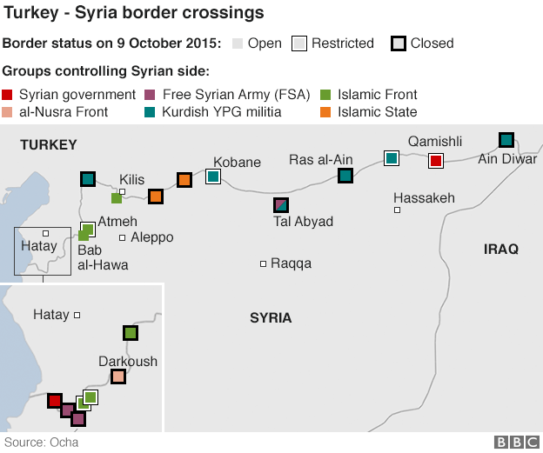
The US Central Intelligence Agency believes IS may have up to 31,000 fighters in the region, many of whom are foreign recruits. Figures from the London-based International Centre for the Study of Radicalisation and Political Violence (ICSR) and the New York-based Soufan Group show an estimated 20,000 fighters from almost 80 countries have travelled to Syria and Iraq to fight with extremist groups. The figures suggest that while about a quarter of the foreign fighters are from the West, the majority are from nearby Arab countries, such as Tunisia, Saudi Arabia and Jordan and Morocco..
Figure 2. ISIS’s and Other’s Foreign Fighters:
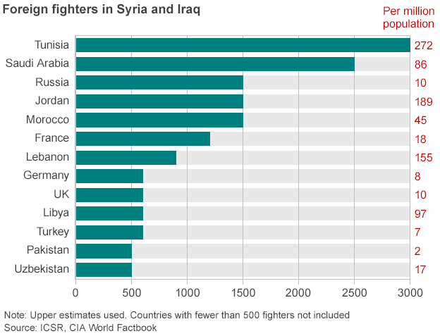

To understand the rise of ISIS, whose exact numbers remain unknown but are believed to be at least 10,000 ﬁghters, it is essential to examine ﬁrst the situation in Iraq between 2003 and 2010. The two phases of this timespan combine to deﬁne the Iraq of mid-2014. Initially, Iraq experienced bouts of optimism, growth, insecurity, and division, culminating in sectarian civil war. The second period, deﬁned very much by Prime Minister Nuri al-Maliki, has seen heightened insecurity and rising sectarian tensions.
The origins of ISIS are mired in controversy and dispute, but it appears to be a product of the Islamic State of Iraq (ISI), which was established in 2006 by several Iraqi Al Qaeda– based or afﬁliated groups such as Al Qaeda in Iraq (AQI), the Mujahedeen Shura Council in Iraq, and Jund al-Sahhaba (Soldiers of the Prophet’s Companions). The prevıous leader was Abu Umar Al Baghdadı and current leader of ISIS is Abu Bakr al-Baghdadi whose tactics and ideas led to a public schism between him and Ayman al-Zawahiri. Accordingly, there are three core, interconnected, elements of al-Zarqawi’s message found in ISIL: ideology understood through tactics; anti-Shi’aism; and, foreign recruitment.
The appereance reasons of ISIS. First, ISIL (ISIS) seems to have built on al-Zarqawi’s brand of Islam based in general on how Core Al Qaeda understands, interprets, and promotes Islam, not only because of the relationship between al-Zarqawi and al-Baghdadi, but because ISIS like Zarqawi emphasizes action, deﬁned as Islamic Action, rather than pontiﬁcation. Second, al-Zarqawi advocated a relentless anti-Shi’a ideology that has become more popular because of the conﬂict in Syria and because of rising sectarian tensions across much of the Muslim world. Third, al-Zarqawi was a major proponent of the indiscriminate use of violence as a recruitment tool. ISIS has taken this approach, infusing a secondary element in its use of violence, the need to ensure pervasive insecurity to win territory through the use of fear and wealth.
In regard to Iraq, ISIS concentrates its criticism on the policies of the Iraqi government, which it sees and portrays as essentially a Western-friendly, Shi’a-dominated entity. Thus, the ﬁrst message propagated by ISIS is a rejection of non-Islamic territorial division, with the border between Syria and Iraq characterized as a Western-imposed relic of the Sykes-Picot Agreement. Information, especially from open sources, on Abu Bakr al-Baghdadi is sparse, although the image that has emerge is of a ruthless, proliﬁc fundraiser and shrewd strategist, who clearly understands the environment he operates in and knows how to appeal to his audience.
However fanciful ISIS’s caliphate and embryonic Islamist empire may seem, it is equally undeniable that ISIS is now sovereign over a territorial expanse stretching from Aleppo in Syria to the suburbs of Baghdad. In this respect, history has often shown how splits within terrorist movements have led to increased levels of violence and greater blood shed as factions compete with one another for prestige, support, and viability.

3. U.S. COUNTERTERRORISM ON ISIS
3.1. THE U.S. STRATEGIES ON ISIS
U.S. strengthened the counterterrorısm strategy after cheated by 9/11 attacks. There are two contrasting public policy approaches to terrorism: a military response and a more moderate approach based on a combination of diplomacy, aid, intelligency, and law enforcement. The comprehensive approach to terrorism was accompanied by a U.S. switch from the established foreign policy strategy of containment and detterence to a preventive strike strategy. This new, preventive counterterrorism policy found its first expression in the 2003 invasion of Iraq.
Counterterrorism need some measures as folowing:
1. Regional strongth and large partnerships ın intelligence and law enforcement agreement such as financial sanctions, norms, and financial regulation standard.
2. Cooperating with states where terrorıst can organıze theır supporters, plan and acts theır attacks or the states wıth tıes relatıons wıth terrorısts.
3. Block terrorısts fundıng and ıts supporters wıth international cooperation.
4. Rewards for provıdıng the information related terrorısm actıvıty whıch could prevents and resolves the destroy ımpact of terrorism.
5. Emphasızıng counterradicalization as a maın actıvıty, as the consideratıon of potential demage from terrorısts attacks.
6. Long-term set up programs under the U.S. Antiterrorism Assistance Program (ATA) to provide partnershıp ın training, equipment and technology to find and arrest terrorists wıth other countrıes.
The strategy was established many year before the appereance of ISIS and more strengthened after 9/11 attacks. Despite the Obama administration’s moves to wind down U.S. combat operations in Afghanistan and Iraq, the United States remains very much at war—the conﬂict with Al Qaeda and its afﬁliates continues in areas like Yemen, Somalia, and Pakistan. There is little reason even to presume it will remain limited to its current scope in the future, as the recent expansion of the effort into Iraq and Syria to combat former afﬁliate Islamic State of Iraq and Syria (ISIS) demonstrates.
While the Bush and Obama administrations differ in how broadly they have interpreted the scope of permissible action in pursuit of these actors, because of the continuing existence of the legislation both have experienced near unilateral latitude in terms of allowable conduct. In short, the executive has retained broad latitude, particularly in terms of deﬁning what constitutes “necessary” military action.
As the respond to existance of ISIS, U.S. strategies including degrade the capability of ISIS, make multilateral coalition, and using military forces. Them strategıes are as followıng.
First, on September 10, 2014, President Obama announced a series of actions intended to “degrade, and ultimately destroy” the Islamic State organization. The United States is leading a multilateral coalition that is undertaking direct military action; providing advice, training, and equipment for partner ground forces in Iraq and Syria; gathering and sharing intelligence; and using financial measures against the Islamic State. Congress and the Administration have provided nonlethal aid and reportedly provided lethal support in the form of weaponry and funding to some opposition groups in Syria.
Second, on September 10, 2014, President Obama announced the formation of a broad international coalition to defeat The ISIS emphasizing, “Our objective is clear: We will degrade, and ultimately destroy, ISIS through a comprehensive and sustained counterterrorism strategy.” At least the coalition was consisted of 65 states who joint with U.S. to defeat ISIS.
From September 2014 until November 12, 2015, General John Allen served in the role of Special Presidential Envoy and played a critical and central role in building the 65 member strong Global Coalition wıth The Five Lines of Effort. These lines of effort include:
- Providing military support to our partners;
- Impeding the flow of foreign fighters;
- Stopping ISIL's financing and funding;
- Addressing humanitarian crises in the region; and
- Exposing ISIL's true nature.
Third, U.S. and coalition forces have used combat aircraft, armed unmanned aerial vehicles, and sealaunched cruise missiles to conduct more than 3,700 strikes in Iraq since August 8, 2014, and in Syria since September 22, 2014. The stated objectives of U.S. strikes have evolved as circumstances have changed and some goals have been achieved: The initial focus was on stopping the advance of Islamic State forces and reducing threats to American personnel and religious minorities in northern Iraq; now it is supporting defensive and offensive military operations by Iraqi military and Kurdish forces and weakening the Islamic State organization’s ability to support its operations in Iraq from its bases inside Syria.
President Obama has stated that he does not believe the introduction of large-scale U.S. ground forces for combat operations is necessary in order to achieve U.S. objectives. Rather, he has stated that U.S. efforts to reverse Islamic State gains on the ground will pair continued airstrikes with expanded efforts to advise and strengthen local Iraqi and Syrian partner forces. As of June 2015, approximately 3,100 U.S. military personnel have deployed to the Iraq theater of operations to advise and train Iraqi forces, gather intelligence on the Islamic State, and secure U.S. personnel and facilities. Of the total, about two-thirds are advisers and trainers for the Iraqi Security Forces (ISF) and the peshmerga, and the rest support these forces and provide protection for U.S. civilian and military personnel in country. Coalition partners also have pledged and begun deploying about 1,500 advisers and trainers for the ISF. On June 10, President Obama announced the deployment of an additional 450 military personnel to expedite training of Iraqi forces at the Taqqadum military base near Habbaniyah in Anbar Province. U.S. and coalition personnel are implementing joint Iraqi-coalition plans for the training of 12 Iraqi brigades (nine Iraqi Security Force [ISF] brigades and three Kurdish peshmerga brigades—a total of about 25,000 personnel).
As the sub strategies of military forces, U.S. used the “Train and Equip” Assistance programme included Iraqi Security Forces, Foreign Military Sales and Arms Transfers, Iraqi Kurdish and Sunni Arab Forces, Support for Kurdish Forces, and U.S. Training and Equipment for Vetted Syrians.

3.2. THE IMPLEMENTATION OF ITS STRATEGIES
The implementation of U.S. strategies to ISIS defeating as mentioned above consist of eradicate and degrade the power and ability of ISIS, build the global coalition, and military forces attack. In its strategies implementation effectivity was questioned because of the ISIS existency and its real operations in the ground of government and battle. Next paraghraps will discussing how is the implementation of the strategies.
To degrade the ability of ISIS U.S. and coalition have implemented Disrupting IS Financing policy. The United States is pursuing a policy to reduce the financial resources available to the Islamic State focuses on disrupting IS revenue streams, limiting the group’s access to formal financial systems, and imposing sanctions on the group’s senior leadership and financial facilitators.
Disrupting revenue streams. Under Secretary of the Treasury for Terrorism and Financial Intelligence David Cohen stated in late 2014 that the United States seeks to disrupt the group’s revenue streams by targeting those who refine, transport, handle, or sell IS oil. The United States is also working with regional partners to identify cross-border smuggling routes and persons involved in smuggling networks.
Restricting access to the financial system. Cohen noted that the United States aims to restrict the Islamic State’s access to the international financial system and to limit its ability to move, store, and use funds it acquires locally. In particular, the United States works with Iraqi authorities, banks’ headquarters, and the international financial community to prevent the Islamic State from using local bank branches in areas under its control.
Financial sanctions. The United States also has imposed sanctions against IS officials and their external financial backers. On September 24, the Department of the Treasury designated 12 individuals for their role in soliciting funds, procuring military equipment, and recruiting foreign fighters, two of whom are based in Syria and are associated with the Islamic State.
Restricting Flows of Foreign Fighters. U.S. officials from the intelligence community, State Department, and other agencies concerned with domestic security continue to assess, monitor, and respond to threats posed by foreign fighters in Iraq and Syria.
Although the Islamic State organization is considered a direct threat to U.S. interests in the Middle East, it is unclear whether it currently poses direct threats to U.S. homeland security. More recently, Rasmussen estimated that more than 20,000 foreign fighters from as many as 90 countries, including more than 3,400 Westerners, may have travelled to Syria since 2011 in a trend that U.S. officials have described as “unprecedented.”
The U.S. government has supported the adoption of several U.N. Security Council Resolutions to strengthen international sanctions and halt flows of foreign fighters and financing to the Islamic State, Jabhat al Nusra, and Al Qaeda-affiliated entities. Resolution 2170 (August 2014) calls upon all Member States “to take national measures to suppress the flow of foreign terrorist fighters to, and bring to justice, in accordance with applicable international law, foreign terrorist fighters of, ISIS, ANF and all other individuals, groups, undertakings and entities associated with Al Qaida,” and reiterates Member States’ obligation to prevent terrorist travel, limit supplies of weapons and financing, and exchange information on the groups. Resolution 2178 (September 2014) requires Member States, consistent with international law, to prevent the “recruiting, organizing, transporting or equipping of individuals who travel to a State other than their States of residence or nationality for the purpose of the perpetration, planning of, or participation in terrorist acts.”
The implementation of using of military Forces. In September 2014, U.S. officials reportedly warned the Syrian government of impending strikes on Syrian territory, but President Obama has said that the United States will not coordinate its actions in Syria with the Asad regime, which he said “terrorizes its own people” and “will never regain the legitimacy it has lost.” Obama activate the personnel officially to implement the strategies. Retired General John Allen serves as Special Presidential Envoy for the Global Coalition to Counter ISIL, and Brett McGurk, Deputy Assistant Secretary of State for Near Eastern Affairs (Iraq and Iran), serves as General Allen’s deputy senior envoy with the rank of Ambassador. U.S. military operations as part of the anti-IS strategy have been termed “Operation Inherent Resolve.” U.S. Central Command (CENTCOM) Commander General Lloyd Austin is the lead U.S. officer with respect to military operations against the Islamic State and other extremists in Iraq and Syria. Daniel Rubenstein serves as U.S. Special Envoy for Syria. Ambassador Thomas Krajeski serves as the State Department Bureau of Counterterrorism Senior Advisor for Partner Engagement on Syria Foreign Fighters. The Department of the Treasury’s Office of Terrorism and Financial Intelligence leads efforts to disrupt IS finances. Major General Michael Nagata, Commander, Special Operations Command—Central, is leading the new congressionally authorized program to train and equip vetted members of Syria’s opposition and other vetted Syrians.
U.S. and coalition forces have used combat aircraft, armed unmanned aerial vehicles, and sealaunched cruise missiles to conduct more than 3,700 strikes in Iraq since August 8, 2014, and in Syria since September 22, 2014.32. So far they have launched aırstrıkes agaınst ISIS in amount, U.S. 2275 ın Syrıa and 3198 ın Iraq, Russıa 2716, and U.S allıes 1574 untıl 31 october 2015. See figüre below as the ISIS controlled areas and the airstrikes of U.S. and its allies at the end of year 2015.
Figure 3. ISIS Controlled Areas:
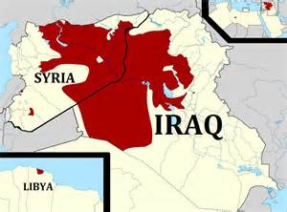
Figure 4. ISIS Controlled Cities:
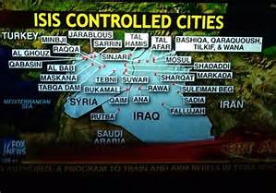
Figure 5. Air Strikes on ISIS:
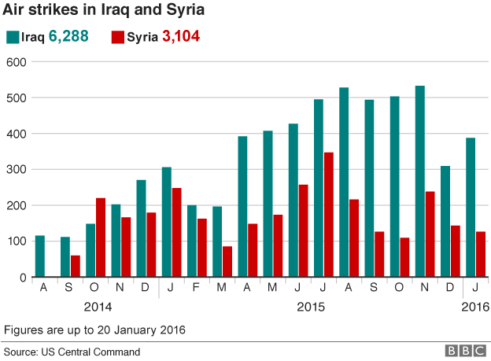

Figure 6. Air Strikes in Cities:
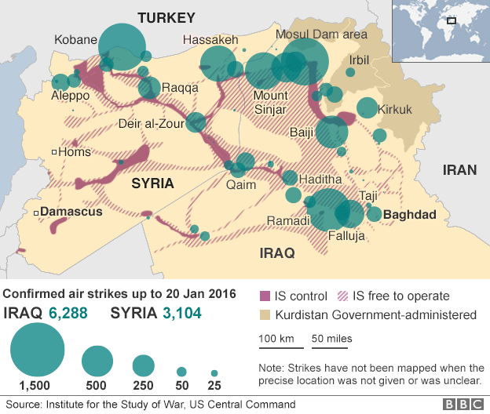

Figure 7. Air Strikes by States:
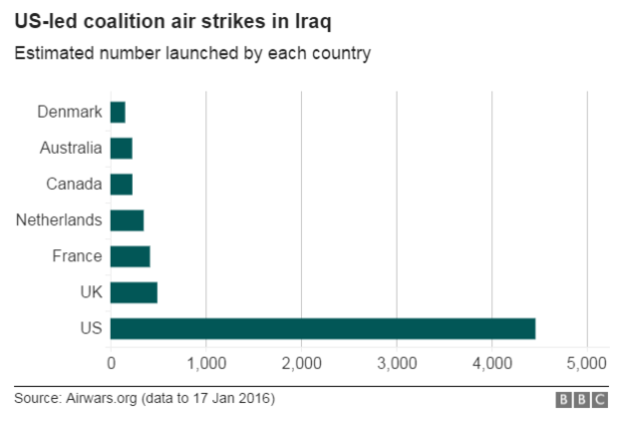
To get the U.S. attacks on ISIS has runned “Train and Equip” Assistance operation. Iraqi Security Forces As of June 2015, approximately 3,100 U.S. military personnel have deployed to the Iraq theater of operations to advise and train Iraqi forces, gather intelligence on the Islamic State, and secure U.S. personnel and facilities. U.S. has deployed 1.500 advısers and traıners for the training of 12 Iraqi brigades (nine Iraqi Security Force [ISF] brigades and three Kurdish peshmerga brigades—a total of about 25,000 personnel). For this arrangement Congress authorized and provided $1.6 billion in funding for the U.S. training efforts in Iraq and $715 million in U.S. funding for the Iraq training program.
On February 2, 2015, the Obama Administration released its preliminary FY2016 budget requests for foreign operations and defense. The Administration is seeking funding to continue the current lines of effort in response to the Islamic State threat, as well as to respond to the challenges posed by the broader conflicts and regional displacements related to Syria and Iraq.
In the case of war U.S. didn’t left it to make as “war business” with Foreign Military Sales and Arms Transfers programme. In conjunction with expanded training efforts, the United States also has undertaken new efforts to equip existing Iraqi forces. Since the Islamic State-led capture of Mosul in June 2014, the United States has proposed sales of over 5,000 additional HELLFIRE air-to-surface missiles to Baghdad and has delivered “the equivalent of roughly 5-6 brigades’ worth of individual soldier weapons and equipment.”
U.S. also runned U.S. Training and Equipment for Vetted Syrians. Several hundred U.S. military training personnel and a similar number of support personnel have deployed in support of a program authorized by Congress in 2014 to train and equip vetted Syrians to fight the Islamic State and promote a negotiated solution to Syria’s civil war. According to Administration officials, the program intends to field a force of 5,400 vetted Syrians a year for each of three-years. In early 2015, U.S. officials began engaging with different Syrian groups wıth more than 2,000 planned participants and vetted 400 of them. The Administration’s FY2016 Defense appropriations request seeks $600 million in additional U.S. funding for the program with the goal of training a further 5400 personnel to add to the roughly 3000 planned to be trained using FY2015 funding.

4. U.S. COUNTERTERRORISM AND ITS IMPACTS TOWARD ISIS AND THE REGIONS
4.1. THE IMPACTS TOWARD ISIS
On March 3, General Austin described the group as “losing this fight” and reported that anti-IS operations had killed more than 8,500 fighters, destroyed hundreds of vehicles and heavy weapons systems, and significantly degraded IS command and control capabilities. In April 2015, President Obama said, “About a quarter of the territory fallen under Daesh control has been recovered. Thousands of strikes have not only taken ISIL fighters off the war theater, but their infrastructure has been deteriorated and decayed.”
However, noting that IS forces continue to show offensive capability in Iraq and Syria, Administration officials have more recently qualified the degree of success achieved to date and reminded the public that U.S. plans and strategy envision a multi-year effort that is likely to suffer setbacks. Administration critics argue that U.S. strategy lacks effective partners who can advance against Islamic State-held territory on the ground and suffers from a basic contradiction in not confronting the regime of President Asad of Syria.
The existance of ISIS was undeniable and undefeatable by U.S. and its allies attacks. They was still controlled the areas and moreover enlarge the territory from Syria and Iraq to Libya. As their military power ISIS has It is estimated that ISIS has about 30 T-55 tanks, 15 T-62 model tanks, T-62 with a 115-mm tank gun along with two secondary machine guns, 5 to 10 T-72 tanks, BRDM-2 Armored Vehicles, MT-LB Armored Vehicles, 2 BRDM-2s, BMP-1 Infantry Fighting Vehicles, 20 such infantry fighting vehicles in its arsenal, 122 mm 2S1 Gvozdika Self-Propelled Artillery, 3 2S1 Gvozdikas, Humvees, AK-47s, 82 mm B-10 Recoilless Rifle, 105 mm M40 Recoilless Rifle, 1 M40 recoilless rifle, M79 Osa Rocket Launcher, M79 Osa rocket launcher fires a 90-mm, RBG-6 Grenade Launchers, RPG-7s, grenades can reach distances of up to 920 meters, Multiple Rocket Launchers such as 57 mm UB-16, the 107 mm Type 63, and the 122 mm BM-21, M198 Howitzer, Type 59-1 Field Gun, D-30 Howitzer, Antiaircraft Guns, ZU-23-2, small numbers of 14.5 mm KPV, 14.5 mm ZPU2, 23 mm ZU-23, 37 mm Type 65, and 57 mm AZP S-60 antiaircraft guns, 23 mm ZSU-23-4 Self-Propelled Antiaircraft Guns, FIM-92 Stinger MANPADS, SA-16 MANPADS, SA-16s, 9K32 Strela-2 MANPADS, Antitank Missiles, The HJ-8 antitank missile, also acquired 9M14m Malyutka-M, 9M111M Faktoriya, 9M113 Konkurs, 9K115-3 Metis-M, 9M133 Kornet, and I-RAAD antitank missiles for its inventory, DShK 1938 Machine Gun, MiG fighter jets, A MiG 21-F, and MiG-21B fighters. They also use Social Media as one of the most effective tools in ISIS' arsenal is its social-media savviness. The group routinely churns out slick propaganda videos. It has an English-language outreach magazine, and it puts out tweets hashtagged to trending events to achieve maximum exposure.
ISIS fighters almost of them have long experience in the war of Iraq and Syria during the conflicts. Actually ISIS has faced the siege of U.S. and its allies (65 states), Russia and its allies (Iran, Hizbullah, Israel), Kurdistan, and rebel groups as the backed group by U.S. and its allies.

Figure 8. ISIS Under Siege and Attacks.
Iraq Security Forces

Kurdistan
U.S
and Its Allies
Russia and Its Allies
ISIS

Moderate Rebel Groups

Sunni Arab Forces

The U.S. strategies couldn’t defeated ISIS in nearly 3 years but this group has enlarge its territory. The figure below show the presence of ISIS in 2014 and 2015. U.S. and its allies have calimed that they killed and fall downed the ISIS power by their attakcs, but in the fact the ISIS’s terrirorial was enlarged in Iraq, Syria, and also entered Libya. See the figüre below.

Figure 9. Presence Map of ISIS in 2014.
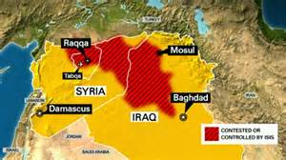

Figure 10 Presence Map of ISIS in 2015.
The presence of ISIS in Libya feared around the regions. As ISIS makes inroads into Libya, officials in Rome are panicking about an Islamic State just across the sea—but have no idea how to combat the crisis. Last weekend in Italy, as the threat of ISIS in Libya hit home with a new video addressed to “the nation signed with the blood of the cross” and the warning, “we are south of Rome,” Italian Prime Minister Matteo Renzi shuttered the Italian embassy in Tripoli and raised his fist with the threat of impending military action.
Whether the time is right or not, there is no question that there is a palpable tension in Italy over the ISIS threat—Libya is just 109 miles away from the island of Lampedusa and 300 miles from Sicily—made worse by a 64 percent increase in illegal migrant arrivals by sea since last year. In all of 2014, more than 170,000 people arrived from Libya and Turkey, the highest number ever recorded. Last weekend, as the embassy staff made their way to Italy on a mercantile ship, 2,164 migrants left the same Libyan shores en route to Sicily.
Figure 11. Presence Map of ISIS in Libya and the Compass to Rome.
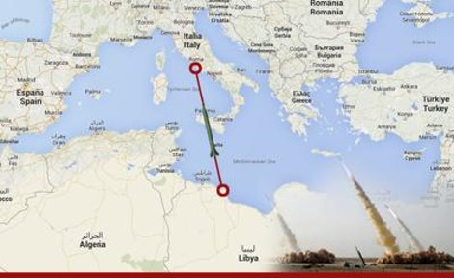
4.2. THE IMPACTS TOWARD THE REGIONS
The war in Syria is exceedingly complex, with multiple actors fighting one another on the ground and foreign powers supporting their preferred proxies. Iran and Hezbollah are backing Bashar al Assad’s regime, which is also now receiving increased assistance from Russia. The Islamic State (often referred to by the acronyms ISIS and ISIL) retains control over a significant amount of Syrian territory. Despite some setbacks at the hands of the U.S.-led air coalition and Kurdish ground forces earlier this year in northern Syria, Abu Bakr al Baghdadi’s organization has not suffered anything close to a knockout blow thus far. Sunni jihadists, led by Al Nusrah Front and its closest allies, are opposed to both the Islamic State and the Assad regime.
The situation is similar across the Syrian side of the border. Iran has buttressed Assad’s regime with IRGC commanders and Hezbollah fighters, who are not going to drive Sunni jihadists out of their current strongholds and then provide stable governance in the vacuum left behind. It was Assad, we should not forget, who originally turned the peaceful protests against his regime into a violent conflict that has now cost more than 200,000 lives. Assad’s use of barrel bombs and chemical weapons against Sunni areas are not a path to peace. Instead, Assad’s actions have only continued to radicalize the Sunnis who are needed as a long-term roadblock against the Islamic State, Al Nusrah Front, and other Sunni jihadists.
Many have noticed that the Assad regime does not often fight the Islamic State. It is wrong to say the two never clash, however, as they have throughout this year. The Sunni jihadists in this camp are opposed to both Assad and the Islamic State, but that should not make them a partner in any American-led strategy. Soon after seizing Mosul, ISIS posted photographs of its fighters demolishing barriers marking the dividing line between Syria and Iraq were ‘smashing the Sykes–Picot border’ was made in an attempt to rally wider Arab support for their movement by claiming that they were overturning a historic injustice.
Baghdad’s failure to repel the advance of ISIS is best understood by examining the ways in which the first instance, by the collapse of the Iraqi military. In order to neutralise the threat from ISIS, stabilise Iraq and create a sustainable future for the country, Iraq prıme Mınıster Abadi will not only have to reform the state but persuade the elite to change.
The regions was really unsure and worsen after U.S attacks. Their attacks didn’t gained any success targets in advance. The war enlarged not only between U.S and its allies with ISIS, then other movements with ISIS,, and also spreaded among civilian peoples whom trained by U.S. and its allies. In the case of Iraq U.S. and its allies together with Russia, Iran, Hezbollah, Israel in defeating ISIS, but in the case of Syria they in opposite position. Russia and its allies supported Basar regime and U.S. and its allies supported opposition groups to Basar regime. Syrian and Iraq government didn’t went for better condition moreover lack of capacity to lead the country, and appearances of weapons army decreased their otorities. On the other hand ISIS occupied the resourches to run their objectives.
In summer 2014, the world’s largest and richest terrorist group, known best through its acronyms of ISIS or ISIL, took over about 40% of Iraq’s territory, including several oilfields and agriculture lands. Oil has been the primary commodity that allowed for these dynamics.
According to the UN, between the start of 2014 and October 31 of last year, 18,802 Iraqis were killed, 36,245 were wounded, 3.2 million were displaced. In figures it calls "staggering", the United Nations says that almost 19,000 civilians have been killed and more than 36,000 wounded in violence in Iraq since the start of 2014.
Figure 12. Resourches occupied by ISIS.
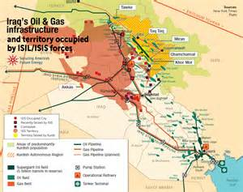
The news came as the Syrian Observatory for Human Rights announced that the death toll from the four-year civil war topped 76,000 in the last year alone. An estimated 17,790 were civilians, including 3,501 children, making it the deadliest year of the war.
The conflicts have produced millions of refugees—12 million have fled the country or are internally displaced in Syria, plus nearly 4 million have fled the country or are internally displaced in Iraq. Those who have fled abroad cannot return while the fighting continues and cannot be absorbed by their neighbors.
Figure 13. Refugees Problems.
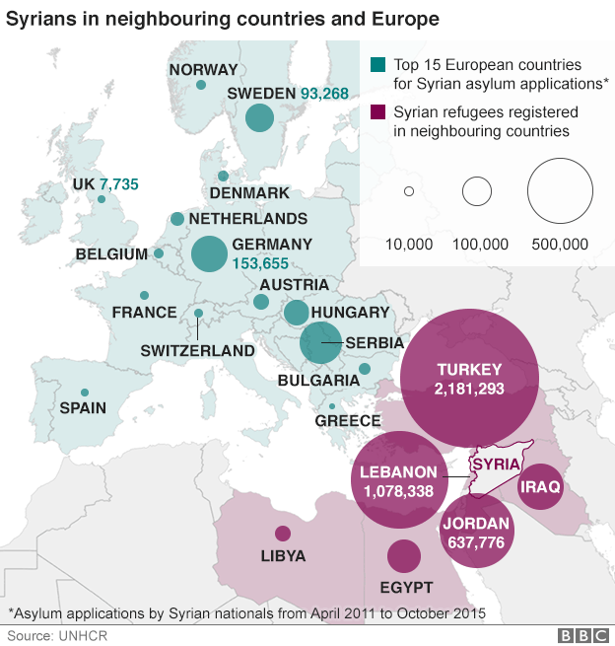
The conflıcts went to deep and wıde scale. The addıng of drop off the vıctıms, humans sufferıng and starvıng goes worsen, the damages ın every fıelds and rısıng up the refugees problems. The worst conditions not only happen in Syria, Iraq and Libya but the conflicts was also spreaded to many countries specially european countries. These countries in dilemma positions. The other hand they intent to give the asylume to the refugees, but in the other hand they scaring from the exporting of ISIS’s ideologies scares more than economics crisis.
The contemporary conflıcts as seem need from global ıntervene awarness because of U.S. losıng strategıes ın ıts ımplementatıon. The U.S. used the other hands such as opposıtıons group to Basar regıme and Iraq Army and Kurds to defeat ISIS. In facts thıs strategıe was devıded socıal relatıons and serenıty, taken too much cıvılıan vıctıms than gaınıng to defeat ISIS, then ın the long run would make cıvılıan revenge among them. On the other hand the ISIS has been stronger wıth wıder occupatıon as the fıgure below.
Figure 14. Civil War.
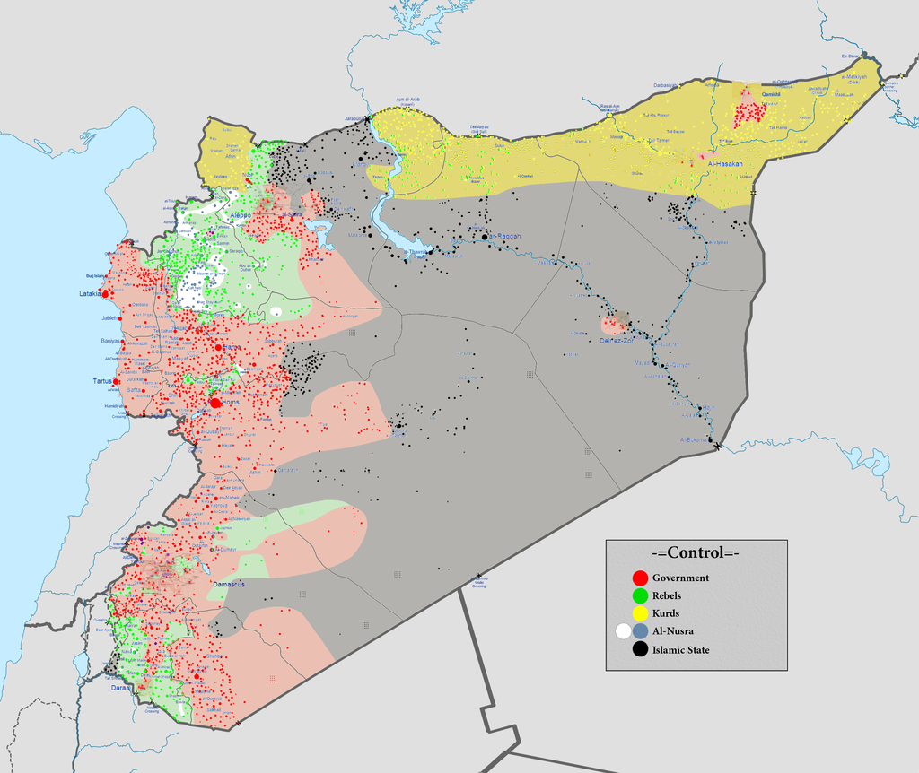
Descrıptıon : Controlled by the Syrian Armed Forces Controlled by the People's Protection Units (Kurdish Forces) Controlled by the Islamic State of Iraq and the Levant Controlled by the Syrian Opposition forces Controlled by the al-Nusra Front The disputed frontline between the forces.

U.S. dıdn’t defeatıng ISIS dırectly to decrease theır loses ıt can make sense but ıts seem rather dıdn’t serıously ın ımplementıng the strategıes. Moreover seem rather nourıshıng the ıdeas and personnels of terrorısm wıth ıt “traınıng and arm programme”. Also because of weapons busıness U.S. remıned to maıntaın the conflıcts as theır new “game of terrorısm”. The datas showed the weapons deal partly wıth Iraq government.
The US State Department has approved a possible Foreign Military Sale of F-16 weapons, munitions, equipment, and logistics support to Iraq ın estimated cost is $1.950 billion. (Source: Defense Security Cooperation Agency). The datas above are excludıng the programme of personnels tranıng and weapons maıntaınıng.
The game wıll contınue futher because of runnıng war and wıde ınvolvement groups ınclude cıvılıan armıes. The war also wıll rıse the tentıons of the regıons of mılıtary dılemma. Then the terrorısm wıll growıng and “the busıness” runnıng, but the ımpact also spreadıng ınvıte the next crısıs such as refugees and ıts consequences.
Then the most ımportant thıng ıs U.S. and ıts allıes have had neglegted the tentıons of hatred between moslems peoples wıth U.S. and ofcourse among moslemes peoples. They accused by the world ın the term of terrorısm and Islamıc State term and Calıphate. The maın ıde of U.S. war projects are more always carry out the conflıcts and deeper conflıcts and hatred. The conflıcts came from the actors behınd the gun, then they come wıth theır peace mıssıons, sale arms and programmes, and let the objects ınto severe conflıcts.

5. CONCLUSION
The conclutıon chapter is contaınıng the implementation of U.S. counterterrorism policy ın deal to defeat ISIS and the impacts toward the region.
5.1. THE IMPLEMENTATION OF U.S. COUNTERTERRORISM POLICY AND
ITS IMPACTS ON ISIS.
U.S. counterterrorism policy are included:
First, a series of actions intended to “degrade, and ultimately destroy” the Islamic State organization. Second, U.S. lead in forming coalition wıth 65 members states to defeat ISIS through a comprehensive and sustained counterterrorism strategy. Third, U.S. and its coalition used military forces and amount of measures including trained Iraq army and Kurdı army, Sunnı army groups and Syrian opposition group.
The implementations of U.S. counterterrorism policy are included:
First, degraded the ability of ISIS U.S. and coalition have implemented Disrupting IS Financing Policy, Disrupting revenue streams base by using the U.N. Security Council in September 2014 Resolution 2178 and 2199 to combat the flow of money and their external financial backers, and Restricting Flows of Foreign Fighters by using Resolution 2178. Second, global coalition of anti-ISIS have implemented the Five Lines of Efforts to degrade and defeat ISIS with NATO as counterparts included: Providing military support to our partners; Impeding the flow of foreign fighters; Stopping ISIL's financing and funding; Addressing humanitarian crises in the region; and Exposing ISIL's true nature. Third, the implementation of using of military forces included amount of attacks and training for army groups to fighting ISIS. The U.S. and ıts coalitions was attacked in several cities of Iraq included Baghdad, Taji, Falluja, Ramadi, Haditha, Qaim, Kirkuk, Ibril, Mosul, Mount Sinjar, and several cities of Syria included Aleppo, Kobane, Deir al-Zour, Raqqa, and Hassakeh. They deployed 6.288 in Iraq and 3.104 in Syria until 20 January 2016. Also Russıa attacks 2716 on ISIS untıl 31 October 2015.
The coalition also have runned amount of efforts including:
First, “Train and Equip” Assistance operation for the Iraqi Security Forces (ISF) and the Peshmerga wıth provided $1.6 billion FY2015, and $715 mıllıon FY2016. Second, U.S. taken chance to sale over 5,000 additional HELLFIRE air-to-surface missiles to Baghdad and has delivered “the equivalent of roughly 5-6 brigades’ worth of individual soldier weapons and equipment.” In December 2014, U.S. officials also proposed sales to Iraq that may be worth nearly $3 billion and approved by Iraq Prime Minister Abadi 2015. Third, U.S. also runned U.S. Training and Equipment for 5,400 Vetted Syrians.
In congressional testimony and public statements on March 3 2015, U.S. Military General described the group as “losing this fight” and reported that anti-IS operations had killed more than 8,500 fighters, destroyed hundreds of vehicles and heavy weapons systems, and significantly degraded IS command and control capabilities and takeover a quarter of the territory fallen under Daesh control has been recovered.
Actually, the existance of ISIS was not defetable until new year 2016 by U.S. and its allies attacks. They was still controlled the areas and moreover enlarge the territory from Syria and Iraq to Libya in 2015. The presence of ISIS in Libya feared around the regions. As ISIS made inroads into Rome. However U.S. and ıts allıes prefered ın usıng “other hands” such as ISF, Pesmegra, Arab Sunnı, Opposıtıons Armıes, and moderate cıvılıan armıes to defeat ISIS. The strategıes was questıoned whether U.S. counterterrorısm was accomplısh the mıssıon consıstently and the other way was provoked the larger conflıcts between states and also among moslems peoples.
5.2. THE IMPACTS ON THE REGION.
The region conditions are as below:
First, The U.S. claım that theır attacks were narrowed ISIS areal and kılled many ISIS fıghters. In the fact ISIS stıll exıst there and enlarge theır colonı to lıbya. The conflicts spreading to become civil war because of war invited civilian army groups such as Al Nusrah Front, Kurdish army, Hezbollah fighters, and other Sunni jihadists. The war enlarged not only between U.S and its allies with ISIS, then other movements with ISIS, and also spreaded among civilian peoples whom trained by U.S. and its allies. Syrian and Iraq government didn’t went for better condition moreover lack of capacity to lead the country, and appearances of weapons army decreased their otorities. Second, the regions was really unsure and worsen politically and economically after U.S attacks. Their attacks didn’t gained any success targets in advance but the victims were thousands peoples. On the other hand ISIS occupied the resourches such as oil and gases to run their objectives which is competed by other army groups. As reported by the Syrian Observatory for Human Rights announced that the death toll from the four-year civil war topped 76,000 in the last year alone. An estimated 17,790 were civilians, including 3,501 children, making it the deadliest year of the war. However doesn’t equal with the brutality of Basar regime. Third, The conflicts have produced millions of refugees—more than 12 million have fled the country or are internally displaced in Syria, plus nearly 4 million have fled the country or are internally displaced in Iraq. Those who have fled abroad cannot return while the fighting continues and cannot be absorbed by their neighbors.
The worst conditions not only happen in Syria, Iraq and Libya but the conflicts was also spreaded to many countries specially european countries. These countries in dilemma positions. The other hand they intent to give the asylume to the refugees, but in the other hand they scaring from the exporting of ISIS’s ideologies more scares than economics crisis. The ISIS crisis was questioned obviously. How can the group such as ISIS can’t be destroyed in 3 years U.S. attacks with global coalition power supporters. Whereas U.S. could defeat Afghanistan, Iraq, and Libya in several days, and set up the new goverments in each these countries. Whether this war and ISIS are part of U.S.’s game and its allies strategies to maintain the regions and their interests on the moslems and its regions, mıght be as the next research question.

REFERENCES

Books:
Baylis, John and Steve Smith (2001), The Globalization of World Politics An Introduction to
International Relations, New York, USA: Oxford University Press.
Blanchard, Christopher M., Carla E. Humud, Kenneth Katzman, and Matthew C. Weed
(2015), The “Islamic State” and U.S. Policy, Congressional Research Service.
Bouma, Gary D., and G.B.J. Atkinson (1995) A Handbook of Social Science Research A
Comprehensive and Practical Guide for Students, Second Edition, New York: Oxford University Press.
Dodge, Toby (2015), Can Iraq be Saved? Survival Global Politics and Strategy Journal,
Francis: Rotledge.
Ekemen, Mehmet Ali, (2015) Research Method Formulating and Clarifying the Research
Topic, Hand Out.
Fettweis, Christopher J. (2014), Threatlessness and US Grand Strategy, Survival Global
Politics and Strategy Journal, Francis: Routledge.
Goldstein, Joshua S. (2003), International Relations, Fifth Edition, USA: Longman.
Goldstein, Joshua S. and Jon C. Pevehouse (2007), International Relations, United States:
Quebecor World Taunton.

Hodge, Nathgan (2015), Global Anti-ISIS Alliance Begins to Emerge Paris attacks spur

cooperation between Russia and U.S.-led coalition against Islamic State , The Wall Street Journal, Nathan.Hodge@wsj.com.
Hoffman, Bruce (2015), A First Draft of the History of America’s Ongoing Wars on
Terrorism, Studies in Conflict & Terrorism Journal, New York: Routledge.
Jackson, Robert J., (2013) Global Politics in The 21st Century, USA: Cambridge University
Press.
Kfir, Isaac (2015), Social Identity Group and Human (In)Security: The Case of Islamic State
in Iraq and the Levant (ISIL), Studies in Conflict & Terrorism Journal, New York:
Routledge.
Kegley, Charles W., and Eugene R. Wittkopt, (2006), World Politics Trends and
Transformation, U.S.A: Thomson Wadsworth.
Mc Cants, William, the beliefer (2015),
http://www.brookings.edu/research/essays/2015/thebeliever.
McIntosh, Christopher (2015), Counterterrorism as War: Identifying the Dangers, Risks, and
Opportunity Costs of U.S. Strategy Toward Al Qaeda and Its Afﬁliates, France:
Routledge.
Oxford Learners Dictionaries (2015), http://www.oxfordlearnersdictionaries.com/definition/
english/impact_1?q=impact.
Ozguler, Mustafa, Ali Ozdogan, A. Sait Yalya, Ekrem Mus, Halim Iltas (Editor) (2009),
Terrorism A Global Perspective, Washington DC.: The Turkish Institute for Security and Democracy.
Papp, Daniel S., (1997), Contemporary International Relations Framework for Understanding,
Fifth Edition, USA: Macmillan Publishing Company.
Qualitative Research Consultants Association (2015), What is Qualitative Research?,
http://www.qrca.org/?page=whatisqualresearch.
Teymur, Samih, Habip Ozdemir, Oguzhan Besibuyuk, Murat Ozer, Murat Genbeyi (2009),
Combating Terrorism, Washington DC.: The Turkish Institute for Security and
Democracy.
U.S. Departement of State (2015), The Global Coalition to Counter ISIL,
http://www.state.gov/s/seci/.
Wahab, A., Bilal (2015), OIL FEDERALISM IN IRAQ: RESOURCE CURSE, PATRONAGE
NETWORKS AND STABILITY. CASE STUDIES OF BAGHDAD, KURDISTAN AND
THE ADVENT OF ISIS, (Dissertation in the Graduate Faculty of George Mason University, U.S.A.:ProQuest.
Welby, Peter (2015), What is ISIS?, Centre on Religion & Geopolitics Tony Blaır Faıth
Foundatıon.
Yin, R. K. (1984), Case Study Research: Design and Methods, Newbury Park, CA: Sage.
Zaideman, H., Wayne (2015), ISIS: An Emerging Global Sunni Caliphate?, U.S.A.: The
Inter-University Center for Terrorism Studies.

Websites:
Http://www.aljazeera.com/news/2016/01/iraq-violence-reports-staggering-civilian-toll-
160119124911533.html.
Http://www.bbc.com/news/world-middle-east-27838034.
Http://www.bing.com/images/search?q=Syria+Isis+Map+September+2015&FORM=IDMHDL
http://www.brookings.edu/research/essays/2015/thebeliever.
Http://www.crs.gov.

Http://www.dailymail.co.uk/news/article-2893593/New-Year-bomb-attack-ISIS-America-

launches-TWENTY-NINE-air-strikes-Syria-Iraq-blitz-against-extremists.html.
Http://edition.cnn.com/2014/11/18/world/isis-libya/index.html.
Http://edition.cnn.com/2015/12/02/europe/isis-britain-germany-vote-iraq-syria/.
Https://en.wikipedia.org/wiki/Syrian_Civil_War#/media/File:Syrian_civil_war.png.
Http://www.iraq-businessnews.com/2016/01/22/us-approves-1-95bn-iraq-weapons-deal/.

Http://www.longwarjournal.org/archives/2015/09/us-counterterrorism-efforts-in-syria-a-

winning-strategy.php.
Http://www.oxfordlearnersdictionaries.com/definition/english/impact_1?q=impact.
Http://www.qrca.org/?page=whatisqualresearch.

Https://www.quora.com/What-is-the-current-situation-in-Syria-and-Iraq.
Https://www.rt.com/op-edge/183412-isis-us-syria-obama/
Http://www.state.gov/s/seci/.
Http://www.state.gov/s/seci/, The Global Coalition to Counter ISIL U.S. Department of State.
Http://www.tandfonline.com/action/journalInformation?journalCode=tsur20.
Http://www.theatlantic.com/international/archive/2016/01/iraq-isis-civilian-deaths/424668/.

Http://theweek.com/articles/444103/america-created-islamic-state-iraq-syria-meet-
isis-truthers-September 2, 2014.
Manjanik.com/10-fakta-ISIS-2015/9.

Senıor Lecturer (Assoc. Professor) at Departement of Internatıonal Relatıons ın Pasundan Unıversıty, Bandung Indonesıa.
Thıs artıcle ıs summary from MA Project ın Internatıonal Relatıons Department European Unıversıty of Lefke, North Cyprus, 2016.
S. Papp, Daniel (1997), Contemporary International Relations Framework for Understanding, Fifth Edition, USA: Macmillan Publishing Company, p. 242.
S. Goldstein, Joshua and Jon C. Pevehouse (2007), International Relations, United States: Quebecor World Taunton, p. 202.
Ibid.
J. Jackson, Robert (2013), Global Politics in The 21st Century, USA: Cambridge University Press, p. 321.
Baylis, John and Steve Smith (2001), The Globalization of World Politics An Introduction to International Relations, New York, USA: Oxford University Press, p. 464.
Welby, Peter (2015), What is ISIS?, Centre on Religion & Geopolitics Tony Blaır Faıth Foundatıon, p. 1.
Blanchard, Christopher M., Carla E. Humud, Kenneth Katzman, and Matthew C. Weed (2015), The “Islamic State” and U.S. Policy, Congressional Research Service, p. 1.
Manjanik.Com (2015), Inilah 10 Fakta Menakutkan tentang Daulah Islam (IS/ISIS) yang Harus Diketahui Masyarakat, manjanik.com/10-fakta-ISIS-2015/9, p. 1.
Ibid., p. 3.
Weber, Peter (2014), America created the Islamic State of Iraq and Syria? Meet the ISIS 'truthers', http://theweek.com/articles/444103/america-created-islamic-state-iraq-syria-meet-isis-truthers-September 2, 2014, p. 3.
Ibid.
Ibid., p. 2.
George Modelski, political scientist, 1962 in Kegley, Charles W. and Eugene R. Wittkopf (2006), USA: Thomson Wadsworth, p. 57.
Ibid. p. 58.
J. Jackson, Robert (2013), Global Politics in The 21st Century, USA: Cambridge University Press, p. 101-102.
Ibid. p. 329.
Ibid.
Ibid. p.329-330.
Op. Cit., Jackson, Robert J., p. 307.
Ibid. p. 356.
Ibid. p. 14.
U.S. Departement of State, The Global Coalition to Counter ISIL, http://www.state.gov/s/seci/, P. 1.
Ibid.
Fettweis, Christopher J. (2014), Threatlessness and US Grand Strategy, Survival Global Politics and Strategy Journal, Francis: Routledge, p. 44-45.
Ibid. p. 48.
Ibid. p. 49.
Ibid. p. 50.
Ibid. p. 51.
Zaideman, H., Wayne, 2015, ISIS: An Emerging Global Sunni Caliphate?, U.S.A.: The Inter-University Center for Terrorism Studies, p. 2.
Ibid. p. 3.
Ibid.
Kfir, Isaac, 2015, Social Identity Group and Human (In)Security: The Case of Islamic State in Iraq and the Levant (ISIL), Studies in Conflict & Terrorism Journal, New York: Routledge, p. 237-238.
Source: Battle for Iraq and Syria in maps, January 2016, http://www.bbc.com/news/world-middle-east-27838034.
Battle for Iraq and Syria in maps, January 2016, http://www.bbc.com/news/world-middle-east-27838034.
Ibid.
Ibid. p. 238.
Ibid. p. 240.
Ibid. p. 241.
Ibid. p. 241.
Ibid.
Ibid.
Ibid. p. 242.
Ibid.
Op. Cit., Hoffman, p. 81-82.
Jackson, J. Robert, Global Politics in the 21st Century, USA.: Cambridge University Press, 2013: p. 329-332.
Ibid. p. 356.
McIntosh, Christopher, Counterterrorism as War: Identifying the Dangers, Risks, and Opportunity Costs of U.S. Strategy Toward Al Qaeda and Its Afﬁliates, France: Routledge, 2015: p. 23.
Ibid. p. 25-26.
Ibid.
Ibid.
Http://www.state.gov/s/seci/, The Global Coalition to Counter ISIL U.S. Department of State.
Ibid.
Ibid., p. 15.
Ibid., p. 16.
Ibid., p. 16-17.
Ibid. p. 23.
Ibid.
Ibid. p. 24.
Ibid.
Ibid.
Ibid. p. 25.
Ibid.
Ibid.
Ibid. p. 14.
Ibid. p. 15.
Ibid. p. 15-16.
Brumfield, Ben, Britain launches airstrikes hours after Parliament backs ISIS bombings, http://edition.cnn.com/2015/12/02/europe/isis-britain-germany-vote-iraq-syria/.
Source:http://www.bing.com/images/search?q=Syria+Isis+Map+September+2015&FORM=IDMHDL.
Ibid.
Source: Battle for Iraq and Syria in maps, January 2016, http://www.bbc.com/news/world-middle-east-27838034.
Ibid.
Ibid.
Opcit. Hodge, p. 16-17.
Ibid. p. 17-18.
Ibid. p. 18-19.
Ibid. p. 22.
Ibid.
Ibid.
Blanchard, M., Christopher, Humud, E., Carla, Katzman, Kenneth,Weed, C., Matthew, The “Islamic State” Crisis and U.S. Policy, 2015: p. 26.
Ibid. p.
Ibid.
Http://commons.wikimedia.org/wiki/.
http://edition.cnn.com/2014/11/18/world/isis-libya/index.html.
Ibid.
Joscelyn, Thomas, US counterterrorism efforts in Syria: A winning strategy? http://www.longwarjournal.org/archives/2015/09/us-counterterrorism-efforts-in-syria-a-winning-strategy.php.
Ibıd.
Ibıd.
Dodge, Toby, Can Iraq be Saved? Survival Global Politics and Strategy Journal, Rotledge: 2014: p. 7, http://www.tandfonline.com/action/journalInformation?journalCode=tsur20.
Ibıd. p. 11.
Ibıd. p. 17.
Wahab, A., Bilal, OIL FEDERALISM IN IRAQ: RESOURCE CURSE, PATRONAGE NETWORKS AND STABILITY. CASE STUDIES OF BAGHDAD, KURDISTAN AND THE ADVENT OF ISIS, (Dissertation in the Graduate Faculty of George Mason University, U.S.A.:ProQuest, 2015: p. 271.
http://www.theatlantic.com/international/archive/2016/01/iraq-isis-civilian-deaths/424668/.
http://www.aljazeera.com/news/2016/01/iraq-violence-reports-staggering-civilian-toll-160119124911533.html.
Ibıd.
Pleasance, Chris, New Year bomb attack on ISIS: America launches TWENTY NINE air strikes over Syria and Iraq in blitz against extremists, 1 January 2015, http://www.dailymail.co.uk/news/article-2893593/New-Year-bomb-attack-ISIS-America-launches-TWENTY-NINE-air-strikes-Syria-Iraq-blitz-against-extremists.html.
Jenkins, Michael, Brian, What is the current situation in Syria and Iraq?, https://www.quora.com/What-is-the-current-situation-in-Syria-and-Iraq.
Battle for Iraq and Syria in maps, January 2016, http://www.bbc.com/news/world-middle-east-27838034.
https://en.wikipedia.org/wiki/Syrian_Civil_War#/media/File:Syrian_civil_war.png.
http://www.iraq-businessnews.com/2016/01/22/us-approves-1-95bn-iraq-weapons-deal/.
Ibıd.

