An Analysis of English Interference into Indonesian
(A Study Towards Pikiran Rakyat Online Newspaper)

A Research Paper

Submmitted to the English Department Faculty of Arts and Letters
Pasundan University Bandung as a Partial Fulfillment of the
Requirements for Taking the Bachelor Degree (S-1)

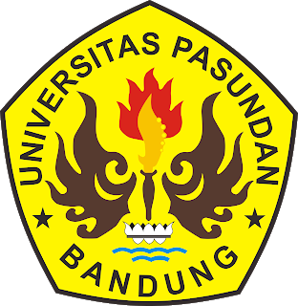

By:
Umi Soliha
147010060

ENGLISH DEPARTMENT
FACULTY OF ARTS AND LETTERS
PASUNDAN UNIVERSITY
BANDUNG
2018

