Tabel 80. Uji Lanjut Duncan Kadar Protein Roti Tawar Sorgum
SSR 5% | LSR 5% | Kode | Rata-rata | Perlakuan |  |  |  |  |  |  |  |  | Taraf Nyata 5%
 |  |  |  | 1 | 2 | 3 | 4 | 5 | 6 | 7 | 8 | 9
 |  | a3b1 | 16,30 | - | - | - | - | - | - | - | - | - | a
3,00 | 1,175 | a3b2 | 16,76 | 0,461^{tn} | - | - | - | - | - | - | - | - | ab
3,15 | 1,235 | a2b1 | 16,80 | 0,499 ^{tn} | 0,038 ^{tn} | - | - | - | - | - | - | - | ab
3,23 | 1,266 | a3b3 | 17,47 | 1,166 ^{tn} | 0,705 ^{tn} | 0,667 ^{tn} | - | - | - | - | - | - | ab
3,30 | 1,294 | a2b2 | 17,50 | 1,201 ^{tn} | 0,740 ^{tn} | 0,701 ^{tn} | 0,035 ^{tn} | - | - | - | - | - | ab
3,34 | 1,309 | a2b3 | 17,57 | 1,269 ^{tn} | 0,808 ^{tn} | 0,770 ^{tn} | 0,103 ^{tn} | 0,069 ^{tn} | - | - | - | - | ab
3,37 | 1,321 | a1b1 | 17,98 | 1,681* | 1,220 ^{tn} | 1,182 ^{tn} | 0,515 ^{tn} | 0,480 ^{tn} | 0,412 ^{tn} | - | - | - | b
3,39 | 1,329 | a1b2 | 18,78 | 2,477* | 2,016* | 1,978* | 1,311 ^{tn} | 1,276 ^{tn} | 1,208 ^{tn} | 0,796 ^{tn} | - | - | b
3,41 | 1,337 | a1b3 | 21,55 | 5,248* | 4,787* | 4,748* | 4,082* | 4,047* | 3,979* | 3,567* | 2,771* | - | c

Tabel 81. Tabel Dua Arah Untuk Interaksi Perbandingan Tepung Dan Konsentrasi Bread Improver Terhadap Uji Kadar Protein (%) Roti Tawar Sorgum
Perbandingan Tepung Terigu dengan Tepung Sorgum Modifikasi (A) | Konsentrasi Bread Improver
 | 0%  (B1) | 0,075%  (B2) | 0,15%  (B3)
75%:25% (A1) | 17,98 A  a | 18,78 A  a | 21,55 A  b
50%:50% (A2) | 16,80 A  a | 17,50 A  a | 17,57 A  a
25%:75% (A3) | 16,30 A  a | 16,76 A  a | 17,47 A  a

Lampiran 10. Gambar Produk
A1B1
(873)
Tampak Atas | Tampak Samping | Tampak Depan | Tampak Bawah
A1B2
(365)
Tampak Atas | Tampak Samping | Tampak Depan | Tampak Bawah
A1B3
(956)
Tampak Atas | Tampak Samping | Tampak Depan | Tampak Bawah

A2B1
(291)
Tampak Atas | Tampak Samping |  | Tampak Depan |  |  | Tampak Bawah
A2B2
(414)
Tampak Atas | Tampak Samping |  | Tampak Depan |  |  | Tampak Bawah
A2B3
(532)
Tampak Atas | Tampak Samping |  | Tampak Depan |  |  | Tampak Bawah
 | 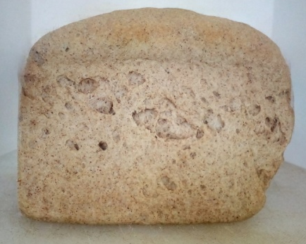 |  |  |  |  | 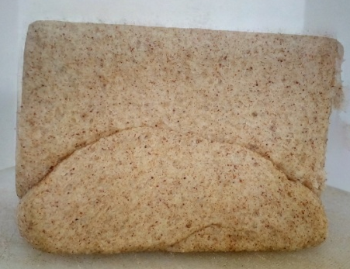
A3B1
(142)
Tampak Atas | Tampak Samping |  | Tampak Depan |  |  | Tampak Bawah
A3B2
(687)
Tampak Atas |  | Tampak Samping |  | Tampak Depan | Tampak Bawah
 |  | 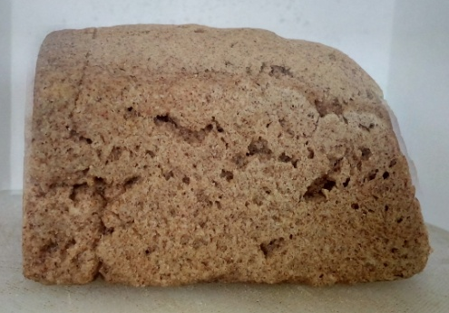
A3B3
(743)
Tampak Atas |  | Tampak Samping |  | Tampak Depan | Tampak Bawah

