LAMPIRAN PERHITUNGAN PROGRAM LINIER
Program linier formulasi I
Kedelai 7,108% = 142,16 gram
Air 92,402% = 1848,04 gram
Gluco Delta Lactone 0,200%= 4 gram
Susu skum 0,290% = 5,8 gram

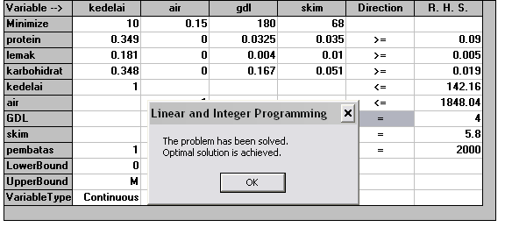
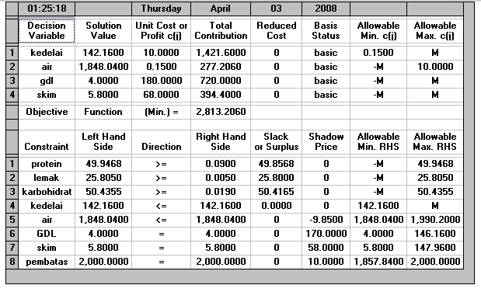
Program linier formulasi II
Kedelai 7,1005% = 142,01 gram
Air 92,3095% = 1846,19 gram
Gluco Delta Lactone 0,200%= 4 gram
Susu skum 0,3900% = 7,8 gram

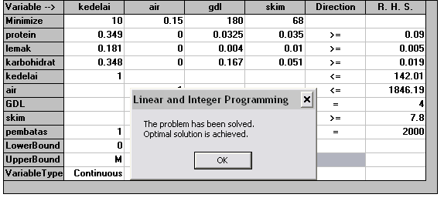
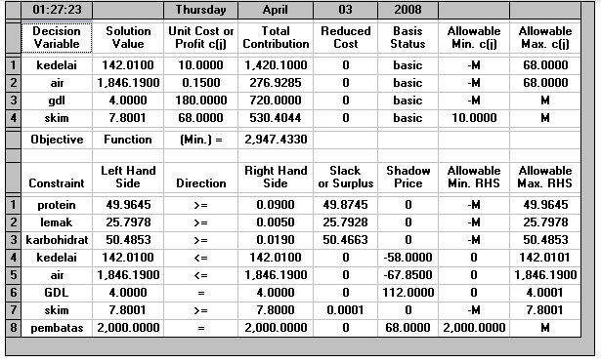
Program linier formulasi III
Kedelai 7,0935% = 141,87 gram
Air 92,2165% = 1844,33 gram
Gluco Delta Lactone 0,200%= 4 gram
Susu skum 0,4900% = 9,8 gram
