Tabel 1. Range of compositions for cast irons

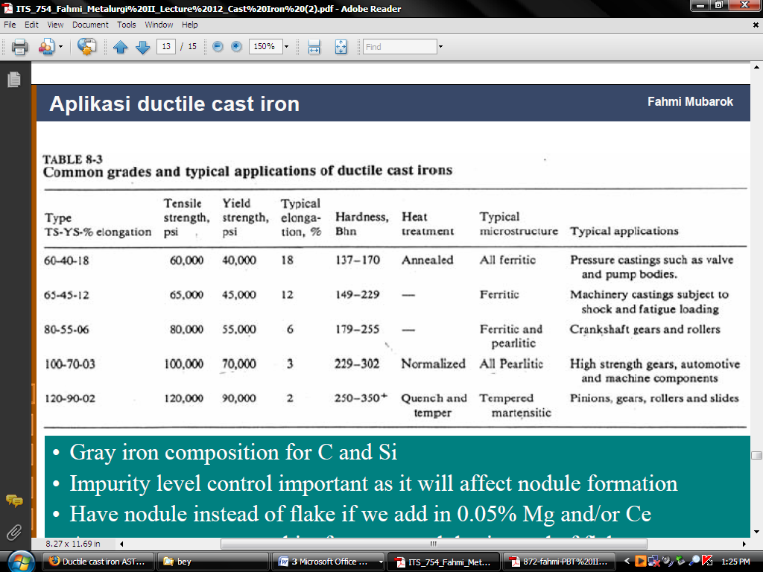Tabel 2. Common grades and typical applications of ductile cast irons.

