FACTORS DETERMINING VALUE AND CUSTOMER TRUST BUILDING
Sri Sustariyah, Sucherly, Undang Juju, OtongKaryono
Langlangbuana University

ABSTRACT

Relationship marketing and service quality are determinant factors in enhancing the value and confidence for customers. BPJS (Social GuaranteeProvider Board) for the health is a new program organized by the government to increase public health’s improvement. The implementation the government's new product in the field of health marketing activities using the proximity system to customers and quality of service delivery has becoma one effective strategies in increasing public confidence. The goal of this study focuses on the effect of relationship marketing and service quality to customer value and its impact on customer confidence.The method of research usesa quantitative approach equipped with expert judgment. Samples used in the research are BPJS participants’ patients at General Hospitals of Local Government in West Java Province. Technique of data collection is proportional cluster random sampling and the analysis technique used is the analysis of SEM (structural equation modeling).Descriptive research results show that relational marketing, service quality, customer value and customer trustranging from poor to the very good level. The results of the study on each indicator show that some indicators are less than optimal still. Results of verification research prove that the relationship marketing and service quality show positive and significant impact on customer value and the customer value shows significant and positive effect on customer trust
.
Keywords: Relational Marketing, Service Quality, Customer Value and Customer Trust.

INTRODUCTION
Customer trust is shaped from the value obtained by the consumer (Peppers and Rogers as quoted by Fadilah, et.al, 2012; Palmatter 2008 and Hasan, Kiong and Ainuddin, 2014). Customer value has been related to trust (Rasheed and Abadi, 2014; Hasan, Kiong and Ainuddin, 2014 and Kamtarin, 2012). An increasing customer value can be gained by improving the service quality. Accordingly, customer value can be created through the service quality provided by the company to their customers. The better the service quality, the higher the value received by consumers. Quality of self - service according to Chen (2007) can not be separated from the company's internal support, especially the support of human resources.

Focusing on improving the service quality in the program BPJS becomes a major prerequisite as a step in supporting BPJS program systematically. Perception of value received by the consumers is made up by health services provided by the government on BPJS program participants. Research conducted by Dalinjong (2012: 1) shows that in general, participants and non-participants will get the health insurance that is appropriate when the value of the provider (namely government) provides services in accordance with standards that have been determined in advance. This result has become evidence that patients can receive the value if the provider can understand what is expected by the consumer. In fact BPJS for Health program that is being implemented by the current government in general has not fully met the expectations of society. The problems that arise are not because of convenience and ease of perceived health facilities but the complexity of the system and difficulties when applying for public health services which in fact to be one of the main reasons (Kompasiana.com, 2014).

Building good relationship with the community means to smoothen the process of supervision and BPJS improvement of system implementation, especially a system that regulates the Provider of Health Services such as hospitals; accordingly the government's role as the owner of the program and the community should be mutually integrated and work together to participate in the success of government programs considered to be very beneficial for the community. The marketing approach became one of the alternatives that can be done by the government is to do relationship marketing. Relationship marketing is not only used in any product marketing, relationship marketing are also useful for marketing of services and social marketing as well as on marketing the BPJS program. Relationship Marketing in the science of marketing is a marketing principle that emphasizes long-term relationship with customers, suppliers, and distributors. In other words, Relationship Marketing is an integrated design that strengthens the company's marketing competence (Tjiptono, 2008: 214). The importance of developing and pursuing the relationship in the organization of government on the implementation of the program of the BPJS is to convince the customers so that people know the excellence of the product and services offered. Relationship Marketing is not just a marketing priority to profitability, but it also applies equally in social marketing. According toLupiyoadi (2006: 72) relationship marketing is highly relevant in the marketing of services, given the involvement of and interaction between customers and relatively high service providers.

Zeithamlet al. (2006: 184) explains that relationship marketing is one of the company's strategies to maintain a good relationship with the customer in the long term. This strategy focuses more on how to keep the existing customers, in order not to switch to products of competitors. Wibowo (2009) stated that the relationship marketing is one of the ways to attract, maintain, and enhance long-term relationship with the customers. Therefore, it is important for the company to be more concerned with the customer, because one of the key factors the company to survive in the current existing markets is to maintain and sustain a long-term relationship with the customer (Perien and Richard, 2010: 195). According Palmatier et al. (2012: 206) relationship marketing is a strategic tool to enhance value and maintain qualified relationships with customers.

The relationship between relationship marketing and customer value expressed by Velnampy and Sivesan (2012); Bhatnagar (2012); Jemaa and TOURNOIS (2014), which examines the relationship marketing with value, it is assumed to have a good relationship and ongoing with customers along with the ability of providers to provide value and meet the expectations of the customer, making it easier to keep the customer at this time, and will make the costs to be incurred by the company will be much less than trying to attract new customers they use conventional marketing communication such as advertising (Sui and Baloglu in Rai Main, 2012). The company should be able to give an advantage or benefit to the customer of a relationship built to the customer (Rauyruen and Miller, 2007: 107). Giving benefit of a relationship or relational benefit actually means that it can be beneficial to both parties, both the customer and the company (Ruiz-Molina et al., 2009: 109).Based on the above study, the researcheris interested in doing in-depth research related to "Determinant Factors in Developing Values ​​and Trust (Survey on Patients of BPJS for Health Participants in the General Hospital of West Java Province).

LITERATURE REVIEW
Relationship marketing is a philosophy of running a business focusing primarily on the improvement of services to existing customers rather than to find new customers. From these definition we can say that Relationship Marketing is an attempt to know consumers better, so the company can meet their needs and wants in the long term (Zeithmal et al., 2012: 138).
The above definition is supported by the opinion of Arafat andSemadi, et al (2012: 161) who argued that the relationship with the customer in the long term is not just creating a transaction. It, furhermore, becomes a new paradigm for achieving marketing success which is to establish and maintain relationships with customers on an ongoing basis. This new paradigm is called relationship marketing.

The rationale for this marketing practice is that building relationships with customers that are considered very effective cost compared with the search for new customers or existing customers who already get a breakup. Indeed, the establishment of long-term relationships between marketers with customers it begins from the creation of the transaction, and similar transactions repeated again and eventually into the fabric of a long-term relationship. Berry in Hennig-Thurau, et al (2010: 368) defines the term relationship marketing is an attempt to attract, manage, and provide various services by utilizing the company's good relationships with customers. Here also he emphasized that relationship marketing is a further step to reach new customers, namely to foster relationships with customers in order to remain loyal to the company. Furthermore,Kotler and Keller (2012: 171) argues that relationship marketing is a movement of the mindset that is solely based on competition and conflict, toward a mindset that is based on a relationship of interdependence and mutually beneficial cooperation. Relationship marketing recognizes the importance of the various parties, among others: suppliers, employees, distributors, agents, and retailers to work together to provide the best values ​​for the target customer.

Zeithaml et al. (2012: 158) states that the primary purpose of relationship marketing is to build and retain commitedprofitable subscribers for the company and at the same time minimizing the time and effort spent on less profitable customers. Based on research conducted by Kinard and Capella, in Semadi, et al (2012: 163) "states that the benefits of relational defined as a benefit received by customers of long-term relationship and outside the core service performance (Gwinner et al., In Yu and Yang, 2009 ). While the study was conducted by Arturo et.al in Hashem (2012: 130) states that relational benefits as benefits tend to be received by the customer as a result of involvement in a long-term relationship with the service provider.

METHODOLOGY
This study uses quantitative method by distributing questionnaires to the respondents. Technique using the questionnaire is a way of collecting data by delivering or distributing a list of questions to the respondents, with the hope they will provide a response to the questionnaire. Questionnaire distribution was conducted uisnga survey technique, the researchers directly into the field to collect data both primary and secondary data with dimensional cross-sectional data, meaning that data is current and not time series data.
In conducting verification analysis, this research uses analysis of Structural Equation Modeling (SEM). The basic decision SEM analysis is tailored to the research model developed by the researchers that allows suitable for doing analysis using SEM. The advantage of SEM is its ability to present a comprehensive model along with its ability to confirm the dimensions of a construct or factor as well as the ability to measure the impact / relationship theoretically. SEM is also seen as a combination of confirmatory factor analysis and regression analysis. Confirmatory factor analysis of the measurement model will produce the so-called coefficient of standard loading or lambda value (I). The lambda value is used to assess the suitability, or unidimensionalitas of instruments in creaying a factor

RESULTS
This study uses analysis Structural Equation Modeling (SEM) with the assistance of IBM SPSSAMOS 20 Software. The theoretical model has been described in the path diagram which then will be analyzed based on the data obtained. After testing parameters, and the model the next test is to analyse using Structural Equation Model (SEM) in Full Model which is intended to test the model and hypotheses developed in this study. Testing the model in Structural Equation Model done with two tests, namely testing the goodness of fit of the model and test the significance of causality through regression coefficient test. The results of data processing for SEM analysis shown in Figure 4.9, Table 4.102 and Tables 4.103. Structural model is the relationship between the latent variables (variables that can not be measured directly and require several indicators to measure) the independent and dependent variables(Bollen, 1989).
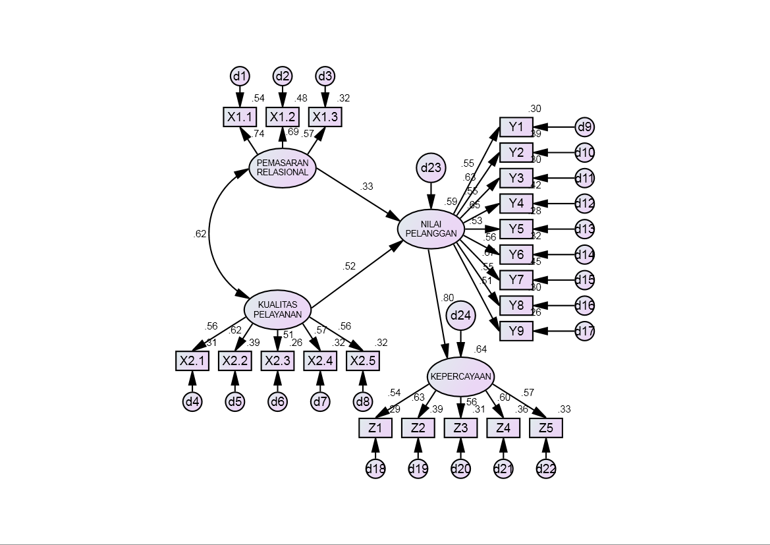

Figure 1 Result of Endogenous Construct Confirmatory Model Test

Table 2 Result of Full Model Test
Criteria | Cut of Value | Result | Evaluation
Chi-Square | Expected to be small | 393.691 | Large sample
Probability | > 0,05 | 0.000 | Large sample
GFI | > 0,90 | 0.911 | Good
TLI | > 0,95 | 0.947 | Marginal
CFI | > 0,95 | 0.934 | Marginal
CMIN/DF | < 2,00 | 1.920 | Good
RMSEA | < 0,08 | 0.049 | Good
Source; data managed, 2015

Based on observations in the picture on the graphic analysis of the full model, it can be shown that the model meets the criteria of goodness of fit.Calculated chi-square test on a full model obtain the chi-square value of 393.691 over the chi-square table for degrees of freedom 205 at the 5% significance level of 239 403. These results suggest that the overall model meets the criteria of model fit. Probability value of 0,000meaning that the value is below 0.05 as well as other criteria that meets the index of goodness of fit well.

The amount of direct effect based on the results of the analysis conducted, it appears that the results estimated parameter values of directeffect of independent variables on the dependent variable is as shown in Table 4.106.

Table 3 Direct Effect Estimation Results

Dependent Variables |  | Independent Variables | Direct effect | T observation/ C.R. | P (sig)
Customer value | <--- | Relationship Marketing | .332 | 3.824 | ***
Customer value | <--- | Service Quality | .515 | 5.163 | ***
Trust | <--- | Customer value | .799 | 7.697 | ***

Based on the direct effect from the relationship marketing variable to customer value amounted to (0.332) 2 x 100% = 11.022%, while the direct effect from the service quality variable to the customer value is (0.515) 2 x 100% = 26.522% and the direct effect of customer value to trust is (0.799) 2 x100% = 63.840%.
a) The amount of Indirect Effect and Total Effect
The indirect effect means that the effect of an exogenous variable to endogenous dependent variable through other exogenous variables. While the total effect is the sum of direct effect and indirect effect. Based on the analysis performed, the amount of Indirect Effect and Total Effect is shown in table4.107.

Table 4 the Indirect Effect and Total Effect

No | Path | Indirect effect | Total effect
1 | X₁ ------> Y through X₂  Relationship marketing --->Customer valuethrough service quality | 0.107 | 0.217
2 | X₂ ------> Y melalui X₁  Service quality --->Customer valuethrough Relationship marketing | 0.107 | 0.372

Based on the data in the table above, the value of the indirect effect of relationship marketing on customer value mediated by quality of service is 0.107 or 10.70%. While the total effect produced between variables in the model and the results of the study is the total effect on the value of customer relationship marketing mediated by service quality is 0,217 or 21.70%, which is the sum of the direct effects + indirect effects. Furthermore, value of the indirect effect of service quality to customers mediated by relationship marketing is 0.107 or 10.70% and the total effect on the quality of service either directly or indirectly is as much as 0.372 or 37.20%.

CONCLUSION
Relationship marketing and service quality significantlyand positivelyaffect simultaneously towards customer value. Relationship marketing positively and significantlyaffects on customer value. Service quality positively and significantlyaffects on customer value. Customer value significantly and positivelyaffects on customer trust.

Improvement of BPJS system dissemination program to the public is necessary, because the BPJS program is still relatively new policy program from the government as well as to increase the government's commitment in providing convenience and proximity to the public on BPJS for health program. Improvement of health care system for BPJS patients is necessary by increasing the budget for the health sector, especially to complete the infrastructure and expanding the capacity of Regional General Hospital which is still limited in the quantity of service.

Organizers of BPJS for health needconduct monitoring and evaluation of program of BPJS implementation considering that there are some problems concerning both technical and non-technical ones. Increase capacity and work ethic of the employees of both administrative staff and health professionals in order to improve the quality of work. Improve the performance of Regional General Hospital employees and BPJS for health employees in West Java province, considering the increasing levels of participation in BPJS when compared to PT. Askes. ImproveBPJS system program considering the level of public confidence in the consistency of BPJS prorgam is still moderate. Consistency of government as the organizer of the BPJS is already quite high, but the process of service delivery by both BPJS organisorsas well as by the Regional General Hospital still needs to be improved, especially in the capacity of health care for BPJS patients. The government should be more focused their attention to the aspect of relationship marketing, service quality, and added value for customers, namely BPJS participants to increase public trust in the BPJS program organized by the government.

Refrences
Chen Po-Tsang , Hsin-Hui Hu. 2010. The effect of relational benefits on perceived value in relation to customer loyalty: An empirical study in the Australian coffee outlets industry. International Journal of Hospitality Management. 0278-4319/$ – see front matter 2009 Elsevier Ltd. All rights reserved. doi:10.1016/j.ijhm.2009.09.006.
Fadilah, Sri, Nurleli, Rini Lestari danHeliana. 2012. MembangunKepercayaanKonsumen : FaktorPentingpadaLembaga Zakat Seluruh Indonesia. Prosiding SnaPP2012 : Sosial, Ekonomi, danHumaniora. ISSN 2089-3590.
Fandy Tjiptono,2008, StrategiBisnisPemasaran. Andi. Yogyakarta.
Hennig-Thurau, Thorsten, Edward C. Malthouse, Christian Friege, Sonja Gensler, Lara Lobschat, ArvindRangaswamy, and Bernd Skiera (2010), “The Impact of New Media on Customer Relationships,” Journal of Service Research, 13(3), 311-30.
Kotler Philip , dan Gary Amstrong. 2012 . Principles Of Marketing, Global Edition, 14 Edition, Pearson Education.
Rasheed, A Firend and Masoumeh F. Abadi. 2014. Impact of Service Quality, Trust and Perceived value on Customer Loyalty in Malaysia Service Industries. International Conference on Accounting Studies 2014, 18-19 August 2014, Kuala Lumpur Malaysia. Procedia. Social and Behavioral Sciences 164 (2014) 298 – 304.
Wibowo, HerryArianto Lestari, 2009. Pengaruh Relationship Marketing terhadapLoyalitasPelangganMelaluiKepuasanPelanggan, JurnalAplikasiManajemen, Vol. 17, No. 4, pp. 818-823.
Wulandari, LuhPutu Sri., Semadi Ni Wayandan Sri SupraptiKetutNurcahya. 2012. PENGARUH ManfaatRelasionalTerhadapKepuasan Dan LoyalitasNasabah Bank (Studipada Bank BPD Bali CabangUtama Denpasar). JurnalManajemen, StrategiBisnis, danKewirausahaan Vol. 6, No. 2 Agustus 2012.
Zeithaml, A Valerie, Mary Jo Bitner and Dwayne D. Gremler. 2012. Services Marketing (6th Edition) : Integrating Customer Focus Across the Firm. ISBN-13: 978-0078112058. McGraw-Hill/Irwin; 6 edition (March 12, 2012).
Zeithaml, A Valerie, Mary Jo Bitner and Dwayne D. Gremler. 2012. Services Marketing (6th Edition) : Integrating Customer Focus Across the Firm. ISBN-13: 978-0078112058. McGraw-Hill/Irwin; 6 edition (March 12, 2012)

