THE MASTERY OF ENGLISH TOURISM TERMINOLOGY
OF LINTAS BUANA WINUTAMA TOUR AND TRAVEL EMPLOYEES

A Research Paper

Submitted to the English Department Faculty of Arts and Letters Pasundan University as a Partial Fulfillment of the Requirements for taking the Sarjana Degree

By:
Miko Andria
117010043

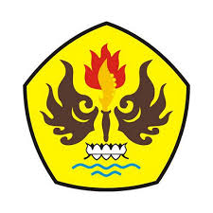

ENGLISH DEPARTMENT
FACULTY OF ART AND LETTERS
PASUNDAN UNIVERSITY
BANDUNG
2016

