The Influence of the Quality Services to Maintain the Loyalty of Guests in Sari Ater Hotel

A PAPER

Submitted to
The English Department Faculty of Art and Letters Pasundan University as a Partial Fulfillment of the Requirements For taking the Sarjana Degree

By :
Karina Ingriani
117010024

ENGLISH DEPARTMENT
FACULTY OF ART AND LETTERS
PASUNDAN UNIVERSITY
BANDUNG
2015
The Influence of the Quality Services to Maintain the Loyalty of Guests in Sari Ater Hotel

A RESEARCH PAPER

By :
Karina Ingriani
117010024

Approved by

Advisor I Advisor II

Drs. H. Gumelar Sastrayudha, CTM Asep Saefudin Noer, S.H., M.M

Dean of Faculty Head of English Department
of Arts and Lettrers

Dr. Hj. Senny S Awasilah, M.Pd. Erik Rusmana, S.S., M.Hum.
NIP Y 151 10 322 NIP Y 151 10 591

DECLARATION

I hereby certify that this paper is actually my own work. I have to quote some of the statements and ideas from other sources and my own work on this book and is able to be responsible for this work.

Bandung, July 2015

The Author

Be Patient ….
Make the patience and pray as your helper (QS.Al Baqarah 45).
Allah does not burden a person but according to their abilities (QS. Al Baqarah 286).

This Paper Dedicated for :
My Parents Mr. Sukendar and Mrs. Nina Herlina
And also for Youngest Brother Febrianto,
and my lovely boyfriend Doddy Permana.
Thank you for never ending love, pray and support.
I love you so much.

Abstract
The rise of the service accommodation, then the competition among hotels are increasingly tight. the hotelier trying to get loyal guests. Hotel management can say successful if the service meets the standards If guests feel the quality of services provided by the Hotel is very good, then the guest will be loyal to Hotel. Hotel management should be trying to fulfill the desire of guests and improve the quality of services. Based on the description above, the author raised the title The influence of the Quality services to Maintain the Loyalty of Guests in Sari Ater Hotel, as a basis for investigation. Quality of service is very influencing guest loyalty to that service quality become the main priority in satisfactory living. If guests feel the quality of services provided by the Hotel is very good, then the guest will be loyal to Hotel. For that hotel should improve the guest satisfaction in order to be loyal guests by improving the quality of services that includes aspects of tangibles, reliability, responsiveness, assurance, and empathy. The author uses descriptive research methods, according to Mohamad Nazir in the (2003; 34), Descriptive method is one method in researching the status of groups of human beings, an object, a set of conditions, a system of thought or a current events class. The purpose of the research is descriptive, picture or painting in a systematic, factual and accurate v regarding the facts, properties and relationships between phenomena investigated. The authors suggest that companies pay more attention again to all aspects that can affect to the guest loyalty.

PREFACE

Bismillahirohmanirohim,
Alhamdulillahi Rabbil ‘Aalamiin..
In the name of Allah SWT, the most gracious our prophet Muhammad SAW, the most merciful, the author has eventually accomplished her task with this paper. This paper entitled “The Influence of the Quality Services to Maintain the Loyalty of Guests in Sari Ater Hotel” is now ready to be submitted to English Department Faculty of Arts and Letters of Pasundan University to fulfill the final assignment.
Therefore, the author hopes this paper can be useful for the author her self and the readers. The author realized that this paper is still far for being perfect, because of that the author hopes some critical, comments and suggestions from the readers in the order to make the author can be better in the future in writing. The author would like to say thanks to all people who have helped her in making and finishing this paper.
Bandung, May 1, 2015

Karina Ingriani

Acknowledgement
By blessing of God, the great of Allah SWT, the most powerful, the gracious our Prophet Muhammad SAW. Finally, the writer finished her paper.
The writer would like to say thanks and appreciated to :
- Dr. Hj. Senny S. Alwasilah, M.Pd., Dean of Faculty of Art and Letters Pasundan University
- Erik Rusmana, S.S., M.M, the Head of English Department Faculty of Art and Letters Pasundan University Bandung.
- Drs. H. Gumelar Sastrayudha, CTM and H. Asep Saefudin Noer, S.H., M.M as the advisor who always guide the author in finishing this paper.
- Beloved parents and her family, for their endless love, sacrifice, supports and prays for the writer until she finished the paper.
- Thanks to all Sari Ater Hotel Resort’s staff which has provided an opportunity for the author to find the data.
- Mr. Iwan, a marketing manager and Mr. Ogie, an assistant front office manager which has provided the data that required by the author.
- Doddy Permana for giving the author support.
- For author’s close friends, Selly Agliani, Siti Winarti, Gilang Resmi, Nur afrianingsih, for giving the writer support.

Bandung, May 1, 2015

Karina Ingriani
TABLE OF CONTENT

APPROVAL
DECLARATION
MOTTO/ DEDICATED
ABSTRACT ………………………………………………………… i
PREFACE ………………………………………………………… ii
ACKNOWLEDGEMENT ………………………………………………… iii
TABLE OF CONTENT ………………………………………………… iv
LIST OF TABLES ………………………………………………… vii

CHAPTER I BACKROUND ………………………………………… 1
  - Identification of The Problem ………………………………………… 3
  - Research Question ………………………………………………… 3
  - Limitation of The Problem ………………………………………… 4
  - The Goals of The Research ………………………………………… 4
  - The Benefits of The Research ………………………………………… 4

CHAPTER II THEORITICAL FOUNDATION ………………………… 5
  - The Definition of The Quality of Service ………………………… 5
  - Factors of Bad Service Quality ………………………………… 5
  - Customer Satisfaction ………………………………………… 7
  - To Measure the Service Satisfaction ………………………………… 8
  - The Customer Loyalty ………………………………………… 9
  - Definition of Service ………………………………………………… 10
  - Characteristic of Service ………………………………………… 10
  - Clarification of Service ………………………………………… 12
  - Definition of The Marketing ………………………………………… 14
  - Definition of Marketing Mix ………………………………………… 15
  - Marketing Strategies for Service Companies ………………………… 17
    - Vision and Mission of Sales & Marketing Department Sari Ater
Hotel & Resor ………………………………………………………… 17
CHAPTER III RESEARCH METHODOLOGY ………………………… 19
3.1 The Object of Research ………………………………………… 19
3.2 Research Design ………………………………………………… 19
3.3 Technique of Data Collection ………………………………… 20
3.1.1 Library Research ………………………………………… 20
3.1.2 Field Research ………………………………………………… 20
3.4 Types and Sources of Data ………………………………………… 21
3.5 Population and Sample ………………………………………… 21
3.6 Operational Variable ………………………………………………… 22
3.7 Data Analysis ………………………………………………………… 24
CHAPTER IV DATA ANALYSIS AND FINDINGS ………………… 26
4.1 Data Analysis ………………………………………… 26
4.1.1 Kind of Service that Provided by Sari Ater Hotel for guests …... 26
4.1.2 How the Guest Assessment about the Quality Service that
Provided by Sari Ater Hotel for Maintain the Loyalty of Guests …….. 35

4.2 Findings ………………………………………………………… 53
4.2.1 History of Sari Ater …..….…………………………………. 54
4.2.2 Number of Visistor ………………………………………… 56
4.2.3 Aspect of Busines Activities ………………………………… 58

CHAPTER V CONCLUSIONS AND SUGGESTIONS ………………… 61
5.1 Conclusions ………………………………………………………… 61
5.2 Suggestions ………………………………………………………… 63

BIBLIOGRAPHY
CURRICULUM VITAE
APPENDICES

LIST OF TABLE
Table 3.6.1 The Variable Research …………………………………………… 22
Table 4.1.1 Meeting Rooms at Hotel Sari Ater & Resort is Quite varied …… 28
Table 4.1.2.1 Assessment of Location of Hotel …………………………… 36
Table 4.1.2.2 Assessment of The Exterior & Interior Design of Hotel …… 37
Table 4.1.2.3 Assessment of The Condition of The Food & Beverage …… 38
Table 4.1.2.4 Assessment of The Hotel Facilities …………………………… 39
Table 4.1.2.5 Assessment of The Comfort and Cleanliness During Stay …… 40
Table 4.1.2.6 Assessment of The Correspondence Between The Rates Offered
by The Service Provided …………………………………………………… 41
Table 4.1.2.7 Assessment of The Easy of Booking …………………………… 42
Table 4.1.2.8 Assessment of The Speed in The Service of Check in and Check
Out …………………………………………………………………………… 43
Table 4.1.2.9 Assessment of Speed in The Serving Complain…………………… 44
Table 4.1.2.10 Assessment of The Speed Providing Information …………… 45
Table 4.1.2.11 Assessment of The Responsibility for Security Hotel…………… 46
Table 4.1.2.12 Assessment of The Honesty of The Hotel Staff …………… 47

Table 4.1.2.13 Assessment of The Hospitality and Courtesy of The Hotel Staff
in Providing Service …………………………………………………………… 48
Table 4.1.2.14 Assessment of The Willingness to Listen to Criticism and
Suggestions guest …………………………………………………………… 49
Table 4.1.2.15 A List of a Few of Domestic Loyal Guest …………………… 50
Table 4.1.2.16 A List of a Few of Loyal Foreign Guest …………………… 52
Table 4.2.2.1 The Number of Sari Ater Hot Spring Visitors 2011-2014 …… 56
Table 4.2.2.2 The Number of Sari Ater Hotel Visitor 2011-2014 …………… 57
Table 4.2.3.1 Meeting Rooms at Hotel Sari Ater & Resort is Quite varied …… 59

CHAPTER I.
Introduction

In this century, the level of the economy becomes one of the benchmark Ratings of the progress of a country. The economic growth in each country is growing rapidly. Indonesia is one of the countries with developing economies. One sign of the growth of the economy in Indonesia is growing despite the efforts in the tourism sector. Indonesia is known as a country that has an attractive tourism spot, both cultural or nature tourism.
The tourism sector is a sector that has become one of the development sectors which is capable of generating economic growth quickly. The development of tourism industry in Indonesia was able to give a positive impact. The tourism industry directly will provide employment for societies that are automatically able to increase income and standard of living for the society itself. In addition, the tourism industry can turn on a variety of other industries, such as food manufacture, souvenirs, travel agencies and accommodation such as hotels, villas, etc.
Today, the industry in the fields of accommodation such as hotels become one of the businesses that play an important role in the tourism industry, it is because the hotel providing accommodation and its facilities that are required by the tourists.

Based on the Ministry Parpostel no Km 94 / HK103 / MPPT 1987:
Pengertian hotel adalah salah satu jenis akomodasi yang mempergunakan sebagian atau keseluruhan bagian untuk jasa pelayanan penginapan, penyedia makanan dan minuman serta jasa lainnya bagi masyarakat umum yang dikelola secara komersil. (The definition of the hotel is one type of accommodation that use part or all parts for an accommodation, food and beverage providers and other services for the general public commercially run).

According to, Sri (1996: 8) :
Pengertian hotel adalah suatu bangunan yang dikelola secara komersil guna memberikan fasilitas penginapan kepada masyarakat umum dengan fasilitas antara lain jasa penginapan, pelayanan barang bawaan, pelayanan makanan dan minuman, penggunaan fasilitas perabot dan hiasan-hiasan yang ada di dalamnya serta jasa pencucian pakaian. (The hotel is a commercial building that is managed to provide lodging facilities to the general public with facilities such as accommodation services, service luggage, food and beverage services, use of facilities furnishings and decorations in it as well as clothes washing services).
The rise of the service accommodation, then the competition among hotels are increasingly tight. the hotelier trying to get loyal guests. Hotel management can say successful if the service meets the standards If guests feel the quality of services provided by the Hotel is very good, then the guest will be loyal to Hotel. Hotel management should be trying to fulfill the desire of guests and improve the quality of services, so as to give rise to the satisfaction of guests. Guests will compare the services that they receive with the services they expect, even guests also compare services at one hotel to the other hotels, if the services they received so much nicer than the services they expect then it can create the loyal guests.
Sari Ater Hotel is a famous hotel in Subang. So as not to lose competitiveness with another hotels, the Sari Ater Hotel continues to improve services to guests, with the hope that guests be loyal guests.
Based on the description above, the author raised the title The influence of the Quality services to Maintain the Loyalty of Guests in Sari Ater Hotel, as a basis for investigation.
  - Identification of the Problem
The service is a major factor that is required in every hotel, services and facilities plays an important role in determining the success of a management of the hotel. through good service, expected visitors will be satisfied with the service provided, so that visitors will be a loyal visitor to the hotel. Each hotel will try to improve the quality of services and facilities in order to gain the loyalty of visitors. For that the author will researching about The influence of the Quality services to Maintain the Loyalty of Visitors in Sari Ater Hotel.

  - Research Question
Based on the background, then there are some problem to be discussed, that are:
- What kind of services that provided by Sari Ater Hotel for guests ?
- How the guests assessment about the quality service that provided by Sari Ater for maintain the loyalty of guests ?

  - Limitation of the Problem
To be more optimal results of this paper, the author make a Limitation Problem as a controller when doing research on the problems. For that the author make the limitation problems with researching about The influence of the Quality services to Maintain the Loyalty of Guests in Sari Ater Hotel, as a problem to be studied.
  - The Goals of the Research
- To find out the services that provided by Sari Ater Hotel for Guests.
- To find out the guests assessment about the quality service that provided by Sari Ater for maintain the loyalty of guests
  - The Benefits of The Research
The researcher hopes that this research give benefit for the readers and the other researcher. The benefits are as follows :
- For Author
This study can be provide insights regarding the quality of services in order to get loyalty of guests, especially at Sari Ater Hotel.
- For other researcher
The results of this study are expected to provide useful information.
- For the Company
The results of this study can be input for Sari Ater Hotel in improving the quality of services in order to gain the loyalty of guests.
CHAPTER II
The Influence of the Quality Services to Maintain the Loyalty of Guests in Sari Ater Hotel

  - The Definition of the Quality of Services
The quality of a product or service is very important, this is caused by the encouragement of the purpose of a service company or product, that are to increase the number of consumers and make the consumer feel satisfied with the services or products offered. The employers in the services or products also compete to make the quality of products or services they offer the better.
According to Kotler (2002 ; 57):
Keseluruhan ciri serta sifat suatu atau pelayanan yang berpengaruh pada kemampuannya untuk memuaskan kebutuhan yang dinyatakan atau yang tersirat. (Definition of the quality of service, Overall characteristics and properties of a service which affects the ability to satisfy stated or implied).

  - Factors of Bad Service Quality
According to Tjiptono (2006 ; 85) factors of bad service quality, namely :
- Produksi dan konsumsi yang terjadi secara simultan ( Production and consumption occur simultaneously)
salah satu karakteristik jasa yang penting adalah jasa diproduksi dan dikonsumsi pada saat bersamaan (inseperability). Dengan kata lain dalam memberikan jasa dibutuhkan kehadiran dan partisipasi pelanggan. Akibatnya timbul masalah-masalah sehunbungan dengan interaksi produsen dan konsumen jasa. Bebarapa kekurangan yang mungkin ada pada karyawan pemberi jasa dapat berpengaruh terhadap persepsi pelanggan pada kualitas jasa misalnya :

- Tidak terampil dalam melayani pelanggan.
- Cara berpakaian tidak sesuai.
- Tutur katanya kurang sopan atau bahkan menyebalkan.
- Bau badannya mengganggu.
- Selalu cemberut atau pasang muka angker
(one of the important characteristics of the services are services produced and consumed at the same time (inseperability). In other words, in providing the services needed the presence and participation of the customer. As a result, problems arise with the interaction with producer and consumer services. Many deficiencies that may exist in a service provider that may affect to the customer's perception of the quality services such as:
- Not skilled in serving customers
- The dress does not fit.
- Spoken irreverent or even annoying.
- Intrusive body odor.
- Always sullen or plug face haunted)

- Intensitas tenaga kerja yang tinggi (High labor intensity)
Keterlibatan tenaga kerja yang intensif dalam penyampaian jasa dapat pula menimbulkan masalah pada kualitas, yaitu tingkat variabilitas yang tinggi. Hal-hal yang bisa mempengaruhinya adalah upah rendah (umumnya karyawan yang melayani pelanggan memiliki tingkat pendidikan dan upah yang paling rendah dalam suatu perusahaan), pelatihan yang kurang memadai atau bahkan tidak sesuai, tingkat karyawan yang tinggi, dan lain-lain.
(Labor intensive involvement in the delivery of services can make problems on quality, that are the level of variability is high. Somethings that could be affected is low wages (generally employees serve customers have a level of education and the lowest wages in an enterprise), inadequate training or do not even accord a high level of employees, and others).
- Dukungan terhadap pelanggan (pelanggan perantara) kurang memadai (Support to the customer (customer intermediaries) inadequate).

- Kesenjangan-kesenjangan (Gaps).
Ada beberapa jenis kesenjangan komunikasi yang bisa terjadi, yaitu :
- Perusahaan memberikan janji yang berlebihan, sehingga tidak dapat memenuhinya.
- Perusahaan idak bisa selalu menyajikan informasi terbaru kepada pada pelanggan, misalnya yang berkaitan dengan perubahan prosedur atau aturan, perubahan susunan barang di rak pajangan supermarket, dan lain-lain.
- Pesan komunikasi perusahaan tdak dipahami pelanggan.
- Perusahaan tidak memperhatikan atau segera menanggapi keluhan atau saran pelanggan.
(There are several types of communication gaps that can occur, that is:
- The company promises excessive, so it can not fulfill.
- The company is not to remain always present the latest information to the customer, such as those relating to changes in procedures or rules, changes in the composition of the goods in the supermarket shelves, and others.
- Message communications companies do not understood customer.
- The company does not pay attention to or immediately respond to customer complaints or suggestions).

- Memperlakukan semua pelanggan dengan cara yang sama (Treat all customers in the same way).

- Perluasan atau pengembangan jasa secara berlebihan (Expansion or excessive development services).

- Visi bisnis jangka pendek (Short-term business vision).
Visi bisnis jangka pendek (seperti orientasi pada pencapaian target penjualan dan laba tahunan, peningkatan produktivitas tahunan, dan lain-lain) bisa merusak kualitas yang sedang dibentuk untuk jangka panjang. Sebagai contoh : kebijakan suatu bank untuk menekan biaya dengan cara mengurangi jumlah kasir (teller) menyebabkan semakin panjangnya antrian di bank tersebut.
(Short-term business vision (such as orientation on the achievement of sales targets and annual earnings, annual productivity increase, etc.) can damage the quality that is being set up for the long term. For example: a bank's policy to reduce costs by reducing the number of cashier (teller) causes more long queues at the bank).

  - Customer Satisfaction
Customer satisfaction is the goal of every business in the service or product. if the customer is satisfied with the services or products provided it is likely that customers will be loyal to the service or product.
According to Kotler (1999 ; 50):
Kepuasan pelanggan adalah tingkat perasaan seseorang setelah membandingkan kinerja produsen (atau hasil) yang ia rasakan dibandingkan dengan harapannya.
(Customer satisfaction is the level of one's feelings after comparing the performance of the manufacturer (or results) that they are felt compared with expectations).

The way to keep visitors according to Kotler (1999 ; 25):
Adalah kepuasan pelanggan. Pelanggan dapat sangat puas akan melakukan tindakan.
(is customer satisfaction Customers can be very satisfied to take action)
- Membeli lebih banyak dan setia lebih lama (Buy more and longer loyal).
- Membeli jenis produk baru atau poduk yang disempurnakan dari perusahaan (Buy a new kind of product or the enhanced poduk from the company).
- Mengumpulkan pujian bagi perusahaan dan produknya kepada orang lain (Gathering praise for the company and its products to others).
- Kurang memperhatikan merek dan iklan pesaing, serta kurang sensitive terhadap harga (Lack of attention to the brand and advertising competitor, as well as less sensitive to price).
- Memberikan gagasan baru atas barang atau jasa perusahaan (Provide new ideas on the goods or services of the company).
- Lebih murah biaya pelayanannya daripada pelanggan baru, klarena transaksinya sudah rutin (The cost of service is cheaper than new customers, because transactions are routine).

  - Measure the Service Satisfaction
According to Tjiptono (2006 ; 148):
Metode yang dilakukan oleh perusahaan untuk memantau dan mengukur kepuasan pelanggan(konsumen juga sebagai competitor) adalah:
(method performed by the company to measure and monitor customer satisfaction (customer also a competitor) that are : ).
- Sistem keluhan saran (System complaint advice).
- Survei kepuasan pelanggan (The customer satisfaction survey).
- Ghost shopping
Metode ini dilaksankan denga cara memperkerjakan beberapa orang (ghost Shopper) untuk berperan atau bersikap sebagai pelanggan atau pembeli potensial produk perusahaan dan pesaing. Lalu ghost shopper tersebut menyampaikan temuan-temuannya mengenai kekuatan dan kelemahan produk perusahaan dan pesaing berdasarkan pengalaman mereka dalam pembelian produk-produk tersebut
(These methods are conducted in the manner of employing a few people (ghost Shopper) to act or behave as a customer or a potential buyer company and competitor products. Then the ghost shopper shared her findings regarding the strengths and weaknesses of the company's products and competitors based on their experience in the purchase of these products)
- Lost customer analysis
Metode ini sedikit unik. Perusahaan berusaha menghubungi para pelanggannya yang telah berhenti membeli atau yang telah beralih pemasok. Yang diharapkan adalah akan diperolehnya informasi penyebab terjadinya hal tersebut. Informasi ini sangat bermanfaat bagi perusahaan untuk mengambil kebijakan selanjutnya dalam rangka meningkatkan kepuasan dan loyalitas pelanggan.
(This method is a bit unique. Companies are trying to contact customers who have stopped buying or who have switched suppliers. Which is expected to be obtained is the cause of this information. This information is very useful for companies to take further policy in order to increase customer satisfaction and loyalty).

  - The Customer Loyalty
After customers or visitors are satisfied with the services and products provided, the customer or visitors will be loyal on services and products.
According to Grifiin (1998 : 4), Loyalty is defined as non random purchase expressed overtime by some decision making unit.
The characteristics of customer loyalty, according Tjiptono (2000 : 107) that are :
- Setia kepada produk perusahaan (Loyal to the company's products).
- Merekomendasikan perusahaan kepada orang lain (Recommend the company to others).
- Melakukan pembelian ulang yang konsisten (Perform a consistent repeat purchases).

According to Griffin (1998 : 35), the stages of the growth of consumer loyalty, that are :
- Suspepects
Include all the people who will buy the goods and services of the company.
- Prospects
Are people who have a need for a particular product or service, and have the ability to buy. Even though the prospects have not to make a purchase, they already know the existence of the company, the goods and services offered, because someone has recommended that goods and services.
- Disqualified Prospect
The prospects who have learned of the existence of certain goods and services, but does not need for those goods and services, or do not have the capacity to purchase such goods and services.
- First Time Customers
The consumers who buy it for the first time. They still became the new consumer.
- Repeat Customers
The consumer has made a purchase of a product as much as twice or more. They are making a purchase of the same product twice, or buy two different kinds of products in two different occasions.
- Clients
Clients buy all the goods and services being offered and, they are need it. They are buy on a regular basis. The relationship with the consumer is very strong and lasts a long time. That makes them not affected by the pull of competition in other products
- Advocates
As with any clients, advocates buying all the goods and services offered thay are needed, as well as make purchases on a regular basis.

  - Definition of Service
According to Kotler (2000 ; 486):
Jasa adalah setiap tindakan atau kegiatan yang dapat menawarkan oleh satu pihak kepada pihak lain, yang pada dasarnya tidak berwujud dan tidak menghasilkan kepemilikan apapun, produksinya dapat dikaitkan atau tidak dikaitkan dengan suatu produk fisik
(A service is any action or activities that can be offered by one part to the other part, that is essentially intangible and does not produce any ownership, its production can be associated or not associated with a physical product).

  - Characteristics of Services
According to Tjiptono (2006 ; 15 ) the characteristic of service :
- Tidak Berwujud (Intangible)
Jasa bersifat intangible, artinya tidak dapat dilihat, diraba, dicium, atau didengar sebelum dibeli, seseorang tidak dapat menilai hasil dari jasa sebelum dinikmati sendiri. Bila pelanggan membeli jasa, maka ia hanya menggunakan, mamanfaatkan, atau menyewa jasa tersebut. Pelanggan tersebut tidak lantas memiliki jasa yang dibelinya.
(Services are intangible, it means that can not be seen, touched, kissed, or heard before purchase, Someone can not judge the result of service before enjoyed themselves. When customers purchase a service, so they are just uses, take advantage , or hire the services. The customer does not necessarily have purchased services).
- Tidak dapat dipisahkan (Inseperabillity)
Barang biasanya diproduksi, kemudian dijual, lalu dikonsumsi. Sedangkan jasa biasanya dijual terlebih dahulu, baru kemudian diproduksi dan dikonsumsi secara bersamaan. Interaksi antara penyedia jasa dan pelanggan merupakan ciri khusus dalam pemasaran jasa, keduanya mempengaruhi hasil dari jasa tersebut. Dalam hubungan penyedia jasa dan pelanggan ini, efektivitas individu yang menyampaikan jasa yang merupakan unsur penting.
(Goods are usually produced, sold and consumed. While the service is usually sold in advance, and then produced and consumed simultaneously. The interaction between service providers and customers is a distinctive feature in marketing services, both of which affect the result of the services. In the relationship service providers and customers, the effectiveness of individuals who deliver services is an important elemen).
- Bervariasi (Variability)
Jasa bersifat sangat variabel karena merupakan nonstandarized output, artinya banyak variasi bentuk, kualitas dan jenis, tergantung pada siapa, kapan dan dimana jasa tersebut dihasilkan.
(Services are highly variable because it is nonstandarized output, it’s mean that many variations of shape, quality and type, depending on who, when and where such services are generated).
- Mudah Rusak (Perishability)
Jasa merupakan komoditas tidak tahan lama dan tidak dapat disimpan dengan demikian bila suatu jasa tidak digunakan, maka jasa tersebut akan berlalu begitu saja. Kondisi diatas tidak akan menjadi masalah jika permintaannya konstan tetapi kenyataannya permintaan pelanggan akan jasa umumnya sangat bervariasi dan dipengaruhi oleh factor musiman. Oleh karena itu perusahaan jasa harus mengevaluasi kapasitasnya (subtitusi dan persediaan jasa) guna menyeimbangkan penawaran dan permintaan. Dalam hal ini perlu dilakukan analisis terhadap biaya dan pendapatan bila kapasitas ditetapkan terlalu tinggi atau terlampau rendah. Pembahasan mengenai strategi mengelola penawaran dan permintaan yang berfluktuasi akan dilakukannya lebih mendalam
(The service is a commodity which not durable and cannot be stored as such if a service is not used, then the service will lose. That conditions will not be a problem if the request is constant but the reality will service customers demand generally varies greatly and is affected by seasonal factors. Therefore service companies must evaluate its capacity (substitution and supply services) in order to balance supply and demand. This needs to be done in terms of an analysis of the costs and income when the capacity is set too high or too low. A discussion of strategies to manage supply and demand fluctuations will do more in-depth).

According Tjiptono (2006 : 70) the principal dimension of service consist :
of tangibles (the location of hotel, exterior and interior design, food & beverage, hotel facilities, the comfort and the cleanliness during stay), reliability (correspondence beetwen the rates offered with the service provided, easy of booking), responsiveness (the speed in service of check-in and check out, the speed in serving complaint, the speed in providing information), assurance (responsibility for security hotels, honesty of the hotel staff), empathy (the hospitality courtesy of the hotel staff in providing service, willingness to listen the criticism and suggestions guests).

  - Clarification of Service
According Tjiptono (2006 ; 8) services can be classified based on objective criteria exist, namely :
- Segmen Pasar (Market Segment)
Berdasarkan segmen pasar, jasa dapat dibedakan menjadi jasa kepada konsumen organisasi (jasa akuntasi, perpajakan, dan jasa konsultasi hokum.
(Based on market segments, can be distinguished services to the customer service organization (accounting services, taxation, legal and consulting services).
- Tingkat Keberwujudan (Tangibility)
Kriteria ini berhubungan dengan tingkat keterlibatan produk fisik dengan konsumen. Berdasarkan kriteria ini jasa dapat dibedakan menjadi tiga macam, yaitu :
(These criteria relate to the level of physical involvement with consumer products. Based on these criteria the service can be divided into three kinds, namely: )
- Rented Goods Service
Dalam jenis ini, konsemen menyewa dan menggunakan produk-produk tertentu berdasarkan tarif tertentu selama jangka waktu tertentu pula. Konsumen hanya dapat menggunakan produk tersebut, karena kepemilikannya tetap berada pada pihak perusahaan yang menyewakannya contoh : penyewaan mobil.
(In this type, consumen hire and use of certain products based on certain rate for a certain period as well. Consumers can only use the product, because the ownership remains with the company who leased example: car rental).
- Owned Goods Service
Produk-produk yang dimiliki konsumen direparasi, dikembangkan atau ditingkatkan kerjanya, atau dirawat oleh perusahaan jasa. Jenis ini mencakup perubahan pada produk yang dimiliki konsumen. Contoh : jasa reparasi, pencucian mobil.
(Products belonging to the consumer, shall be developed or upgraded it works, or maintained by service companies. This includes changes in the types of products that belong to the consumer. Example: service repairs, car washes).
- Non Goods Service
Karakteristik khusus pada jenis ini adalah jasa personel bersifat intangible ditawarkan kapada para pelanggan. Contoh : sopir, baby sitter .
(Special characteristics of this type is an intangible personnel services offered to the customers. Example: driver, baby sitter).

- Keterampilan Penyedia jasa (Skills Service providers)
Berdasarkan tingkat keterampilan penyedia jasa, jasa terdiri atas profesional service dan non profesional service. Pada memerlukan keterampilan tinggi dalam proses operasinya, pelanggan cenderung sangat selektif dalam memilih penyedia jasa. Hal inilah yang menyebabkan para profesional dapat menikat para pelanggannya. Sebaliknya jika tidak memerlukan keterampilan tinggi, seringkali loyalitas pelanggan rendah penawarannya sangat banyak.
(Based on the skill level of service providers, the service consists of professional service and non-professional service. At that require high skills in the process of operation, customers tend to be very selective in choosing a provider. This is why professionals can bind its customers. Conversely, if it does not require high skills, customer loyalty is often very much lower bid).
- Tujuan Organisasi (Organizational Objevtives)
Berdasarkan tujuan organisasi, jasa dapat dibagi menjadi commercial service atau profit serice. Contoh : yayasan dana bantuan, panti asuhan, panti warda, perpustakaan, dan museum.
(Based on the goals of the organization, the service can be divided into commercial service or profit service. Example: foundation grants, orphanages, homes warda, libraries, and museums).
- Regulasi (Regulation)
Dari aspek regulasi, jasa dapat dibagi menjadi regulated service contohnya perbankan, dan non regulated service contohnya: makelar, catering.
(From the regulatory aspects, services can be divided into regulated service for example banking, and non-regulated service example: realtor, catering).

- Tingkat intensitas karyawan (The Intensity Level Employees)

Berdasarkan intensitas karyawan (keterlibatan tenaga kerja) jasa dikelompokan menjadi:
(The intensity level employees Based on the intensity of employees (labor involvement) services are grouped into: )
  - Equipment Based Service
Contoh : jasa sambungan telpon jarak jauh, ATM, cuci mobil
Otomatis
(Example: long-distance telephone connection services, ATM, automatic car wash).
  - People Based Service
Contoh : jasa akuntansi, konsultasi manajemen, dan konsultasi hukum
(Example: accounting services, management consulting, and law consultation).

- Tingakat Kontrak Penyedia Jasa dan Pelanggan (Rate Contract Service Providers and Customers).
Berdasarkan tingkat kontrak ini, secara umum jasa dapat dibagi menjadi high contract service (contoh : bank, pegadaian) dan low contract service (contoh : Bioskop)
(Based on the level of this contract, the general services can be divided into high contract service (example: banks, pawnshops) and low contract service (example: Cinema)

  - Definition of The Marketing
Basically, marketing is the process of preparing an integrated communication which aims to give information about the goods or services in relation to satisfying human needs and desires.

According to Kotler (2000 ; 9):
Pemasaran adalah suatu proses sosial yang didalamnya individu dan kelompok mendapatkan apa yang mereka butuhkan dan inginkan dengan menciptakan, menawarkan dan secara bebas mempertukarkan produk yang bernilai dengan pihak lain
(Marketing is a social process in which individuals and groups to get what they need and want by creating, offering, and freely exchanged the product that value with others).

According to Wijiyanti (2012, 2014; 1) :
Arti umum marketing adalah suatu system kegiatan bisnis yang dirancang untuk merencanakan, menentukan harga, promosi, dan mendistribusikan barang yang dapat memuaskan keinginan dan mencapai target pasar dan sesuai dengan tujuan bisnis perusahaan. Marketing juga berarti menyesuaikan kemampuan perusahaan dengan kebutuhan para pelanggan demi mencapai tujuan perusahaan berupa profit yang berkelanjutan. Marketing ini harus disesuaikan dan diselaraskan dengan anggara (budget) dan perkiraan penjualan (forecast) untuk mendapatkan profit bagi perusahaan).
(Generally marketing is a system of business activities that are designed to plan, determine pricing, promotion, and distribution of goods, which can satisfy the desires and reach your target market and in accordance with the business goals of the company. Marketing also means adjusting the company's capabilities with the needs of its customers in order to achieve the objectives of the company in the form of a sustainable profit. Marketing should be adjusted and aligned with the budget (budget) and sales estimates (forecast) to get the profit for the company).

According to Titik Wijiyanti (2012, 2014; 2) :
Ada empat tahap dalam marketing, yaitu manajemen analisis situasi marketing, perencanaan strategi marketing, penmgembangan program marketing, serta pembuatan strategi pelaksanaan dan pengelolaan. (There are four stages in the marketing, the management of the marketing situation analysis, marketing strategy planning, penmgembangan marketing programs, as well as the making of strategy implementation and management).
Planning
Strategies and Tactics
Analysis

Development
Strategies Design and Management Marketing
Source: Marketing Plan dalam Bisnis (2012-2014 ; 3)

  - Definition Of Marketing Mix
Every marketer always use some tools to get the results that they expect, then the tool is forming a marketing mix.
According to Kotler (2000:18) The marketing mix is the set of marketing tools used to achieve the company objectives in the target market. (Bauran pemasaran adalah seperangkat alat pemasaran yang digunakan perusahaan untuk mencapai tujuan dalam pasar sasaran).
In marketing services will certainly need a marketing mix, that is the marketing mix of services.According to Yazid (2001 ; 15) :
Bauran pemasaran jasa adalah semua variabel yang dapat dikendalikan oleh perusahaan dalam mengkomunikasikannya dan akan dihgunakan untuk memuaskan konsumen sasaran (Services marketing mix are all variables that can be controlled by the company in communicating his and will be used to satisfy the consumer target).

According to Kotler marketing mix divided into four variables (4P), that are Product, Price, Place, and promotion. But according to Rambat Lupiyoadi (2001 ; 18) :
Pemasaran jasa membuat modifikasi akaibat perbedaan kualitas antara barang dan jasa, maka bauran pemasaran jasa tidak hanya pada 4P tetapi ditambahkan tiga unsur lagi yaitu people, Physical evidence dan process. (Marketing services make modifications due to the difference in quality between the goods and services, then the marketing mix is not only the 4P but added three more elements, namely people, Physical evidence and process).
The Description of Each Element :
- Produk (Product)
Berkenaan dengan penawaran yang dilakukan perusahaan kepada pasar termasuk didalamnya pertimbangan tentang barang-barang tambahan atau pelengkap jasa, tingkat kualitas, aksesoris, cara mengenal, garansi dan pemberian merek.
(With regard to the offer by the company to the market including the consideration of additional goods or complementary services, the level of quality, accessories, how to recognize, guarantee and branding).
- Harga (Price)
Secara harfiah harga merupakan sejumlah uang yang baru dibayarkan konsumen untuk membeli produk. Harga merupakan pengorbanan bagi konsumen dalam membeli suatu produk.
(Literally the price of a new amount of money paid by consumers to buy the product. Price is a sacrifice for the consumer to purchase a product).

- Tempat (Place)
Alat bauran pemasaran jasa untuk segala aktivitas yang dilakukan perusahaan agar produknya mudah dijangkau dan tersedia bagi pelanggan sasarannya (Marketing mix tool for all activities of the company to get the product easily accessible and available to target customers).

- Promosi (Promotion)
Jasa alat bauran pemasaran untuk semua kegiatan yang dilakukan oleh perusahaan untuk mengkomunikasikan produknya kepada target pelanggan mereka.
(Services marketing mix tools for all activities undertaken by the company to communicate its products to their target customers).

- People
Semua orang yang mengambil bagian dalam pemberian serta yang ikut memberikan pengaruh terhadap persepsi pembeli.
(Everyone who took part in the awarding and who also gave an influence on the perception of the buyer).

- Physical Evidence
Alat bauran pemasaran jasa yang berupa lingkungan dimana jasa disampaikan dan dimana perusahaan dan pelanggan beiteraksi, serta segala komponen fisik atau nyata (tangible) yang memfasilitasi proses/hasil atau komunikasi jasa. Physical Evidenca merupakan alat yang memberikan peluang bagi perusahann jasa untuk menyampaikan pesan tentang tujuan organisasi, segmen, sasaran, dan hakekat jasanya.
(Marketing mix tools that form the environment in which the service is delivered and where companies and customers interact, as well as any physical or tangible components (tangible) which facilitates the process / results or communications services. Physical Evidenca is a tool that provides opportunities for service companies to deliver a message about the organization's goals, segment, target, and the nature of its services).

- Proses (Process)
Alat bauran pemasaran jasa yang merupakan prosedur berjalan mekanisme, dan diluar aktifitas-aktifitas yang dilakukan dalam penyampaian jasa. Pada jasa yang memerlukan keterlibatan tinggi dari pelanggan, peran proses sangat penting kerena keterlibatan konsumen sebagai bagian dari jasa itu memberikan pengaruh besar dalam penilaiannya dalam penilaian terhadap jasa yang bersangkutan
(Tool marketing mix that is running mechanism procedure, and outside activities that are carried out in the delivery of services. In services that require high involvement of the customer, the role is very important, because the involvement of consumers as part of the services it provides a major influence in his judgment in the assessment of the services concerned).

  - Marketing Strategies for Service Companies
A lot of elements that affect the business in services, as well as the environment, system management, Customer comments, advertisements, or promotions. According to Kotler (2000 : 294):
Pemasaran jasa tidak hanya membutuhkan external marketing (pemasaran external), tetapi juga internal marketing (pemasaran internal) dan interactive marketing (marketing interaktif. (marketing services not only requires external marketing (external marketing), but also internal marketing (internal marketing) and interactive marketing (interactive marketing).

2.11.1 Visioon and Mision Sales & Marketing Department Sari Ater Hotel & Resort
• Visi (Vision)
Sari Ater Hotel & Resort merupakan tempat favorit dan pilihan utama bagi seluruh masyarakat Nasional dan Internasional untuk Bisnis dan Rekreasi (Sari Ater Hotel & Resort is a favorite place and the ultimate choice for all national and international society for Business and Recreation).

• Misi (Mission)
- Memberikan layanan yang terbaik bagi stakeholder (Provide the best service for stakeholders).
- Mengikat para pelanggan agar menjadi pelanggan yang loyal (Binding customers to become loyal customers).
- Setiap orang yang teerkait dalam perusahaan ini dituntut untuk “memikirkan pelanggan” (Everyone which teerkait in this company is required to "think customer).
- Menciptakan dan memberikan nilai serta kepuasan pelanggan yang optimum (Creating and delivering value and optimum customer satisfaction).
- Selalu mengembangkan dan menciptakan paket-paket yang favorit (Always develop and create packages favorites).
- Aktif dalam kegiatan promosi di dalam dan di luar negeri (Active in promotional activities at home and foreign).
- Menjadi penjual professional yang berkompetensi (Being a competent professional sellers).

CHAPTER III
Research and Methodology

  - The Object of Research
The location is the object of study in this thesis is a service company that Sari Ater Hotel located on Highway Ciater Subang, with the title "The Influence of the Quality Service to Maintain the Loyalty of Visitors in Sari Ater Hotel in Subang”.
Sari Ater Hotel & Resort is an accommodation that is located in a very well known recreation area in Subang, West Java region, that is Recreation and Natural Thermal Baths. With the classy hotel in the middle of the tourist attractions which always been a destination for sightseeing in the area of West Java, can help the visitors who come from outside the island of Java or who lived far from the recreation place to stay. The air is cool, friendly service, convenient place can make the guests feel comfortable in the hotel.

  - Research Design
The author uses descriptive research methods, according to Nazir (2003: 34):
Metode deskriptif adalah salah satu metode dalam meneliti status kelompok manusia, suatu objek, suatu set kondisi, suatu system pemikiran ataupun suatu kelas peristiwa pada masa sekarang. Tujuan dari penelitian deskriptif, gambaran atau lukisan secara sistematis,v factual dan akurat mengenai fakta-fakta, sifat-sifat serta hubungan antar fenomena-fenomena yang diselidiki
(Descriptive method is one method in researching the status of groups of human beings, an object, a set of conditions, a system of thought or a current events class. The purpose of the research is descriptive, picture or painting in a systematic, factual and accurate v regarding the facts, properties and relationships between phenomena investigated).
  - Technique of Data Collection
The data collection technique is one of the activities necessary to get the data in the study, the data collection techniques used in this study are as follows:
    - Library Research
Research carried out by reading and studying books as a reference in the study. These books should be in accordance with the problems examined.
    - Field Research
An observation which took place in the place which became the object of research, with the aim of obtaining the necessary data and information.
Research technique is as follows:
- Interview
The author conducted interviews with the authorized companies in the field related to the problem to be studied.
- Observation
The author collected data by direct observation in the field to get the data.
- Questionnaire
The author asks a question about the quality of services to the guests Sari Ater Hotel.

  - Types and Sources of Data
The data used by the authors collected through the collection of primary data and secondary data, such as:
- Primary data
That is data obtained directly from the research object.
- Secondary Data
Data obtained from a variety of books that became a reference in this study

  - Population and Sample
- Population
The author uses the guests Sari Ater Hotel as the object of study population.
- Sample
In determining the number of samples, according to Gay was quoted by Umar (2002: 34) :
Dalam menetapkan jumlah ukuran sampel menurut Gay yang di kutip oleh Umar (2002: 34) mengetahui ukuran minimum yang dapat diterima berdasarkan desain atau metode penelitian yang menggunakan teknik korelasi jumlah minimum yaitu 30 objek
(to find out the minimum size that can be accepted based on the design or research methods using correlation techniques minimum number is 30 objects. In this study the authors used a sample taken from some of the guests who are staying at the Sari Ater Hotel).

  - Operasional Variabel
According Arikunto (1993: 91) :
Mengatakan bahwa variabel adalah objek penelitian atau apa yang menjadi titik perhatian suatu penelitian. Secara teoritis variabel dapat didifinisikan suatu atribut seseorang atau objek yang mempunyai “variasi” antar satu orang dengan yang lain atau satu objek dengan objek lain.
(Suggested that the variable is an object of research that became a point of concern of research. in teorotis variables can be defined an attribute of a person or object that have the "variation" between one person to another or one object with another object).

To make the variable clear and detailed, the author presented the variable research table, as a follow :
Table 3.6.1
The Variable Research
Variable | Variable Concept | Sub Variables | Indikcator
Quality of Service | “quality of service overall characteristics and properties of a service which affects the ability to satisfy stated or implied”  (keseluruhan ciri serta sifat suatu atau pelayanan yang berpengaruh pada kemampuannya untuk memuaskan kebutuhan yang dinyatakan atau yang tersirat )  Philip Kotler (2002 ; 57) | Tangible | - Location of hotel  - Exterior & interior design  - Food & beverage  - Hotel facilities  - The comfort & cleanliness
 |  | Reliability | - Correspondence between the rates offered  - Ease of booking
 |  | Responsiveness | - The speed in the service check in & check out  - The speed in serving complaint  - The speed in providing information
 |  | Assurance | - Responsibility for security hotel  - Honesty of hotel staff
 |  | Emphaty | - The hospitality and courtesy of the hotel staff in providing service  - Willingness to listen to criticism and suggestion guest

3.7 Data Analysis
To obtain the data that is used to answer the problems that has been identified in the previous chapter, the authors combine the data obtained from interviews, observations, and questionnaires, then conclude and presented not in the form of numbers.
Tahap-tahap dari pengolahan data hasil penelitian ini adalah sebagai berikut :
- Pemeriksaan akan kelengkapan jawaban. Pada tahap ini data yang diperoleh diperiksa kembali untuk mencari jawaban dari kuisioner yang tidak lengkap.
- Tally, yaitu menghitung jumlah atau frekuensi dari masing-masing jawaban dalam kuisioner.
- Menghitung presentase jawaban responden dalam bentuk tabel tunggal melalui distribusi frekuensi dan presentase. Dengan menggunakan rumus :
P = F/ N x 100%
P : Presentase
F : Frekuensi Data
N : Jumlah sample yang diolah.
(Warsito, 1992: 59)
(Stage of data processing of this result are as follows:
- To check of completeness answer. At this stage the data obtained checked again to seek answer from the quisionaire.
- Tally, that is to calculats the number or frequency of each answer in the quisionaire.
- Calculate the precentage of respondents in the form of a single table through frequency distribution and precentage. By usinbg the formula :
P = F/ N x 100%
P : Precentage
F : Frequency Data
N : Number of samples processed).
(Warsito, 1992: 59)

CHAPTER IV
Data Analysis and Findings

  - Data Analysis
    - Kind of services that provided by Sari Ater Hotel for guests
In improving the quality of services for guests, Sari Ater Hotel strive a service prescribed by the hotel management to increase the guests' satisfaction, so if guests feel very satisfied then most likely it will be a customer loyalty. As for the quality of services provided by Sari Ater Hotel from interviews and connected with the principal dimension of service quality according to Fandy Tjiptono (2006; 70), consist of Tangibles, Reliability, Responsiveness, Assurance, and Emphaty, to explain the dimensition of service anaility at Sari Ater such as :
- Tangibles include:
  - The location of Hotel
Sari Ater Hotel in the midle of the fanmous tourism attraction in Ciater street Subang, West Java. The presence of classy hotel in the middle of the tourist attraction, can help as acomodation for the visitors who come from outside the island of Java or who lived far away from the place of recreation, and even foreign to be able to stay close to the recreation area.

  - Exterior & Interior Design
Sari Ater Hotel has a traditional design nuances of western Java, combined with a modern feel.
  - Food & Beverage
Food and beverages provided by Sari Ater Hotel is very variety, ranging from food and beverage typical of West Java, Indonesia Typical food and beverages, to foreign and arabian food and beverage was there in Sari Ater this hotel. Such as Grilled Chicken Double Breast, Sirloin Steak, Tom Yam Goong, Sop Buntut Goreng, Pisang Mayang, Buchory Bii Laham, Fried/ Grilled Gurame, Strawberry Delight, Strawberry Smoothies, Tim Rice in Banana Leaf, Lechy Melba, Fried/ Grilled Banana Mayang Style, Idham Bii Laham, Briyani Bii Dujaj.
  - The hotel facilities
  - Rooms
Currently Sari Ater Hotel has a wide variety of rooms in each room is equipped by a television, telephone, mini bar, coffee maker, bathroom with cold and hot spring water. Type the rooms that are as follows:
- Deluxe Balcony Rooms available 16 Rooms, capacity of two people.
- Deluxe Rooms are available 14 Rooms, capacity of two people.
- Standard Rooms are available 48 Rooms, capacity of two people.
Luxuries are available in every room, and covered by natural fresh air of the mountains are able to create comfort in the rest.

  - Meeting rooms
Table 4.1.1 Meeting Rooms at Hotel Sari Ater Hotel
Rooms | Dimension | Theatre | U-Shape | Recept | Class | Oval | Banquet seat
Main Hall | 28 X 14 M | 380-450 | 150 | 350-700 | 224 | 100 | 224
Sangkuriang 1 | 14 X 14 M | 164 | 44 | 175-250 | 104 | 30 | 128
Sangkuriang 2 | 6 X 14 M | 36 | 18 | - | 20 | 18 | -
Sangkuriang 3 | 6 X 14 M | 36 | 18 | - | 20 | 18 | -
Wangsadipa 1 | 6 X 14 M | 20 | 18 | - | 16 | 14 | -
Wangsadipa 2 | 6 X 14 M | 20 | 18 | - | 16 | 14 | -
Domas | 6 X 19 M | 70 | 40 | 80 | 40 | 25 | 50
Kabayan | 6 X 12 M | 30 | 18 | - | 16 | 14 | -
Source: Sales Marketing Sari Sari & Ater & Resort Hotel
  - Restaurant
- Sunan Ambu café.
- Ki Mannis Family Restaurant.
- Jambu Café.
- Kadaka Lounge Terrace.
- Lesehan Kampung Kabayan

  - The comfort and the cleanliness during stay
Sari Ater Hotel located in the area that has the cool air, wrapped in traditional shades of western Java, make guests feel very comfortable to rest in Sari Ater Hotel. Hospitality given by the workers can give a distinct impression in the hearts of our guests. Cleanliness which has always maintained became the pride of Sari Ater Hotel. The House keeping responsible for maintaining the cleanliness the hotel.
- Reliability includes:
- Correspondence between the rates offered with the service provided
In this case, Sari Ater hotel to emphasizes the principle of hospitality in the services and try to fulfill desire of all guests with the best service, in order to increase the guest and to maintain the loyalty of guest. The rate offered is inclusive free entrance to recreations park and natural thermal bath. With the best quality service that provided by sari Ater Hotel, the guests will not be disappointed between the rates with services provided.
- Ease of booking
Along with the development, now the development of technology is growing rapidly, one of the internet, the internet can facilitate all requirements including business requirements. Sari Ater Hotel utilize advances in technology as a means of channeling services in the field of reservation. By using the Web site www.sariater-hotel.com consumers will easily make a reservation.

- Responsiveness
- The speed in the service of check-in and check-out
By providing quality service to the guests, the Sari Ater Hotel always trying to provide best service in the process of check-in and check-out, Sari Ater Hotel guests will get the services without having to wait.
- The speed in serving complaint
Any complaints expressed by the guest, will be follow-up immediately, that the complaint did not complain again by the guests.
- The speed in providing information
For guests, the speed of hotel workers in providing information, is an important thing. Sari Ater Hotel strive workers for fast and precise in giving information without being asked first by the guests. Information can provided by various way, such as to direct informed by front office staff to the guest, write on billboard, informed speaker, informed by e-mail, and informed by phone.
- Assurance
- Responsibility for security Hotels
For Sari Ater Hotel, assurance the security of guests and guest property is very important, because the hotel is aware that every guest who stays besides wantsto get a good quality of service, also wants security assurance during the stay. For that Sari Ater hotels provide security services to presents security personnel on duty to maintain safety around.
- Honesty of the hotel staff
Every employee Sari Ater Hotel, in addition to having a soul hospitality also emphasized to have a high honesty, be honest with the guests in providing services and provide information and be honest to friends.
- Empathy
- The hospitality and courtesy of the hotel staff in providing services
Every employee Sari Ater Hotel emphasized to have a soul hospitality and apply them when providing services to all guests regardless of caste.
- Willingness to listen to criticism and suggestions guests
The employees at the Sari Ater Hotel is always willing to listen to all the problems experienced by guests during their stay. Criticism and suggestions are always used as material to continue to innovate and improvise in order to improve the quality of the Sari Ater Hotel, both in terms of quality of service or quality of facilities.
Sari Ater Hotel has standard operational procedure for maintenance loyal guest, they are :
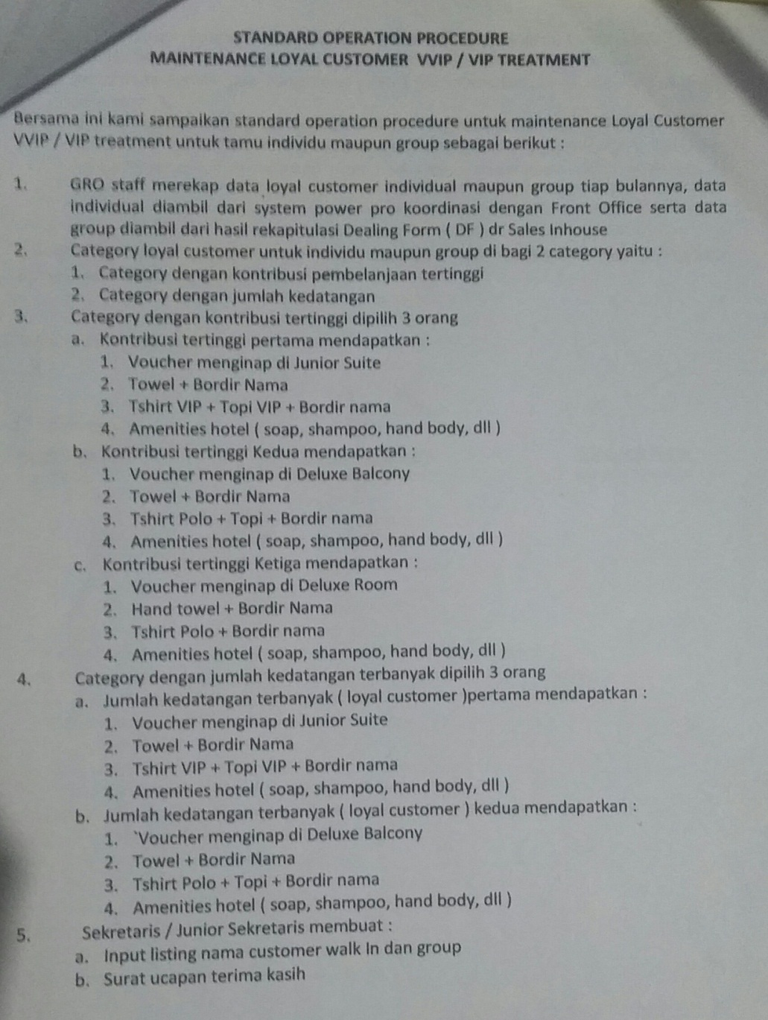
Picture: Standard Operation Procedure Maintain Loyal Customer Sari Ater Hotel

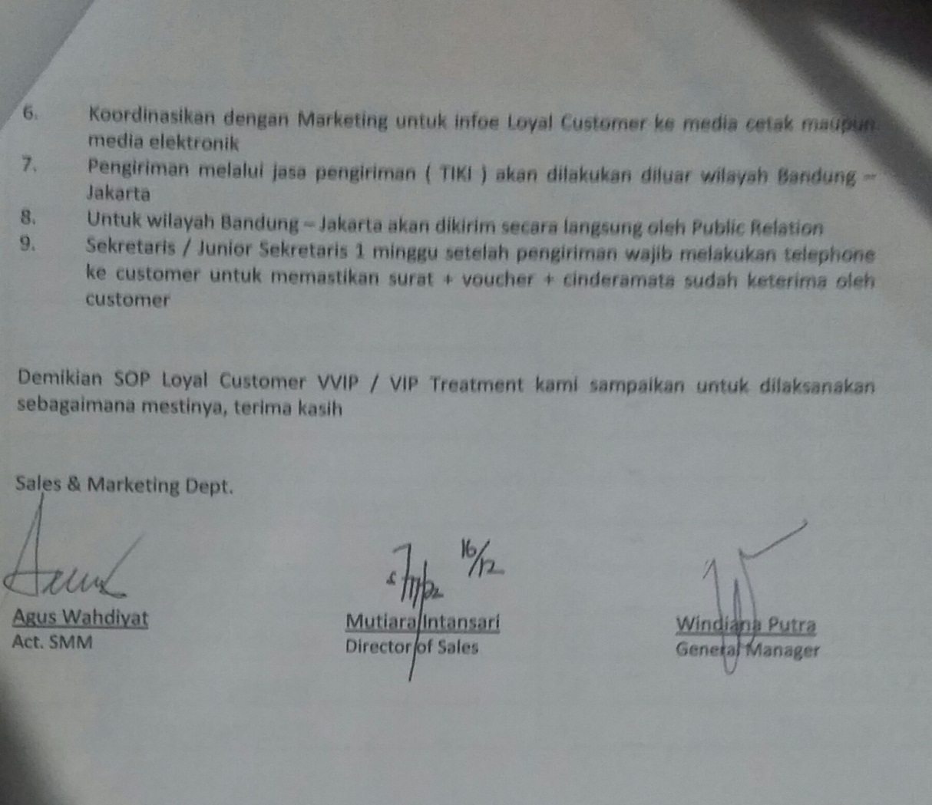
Picture: Standard Operation Procedure Maintain Loyal Customer Sari Ater Hotel

    - How the Guests Assessment about the Quality Service that Provided by Sari Ater Hotel for Maintain the Loyalty of Guest
Quality of service is very influencing to maintain the loyalty of guests. For Sari Ater Hotel service quality become the main priority in satisfactory living, satisfaction of guests is an important thing and the loyal guests isa precious property. If guests feel the quality of services provided by the Sari Ater Hotel is very good, then the guest will be believe and will be loyal to Sari Ater Hotel.
A guest can be said to be loyal if it has repeatedly stayed in Sari Ater Hotel. From survey the guests were very happy and satisfied with all the services provided by the hotel. Therefore have a lot of guests who become loyal guest. The one reason of guests to be loyal to the hotel, because the service provided is very good, all employee are very friendly,
To be able to measure the quality of service that is felt by hotel guests, Sari Ater and author make questionnaire and filled by hotel guests when checking out. From the results of questionnaires in the form of a guest comment form which distributed to hotel guests, about 30 respoundens as sample. The authors obtain the following results:

Table 4.1.2.1
Assessment of the location of hotel
No | Result | Frequency | Percentage
1 | Excellent | 11 | 37%
2 | Good | 19 | 63%
3 | Fair
4 | Poor
Total |  | 30 | 100%
Source : Marketing Department

The table above shows an assessment of the location of the hotel. Based on the table, from 30 guests 11 people or 37% of guests gave excellent assessment, and 19 people or 63% gave good assessment to the location of the Sari Ater Hotel. Seen from the assessment guests, mostly from guests judge that the location of the Sari Ater Hotel is good.

Table 4.1.2.2
Assessment of the exterior & interior design of the hotel
No | Result | Frequency | Percentage
1 | Excellent | 13 | 43%
2 | Good | 17 | 57%
3 | Fair
4 | Poor
Total |  | 30 | 100%
Source : Marketing Department

The table above shows an assessment of the exterior & interior design of the hotel. Based on the table, from 30 guests 13 people or 43% of guests gave excellent assessment, and 17 people or 57% gave good assessment to the exterior & interior design of the Sari Ater Hotel. Seen from the assessment guests, mostly from guests judge that the exterior & interior design of the Sari Ater Hotel is good.

Table 4.1.2.3
Assessment of the condition of the food and beverage
No | Result | Frequency | Percentage
1 | Excellent | 12 | 40%
2 | Good | 18 | 60%
3 | Fair
4 | Poor
Total |  | 30 | 100%
Source : Marketing Department

The table above shows an assessment of the condition of the food and beverage of the hotel. Based on the table, from 30 guests 12 people or 40% of guests gave excellent assessment, and 18 people or 60% gave good assessment to the condition of the food and beverage of the Sari Ater Hotel. Seen from the assessment guests, mostly from guests judge that the condition of the food and beverage of the Sari Ater Hotel is good. For that, sari ater hotel must continue to increase the quality of food and beverages in order to become excellent condition.

Table 4.1.2.4
Assessment of the hotel facilities
No | Result | Frequency | Percentage
1 | Excellent | 10 | 33%
2 | Good | 20 | 67%
3 | Fair
4 | Poor
Total |  | 30 | 100%
Source : Marketing Department

The table above shows an assessment of the facilities of the hotel. Based on the table, from 30 guests 10 people or 33% of guests gave excellent assessment, and 20 people or 67% gave good assessment to the facilities of the Sari Ater Hotel. Seen from the assessment guests, mostly from guests judge that the facilities of the Sari Ater Hotel is good.

Table 4.1.2.5
Assessment of the comfort and cleanliness during stay
No | Result | Frequency | Percentage
1 | Excellent | 11 | 37%
2 | Good | 19 | 63%
3 | Fair
4 | Poor
Total |  | 30 | 100%
Source : Marketing Department

The table above shows an assessment of the comfort and cleanliness during stay of the hotel. Based on the table, from 30 guests 11 people or 37% of guests gave excellent assessment, and 19 people or 63% gave good assessment to the comfort and cleanliness during stay of the Sari Ater Hotel. Seen from the assessment guests, mostly from guests judge that the comfort and cleanliness during stay of the Sari Ater Hotel is good.

Table 4.1.2.6
Assessment of the correspondence beetwen the rates offered by the service provided
No | Result | Frequency | Percentage
1 | Excellent | 8 | 27%
2 | Good | 22 | 73%
3 | Fair
4 | Poor
Total |  | 30 | 100%
Source : Marketing Department

The table above shows an assessment of the correspondence beetwen the rates offered by the service provided of the hotel. Based on the table, from 30 guests 8 people or 27% of guests gave excellent assessment, and 22 people or 73% gave good assessment to the correspondence beetwen the rates offered by the service provided of the Sari Ater Hotel. Seen from the assessment guests, mostly from guests judge that the correspondence beetwen the rates offered by the service provided of the Sari Ater Hotel is good.

Table 4.1.2.7
Assessment of the easy of booking
No | Result | Frequency | Percentage
1 | Excellent | 9 | 30%
2 | Good | 21 | 70%
3 | Fair
4 | Poor
Total |  | 30 | 100%
Source : Marketing Department

The table above shows an assessment of the easy of booking of the hotel. Based on the table, from 30 guests 9 people or 30% of guests gave excellent assessment, and 21 people or 70% gave good assessment to the easy of booking of the Sari Ater Hotel. Seen from the assessment guests, mostly from guests judge that the easy of booking of the Sari Ater Hotel is good.

Table 4.1.2.8
Assessment of the speed in the service of check in and check out
No | Result | Frequency | Percentage
1 | Excellent | 9 | 30%
2 | Good | 21 | 70%
3 | Fair
4 | Poor
Total |  | 30 | 100%
Source : Marketing Department

The table above shows an assessment of the speed in the service of check in and check out of the hotel. Based on the table, from 30 guests 9 people or 30% of guests gave excellent assessment, and 21 people or 70% gave good assessment to the speed in the service of check in and check out of the Sari Ater Hotel. Seen from the assessment guests, mostly from guests judge that the speed in the service of check in and check out of the Sari Ater Hotel is good.

Table 4.1.2.9
Assessment of the speed in the serving complaint
No | Result | Frequency | Percentage
1 | Excellent | 8 | 27%
2 | Good | 22 | 73%
3 | Fair
4 | Poor
Total |  | 30 | 100%
Source : Marketing Department

The table above shows an assessment of the speed in the serving complaint of the hotel. Based on the table, from 30 guests 8 people or 27% of guests gave excellent assessment, and 22 people or 73% gave good assessment to the speed in the serving complaint of the Sari Ater Hotel. Seen from the assessment guests, mostly from guests judge that the speed in the serving compalin of the Sari Ater Hotel is good.

Table 4.1.2.10
Assessment of the speed providing information
No | Result | Frequency | Percentage
1 | Excellent | 10 | 33%
2 | Good | 20 | 67%
3 | Fair
4 | Poor
Total |  | 30 | 100%
Source : Marketing Department

The table above shows an assessment of the speed providing information of the hotel. Based on the table, from 30 guests 10 people or 33% of guests gave excellent assessment, and 20 people or 67% gave good assessment to the speed providing information of the Sari Ater Hotel. Seen from the assessment guests, mostly from guests judge that the speed providing information of the Sari Ater Hotel is good.

Table 4.1.2.11
Assessment of the responsibility for security hotel
No | Result | Frequency | Percentage
1 | Excellent | 13 | 43%
2 | Good | 17 | 57%
3 | Fair
4 | Poor
Total |  | 30 | 100%
Source : Marketing Department

The table above shows an assessment of the responsibility for security of the hotel. Based on the table, from 30 guests 13 people or 43% of guests gave excellent assessment, and 17 people or 57% gave good assessment to the responsibility for security of the Sari Ater Hotel. Seen from the assessment guests, mostly from guests judge that the responsibility for security hotel of the Sari Ater Hotel is good.

Table 4.1.2.12
Assessment of the honesty of the hotel staff
No | Result | Frequency | Percentage
1 | Excellent | 11 | 37%
2 | Good | 19 | 63%
3 | Fair
4 | Poor
Total |  | 30 | 100%
Source : Marketing Department

The table above shows an assessment of the honesty of the hotel staff of the hotel. Based on the table, from 30 guests 11 people or 37% of guests gave excellent assessment, and 19 people or 63% gave good assessment to the honesty of the hotel staff of the Sari Ater Hotel. Seen from the assessment guests, mostly from guests judge that the honesty of the hotel staff hotel of the Sari Ater Hotel is good.

Table 4.1.2.13
Assessment of the hospitality and courtesy of the hoteal staff in providing service
No | Result | Frequency | Percentage
1 | Excellent | 17 | 57%
2 | Good | 13 | 43%
3 | Fair
4 | Poor
Total |  | 30 | 100%
Source : Marketing Department

The table above shows an assessment of the hospitality and courtesy of the hoteal staff in providing service of the hotel. Based on the table, from 30 guests 17 people or 57% of guests gave excellent assessment, and 13 people or 43% gave good assessment to the hospitality and courtesy of the hoteal staff in providing service of the Sari Ater Hotel. Seen from the assessment guests, mostly from guests judge that the hospitality and courtesy of the hotel staff in providing service of the Sari Ater Hotel is excellent.

Table 4.1.2.14
Assessment of the willingness to listen to criticism and suggestions guest
No | Result | Frequency | Percentage
1 | Excellent | 9 | 30%
2 | Good | 21 | 70%
3 | Fair
4 | Poor
Total |  | 30 | 100%
Source : Marketing Department

The table above shows an assessment of the willingness to listen to criticism and suggestions guest of the hotel. Based on the table, from 30 guests 9 people or 30% of guests gave excellent assessment, and 21 people or 70% gave good assessment to the willingness to listen to criticism and suggestions guest of the Sari Ater Hotel. Seen from the assessment guests, mostly from guests judge that the willingness to listen to criticism and suggestions guest of the Sari Ater Hotel is good.

From the above data looks that guests are happy with the service provided by Sari Ater Hotel, so guests gave a good assessment. Therefore the quality of service is affected to guests assessment toward Sari Ater Hotel and the quality of service is affected for guest loyalty. The good service able to maintain guests loyalty.
Have a lot of guests who become members in Sari Ater Hotel, guests are classified as loyal guests. not only domestic guests who become loyal guests, but also foreign guests were many who become loyal guests. they feel very happy with all that they can when staying at the Sari Ater Hotel. The following are several loyal guest list, that:
Table 4.1.2.15
A list of a few of domestic loyal guests
NAME | CITY
Novel | Jakarta
Holil | jakarta
Sugeng A | Karawang
Maryadi | Bandung
Dimas | Jakarta
Rizki V | Jakarta
Timbul Purnomo | Jawa Tengah
Heri haryanto | Kebumen
Andri Nugraha | Cikampek
H.R Wiratmoko | Jakarta
Jose Rizal | Jakarta
Mustofa Alayidrus | jakarta
Suherman | surabaya
M.Nadjib F | Jakarta
Yul Anwar | Lampung
Hamad Mubarak | Jakarta
H. Salim Mubarak | Jakarta
Fitri Wijayanti | Tangerang
Bob Budiman | Depok
Tian Kuswara | Cianjur
Prima N.A | Cirebon
Fauzi A | Jakarta
Source : front Office Department

Table 4.1.2.16
A list of a few of loyal Foreign Guest
NAME | COUNTRY
Gianluca s | Italy
Abdullah Syam | Saudi Arabia
Sarwah binti pullan | Selangor
Joe G | Singapore
Lee Byeng woo | Singapore
Myung Sok kim | Korea
Oh Sung Kwon | China
Lee kehn Liem | Brunei Darussalam
Source: Front Office Department
To maintain the loyalty of the guests, Sari Ater Hotel makes a procedure to maintain and improve guest loyalty, which are as follows :
- Loyal guests will get a reward in the form of a free voucher for stay and merchaindaise such hats, t-shirt, towel, room aminities.
- Loyal guests who are staying will get a fruit basket and a welcome letter.
- When loyal guests check in, will be welcomed and accompanied by officers.
- When loyal guests check-out, will be accompained by public relation of Sari Ater Hotel until the administration has done.
- And than the loyal guest will get a souvenir from Sari Ater Hotel.

  - Findings
After conducting this research, finally the writer find the answers of the research problems. In this finding, the writer wants to describe the result of the research according to the data which is found in both interview and observation activities. It also use questionnaire on the other hand to support the data analysis. Proper with the title of this research that is The Influence of Quality Service to Maintain Loyalty of Guest in Sari Ater Hotel.
Hence the writer makes two categories from the data and each category consist of some dat. Is this finding, the writer would to describe them one by one. From the first category the writer to describe about the quality of service that provided by Sari Ater hotel based on the result from interview, observation and connected with the principal dimension of service quality according to Tjiptono (2006: 70), consist of Tangibles (The location of hotel, Exterior & Interior design, Food & Beverage, the hotel Facilities, the comfort and the cleanliness during stay), Realibility (Correspondence beetwen the rates offered by the service provided, Ease of Booking), Responsiveness (The speed in the service of check-in & check-out, the speed in serving complaint, the speed in providing information), Assurance (Responsibility for security hotel, honesty of the hotel staff), Emphaty (The hospaitality and the courtesy of the hotel staff in providing service, willingness to listen criticism and suggestion guests). From the second category based on quisionaire there are found fourteen data of the guests assessment about the quality service that provided by Sari Ater hotel for maintain the loyalty of guests. The assessment base on catagories from dimension of service.

    - History of Sari Ater
Sari Ater Hot Spring Resort is the Venue for regular baths used by the communities surrounding Ciater, Nagrak and Palasari. In 1968, Pemda Kabupaten Subang via District in collaboration with Dispenda PU slowly began to develop this natural hot springs ciater as tourist attractions.At first the natural hot springs Attractions Ciater which is now better known as Sari
As the first manager appointed Mr. Sahro of PU County while the number of employees at that time more or less just 11 people. In 1972 the PPN DWIKORA IV (now ptpn XIV XIII Ciater) makes 1 fruit building to the bathroom and the door gate joglo complete with Office and ticket sales counters. On March 20, 1974 Government TK II handed over the management of Subang Regency Sights hot water Ciater to PT.Sari Ater led by Mr. H. A. Soewarma. the first Manager was entrusted by PT.Sari Ater to lead the management of the natural hot springs attractions Ciater is the father of Gautama, alm (thn 1974 s/d 1975). The number of employees who were at that time approximately 16 people and Whole tourist area of 7.335 H, managed and produced a restyled guardrail of barbed wire.
In 1976, began construction of the Restaurant Dayang Sumbi, Bungalows kabayan, parking and recreation outdoor boat. The leadership on that could be entrusted to a third manager Mr. J.R. Iskandar, Alm (from 1976 until 1977). Business leaders in 1977 was entrusted to Mr. Evandra aka Mr. Muhammad Effendi, an expert on Italy (1977 until 1979) and the number of employees has risen to approximately 70 people.
In 1980 began revamping and development of major infrastructure and facilities, at a time when it was built: the pool bottom or better II Jammbu, bungalows, recreational areas to curug Jodo. with the source of funds from BAPINDO. Manager to the IV who led when it is Mr. Anton Tirto (1979 until 1985) while employees amounted to approximately 100 people.
Manager to the VI ruled by Mr. Ruby and in 1987 led by ceded to Mr. Herrie Hermanni with positions as Operational Manager. On October 24 1994 carried out a restructuring of the Organization and set out a General Manager for leading hotels and tourist attractions with the name Sari Ater Hot Spring Resort. As general manager of the first assigned Mr. Herrie Hermanni with number of employees at the time the person while the broad area of 333 hotels and attractions have become 32.
In 1998 the rebuilt one natural hot water facilities in a recreational area with the name Pulosari, with a capacity for 500 people and was inaugurated by the Governor of level II subang Mr. Drs. h. Abdul Wahyan precisely on July 25, 1998.
Until now a hotel and tourist attraction of natural hot spring water more famous as Sari Ater Hot Spring Hotel and Recreation.

    - Number of Visitors
Table 4.2.2.1
The Number of Sari Ater Hot Spring Guest 2011-2014
No | Years | Domestic | Foreign
1 | 2011 | 68.303 | 12.053
2 | 2012 | 69.679 | 12.081
3 | 2013 | 71.376 | 14.618
4 | 2014 | 68.067 | 11.569
 | Total | 277.425 | 50.321
Source: Recreation Department

Domestic tourists who visit the Sari Ater Hot Spring Resort comes from various cities in Indonesia, which aims to recreation and to spend vacation time in the Sari Ater Hot Spring Resort. most of them are directly stay at the Sari Ater Hotel or go back to their homes. while foreign tourists come from various of countries and have the same purpose, namely to recreation, some of them also directly stay the Sari Ater Hotel or at another hotel.

Table 4.2.2.2
The Number of Sari Ater Hotel Guest 2011-2014
No | Years | Domestic | Foreign
1 | 2011 | 23.076 | 5.475
2 | 2012 | 24.357 | 6.636
3 | 2013 | 28.924 | 6.132
4 | 2014 | 25.578 | 6.493
 | Total | 101.935 | 24.736
Source: Front Office Department
Domestic tourists staying at the Sari Ater Hotel people from outside of Subang, who lived far away from the Sari Ater tourist attractions and aims for recreation and spend vacation time in the Sari Ater. besides aiming for recreation, guests staying at the Sari Ater Hotel also aims for business or meetings.
Foreign tourists who stay in Sari Ater Hotel solely for purposes of recreation, mostly from Saudi Arabia, Singapore, Malaysia, etc
    - Aspect of Business Activities
Sari Ater has a very cozy room type so as to make guests ' stay to become more qualified, in addition, the Hotel is equipped with a wide variety of these can complement the perfection of the stay of the guests.
- Rooms
Currently Sari Ater Hotel has a wide variety of rooms in each room is equipped by a television, telephone, mini bar, coffee maker, bathroom with cold and hot spring water. Type the rooms that are as follows:
- Deluxe Balcony Rooms available 16 Rooms, capacity of two people.
- Deluxe Rooms are available 14 Rooms, capacity of two people.
- Standard Rooms are available 48 Rooms, capacity of two people.
Luxuries are available in every room, and covered by natural fresh air of the mountains are able to create comfort in the rest.

- Meeting rooms
Table 4.2.3.1 Meeting Rooms at Hotel Sari Ater & Resort is quite varied
Rooms | Dimension | Theatre | U-Shape | Recept | Class | Oval | Banquet seat
Main Hall | 28 X 14 M | 380-450 | 150 | 350-700 | 224 | 100 | 224
Sangkuriang 1 | 14 X 14 M | 164 | 44 | 175-250 | 104 | 30 | 128
Sangkuriang 2 | 6 X 14 M | 36 | 18 | - | 20 | 18 | -
Sangkuriang 3 | 6 X 14 M | 36 | 18 | - | 20 | 18 | -
Wangsadipa 1 | 6 X 14 M | 20 | 18 | - | 16 | 14 | -
Wangsadipa 2 | 6 X 14 M | 20 | 18 | - | 16 | 14 | -
Domas | 6 X 19 M | 70 | 40 | 80 | 40 | 25 | 50
Kabayan | 6 X 12 M | 30 | 18 | - | 16 | 14 | -
Source: Sales Marketing Sari Sari & Ater & Resort Hotel
- Restaurant
- Sunan Ambu café.
- Ki Mannis Family Restaurant.
- Jambu Café.
- Kadaka Lounge Terrace.
- Lesehan Kampung Kabayan

CHAPTER V
Conclusions and Suggestions

5.1 Conclusions
Based on the results of research, the data obtained by interviews, observations, questionnaires, with 30 respondents, it can be concluded as follows:
- Sari Ater Hotel is a hotel located in the very popular recreation area in West Java, namely Recreation and Natural Thermal Baths, which is located in Ciater Subang. With the classy hotel in the middle of the tourist attractions which always been a destination for sightseeing in the West Java, can help the visitors who come from outside of Java Island or who lived far away from the place of recreation, and even foreign to be able to stay close to the recreation area.
The quality of the service greatly affect visitor loyalty, to the quality of the service to be top priority in satisfying visitors. If it is a quality of service provided by the Sari Ater Hotel is very good, then the guest will be loyal to Sari Ater Hotel. In improving the quality of services for guests, Sari Ater Hotel strive a service prescribed by the hotel management to increase the guests' satisfaction, so if the guests feel very satisfied then, most likely the guest will be a loyalty guest. The quality of services provided by Sari Ater Hotel can be seen from the services rendered and connected with the principal dimension of service quality according to Fandy Tjiptono (2006; 70) is Tangibles, Reliability, Responsiveness, Assurance, and Empathy.
- The influence of the quality of services to the guest loyalty in Sari Ater is powerful, The quality of the service greatly affect visitor loyalty, to the quality of the service to be top priority in satisfying visitors. If it is a quality of service provided by the Sari Ater Hotel is very good, then the guest will be loyal to Sari Ater Hotel. To be able to measure the quality of service perceived by guests of the hotel, Sari Ater Hotel, create the Guest Comment form that will be filled by guests of the hotel when check out. From the results of the guest a comment is visible responses from the guest for the quality of services provided by Sari Ater Hotel. Assesment guests to Sari Ater Hotel is quite good, seen in terms of the dimension Tangibles, Reliability, Responsiveness, Assurance, and Empathy. It is seen from the questionnaires were collected, most of the guests were satisfied with the services provided by Sari Ater Hotel, even on part of them has been a member of the Sari Ater Hotel, it indicates that the Sari Ater Hotel is able to provide a good service, so that the guests gave a good response and most of them will be the loyalty guests.

5.2 Suggenstions
After analyzing, processing, and presenting data that has been obtained, the author gives some suggestions for Sari Ater Hotel in an effort to improve the quality of services, including:
- Sari Ater Hotel not only ask the guest comment to guests but also need to recapitalize all of the guest comment as a comparison of responses from visitors to the service provided every day.
- Sari Ater Hotel is expected to provide a more varied gift for guests who are loyal to Sari Ater Hotel.
- Sari Ater hotel is expected to increase the number of rooms, in order to be able to accommodate more guests.

BIBLIOGRAPHY

Grifin, Jill. 1996. Customer Loyalty.
New York: Lexington Book Co.

Kotler, Phillip. 1999. Manajemen Pemasaran.
Jakarta: PT. Prenhalindo.

Kotler, Phillip. 2000. Manajemen Pemasaran, Edisi Bahasa Indonesia , Jilid I dan
II. Jakarta: PT. Prenhalindo.

Kotler, Phillip. 2002. Markerting Management, 11 th Ed.
New Jersey: Peasron Education. Inc. Upper Sadde River.

Lupiyoadi, Rambat. 2001. Manajemen Pemasaran Jasa.
Jakarta: Salemba Empat.

Nazir, Muhammad. 2003. Metode Penelitian.
Jakarta: Ghalia Indonesia

Tjiptono, Fandy. 2000. Persepektif Manajemen dan Pemasaran Kontemporer,
First Edition. Yogyakarta: Andi Offset.

Tjiptono, Fandy. 2006. Manajemen Jasa.
Yogyakarta: Andi Yogyakarta

Warsito. 1992. Pengantar Metodologi Penelitian.
Jakarta: Pendidikan Gramedia Pustaka Utama

Wijayanti, Titik. 2012. Marketing Plan Dalam Bisnis, Second Edition.
Jakarta: Elex Media Komputindo

Yajid, 2001. Pemasaran Jasa Konsep dan Implementasi, First Edition
Yogyakarta: Fakultas Ekonomi UII

http://en.wikipedia.org/wiki/Marketing
http://en.wikipedia.org/wiki/Promotion_%28marketing%29
http://en.wikipedia.org/wiki/Category:Customer_loyalty_programs
http://en.wikipedia.org/wiki/Hotel
http://ruangmarketing.blogspot.com/2012/12/pengertian-bauran-pemasaran-marketing.html

APPENDICES

Operational Variable
Questionnaire Guest Comment
The Influence of The Quality Services to Maintain The Loyalty of Guests in Sari Ater Hotel
Name :
Number of Room :
Arrival Date :
Departure Date :
Address :
Phone Number :

Give a mark √ on the following statement in accordance with your opinion
Kind of Service | Excellent | Good | Fair | Poor | Comment & Suggestion
- Location of hotel
- Exterior & interior design
- Food & beverage
- Hotel facilities
- The comfort & cleanliness
- Correspondence between the rates offered
- Ease of booking
- The speed in the service check in & check out
- The speed in serving complaint
- The speed in providing information
- Responsibility for security hotel
- Honesty of hotel staff
- The hospitality and courtesy of the hotel staff in providing service
- Willingness to listen The speed in providing information to criticism and suggestion guest

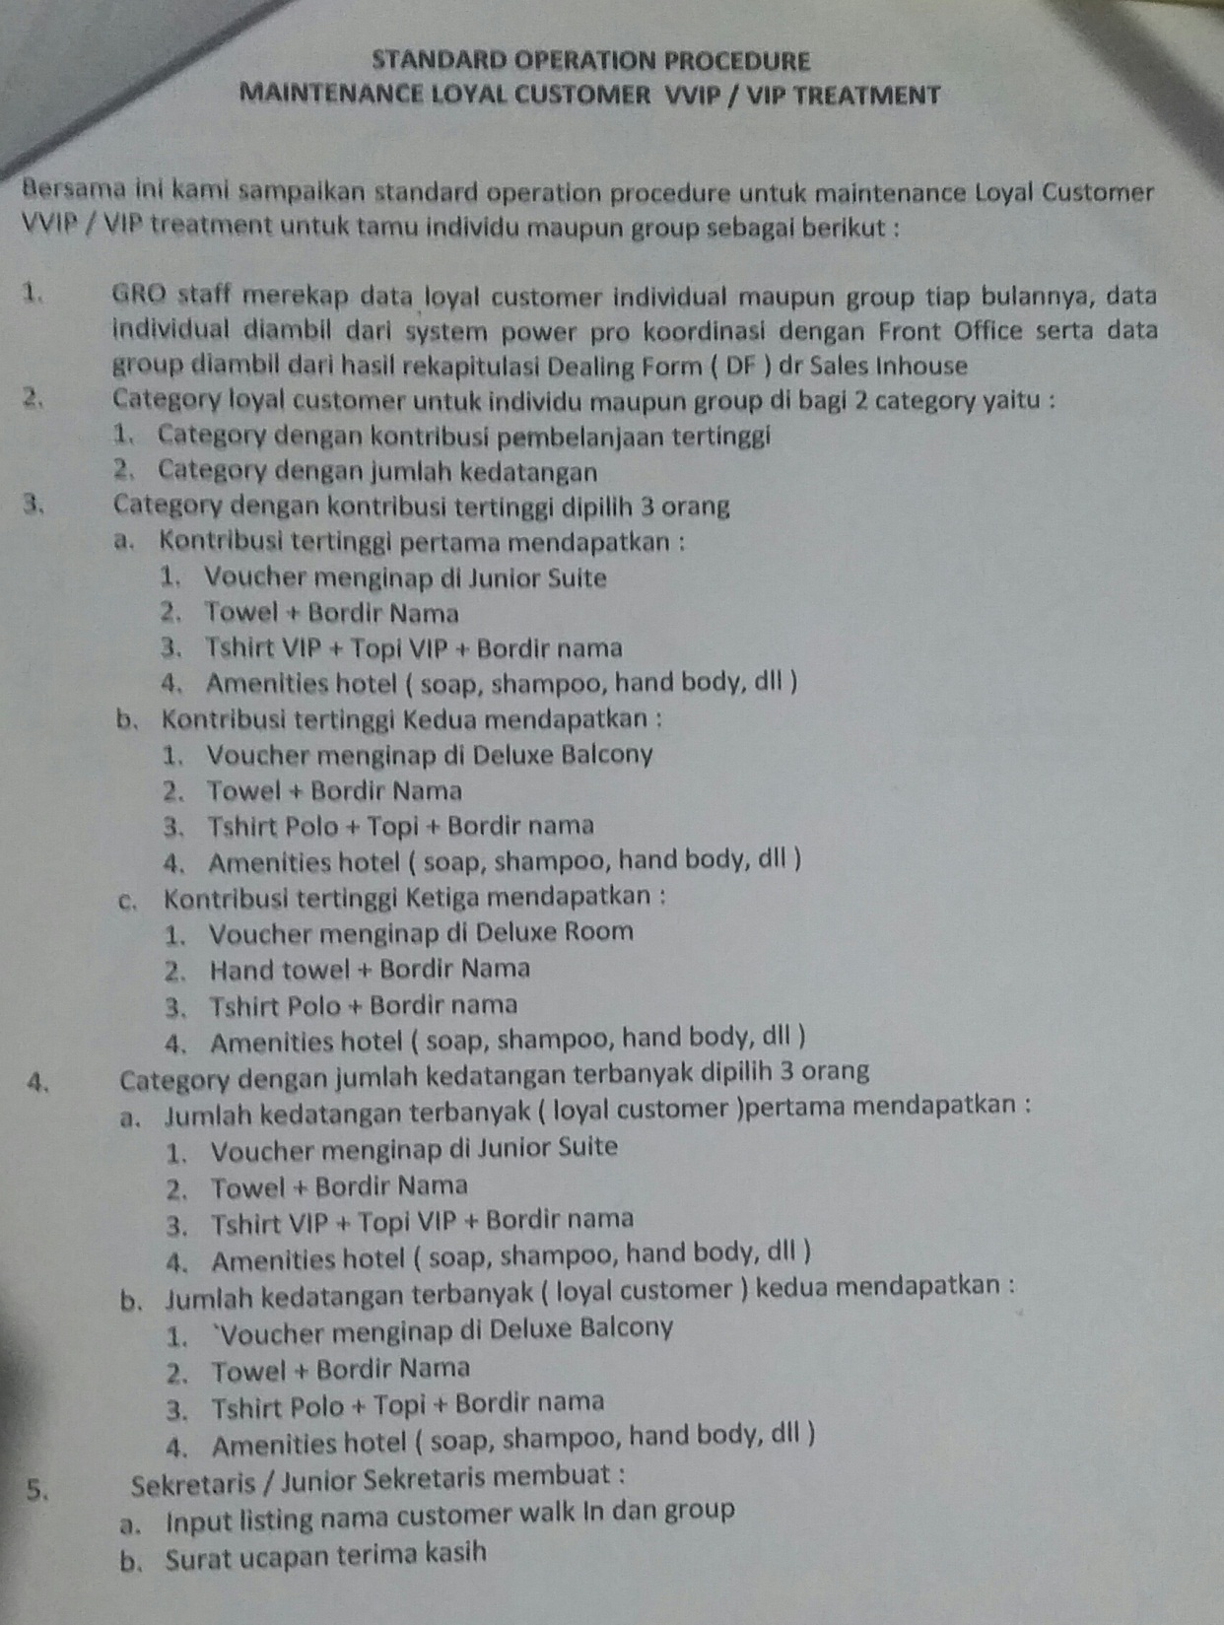
Picture: Standard Operation Procedure Maintain Loyal Customer Sari Ater Hote

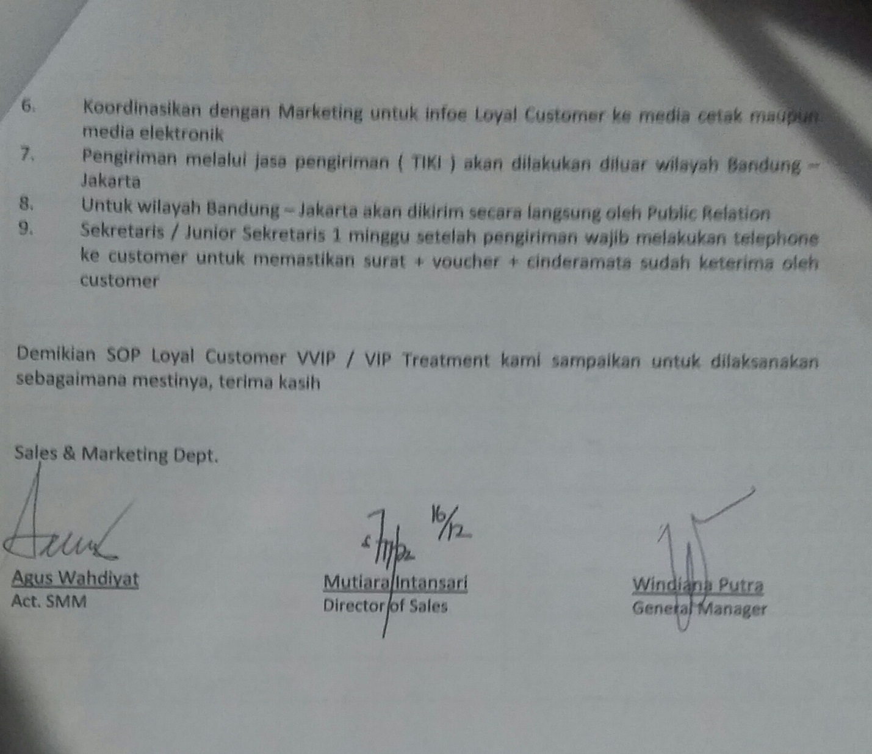
Picture: Standard Operation Procedure Maintain Loyal Customer Sari Ater Hotel

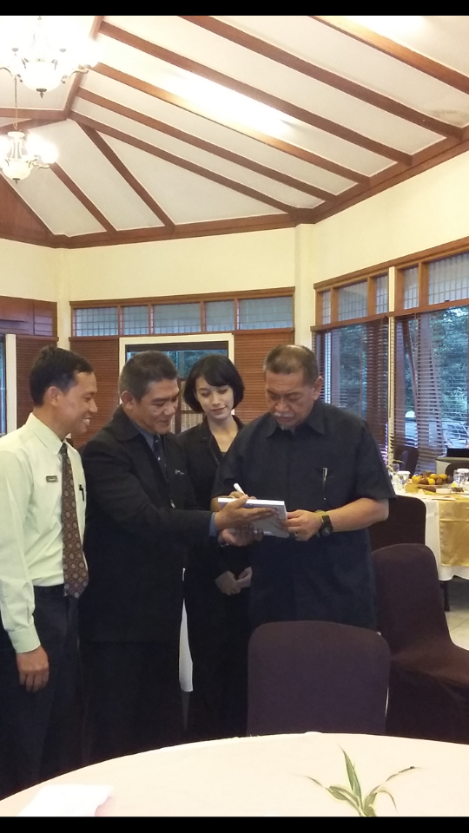
Picture: Deputy Governor of West Java Given a Comment to Sari Ater Hotel

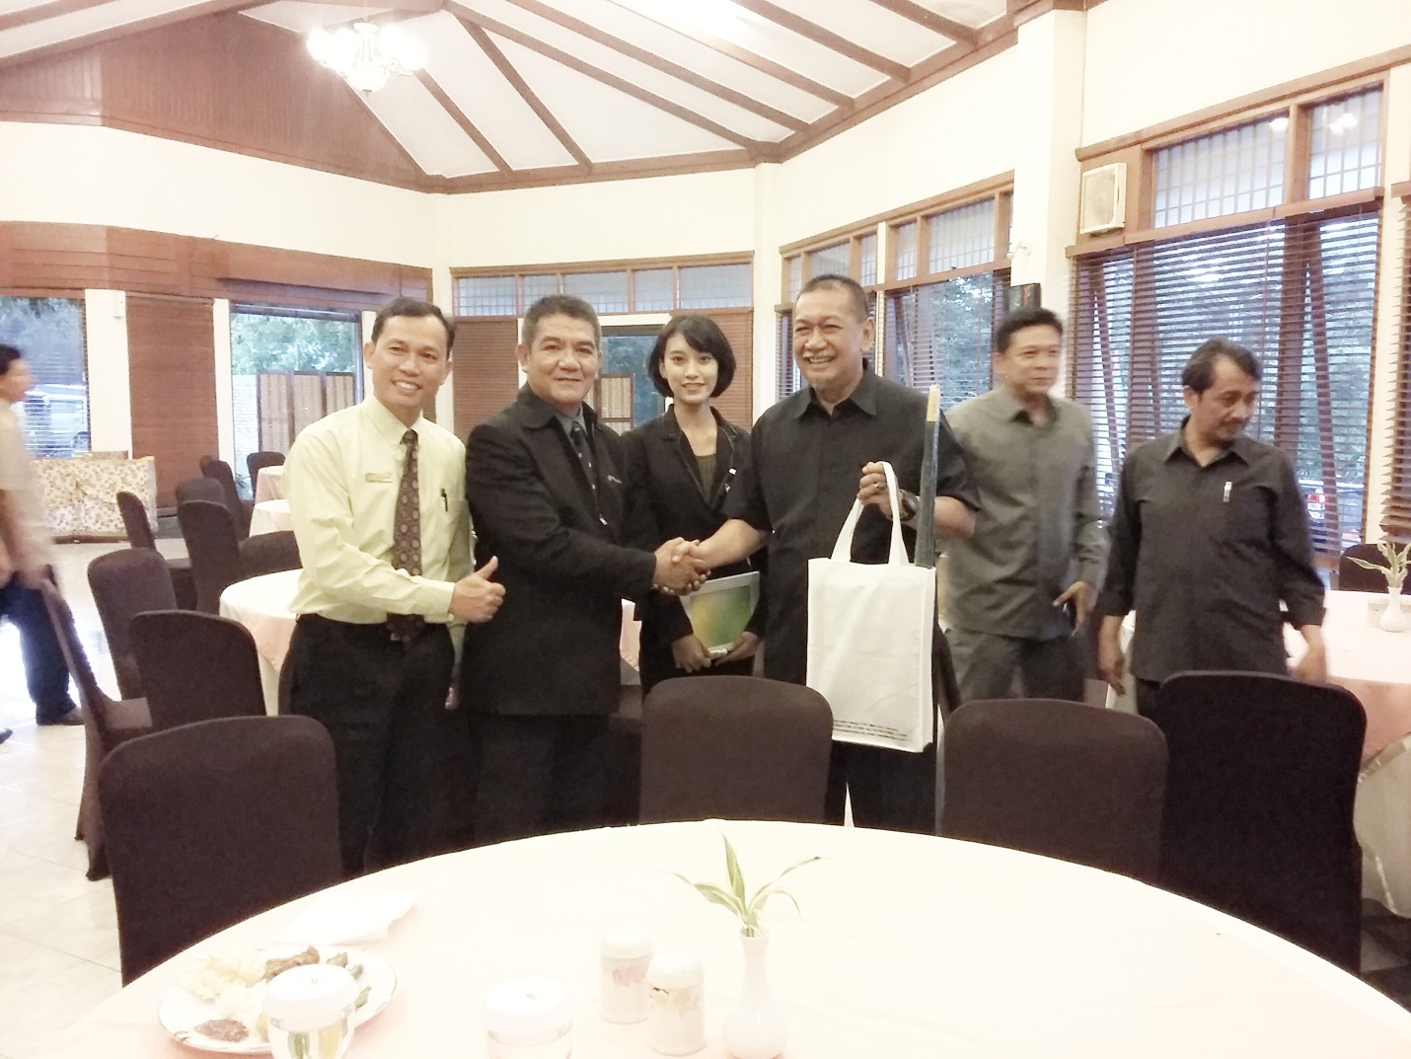
Picture: Author with Deputy Governor of West Java, Public Relation Manager and Human Resource Executive.

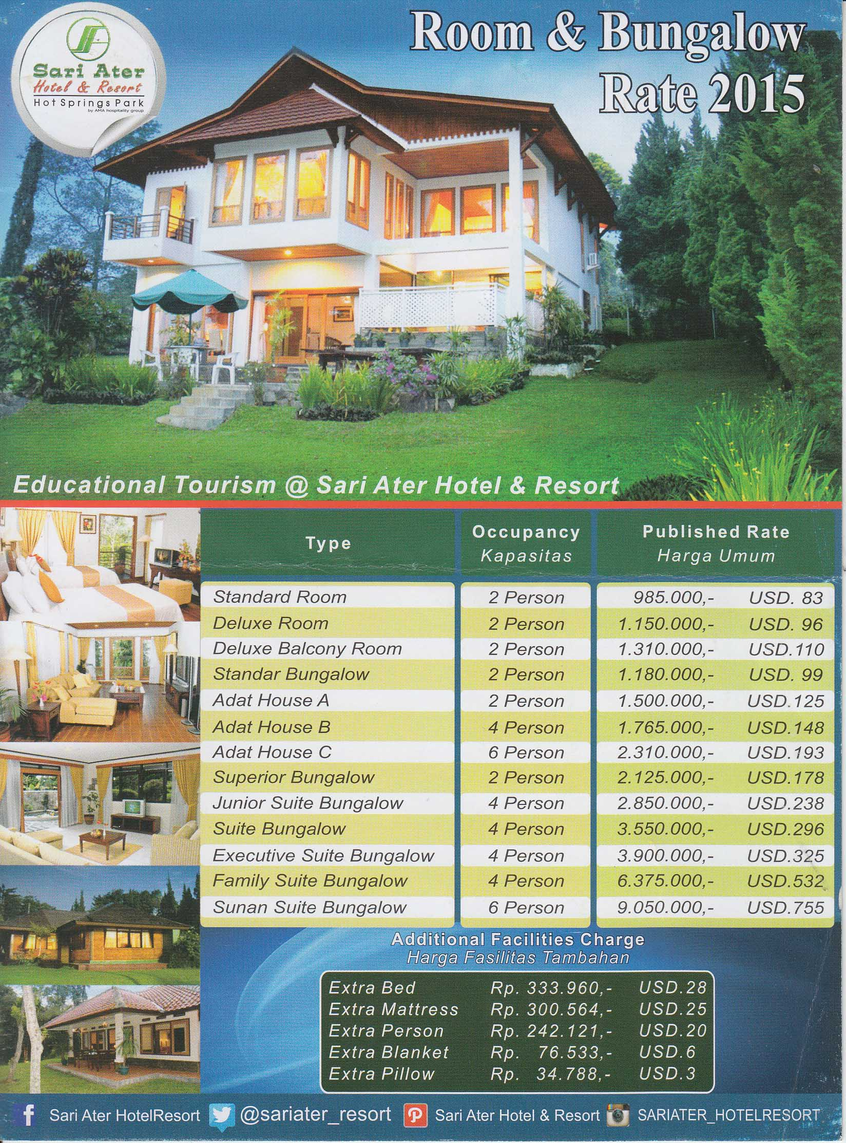
Picture : Room Rate Hotel

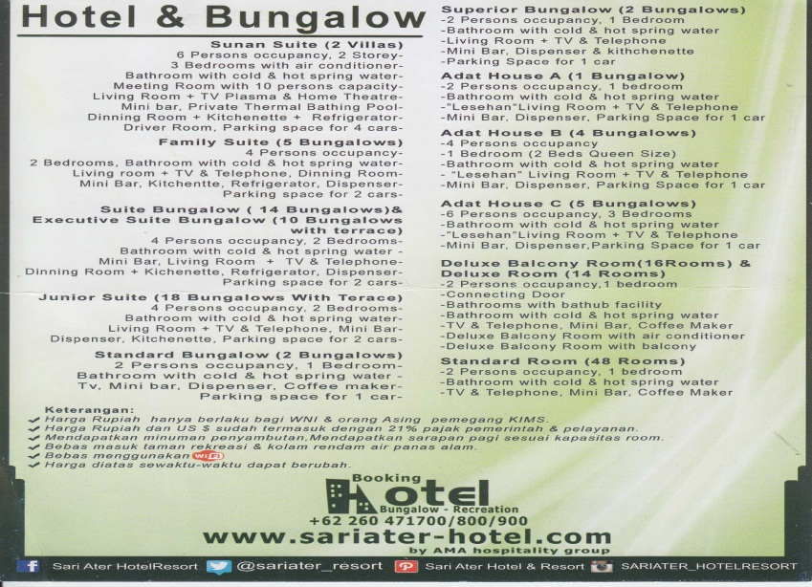
Picture: Brocure Hotel Facilities

