CHAPTER I
Introduction

  - Background of The Study
English is one of the international languages that is used by many people in the world and in many areas of everyday life, English is as foreign language in Indonesia using English is the easiest way to communicate with people from other countries about many aspects in human life such as technology, economy, social, and politics. For Indonesia, learning a foreign language requires four language skills; listening, speaking, reading and writing. Speaking is an important part to have communication with other foreign people, that is way in teaching and learning English. Speaking involves some language components (spelling, grammar, vocabulary, and pronounciation).
The most of students get difficult and afraid to speak English or share their opinion to each other it caused by some factors, those are; motivation, interest, teaching techniques and using teaching media. By using teaching media, teacher can increase the students’ motivation and create an interesting learning atmosphere (Kamaludin, 2009). An alternative way to create suitable and interesting techniques related to students’ condition. Through pictures as media in learning English it expected can be one of the positive ways to increase students enthusiastic in learning English and help the students to build spirit in speaking. A good deal of typical classroom interaction is characterized by teacher of language, we ask question, give directions, and provide information and students have been conditioned only to “speak when spoken to” (Brown 2001:276). they tend to be practical and easy to use, by using pictures believed that teaching and learning process will be more effective, teaching learning situation will be more attractive, and both teacher and students get advantages from the use visual media in classroom. As the common teaching media, pictures may be presented in many ways, especially presenting pictures as a single picture.
Based on the explanation above, the writer intended to conduct the classroom action research focusing on the use of pictures as media in teaching English. The aim of the research for the students to know the development of speaking ability by using picture media

  - Identification of the Problems
There are many problems in speaking learning, it does not like what they expect to, many students learning English for 3 years (elem
entary school) but they cannot use English language well, it caused some factors, those are :
Mostly students have not motivated to English speaking learning, when speaking English learning in classroom the most of students read from the text.
A teacher should have interesting teaching method to make students comfortable in English learning class, monotonous teaching technique sometimes can make students get bored and lose attention
The use of interesting media also influence and needed in teaching and learning process. The students need motivation and encouragement to follow the activities in the classroom, interesting and update media is one of the students to attract students in learning English.
The facilities are also important to support teaching and learning process. Facilities include comfortable room, tables and chairs, whiteboard or blackboard and also infocus as one of complement in teaching learning. The most problems that often occur is the total number of students are more than tables and chairs.
Based on problems above, the writer conduct research to investigate using series picture to improve students’ ability especially in speaking skill.

1.3 Limitation of the Problem
Limitation of the study based on Sylabus SMP 2013 it focused on Descriptive Text, the research choose 7th grade students of SMP Kemah Indonesia 4 Bandung, it consist of 30 students. The method in English teaching and learning using pictures as a media to improve speaking ability, it will implemented at the first semester

1.4 Research Problems
The writer formulates the problem as follows:
- How are the teaching procedures using pictures as media to improve speaking students’ ability ?
- What are the role of teacher in teaching and learning activity in using pictures as media to improve speaking students’ ability ?
- What are the teaching material in using pictures as media to improve speaking students’ ability ?
- What are the form evaluation of teaching and learning in using pictures as media to improve speaking students’ ability ?
- What are the students’ opinions in pictures as media to improve students’ speaking ability?

1.5 Objectives of The Research
The objectives of the study as follows:
- To find out the teaching procedures in using pictures as media to improve speaking students’ ability
- To find out the role of teacher in teaching and learning activity in using pictures as media to improve speaking students’ ability
- To find out the teaching material in pictures as media to improve speaking students’ ability
- To find out the form evaluation of teaching and learning in using pictures as media to improve speaking students’ ability
- To find out students’ opinions in pictures as media to improve students’ speaking ability

  - Significances of The Research
This research is expected can give benefits for the purpose of theoritical and practical, especially for the teacher, It gives the alternative solution in teaching speaking skill.
For students, it can help them to improve their creative thinking skills, the students’ motivation and interest.
For English Department of UNPAS can be beneficial regarding to improve the education quality and give contributions to education research.

  - Population and Sample
- Population
According to Arikunto (2002:108) Populasi adalah keseluruhan subjek penelitian. It means that whole collection subjects of research. The population would be conduct in 7 grade students of SMP Kemah Indonesia 4 bandung divided into 2 classes, there are class A and class B totally 60 students

- Sample
According to Arikunto (2002:109) Sampel adalah sebagian atau wakil populasi yang diteliti. It means that sample is part of population. The research would take random sample class because through this technique the researcher will take sample class without knowing the sample identity. Only 1 class where selected as a sample research from 2 class of 7th grade , it is class A consists of 30 students.

CHAPTER II
Theoretical Foundation

This chapter provides some theories based on the current study. The first, explain about teaching speaking. The second, explain about the procedure of teaching using media, the third, exlpain about thechnique speaking evaluation.
2.1 Teaching Speaking
Language is a tool for communicating with each other and Speaking as one of four abilities aspecs of languages, According to Kridalaksana (1985:12) Bahasa adalah sistem bunyi bermakna yang dipergunakan untuk komunikasi oleh kelompok manusia, the statement means that language is meaningful sound system that used for communication by a human group. A linguist said that speaking is language (Tarigan,2008:3), both language and speaking have tight relation, as the masters of the language said that speaking is as a language skill. In addition Tarigan (2008:16) stated that Berbicara adalah kemampuan mengucapkan bunyi-bunyi artikulasi atau kata-kata untuk mengekspresikan, menyatakan atau menyampaikan pikiran, gagasan, dan perasaan, it means that through speaking everybody can be expressing ideas in their mind, or can be expressing the feelings. in speaking ability there are several aspecs that must be considered those are as regard pronounciation, grammar, and speaking intonation. According to Harmer (2007:343) that if students want to be able to speak fluently in English, they need to be able pronounce phonemes correctly, use appropriate stress and intonation patterns and speak in connected speech. Added by Brown (2001:273) that the Students expected be able to understand the meaning. Intensive speaking goes one step beyond imitative to include any speaking performance that is designed to practice some phonological or grammatical aspect of language.
To make students speaking active in the class, it should be directed to activities that make them active in speaking learning. Speaking learning activity should be make students interested, encourage them to be able speaking spontaneously, Harmer (2007:345) stated that getting students to speak in class can sometimes be extremely easy. In good class atmosphere, students who get on with each other, and whose English is at an appropriate level, will often participate freely and enthusiastically if we give them a suitable topic and task. A good deal of typical classroom interaction is characterized by teacher of language, we ask question, give directions, and provide information and students have been conditioned only to “speak when spoken to” (Brown 2001:276). The role of a teacher in teaching speaking is important, a teacher should choose the suitable method that would be used in the class, teacher can give contribution to make students more comfortable and confidence in teaching and learning English, especially to speak English in the classroom.
Teaching speaking means to teach students to:
- Produce the English speech sounds and sounds pattern
- Use word and sentence stress, intonation patterns and the rhythm of the second language
- Select appropriate words andsentences according to the proper social setting audience, situation and subject matter
- Organize their thoughts in a meaningful and logical sequence
- Use language as a means of expressing values and judgements
- Use the language quickly and confidently with few unnatural pauses, which is called as fluency (David Nunan, 2003, cited in Susanti)

However a teacher role extremely needed to students to build their spirit, as a facilitator and also as source knowledge. Harmer (2007:345) stated that In teaching English, teacher has an important role in teaching English in the classroom, teacher can give contribution to make the students more interest and comfortable in learning English, especially on how to make students confident to speak English in the classroom. In a good class atmosphere, students who get on with each other, and whose English is at an appropriate level, will often participate freely and enthusiastically if we give them a suitable topic and task. Added by Weaver (1960:126) that all visual divices are vital aids to learning. they are not only attention, but also interest ratiners. Visual aids present, in concrete form what often is either difficult or almost impossible to describe adequately with words.
The roles of teacher:
- Controller : Teachers who view their job as the transmission of knowledge from themselves to their students are usually very comfortable with image of themselves as controllers.
- Prompter : when we prompt, we need to do it sensitively and encouragingly but, above all, with discretion. If we are too adamant, we risk taking initiative away from the student.
- Participant : The danger when teachers act as participants, of course, is that they can easily dominate the proceedings.
- Resource : when we are acting as a resource, we will want to be helpful and available, but at the same time we have to resist the urge to spoon-feed our students so that they become over reliant on us
- Tutor : it is essential for us to act as tutors from time to time, however difficult this may be. In this more personal contact, the learners have a real chance to feel supported and helped, and the general class atmosphere is greatly enchanced as a result. Harmer (2007:109)
In teaching English, a teacher as the major sources of language to students, particullary in improving English speaking.

2.2 The Prosedure of Speaking Learning using Pictures as Media
The prosedure using pictures as media to support teaching and learning English activities and also to help the students in describe a thing orally. firstly the teacher greeting upon entering the classroom, The teacher asking the student before start the lesson, it create kinship atmosphere between teacher and students. secondly the teacher explain about descriptive text for describing person, animal or thing. next step the teacher gives an example of descriptive text to describe an animal (a cat) together the teacher also can screw vocabularies also introduce about the use of has and have that related to the picture, such as tail, claws, its colour is white like snow, its has big eyes, and so on. After all done the use a picture as a learning media begins, the teacher shows other animal picture to describe(crocodile) todescribing by the students, then every student should come forward to describe it in front of the class orally.
The descriptive material teaching for SMP 7 grade, which cover:
- Vocabularies related to descriptive text, for example descriptive animal cat, pet, tail, leg, fur, claws, tame and so on.
- Using Have/Has and To be: is, am, are
- The example of Descriptive text
all right students, today I would like to tell you about a pet.I have a pet. It is a cat Its name is “Si Manis” It has black and white fur. It has four legs and long tail. It likes fish, salty fish and milk It usually meows when it feels hungry
The teacher should be able to choose appropriate teaching media to achieve the benefits of using teaching media. The teaching media should be choosen by considering the goals of the lessons and characteristics of the students. determnining the appropriate equipment can also be done by choosing common teaching media, one of the common teaching media is picture.Picture is one of media that can help teacher draw students’ interest and improve students’ motivation to learn because visual media, in this case, pictures assist students to develop creativity and increase thinking ability (Canning-Wilson,2001).By using pictures, it is believed that teaching and learning process will be more effective, teaching and learning situation will be more attractive, and both teacher and students get advantages from the use visual media in classroom. It was supported by Sudjana & Rivai (2009) who explain that the teaching materials are visualized realistically to be similar with the real condition. In teaching and learning English, picures is usefull to use, it can help and support students in learning descriptive text expecialy to describe the person or thing. Showing a picture while they try to describing according to the picture is hoped to lead speaking’s student to describing something.
A teacher has the roles in the class to direct and monitor the students. Harmer (2007:179) said that some theacher and materials designers object to this use of illustration because they consider it gratuitous, but it should be remembered that if the pictures are interesting, they will appeal strongly to at least some members of the class.
The roles of teacher According to Harmer (2007:347) However, three have particular relevance if we trying to get students to speak fluently:
- Prompter: students sometimes get lost, can’t think of what to say next or in some other way lose the fluency we expect of them
- Participant: teachers should be good animators when asking students to produce language
- Feedbackprovider: the vexed question of when and how to give feedback in speaking activities is answered by considering carefully the effect of possible different approaches.

Gerlach (1980) stated that picture may be drawn, printed or photographically processed they vary in size and color, they may be highly representational or abstract teaching and learning English by using picture expected will make situation in learning English more attractive, both students and teacher get advantages from using media. And also the use of picture in teaching and learning English expected will make students focus on material because through pictures learning activity will more fun and it will not be seen difficult in learning speaking.
Through pictures as media in teaching learning expected be interested in leraning English, they be able to feel more fun in the class. The teachers can determine what teaching media can be used in certain speaking teaching and learning process. According to Harmer (2007:178) that teachers have always used pictures or graphic-whether drawn, taken from books, newspapers and magazines, or photographed – to facilitate leraning. Picture as one of ways usefully in teaching and leraning English, in this comcerning to improve speaking ability through describing picture of a thing, or describing picture of a person, using colour and size on picture also should appropriate for effect. He also added that The most important thing is that pictures should be visible, they have to be big enough so that all our students – taking into account where they will sitting – can see necessary detail.

2.3 Technique Speaking Evaluation
Brown (2001:384) mentioned that A test is a method of measuring a person’s ability or knowledge in a given domain. Added by Gronlund (1984:5) that from an instructional standpoint evaluation may be defined as a systematic process of determining the extent to which instructional objectives are achieved by public. Evaluation as a ways for knowing how far ability a person.
Brown (2001:385) categorized that there a three classic criteria for “testing a
test”:
- To know student’s ability especially in speaking English, a teacher should emplement evaluation test according to kinds ability, those are reading test, writing test, speaking test and listening test. Brown (2001:385) added that a test Practicality, A good test is practical. It is within the means of financial limitation, time constraints, ease of administration, and scoring and interpretation.
- Reliabilit, A reliable test is consistent and dependable. Sources of unreliability may lie in the test itself of in the scoring of the test.
- Validity, By far the most complex criterion of a good test is validity. The degree to which the test actually measures what it is intended to measure.
To know student’s ability especially in speaking English, a teacher should emplement evaluation test according to kinds ability, those are reading test, writing test, speaking test and listening test. Brown (2001:385) added that a test has the purpose of measuring. In addition a test measures a person’s ability or knowledge (Brown, 2001:385).
According to Brown (2001:396) where the five levels are described. In a series of structured task the OPI (Oral Proficiency Interview is carefully designed to elicit pronounciation, fluency/integrative ability, sociolinguistic and cultural knowledge, grammar, and vocabulary.
This is the example of assessment table that will be used in technique evaluation for intermediate level
Table speaking assessment
No | Name | Aspects of Assessment |  |  |  |  | Score
 |  | Pronunciation | Grammar | Vocabulary | Fluency | Comprehension

Scoring Rubric
ASPEK | SKOR | KETERANGAN
Pengucapan/ | 5 | Mudah dipahami dan memiliki aksen penutur asli
Pronunciation | 4 | Mudah dipahami meskipun dengan aksen tertentu
 | 3 | Ada masalah pengucapan yang membuat pendengar harus konsentrasi penuh dan kadang-kadang ada kesalahpaham
 | 2 | Sulit dipahami karena ada masalah pengucapan, sering diminta mengulang
 | 1 | Masalah pengucapan serius sehingga tidak bisa dipahami

ASPEK | SKOR | KETERANGAN
Tata Bahasa/ | 5 | Tidak ada atau sedikit kesalahan tata bahasa
Grammar | 4 | Kadang-kadang membuat kesalahan tata bahasa tetapi tidak mempengaruhi makna
 | 3 | Sering membuat kesalahan tata bahasa yang mempengaruhi makna
 | 2 | Banyak kesalahan tata bahasa yang menghambat makna dan sering menata ulang kalimat
 | 1 | Kesalahan tata bahasa begitu parah sehingga sulit dipahami

ASPEK | SKOR | KETERANGAN
Kosa Kata/ | 5 | Menggunakan kosa kata dan ungkapan seperti penutur asli
Vocabulary | 4 | Kadang-kadang menggunakan kosa kata yang tidak tepat
 | 3 | Sering menggunakan kosa kata yang tidak tepat, percakapan menjadi terbatas karena keterbatasan kosa kata
 | 2 | Menggunakan kosa kata secara salah dan kosa kata terbatas sehingga sulit dipahami
 | 1 | Kosa kata sangat terbatas sehingga percakapan tidak mungkin terjadi

ASPEK | SKOR | KETERANGAN
Kelancaran/ | 5 | Lancar seperti penutur asli
Fluency | 4 | Kelancaran tampak sedikit terganggu oleh masalah bahasa
 | 3 | Kelancaran agak banyak terganggu oleh masalah bahasa
 | 2 | Sering ragu-ragu dan terhenti karena keterbatasan bahasa
 | 1 | Bicara terputus-putus dan terhenti sehingga percakapan tidak mungkin terjadi

ASPEK | SKOR | KETERANGAN
Pemahaman/ | 5 | Memahami semua tanpa mengalami kesulitan
Comprehension | 4 | Memahami hampir semuanya, walau ada pengulangan pada bagian tertentu
 | 3 | Memahami sebagian besar apa yang dikatakan bila bicara agak diperlambat walau ada pengulangan
 | 2 | Susah mengikuti apa yang dikatakan.
 | 1 | Tidak bisa memahami walaupun percakapan sederhana

CHAPTER III
Research Methodology

In this chapter discusses some aspects of research methodology that will be applied in the research. The first explain about research design. The second explain about research method . The third explain about the technique of collecting data.the fourth explain about technique of analyzing data. In this research, the research uses the qualitative research method.
3.1 Research Design
Research is a carefully study of a subject, especially in order to discover a new fact or information about it (Oxford Dictionary). Research design is the plan, structure, and strategy of investigation conceived so as to obtain answers to research questions and to control variance (Kerlinger,1973:300). Research design has two basic purposes: (1) to provide answers to research questians and (2) to control variance(Kerlinger,1973:300). This research conducted to find out the use of pictures as media in descriptive text effective to improve students’ speaking ability or not. The researcher use qualitative method in this research, in this research the researcher divided into several steps, those are:
3.1.1 Planning
The researcher should has a planning as a first step in the research, there are some steps that should be done by the researcher, those are:
- Select a school, the researcher must choose one of schoolsas the research object, it is SMP Kemah Indonesia 4 Bandung location at JL. Sadang Serang Tengah, Rt. 003/13, Bandung.
- Visit, the school to give a research letter to have permission to conduct research.
- Make an appointment the English teacher in the school to discuss about the research and ask permission to use one class as the object of research.
- Prepare the instruments that will be needed in research action class.
3.1.2 Implementation
In this step, the researcher conduct research using one class practically, the researcher proposes a teacher to act as a model in teaching English using picture as the media. The researcher will conduct action research, according to Ekawarna (2010:4) that Penelitian Tindakan Kelas adalah penelitian tindakan (action research) yang dilaksanakan oleh guru di dalam kelas, it means that action research is conducted by the teacher in the class, in this research will conduct two cycles according to Ekawarna (2010:6) PTK pada dasarnya memiliki sejumlah karakteristik, atau ciri-ciri sebagai berikut a) Bersifat siklus atau berulang, artinya dalam PTK terdapat siklus-siklus atau perulangan mulai dari perencanaan, pemberian tindakan, pengamatan dan refleksi, sebagai prosedur baku PTK. It means that the action research class needs some cycles as a basic prosedure.
This is the Action Research Model
CYCLE I CYCLE II NEXT CYCLE
REVISED PLANNING
PLANNING
ACTION

REFLECTION
ACTION
REFLECTION
OBSERVATION
OBSERVATION

Conducting the data, the researcher uses two cycle or more, In the research, the researcher doing the following steps of cycles:
- Planning
In this step, The activity that will be conductedare : The researcher makes the lesson plan (RPP) appropriate with sylabus andapplies the teaching material for cycle I. Preparing some pictures as media to support the research related to the use of pictures as media to improve speaking students’ ability. The researcher also arrange evaluation to know students’ progress in speaking.
- Action
In this action, the teacher as implementer action conduct teaching and learning activity based on lesson plan (RPP).
In this step the researcher will find some problems while teaching and learning process. The action is aimed to solve the problem

- Observation
This step is to observe the implementation of lesson plan (RPP) in collecting the data, that covers students progress while teaching and learning activity.
- Reflection
Reflection is conducted to know some students progress in the class, the teacher teaching the media that is used in the class. The researcher and collaborator will observe to found the weakness in cyclus I. Then will revised in cyclus II.
3.1.3 Reportation
The result of this research is a research paper, after the researcher finish to do the research in SMP Kemah 4 Bandung, the researcher should make a reportation using description as a qualitative method in research design.

3.2 Research Method
Qualitative method is chosen in this research becauseusing qualitative method be able to describing the data result of the speaking learning activity, Qualitative is used to collect the data by comparing the inventory Pre-test and Post test.
Penelitian Kualitatif adalah deskriptif, data yang dikumpulkan lebih mengambil bentuk kata-kata atau gambar daripada angka-angka (Emzir:3,2010), it is clarified that result of data by using qualitative method are description, describes by words. In addition Koentjaraningrat (1977:30) penelitian yang bersifat deskriptif memberi gambaran yang secermat mungkin mengenai suatu individu, keadaan, gejala atau kelompok tertentu. Description research be able to make result of the research more focused on an individual, a fenomena or population.

3.3 Technique of Collecting Data
In this step, there are three ways that used as technique of collecting data those are: Observation, Test and Interview. There are five data that expected by the researcher, those are:
- To find out data of teaching procedure, the researcher conduct observation in teaching and learning activity, it starts from the teacher come in the class, how the students activity in the class until clossing the lesson.
- To find out data of teacher’s role in teaching media, the researcher should conduct observation in the class, the observation focuses on teacher activity, how the way the teacher teaching the lesson to students, how the teacher solves the students’ problems in the class, then it will be compared with the theory about “the role of teacher” in chapter two.
- To find out data of teaching material, the researcher should conduct observation in the class, the researcher focuses on media as the teaching material.
- To find out data of teaching and learning evaluation , the researcher can conduct test, there are two ways to conduct test, those are Pre-test and Post-test. Pre-test is given to know the students’ speaking skill before the students are being taught using the media. while Post-test is given to know the students’ speaking skill after they are being taught using the media.
- Interview as a technique of collecting data to find out the students’ opinions about the media using pictures in teaching speaking.

3.4 The Technique of Data Analysis
Analysing the data is performed after collecting the data. There are five data that must be analized, those are :
- Data of teaching and learning procedure, the researcher compares the lesson plan and teaching and learning activity in the class, it is conducted to know the coherence between lesson plan and teaching and learning activity in the class using table checklist.
- Data of teacher’s role in the class, the researcher is also comparing the data from observation with the document sources that explained about the role of teacher.
- Data of teaching material, the researcher ensures the media and the material content are suitable.
- Data of teaching and learning evaluation, the researcher takes the data development of Pre-test and Post-test. It is conducted to know the evaluation results and students’ progress in speaking English using pictures as the media, it will be compared both of Pre-test score and Pos-test score.
- Data of students opinions, the researcher should describe the students’ responses on teaching and learning using pictures as the media.

3.5 Population and Sample
a. Population
Population and samples have important role in conducting data in the study. According to Arikunto (2006:130), population is all individuals who are played as the subjects in the research. The population in this research is the whole class seventh grade students in SMP Kemah Indonesia 4 Bandung, there are two classes and the number are 60 students.

b. Sample
Meanwhile, Arikunto (2006) states that sample is part of population. It has smaller group as representative of the population. In this research, the sample is class of 7A, this class is choosen randomly, class A used as the object research. This class consists of 30 students.

CHAPTER IV
Data Analysis and Findings

This chapter has two main parts, those are Data Analysis and Findings. Data Analysis is divided into several parts namely procedure of teaching and learning, teaching material, evaluation test to show the students’ progress, the teacher’s role and the last one is students’ opinions to know students’ interesting toward the media.
4.1 Data Analysis
4.1.1 Analysis of Teaching Procedure
This research was carried on Tuesday, November 11th 2014 at 10.00 am in 7th grade of class A, the researcher acted as observer to monitor the teaching and learning activity in the class, in the first meeting the teacher introduced activities steps based on the lesson plan, it way applied well by the teacher.
The teacher had good preparation. the researcher started analyzing when the teacher gave greetings to the students, invited to pray before the activity starts, warming up and how the teacher managed the class. Those were all applied well by the teacher.
The teacher tried to explain about how to describe something then what the descriptive text is, how to describe something to the students. It is explained that adjective words that common used to describe animal for more understanding, then the teacher showed an animal picture, he asked the students to mentions the characteristic of the animal. The students felt interesting about the picture even they difficult to find vocabularies and eventhough there are some students cannot pay attention.
The class was divided into pairs work, each group gave an animal picture with blank descriptive sentences, then each group filled the blank sentences based on the picture, after that the teacher asked them to describing the picture without looked at the text. In this sesions most of students will not to describing in front of the class, so the teacher mentioned some students to came forward and describing. The researcher saw theteaching and learning process are running well, even though a little bit chaos in divided the groups, several group did not work the tasks, some students instead gabbed with other group, this situation made teaching and learning did not work as well as planned, each group only one person to come forward to speaking, to make student give their attention, it can do with each member group should speaking too at least one sentence, it expected can make students prepare their selves and focus on the lesson.

In the final activities the teacher gave the opportunity to the students to ask about the material, the teacher also always make sure the students that they really understood about the lesson. Before the teacher closed the lesson he gave the task home to describe their pet using their words. The teacher finished the class well enough and it was appropriate with the lesson plan. The researcher used two cycles to find out the disadvantages in first cycle, then revised the weakness that was found. The result of reflection will be the guide for planning actions that will apply for the next cycle.
In Cycle I the students did not to speak enjoy in front of the class because most of them did not have many vocabularies, therefore the researcher reflectioned on cycle II, the researcher tried to make the descriptive text more fun with embedded some animal pictures on the whiteboard in front of the class each pictures were different each other, The researcher had prepared some random descriptive text about characteristic the animal on the piece of paper , the students matched the text with the picture, the researcher had underlined the adjective text then the students was found the meaning of the adjective words. this way was success and made them enthusiastic to speak up about characteristic the animal. At least through this way the students could know kinds of adjective words that can used to describe someone, something or animal. Through underlining the adjective words, this process comprehended vocabulary indirectly.

4.1.2 Analysis of the Role of Teacher in Teaching and Learning Activity
A teacher has the roles and, in this observed the teacher do during teaching and learning process. Teacher explained specifically the new material about describing animal based on a picture to the students until they understand what should they did it called the teacher as controller. The teacher as prompter it seen when he always mentions every students to come forward and speak up, especially describing a picture. The teacher as participant based on observation that the teacher did not act as participant in learning process, he was put his self as a teacher. I think the teacher sometimes should act as participant, in this case he can comprehend their problems and know what make they difficult in learning.
The teacher as resource based on observation the teacher be helpful and available for students, it seen when the students tried to ask what they have not understand yet and gave guess about the lesson, the teacher explained until they understand and could handle the lesson by themselves.
The tacher as tutor the English teacher in this school did not act as tutor for the students, sometimes the teacher was not close to students but even so the teacher tried to give attention on every students.
The teacher used regular speak in English, sometimes it made the students did not understand what the teacher means, I think the teacher should combine with speak in indonesia.
4.1.3 Analysis of Learning Media
By the observation the researcher got the data, to get the result teaching material in pictures as media, the material media must be compared with theory from Gerlach (1980).
he stated that picture may be drawn, printed or photographically processed they vary in size and color, they may be highly representational or abstract teaching and learning English by using picture expected will make situation in learning English more attractive, both students and teacher get advantages from using media. from observation in the class at the cycle I the researcher saw media that used in teaching and learning was not perfect yet. The pictures in cycle I, the material is animal printed on the papers. about size at the media in cycle I it seen size of the animal printed was not big enough to looked by the students in front of the class most of students who sit at the behind or at the corner did not attention morover did not looked at the picture clearly.
The researcher did not used many color on the picture,when the teacher showed the picture, some students felt bored because an animal only has one color, the picture has impression not interesting for students and also the kind of picture in cycle I is cartoon.

From the observation in cycle II the researcher had made a change for better, about size the researcher had changed from small size to big size thus the students who sat at the behind and at the corner of class can paid attention clearly.
The researcher also changed the color picture. She used the real picture, it had multiple color, it did not make the students bored able to guess the character of animal.
The weakness of these media are about the size of media, it should bigger size, it is expected all of students could keep attention on the picture although for the students whose sat at the backside, therefore, the students focussed on the lesson.
4.1.4 The Data Analysis of Learning Evaluation
To know the progress of the students speaking in learning and teaching by using media,the researcher showed the students’ score in Pre-test,Post-test and their final score. The result is as follows :

STUDENTS' NAME | PRE-TEST SCORE |  |  |  |  | AVERAGE
 | P | G | V | F | C
Student 1 | 4 | 3 | 3 | 1 | 2 | 2,6
Student 2 | 3 | 4 | 3 | 2 | 2 | 2,8
Student 3 | 4 | 3 | 4 | 2 | 2 | 3
Student 4 | 3 | 3 | 3 | 2 | 2 | 2,6
Student 5 | 2 | 3 | 3 | 2 | 2 | 2,4
Student 6 | 3 | 2 | 3 | 3 | 3 | 2,2
Student 7 | 3 | 3 | 4 | 4 | 4 | 3,6
Student 8 | 2 | 3 | 3 | 3 | 2 | 2,6
Student 9 | 2 | 2 | 2 | 3 | 3 | 2,4
Student 10 | 2 | 2 | 2 | 2 | 1 | 1,8
Student 11 | 3 | 3 | 2 | 2 | 1 | 2,2
Student 12 | 1 | 3 | 3 | 2 | 2 | 2,2
Student 13 | 3 | 2 | 3 | 2 | 2 | 2,4
Student 14 | 2 | 3 | 3 | 3 | 3 | 2,8
Student 15 | 3 | 3 | 2 | 2 | 2 | 2,4
Student 16 | 2 | 2 | 2 | 3 | 3 | 3
Student 17 | 3 | 1 | 2 | 1 | 3 | 2
Student 18 | 2 | 1 | 3 | 2 | 3 | 2,2
Student 19 | 3 | 3 | 3 | 2 | 3 | 2,8
Student 20 | 2 | 2 | 2 | 2 | 2 | 2
Student 21 | 3 | 2 | 1 | 2 | 3 | 2,2
Student 22 | 2 | 2 | 2 | 2 | 1 | 1,8
Student 23 | 2 | 3 | 3 | 3 | 3 | 2,8
Student 24 | 3 | 3 | 3 | 3 | 3 | 3
Student 25 | 3 | 3 | 2 | 1 | 2 | 2,2
Student 26 | 3 | 2 | 3 | 1 | 2 | 2,2
Student 27 | 3 | 1 | 1 | 2 | 3 | 2
Student 28 | 1 | 3 | 1 | 2 | 2 | 1,8
Student 29 | 2 | 1 | 2 | 3 | 2 | 2
Student 30 | 1 | 2 | 2 | 3 | 1 | 1,8

Formula : P+G+V+F+C
5
P: Pronounciation V: Vocabulary C: Comprehension
G: Grammar F: Fluency
STUDENTS' NAME | PRE-TEST SCORE |  |  |  |  | AVERAGE
 | P | G | V | F | C
Student 1 | 4 | 4 | 3 | 4 | 4 | 3,8
Student 2 | 3 | 3 | 4 | 3 | 4 | 3,4
Student 3 | 3 | 4 | 3 | 3 | 3 | 3,2
Student 4 | 4 | 4 | 4 | 4 | 3 | 3,8
Student 5 | 3 | 3 | 4 | 4 | 4 | 3,6
Student 6 | 5 | 4 | 3 | 3 | 3 | 3,6
Student 7 | 5 | 4 | 4 | 4 | 5 | 4,4
Student 8 | 4 | 3 | 3 | 3 | 4 | 3,4
Student 9 | 4 | 4 | 4 | 4 | 4 | 4
Student 10 | 3 | 3 | 4 | 3 | 3 | 3,2
Student 11 | 4 | 4 | 3 | 3 | 3 | 3,4
Student 12 | 3 | 3 | 4 | 3 | 4 | 3,4
Student 13 | 3 | 4 | 4 | 4 | 3 | 3,6
Student 14 | 3 | 3 | 3 | 4 | 4 | 3,4
Student 15 | 3 | 3 | 3 | 3 | 3 | 4
Student 16 | 4 | 4 | 4 | 3 | 3 | 3,6
Student 17 | 3 | 2 | 4 | 4 | 5 | 3,6
Student 18 | 5 | 4 | 3 | 3 | 4 | 3,8
Student 19 | 4 | 3 | 5 | 3 | 3 | 3,6
Student 20 | 4 | 4 | 3 | 4 | 5 | 4
Student 21 | 3 | 3 | 4 | 4 | 4 | 3,6
Student 22 | 4 | 4 | 3 | 3 | 3 | 3,4
Student 23 | 4 | 4 | 4 | 4 | 3 | 3,8
Student 24 | 3 | 4 | 3 | 4 | 3 | 3,4
Student 25 | 3 | 3 | 3 | 4 | 4 | 3,4
Student 26 | 4 | 4 | 4 | 3 | 3 | 3,6
Student 27 | 3 | 3 | 3 | 3 | 3 | 4
Student 28 | 4 | 3 | 4 | 3 | 3 | 3,4
Student 29 | 5 | 3 | 4 | 3 | 3 | 3,6
Student 30 | 5 | 4 | 4 | 3 | 3 | 4
Formula : P+G+V+F+C
5
P: Pronounciation V: Vocabulary C: Comprehension
G: Grammar F: Fluency
NO | STUDENTS' NAME | SCORE |  | DEVELOPMENT
 |  | PRE-TEST | POST-TEST
1 | Student 1 | 2,6 | 3,8 | 1,2
2 | Student 2 | 2,8 | 3,4 | 0,6
3 | Student 3 | 3 | 3,2 | 0,2
4 | Student 4 | 2,6 | 3,8 | 1,2
5 | Student 5 | 2,4 | 3,6 | 1,2
6 | Student 6 | 2,2 | 3,6 | 1,4
7 | Student 7 | 3,6 | 4,4 | 0,8
8 | Student 8 | 2,6 | 3,4 | 0,8
9 | Student 9 | 2,4 | 4 | 1,6
10 | Student 10 | 1,8 | 3,2 | 1,4
11 | Student 11 | 2,2 | 3,4 | 1,2
12 | Student 12 | 2,2 | 3,4 | 1,2
13 | Student 13 | 2,4 | 3,6 | 1,2
14 | Student 14 | 2,8 | 3,4 | 0,6
15 | Student 15 | 2,4 | 4 | 1,6
16 | Student 16 | 3 | 3,6 | 0,6
17 | Student 17 | 2 | 3,6 | 1,6
18 | Student 18 | 2,2 | 3,8 | 1,6
19 | Student 19 | 2,8 | 3,6 | 0,8
20 | Student 20 | 2 | 4 | 2
21 | Student 21 | 2,2 | 3,6 | 1,4
22 | Student 22 | 1,8 | 3,4 | 1,6
23 | Student 23 | 2,8 | 3,8 | 1
24 | Student 24 | 3 | 3,4 | 0,4
25 | Student 25 | 2,2 | 3,4 | 1,2
26 | Student 26 | 2,2 | 3,6 | 1,4
27 | Student 27 | 2 | 4 | 2
28 | Student 28 | 1,8 | 3,4 | 1,6
29 | Student 29 | 2 | 3,6 | 1,6
30 | Student 30 | 1,8 | 4 | 2,2

4.1.4.1 Students’ Evaluation
It was conducted on Friday, November 7th 2014. In the first meeting the researcher scored the students’ speaking ability. Every students gave a picture with descriptive text, it had some parts of blank sentences, first things they should be fill the blank sentences by their words based on the picture. Then every students came forward and describing the picture orally. By the pre-test table, score can be seen that most of students got less score, it is because the students have not got the treatment.
The post-test was conducted after students had received treatment using media in several meetings. It was conducted on Tuesday, November 18th 2014 Between pre-test and post-test score (see appendix), based on the result got, the treatment that was given (learning speaking using picture media) successfully to developed students’ speaking ability.
We can see on Post-test table score after the students got the treatment of using media in their speaking learning and the students was being evaluated by the researcher to find out what the students got during the speaking learning. On the table of Pre-test and Post-test score we can know the students progress during speaking learning using media it was done, by comparing between Pre-test and Post-test score, there was a student who got the biggest score in the evaluation because this student understood about the lesson.

4.1.4.5 Data Analysis of Students’ Opinions
Interview
Date : Friday, November 21st 2014
Subject : Asking about using media in speaking learning
Place : Classroom

There were 10 questions given to the students. In this case, the researcher took 5 students for interview and the researcher given 10 questions about picturesmedia. we can know what they felt from their answers. We can see their questions and responds from interview ( can be seen in appendix).
The students interested in studying speaking English using picture. In addition picture helped students attracted in learning speaking and understood in practicing speaking.Interview was conducting in the last meeting. Interview were applied to draw students’ responses toward the use of picture to describing in teaching and learning speaking. The interview was about students’ like or dislike. Students’ advantages and disanvantages feeling after using picture.
Based on interview, the students’ responses toward their feeling after using picture in speaking learning, they enjoyed the activity of describing picture. In addition the result of the interview mentions almost all of the students agreed that the media provide the advantages in describing animals, person or object orally. Media picture is not only giving the advantage in describing the picture, but also can be difficulty for some of the students because they did not have enough vocabulary to expressed the picture. Nonetheless, the difficultiess from the students in describing the picture were solved by various ways. Morover, the data of interview also mentioned almost all of students agreed that the picture gave good impact for them to improve their speaking skill. In addition, the students assumed that the media created fun learning and appeals their interest. Thus, the students motivated to be involved in teaching and learning process by using the pictures.

4.2 Findings
In this research the researcher used pictures media to improve students’ speaking, especially in descriptive study.The findings are:
4.2.1 Teaching Procedure
In this finding, the teaching procedure using media in descriptive study, most of students got difficult to describing a picture, actually they were enthusiastic toward the picture media. that all was caused they have not enough vocabularies when they speaking in front of the class. in the next meeting the researcher made descriptive study using media picture more interest and simple, the teacher stamped three kind of animal picture on the white board, then there are some sentences to describe the animal on pieces of paper, the students came forward to take a piece of paper and than matched with animal picture, at least this way could helped them intoduce kinds of adjective words, and also this activity could built they entusiastic in English learning, from this activity to next activity the students more easy to describing an animal, they also did not felt awkward to speaking in front of the class.

4.2.2 The Roles of Teacher
The researcher also found the role of teacher in teaching speaking by using picture media, From the result of observation, the writer can conclude that the role of the teacher in teaching and learning proccess especially in reading comprehension as follows:
Controller : Teachers who view their job as the transmission of knowledge from themselves to their students are usually very comfortable with image of themselves as controllers. In the observation find the teacher explained specifically the new material about describing animal based on a picture to the students until they understand what should they did
Prompter : when we prompt, we need to do it sensitively and encouragingly but, above all, with discretion. If we are too adamant, we risk taking initiative away from the student. In the observation the teacher always mentioned every students to come forward and speak up, especially describing a picture.
Participant : The danger when teachers act as participants, of course, is that they can easily dominate the proceedings. In the observation that the teacher did not act as participant in learning process, he was put his self as a teacher
Resource : when we are acting as a resource, we will want to be helpful and available, but at the same time we have to resist the urge to spoonfeed our students so that they become over reliant on us. In the observation the teacher be helpful and available for students, it seen when the students tried to ask what they have not understand yet and gave guess about the lesson, the teacher explained until they understand and could handle the lesson by themselves.
Tutor : it is essential for us to act as tutors from time to time, however difficult this may be. In this more personal contact, the learners have a real chance to feel supported and helped, and the general class atmosphere is greatly enchanced as a result. In the observation, the English teacher in this school did not act as tutor for the students, sometimes the teacher was not close to students but even so the teacher tried to give attention on every students.
In the teaching and learning in the classroom, the teacher little bit speak in English, although speaking in English he always translated into indonesia, it did because most of the students in this class not really understand English.
4.2.3 Learning Media
This part explain about picture media, Media is made happiness and enthusiastic in teaching process. include size, color. Based on observation in the classroom, the students felt happy and interested to the picture media, the prefer the real picture than picture animasi. In the teaching activity, for size the researcher used size an HVS, in fact size could influence the students attention, to made them keep attention the media, it needed big size for a picture also include full collor to make it interesting.

4.2.4 Learning Evaluation
The assessment the researcher uses the formula to get the final score of the student’s work. The researcher evaluates the data of pre-test and post-test, and then the researcher counts the total score of pre-test and post-test. Finally, the researcher got the final score of the students based on the criteria that the researcher has made.
From the result of pre-test and post-test, the students increase in learning speaking. the researcher also found that the students got progress in speaking learning using media it could known based on the table score.
4.2.5 Students’ Opinions
Based on students’ interview, the researcher got opinion that most of students enthusiasctic to learn speaking English using picture especially in descriptive, as long as they learn english with their teacher before, sometimes they felt bored and sleepy. But after they gave new threatment over all they felt different in teaching speaking they got had fun when speking learning, there were not felt bored anymore, they expected could learning more fun as at that moment.

CHAPTER V
CONCLUSION AND SUGGESTION

This chapter presents the conclusion of what has been discussed in the previous chapter and the suggestion. It includes the explanation result of the use of pictures as media to improve students’ speaking ability in descriptive study, and some suggestions for further research.
5.1 Conclusions
- Teaching Procedures of using picture as media, Based on the result shows that the students’ speaking ability in seventh grade are improving afterusing treatments. Especially in describing a picture in descriptive study. Morover, the learning situation and interaction in class could also be affective while utilizing a media in teaching speaking. This way leading to the increasing of students’ enthusiasm in learning.
- Teacher’s roles in teaching and learning activity in using pictures as media, it showed that both teacher and students got advantages through pictures media, because the teacher gave contribution to make the students more interested and comfortable in learning English.
- Teaching material in using pictures as media, the conclusions that material that used in teaching speaking for junior high school are effective to make them improve their speaking, because it had helped them to tell what willl they say.
- Evaluation of teaching and learning using media, it showed that after they got treatments learning using pictures media, they have got high scores compared before they have got the treatment. It showed that speaking learning using pictures media was very advantageous.
- Furthermore, from the result of the interview, it shows that using pictures as media in speaking learning is really good. The students agreed that pictures was useful in improving their speaking in descriptive study because pictures helped them described easily. Besides that, it could make the situation in English classroom more fun. Therefore, their motivation increased and the learning will be more various and effective learning and the students will comprehend the lesson more easily.
As discussed in the previous chapters, the use of pictures as media in the classroom gives benefits to both the students and the teacher. In other words, pictures can increase students’ motivation, asisst students’ learning and help students to explain what would they say easily. As for the teacher the pictures help them to explain the learning material easily, create pleasant learning environment as well as minimize the feeling of bored when learning by using various material and activity.
In conclusion, the use of pictures as media are effective in improving students’ speaking ability to the sevent grade students in SMP Kemah Indonesia 4 Bandung .
5.2 Suggestions
Research findings shows that pictures are effective in using media to improve students’ speaking ability. However, this research, was conducted in limited situation. Therefore, it is necessary for further research to consider some suggestions in implementing pictures in the classroom.
First, use more colorful pictures to make students interest because pictures are visual things which are effective to catch students’ attention. Therefore, more unique and colorful pictures, hopefully can motivate students better.
In addition, using more creative and well-planned instructional planning is also sugessted. The activities in delivering the material should be more creative and make the students involve more in teaching and learning process actively.

BIBLIOGRAPHY
Brown, H. Douglas. 2001. Teaching by Principles An Interactive Approach to Language Pedagogy. Addison Wesley. New York: Longman. Inc.
Canning-Wilson, C. 2001. Visual and Language Learning is There a Connection?. The weekly Column Article 48 [online]. Available at: www.eltnewsletter.com/back/feb/2001/art.htmtheweeklycolumn. Retrieved on January 22nd 2015
Daryanto. 2012. Panduan Operasional PENELITIAN TINDAKAN KELAS. Jakarta. Prestasi Pustakaraya.
Ekawarna. 2010. Penelitian TINDAKAN KELAS. Jakarta. Gaung Persada.
Emzir2010. Metodologi Penelitian Kualitatif Analisis Data. Jakarta. Raja Grafindo Persada.
Fitri, Susanti. 2006. Teaching Speaking English Through Pictures in Improving Students Speaking Ability.Universitas Pendidikan Indonesia, Bandung: Unpublished Skripsi.
Fred N. Kerlinger. 1973. Foundations of Behavioral Research (Second Edition). New York University.
Gilbert G. Weaver and Louis Cenci-Pitman. 1960. Applied teaching techniquesNew York London. publishing Corporation.
Harmer, Jeremy. 2007. The Practice of English Language Teaching fourth edition. China: Longman.
Henry Guntur Tarigan. 2008. Berbicara Sebagai Suatu Keterampilan Berbahasa (edisi revisi). Bandung: Angkasa.
Kridalaksana, Harimurti. 1985. Fungsi Bahasa dan Sikap Bahasa. Flores: Nusa Dua
Manser, H. Martin. 1983. Oxford Learner’s Pocket Dictionary. Oxford: Oxford University Press.
Nasution, S. 2009. Metode Research (Penelitian Ilmiah). Jakarta. Bumi Aksara.
Nunan, David. 2003. Research Methods in Language Learning. New York: Mc Graw Hill.
Pressy. Dian 2010. Describing Pictures: The Use of Pictures In Improving Students’ Speaking Skill. Universitas Pendidikan Indonesia, Bandung: Unpublished Skripsi.
Suharsimi Arikunto. 2002. Prosedur Penelitian Suatu Pendekatan Praktek (edisi revisi v). Jakarta: PT Rineka Cipta.
Sudjana, N and Rivai, A. 2009. MediaPembelajaran. Bandung: Sinar Baru Algesindo.
Vernon, S Gerlach. 1980. Teaching and Media: A systematic Approach. Prentice-hall, inc., englewood cliffs United States of America.
Wuryanto, Agus. 2011. Rubrik Penilaian Pembelajaran Bahasa Inggris. Available at http://aguswuryanto.wordpress.com/2011/09/13/rubrik-penilaian-pembelajaran-bahasa-inggris/. Retrieved on September 10th 2014 at 10.59 p

RENCANA PELAKSANAAN PEMBELAJARAN
Satuan Pendidikan : Sekolah Menengah Pertama
Kelas : VII
Kompetensi : Descriptive Text
Alokasi Waktu : 2x45 Minutes

- Kompetensi Inti

KI 1 : Menghayati dan mengamalkan ajaran agama yang dianutnya.
KI 2 : Menghayati dan mengamalkan perilaku jujur, disiplin, tanggung jawab, Peduli (gotong royong, kerjasama, toleran, damai), santun, responsif dan pro-aktif dan menunjukan sikap sebagai bagian dari solusi atas nernagai permasalahan dalam berinteraksi secara efektif dengan lingkungan sosial dan alam serta dalam menempatkan diri sebagai cerminan bangsa dalam pergaulan dunia.
KI 3 : Memahami, menerapkan, menganalisis pengetahuan faktual, konseptual, proseduralberdasarkan rasa ingin tahunya tentang ilmu pengetahuan, teknologi, seni, budaya dan humaniora dengan wawasan kemanusiaan, kebangsaan, kenegaraan dan peradaban terkait penyebab fenomena dan kejadian, serta menerapkan pengetahuan prosedural pada bidang kajian yang spesifik sesuai dengan bakat dan minatnya untuk memecahkan masalah.
KI 4 : Mengolah, menalar dan menyaji dalam ranah konkret dan ranah abstrak terkait dengan penegembangan dari yang dipelajarinya di sekolah secara mandiri dan mampu menggunakan metoda sesuai kaidah keilmuan.

B. Kompetensi Dasar
4.12 menangkap makna dalam teks deskriptif lisan dan tulis, sangat pendek dan sederhana.
4.13 menyusun teks deskriptif lisan dan tulis, sangat pendek dan sederhana tentang orang, binatang dan benda dengan memperhatikan fungsi sosial, fungsi teks dan unsur kebahasaan, dengan benar dan sesuai konteks.
C. Indikator:
4.12 - Siswa mampu mengenal jenis teks deskriptif
- Siswa mampu memahami isi dari teks deskriptif
4.13 - Siswa mampu memnyebutkan karakteristik tentang binatang secara umum
- Siswa mampu menyebutkan Vocabularies sesuai gambar
- siswa mamapu mendeskripsikan sesuai gambar secara lisan
E. Materi Ajar
Team work ! mencocokan ciri-ciri binatang yang tertera pada kertas sesuai gambar, kemuadian artikan kata yang bergaris bawah merah.
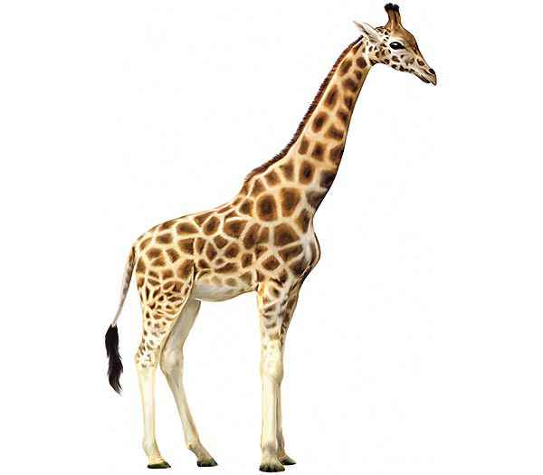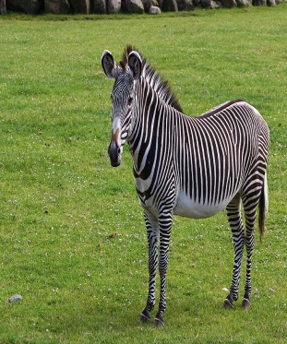
What the name of this animal? What the name of this animal?
This animal has long feet This animal has four feet to walk or run
This animal has long neck This animal has two colors, black and white
This animal has long tail This animal has stripes on part of the body
What the name of this animal?
This animal can fly
This animal has wings to fly
This animal has feathers

Pairs work ! fill in the blank descriptive text below based on the picture, then read the result in front of the class.
(Kerjakan denga teman sebangku ! Isilah kalimat rumpang dibawah ini berdasarkan gambar, lalu bacakan didepan kelas.

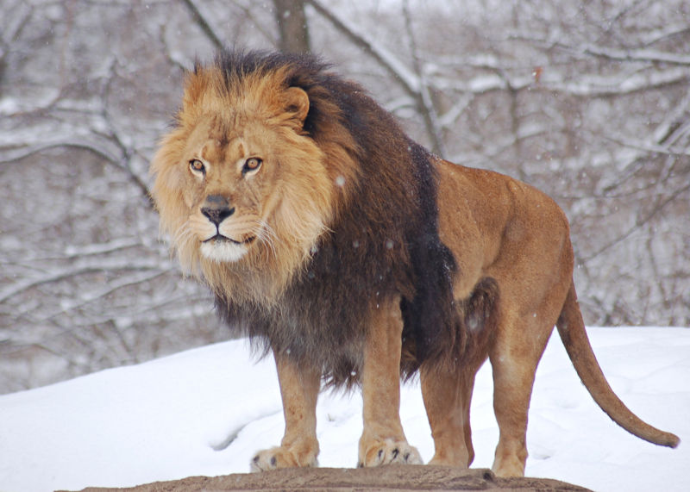
This animal is Lionthe people know from their reputation as the king of jungle, the color of this animal is brown, it has four feet to walk, if this animal feel hungry it will eat meat or other animal like a horse, a cow, or a sheep, because this animal has sharp teeth. This animal live in the wild.

Pairs work ! fill in the blank descriptive text below based on the picture, then read the result in front of the class.
(Kerjakan denga teman sebangku ! Isilah kalimat rumpang dibawah ini berdasarkan gambar, lalu bacakan didepan kelas.
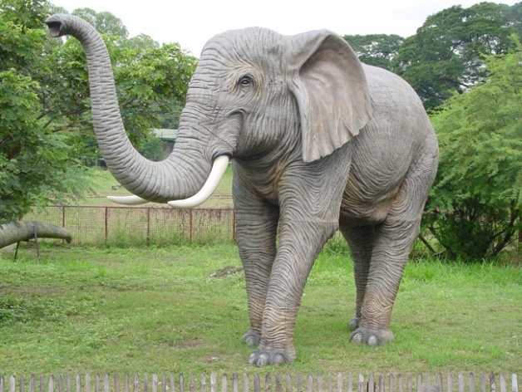
This animal is Elephant, this animal is very big, the color is grey, this animal has four feet to walk, it has long trunk and big ear. This animal live in thewild. But I also can see that animal at the zoo.
G. Metode Pembelajaran
- Pendekatan : Scientific
- Teknik : Unjuk Kerja
H. Kegiatan pembelajaran

Kegiatan | Deskripsi | Waktu
Pendahuluan | - Guru mengucap salam dan berdoa bersama  - guru menanyakan kabar siswa dan mengabsen  - Guru melakukan Brainstorming : memperlihatkan beberapa gambar di ruangan kelas, menanyakan pendapat mereka tentang gambar tersebut  - Guru menanyakan pada siswa materi yang akan dipelajari saat itu  - Guru menjelaskan pada siswa mater yang akan dipelajari saat itu | 10 Minutes
Inti | - Guru memperlihatkan gambar  - Guru meminta siswa membuat kelompok  - Siswa mencocokan kalimat deskriptive dengan gambar  - Siswa mengartikan kata yang digaris bawah  - Guru mengelompokan siswa secara berpasangan  - Setiap pasangan akan mendapat sebuah gambar, setiap pasangan diminta mengisi teks rumpang pada descriptif teks sesuai gambar tesebut.  - Guru meminta setiap grup maju kedepan untuk mendeskripsikan gambar tesebut secara lisan | 70 Minutes
Penutup | - Guru menyimpulkan materi pembelajaran yang telah dibahas  - Guru menanyakan kesulitan siswa mengenai topik yang dibahas  - Guru memberikan kesempatan pada siswa untuk bertanya  - Guru memberikan tugas untuk membawa gambar binatang  - Menutup kegiatan belajar | 10 Minutes

I. Media
- Bahan yang dibuat oleh guru
- Exercise
- Gambar-gambar
J. Sumber belajar
- Buku English on sky
- Gambar-gambar yang relevan diambil dari website
- Lks

Bandung,

Guru Mata Pelajaran

RENCANA PELAKSANAAN PEMBELAJARAN
Satuan Pendidikan : Sekolah Menengah Pertama
Kelas : VII
Kompetensi : Descriptive Text
Alokasi Waktu :2x45 Minutes

- Kompetensi Inti

KI 1 : Menghayati dan mengamalkan ajaran agama yang dianutnya.
KI 2 : Menghayati dan mengamalkan perilaku jujur, disiplin, tanggung jawab, Peduli (gotong royong, kerjasama, toleran, damai), santun, responsif dan pro-aktif dan menunjukan sikap sebagai bagian dari solusi atas nernagai permasalahan dalam berinteraksi secara efektif dengan lingkungan sosial dan alam serta dalam menempatkan diri sebagai cerminan bangsa dalam pergaulan dunia.
KI 3 : Memahami, menerapkan, menganalisis pengetahuan faktual, konseptual, proseduralberdasarkan rasa ingin tahunya tentang ilmu pengetahuan, teknologi, seni, budaya dan humaniora dengan wawasan kemanusiaan, kebangsaan, kenegaraan dan peradaban terkait penyebab fenomena dan kejadian, serta menerapkan pengetahuan prosedural pada bidang kajian yang spesifik sesuai dengan bakat dan minatnya untuk memecahkan masalah.
KI 4 : Mengolah, menalar dan menyaji dalam ranah konkret dan ranah abstrak terkait dengan penegembangan dari yang dipelajarinya di sekolah secara mandiri dan mampu menggunakan metoda sesuai kaidah keilmuan.

B. Kompetensi Dasar
4.12 menangkap makna dalam teks deskriptif lisan dan tulis, sangat pendek dan sederhana.
4.13 menyusun teks deskriptif lisan dan tulis, sangat pendek dan sederhana tentang orang, binatang dan benda dengan memperhatikan fungsi sosial, fungsi teks dan unsur kebahasaan, dengan benar dan sesuai konteks.
C. Indikator:
4.12 - Siswa mampu mengenal jenis teks deskriptif
- Siswa mampu memahami isi dari teks deskriptif
4.13 - Siswa mampu memnyebutkan karakteristik tentang binatang secara umum
- Siswa mampu menyebutkan Vocabularies sesuai gambar
- siswa mamapu mendeskripsikan sesuai gambar secara lisan

E. Materi Ajar
Team work ! mencocokan ciri-ciri binatang yang tertera pada kertas sesuai gambar, kemuadian artikan kata yang bergaris bawah merah.
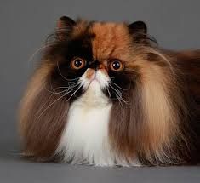
What the name of this animal? What the name of this animal?
This animal has has beautiful eyes and long hair This animal has sharp teeth for eating
This animal has four feet This animal live in the wild
This animal is very cute and beautiful The color of this animal is gray

Individual work ! draw and describe your pet using your words on piece of paper then present it in front of the class.
G. Metode Pembelajaran
- Pendekatan : Scientific
- Teknik : Unjuk Kerja
H. Kegiatan pembelajaran

Kegiatan | Deskripsi | Waktu
Pendahuluan | - Guru mengucap salam dan berdoa bersama  - guru menanyakan kabar siswa dan mengabsen  - Guru melakukan Brainstorming : memperlihatkan beberapa gambar di ruangan kelas, menanyakan pendapat mereka tentang gambar tersebut  - Guru menanyakan pada siswa materi yang akan dipelajari saat itu  - Guru menjelaskan pada siswa mater yang akan dipelajari saat itu
Inti | - Guru memperlihatkan gambar  - Guru meminta siswa membuat kelompok  - Siswa mencocokan kalimat deskriptive dengan gambar  - Siswa mengartikan kata yang digaris bawah  - Guru meminta siswa membuat deskriptif teks tentang binatang peliharaan pada selembar kertas  - Guru meminta setiap orang maju kedepan untuk mendeskripsikan gambar tesebut secara lisan | 70 Minutes
Penutup | - Guru menyimpulkan materi pembelajaran yang telah dibahas  - Guru menanyakan kesulitan siswa mengenai topik yang dibahas  - Guru memberikan kesempatan pada siswa untuk bertanya  - Menutup kegiatan belajar

I. Media
- Bahan yang dibuat oleh guru
- Exercise
- Gambar-gambar
J. Sumber belajar
- Gambar-gambar yang relevan diambil dari website
- Lks
K. Penilaian
No | Name | Aspects of Assessment |  |  |  |  | Score
 |  | Pronunciation | Grammar | Vocabulary | Fluency | Comprehension

SCORING RUBRIC
ASPEK | SKOR | KETERANGAN
Pengucapan/ | 10 | Mudah dipahami dan memiliki aksen penutur asli
Pronunciation | 9 | Mudah dipahami meskipun dengan aksen tertentu
 | 8 | Ada masalah pengucapan yang membuat pendengar harus konsentrasi penuh dan kadang-kadang ada kesalahpaham
 | 7 | Sulit dipahami karena ada masalah pengucapan, sering diminta mengulang
 | 6 | Masalah pengucapan serius sehingga tidak bisa dipahami

ASPEK | SKOR | KETERANGAN
Tata Bahasa/ | 10 | Tidak ada atau sedikit kesalahan tata bahasa
Grammar | 4 | Kadang-kadang membuat kesalahan tata bahasa tetapi tidak mempengaruhi makna
 | 3 | Sering membuat kesalahan tata bahasa yang mempengaruhi makna
 | 2 | Banyak kesalahan tata bahasa yang menghambat makna dan sering menata ulang kalimat
 | 1 | Kesalahan tata bahasa begitu parah sehingga sulit dipahami

ASPEK | SKOR | KETERANGAN
Kosa Kata/ | 10 | Menggunakan kosa kata dan ungkapan seperti penutur asli
Vocabulary | 9 | Kadang-kadang menggunakan kosa kata yang tidak tepat
 | 8 | Sering menggunakan kosa kata yang tidak tepat, percakapan menjadi terbatas karena keterbatasan kosa kata
 | 7 | Menggunakan kosa kata secara salah dan kosa kata terbatas sehingga sulit dipahami
 | 6 | Kosa kata sangat terbatas sehingga percakapan tidak mungkin terjadi

ASPEK | SKOR | KETERANGAN
Kelancaran/ | 10 | Lancar seperti penutur asli
Fluency | 9 | Kelancaran tampak sedikit terganggu oleh masalah bahasa
 | 8 | Kelancaran agak banyak terganggu oleh masalah bahasa
 | 7 | Sering ragu-ragu dan terhenti karena keterbatasan bahasa
 | 6 | Bicara terputus-putus dan terhenti sehingga percakapan tidak mungkin terjadi

ASPEK | SKOR | KETERANGAN
Pemahaman/ | 10 | Memahami semua tanpa mengalami kesulitan
Comprehension | 9 | Memahami hampir semuanya, walau ada pengulangan pada bagian tertentu
 | 8 | Memahami sebagian besar apa yang dikatakan bila bicara agak diperlambat walau ada pengulangan
 | 7 | Susah mengikuti apa yang dikatakan.
 | 6 | Tidak bisa memahami walaupun percakapan sederhana

STUDENTS’INTERVIEW
No | Pertanyaan
1 | Apakah kamu suka belajar "Speaking" atau berbicara dalam bahasa Inggris?
2 | Apakakah Belajar "Speaking" sulit?
3 | Apakah menurut kamu belajar "Speaking" karena membantu dalam mengungkapkan ide?
4 | Apakah kamu senang belajar "Speaking" menggunakan media gambar?
5 | Apakah menurutmu penggunaan gambar dalam pembelajaran "Speaking" bermanfaat khususnya dalam belajar deskripsi?
6 | Apakah media gambar memudahkan dalam menemukan kosakata untuk diungkapkan?
7 | Apakah media gambar memudahkan kamu dalam mencari ide untuk menulis teks deskripsi?
8 | Apakah kamu merasakan kemajuan dalam "Speaking"
 | terutama teks deskriptif setelah menggunakan media gambar?
9 | Apakah menggunakan media gambar membuat pelajaran "Speaking" menjadi lebih menarik
10 | Apakah selama belajar “speaking” lebih suka menggunaka gambar atau tidak?

Transcript of InterviewI

Researcher : Lagi pada ngapain, yang lain belum datang?
Siti : Belum miss, lagi pada sholat dhuha berjamaah
Researcher : Ko kalian ga ikut sholat?
Siti : Engga miss, lagi dapet
Researcher : Oh yaudah kita ngobrol-ngobrol aja ya, sambil interview, Siti dulu deh yang di Interview
Siti : Di interview gmn miss? Malu ah
Researcher : Gak apa-apa Cuma nanya-nanya tentang belajar aja
Siti : Oh, yaudah tapi pake Indonesia ya, miss
Researcher : Iya, kamu suka belajar speaking ga? Speaking itu yang ngomong-ngomong pake Bahasa Inggris
Siti : Engga begitu sih miss
Researcher : Terus sukanya apa? Speaking, Reading, Writing atau Listening?
Siti : Nulis
Researcher : Jadi Speaking gak suka?
Siti : Speaking suka tapi gak bisa ngomongin nya, jadi tau mau ngomong apa tapi gak bisa ngomongnya
Researcher : Jadi menurut kami, speaking itu lebih sulit dari reading, writing gitu ya? Tapi klo writing bisa?
Siti : iya bisa miss
Researcher : menurut kamu, selama belajar speaking pake gambar seneng ga? kaya kemarin belajar kita pake gambar-gambar binatang
Siti : Seneng Miss
Researcher : Sebelumnya suka belajar speaking pake gambar gak? Sama pa Hendri (English Teacher)
Siti : Pa Hendri mah Engga, klo belajar sama pa Hendri mah diem gak bisa mikir, klo belajar sama miss mah jadi seneng ke kitanya
Researcher : Kan yang kemarin kita belajar deskripsi ya, pas pake gambar membantu pas speakingnya ga atau biasa aja?
Siti : Iya ngebantu, kan jadi bisa nyebutin ciri-cirinya liat dari gambar jadi bisa lah ngungkapin sedikit-sedikit
Researcher : Terus klo vocabulary nya nambahin ga? Kaya kemarin kata yang di garis bawahi
Siti : Nah iya nambahin, Miss
Researcher : Ada kemajuan ga belajar speaking nya pake gambar?
Siti : Iya lumayan miss, jadi pengen ngomong terus lebih menarik aja
Researcher : Jadi klo pake gambar suka ya?
Siti : Iya suka miss, gambar nya lucu-lucu hehe
Researcher : Yaudah makasih ya
Siti : Iya miss, sama-sama

Transcript of InterviewII

Researcher : Windri, lagi sibuk ga? Kita ngobrol-ngobrol dulu ya
Windri : Eh engga miss, lagi main game aja
Researcher : Boleh interview sebentar?
Windri : Oh iya miss di rekam ya?
Researcher : Iya di rekam buat penelitian hehe
Windri : Ok miss siap.. siap
Researcher : Nah klo Windri suka ga belajar speaking pake bahsa Inggris?
Windri : Sebenernya mah gak suka, miss
Researcher : Sukanya apa atu?
Windri : Suka nya Listening
Researcher : Jadi menurut kamu belajar speakign itu sulit gak? Yang kaya kemarin-kemarin kita belajar
Windri : Menurut aku mah sulit sih miss, susah diatalar
Researcher : Terus klo pas pake gamabr, belajar speaking nya jadi gimana?
Windri : Seneng sih, lebih terhibur pas pake gambar-gamabar malahan
Researcher : Oh, gitu terus pake gambar ngebantu ga pas belajar deskripsi?
Windri : Iya jadi lebih mudah miss
Researcher : menurut kamu, pas kita belajar deskriptif pake gambar, jadi lebih mudah ga?
Windri : Iya jadi gampang buat ngungkapin karna bisa mengambil apa yang mau diomongin dari gambar jadi gak ribet
Researcher : Oh gitu, berarti ada kemajuan ya dari listening jadi merambah suka ke speaking?
Windri : Iya miss lumayan seneng gampang ternyata
Researcher : Pas sama Pak Hendri, suka pake gambar-gambar gak?
Windri : Gak pernah sih miss sama bapak mah, pas sama miss belajar nya jadi seneng bisa ketewa-ketawa
Researcher : iya syukur atuh klo lebih seneng mah, yaudah makasih yah Windri
Windri : Iya miss, sama-sama

Teaching and Learning in the Classroom on Research Action Class

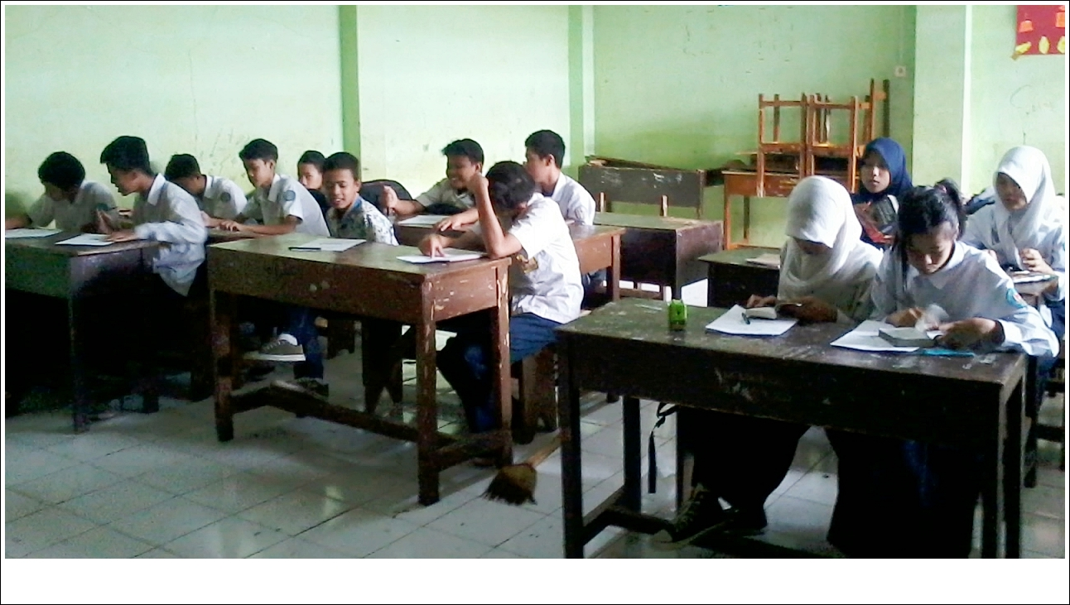

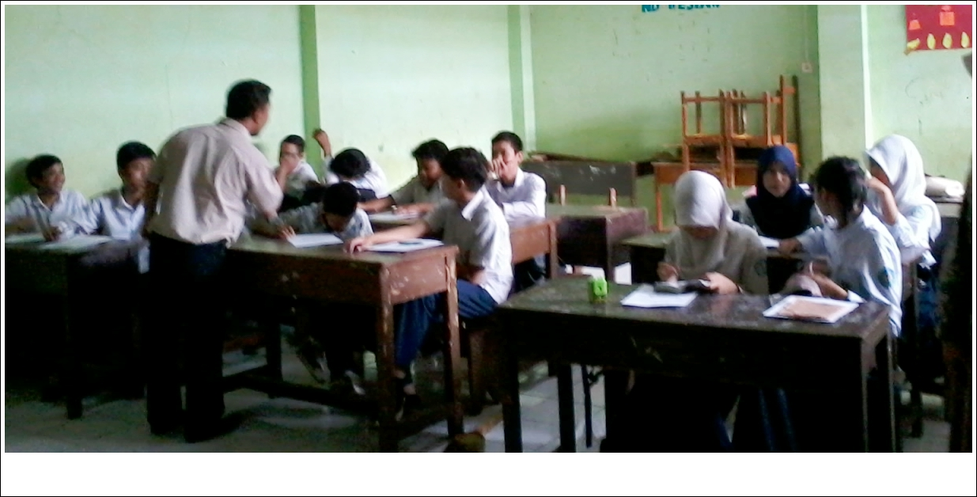

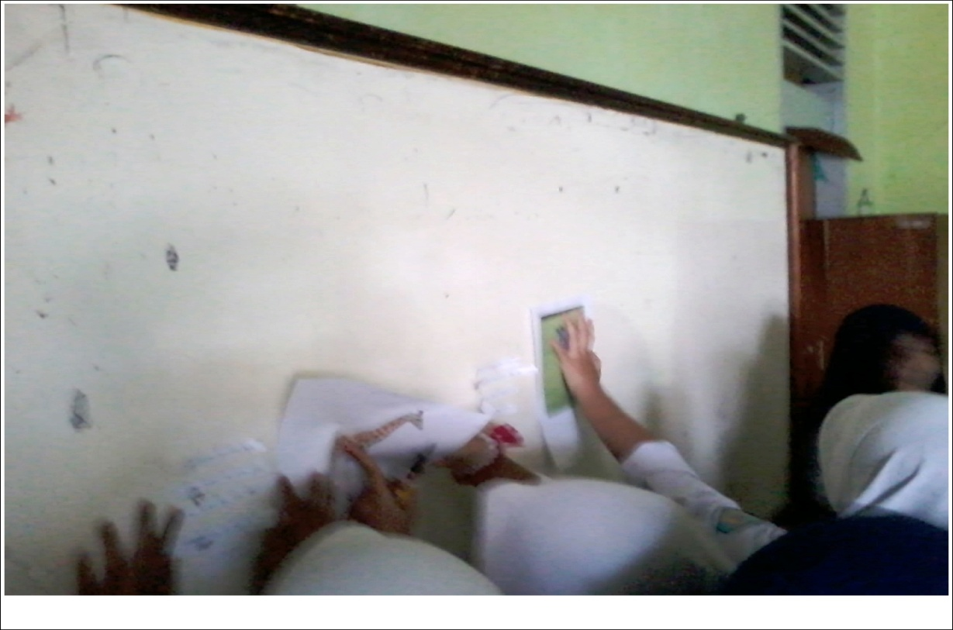

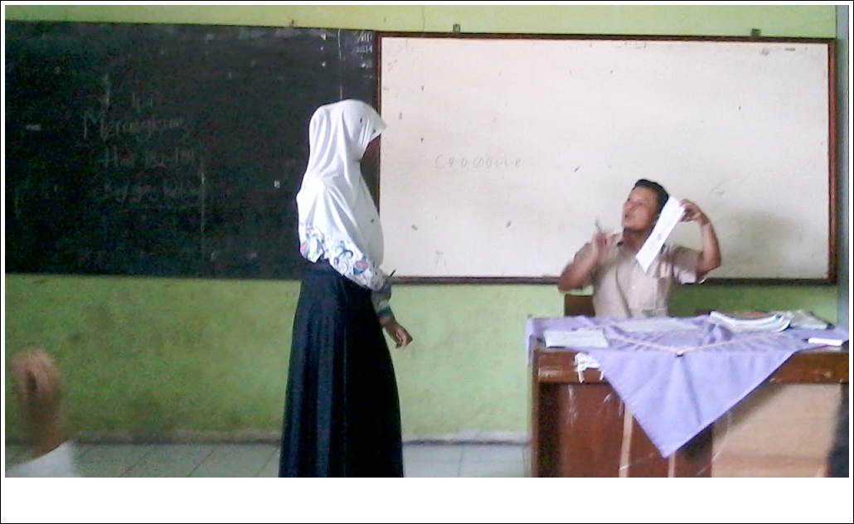

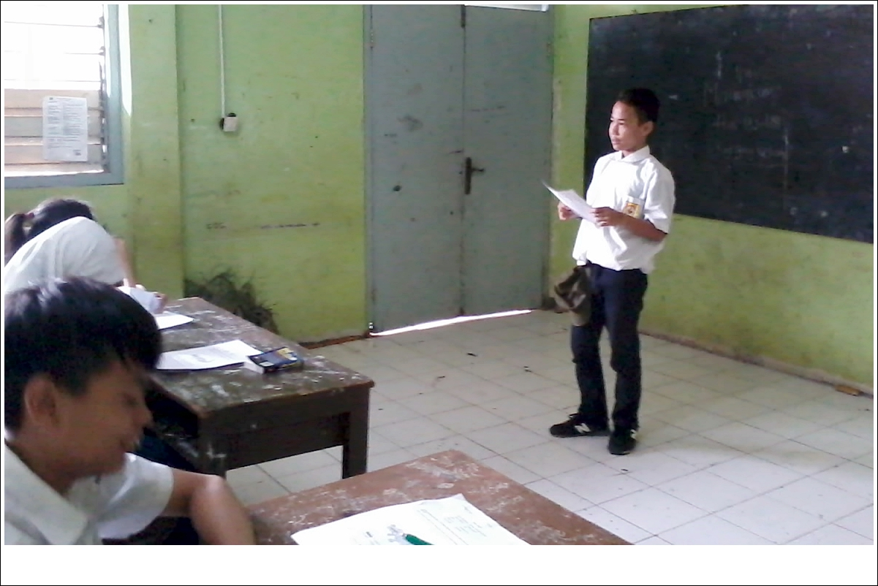

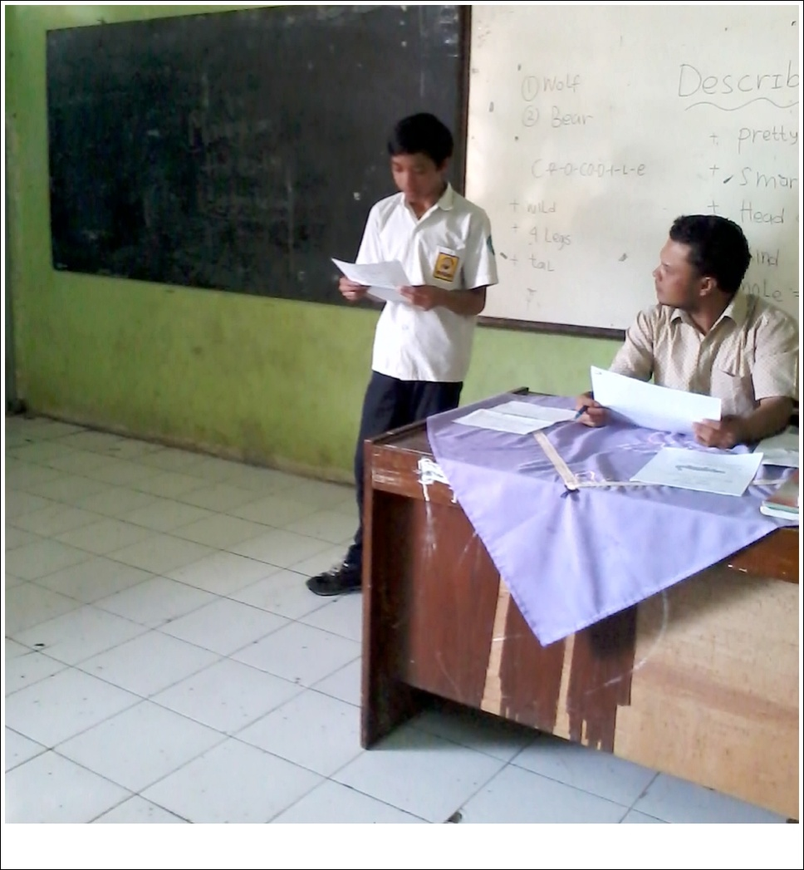
ABOUT THE WRITER
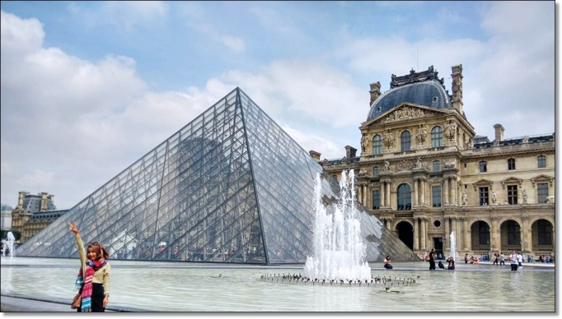Assalamualaikum Wr. Wb.
Criestia Nofia Dewi called Cristy, was born on November 4th 1992 in Bandung. She is the first daughter from three siblings. Grew up in the town she began her formal education in SDN Sirnamanah 1 Bandung, then she continued her study to SMPN 40 Bandung, in 2008 she entered SMKN 1 Bandung she took majoring Administrative of Office. In 2010 after she graduated from SMKN, she decided to continue her higher education in UNPAS (Universitas Pasundan) majoring English Department Faculty of Arts and Letters (FISS). During her college she filled the activity by joining the community Jamparing UNPAS as Traditional Dancer, then she also took a freelancer job and also she job training in SMAN 15 Bandung as an English teacher, now she work at PT. ADIRA Multi Finance as Admin Collections staff. She loves dancing very much, watching movie, reading books and coming to music event.
These are her social media that can be contacted Fb: Cristy Nofia Dewi t:@ristynofia IG: cristynofia and Email 107010008.criestya@gmail.com

