Chapter II
Theoretical Foundation
The theories that used as the foundations are from related to the object of the study. The theories in this chapter are almost based on the qualified expert opinion which is also well-known in their area expertise. All the theories in this chapter can be read are as follows.

2.1 Tourism
The writer gives some definitions about tourism, which could be the references for his research. Many statements suggested as a basis of tourism definition. The statements of tourism definition have related to this research below.
According to Partier in Pengantar Ilmu Pariwisata (Yoeti, 1996: 100)
“Merupakan suatu gejala (phenomena) ekonomi, sosiologi dan psikologi, yang satu sama lainnya saling berkaitan dan banyak sangkut pautnya dengan hidup dan kehidupanmasyarakat, baik secara regional, nasional maupun internasional.” (= is an economy, sociology, and psychology symptoms (phenomenon) which are related to human being, its rather in regional, national or international.)

According to Schulalard in Yoeti (1996: 114)
“Tourism is a sum of operations, mainly of an economic nature, which directly related to the entry, stay and movement of foreigner inside certain country, city or region.”

As regards to the statement above, some other experts said different about tourism when it called in technique side. Hunzieker and Krapt gave some limitation about tourism in Yoeti (1996), as follows:
“Tourism is the totally of the relationship and phenomena arising from the travel and stay of strangers (Ortsfrende), provide the stay does not imply the establishment of a permanent resident.”

From the definition above, we can conclude that tourism is a tour activity undertaken by person or group to visiting some places for the purpose of recreation.
In principle, someone has a desire to do some traveling. It simulated by any motivations, according to McIntosh (1977) and Murphy (1985, cf. Sharpley, 1994) told that its motivations could split in four groups, as follows:
- Physical or physiological motivation, it is include of relaxation, health, pleasantness, etc.
- Cultural motivation, it is an eagerness to know culture, tradition and arts from other regions.
- Social motivation or interpersonal motivation, it same as Visiting Friends or Relations (VFR) where the activities could give some achievements rather in material things or psychological necessities, for examples, meeting some job partners, journey to a holy place and a runaway from any bored situations.
- Fantasy motivation, it is a motivation that caused by people’s fantasy to take some traveling. These motivations are usually done to cure their exhaustion and ego-enhancement that could give psychological satisfaction.
We can conclude that every motivation could be combined as an aim. People went traveling for something that never got before. This traveling can say as vacation, holiday tour, business, etc.
Based on visitor’s categories above, we can see that tourism has many limitations. Some experts suggested these limitations, more over Munt (1994:104) told that tourism is everything and everything is tourism. It caused by tourism suggestions are considerable as if unlimited. Finally, it comes as a tautological definition, as follows:

“Tourism becomes absolutely everything associable with acts of tourist, or to put its proper tautological form, ‘tourism is tourism’ or ‘tourism is what tourist do’.” (Franklin, 2003:28)

2.2 Definition of Tourist
Tourism place was absolutely need tourists who visits as an income source. The tour objects would be different depends on what people’s motivation to do traveling. Then, people can tell the visitor depends on their motivations. Suwantoro (1997) divided into two categories to call the visitors, as follows:
- Tourist is the visitors who stay for a while at least 24 hours in the country.
- Excursionist is the visitors who stay in the country that visited less from 24 hours.
According to Indonesian dictionary (KBBI), tourist has a meaning as a people who do traveling, as follows:
“wi·sa·ta·wan n orang yg berwisata; pelancong; turis: Pemerintah berusaha menarik lebih banyak arus -- luar negeri dng memperkenalkan tempat-tempat yg indah dan menarik;
-- asing wisatawan yg berasal dr luar negeri; wisatawan mancanegara; -- domestik wisatawan nusantara; -- nusantara wisatawan yg berasal dr negeri sendiri; wisatawan dalam negeri”
It explained above that tourist is a person who travels for pleasure. So that clear that most of the tourists do a travel or recreation to refresh their mind and body from their daily activities. according to Spillane(1987):

“pariwisata ini dilakukan oleh orang-orang yang menghendaki pemanfaatan hari-hari liburnya untuk beristirahat, untuk memulihkan kembali kesegaran jasmani dan rohaninya, yang ingin menyegarkan keletihan dan kelelahannya”=(the tourism does the people who want usage their days to vacation for take a rest,to refresh body and spiritual, who would like refresh tiredness and fatigue)

There are general principal components about limitations about tour (tourist). As it was said in Pitana and Gayatri (2005:46):
- Traveler is people who do the trip between two or more places.
- Visitor is people who do the trip to region which is not his/her place/home, more than 12 months, and their purpose trip is not to involve with seeking job.
- Tourist is part of visitor who spent the time about one night (24 hour) to the place that they visit). (WTO, 1995)

2.3 Tourism Object
The term of “tourism object” will never find out in foreign tourism literature, it is different by the term in Indonesia. Foreign people were familiar with “tourist attractions”. It could be an attraction for people to visit somewhere. These differences are still being a controversy by some experts.
Tourism products dominate all the tourism facilities, it begins from people who want to go out from their house. When people go to somewhere, the tourism products are the sense from the trip to its destinations. It caused by people motivations to do traveling, which was planned when they are at home. Benefits and satisfactions have been decided by two factors related, tourism resources and tourist services.
Marioti in Yoeti’s book (1996) said that tourism resources known as “attractive spontanee”. It is everything that was found in a tourism place, which could be attractions to people who want to visit their destinations. Here some place for tourism attractions:
- Things that available in this world, it usually known as “Natural Amenities”. They are grouped as follows:
- Climate, for examples clean air, sunny day, mild, dry, hot, wet, etc.
- Land configuration and landscape, it is contains of plains, scenic mountain, lakes, river, beaches, water-fall, volcanoes and panoramic views.
- The sylvan elements included forest and trees.
- Flora and fauna, it is like uncommon vegetation, birds, fish, wild life, national park, hunting and photographic safari.
- Health center, they are natural springs of mineral water, mud baths, hot springs where all of these object are to heal many disease.
- Man-made supply, this group divided into four important elements such as the historical, cultural, and religious things, for examples:
- Historical monuments and the rest of old-civilizations.
- Museums, art galleries, libraries, handicraft.
- Traditional events, exhibitions, festival, the ceremonial to pilgrimage to Mecca, wedding ceremony, circumcision, etc.
- Tabernacles like mosque, church, a Buddhist or Hinduism temples.
- The way of traditional life from any regions, the one of important source that could be offered for tourists. It offered about how their behavior, their tradition, etc. all these things can sell as events by Tour Operator, for examples:
- Cremation (Ngaben) in Bali.
- Cremation ceremony in Tana Toraja.
- Circumcision ceremony in Parahyangan region.
- Tea ceremony in Japan, etc.
In tourist service, Marioti in Yoeti’s book (1996) mentioned as “attraction device”. It is all of facilities and activities, which can be used or available by some companies on commercial ways. He said that tourist service is not an attraction in tourism, but the existence has needed if they intend to develop tourism in some regions. This situation is relevant when “Tourist resource” and “Tourist Service” fulfilled each other.
Actually, any regions have much potency to offer as a tourism attraction. It could attract some visitors who come to its destination in various markets. Tourism places have to qualify on three requirements, those are:
- “Something to see”, it means some regions should have a different tourism object or tourism attraction with other regions. In other words, its regions should have the special attractions or something to attract as an entertainments, if people come to visit.
- “Something to do”, it means between has something to see, the regions were supplied some facilities or amusements that could make people endure to stay there.
- “Something to buy”, it means the regions should have facilities for shopping, especially souvenirs as a present to carried. These facilities not only have something to buy, but any facilities to help such as moneychanger, bank, etc.

2.4 Kinds of Tourism
The kinds of tourism based on Yoeti (1996) are as follows:
- Based on geographical location:
- Local Tourism is the kind of tourism that has a relative scope and limited in the choice place, for example, Bandung tourism or Jakarta tourism.
- Regional Tourism is tourism activity, which grows wider in the region than any regions that belonging to “Local Tourism”. The example is North Sumatra and Bali.
- National Tourism, such as:
- In the narrow meaning, this tourism activity grows in a region of country or the synonym is domestic tourism. Every tourist is the people of its country only.
- In the extensive meaning, this tourism activity grows in a region of country as domestic tourism also foreign tourism, where has included in bound tourism and out bound tourism.
- Regional-International Tourism is tourism activity grows in the limited international regions, but they passed more than two or three countries. The example is ASEAN, Middle East, South Asia, etc.
- International Tourism is tourism activity grows in all around the world.
- Based on the effect of trade scale:
- In Tourism (Pariwisata Aktif) is tourism activity that marked by arrival of foreign tourists to the country. It caused by foreign tourists who visited will intake the currency exchange for its country, to strengthen the balance of payments.
- Out-going Tourism (Pariwisata Pasif) is tourism activity that marked by self-citizens of its country, going to other country as a tourist.
- Based on tourism object:
- Business Tourism is the kind of tourism where the visitors visited for business, congress, convention, seminar, etc.
- Vocational Tourism is the kinds of tourism where the visitors tripped consist of the people were vacation or furlough.
- Educational Tourism is the kind of tourism where the visitors tripped for studying or learn the knowledge field.

- Based on time arrival:
- Seasonal Tourism is tourism activity that doing in the fixed season.
- Occasional Tourism is kinds of tourism where the trip related to some occasions or events, for example Galungan and Kuningan in Bali, Sekaten in Yogya and Cherry Blossom Festival in Tokyo or Washington.
- Based on the object divisions:
- Cultural Tourism is kinds of tourism where the visitors tripped because of attractions from cultures in that region.
- Healthy Tourism is a kind of tourism for the purpose is; to recovery the disease like skin’s sore, which could recover by visiting some hot springs.
- Commercial Tourism called Trade Tourism, it caused by the trip connected with national trade activity or international such as expo, fair, exhibition, etc.
- Sport Tourism is tourism activity, which intends to see or showing the exercise like Olympics.
- Political Tourism is tourism activity, which intends to see or showing the occasion that connected to countries activity.
- Social Tourism is kinds of tourism, which intends to look for the profit such as study tour, picnic, etc.
- Religion Tourism is tourism activity, which intends to see or showing the religion’s ceremony.
Richardson and Fluker in Pitana and Diarta (2009) made classification about the kinds of special attraction tourism resource, as follows:
No | Classification | Examples
1 | Active Adventure | - Caving  - Parachute Jumping  - off-road Adventure  - Mountain Climbing
2 | Nature and Wildlife | - Bird-watching  - Ecotourism  - Geology  - National Park  - Rain Forest
3 | Family | - Amusement Park  - Camping  - Shopping Trips  - Whale-watching
4 | Soft Adventure | - Back Packing  - Bicycle Touring  - Canoeing  - Scuba Diving
5 | History/Culture | - Agriculture  - Art/Architecture  - Art Festival  - Film/Film History
6 | Spiritual | - Pilgrimage/Mythology  - Religion Spiritual

Tourist Destination is a shape between interactions to various elements, according to Leiper (1990) in Pitana and Gayatri (2005):
“A tourist destination is a systematic arrangement of three elements: a person with touristic needs, a nucleus (any feature or characteristic of a place they might visit) and at least one marker (information about nucleus)” (Leiper, 1990:381).

The development of some regions was influence by the important assertions to become a tourist destination, such as:
- Attractive to Client
- Facilities and attractions
- Geographic location
- Transport link
- Political stability
- Healthy environment
Every little things to become a tourist destination should be gave impacts. One of them is the impact for social-economy, it possibly happened to local citizens. In Pitana and Gayatri (2005), this condition could be categorized in eight groups, as follows:
- The impact toward currency exchange’s acceptance
- The impact toward citizen’s income
- The impact toward career opportunities
- The impact toward costs
- The impact toward benefit distribution/profit
- The impact toward ownership and control
- The impact toward general development, and
- The impact toward Government’s income
Almost all impacts could give opportunities to local citizens as positive profits. Therefore, tourism department should be able to produce the high “multiplier effect” (angka pengganda), more than any multiplier effect in other economically programs. It caused by tourism was the one of export type that considered favorable, especially for national economic of country.
2.5 Ecotourism
The essence of ecotourism is the form of tourism that standing as the responsible to conservationism. According to The Ecotourism Society (1990) in Fandeli (2000),
Ekowisata adalah suatu bentuk perjalanan wisata ke area alami yang dilakukan dengan tujuan mengkonservasi lingkungan dan melestarikan kehidupan dan kesejahteraan masyarakat setempat. (=Ecotourism is form of trip to nature as an aim to conserve its nature area, between done to perpetuate citizen life and safety.)

Ecotourism became a popular tourism aspect that belongs to Indonesia. According to WTO’s study, “Adventure travel, Cruises, Ecotourism, Cultural Tourism and Thematic tourism will emerge as the hottest trends over the next two decades.” It was a potential business to who could manage the originality of nature. The citizen traders are one of the ways to make prosper surrounding people.
Therefore, marketing strategy is needed to develop the facilities of customers using. The one of the marketing’s way is Lifestyle Marketing, because it makes surrounding people involved either in protect the area or doing the business. According to Noel (8:2005),
“Lifestyle marketing shows more efficiency than traditional marketing because it is shaped around the interests, attitudes, opinions, and way of life of consumers, and therefore enable companies to connect with how their potential customers live.”

2.6 Tourism Economy
The development of regions to become a tourism destination is not only gave career opportunities, but it also attracted the outsiders came from other regions. it comes from its job opening, because the outsiders was not always have the same characteristic and culture to local citizen. James J. Spillane ever said in his book Ekonomi Pariwisata (1984),
“...tourism could modify a motivation to many cultures. Arts and ceremonial cultures, which originally done by tradition and spiritual motivation were lost or escaped from it. It caused by the existence of other motivations that having the character of commercials.”

The commercial here was held on to the theory that has been as natural law. According to Indonesian Dictionary (KBBI):
“ju·al·an 1 n barang-barang yg dijual; dagangan: pedagang kaki lima menjajakan ~ nya; 2 v berdagang; berjualan sesuatu: dilarang ~ di halte bus;
pen·ju·al n orang yg menjual (baju, sayur, dsb);
~ bangsa pengkhianat bangsa;
pen·ju·al·an n 1 proses, cara, perbuatan menjual: ~ barang kebutuhan pokok lancar dan mantap; 2 tempat menjual: krn spekulasi, ~ valuta asing sangat ramai”

Economic in tourism sector is not only related to economic activities like hotel affairs, restaurant, and tourism packaging. There are some other economic activities, which related to tourism such as transportation, telecommunication and small business. Generally, economic subject divided into two groups, as follows:
- Microeconomics is a branch of economic that studies the behavior of individual households and firms in making decisions on the allocation of limited resources.
- Macroeconomics is a branch of economic dealing with the performance, structure, behavior and decision-making of an economy as a whole, rather than individual markets.
In tourism sector, the economic activity flows with fast income to local citizen. It needs a minimal fund but inclined too fast in producing income, especially resident income. The product primarily sells services or intangible goods, such as beautiful nature, historical sites, which never expired.
Tourism potency depends on the price competitiveness, which give impacts to every seller on its tourism objects. Sellers have to make some innovation to attracted tourist’s arrival. In this case, Maribaya Tourism Object is the one of tourism object that has developed to increase tourist arrival. It attempted to compete with other more advanced tourism objects.
According to Forsyth and Dwyer in Economics of Tourism (2010:14), price competitiveness explained in some factors, as follows:
“Factors that impinge on price competitiveness include: exchange rates; inflation; the price of labour; productivity; export booms; tax structures and levels; infrastructure charges; fuel prices; and environmental charges.”

The factors mentioned to make peoples know about how big the chance for people’s career opportunities. Citizens who live in tourism destination would have a great chance to get the job. It does not matter about what kinds of job to do, surely the jobs related to its tourist destination. Salah Wahab in Manajemen Kepariwisataan (2003), explained about factors that influenced impact of tourism industry for career opportunities, those are:
- Characteristics of economy’s system and the wisdom of workforces on its country;
- The Characteristics of tourism industry on its country;
- Skill’s level on workforces, efficiency and situation appropriateness for tourism industry;
- The competitiveness between tourism industry and other production sectors;
- Does the tourism industry influenced by its conspicuous season or tourist’s arrivals are balance on year-round;
- An image of tourism product on its country (attracted or not for young educated generation);
- How many tourism jobs that created by each investment of capital, does the investment give a career opportunities in development of tourism infrastructures;
- Does the part-time work would be calculated or not.
At the fifth and seventh point, the writer found the statement that mentioned related to Maribaya Tourism Object. Wahab said that tourism industry influenced by its conspicuous season. It was the appropriated situation to what happened in Maribaya Tourism Object. Therefore, the natives are traders in Maribaya Tourism Object.

2.7 Definition of Income
Tourism could be a biggest currency exchange’s producer in Indonesia. It depends on how big the effort of its workforce to make an income source. Purchaser and seller, they are a group that works for tourism activity. They are who make an income source come from their tourists. According to Hendrikson in Sinaga (1995:164), income is:
“pendapatan adalah ekspresi moneter dari keseluruhan produk atau jasa yang ditransfer oleh suatu perusahaan kepada pelanggannya selama satu epriode.=(income is a monetary expressions to all of services or products, which transferred by companies to its customers in a period)”

Based on the statement above, an income would be felt if any customers come and buy the tourism product. If the workforces could compete with other, they would have a portion of their income. However, the citizen’s traders have to make some innovation in their products or services. It aimed to make seller’s potency. Meanwhile, Shahab (1994) mentioned that income is:
“pendapatan adalah peningkatan jual aktiva atau penurunan suatu badan usaha yang timbul dari penyerahan barang dagangan atau jasa atau aktivitas usaha lainnya di dalam suatu periode.=(Income is an increasing asset selling or a decreasing of business branches that emerge by transferring stuff’s commodity in a period.)”

Based on the explanation above, the writer would apply about what the traders get from Maribaya Tourism Object. Tourism destination should be potential in giving an income for its citizen traders, as it explained in Oxford Dictionary: fourth edition, “income is money received during a month, year, etc, especially as payment for work”. It means the potential aspect from its tourism object that what makes people got opportunities. It could be observed with the theories above.

Profile of Maribaya Tourism Object
Maribaya is one of tourism object for local government of Kabupaten Bandung. This tourism object is formerly famous for its hot spring water.
Along with hot spring water, on this location you can also found another big waterfall called Curug Omas, with height approximately 30 meter.
Maribaya tourism object is at an altitude above 1000 meters offers many charms of affection to miss. Object area of 5.5 hectares, this tourism attraction hot mineral springs, waterfalls, up to a beautiful panorama of the forest.
Located about 27 kilometers from downtown Bandung or five miles east Lembang, the atmosphere is very cool. There is also a hot springs for you to enjoy on the cool air. If you want to enjoy the hot springs, the manager will accommodated water into a pool for rent. Pool size of about 20x10 meters of hot water with temperatures of 20-40 degrees centigrade. If you saw that the water turn yellowish, it means that the water was coming from a high content of sulfur minerals.
Besides offering hot springs, also flown by Maribaya two rivers, called the River Cigulung and Cikawari River. Two of these rivers form the three waterfalls. There's Cikawari waterfall, Cigulung Waterfall, and Cikoleang Waterfall. Cikawari is the only waterfall which basically quite shallow from all of them.
In addition to the hot springs and waterfalls, the other charms that make visitors feel at home Maribaya is cool and mountainous. The appeal of the mountains, the natural situation indeed become the main selling power Maribaya. Therefore, the beauty of these sights is maintained properly.
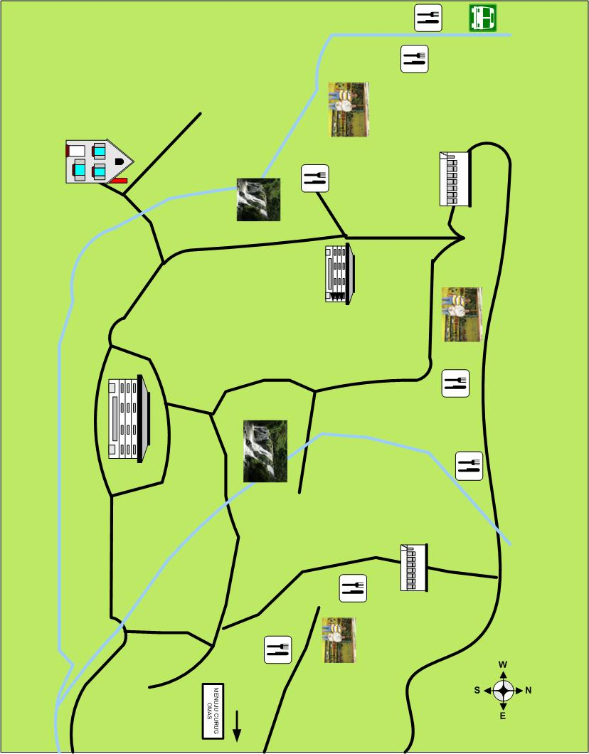
MAP OF MARIBAYA TOURISM OBJECT

